312/2
GEOGRAPHY
Paper 2

MOKASA JOINT EXAMINATION
Kenya Certificate of Secondary Education
312/2
Paper 2
GEOGRAPHY
MARKING SCHEME

SECTION A
Answer all the questions in this section.

1. (a) Give two uses of soda ash. (2 marks)

- Manufacture of glass.
- Manufacture of soap
- Manufacture of detergent.
- Manufacture of caustic soda.

(b) State three ways in which mining derelicts can be rehabilitated. (3 marks)

- Planting trees.
- Creating a park to attract tourists.
- Introducing aquaculture/fish farming.
- Landscaping for settlement or faming.
- Refilling the pits.

2. (a) Name two crops grown in Perkerra irrigation scheme. (2 marks)

- Seed maize
- Pawpaw
- Chillies
- Onions
- Water melons
- Tomatoes

(b) State three physical factors that influenced the location of Mwea Tebere irrigation scheme. (3 marks)

- Black cotton soil with a high water retention suitable for rice cultivation.
- Gently sloping land to allow gravitational flow of water.
- Abundant and regular water supply from Rwey Theba and Nyamidi.
- Warm weather suitable for rice growing.
- Availability of extensive land for rice cultivation and future expansion.

3. (a) Name two exotic breeds of dairy cattle reared in Kenya. (2 marks)

- Fresian
- Holstein
- Asyhire
- Guernsey
- Jersey
- Aiderney
- Brown swiss

(b) State three factors that favour dairy farming in Denmark. (3 marks)

- The landscape is gentle sloping which is suitable for grazing.
- The climate is warm/sunny summer/moderate temperature 10⁰ - 17⁰ that allow out door grazing.
- There is cool climate suitable for pasture growing.
- The moderate rainfall (500 - 1000mm) that supports growing.
- Boulder clay soil are fertile which supports high posture.

4. (a) Define wildlife. (2 marks)

- Wildlife is defined as all untamed plants/flora and animals/ fauna existing in their natural habitats.

(b) State three reasons why it is necessary to conserve wildlife in Kenya. (3 marks)
- To maintain the genetic diversity.
- To attract tourist.
- To protect endangered species of plants and animals.
- To preserve wildlife for future generation/posterity.
- To ensure sustainable utilization of species.
- To maintain aesthetic value for recreation.
- To provide raw materials for medicinal.

5. Study the sketch map of Lake Victoria below and use it to answer question (a).
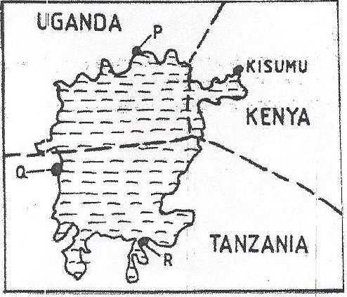
P
N
M
(a) Name the lake parts M, N and P. (3 marks)
M - Jinja
N - Bukoba
P - Mwanza
(b) State two advantages of using water transport. (2 marks)
- It is a cheaper means of transport for bulky goods.
- The water transport has less traffic congestion
- Convenient to carry large quantity of goods.

SECTION B
Answer question 6 and any other TWO questions from this section.
6. Study the photograph below and answer question (a).
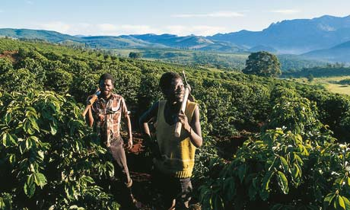
(a) (i) Identify the type of photograph shown above. (1 mark)
- Ground general view.
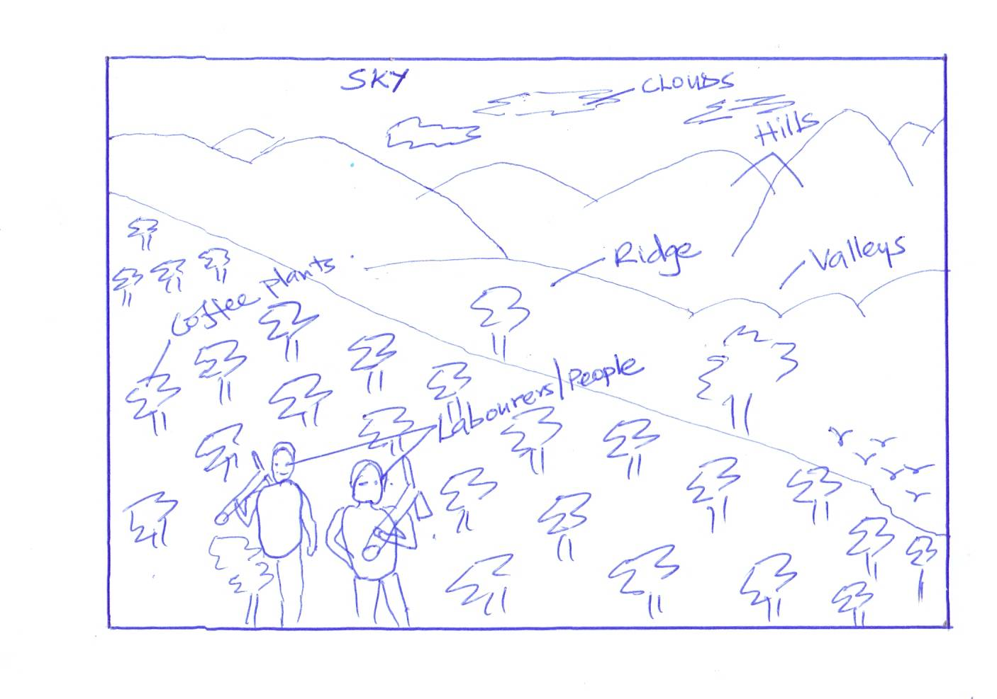
(ii) Draw a rectangle measuring 15cm by 10cm to represent the area covered by the photograph. (1 mark)

Tree

(iii) On the rectangle, sketch and label four main features shown on the photograph. (4 marks)
- Clouds
- Sky
- Trees
- Coffee plants
- People/labourers/workers
- Ridges
- Hills
- Valleys
(iv) Describe the nature of the landscape of the are represented by the photograph. (3 marks)
- The land in the foreground rises from the right to the left.
- The land in the middle ground rises to the background
- The land in the background has ridges and valleys/hilly.
- There is a slight depression in the middle ground.
(b) Give three physical conditions that favour coffee growing in Kenya. (3 marks)
- Moderate temperatures ranging from 14⁰C – 26/cool climate/cool conditions.
- High rainfall/1000mm – 2030mm per year.
- Well distributed rainfall throughout the year.
- Gently sloping landscapes.
- Deep, well-drained volcanic soils.
(c) Explain three problems facing coffee in Kenya. (6 marks)
- The crop is attacked by pests such as leaf miner/aphid/thrips and diseases/ CBD/ Leaf rust/ root rot which lower the yields/quality of barriers.
- Fluctuation of coffee prices in the world market cause uncertainties to farmers making it difficult to plan ahead.
- Inadequate rainfall in some areas destroy crops leading to losses.
- Poor feeder roads in some areas leads to delayed delivery of the coffee barriers to the factory lowering the quality/profit.
- Mismanagement of the co-operatives leads to delayed payment which discourage the farmers.
- Poor marketing strategies leads to low prices which discourage farmers.

(d) Compare coffee growing in Kenya and Brazil under the following sub-headings.
- Coffee growing areas. (2 marks)
- Coffee in Brazil is mainly grown at lower altitudes/upto 900 metres/on gently rolling Brazillian plateau while in Kenya coffee is mainly grown in the highlands.

- Soil (2 marks)
- Coffee in Brazil is grown in deep porous/terra rosa soils while in Kenya it is grown in deep volcanic soils.

- Labour (2 marks)
- In Kenya the work is done by family members while in Brazil the work is done by tenants.
7. (a) (i) What is agro forestry? (2 marks)
- The deliberate growing of trees, crops and keeping of livestock on the same piece of land.
(ii) Differentiate between indigenous and exotic forests. (2 marks)
- Indegenous forests are trees which are natural native to a country/trees grow naturally while exotic forests are trees that are alien to a country/trees introduced to the country from other parts of the world.
(iii) Name two indigenous softwood trees species. (2 marks)
- Podo
- Ceda/juniper
- African pencil.
(b) (i) Explain three factors that favour the growth of natural forests on the slopes of Mt. Kenya. (6 marks)
- The area receives heavy rainfall over 1000mm throughout the year which encourages growth of trees.
- The area has deep fertile volcanic soils that allow the roots to penetrate deep into the ground to support the trees.
- The area has well drained soils thus there is no water logging which can choke plant and interfere with their growth.
- The area has moderate to cool conditions/climate which are ideal for the growth of a variety of trees.
- The area is a gazette forest reserve hence settlement and cultivation are prohibited thereby allowing forests to grow without interference.
- The steep slopes discourage human activities thus enabling forests to thrive without human interference.
(ii) State four factors that have led to the reduction of the area under forest on the slope of Mt. Kenya. (4 marks)
- The illegal encroachment of human activities.
- The government policy of degazzettement has allowed encroachment of human activities.
- Increase population of elephants, buffaloes etc destroy the trees.
- Prolonged droughts have caused drying of some trees.
- Plant disease/pests destroy some trees in the forest.
- Over exploitation of certain species of trees.
(c) Give the differences in the exploitation of softwood forests in Kenya and Canada under the following headings.
(i) Tree species (2 marks)
- In Kenya there are both exotic and indigenous trees while In Canada there are only indigenous softwood trees only.
(ii) Problems facing forestry. (2 marks)
- In Kenya pests and diseases affect exotic trees, in Canada harsh cold climate slow down the regeneration of forests after trees have been felled.
- In Kenya forests is cleared for settlement and agriculture practices while in Canada some parts are not accessible in winter due to cold climate and rugged landscape.
(d) Form four students in a school carried out a field study on the forestry within their county.
(i) Give three reasons why recconnaince was necessary for field study. (3 marks) - It help in designing methods of data collection.
- To help in formulating the hypothesis/objectives of the study.
- To help estimating the cost of the study.
- To get in contact with relevant authority for permission for the visit.
- To help prepare working schedule.
- To help in assembling appropriate apparatus equipment/instruments for the study.
- To help identify the location of various tree species before the study.
- To identify problems likely to be experienced.
(ii) State two advantages of using the content Analysis in the study of forests. (2 marks) - It provides old information.
- It is easy to collect the data as they are already analyzed.
- Less expensive because relevant publication is available.
8. (a) What is fishing? (2 marks)
- It is the exploitation of aquatic animals/fish.
OR
- It involves the catching of aquatic animals for food or for economic reasons.
(b) (i) Name two types of marine fish caught along the East African coast. (2 marks) - Crabs - Blackskin
- Oyster - Cat fish
- Sardines - Mullet
- Tuna - King fish
- Prawn - Barracuda
- Bonito - Queen fish
(c) Use the map of North-West Atlantic fishing ground to answer questions c(i).
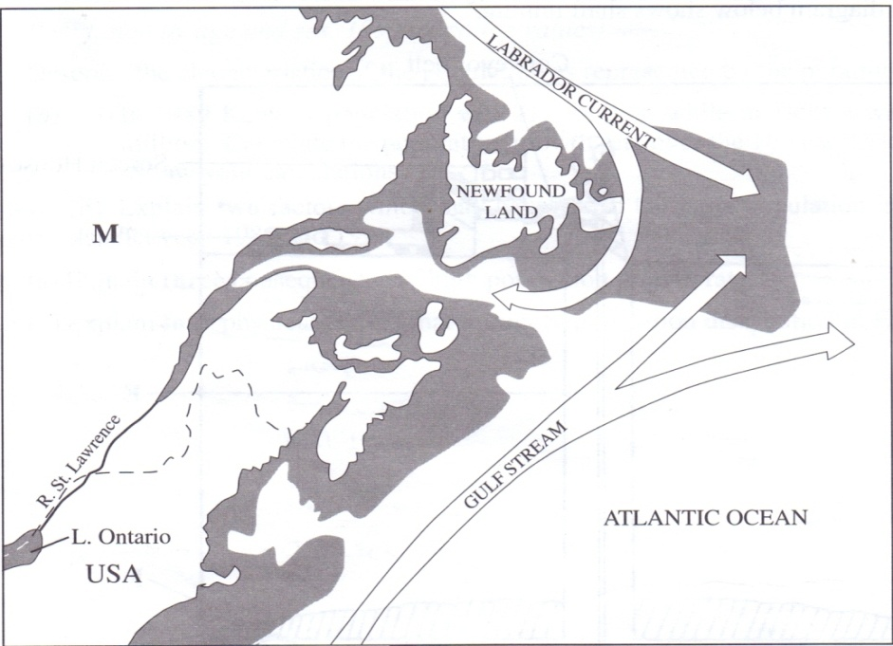
P
Q
(i) Name the ocean currents marked P and Q. (2 marks)
P - Cold Labrador current
Q - Warm gulf stream
(ii) Explain three ways in which the convergence of ocean currents marked P and Q influence fishing. (6 marks)
- The warm gulf stream raises the temperature of ocean water making it ice-free thereby encouraging fishing throughout the year.
- Convergence of the ocean currents causes upwelling of water which increases supply of oxygen and minerals required for the growth of planktons hence presence of mery fish.
- It causes cool conditions, thereby favouring the growth of planktons required by fish.
(d) (i) Describe how drifting method is used in fishing. (5 marks)
- The drift net is held vertically in the water by fitting floats on the upper side and weights at the bottom end of net. This helps to stretch the net.
- The net is held close to the surface of water since this method is meant to catch pelagic fish; while swim in large shoals.
- As the fish try to go past the net they are trapped by their gills.
- Once the net has caught enough fish the drifters are used to haul it and the catch onto the shore.
- The fish are then removed from the net and take for processing.
(ii) State three factors which are considered when choosing a fishing method. (3 marks)
- The type of fish.
- The depth of water.
- The level of technology.
- The purpose of fishing - commercial consumption.
(iii) State three problems which face fishing in Lake Turkana. (3 marks)
- Limited modern technology/inadequate capita to develop fishing.
- Shortage of reedy market due to remoteness and sparse population.
- Overfishing leading to a reduction in the fish population.
- Mismanagement of fishing cooperative society.
- Reduction/fluctuation in water levels lead to decline in fish catch.
(e) State two reasons why fish farming should be encouraged in Kenya. (2 marks) - It helps meet the demand for food with high protein content.
- It allows better use of land and water resources for example ponds and swamps/occupies a small land.
- It creates employment opportunities for many Kenyans for example pond construction, etc hence it is a source of income.
- It is free from inter-territorial conflicts and disputes.
- It leads to development of related industries e.g. canning, net-making etc.
- The fish can be exported to earn foreign exchange for the country.
- It may facilitate scientific research on the general behavior of fish.
- Fish farming assists in the conservation of rare and endangered fish species in danger of depletion.
9. (a) (i) Give two renewable sources of energy. (2 marks)
- Water
- Wind
- Sun
- Geothermal steam
- Biomass
- Wood
- Drought animals
(ii) State two advantages of using uranium as a source of energy. (2 marks)
- It occurs in huge reserves
- It produces large amounts energy compared to other sources/ A relatively small amount of uranium generates large quantities of energy.
- It has a longer lifetime compared to other non-renewable sources of energy.
(b) (i) Apart from generating H.E.P, give three other benefits that have resulted from the construction of Masinga Dam. (3 marks)
- It filters silt to save the other dams which downstream.
- It provides a fishing ground for the local communities.
- It provides water for domestic use.
- It is a tourist attraction/recreation.
- The dam provides a link across river Tana.
- The reservoir provides water for irrigation.
(ii) Explain four physical factors that influence the location of a hydro- electric power station. (8 marks)
- Presence of large volume of water from a river/lake/large catchment area to provide water to drive the turbines.
- Regular/constant supply of water to ensure continuous generation of power.
- Hard basement rock to provide a firm foundation for the construction of a dam.
- Presence of rapids/waterfalls/knick points to provide a massive hydraulic force/lead for power generation.
- Presence of a deep valley/a river gorge to save on the cost of the construction of the dam/to provide spare for the reservoir.
- Non-porous rock/impervions to prevent seepage of water.
(c) State two conditions necessary for the formation of petroleum. (2 marks)
- Presence of remains /deposits of flora and fauna over a long period of time.
- Presence of non-porous rocks underneath the deposits of flora and fauna.
- Deposition of other layers of rocks/non-porous rocks over the remains of flora and fauna.
- Presence of porous rocks.
- Compression of the remains of the flora and fauna due to folding of layers of rocks.
(d) Explain four effects that the increase in oil prices has had on the economies of Kenya. (8 marks)
- The country spend more of their foreign exchange on importation of oil thus leading to decline in other sectors of their economies.
- There has been increasing cost of transport causing a rise in the cost of movement of people, goods and services.
- Production costs have increased leading to an increase in prices of commodities thus reducing the demand on the commodities.
- Some industries that rely on by-products of petroleum have reduce production leading to redundancy/unemployment.
- The country have experienced low economic growth leading to general poverty among the citizen.
- It has led to the need to establish/look for cheaper sources of energy to replace/supplement oil.
- It has created an awareness on the need to conserve energy.
- The countries that have oil potential have started exploring the possibilities of drilling their own oil to reduce/stop importation.
10. (a) (i) Distinguish between industry and industrialization. (2 marks)
- Industrialization is setting up of more industries/is the process and pace/speed at which a country and community sets and undergoes to establish more industries.
OR
- The process of change from primary to secondary and tertiary production while an industry is an establishment set up to process and transform raw materials to more complex material of great value.
(ii) State five factors that have influenced industrial development in Thika. (5 marks) - A rich agricultural hinterland of Thika town provides raw materials.
- River Channia provided fresh water for industrial use.
- Well developed road and railway provide transport services required for industrialization.
- Proximity to Nairobi provides large market.
- Availability of power.
- Availability of labour.
(b) (i) Explain three reasons a government may have for influencing industrial location. (6 marks)
The government may establish industries in place for the purpose of creating employment.
- It leads to utilization of locally available raw materials that would otherwise be left idle.
- It leads to improvement of transport and communication thus opening up the area where the industries are located.
- It leads to the development of social amenities like water supply and electricity thereby raising the living standard of people.
- It leads to diversification of the economy thus reducing the over reliance on Agriculture products.

(ii) Explain four factors that have led to the rapid development of automobile industries in Japan. (8 marks)
- The mountainous and rugged terrain together with thin and Availability of capital acquired from other industries like fishing, ship building together with financial assistance from the government have helped in the setting up and expansion of the industry.
- Large population provides large domestic market in addition to large external market for the cars has encouraged the industry.
- Japanese have advanced technology a fact that has promoted efficient methods of production of high quality goods that are
competitive in the world market.
- There are many sea ports that ease the importation of raw materials and exportation of finished cars.
- Japan has skilled industrious workforce which enhance efficiency in production.
- The large source of power from her H.E.P and imported oil has encouraged the growth of Automobile industries.
- Permafrost soil inhibits agriculture and hence Japanese have turned to automobile and electronic industries.

