K.C.S.E. GEOGRAPHY P2
2012 QUESTIONS

SECTION A
Answer all the questions in this section.

1 (a) What is mining? (2 marks)

(b) State four benefits of Soda Ash mining to the economy of Kenya. (4 marks)

2. (a) Name two methods used in deep sea fishing. (2 marks)

(b) State three ways in which the government of Kenya is promoting the fishing industry.
(3 marks)

3 (a) Apart from the sun, name three other sources of electricity. (3 marks)

(b) Give three advantages of using solar energy. (3 marks)

4. Give three reasons why it is necessary for the government of Kenya to carry out a national census. (3 marks)

(a) Identify two methods used to control tsetse flies in Kenya. (2 marks)

(b) State three negative effects of uncollected garbage on the environment. (3 marks)

SECTION B
Answer questions 6 and any other two questions in this section.

6. Study the photograph below and answer question

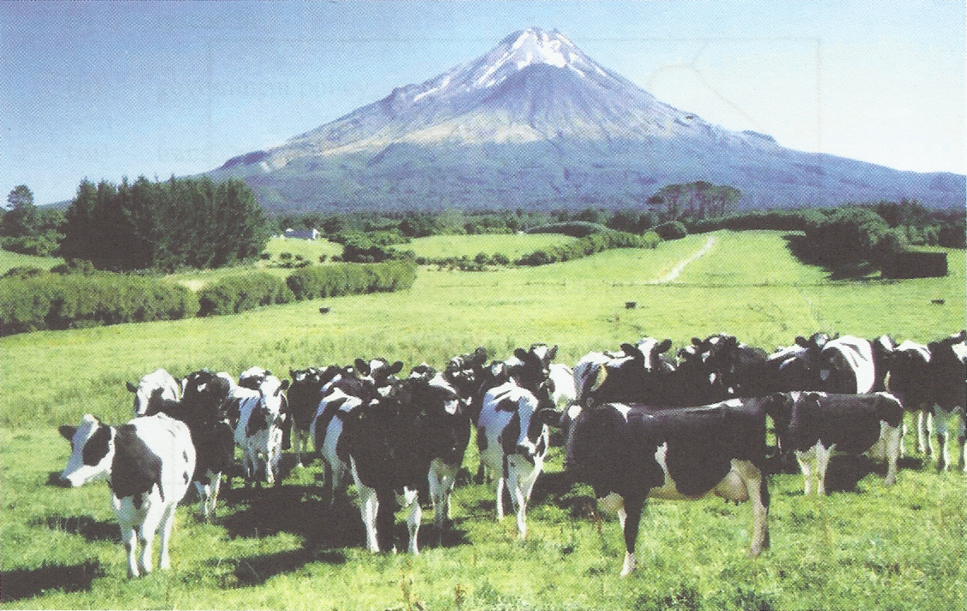
Source: Internet

(a) (i) Identify the type of photograph shown above. (1 mark)

(ii) Draw a rectangle measuring 15 cm by 10 cm to represent the area covered by the
photograph. (1 mark)

(iii) On the rectangle, sketch and label four main features shown on the photograph.
(4 marks)

(iv) Using evidence from the photograph, identify two indicators which show that
the area receives high rainfall. (2 marks)

(b) (i) Name three exotic types of dairy cattle reared in Kenya.
(3 marks)

(ii) Explain three human factors that favour dairy farming in the Kenya Highlands.
(6 marks)

(C) Explain four ways in which dairy farming in Kenya is different from dairy farming in Denmark.
(8 marks)

7. (a) (i) What is agro-forestry? (2 marks)

(ii) Give four reasons why agro-forestry is encouraged in Kenya. (4 marks)

(b) Use the map of Kenya below to answer questions (b) (i) and (ii).

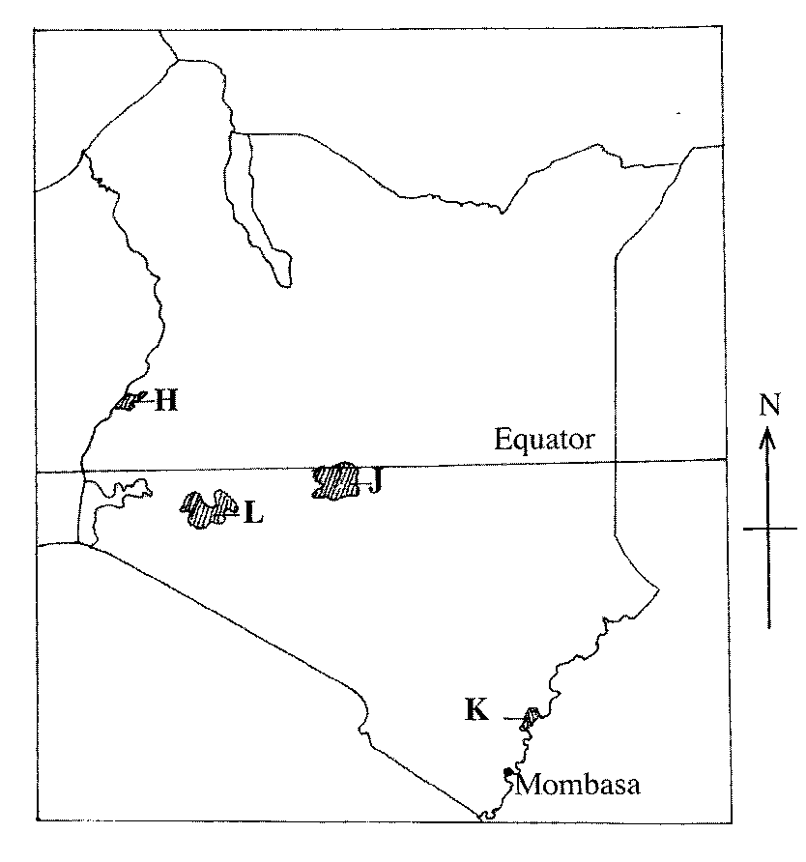

- Name the forest reserves marked H, J and K. (3 marks)

(ii) Explain four factors that favour the growth of natural forest in the area
marked L. (8 marks)

(c) Explain four problems facing forestry in Kenya. (8 marks)

8. (i) Name two provinces in Canada where wheat is grown on a large scale. (2 marks)

- (ii) State three physical conditions that favour wheat farming in Canada.
(3 marks)

(b) Compare wheat farming in Kenya and Canada under the following subheadings:
(i) research; (2 marks)

(ii) government policy; (2 marks)

- transport. (2 marks)

- Explain four problems that affect wheat farming in Canada. (8 marks)

- Your Geography class intends to carry out a field study on wheat harvesting in a farm.

- State two reasons for preparing a working schedule. (2 marks)

(ii) Outline two problems that face wheat harvesting you are likely to find out.
(2 marks)

(iii) Suppose during the field study you used the interview method to collect data,
state two limitations of the method. (2 marks)

9. (a) (i) Identify the three types of inland waterways used for transport in Africa.
(3 marks)

(ii) Give four reasons why the government of Kenya is expanding pipeline transport.
(4 marks)

(b) (i) State three advantages of railway transport. (3 marks)

(ii) State four conditions of roads in Kenya that may lead to motor vehicle accidents.
(4 marks)

(c) The sketch map below shows the Great Lakes and St. Lawrence Seaway. Use it to answer question C.

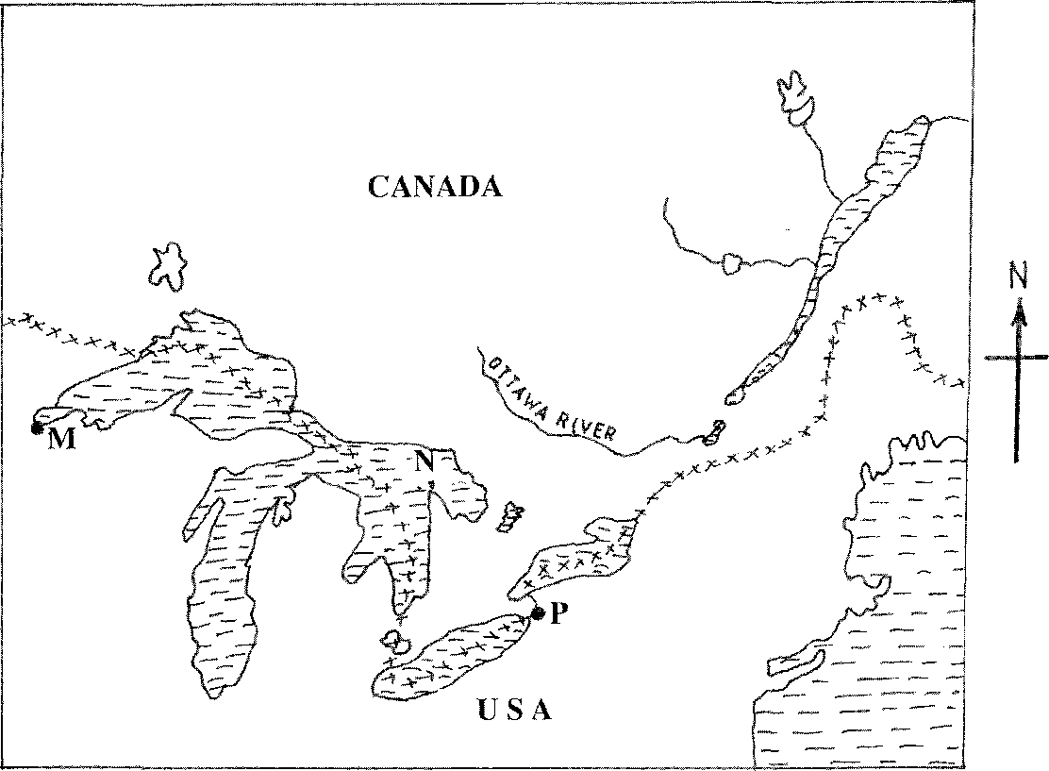

KEY:
xxxxxx - International Boundary.

Name:
(i) the ports marked M and P.
(ii) the Lake marked N.

(d) Explain four benefits of the Great Lakes and St. Lawrence Seaway to the economies of
U.S.A. and Canada. (8 marks)

10 . (a) (i) Name two settlement patterns. (2 marks)

(ii) Explain four physical factors that influence settlement. (8 marks)

(b) (i) Explain how the following factors have led to the growth of Thika town.

• Eocation; (2 marks)

• Transport; (2 marks)

• Eand. (2 marks)

(ii) Apart from being a transport and communication centre, give three other
functions of Thika town. (3 marks)

(c) Explain three positive effects of urbanization to a country. (6 marks)

