K.C.S.E GEOGRAPHY 2012
PAPER 1
SECTION A

Answer all the questions in this section.
(a) What is the relationship between Geography and Mathematics? (2 marks)
(b) State four reasons why it is important to study Geography. (4 marks)
2 (a) Name the two layers of discontinuity that are part of the interior structure of earth. (2 marks)
(b) State three characteristics of the outer core in the interior structure of the earth. (3 marks)

3 (a) Name two forms of precipitation that commonly occur in Kenya. (2 marks)
(b) What is a Stevensons screen? (2 marks)
4 (a) Identity two causes of earth movement. (2 marks)
The diagram below shows some features formed as a result of faulting.

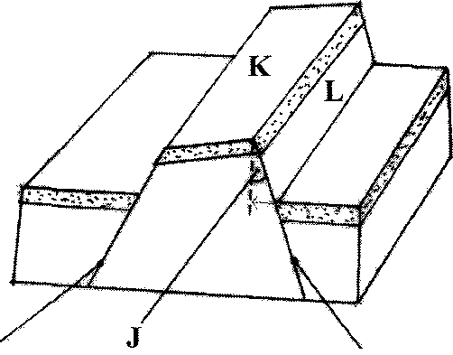
Fault Fault
(b) Identify:
(i) the angle marked J. (1 mark)
(ii) the features marked K and L. (2 marks)
(a) Identify two sources of water found in a lake. (3 marks)

(b) Give three characteristics of lakes formed due to faulting (2 marks)

SECTION B
Answer question 6 and any other two questions from this section.

Study the map of Kitale 1:50,000 (sheet 75/3) provided and answer the following questions.

(a) (i) Identify the two human made features found at the grid square 2320.
(2 marks)

(ii) What is the altitude of the highest point in the area covered by the map?
(2 marks)

(iii) Give three types of natural vegetation found in the area covered by the map.
(3 marks)

(b) (i) What is the bearing of the Air Photo Principal Point at grid square 3426 from the
Air Photo Principal Point at grid square 2931? (2 marks)

(ii) Measure the distance of the dry weather road (C 640) from the junction at point M (345142) to the junction at point N (416201). Give your answer in Kilometres. (2 marks)

(c) (i) Using a scale of 1 cm to represent 40 metres, draw a cross section from grid
reference 410180 to grid reference 500180. (4 marks)

(ii) On the cross-section, mark and name the following:
• a dry weather road; (1 mark)
• River Kaptarit; (1 mark)
• a ridge. (1 mark)

(iii) Calculate the vertical exaggeration (VE) of the section. (2 marks)

(d) Citing evidence from the map, identify five social services offered in Kitale
Municipality. (5 marks)

(7) | (i) What is a mineral? | (2 marks)
 | (ii) Describe the following characteristics of minerals:
 | • lustre;  • colour;  • density. | (2 marks)  (2 marks)  (2 marks)
(b) | (i) Name two examples of extrusive igneous rocks. | (2 marks)
 | (ii) Describe three ways in which sedimentary rocks are formed. | (9 marks)
(c) | Explain the significance of rocks to the economy of Kenya under the following subheadings:
 | (i) tourism; | (2 marks)
 | (ii) energy; | (2 marks)
 | (iii) water. | (2 marks)
8.(a) | Explain the following processes of weathering:
 | (i) hydration; | (2 marks)
 | (ii) oxidation; | (2 marks)
 | (iii) frost action. | (3 marks)
(b) | Describe how an exfoliation dome is formed. | (6 marks)
(c) | Explain three physical factors that enhance movement of materials along a slope due to gravity. | (6 marks)
(d) | (i) Give two processes of rapid mass movement. | (2 marks)
 | (ii) State four indicators of occurrence of soil creep in an area. | (4 marks)

9. (a (i) Outline two factors that influence the development of drainage patterns. (2 marks)

(ii) Outline five characteristics of a river in its youthful stage. (5 marks)

(b) Describe the following processes of river erosion:

(i) attrition; (2 marks)

(ii) corrasion. (4 marks)

(c) Explain three negative effects of rivers to the human environment.

(d) Your class is planning to carry out a field study of a river in its old stage.
(3 marks)

(i) State three reasons why it would be necessary to pre-visit the area of study.
(3 marks)

