5.4.2 Chemistry Paper 2 (233/2)

1.

(a)

(b)

Cl Cl

I ! H-C-C-H

H Cl

Cl H

Cl — C — C -H ©

✓

Cl H

Bubble each through acidified potassium dichoromate (VI) V1 with ethene the solution changes from orange to green 4/ while in ethane the solution remains orange. vx

Bubble each through acidified Potassium manganate(VII) a 1 with ethene the solution changes from purple \o\ V- colourless while in ethane the solution remains purple. ^ /

Add a few drops of bromine water a 1 with ethene the solution changes from orange/ brown vZ to colourless, while in ethane the solution remains orange / brown, v'/

Ethene burns with yellow or sooty flame. Ethane bums with non-luminous or blue flame.

(c) (i) Concentrated sulphuric (VI) acid or ALO or H PO . Vl

Choose any 2

(ii)

- CH-CHr

1

-CH,

✓

(iii)

(iv)

2CH3CH2COOH + Na2C03

-*2CH3CH2COONaaq)+ C02(g) + H20 (1)

2CH3CH2CH2OH + 902

Moles of CO 2 =

6CO, + 8H O (1)

QA)

Moles of CRCH„CH„OH =

2 2

IB ^ 1 24 3

R.M.M. of CH3CH2CH2OH = 60 (V2)

24 X 3

Mass = _L». x 4- x 60 = 15 g (1/z)

(a) C V(l) has the smallest atomic radius and is the most electronegative element in the periodic table. Vl / as one traverses the period number of protons increases hence the nuclear attraction increases.

(b) (i) AB2/AB/C02 or CO Vl (ii) Covalent bond V1

296

(c)

(d)

(e)

(f)

1. Halogens Vl

(ii)

C, + 2H" -

z(g) (aq

-» 2C~ + H Vl

) (aq) 2(g)

F has a giant atomic 4/ stracture with strong 4/ covalent bond which is strong and difficult to break hence high melting point. While G although it exhibits covalent bond it has simple 4/ molecular structure with weak van der waal’s forces between its molecules VK hence the low melting point.

D20 4/ and D202V/^

|  |  |  |  |  |  |  |  |  |  |
| --- | --- | --- | --- | --- | --- | --- | --- | --- | --- |
| D |  |  |  | | | | | |  |
|  |  | (0 |  |  |  |  |  | | |  |
| D | j | ✓ |  |  |  |  |  |  |  |

1. (i) Concentrated Vl sulphuric (VI) acid.
2. Potassium nitrate Vl
3. To condense the fumes or vapour of nitric (V) acid into liquid Vl
4. (i) Nitric acid (V) will corrode the rubber Vl
5. The reaction produces nitrogen monoxide (colourless) 4/ which is oxidised by oxygen from the air to form nitrogen(IV) oxide. 4/

(c) (i) • Water

* Alkanes
* Biogas
* Water gas

(ii) NH + HNO,

V

'A

any 2

->NH„N(X Vl

Mass of NH4N03 = 80 VX either

Moles of NH4NO = 4800 x 10s = 6

Moles of NH3 = 6x10

80

.4 J/

xlO4

Mass of NH.

**6 x 17 x IQ4**  
1000

= 1020 kg

1. Explosives eg. T.N.T. *\J

Production of polymers (terylene) Textile dyes.

Manufacture of drugs

?any 2

297

Surface area/particle size Vl. (i)

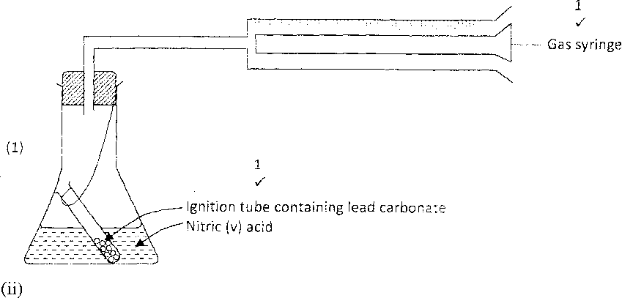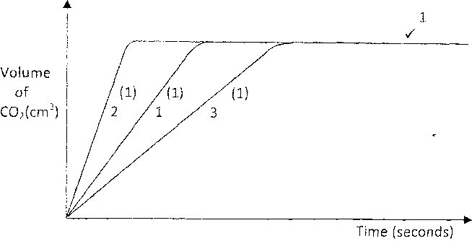

(iii) PbCO, + 2HNO

J(S)

3(aq)

^ Pb(NO ) Vl + CO + HO

3 2 2(g) 2 (0

With hydrochloric acid an insoluble lead chloride is formed, which coats the  
lead carbonate VX preventing the reaction between the acid and the carbonate from  
proceeding. Vl

The reaction would shift to the left changing the solution from colourless to yellow/  
orange Vl. Addition of HC1 creates excess H+ which disturbs the equilibrium so it  
shifts to the left to get rid of the excess H+ ions. Vl

1. The anode is X. Vl Since hydrogen is liberated at the cathode which is Y. Vl

40H

(aq)

-> 2H O + O, +4e.Vl

2 W 2(g)

The hydrogen ions and hydroxide ions which form water (1) are discharged at the electrodes leaving MgS04 concentrated. The amount of water electrolysed is more than the amount of water formed at the anode. Vl

298

1. Blue litmus remains VV2 blue while the red litmus remains redVVz. Indicating that the solution is neutral. Vl
2. Quantity of electricity - 0.3 x 30 x 60

= 540 Vl

Oxygen requires 4 Faradays VX of electricity

24 dm3 = 4 x 96500 4/

? = 540

24 X 540 - = 0.32 dm3

4 x 96500

1. Electroplating

Purification of metals

(a) (i) Cu2+Vl

(b)

(c)

(d)

(ii) CuC03 Vl / ZnS04 Vl

Ba2+ + SO.2" -

4 (aq)

(aq)

BaSO. Vl

(s)

The solution changes from blue to colourless Vl and a brown solid is formed. Vl The magnesium which is above copper in the reactivity series displaces the copper ions Vl from the solution. Apparatus become warm. The reaction is exothermic.

1. Add nitric (V) acid to lead oxide, filter//^, add a soluble sulphate/ sulphuric acid to the filtrate 4/. Filter VX, and wash residue with distilled water VV2 to remove traces of the filterate, then dry residue between VX filter papers /oven.
2. Determine the melting Vl point, if it is pure the melting point will be constant. Vl

(a) (i)

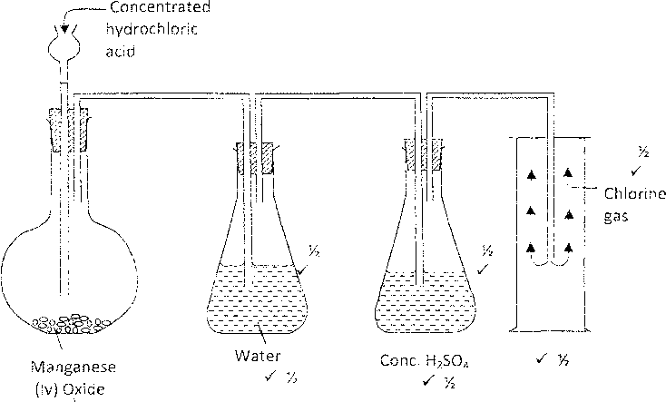

299

1. Potassium Manganate (VII) VK and remove heat 4'A.

Pb02 and heat OR CaOCL2 No heating.

L ^ + ^^

II. 3Cl2(g) + 6NaOH(aq) > NaCl. -

|  |  |  |
| --- | --- | --- |
|  | Cl | O |
| Mass | 0.07 | 1.12 |
| RAM | 35.5 | 16 |
| Moles | 0.07 | 1.12 |
|  | 35.5 | 16 |
|  | 0.02 | 0.07 |
|  | 0.02 | 0.02 |
|  | 1 | 7  2 |
|  | 2 | 7 |
| pirical | formula | C1207 Vi |

Sterilising drinking water supplies V Manufacture of hydrochloric acid V Manufacture of plastics V Manufacture of chloroform V Manufacture of bleaching agents V

(aq)

(Any 2)

NaCIO