5.4 CHEMISTRY (233)

5.6.1 Chemistry Paper 1 (233/1)

1. (a) Carbon (IV) Oxide and Carbon (II) Oxide

Fire extinguishers Fizzy drinks Food preservative Solvay process

(b) C02

Choose 1

Manufacture of fuel (water gas) Reduction in the extraction of metals Manufacture of methanol

CO

Choose 1

1. Add water to dissolve CuS04 while Fe203 does not. Filter out the undissolved Fe203 Wash residue with plenty of distilled water to remove traces of the filtrate.

Dry the residue between filter papers.

1. Grey Solid deposited PbO has been reduced to lead metal. A colourless

liquid condenses on the cooler parts of the combustion tube. The hydrogen has been oxidised to water.

1. (a) BDAC

Across the period the atomic radius decreases.

(b) D

Across the period the conductivity increase due to increase in delocalised electrons.

1. The water must contain impurities. The presence of impurities elevates the boiling point.
2. (i) Copper (II) Sulphate; at 40°C only 28g is soluble leaving undissolved CuS04

Pb (N03) all dissolves.

(ii) 35 - 28 = 7g

7.

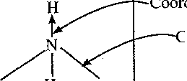

+

loralent bond

H H h

Coordinate (Dative) bond

H2S04iaq) + 2NaOH{aq) Na2S04(aq) + H20(l)

Moles of NaOH i^oX0.1= 0.0036

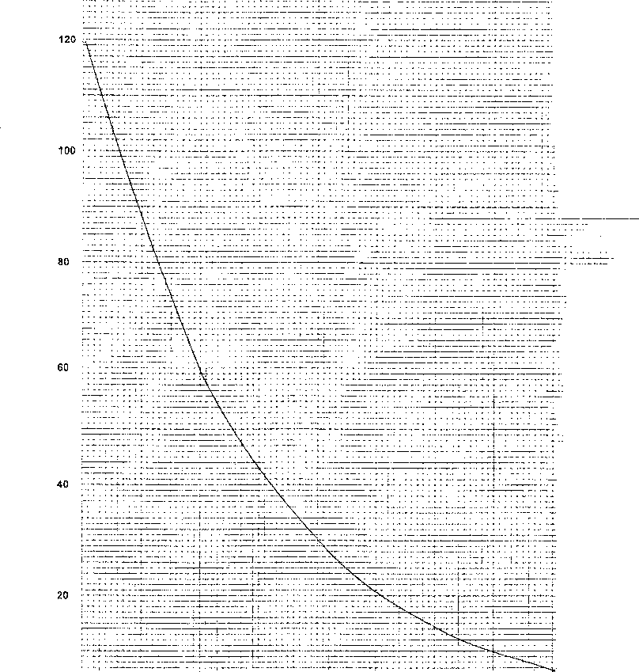

MASS

24 32

DAYS

10. (a) Mg2+,Ca2+

1. The Ca2+ and Mg2+ exchange with Na+ on the ions exchange resin^ 2R - Na + Ca2+ ► R2 - Ca + Na+

2R - Na + Mg2+ ► R2 - Mg + Na+

*PiVi* = *P2V2* T, *T2*

1 x Vi _ 56 x 1 273 546

ir _ 56 x 1 x 273

V' 546

VI = 28cm3

P2 = 1 litre Pj = 1 atm

V2= ? V, = 56cm3

T2 = 273K T, = 546K

0.47g of A occupies 28cm3 at STP ? 22400cm3

0.47 x 22400 27C

CH2Br = 12 + 2 + 80 = 94

94n = 376

n = 376/94 n = 4

(CH2Br)4 = C4HgBr4

1. (a) Calcium Oxide
2. Expose ammonia to hydrogen chloride gas, dense white fumes of ammonium chloride are observed.
3. Steam/water *
4. The catalyst has no effect on the position of equilibrium.

The catalyst will increase the rate of forward and backward reactions to the same extent.

1. Ionisation energy

This is the energy required to remove an electron from an atom in its gaseous state.

Electron affinity:

This is the energy change that results in the formation of an ion when an atom gains an electron.

1. (a) Represents salt bridge.

(b) EMF = E0- gaining - EG-losing

+0.80 - (-0.13)

+0.93V

1. (a) S,H,V,T(2) - If only 1st and last letters are correct (b) T(s) + V2+(aq) ►T2+(aq) + V(s)
2. (a) Heat of reaction

(b) Using a catalyst

Catalyst reduce activation energy.

1. (a) Sulphur (IV) Oxide is oxidised

The change in Oxidation state for

so2 ► h2so4

X = +4 ►X = +6

Since it is increasing, this is oxidation.

(b) • Preservative for Jams and fruits

* Bleaching in the paper industry
* Fumigant
* Disinfectant

1. The level of water in glass tube would go down this is because hydrogen gas being less dense than air diffuses through the porous bag, forcing the level of water in the glass tube to go down while the level of water in the beaker rises slightly.

CM . - CH - CH2CH3

CH,

2 - methylbutane

CH,

2,2- dimethylpropane

CH, C —CH

CH,

21. - Plastic bottles

* Packaging of materials
* Tooth brush handles.

Any 1 (1)

22.

(a) (i)

Maleable

Can be hammed into sheets

Can be drawn into wires

(ii) Ductile

(b) (i) Saucepans

(ii) Electrical transmission lines

1. • Weigh copper carbonate

* Heat Cu CO , to constant mass in a combustion tube
* Reduce CuO using dry H2/NH3 or CO
* Allow to cool and reweigh to get mass of copper

_ Mass *of* Cu

* %— xlOO

Mass *of* CuCOi

1. (a) No air due to boiling.

(b) • Aluminium being very reactive forms a layer of A1,0, on the metal making it impervious to moisture.

* Aluminium being more reactive than iron protects the iron through sacrificial protection/ cathodic protection.

1. 2KOH(aq) + H SO

2 4(aq)

x2= 0.4 moles

200

1000

Moles of KOH

*Moles of H2SO4*

0.4

= 0.2 moles

x = 100cm

Mix 200cm3 of 2M KOH with 100cm3 of 2M H2S04. Concentrate the mixture to drive off excess water, crystallise using a water bath, then dry crystals between filter papers.

1. • Add Na2C03 or NaHC03 to each, with ethanoic acid there will be effervescence, no reaction with

ethanol.

* Add acidified potassium dichromate (VI) or acidified potassium manganate (VII) ethanol will decolarise acidified potasium manganate (VII) and change acidified potasium dichromate (VI) from orange to green. Ethanoic acid has no reaction with the reagent.

1. (a) Group is 5

Period is 3

(b) (i) Noble gases/inert gases

(ii) Used in fluorescence lamps, x-rays tubes

1. (a) 2C1\ . ► CL.. + 2e"

(b) Oxygen

There will be a higher concentration of the hydroxide ion in the dilute solution.

The hydroxide ion being higher in the electromotive series than the chloride ion will then be preferentially discharged.

1. (a) No change or no effect

Presence of water is necessary to form H+ and Ocl' ions which change the litmus paper

(b) Add dilute hydrochloric acid to each of the salts. BaS03 gives effervesence and the salt dissolves. There is no effervesence or effect on BaSQ4.