K.C.S.E YEAR 2010
PAPER 2

        - Which one of the following compounds; urea, ammonia, sugar and copper (II) chloride will conduct an electric current when dissolved in water? Give reasons. (2 marks)
        - The diagram below shows an electrochemical cell. Study it and answer the questions that follows.
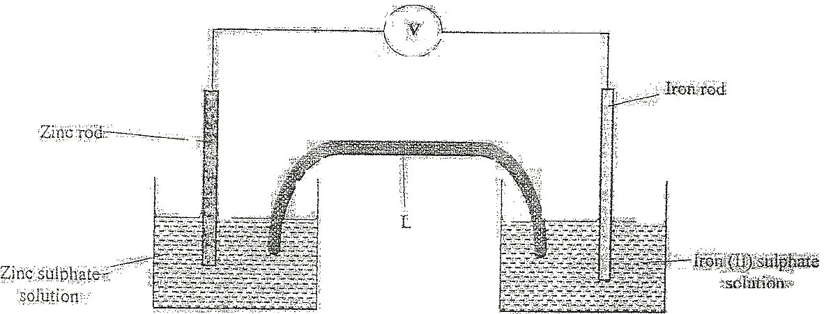

Given the following
Fe²⁺ (aq) + 2e Fe (s); E^{θ} = - 0.44V
Zn²⁺ (aq) + 2e Zn (s); E^{θ} = - 0.76V

- Show on the diagram using an arrow, the direction of flow of electrons (1 mark)
- Name two subsrances that are used to fill the part labeled L (2 marks)
        - In an experiment to electroplate iron with silver, a current of 0.5 amperes was passed through a solution of silver nitrate for an hour
- Give two reasons why it is necessary to electroplate iron with silver (2 marks)
- Calculate the mass of silver that was deposited on iron (Ag = 108, 1 Faraday = 96,500 coulombs) (3mks)

          - Give the name of the following compounds:
- CH₃

CH₃ C CH₃

CH₃ (2 marks)
- CH₃C = CCH₂CH₃ (1 mark)
          - Describe a chemical test that can be carried out in order to distinguish between
CH₃
CH₃ CH C and CH₃ and CH₃C = CCH₂CH₃

CH₃ (2 marks)
          - Study the flow chart below and answer the questions that follows
              - Ethanoic acid
              - Concentrated Sulphuric(vi) acid

M | Polymerization | Ethene | Step 1 | Ethanol | Warm  Step2 | L

Hydrogen nickel 150⁰C
N | - Excess chlorine  - U.V. light | P
Step 3

- Name the compounds: (2 marks)
            - L
            - N
- Draw the structural formula of compound M showing two repeat units (1 mark)
- Give the reagent and the conditions used in step I (1 mark)
- State the type of reaction that take place in: (2 marks)
        - Step 2
        - Step 3
      - The molecular formula of compound P is C₂H₂Cl₄. Draw the two structural formulae of compound P(2 marks)
- Use the information in the table below to answer the questions that follow. The letters do not represent tha actual symbols of the elements.

Element | Atomic number | Melting point (⁰C)
R  S  T  U  V  W | 11  12  15  17  18  19 | 97.8  650.0  44.0  -102  -189  64.0

          - Give the reasons why the meling point of:
- S is higher than that of R (1 mark)
- V is lower than that of U (2 marks)
          - How does the reactivity of W with chlorine compare with that of R with chlorine?
Explain, (2 marks)
          - Write an equation for the reaction between T and excess oxygen (1 mark)
          - When 1.15g of R were reacted with water, 600cm³ of gass was produced.
Determine the relative atomic mass of R. (Molar gas volume = 24000cm³) (3 marks)
          - Give one use of element V (1 mark)

        - 50cm³ of 1M copper (II)sulphate solution was placed in a 100cm³ plastic beaker. The temperature of the solution was measured. Excess metal A powder was added to the solution, the mixture stirred and the maximum temperature was repeated using powder of metals B and C. The results obtained are given in the table below:
 | A | B | C
Maximum temperature (⁰C) | 26.3 | 31.7 | 22.0
Initial temperature (⁰C) | 22.0 | 22.0 | 22.0

            - Arrange the metal A, B, C and copper in order of reactivity starting with the least reactive. Give reasons for the order. (3 marks)
            - Other than temperature change, state one other observation that was made when the most reactive metal was added to the copper(II) sulphate solution. (1 mark)
        - The standard enthalpy change of formation of methanol is -239 kJmol⁻¹.
- Write the thermol chemical equation for the standard enthalpy change of formation of methanol. (1 mark)
- Methanol is manufactured by reacting carbon(II)oxide with hydrogen at 300⁰C and a pressure of 250 atmospheres.
The equation for the reaction is:

CO_{(g)} + 2H_{2(g)} CH₃OH_{(g)}

            - How would the yield of methanol be affected if the manufacturing process above is carried out at 300⁰C and a pressure of 400 atmosphere? Explain (2 marks)
            - Use the following data to calculate the enthalpy change for the manufacture of methanol from carbon(II)oxide and hydrogen (3 marks)
CO_{(g)} + ½ O_{2(g)} CO_{2(g)} ; ∆H^{θ} = -283kJmol⁻¹
H_{2(g)} + ½ O_{2(g)} H₂O_{(l)}; ∆H^{θ} = -286kJmol⁻¹
CH₂ OH_{(l)} + 3/2 O_{2(g)} CO_{2(g)} + 2H₂O_{(L)}; ∆H^{θ} = -715kJmol⁻¹
- The calculate enthalpy change in part B(ii) (II) aove differ from the standard enthalpy change of formation of methanol. Give a reason. (1 mark)

- A student set u the apparatus as shown in the diagram below to prepare and collect dry ammonia gas.
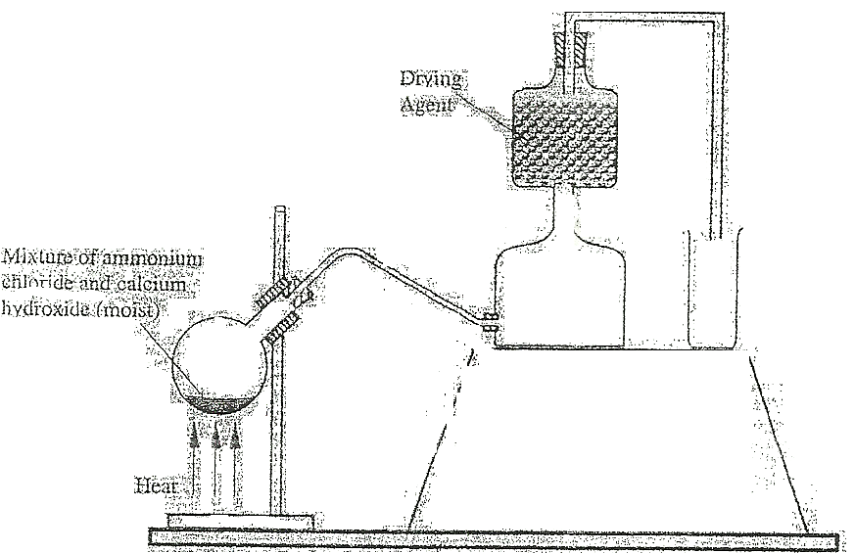
- Identify two mistakes in the set up and give a reason for each mistake. (3 marks)
            - Mistake
Reason
            - Mistake
Reason
- Name a suitable drying agent for ammonia (1 mark)
- Write an equation for the reaction that occurred when a mixture of ammonium chloride and calcium hydrogen was heated. (1 mark)
- Describe one chemical test for ammonia gas (1 mark)
        - Ammonia gas is used to manufacture nitric (V) acid, as shown below.

Gases
Water
High temperature
Cooling chamber
Absorption tower

Ammonia A B Air

Air
Unit I Unit II Unit III

Water(v)acid

- This process require the use of a catalyst. In which unit is the catalyst used? (1 mark)
- Identify compound A and B (1 mark)
- Using oxidation number, explain why the conversion of ammonia to nitric(V) acid is called catalytic oxidation of ammonia (2 marks)
- Ammonia and nitric(V) acid are used in the manufacture of ammonium nitrate fertilizer. Calculate the amount of nitric (V) acid required to manufacture 1000kg ammonium nitrate using excess ammonia. (3 marks)

- The melting and boiling points of zinc are 419⁰C and 907⁰C respectively. One of the ores of zinc blende. To extract zinc, the ore is first roasted in air before feeding it into a furnace.

- Write the formula of the main zinc compound in zinc blende. (1 mark)
- Explain using an equation why it is necessary to roast the ore in air before introducing it into the furnace
(2 marks)
        - The diagram below shows a simplified furnace used in the extraction of zinc. Study it and answer the questions that follows:
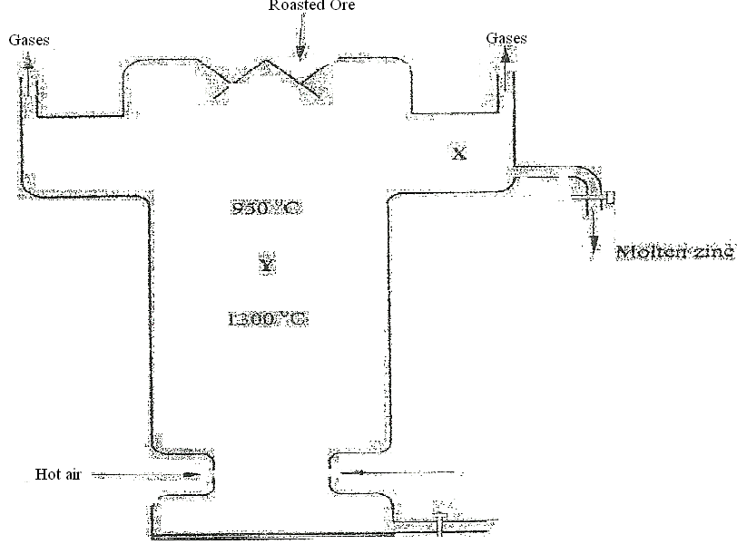

- Name two other substance that are also introduced into the furnace together with roasted ore. (1 mark)
- The main reducing agent in the furnace is carbon(II) oxide. Write two equations showing how it is formed.
(2 marks)
- In which physical state is zinc at point Y in the furnace? Give a reason (1 mark)
- Suggest a value for the temperature at point X in the furnace. Give a reason. (1 mark
- State and explain one environmental effect that may arise from the extraction of zinc from zinc blende(2 mks)
- Give two industrial uses of zinc. (1 mark)

- The figure below shows how the rate of the following reaction varies with the time.
A _{(g)} + B_{(g)} 2C_{(g)} + D_{(g)}

Rate of Curve II
reaction

Y
Curve I

X Time(minutes)
- Which of the two curves represent the rate of the reverse reaction? Give a reason (2 marks)
- What is the significance of point X and Y on the figure? (2 marks)
- State and explain the effect of an increase in pressure on the rates of the following reactions.
- H_{2(g)} + Cl_{2(g)} 2HCl_{(g)} (2 marks)

- CH₃OH_{(l)} + CH₃COOH_{(l)} CH₃COOCH_{3(l)} + H₂O_{(l)} (2 marks)
- In an experiment to study the rate of reaction between barium carbonate and dilute hydrochloric acid; 1.97g of barium carbonate were reacted with excess 2M hydrochloric acid. The equation for the reaction is
BaCO_{3(s)} + 2HCl_{(aq)} BaCl_{2(aq)} + CO_{2(g)} + H₂O_{(l)}

The data in the table was obtained

Time in seconds | 0 | 30 | 60 | 90 | 120 | 150 | 180 | 210 | 240
Volume of gas (cm³) | 0 | 80 | 135 | 175 | 210 | 230 | 240 | 240 | 240
- On a grid plot a graph of volume of gas produced (vertical axis) against time (3 marks)
- From the graph, determine the rate of the reaction at:
            - 15 seconds (1 mark)
            - 120 seconds (1 mark)
            - Give a reason for the difference between the two values. (1 mark)

