K.C.S.E YEAR 2010
PAPER 1

        - Distinguish between a deliquescent and a hygroscopic substance. (2 marks)
        - Give one use of hygroscopic substance in the laboratory. (1 mark)
      - a) What is meant by the terms: (2 marks)
        - element
        - atomic number
b) The formula for a chloride of titanium is TiCl₃. What is the formua of its sulphate? (1 mark)
- What is the name given to each of the following:
- Ability of a metal to be made into a wire: (1 mark)
- Minimum energy required for a chemical reaction to start; (1 mark)
- Type of force that hold atoms of noen together? (1 mark)
- Draw the structure and give the name of the three alkaline having molecular formula C₅H₁₀ (3 marks)
- Hydrate cobalt(II) chloride exists as pink crystals and anhydrous cobalt(II) chloride is a blue powder. Describe a laboratory experiment that can be used to show that the action of heat on hydrated cobalt(II) chloride is a reversible reaction. (3 marks)
- Aluminium oxide reacts with both acids and bases.
- Write an equation for the reaction between aluminium oxide and hydrochloric acid. (1 mark)
- Using the equation in (a) above, calculate the number of moles of hydrochloric acid that would react completely with 153.0g of aluminium oxide. (AL = 27.0, 0= 16.0) (2 marks)
- Complete the table below by writing the poduct formed at the electrodes during the electrolysis of the electrolytes given in the table. (3 marks)

Electrolyte | Product at anode | Product at cathode
Aqueous sodium sulphate using inert electrodes | oxygen  (1/2 mark) | Hydrogen  (1/2 mark)
Aqueous copper(II) sulphate using copper electrodes | Copper ions  (1 mark) | Copper metal  (1 mark)

- The pressure of nitrogen gas contained in a 1dm³ cylinder at -196⁰C was 10⁷ Pascals.
Calculate the:
- Volume of the gas at 25⁰C and 10⁵ Pascals. (1 ½ marks)
- Mass of nitrogen gas(Molar volume of gas is 24dm³, N = 14.0) (1 ½ marks)
- Carbon -14,¹⁴₆C, is used in carbon dating. It decays to form nitrogen, ¹⁴₇N. The graph below shows the amount of carbon -14 left in a sample against its age in years.
- Write a nuclear equation for the decay process of carbon -14. (1 mark)
- From the graph, determine the;
- Half-life of carbon -14; (1 mark)
- Percentage of carbon -14 in a sample whose age is 1950 years. (1 mark)

- The figure below shows an energy cycle.

H_{2(g)} + O_{2(g)} | ∆ H₁ = - 187.8kJmol⁻¹ | H₂O_{2(l)}

∆H₂ = -285.8kJmol⁻¹ ∆H₃

H₂O_{(l)} + ½ O_{2(g)}

- Give the name of the enthalpy change ∆H₁. (1 mark)
- Determine the value of ∆H₃. (2 marks)
- Hydrogen sulphide is a highly toxic and flammable gas. It is normally prepared in a fume chamber.
- Name two reagents that can be used to prepare hydrogen sulphide in the laboratory. (1 mark)
- One of the uses of hydrogen sulphide is to produce sulphur as shown in the following equation;

2H₂S_{(g)} + SO_{2(g)} 3S_{(s)} + 2H₂O_{(l)}

Identify the reducing agent in this reaction and give a reason for your answer. (1 mark)
- Other than production of sulphuric(IV) acid, state one commercial use of sulphur. (1 mark)
- A beaker contained 75.0cm³ of aqueous copper (II) sulphate at 23.7⁰C. when scrap iron metal was added to the solution, the temperature rose to 29.3⁰C.
- Write an ionic equation for the reaction that took place. (1 mark)
- Given that the mass of copper deposited was 5.83g, calculate the molar enthalpy change in kJmol⁻¹. (specific heat capacity of solution = 4.2Jg⁻¹ K⁻¹, density of solution 1.0gcm⁻³, Cu = 63.5) (2 marks)
- Some animal and vegetable oils are used to make margarine and soap. Give the reagents and conditions necessary for converting the oils into:
- Margarine (2 marks)
- Soap (1 mark)
- Using electrons in thee outermost energy level, draw the dot (.) and cross (x) diagrams for the molecules H₂O and C₂H₄. (H = 1, C = 6, O = 8) (2 marks)
- H₂O
- C₂H₄
- The formula of a complex ion is Zn(NH₃)₄²⁺. Name the type of bond that is likely to exist between zinc and ammonia in the complex ion. (1 mark)
- Carbon (II) oxide is described as a “silent killer”
- State one physical property of carbon (II) oxide that makes it a “silent killer” (1 mark)
- State and explain one chemical property that makes carbon (II) oxide poisonous to human beings (2 marks)
- A sample of fertilizer is suspected to be calcium ammonium nitrate. Describe chemical tests for each of the following ions in the sample:
- Calcium ions; (2 marks)
- Ammonium ions. (1 mark)
- Analysis of a compound showed that it had the following composition: 69.42% carbon, 4.13% hydrogen and the rest oxygen.
- Determine the empirical formula of the compound. (C = 12.0, H = 1.0, O = 16.0) (2 marks)
- If the mass of one mole of the compound is 242, determine its molecular formula (1 mark)
- The diagram below represents set up for large scale manufacture of hydrochloric acid. Study it and answer the questions that follow.
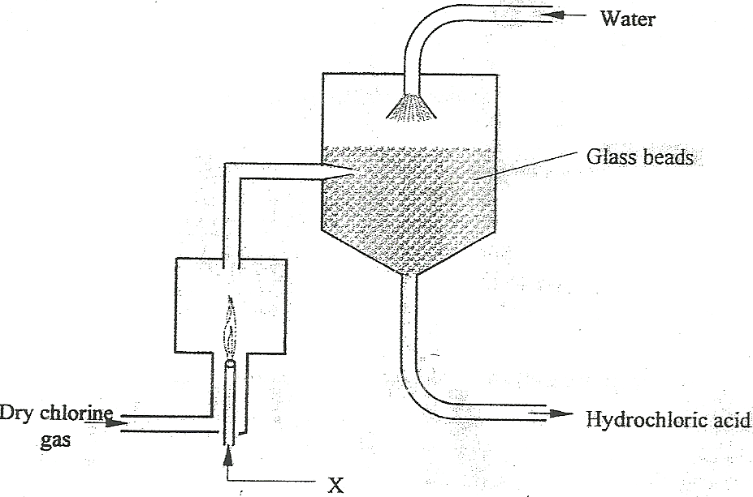
- Name substance X (1 mark)
- What is the purpose of the glass beads? (1 mark)
- Give two uses of hydrochloric acid. (1 mark)
- The half equations involved in a cell are:

2H₂O_{(l)} + 2e = H_{2(g)} + 2OH⁻_{(aq)}: E^{θ} = - 0.83V

O_{2(g)} + 2H₂O_{(l)} + 4e = 4OH⁻_{(aq)}: E^{θ} = + 0.40V

- Write the oveall equation for the electrochemical cell. (1 mark)
- Calculate he e.m.f. generated by a battery consisting of ten cells. (1 mark)
- State one environment advantage of using these cells in spacecrafts. (1 mark)
- In an experiment to prepare nitrogen (I) oxide, ammonium nitrate was gently heated in aflask.
- Write the equation for the reaction that took place in the flask. (1 mark)
- State and explain how the gas was collected. (1 mark)
- A sample of the gas was tested with damp blue and red litmus papers. What observations were made?
- The use of CFCs has been linked to depletion of the ozone layer.
- What does CFC stand for? (1 mark)
- Explain the problem associated with the depletion of the ozone layer (1 mark)
- State another environment problem caused by CFCs (1 mark)
- Nitrogen and hydrogen react to form ammonia gas as shown in the following equation:

N_{2(g)} + 3H_{3(g)} 2NH_{3(g)} : ∆H is negative

- The figure below shows how the percentage of ammonia gas in the equilibrium mixture change with temperature.
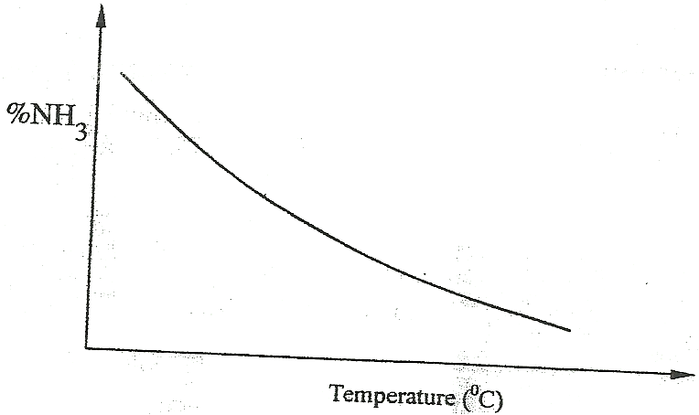
Explain why the percentage of ammonia gas change as shown in the figure. (2 marks)
- On the axes below, sketch a graph showing how the percentage of ammonia gas in equilibrium mixture changes with pressure.
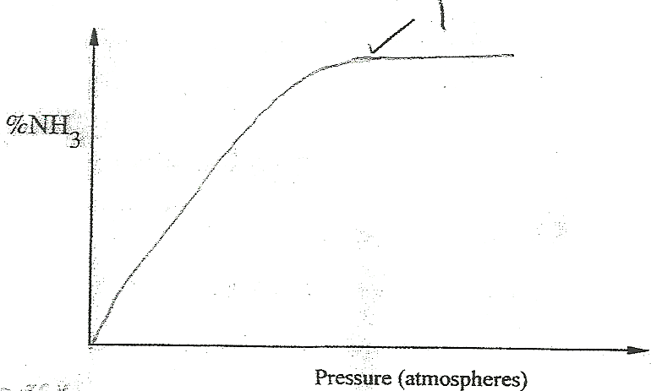
- The curves below shows how the electronic conductivity of hydrochloric and ethanoic acids vary with concentration.
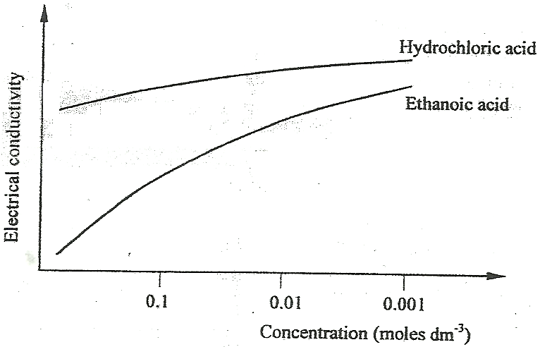
Explain why the electrical conductivity of 0.01M hydrochloric acids is higher than that of 0.01M ethanoic acid. (2 marks)
- Describe how a solid sample of the double salt, ammonium iron(II) sulphate, can be prepared using the following reagents; Aqueous ammonia, sulphuric(VI) acid and iron metal. (3 marks)

- A sample of river water was divided into three portions. The table below shows the test carried out on the portions and the observations made.

Test | Observation | Inference
To the first portion, 1cm³ of soap solution was added | No lather formed
The second portion was boiled, cooled and 1cm³ of soap solution was added | No lather formed
To the third portion, 3cm³ of aqueous sodium carbonate was added, the mixture filtered and 1cm³ of soap solution added to the filtrate. | Lather formed immediately

Complete the table by filling in the inferences. (3 marks)
- A water trough, aqueous sodium hydroxide, burning candle, watch class and a graduated gas jar were used in an experimental set up to determine the percentage of active part of air. Draw a labeled diagram of the set up at the end of the experiment. (3 marks)
- The atomic numbers of phosphorus, sulphur and potassium are 15, 16 and 19 respectively. The formulae of their ions are P³⁻,S²⁻ and K⁺. These ions have the same number of electrons.
- Write the electron arrangement for the ions. (1 mark)
- Arrange the ions in the order of increasing ionic radius starting with the smallest. Give a reason for the order. (2 marks)

