2010
GEOGRAPHY PAPER 1
SECTION A
1. Give three components of the solar system.
- the sun
- the planets
- Asteroids
- meteors
- comets (Any 3 x 1 = 3 marks)

2. a) Identify two types of high level clouds
- Cirrus
- Cirro-cumulus
- Cirro stratus (any 2 x 1 = 2 marks)

b) Draw a well labelled diagram of a hydrological cycle.

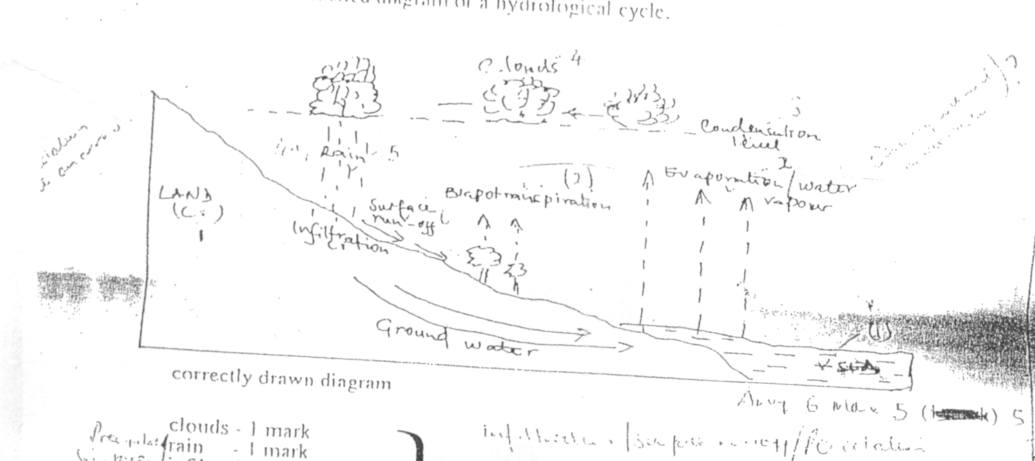

Correctly drawn diagram
Clouds - 1 mark
Rain - 1 mark
Surface run off - 1 mark
Lad/ocean - 1 mark (max = 4 mks)

3. a) Give three causes of earthquake
- Growth low pressure
- Convergence/collision
- Movement of magma within the earth’s crust/volcanic eruption (volcanicity)
- folding/faulting
- Isostatic adjustment
- Blasting of rocks/bomb any 3 x 1

b) Name two major earthquake/ones of the world.
- the Circum - Pacific belt
- the Tethyam - Mediterranean belt
- the Great Rift Valley belt
- Mid Atlantic Ocean belt (Any 2 x 1 = 2)

3. a) What is a rock?
- Any naturally formed solid aggregate/a naturally occurring solid material composed of one of minerals.

b) Give three characteristics of sedimentary rocks
- some sedimentary rocks contain fossils.
- The rocks have cleavage/are foliated/have planes
- The rocks horizontal layers/are stratified. (any 3 x 1 = 3 marks)

5. a) The diagram below shows some coastal features.
- Refer to question paper
Name the features P, Q and R
P - Headland
O - Spit
R - Stack ( 3 x1 = 3 marks)

b) State two conditions necessary for the forestation of a beach.
- Presence of abundant supply of materials to be deposited.
- Presence of a shallow shore/continental shelf.
- A relatively weak long shore current
- A weak backwash/strong wash/constructive wires.
- Gently sloping land at the sea shore. (Any 2 x 1 mark each)

6. Study the map of Homa Bay (1:50,000) sheet 129/2 provided and answer the following question
a) A pipeline is to be laid along the line marked X - Y
i) What is the length of the piping to be used? (Give your answer to the nearest 100m)
7km 100m/7100m
ii) calculate the bearing of point Y from point X
2250 + 10 (2240 - 2100)

iii) Calculate the area of the part of Lake Victoria shown on the map excluding the marshy sections. Give your answer in square kilometres
15km2 + 1km2 (2 mks)

b) The rectangle below represents the area in the map extract bounded by Eastings 54 and 60 and Northings 25 and 40. Identify and name the features marked J, K, L and M.
J - Lala Dam
K - Magare School
L - Dry weather road
M - forest (4 mks)

c) i) Explain three factors which have influenced the distribution of settlement in the area covered by the map.
- There are mean settlements in the Eastern part of the area because the land is gently slopping.
- There are clusters of settlements where there are markets/urban centres such as Homa Bay because there are social amenities and economic activities that attract settlements.
- The hilly areas around Ruri had few or no settlements because the lad is steep/
- There are no settlements to the south west because the area is set aside as a national reserve and it is forested.
- Shores of Lake Victoria have no settlement because they are poorly drained/marshy
- Homa Bay, Municipality area is the most densely settled because it has (Any 3 x 2)

ii) Citing evidence from the map, give two agricultural activities carried out in the area covered by the map.
- cereal farming - flour mills/maize control store
- cotton growing - cotton experimental farm/ginnery
- sisal farming - sisal factory(3 marks)

d) Describe the drainage of the area covered by the map.
- the main drainage feature is Lake Victoria
- the main river is River a keen/run off they drain into L. Victoria
- there are many short streams originating from Ruri Hills
- Some rivers for parallel pattern
- many streams disappear
- River Akech and its tributaries form dendtritic pattern
- The area has dams/water holes (Any 5 x 1 = 5 marks)

7. The map below shows some vegetation regions of the world. Use it to answer questions (a) and (b)
Refer to question paper

a) i) name the temperate grasslands marked D, E and F.
D - Prairies
E - Steppes
F - Downs (3 marks)

ii) Describe the characteristics of the natural vegetation found in the shaded area marked G.
- the forests consists of nixed variety of tree species.
- the trees shed their leaves at different times of the year/forests are evergreen.
- the trees are tall/with the trunks
- the trees have broad leaves/drip tipped leaves.
- the trees take long to manure
- the tree species are mainly hardwood
- the trees grow close to each other
- the forests have little or no undergrowth.
- the trees has numerous lianas/climbing plants/epiphytes.
- some of the trees have buttress roots.
- the forests have canopies
- the forest crowns form three distinct layers. (9 marks)

b) Explain how climate has influenced the existence of the following types of vegetation shown on the map.
i) Desert vegetation
- the area has scarce vegetation because it receives low rainfall/experience droughts.
- the long periods of drought causes seeds to exist in a dormant state only to germinate during the short rains,
- the higher rainfall along the margins of the region lead to more luxuriant vegetation in the areas.
- strong winds may uproot some of the plants leaving the ground bare/strong winds disperse seeds from one part of the region to another leading to establishment of plant species far and wide in the region.
Any 2 x 2 = 4 marks

ii) Coniferous forests
- the long cold winter and short summers make trees grow at a slow rate.
- Due to long cold winters and short summers the vegetation types consists of a limited variety of species of plants.
- The low rainfall received in the area/permanently frozen subsoil makes the trees develop shallow roots that spread widely to utilize the moisture in the top soil.
- precipitation in the region is mainly in form of snow. (4 x 2 = 8 mks)

c) You are required to carry out a field stuffy of the natural vegetation within your local environment.
i) apart from identifying the different types of plants, state three other activities you would carry out during the field study.
- Collecting samples of plants
- measuring distances
- estimating heights of plants
- drawing sketches/transacts
- recording/taking notes
- taking photographs of plants
- counting plants (Any 3 x 1 = 3 marks)

ii) How would you identify the different types of plants?
- by their appearance
- by their colour
- by their leaf size/pattern/type
- by their age
- by the texture of the leaves
- by their flowers (any 3 x 1 = 3mks)
iii) State two ways in which the information collected during the field study would be useful to the local community.
- It can be used to plan agricultural activities
- It can be used to help in the conservation of land/wildlife/soil/water
- It can be used to help in the rationalization of land use.
- It can be used for future reference.
- It can be used to determine the economic uses of plants/herbal medicine (Any 3 marks)

8. a) Describe plucking as a process in glacial erosion.
- pressure from the overlying mass of ice cause freeze thaw action
- melting water fills the cracks/joints in the bed rock.
- as water freezes it exerts pressure on the cracks enlarging them.
- the enlarged cracks lead to disintegration of the rock.
-
b) Explain three conditions that lead to glacial deposition.
- rising temperature lead to melting of ice thereby causing the ice to deposit its loads.
- change of gradient to relatively flat surface will reduce the velocity of the glacial.
- movement which will subsequently lead to deposition of glacial materials.
- alternating warm and cold periods lead to seasonal melting of ice which allows materials embedded in the ice to be released and deposited.
- Stagnation/accumulation of glacier leads to pressure at the base of the glacier which in turn leads to melting of ice at the base.
- The melt water then carries and deposits materials underneath which loosens the heavy materials beneath the mass of ice and subsequently deposited.
Condition 1 mark
Explanation 1 mark (any 3 x 2 = 6 marks)

c) The diagram below shows features resulting from glacial on a lowland area.
Refer to question paper

i) Name the features marked X, Y and Z.
X - Drumlins
Y - A river/melt water
Z - kettle lake/lake (3 marks)
ii) Describe how terminal moraine is formed
- moving ice carries solid materials
- moving ice stagnates
- melting ice releases its load
- gradually the load piles into a ridge
- over time the ridge forms a horse shoes shape/block of solid materials called terminal moraine.
(4 marks)

d) Explain four positive effects of glaciation in lowland areas
- Glacial till provides fertile soils which are suitable for arable farming.
- Ice sheets in their scouring effect reduce the surface which may expose the minerals making them easy to extract.
- Out wash plains comprise of sand and gravel which are used as building materials.
- Glacial lakes found in lowland areas can be exploited for various economic uses such as fishing transportation.
- Glaciation forms features such as drumbing eskers which are tourists attractions.
- Glaciated lowlands are generally flat and ideal for establishment of settlements/development of transportation network. (8 marks)

9. a) Differentiate between river rejuvenation and river capture.
- River rejuvenation is the renewal of the rivers erosive activity while river capture part of the river with more than that of the neighbouring river. (2 marks)
b) Give three features resulting from
i) river rejuvenation
- knick point/waterfall
- river terraces
- incensed meanders
- river gorges/rejuvenation gorges
- valley within a valley
Aberdare meanders

ii) River capture
- wind gap/dry river valley
- elbow of capture
- pirate stream
- beheaded stream/misfit/captured river (3 marks)
c) Explain the four ways through which a river transports its loads.
- The fine particles such as silt are carried in suspension because they are light and can be maintained within the turbulence of the water/some of the light materials float on the surface of the water.
- The fairly heavy particles/pebbles are lifted and bounce over short distances by the turbulence of the water. This process is known as siltation/hydraulic lift.
- The large and heavy particles are slide along the river bed. The process is known as traction/welling.
- Soluble materials are dissolved in water and carried in form of solution.
W - L
C - 4 (8 marks)
d) You are planning to carry out a field study on the lower course of a river.
i) - give three reasons why you would require a route map.
- to help identify the direction to flow.
- to help prepare a work schedule
- to help identify location of features for study
- to help estimate distances to be covered
- to help estimate the time the field study is likely to take. (3 marks)

ii) State three characteristics of a river at the old stage that you are likely to observe during the field study.
- the river flowing at a low speed
- the river carrying silt in suspension/the water is brown
- the river braids as a vent.
- the river meandering in the flood plain
- Distributions
- Dispersal to form
iii) Give three follow up activities you would be involved in after the field study.
- Reading more on the topic.
- Displaying photographs/items collected
- Asking/answering questions
- Writing reports
- Discussing with the rest of the class
- Analyzing/assessing the information collected against the hypothesis. (Any 3 x 1 = 3 marks)

The diagram below represents a well developed soil profile. Use it to answer question (a)
Refer to question paper
a) i) Describe the characteristics of horizon B
- it is the accumulation zone for leached minerals from horizon A.
- the soil texture is clay in nature
- the zone sometimes forms the hard pan/murram/lateric duri crust. (Any 3 x 1 = 3 marks)
ii) Apart from humus, name three other components of soil air/soil
- water/soil water
- rock particles/weathered materials
- living organisms (any 3 x 1= 3)
iii) state three ways in which humus contributes to the quality of soil
- it helps improve soil texture
- it provides essential minerals to the soils from the decomposed plant matter/humification and nitrification.
- it enables soil to retain moisture
- it facilitates aeration of the soil
- humus in a source of food for micro-organisms (3 marks)

b) i) Differentiate between soil structure and soil texture
- soil structure is the way the individual soil particles are arranged into aggregate compound particles while soil texture is the degree of fineness or coarseness of the soil particles. (2 marks)

ii) Explain how the following factors influence soil formation
- Topography
valley bottoms encourage formation of deep fertile due to depositional/accumulation of weathered materials.
- steep slopes encourage of the top soil thus slowing down formation of soil/they have thin soil/have poorly developed soils.
formation (Any 3 x 2 )
Time
- where soil formation processes takes a short duration the soils are generally immature/where the process has taken a long period of time soils are generally well developed/mature.
- Young soils retain the characteristics of the parent rock because they have not been exposed to the factors that may cause change/mature soils may not display the characteristics of the parent rock. (Any 2 x 1 = 2 marks)
c) Explain how the following farming practices may lead to the loss of soil fertility
i) Overgrazing
It leads to removal of vegetation cover thereby imposing soil to agents of erosion. (2 marks)
ii) Frequent ploughing
- this weakens soil structure making it easy for agents of soil erosion to carry it away.
- It increases oxidation which results in loss of organic matter. Any 2 x 1 = 2 marks

iii) continuous irrigation
It causes leaching of soil nutrients making the top soil deficient of soluble minerals/causes salinity
(2 marks)

2010

GEOGRAPHY PAPER 2 MAKING SCHEME
SECTION A
1. Give three reasons why it is important to study Geography
- It provides knowledge about the immediate and wider environment. It makes to understand the earth on which we live.
- It create awareness about the country and the rest of the world and promotes international understanding
- It promotes awareness on the sustainable use of resources.
- It promotes development of skills and critical thinking
- It prepares one for career opportunities.
(a) What is mixed farming?
- Mixed farming is the growing of crops and rearing of livestock on the same farm.
(b) State four physical conditions that favour cocoa growing in Ghana.
- High temperatures of 24 C to 30 C.
- High rainfall of 1, 200mm - 1,500mm well distributed rainfall throughout the year.
- Deep, well drained fertile soil , loamy soils/light clays
- High relative humidity 70% - 80%
- Shade from strong sun rays for the seedlings.
- Undulating lowlands 0 - 750m above sea level.
- Sunshine for ripening of pods.
2. (a) Name two forest reserves found in the costal region of Kenya.
- Shimba hills forest
- Arabuko Sokoke forest reserve
- Boni / Dodori forest
- Mangrove forest
- Kenya forest
(b) State three ways in which the clearing of forests have affected the natural environment in Kenya.
- It has led to reduced volume of water in the rivers / caused drying up of rivers.
- It has led to the destruction of the natural habitat for the wildlife. It has
endangered some of the wildlife species.
- It has led to changes in the rainfall pattern/ Desertification.
- It has interfered with the beauty of the environment / lowered the aesthetic value of the environment.
- It has disrupted the ecosystem
- It has accelerated soil erosion.
3. (a) Why is Kenya’s petroleum refinery located at Mombasa?
- It is easier to transport refined petroleum products than crude hence the need to process crude oil
at the point of entry crude oil.
- The raw material for the refinery comes by sea to the port of Mombasa
- Nearness to the source of raw material.
- Mombasa is the only port of entry.
(b) State four characteristics of the cottage industry in India.
- It requires little capital to set up and run
- It is labour intensive.
- It relies on simple equipment / machines.
- Different establishments are owned by individual/families.
- It uses locally available raw materials
- The products are mainly for local market.
- The industrial establishments are widespread in the country/located in homes.
- Labour is provided by members of the family/individual owners.
- The craftsmen are highly skilled. (Any 4 x 1 = 4 marks)

5. a) Name two proposed major highways in Africa.
- the Trans Africa Highway to Mombasa
- The Great North Read/Cairo for Gaborone (Cape town)
- The Trans-Saharan Highway/Algiers to Lagos
- Tripoli to Windhoek (Cape town)
- Cairo to Dakar (Any 2 x 1 = 2 marks)

b) Give three reasons why it is not possible to transport goods by road directly between Mombasa and Lagos. (3 marks)
- In some of the countries between the two parts, there are alternative modes such as railway and water which are cheaper than road transport.
- Some of the countries have not developed proper road links with their neighbours due to political differences/neglected maintenance of highways thick forests.
- Most parts of the route have difficult terrain/making movement of heavy commercial vehicles difficult/construction of roads expensive/difficult/internal/external conflicts.
- There is insecurity along some parts of the road between the two ports.
- The bulky goods that may be transported between the two ports may be costly to transport by road. (any 3 x 1 = 3 marks)

6. Study the photograph provided and answer questions (a) and (b)
a) Name
i) the mining method shown in the photograph
Panning/alluvial mining/placer mining (1 x 1 = 1 mark)

ii) two minerals that may be mined using the method shown in the photograph
Gold
Diamond
Platinum
Tin (2 x 1 = 2 marks)

b) i) Using evidence from the photograph give four indicators that show that the weather was hot when the photograph was taken.
- Almost all the miners have removed their soils/have chested
- Some miners are wearing hats/head scarfs
- The sky is clear
- The shadows indicate that the sun is almost overhead.
- Use of an umbrella by a person at the middle ground.
- Bodies are glustering with sweat/sweaty bodies
- There is a reflection of the sun rays on the wider surface (any 4 x 1 = 4 marks)
- A mixture of water, solid/mud and mineral particles is scooped from the water bed using a pan.
- Water is added if the mixture is thick/if the water is excess it is decanted
- The material scooped is swirled in the pan. This separates the lighter material from the heavier particles which contain the mineral particles.
- The lighter material is removed/poured out
- The heavier materials are sorted to display mineral particles.
- The mineral particles are collected from the pan. (Any 5 x 1 = 5 marks)

iii) Citing evidence from the photograph, explain two ways in which the mining methods has affected the environment.
- The scooping of materials ha sled to water pollution as indicated by the brown colour stagnant water which may make it unfair for people to use.
- The continuous scooping and dumping of the waste has led to land dereliction as indicated by the depression and heaps of waste material.
- The method has led to destruction of vegetation as miners cleared the land to access the area with the mineral as indicated by absence of vegetation bare ground/in the foreground/middle ground.
- The method has led to loss of biodiversity/destroyed the ecosystem as indicated by the absence of plant life where mining is taking place. (any 2 x 2 = 4 marks)

iv) apart from the method shown in the photograph, name three other mining methods.
- Opencast/quarrying/stripping method
- Deep shaft/underground method/solution
- Adit/drift/horizon/tunnel method/slope mining
- Drilling method (any 3 x 1 = 3 marks)

Evaporation
- High temperatures in arid and semi arid areas cause evaporation of water in lakes/seas.
- This leads to high concentration of mineral salts in the water. Continued evaporation causes further recrystallization of the salts which may thereafter be attracted as minerals such as soda ash and common salt/deposition of salts near the surface. (2 marks)

Volcanicity
- When molten magma intrudes into rock joints minerals contained in the magma embedded in the joints called veins. Such minerals as tin and Copper occur in this form/Hop springs/gersey. Fonaliss bring minerals to the earth’s surface. (2 marks)

• Metamorphism
High pressure and heat cause recrystallization and hardening of certain rocks causing them to change their nature to ebcome minerals such as diamond. (2 marks)

7. a) i) Apart from draining of swamps give two other methods through which land has been reclaimed in Kenya.
- Irrigation
- tsetse lfy control
- planting of trees/afforestation
- flood control (any 2 x 1 = 2 marks)

ii) Give two methods that are used to drain swamps in Kenya.
- constructing drainage pipes
- digging open ditches/canals
- pumping out the water (any 2 x 1 = 2 marks)

b) i) Name two rivers that supply water to the Mwea Tebere irrigation scheme.
- Thiba river
- Nyamindi river
- Murubara (any 2 x 1 = 2 marks)

ii) Explain how the following factors influenced the establishment of Mwea Tabere Irrigation scheme.
Topography
- The gently slopping land makes it possible for water to flow by gravity into/out of the irrigated fields.
- The gently slopping land allows for mechanization which allows large areas to be put under cultivation. (Any 1 x 2 = 2 marks)

• Soils
- Presence of black cotton soils which is suitable for cultivation of rice/which retains water for along time. (2 marks)
• Population
- the area was originally sparsely populated which enabled large areas to be put under cultivation/very few people were displaced it was cheap to start the scheme. (2 marks)

• Government policy
- There was need to keep political detainees busy/This made the colonial government to set up the scheme at Mwea where there was a large detention. (2 marks)

c) i) Name three areas which make up the Zuider Zee reclamation project in the Netherlands.
- Markerwaard
- South Flevoland
- East Flevoland
- North-Eastern Polder
- Wieringer Meer Polder (Any 3 x 1 = 3 marks)

ii) Give four differences between land reclamation in Kenya and the Netherlands.
- In Kenya, the area that is reclaimed is relatively small while the areas reclaimed in the Netherlands are large.
- In Kenya, land is mainly reclaimed from swamps and marginal areas while in Netherlands reclamation is from sea.
- In Kenya the methods used for draining water form marshy areas is digging of canals/ditches while in the Netherlands the methods are advance/use of wind pumps to drain sea water from the polders.)
- In Kenya irrigation is used as reclaiming dry areas while irrigation in the Netherlands is used to lower the salinity of the soil in the claimed lands.
- In Kenya the methods of land reclamation are simple like digging canals/ditches to drain water from lad while in the Netherlands the method used are highly advanced like reclaiming land from the sea/creation of polders.
- Furrow/ridges protect the reclaimed land from invasion by the sea. (Any 4 x 2 = 8 marks)

8. a) Apart from uranium, give two other non-renewable sources of energy.
- coal
- petroleum
- natural gas (Any 2 x 1 = 2 marks)

ii) State two advantages of using uranium as a source of energy.
- It occurs in huge reserves.
- It produces large amounts of energy compared to other sources relatively small amount of uranium generates large quantities of energy.
- Iyt has a longer lifetime than the other non-renewable sources of energy. (Any 2 x 1 = 2 marks)

b) i) What is energy crisis.
It refers to a situation where the prices of fossil fuels rise uncontrollably as a result of short supply relative to demand. (2 marks)
ii) Explain three ways in which energy crisis affects the economy in Kenya.
- The increase in the prices of crude oil makes Kenya to spend a lot of foreign exchange in importation. This lowers the foreign currency reserve which brings about unfavourable balance of trade which slows down the rate of economic growth.
- Increase in oil prices triggers the increase in the prices of commodities leading to low standards/high cost of living
- Increases in oil prices leads to increase in the prices of farm inputs which in turn leads to reduced agricultural production/leads to food crisis.
- The high cost of fuels increases the cost of production slowing down industrial growth.
- Oil crisis to scarcity of by-products of oil leading to shortage of raw material for certain industries.
- Increase in fuel prices leads to increased transport costs which trigger price increases in almost all the sectors of the economy. (Any 3 x 2 = 6 marks)
NB: No credit for effect without crisis.

b) L, M and N: Refer to question paper
L - Kaiji dam
M - Owen falls dam/Nalubaale
N - Kariba dam (3 marks)

ii) State fours ways in which Kenya has benefited from the development of geothermal power.
- It has provided alternative source of energy.
- It has increased Kenya’s energy input.
- It has helped stabilize the cost of electricity for consumers.
- It has helped in opening up of formerly remote areas.
- It has increased employment opportunities
- It has led the reduction of importation of hydro-electric power from Uganda/has saved foreign exchange. (any 4 x 1= 4 marks)

d) Explain three physical factors that influence the establishment of hydro-electric power dams.
- Presence of a hard basement rock which provides a foundation for the dam.
- Large volume of water/constant supply of water to enable continuous production of electricity.
- presence of narrow gorge behind the dam which minimizes the cost of construction of the dam.
- The deep gorge for the riverine head of water.
- Presence of steep rivers gradient/water fall/rapids to provide sufficient hydraulic force to turn the turbines.
- the presence of improper work to prevent seepage. (Any 3 x 2 = 6 marks)

9. a) Distinguish between a game sanctuary and a national park.
- A game sanctuary is a specific area established to give protection to a specific animal community which is either threatened with extinction or only found in a particular area while a national park is a large area set aside for the propagation, protection and reservation of wild life in their natural habitat and in which hunting is prohibited. (2 marks)

ii) Draw a map of Kenya and on it mark and name Sibiloi National Park, Maasai Mara National reserve and Tsavo National Park. (4 marks)
SEE AMP
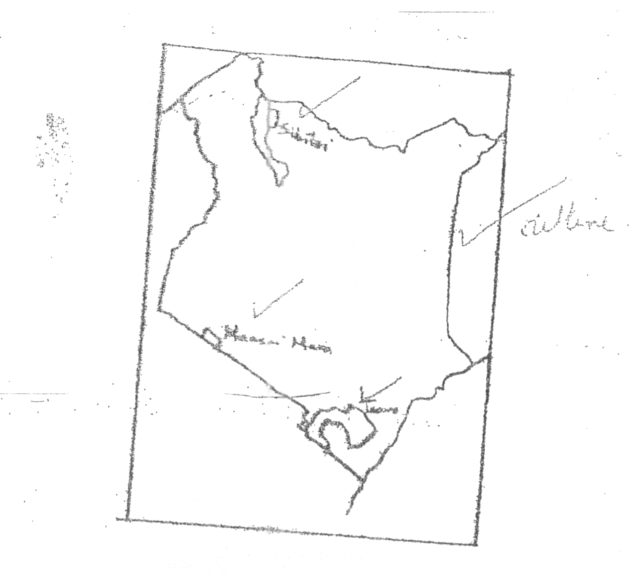

b) i) Give three factors that favour the establishment of national parks semi-arid areas of East Africa.
- Availability of large tracts of sparsely populated land.
- Availability of a wide variety of vegetation which provides food for the wild animals.
- The harsh climatic condition that discourage farming and settlement/makes wildlife conservation the best alternative land use.
- The type of vegetation found in such areas provide suitable habitat for wild animals.
(any 3 x 1= 3 marks)

ii) Explain two effects of drought on wildlife in Kenya.
- It leads to shortage of pasture and water causing loss of life of animals and drying up of plant spices.
- Prolonged drought leads to migration of animals to areas that have sufficient supply of food/water/some animals migrate to the neighbouring countries reducing the number of wild animals.
- Forest fires break out during drought causing environment degradation and destroying the habitat for wild life.
- wild animals invade farmlands destroying crops/some killed as they search for food.
(Any 2 x 2 = 4 marks)
c) Explain four measures that the government of Kenya has taken to conserve wildlife.
- establishment of national parks and game reserves to protect wildlife from human interference.
- Enacting laws and regulations to curb poaching and game trade.
- Educating and general public on the need to conserve wildlife/to support conservation practises/discouraging joint ownership of parks with local authorities/local communities who also benefit from the proceeds.
- Enhancing international cooperation to help enforce the existing laws and convections which protect wildlife especially the endangered species.
- Promoting ecotourism to reduce tourism related environment damage that may lead to extinction of wildlife species.
- Constructing electric fences around the parks to minimize human animal conflict.
- Establishing the ministry of wildlife to oversee to conservation process/creating of the anti-poaching unit to track down and arrest poachers/forest guards to protect forests.
- Encouraging individuals to set up game ranches for controlled/hunting.
- Provision of vet animals to treat animals/translocation of game research by laws. (any 4 x 2 = 8 marks)

d) State four ways in which wild animals are of insignificance to the economy of Kenya.
- They are a major tourist attraction/earn foreign exchange
- They create employment opportunities
- They promote research activities
- Tourism creates a large demand for food leading to agricultural development.
- Some provide raw materials for industries.
- They provide game meat
- Government earns revenue. (Any 4 x 1 = 4 marks)

10. a) i) Differentiate between internal and regional trade.
- Internal tarde is the buying and selling of goods and services within a country’s borders while regional trade between countries that are found within the same geographical region. (2 marks)
11. a)
- coffee
- Tea
- fluorspar
- Horticultural products
- Pyrethrum extract
- Flowers/fruits/vegetables
- Soda ash (any 3 x 1 = 3 marks)

b) Give four reasons why the Southern African Development Co-operation (SADC) was formed.
- To promote regional integration among member countries.
- To promote sustainable economic growth in the region.
- To establish a common market for member states/wider market
- To liberalize trade within the region/to lower among members
- To strengthen the bargaining power in international trade.
- To foster peace, stability and democracy among member states.
- To eradicate poverty in the region
- Toe encourage the movement off labour. (Any 4 x 1 = 4 marks)

c) Explain four problems facing trade in Kenya.
- Cheap imported create unfair competition for some local products leading to reduction in the production of such goods/closure of some industries.
- Exports are mainly raw agricultural products which are lowly priced, hence earning little revenue for the country.
- The high fuel prices increase production/transport costs leading to increased prices of goods/low demand for goods.
- Insecurity in the country discourages investors/traders incur great losses.
Problem - 1 mark Explanation - 1 mark Any 4 x 2 - 8 marks

d) Explain how the future of international trade in Kenya can be improved.
- Kenya exploring new markets in the For East countries to avoid over reliance on the European market. (This is likely to increase the quantity f Kenya’s exports.)
- Kenya has signed trade agreements with various countries in Africa and in America which will help improve trade.
- Kenya’s trade with African countries is likely to improve through the membership in trade such as COMESA and EAC.
- Some Kenya entrepreneurs are setting up branches of their industries in the neighbouring countries in order to expand trading activities.
- Kenya is undertaking partial processing of some of the agricultural products before export in order to add value to increase earnings.
- Interpretation of vision 2030 it will lead to increased production hence increased trade.
- Kenya should diversify her export products to attract a wider market for her goods.
- Kenya should be aggressively advertise her products to attract more buyers.
- Kenya should improve her international transport and communication links for efficient transactions. (Any 4 x 2 = 8 marks)

GEO Paper 1 MARKING SCHEME 2011
a) Name the parts of the earth's surface marked J and K
J- North pole
K-South pole

(b) Give two reasons why the intensity of the isolation Is higher at M than at N
-There is a higher concentration of heating at M than at N because the surface area at M is small than at N.
- The angle of incidence of the sun’s rays at M is higher than at N hence the variation in intensity
- At N the sun’s rays travel over a longer distance than atMthus losing the heat resulting to low intensity

2(a) weathering is the breaking down /disintegration and decomposition of rocks at or near the Earth ‘s surface by physical or chemical procces.

(b) climate
Nature of the rock
Topography
Living organisms
Human activities
Time

3(a)
P - crater
Q - lava layers
R - dyke

(b) - pressure is reduced causing the magma from the interior of the earth to fail to reach the volcano.
-The conelet is the parasitic cone
- form a conlet on the side of the composite volcano
- the successive outputting of magma through the side vent build alternate layers of ash and lava

4(a) it is a mass of cool air blowing from the land to the sea during the night

(b) - it lowers temperature of adjacent areas
- it may increase rainfall
- it may increase relative humidity
- it moderates diunal range of temperature
- it may lead to convectional rainfall

5.(a) E - traction / surface creep
F - saltation
G - suspension

(b) - rock pedestals
- zeugens
- yardangs
- ventifacts/elnkanters
- mushroom blocks
6.
(a) (i) latitude -0⁰00 and
Longitude -37⁰ 45 E

(ii) - contours
- Trigonometrical stations
- Depression symbols

(iii) relief feature found at the top of kirui hill
Depression

(iv)
- Medical services
- Educational services
- Commercial Services
- Religious services
- Communication
- transportation

(b)(i) 7.0 + 0.1
-
6.9 -7.1

(ii) • The rugged relief which may necessitate road cuttings many_road bend..
• Many rivers/river Valleys’ may lead to the construction of many bridge/culverts.
* The high density of settlement may lead to high cost of compensation
• The presence of Rurie swamp/swamps may lead to detouri ng of roads/tracks.

(c) - the presence of scrub and scarttered trees show that there is natural pasture for cattle
- Sources of many rivers show that there is adequate water for cattle
-The area has high altitude which provides cool condition suitable for cattle
- the many cattle dips for treatment of cattle show that there is access to veterinary services .
- dense settlements to provide market of cattle
- availability of extension service to the farmers as shown by farmers training center
d)
• The main drainage feature are rivers.
• The other drainage features are lakes and seasonal swamps.
• There is a high density of/many rivers in the area.
• The rivers are permanent.
• Most rivers originate from forest
• Most rivers from the forest flow Eastwards. _
• Most rivers form a dentritic pattern,
• The main rivers, are Kithinu and Thingithu.
• Most rivers are in the youthful stage.
• Some, rivers are bending

7(a) (i) Their should be away from buildings/trees
The ground should be free from flooding
The area should have a wide view / open space
The area should be secure.
The ground should be gently sloping

(ii)
- it enables farmers to plan their farming
- It help s people to choose the clothing for the day
- It influences design of houses
- It guides in the timing of sporting/tourist activities
- It helps in averting natural disaster. related to weather
- It guides in landing and taking off of aircrafts

(b) (i) the mean -16.1⁰ C/ 16.075⁰C/ 16.08⁰C
(ii) annual range temperature -2.1⁰C

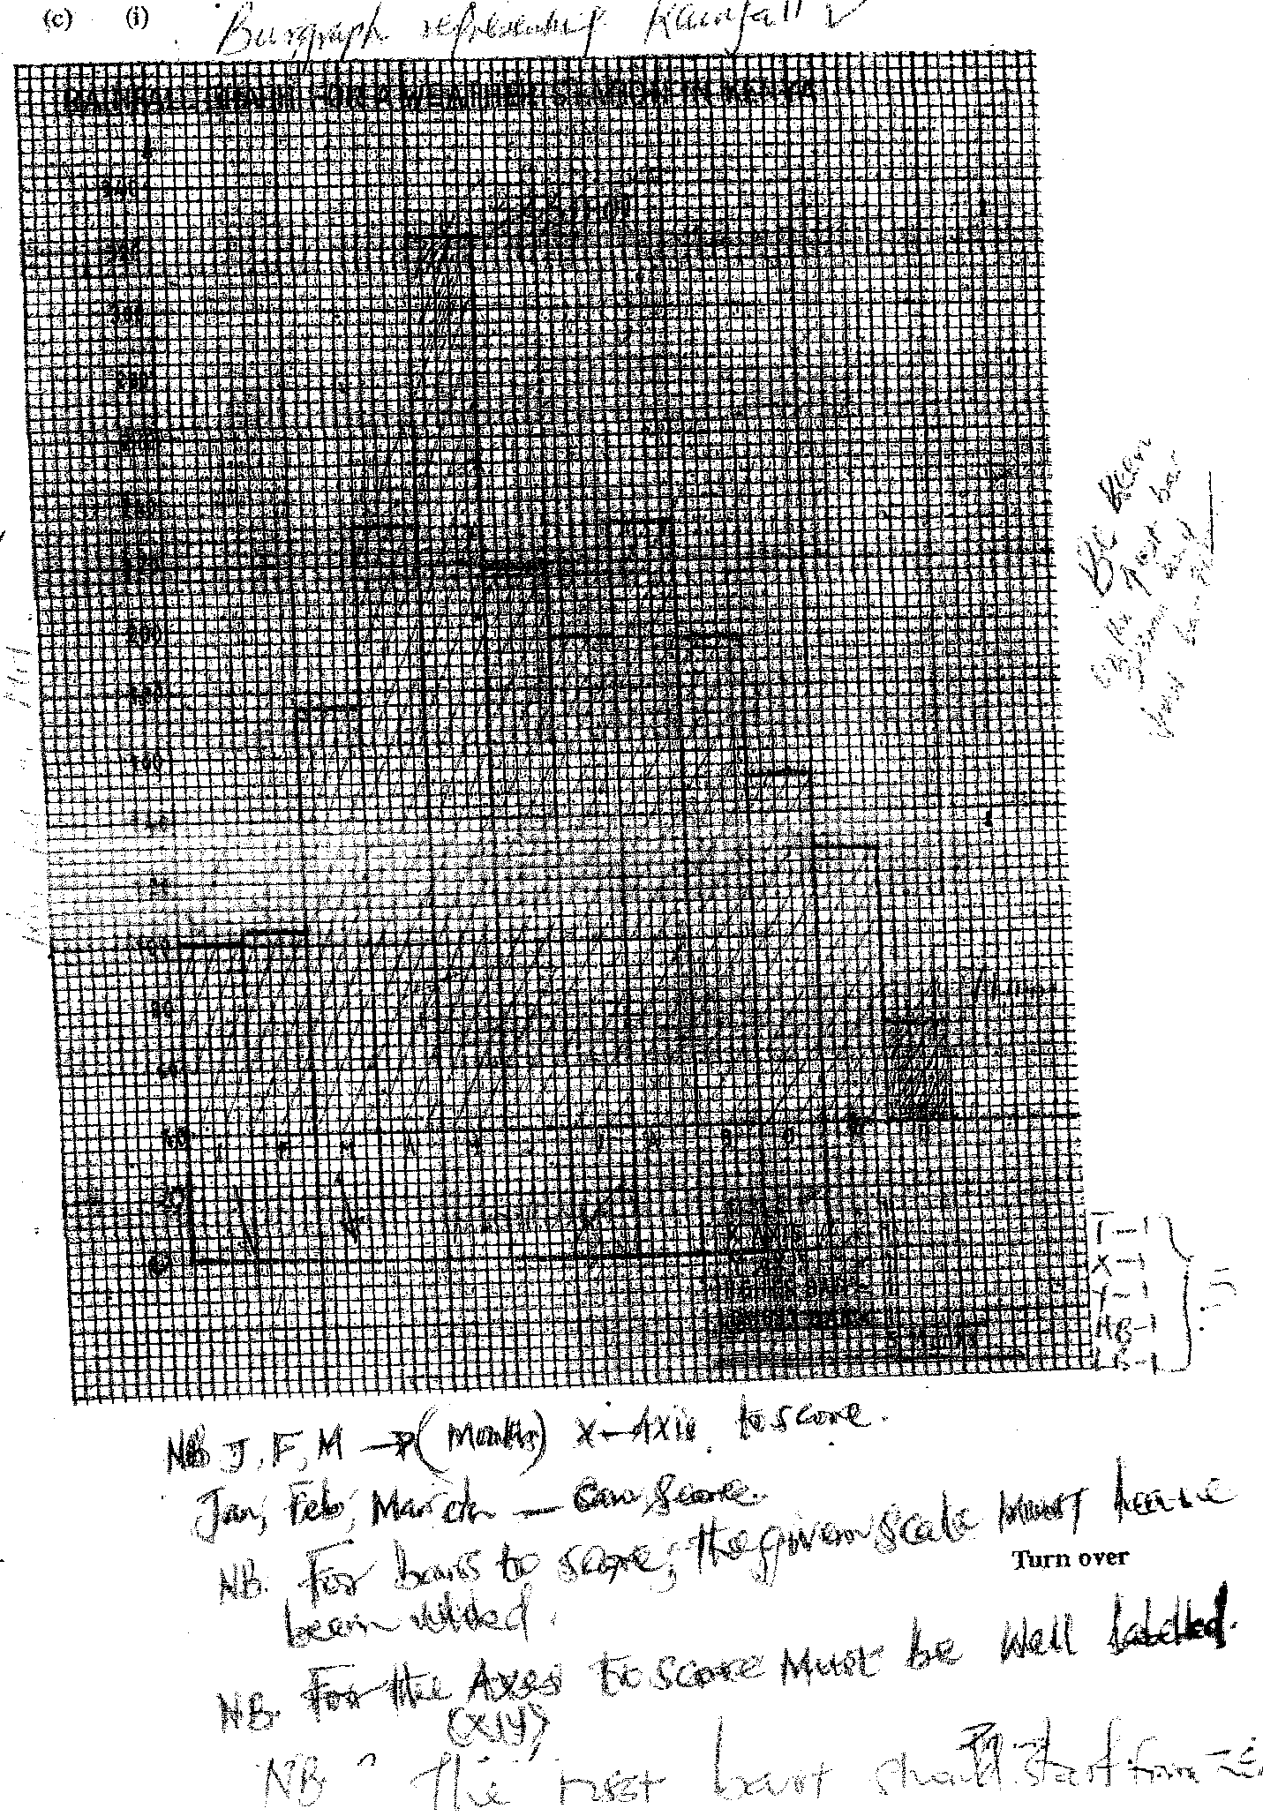

C(ii) - The climate conditions are generally cool
- The station receives high rainfalI/2125mm;
- The lowest rainfall (71 mm) is received in December/the highest rainfall (323 mm)
is received in May
- The temperature ranges from 15.0⁰.to 17.1 ⁰ C in March/April /"The annual
range of temperature is small /2.1 ⁰ C.
- The area receives rainfall throughout the year .There is no dry month.

d(i) - Observation
- Interviewing
- Reading from secondary sources
- Administering questionaries
- Taking measurements (rainfall

(ii) - It enables students to collect fast hand information .
- It helps students to develop manupurative skills
- it enables students to learn how to use weather recording instruments
- it enables students to apply the knowledge learned in the classroom
- it makes leaning more interesting

8(a) P- Andes
Q- Appalachian
R- Atlas
S - Himalayas

b(i) synclinal valleys
rolling plains
ridges
intermontane basins
intermontane plateaus
(ii)
- Extensive shallow depression s called geosynclines develop on the earth's surface.,
- Prolonged and extensive erosion occurs on the surrounding higher grounds
- Sediments are deposited in the geosynclines forming thick layers
-The weight of sediments causes subsidence of the geosynclines leading ro accu
mulation of more sediments to great thicknesses,
- Further subsidence of the g ecosyncli e triggers off compressional forces which cause
The sediments to fold
- The folded layers of sediments in die geosyncline are thrust upwards to form fold
Mountains

(c) t V"
( c)
* fold mountains are sources of rivers that provide water for generation of H.E.P / domestic use/irrigation /industrial use.
* Fold mountains are often forested and provide timber which is used in the building" and construction industry/medicinal/aesthetic/wildlife habitat.
* Some fold mountains have exposed valuable minerals deposit which are mined
* Fold mountains are tourist attractions /snow covered slopes encourage sporting activities thus earning countries foreign exchange.
* The wind ward slopes of fold mountains receive heavy precipitation which enhances
agricultural activities //
* The rugged nature of some fold mountain landscapes hinder human sefllemeAfagii-cultural activities.
* The leeward slope of some fold mountain create rain shadow effect which result into aridity discouraging crop farming
* Some fold mountains may act as barrier to transport and communication make the
construction of transport and communication lines difficult / expensive

9. (a) (i) Tides are the periodic rise and fall in the level of ocean as a result of
the gravitational attraction of the Sun and moon

(ii) differences in ocean water density /salinity
Differences in ocean water temperature
Winds blowing over the ocean
Shape of coastal land mass
Eath’s rotation

(iii)
Benguela
Guinea
Cannary

(b)(i)
- The coasts have broad shallow indentation estuaries
- The coasts have several creeks
- The coast shave extensive marshes/mudflats exposed
- broad continental shelf

(ii) - The duration exposure of the coast to wave erosion- The longer the exposure to
coastal waves, the higher the rate of erosion.
- The degree of exposure of the coast to wave erosion. The exposed coasts are eroded,
more than the sheltered coast hence reducing the rate of erosion .
- The nature / supply of material .Heavy materials / have a higher erosive power than fine materials
- The nature / structure of the coastal rock .A coast made up of soft rocks wears away easily when subjected to sea waves / when rocks are well jointed

(c) - Waves attack both sides of a head land at right angle
- The waves erode through abrasion and hydrauric actions forming waves on both sides of the headland
- Continued wave erosion and weathering leads to elaption of the waves to the headland
- The isolated heahland is the stack
- The roof of the arch collapses leading to isolation of the part of the headland on the seaward side

10(a) (i) depression

(ii)
challa
paradise
simbi
sonanchi
crater on central island in l. Turkana
(b)(i) corrie lake

- Snow accumulates in a depression on the mountain side
-Snow gets compacted into ice forming a cirque graciers
- Frost action /alternate freez –thaw action enlarge the hollow
-Plucking process sleepens the back wall
-Eventually a deep arm – chair shaped depression snow as corie is formed
- When the corrie fills up with melt water it forms a corrie lake

(ii) oasis
- A pre existing depression formed through faulting or otherwise is exposed to wind erosion
-Wind eddies remove un consolidated materials through deflation
-Futher deflation leads to depression reaching the water table
-Water oozes out of the ground and collects into the depression to form a lake known as an oasis

(iii) lagoon
-Sand / single are deposited along indented / irregular coast
-The deposits accumulate forming a spit
-The continued deposition elongate the spit eventually blocking the mouth of of the bay forming a bay bar
- The bay bar separates part of the sea water from the open sea
- The encloses sea water is the lagoon

(c) (i) They lack outlets to the sea
- Some have salt bearing rocks on the lake bend
-High temperature in the surrounding area lead to high evaporation
-Heavy deposition of mineral salts into the lakes by the surface run off
- Underground seepage of water that is rich in mineral salts
(ii) deforestation
- It exposes soil which is eroded and carried into the lake causing siltation
- It destroys catchment areas which reduces water fed into the lakes

Industrialization

-Establishment of industries had led to disposal of waste /pollution / contamination of lakes
-Establishment of industries had led to increased water use which has lowered water levels

Geo paper 2 marking scheme
1(a)
- Aberdeen Angus
- Here ford golloway
- Charolais
- Shorthorns
(b) in both coutries the mainly reared in areas of natural grazing
-In both countries crossbreading of beef cattle is common
-In both countries beef cattle are reared mainly in ranches
2.(a)
- Fisheries are water bodies where aquatic organisms / fish are found / reared for exploitations

(b) restocking the overfished areas
-Standardizing the mesh size of nets to be used in fishing
-Licencing commertial fishermen to control their numbers
-Restricting fishing tospecific seasons
-Restricting the disposal of untreated waste into the sea
--Monitoring and discouraging the entry of foreign fishermen offthe Indian ocean waters
-Enforcing the international conventions to protect endangered fish species
3.(a)- Saskatchewan
- Alberta
- Manitoba

(b)-there is extensive cheap land that allows cultivation on a large scale
-The un dulating landscape allows use of farm machinery / mechanization
-There is suitable climate with a frost free riod which allows for timely ripening and harvesting
- The area receives moderate rainfall average 560mm annually which is suitable for wheat growing.
4.(a )
- The industries need large amount of water for cleaning
- The industries use water for cooling machines.
- The industries dispose off their waste materials through water
- Water provide cheap means of transport
- Some industries are, located near large rivers that may provide HEP
(b) - Tobacco processing
- fibre processing
- Saw milling,
⁻ Paper making.
- Leather tanning
- Non-edible oil processing

5(a) -- There has been widespread irnmunization for children
- The government provides free medical services for children
- The government provides parental educations to ensure better care for children
- There is a government policy granting longer maternity leave for mothers to take care of the newborn
- RResearch on infant related diseases has been steped up
- The government provides parental education to ensure better care of children /family planning
(b) - It leads to under utilization of resources,
- It leads to reduced market or goods
- leads to reduced labour force it is expensive to provide medical care / transport

6 (a) (i) - The photograph capture the broad view of area
- The rocus is on the many objects
- The objects become progressively towards the ground
(iii) - planted crops
-Tree stumps
- Forests
- Felled trees
(iv)- the forest has some shrubs / undergrowth
-some trees has thin stems
- Some trees are umbrella shaped
- The trees have straight stems

(b) (i) --in Kenya harvesting of trees is done throughout the year while in Canada harvesting is
d one in winter and early spring
- In Kenya harvesting is done selectively while in Canada clear / indiscriminate cutting of trees is done
(ii) In Kenya forest products are mainly sold locally whereas forest products in Canada are mainly exported
- E-R. congo
F-.R Zambezi
G- R orange
- H – kainji
J - Nasser
- -The -waterways should be dredged regularly to control siltation / maintain constant depth of the rivers and lakes for easier navigation
-Dams /barrage should be constructed to control flooding hence allowing navigation
- constant clearing / controlling the growth of vegetation
- Using modern vessels and equipment
- Removal of rock obstacles from the river

(b) - Technological efficiency in comrnunication makes business transactions easier / faster
- Modern communication network allow for the spread of ideas / information for desition making which enhances economic development
- communication promotes development of related industries / business opportunities
-Communication services provide employement opportunities
- Communication connectivity promotes mobility of labour
-Government derives from communication services

(c) African countries use different railway gauges.which makes
- difficult to have an integrated railway transport system transpment of goods
- construction of railways require large amounts of capital that most countries lack, either to maintain the existing linesV
- Tropical storm waters at time wash away vital section of the railway lines there by disrupting transport
-- Railway transport faces stiff competation from the more faster flexible means of transport
- Fueling /maintenance of railwaystations and other related overhead costs are high this reducing profit margins

- Both countries have varied of climatic condition
- In both countries irrigation is carried out
- In both countries horticultural farming is practiced in areas with well drained soils
- In both countries sell their horticultural produce in the local and international market
- In both countries large companies / private organization have invested in horticultural farming

(ii) - the farms are generally small in size
- Most farmers use advanced / highly specialize techniques of crop production / farmers use greenhouse
- Most farmers practice mixed farming
- The farms are intensively used
- Farming is largely labour intensive
(ii) -The quantities of exports are fluctuating
-----The lowest exports were in august 2008 and December 2008
---The highest quantity of export was in match 2009
--Their was a significant drops in the quantity of exports between match and April 2009

7 - the impassable roads during the rainy season make it difficult for the perishable produce to reach the market on time hence causing losses to the farmers
- The cost of transporting produce by air ishigh thus lowering the profit margin
- Poor marketing structure leads to reliance on middlemen who exploit the farmers
- Fluctuating of the market rates cause inconsistencies in the profit margin thus discouraging the farmers
- low quality produce may lead rejection
- limited preservation facilities
- Strigent quality standards required at the international market increases the production
- The cost of transporting produce by air is high thus lowering the profit margin

- what nature provides while protecting it

- (i) marine parks
- Historical sites
-sandy beaches
- Sunny /warm climate
- Traditional culture water sports wildlife
(ii) -Tourism has led to increase in drug abuse
- A number of youths especially at the Coast have dropped out of school to become tour guides /beach boys /sex workers
- tourism has led to spread of diseases such as stds
-Tourism has led to pollution of environment/ national parks
-Tourism has led to international terrorism /piracy
-Tourism has led to increase in crime/ insecurity
