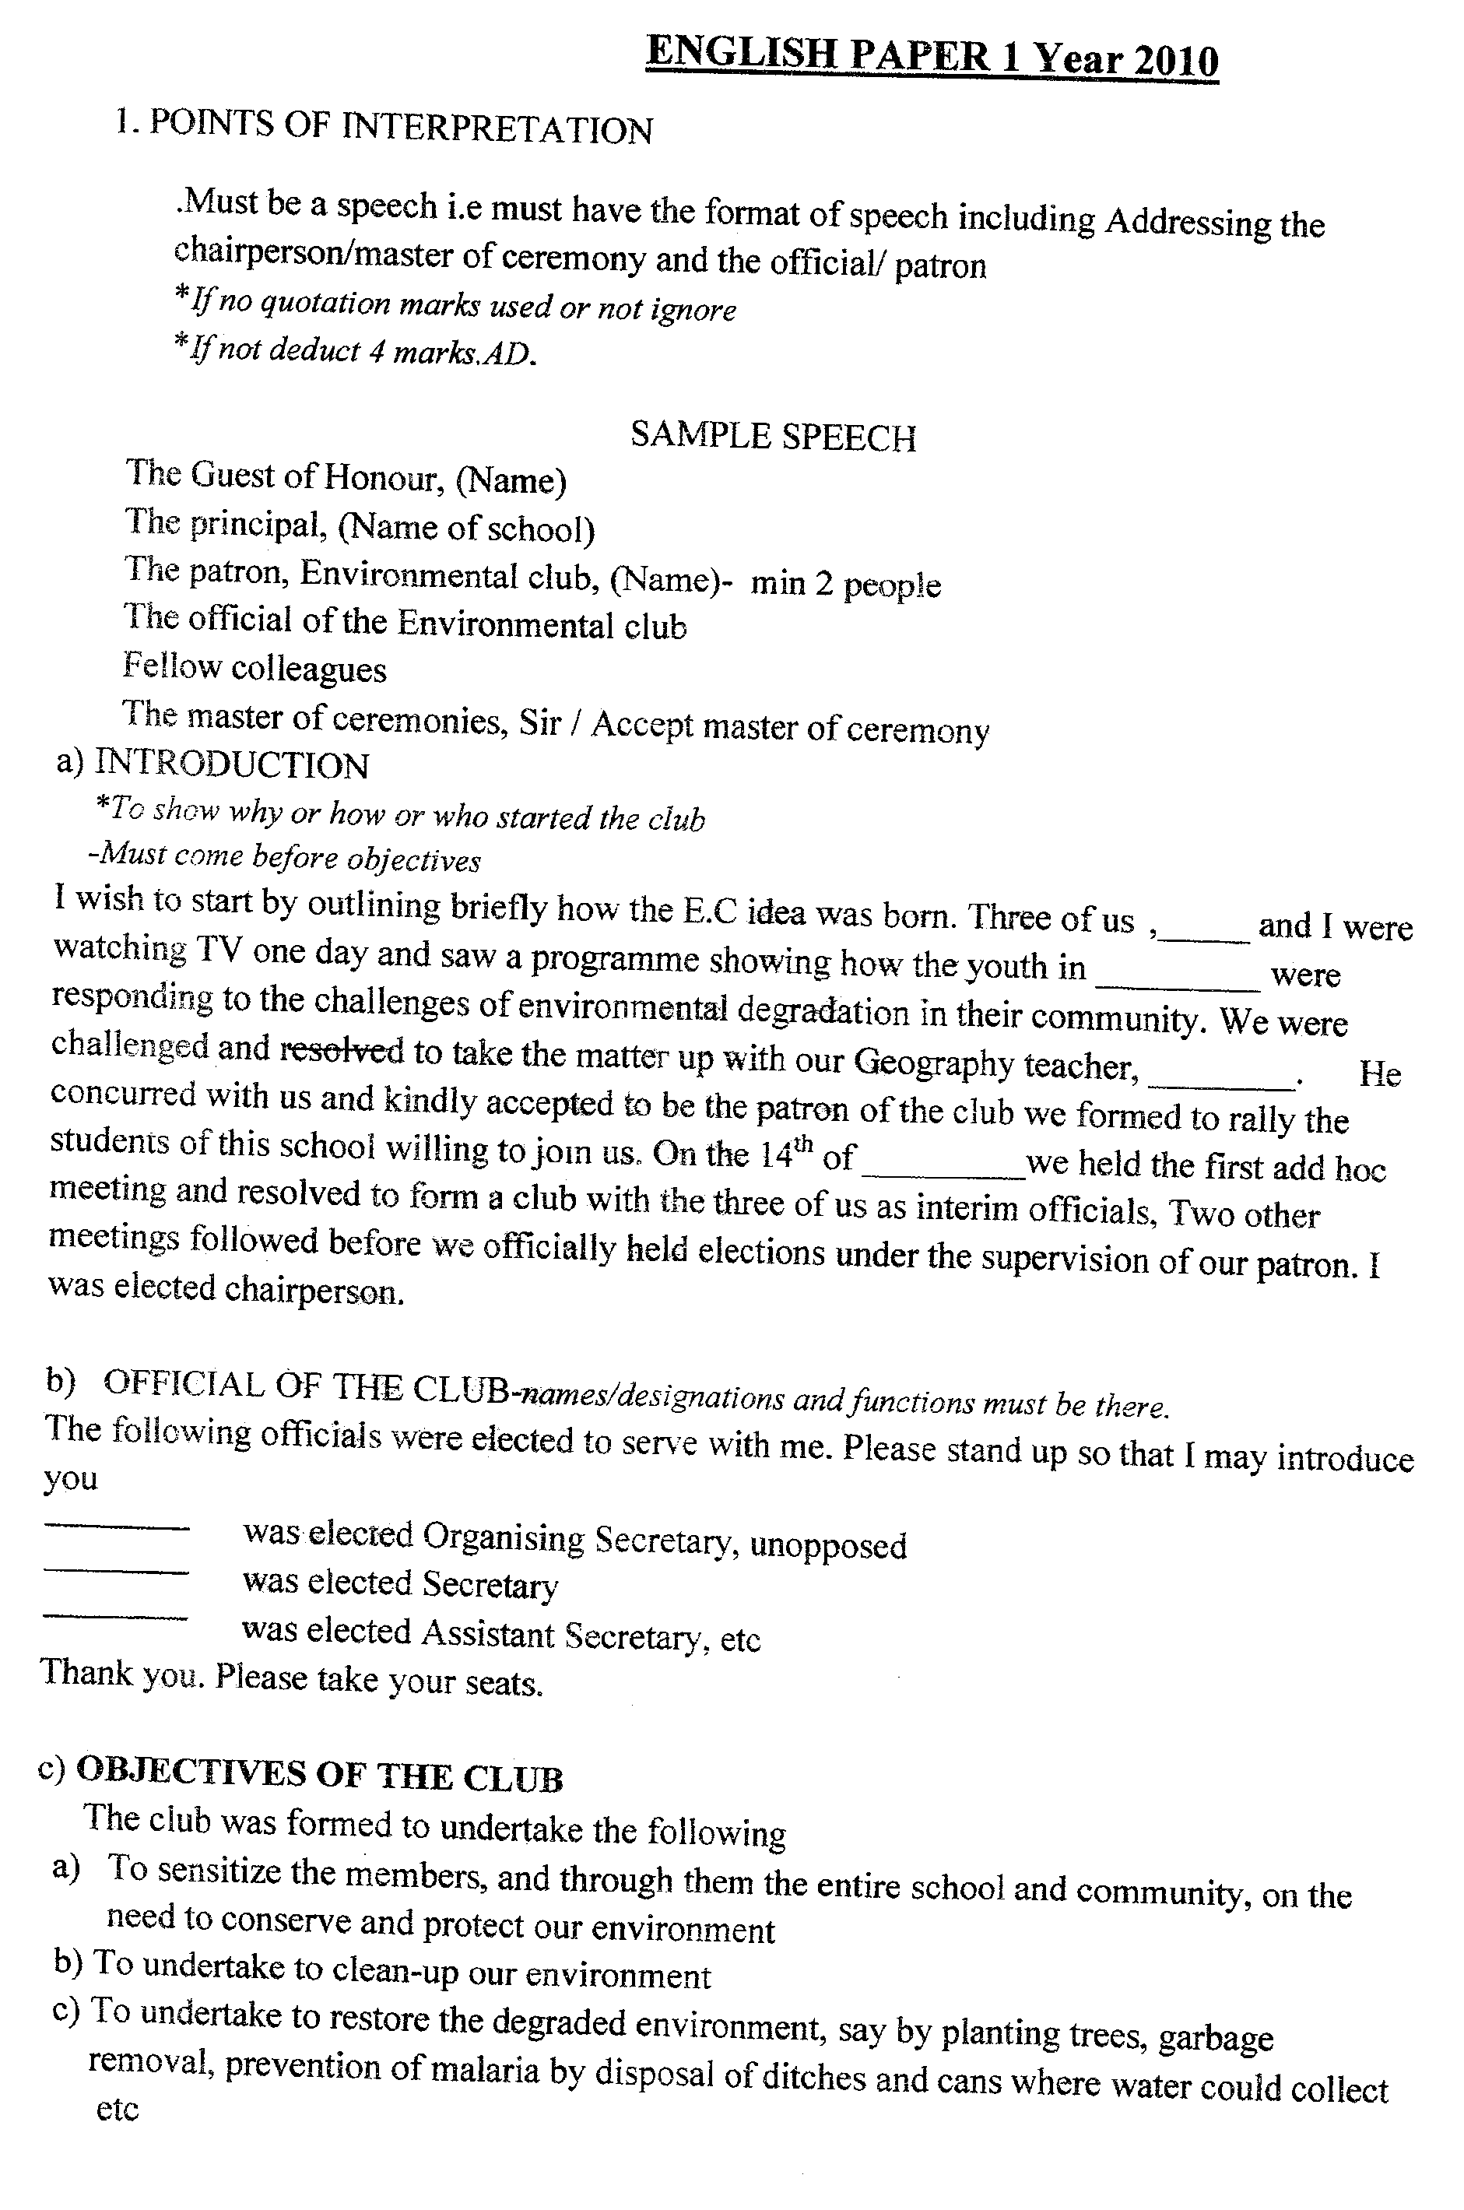

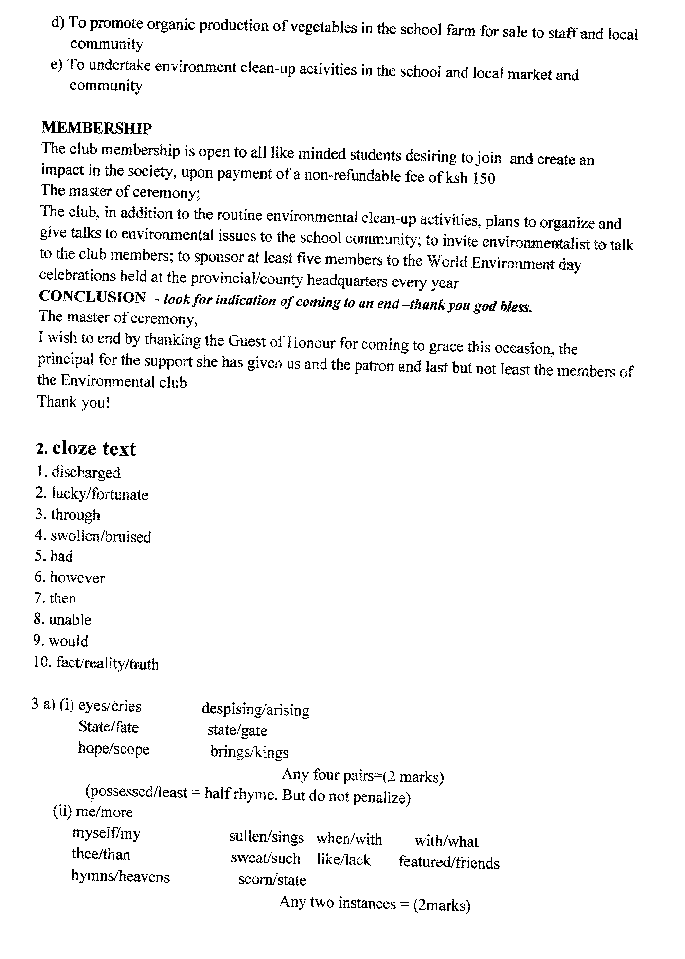

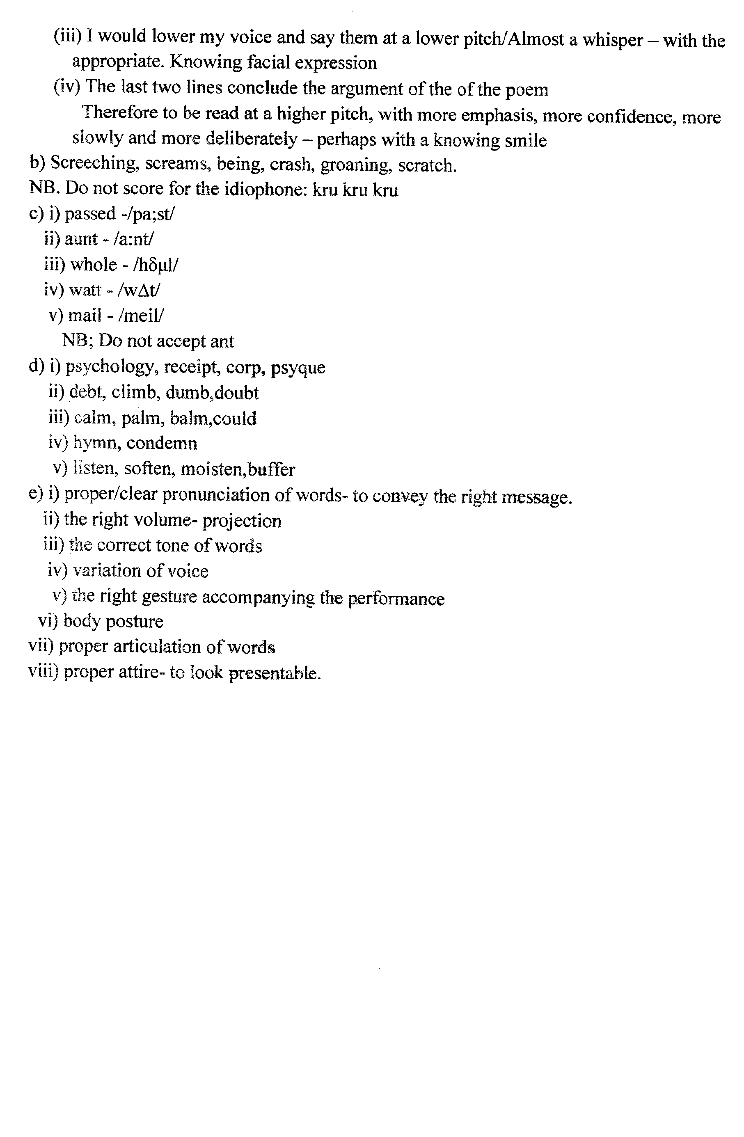

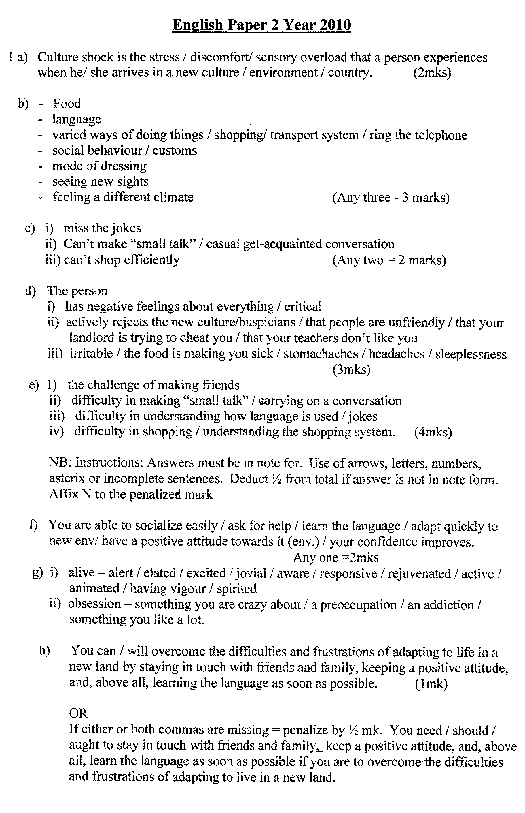

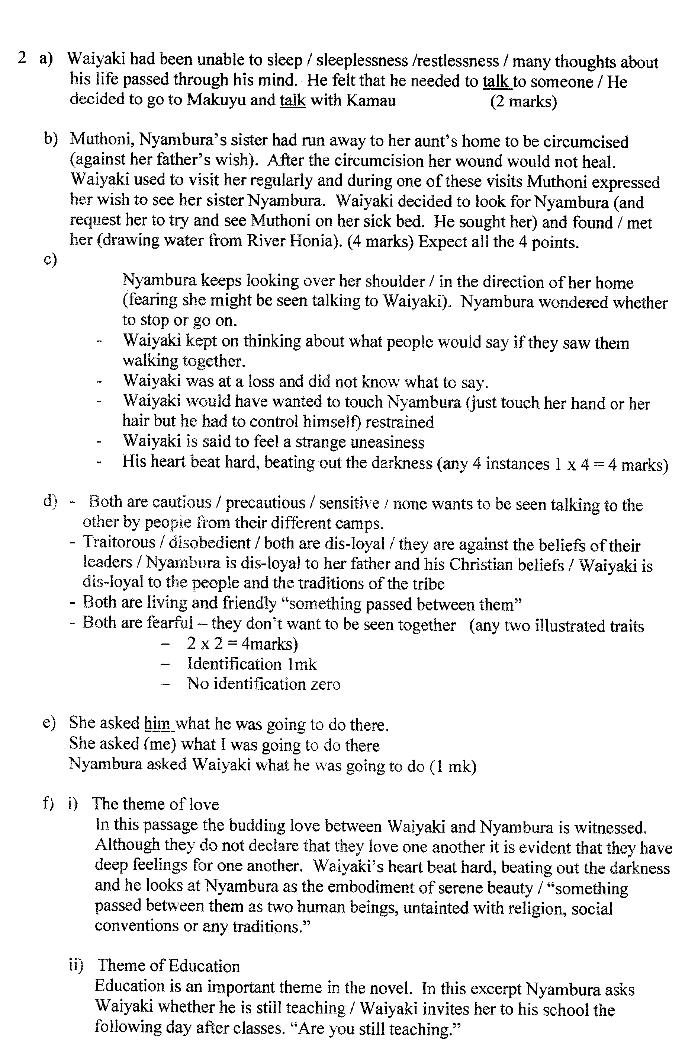

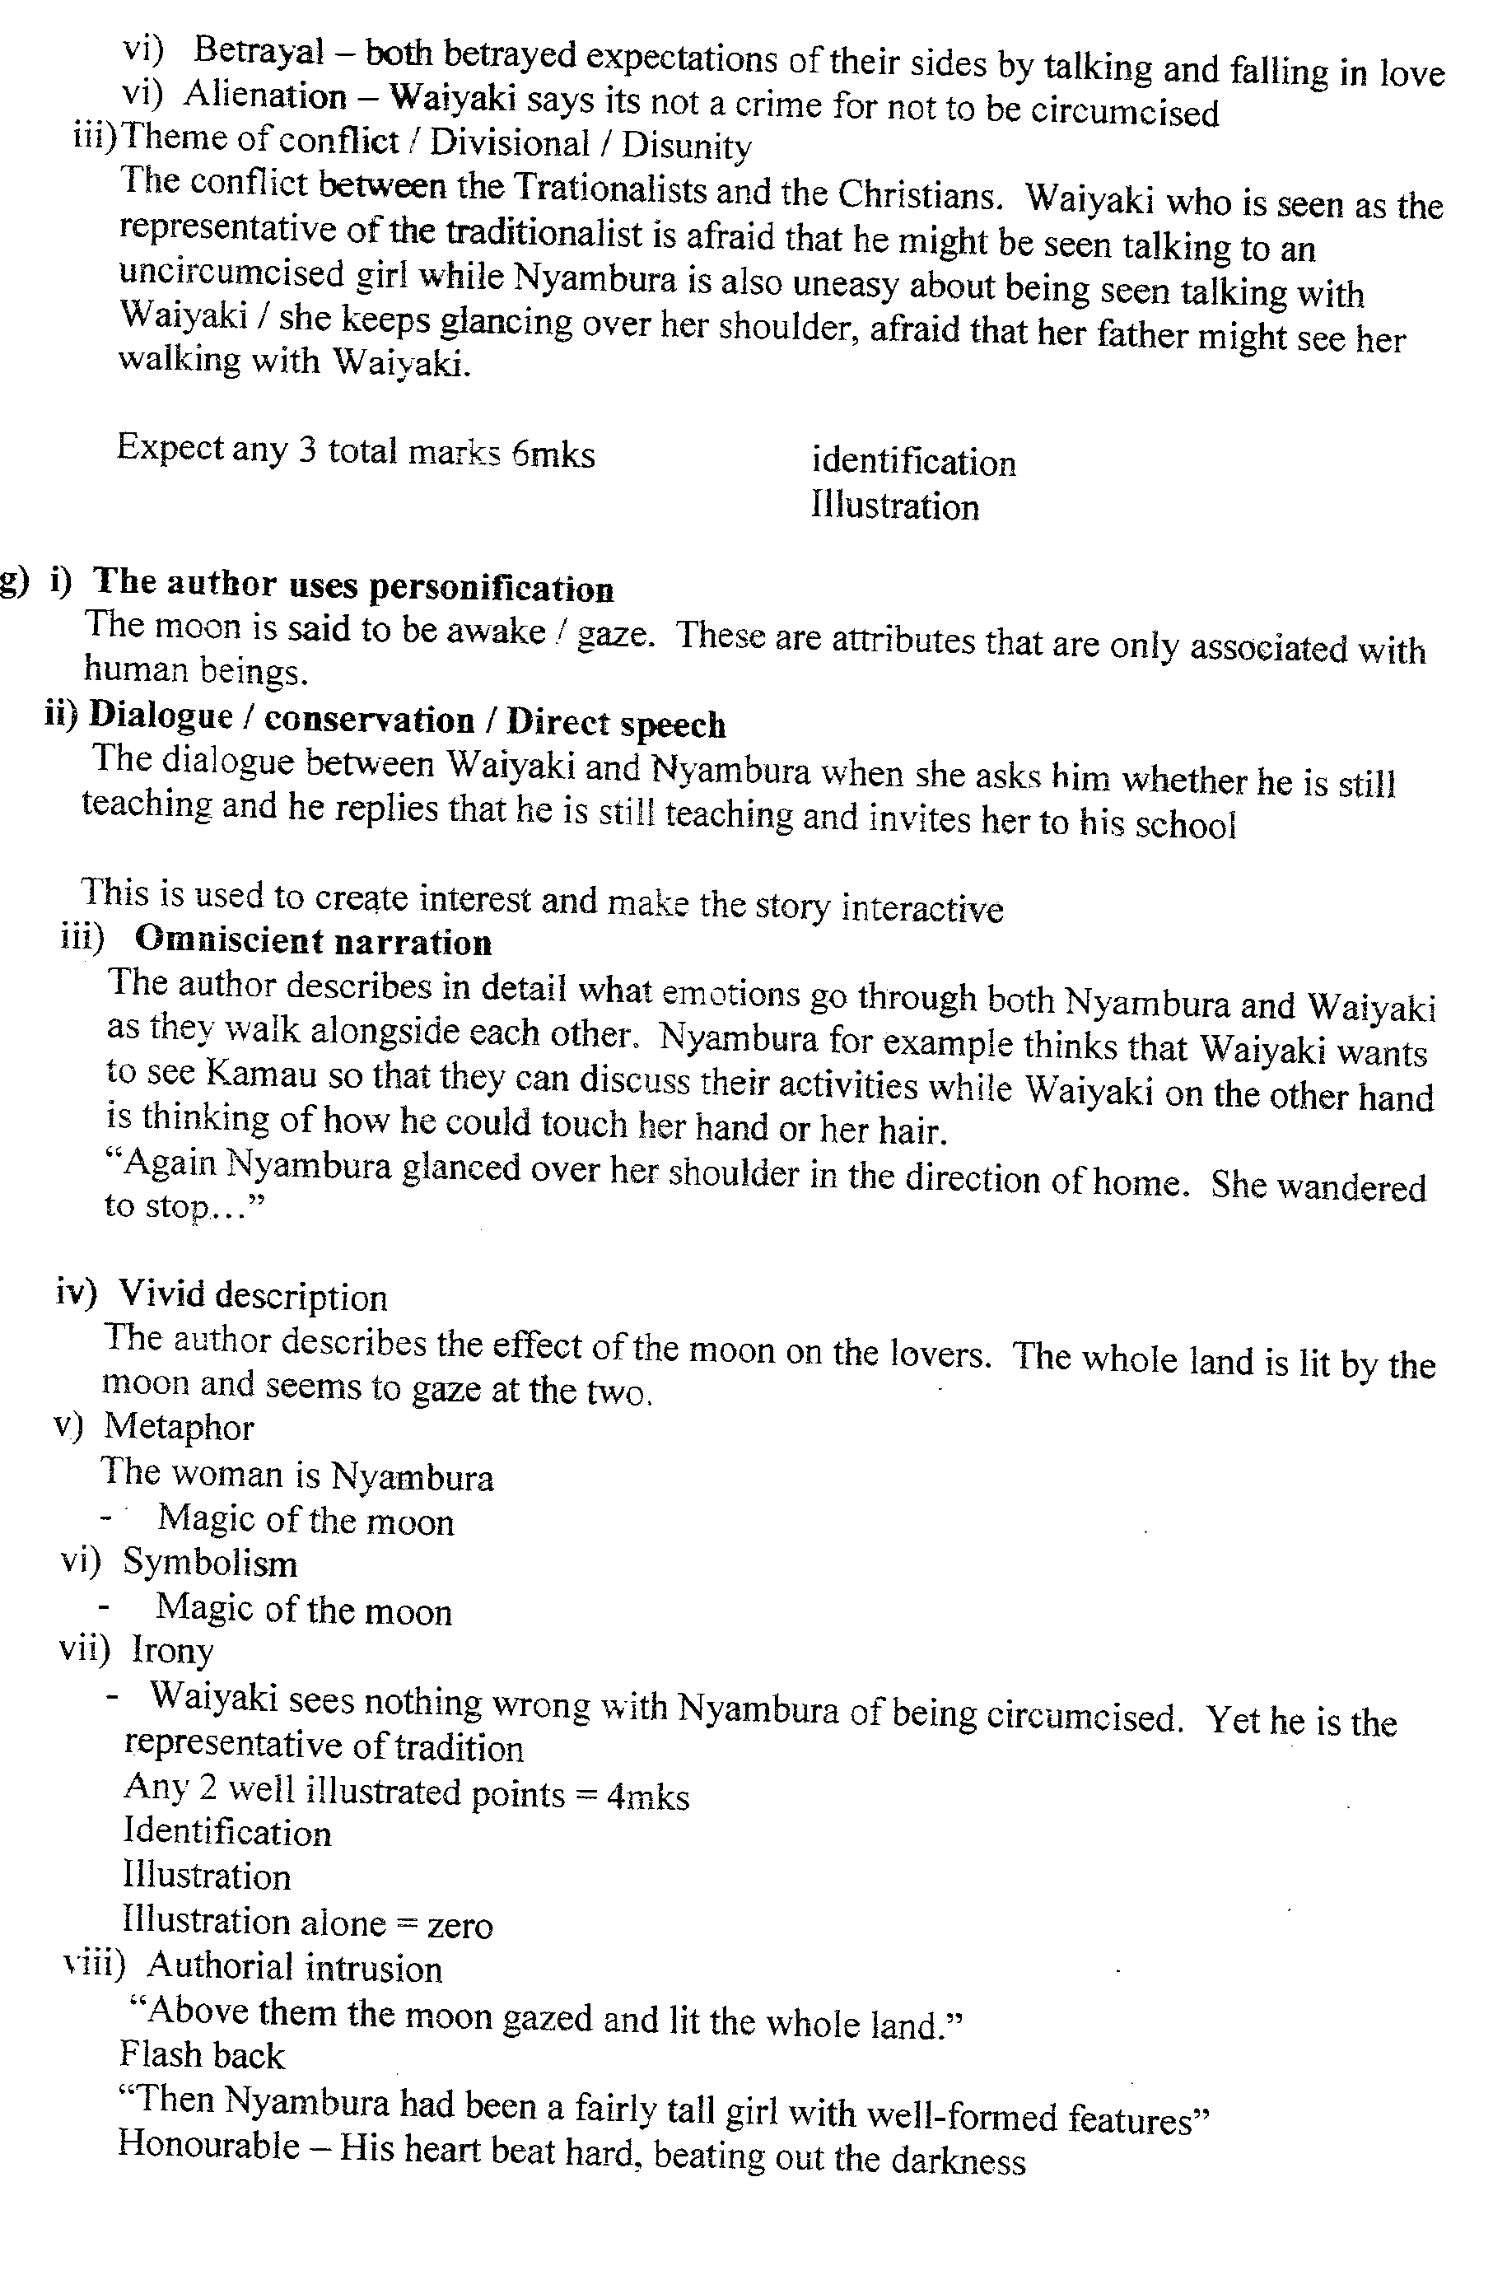

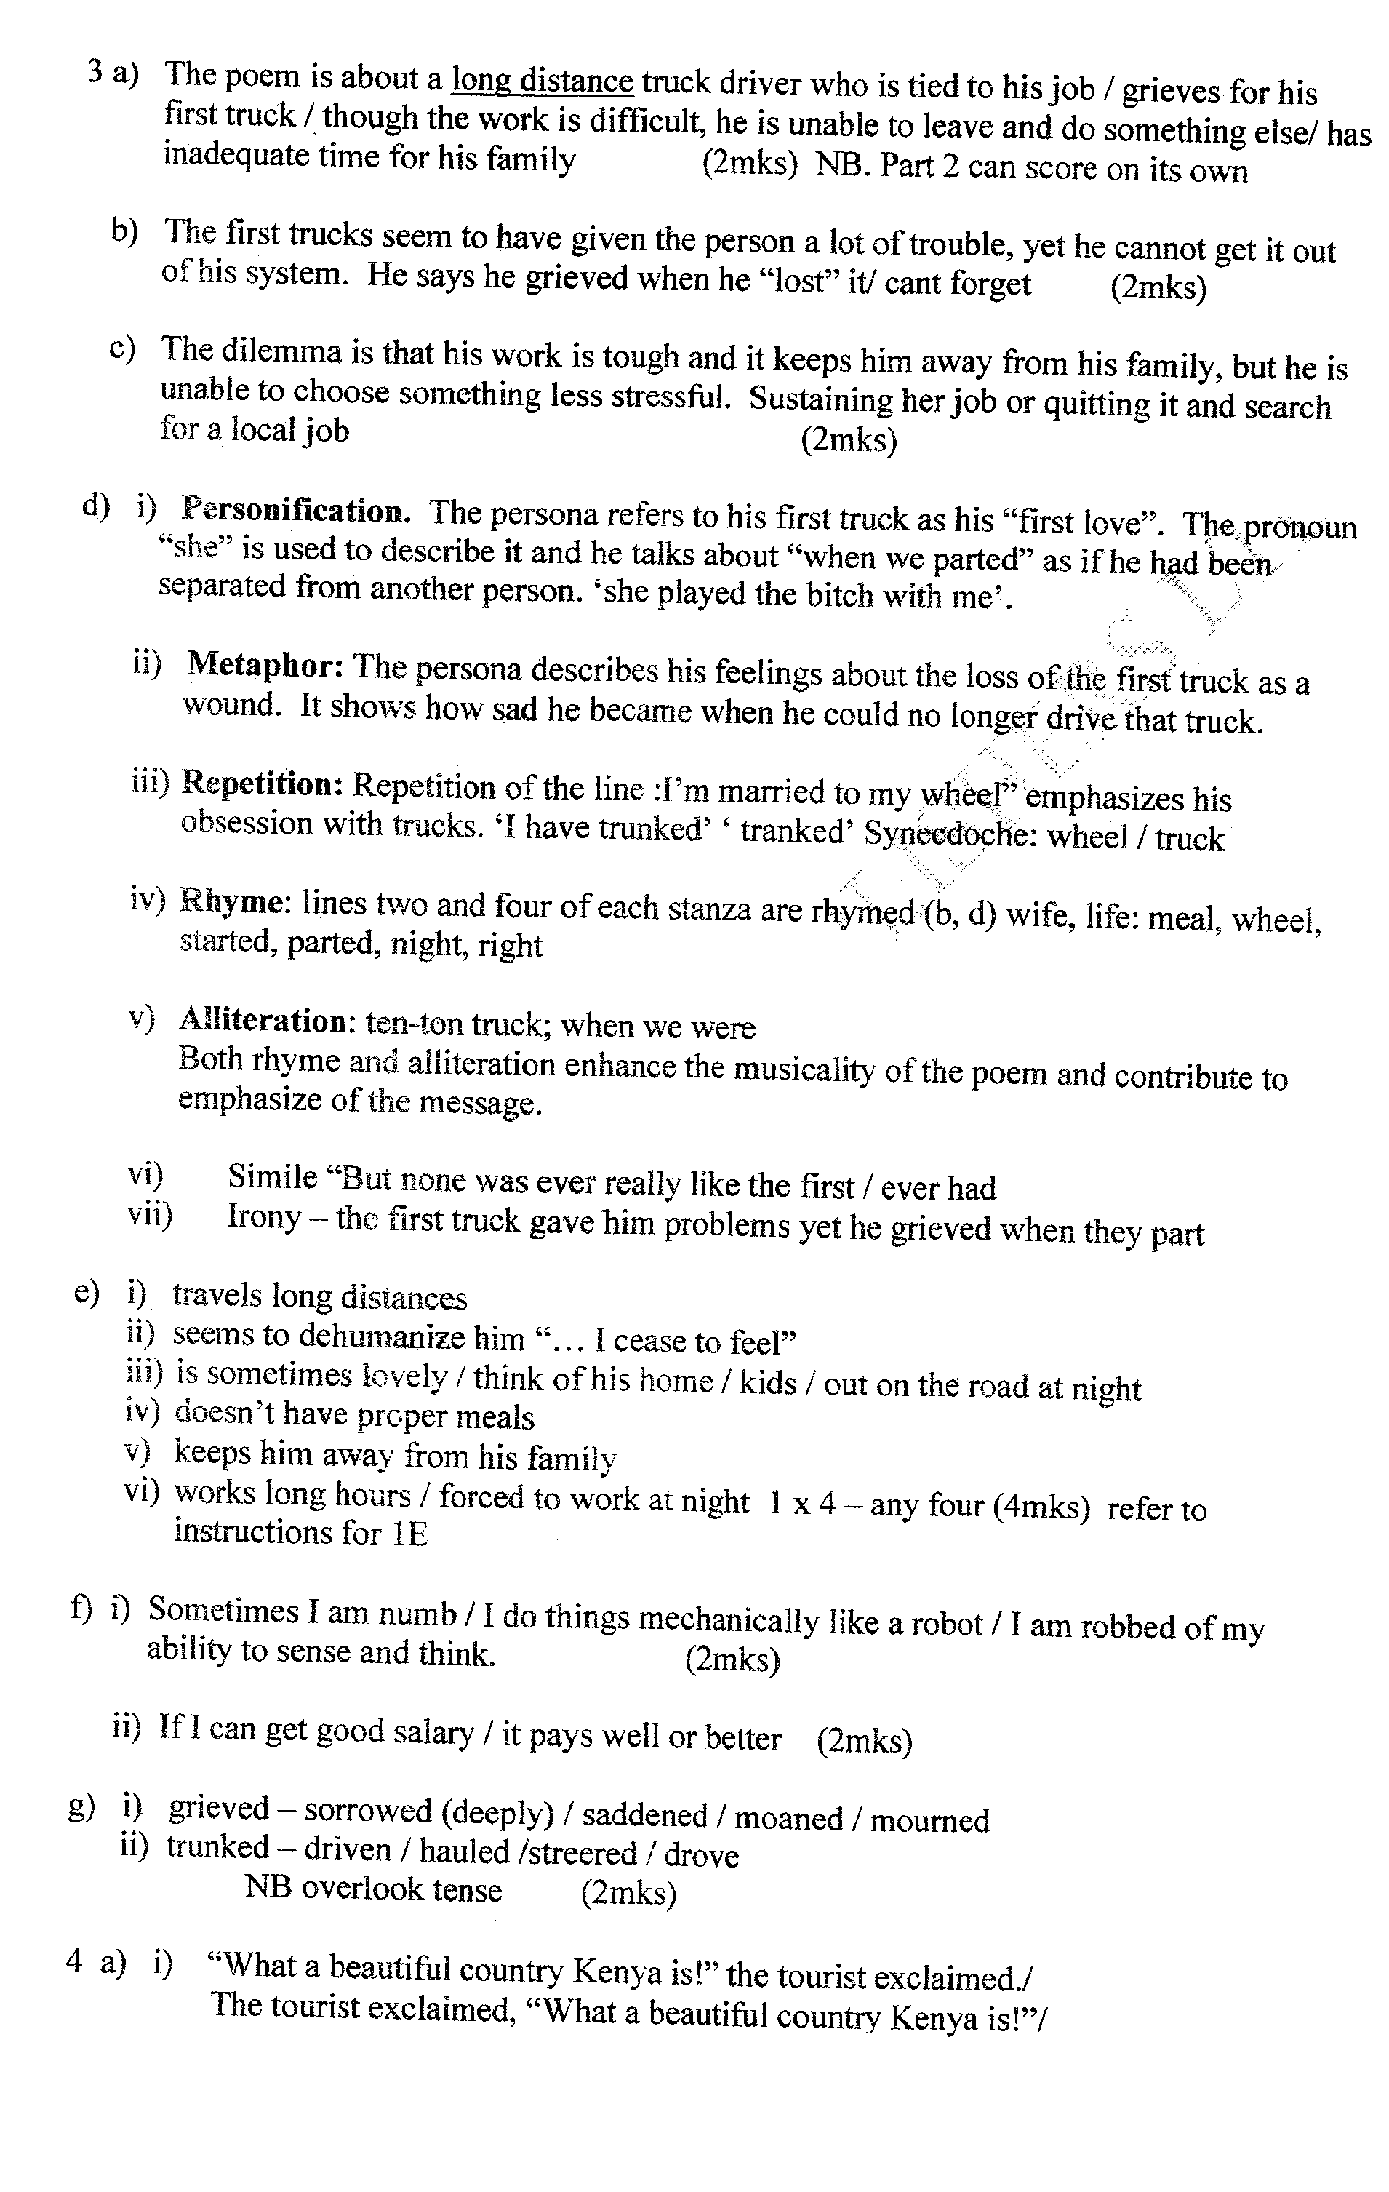

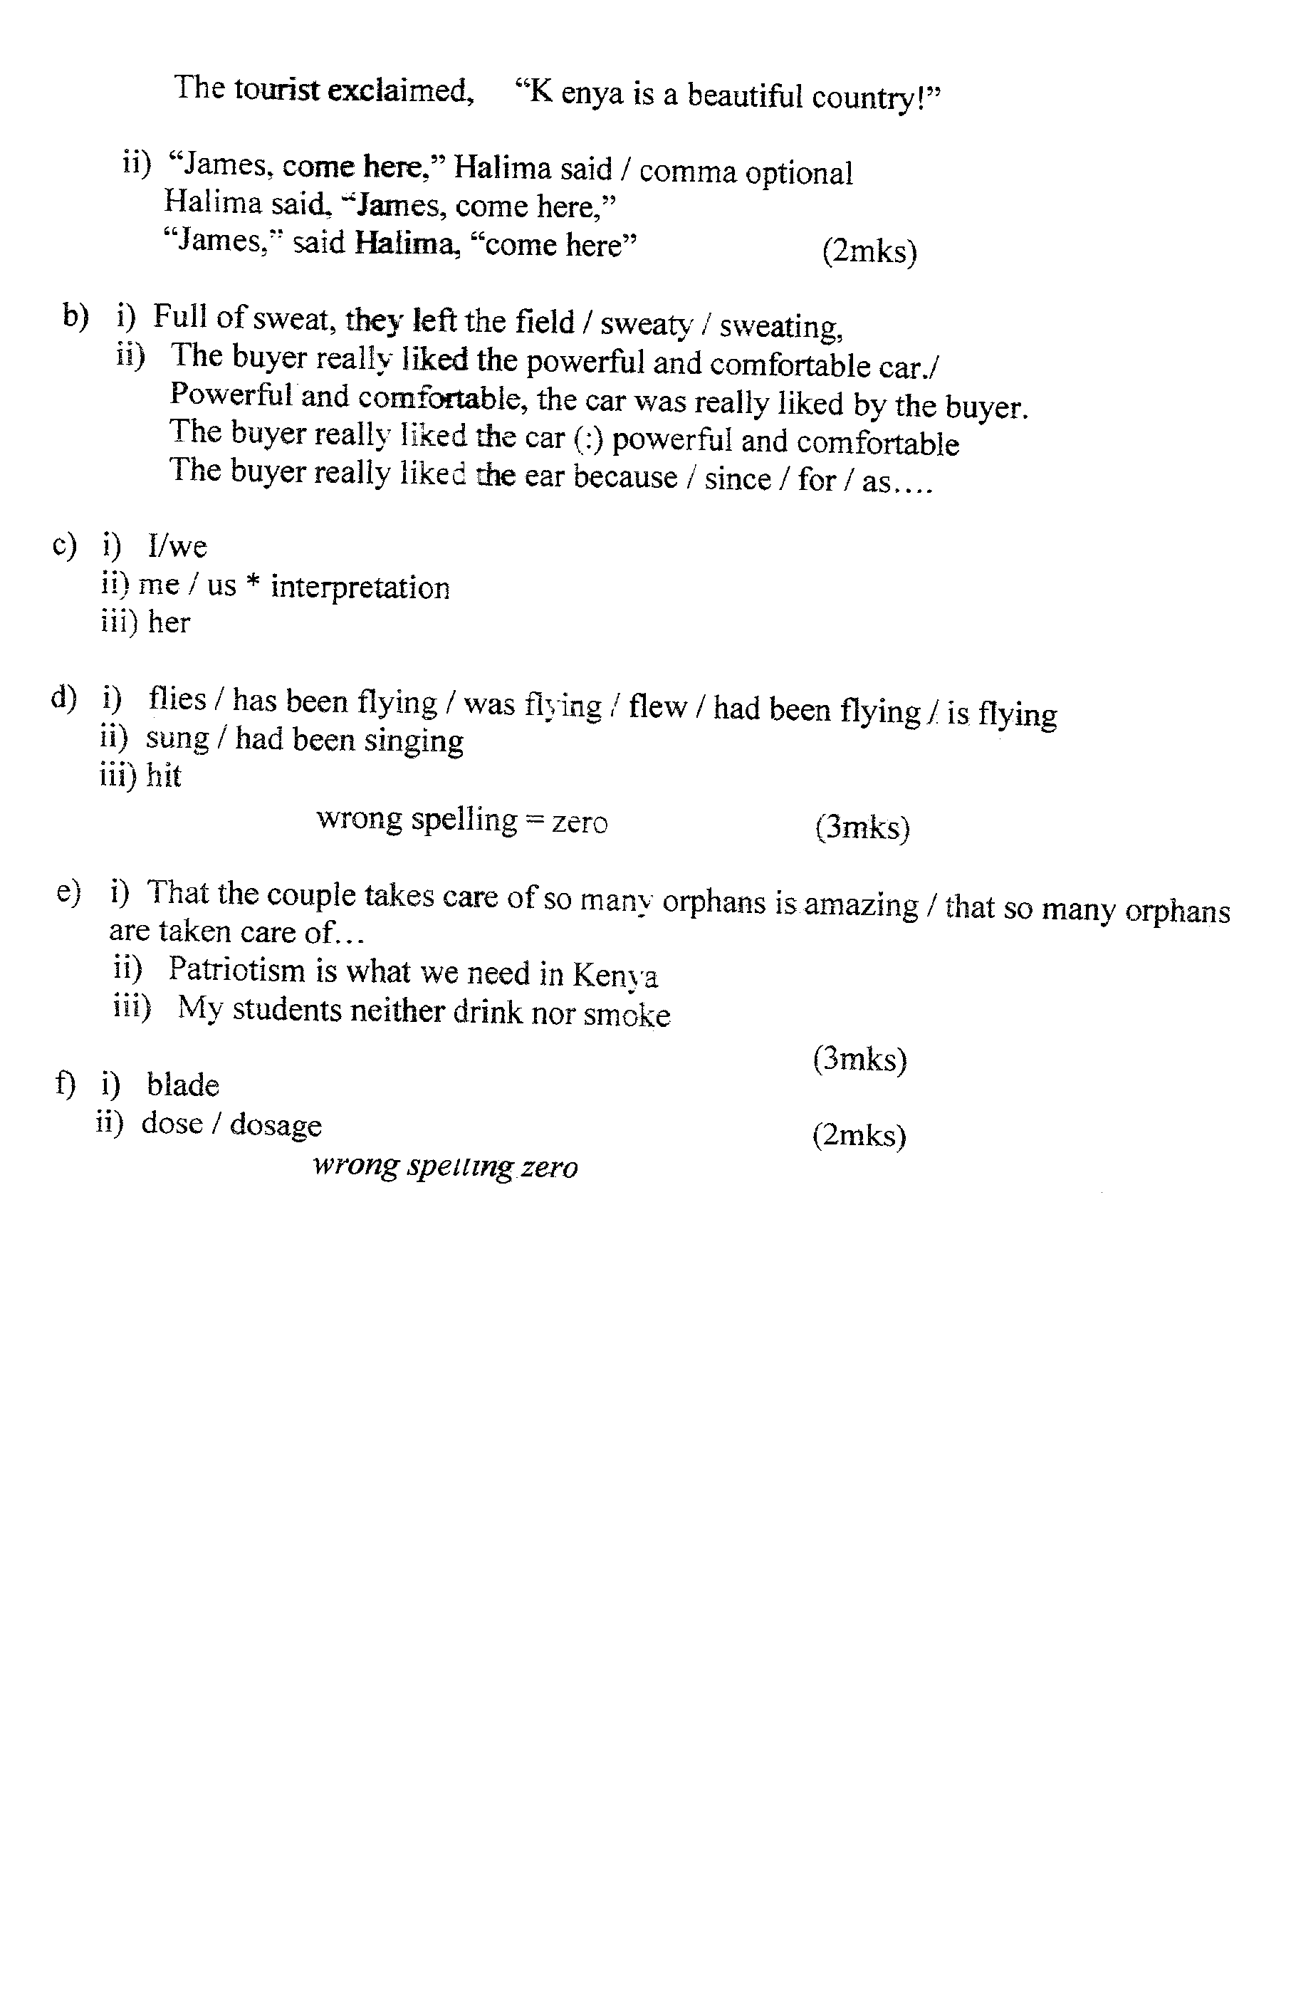

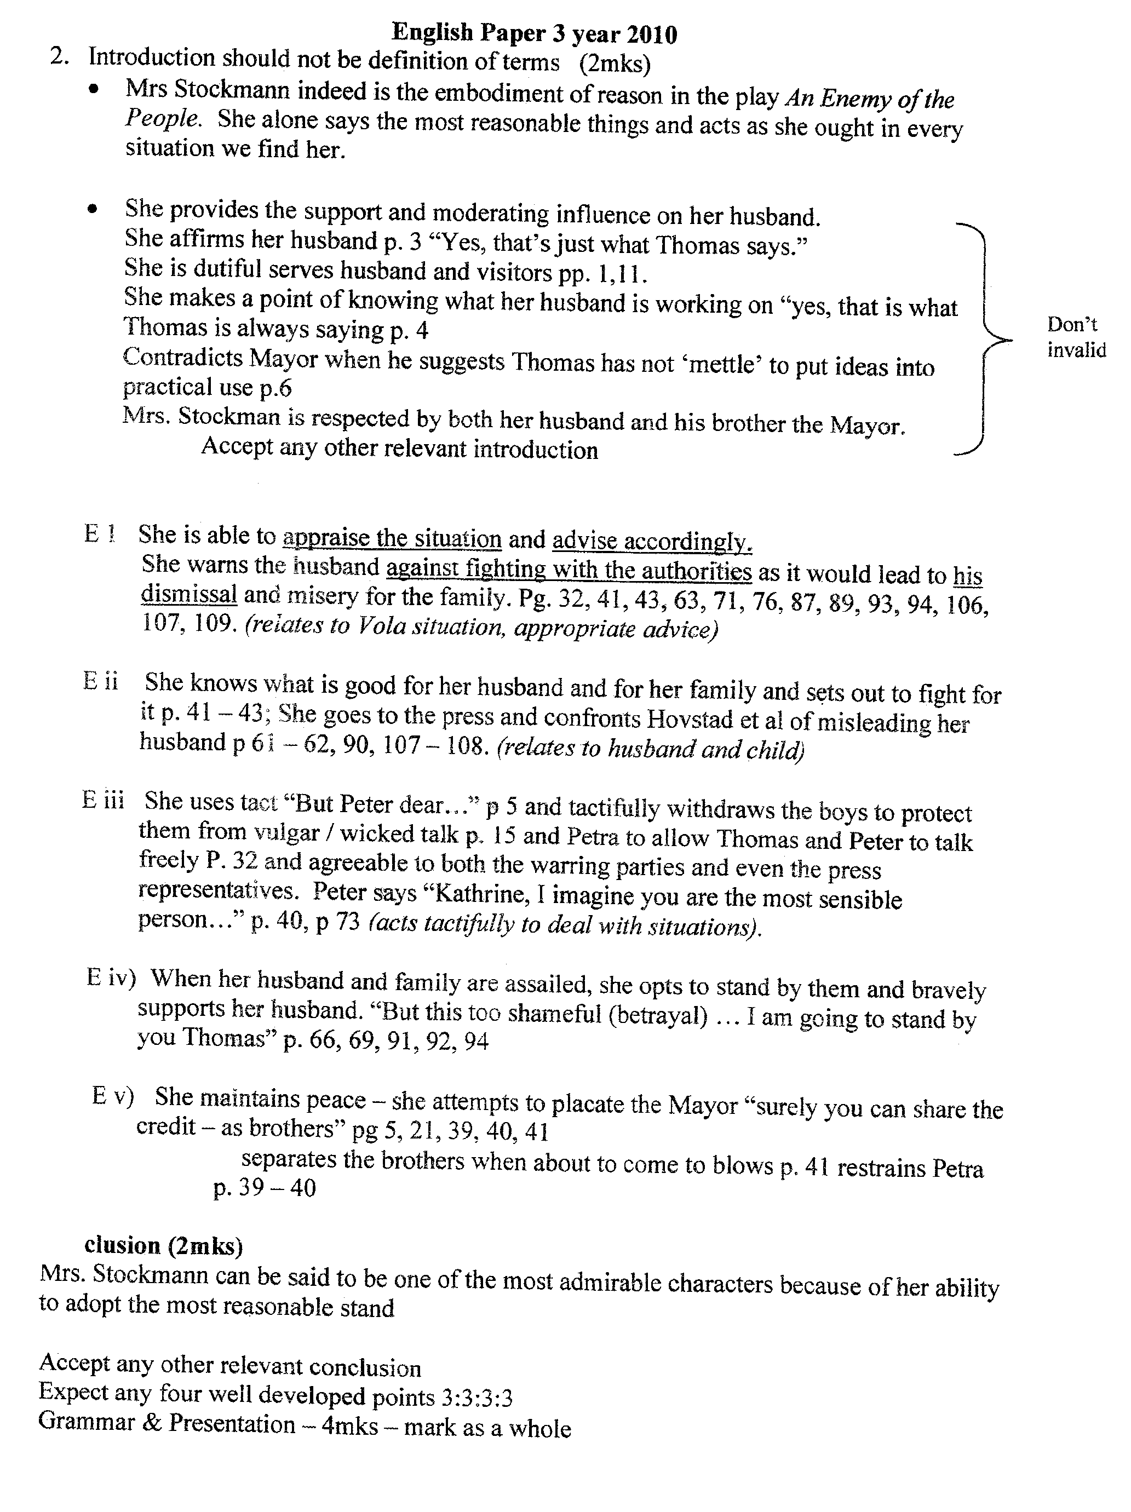

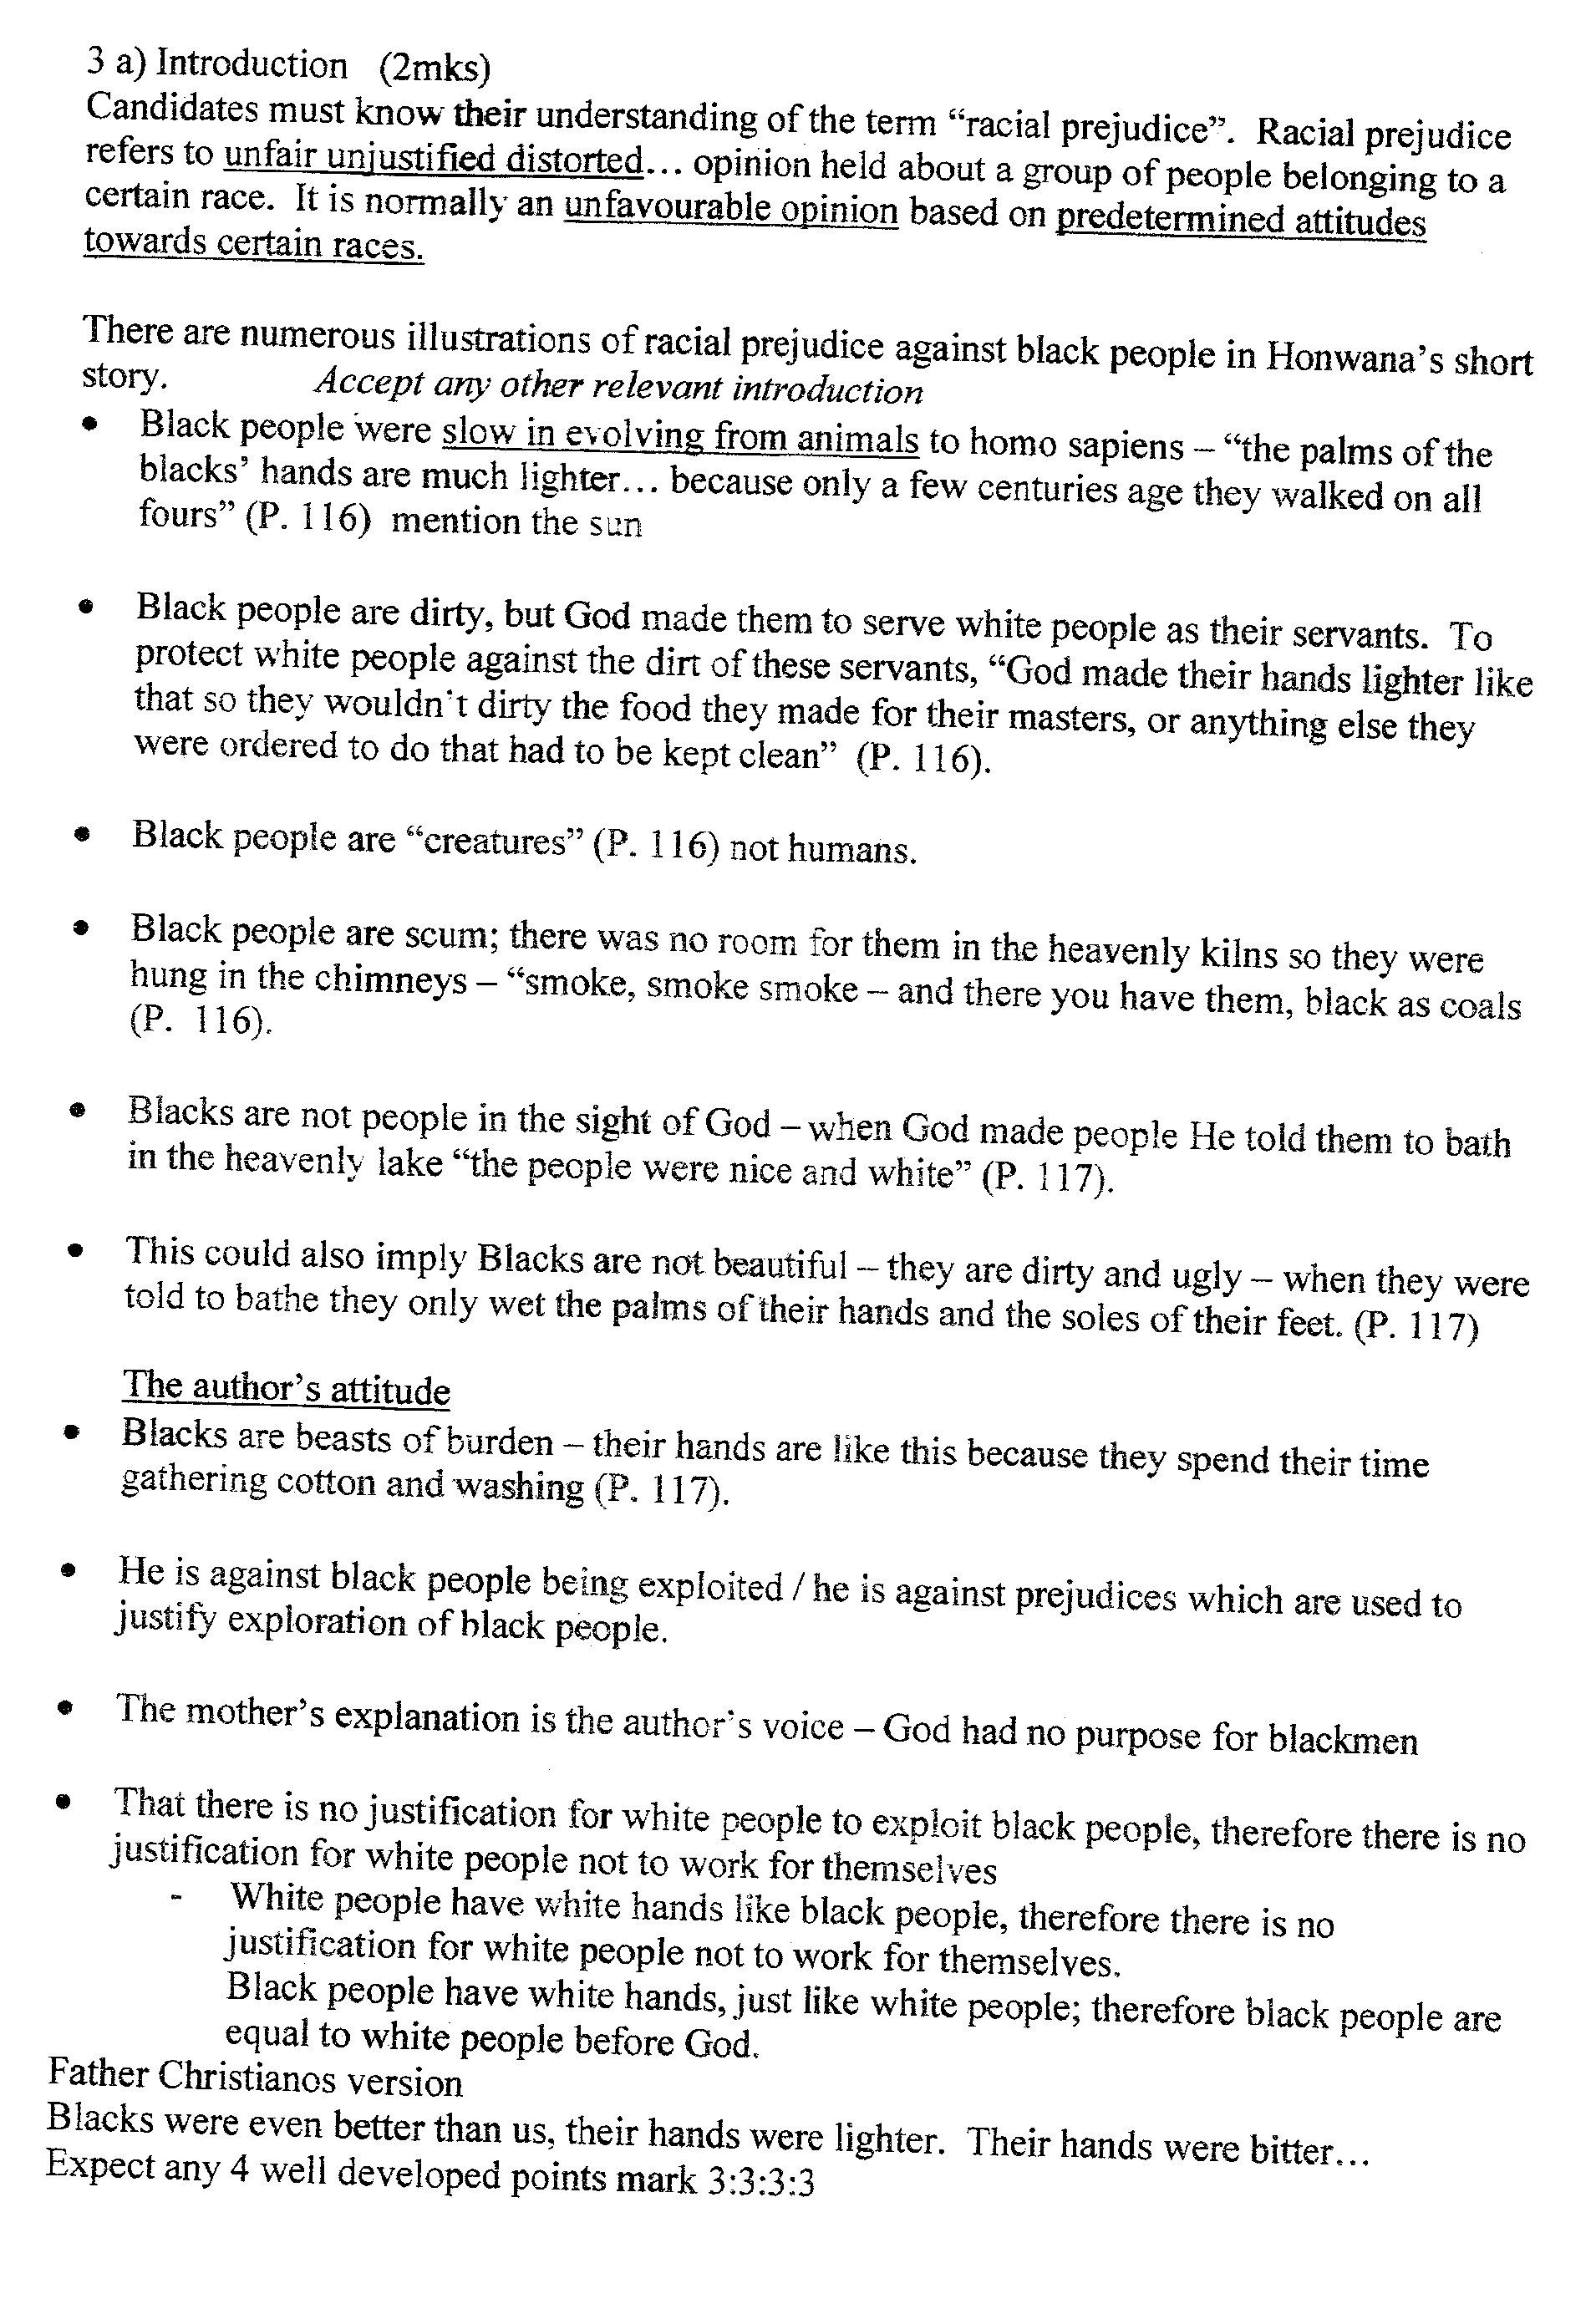

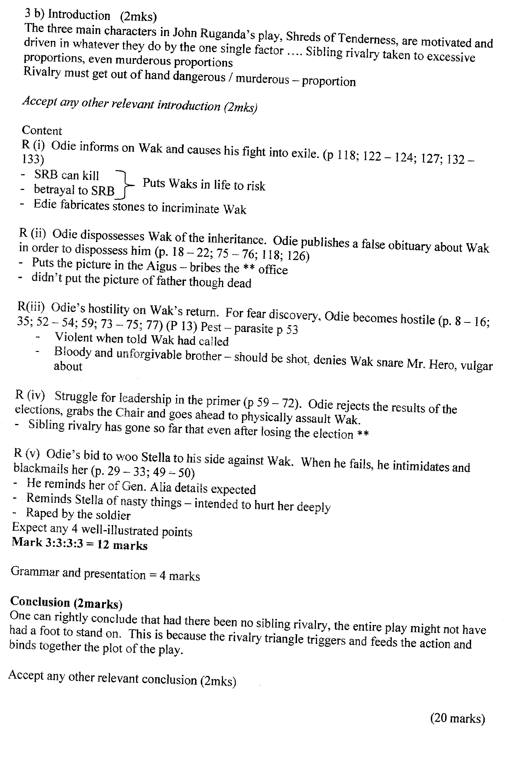

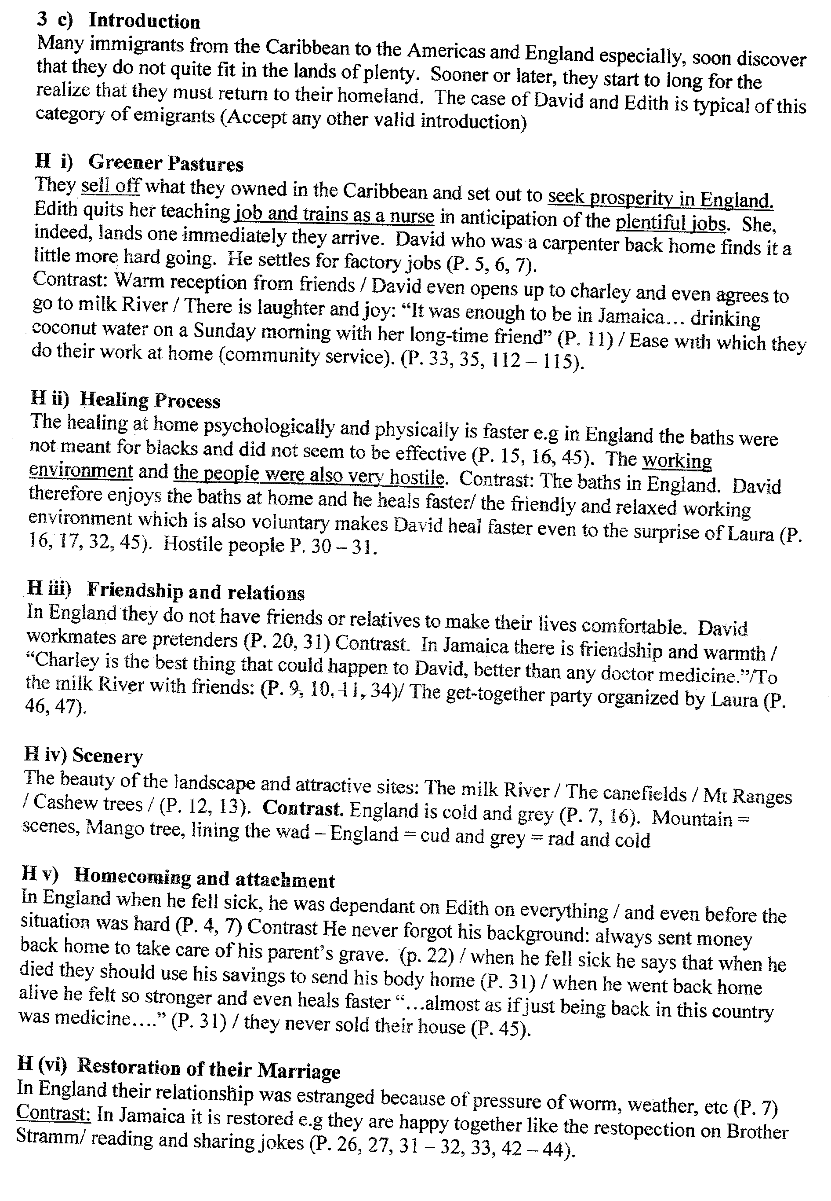

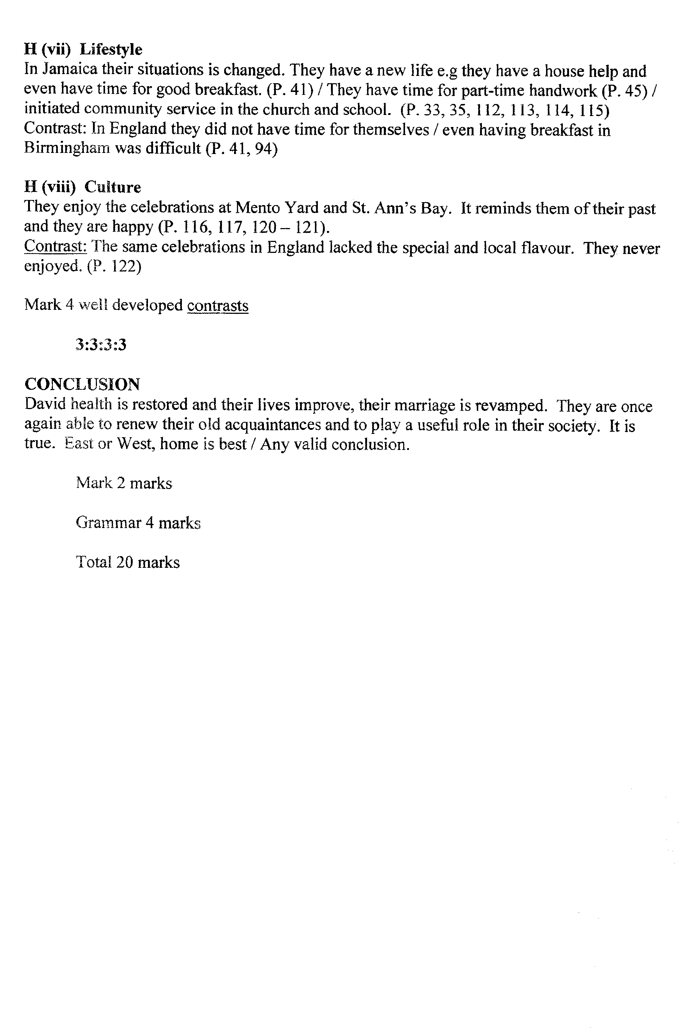

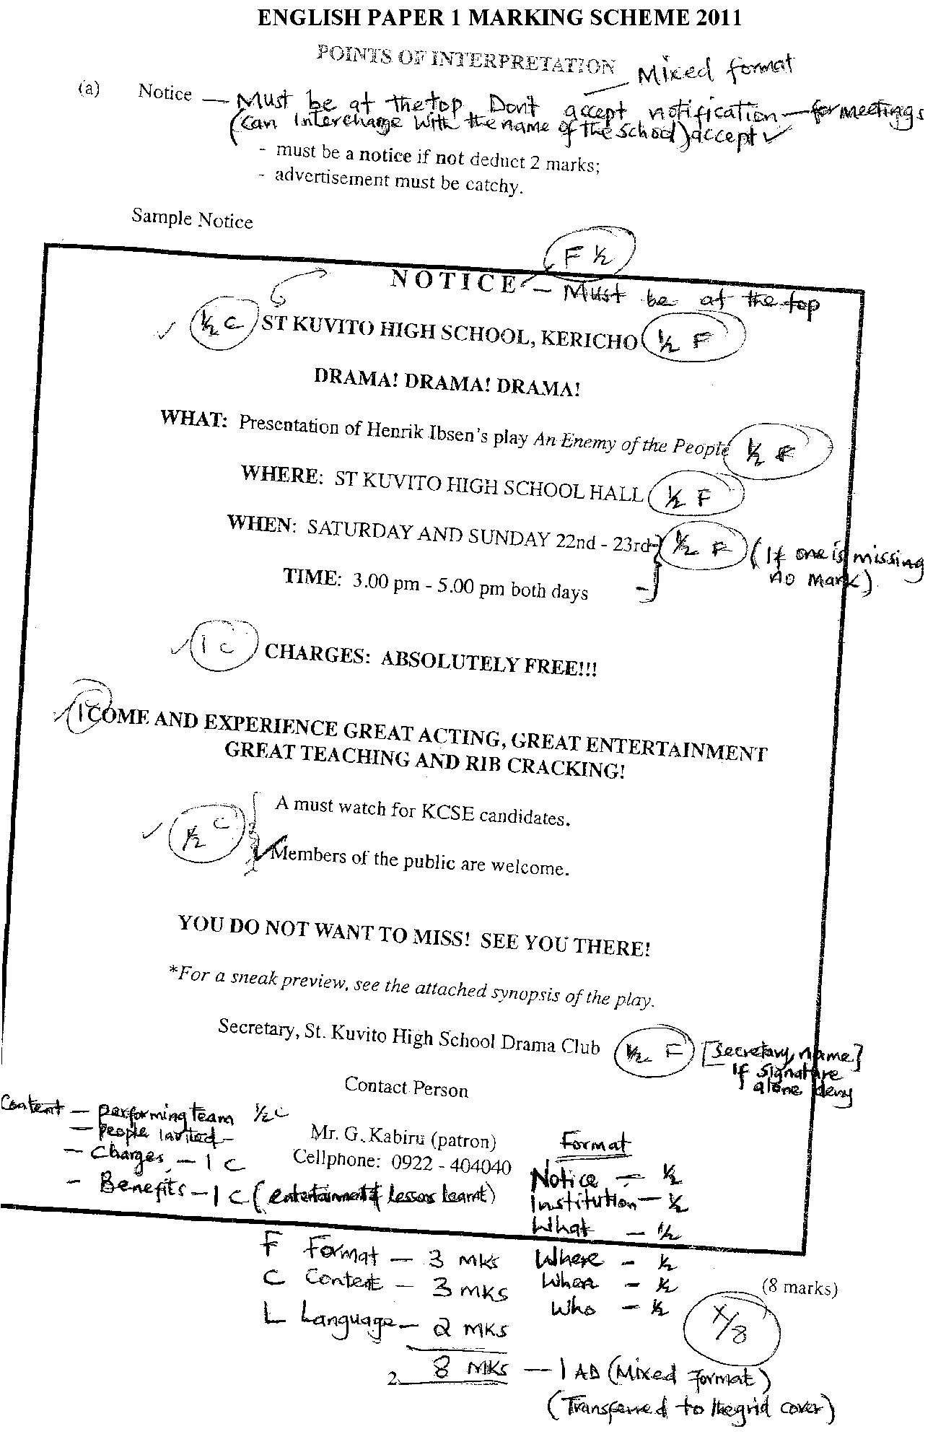
ENGLISH PAPER 1 MARKING SCHEME 2011
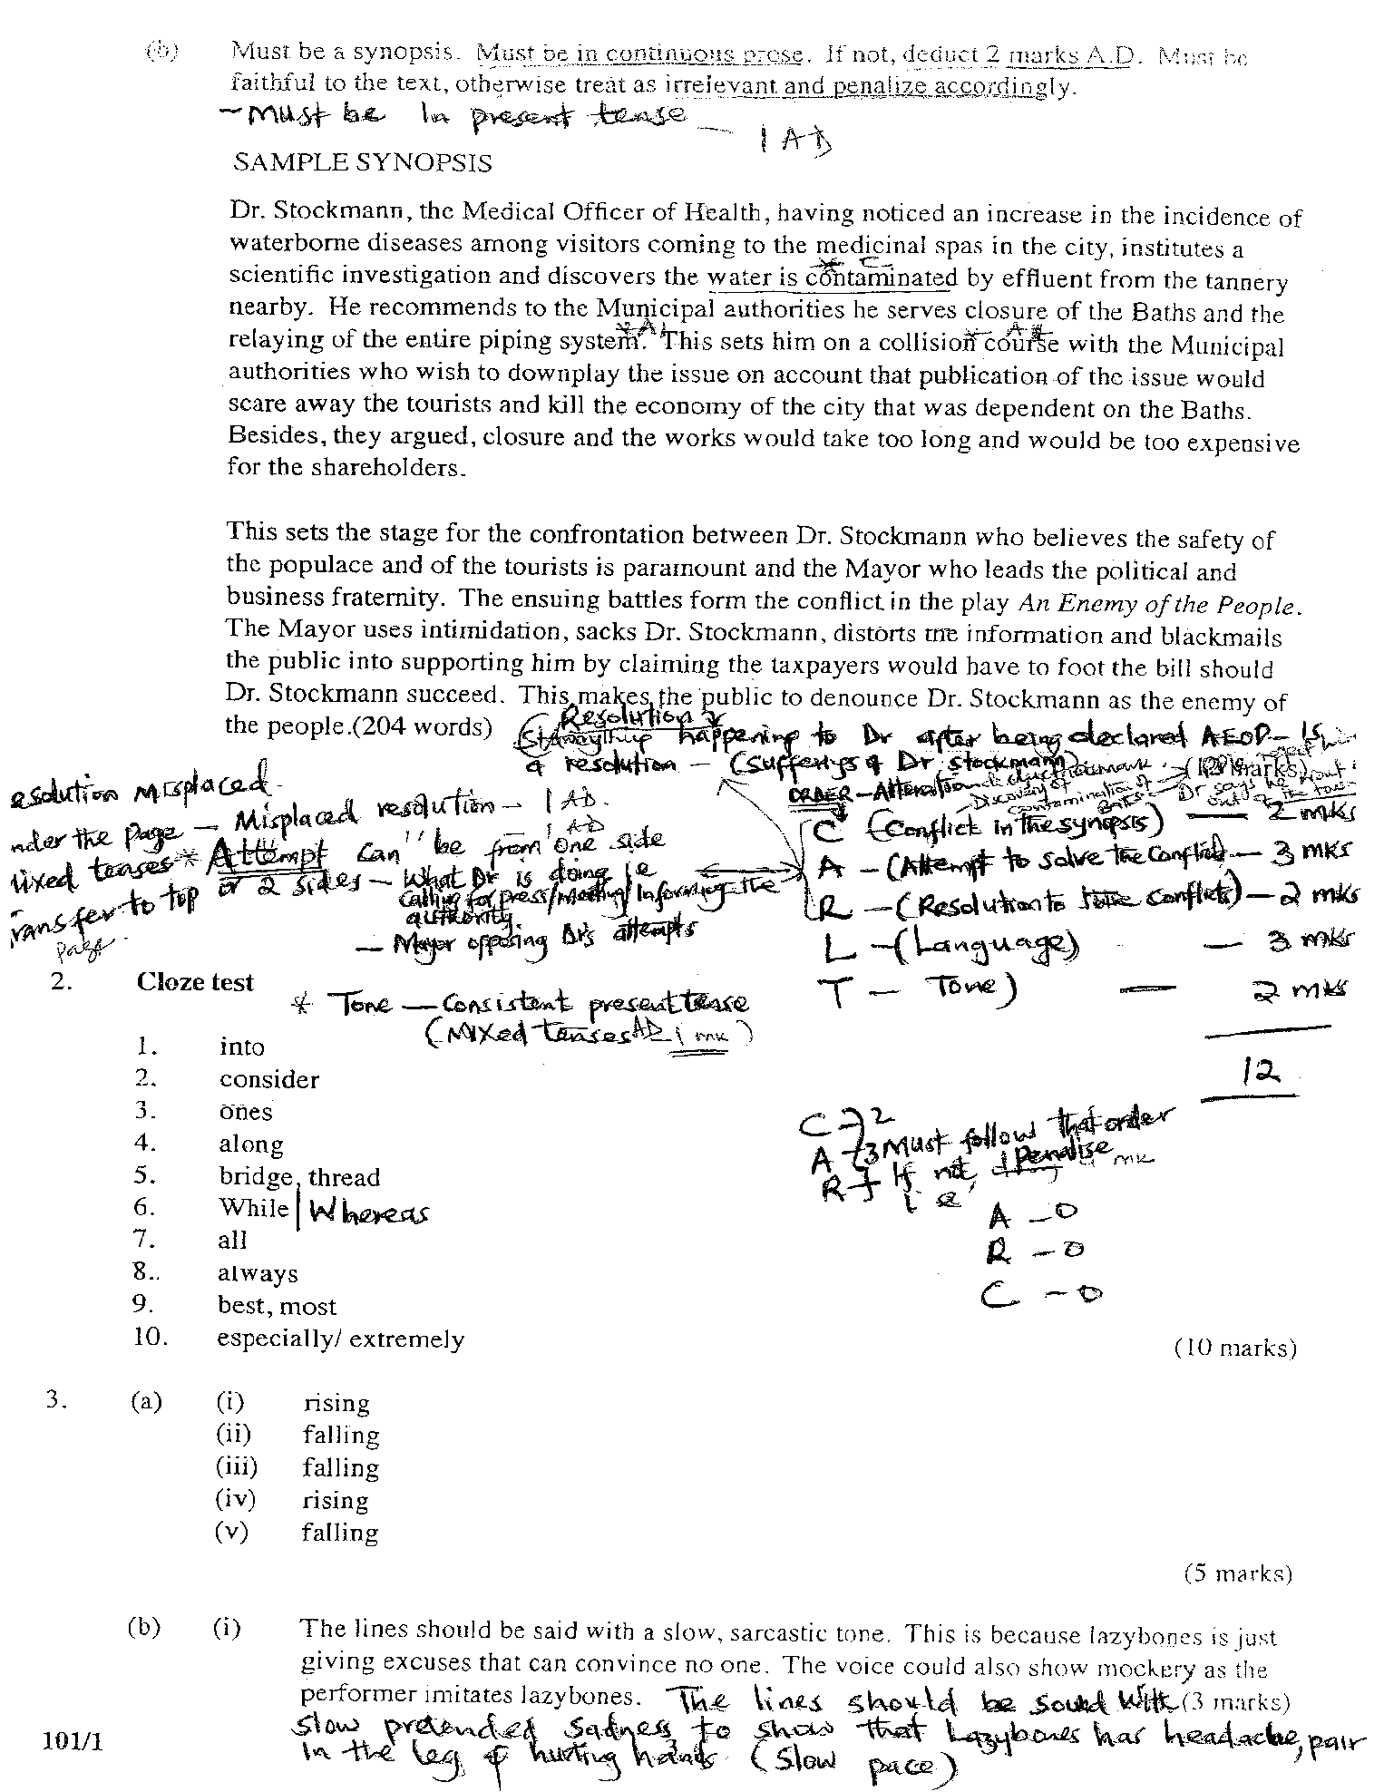
2011
ENGLISH PAPER2 MARKING SCHEME
Q1 A)
That his mother worships Obama in her living room/Obama is a saint /super human whom she worshipped. 2mks
That her collections were sacred/ the room was considered sacred because of the collections
The collections had t o be handled with utmost .care 2 mks
She treated the room with reverence / /holiness as a sacred place . 2mks
Any one point = 2 mks

B) - Obama has awakened a dormant optimism in her 1 mk
- His message of unity 1 mk
- His message of hope ( of going beyond)transcendence 1 mk
- His stubborn rejection of cymes-i.e. people with a low view of values/.who discourage him/his unwillingness to be cowed (a chorus of cynic 1 mk
- That his election would mean ,America has gone beyond race/Obama is a black American like his mother. 1 mk
- That Obama is, therefore , running a positive campaign 1mk
Any 2 points one mark each
2 x 1 = 2mks

C) Being a black ( African American ) and having suffered under the hands of white Americans she was thrilled by the fact a follow black man was on the verge of /on clinching the presidency of America . the unimaginable was imminent 2 mks The change she was eager for as the blacks had suffered this suffering / bitter memories come to an end 2 mks
Any 1 x2 = 2 mks

(D)
- At age 77 , this woman had probably never dreamt that this would come to pass in her life time 2 mks
- she has witnessed so much racism that this appears a life changing revolution 2 mks
- That a person who stands for such positive values has won is almost
unbelievable/ unimaginable / incredible /a dream come true 2mks
- for the first time in History a black man becomes the president of America 2mks Any 1 point x2 =2mks

(E)
- To give the Obama story a historical dimension (e. g reference to the mother as
a child of the depression) 2 mks
- To personalize the issue of the obama campaign and victory 2 mks
(seeing the issue in relation to his mother the closest person )
- To present the issue in terms of generations 2 mks (grandparents)- mother –son (perhaps grand children )
- To underscore the gender dimension on ordinary black woman who grew up during the depression enthusiastically supporting obama
- To hook the reader with a anecdote about his mother/catch the reader's
interest 2 mks
The mother has a firsthand experience of' the suffering of the blacks during the pervious regime / the mother has more to tell than the author 2 mks
Any 1 point 2 mks

(F) She married young for she was a child of the depression / for she was a child of the depression she married young
Comma missing = 1/2 mk
‘the” missing = 0
Small D depressing = 0 1 mk

G)
- -Flank / sincere- telling it exactly as it is / typical of a black woman of her generation
- supportive --- understands where the mother is coming from
- Empathetic - sees things from his mother’s point of view
- loving / warm / close /intimate /cordial / happy
- my mother is special to me
- the son is the one telling the story ,but behind it we can fell a mother’s love for her son
- Inspiring /inspirational/ influential /administration

…………..deeply informs my own life
Any two points 2 mks ----2 x 2 =4
Indentification -1 mk
Illustration – 1mk
2 indentifications
2 illustrations

(H) Negative 1mk
- It is associated with ‘chilling tales’ / open and violent hostility towards African –Americans
indentification 1 mk
illustration 1 mk =2 mks

- (i) staple of my mother’s conversation –major /main topic of her discussion /center of
her talk /core /main subject / key
(ii) surge – emergence /overflow /bubbling /sudden strong feeling /boost /increase
(iii) Digested – adopted /processed/internalized imbibed //understood /comprehended/taken in / absorbed / memorized
1 mk each 1 x 3 = 3mks

Q2. AN ENEMY OF THE PEOPLE
(a) I lovstad and billing had been talking about Dr stockmann’s 1mk the impact 1mk it will have on the aristocracy. They have been discussing how they can use the situation to get control of the municipal affairs 1 mk ALslaken and the mayor are likely to opposethe article / They were discussing about Aslaksen’s cowardly nature 1 mk
Any 2 x 1 = 2 mks

(b) He had expected that the mayor would bring the article before theBaths committee and get them to start rectifying the situation /correcting the problem / He had hoped to convince the mayor to accept the content of the article / he wanted to discuss with the brother / the mayor .
Any 1 point = 2 mks

c) Contents of the article include
1) A11 the effluent at molledal….... is infecting the water in the conduit pipes leading
to the reservoirs/contamination of the water is due to impurities in the soil/
poisonous morass up at molledal
2) The same cursed fifth oozes onto the shore 1 mark
3) The water causes typhoid and gastric fever 1 mk
4) Therc is decomposing organic matter in the water 1 mk
5) A11 the conduit pipes will have to be re-laid. I mk
6) The intake is too low down. 1 mk
7) it will have lo lie- moved much higher up. I mk
8) will have to build a sewer to carry off the alleged impurities, 1mk
9) The water was unfit for both human consumption and bathing. 1 mk
Any 4x1 Marks

d) Aslaksen is unenthusiastic 2 mks/ skeptical 2mks /non committal 2mks / cautious unsupportive/ 2mks / indifferent /indessive 2mks /fearful about publishing the article. He does not want to displease the people in power 1mk. he wants to be assured that it is okay with both the "prudent point he supports at another he is against
2mks identification
= 3 mks
1 mk illustration

E)
i) Dr.Stockmann is sacked from the Baths committee 1 mk
ii) His house is vandalized 1 mk
iii)the landlord asks him to vacate the house I mk
iv)his clothes were torn 1 mk
v) he is branded an enemy of the people 1 mk
vi)He is barred from medical practice 1mk
vii) His daughter loses her teaching job and the boys are sent away from school 1mk
viii) His friend loses his job as captain of the ship. lmk
ixj Kathrine and the children lose their inheritance. 1mk
Any 6 points including captain hoster's being sacked 1mk each
6 x 1 = 6mks

(5)
- They / the authorities / the people / have threatened me with all sorts of things 1 mk
- He has threatened me with all sorts of things
- All sorts of things have been used to threaten me 1 mk
Any 1 x 1 = 1mk

Q3 . ORAL LITERATURE

- Nzoko was inspired by the murmuring of the river 1 mk the rustle of the wind in the trees 1 mk and the hum of the bumble bees 1 mk
Any 2 x 1 =2 mks

b) it is broken to indicate hesitation 1mk /uncertainity 1mk caused by fear /shock / amazement /surprise/ anxiety fright brought by the presence of the little fairy man 1mk from each of the three areas 1x3= 2 mks

(c) we are told that he did not need telling twice = 2 mks

d) To encourage Nzoko to develop his talent to the fullest/to perfect his music. 2mks
* To bring good to the world by stopping fighting and healing the sick through Nzoko\'s talent/to use music to bring hamony/to make the world a better place 2mks
• To teach Nzoko that precious things do not come cary/ to test his determination /patience/the riddle is given to the best 2mks
Any 2x2=4mks

e) the six are mentioned to show how exceptionally good Nzoko's music was if it managed to charm all manner of birds into silence -2rnks
F)
* Obedient /responsible/ dutiful- I mk --he went lo graze his father's goats after school, I mk
* Determined /persistent 1 mk --he did not give up even after he initially failed to ousting the-
blackbird. He kept practicing 1mk
* Creative/innovative I mk -he fashioned flute from the wood of a willow tree
-he also composed many songs

- Talented his music said to be equal only to that of the the fairy piper and, he managed to fulfill all the three conditions 1 mk
* Compassionate /sympathetic/emotional/empathetic 1 mk
tears welled his eyes when he saw the little sick girl.
* patient /self –controlled 1 mk – able to wait till all the conditions are fulfilled before turning;
The ring, 1 mk
* industrious /hardwor king 1mk -after school he went to graze his father;s goats. l mk
He worked over and over again to perfect his music. 1mk

1mk trait
I mk illustration
Any 2 x 2 = 4 mks

g)They valued

* Education ---Nzoko went to school
- The cnvironmcnt-they preserved the forest with its river, birds and bees.
* herbal/medicine/health the mother of the sick child had gone to look for herbs.
* Music/singing/compositing songs/Nzoko's music was appreciated and he was reworded for
excelling in it.
- Animals -harmony/peace /compassion :
* Responsibility - kindness /honesty
* Creativity/innovation -entertainment
* hard work - patience Any 3 x1 =3mks

Q4. GRAMMAR

A(i) "(please)return my key tomorrow. '' Aisha asked Tom
"Tom return my key tomorrow, " Aisha said
Aisha told Tom , "re-turn my key tomorrow."

(ii)" Where were you last friday9? the teacher asked them.
"Where?" the teacher asked them "were you last fr iday?" Small f- ½ 'mk
Comma missing- ½ mk
Wrong punctuation = = 0

(ii) what e pleasant surprise (it is ) to meet you again after all these years !
1 x 3 = 3 mks
B)
(i) is /was /has / has been /is being will be / had been /would be
(ii) are /were /would / will be should be /could be
1mk each = 2mks

c)
(i) All the money they needed , they collected no more , no more less / target /money was enough / sufficient 1mk
(ii) whatever money they collected ,they needed all of it .They could not spare any for anyone else /no excess whatever was collected was required
1mk
11)i) There were number of students only four from the group were admitted to the university 1mk
ii) there were only four students and all of them were admitted to university 1 mk

D)
I) break- through / breakthrough
ii) break- up / breakup
ii)break –even / breakeven
1x3=3mks

E)
I) Risen
ii) dwelt /dwelled
iii)unconditionally
1x3=3 mks

