K.C.S.E YEAR 2010
PAPER 1

- In the spaces provided below, indicate the type of utility created by each of the following commercial activities: (4 marks)
Commercial activity Type of utility
(i) Selling goods to customers; ..........................................................
(ii) Transporting goods; .........................................................
(iii) Storekeeping; .........................................................
(iv) Making a chair. ......................................................... (5 marks)
- Give five reasons why the government may find it necessary to start a parastatal.
- Name the types of warehouses associated with each of the statements given below: (4 marks)
Statement Type of warehouse
(i) Goods can be stored before payment of customs duty.
(ii) Individuals can hire storage facilities.
(iii) Goods are stored from several manufacturers.
(iv) Specialised goods are stored

- The figure below shows a shift in the supply curve of a given commodity.
Price
P E_{o} E₁
S_{o} S₁
O Q_{o} Q₁ Quantity

Outline four factors that may have caused the shift in the supply curve from S_{o} to S_{r}
- The balances given below relate to Enotika Traders for the year e. 31ST December 2008.
Shs
Capital ?
2 year bank loan 230,020
Creditors 95,200
Fixed assets 480,000
Current assets 145,220
Prepare a balance sheet as at 31st December 2008. (5 marks)
- Give two reasons why a three column cashbook is used both as a journal and a ledger. (4 marks)
- The management of national debt, credit control and lender of last resort are some of the functions of the Central Bank. Match these functions with the statements given below. (3 marks)

 | Statement | Function
i. | Repayment of Government securities as they mature.
ii. | Receipt of treasury bills to secure loans.
iii. | Directing commercial banks on the preferred sectors to lend money.

- State the meaning of the following terms of sale as used in international trade: (4 marks)
(i) LOCO.....................................................................................................
(ii) C.I.R ......................................................................................................
(iii) F.A.S. .....................................................................................................
- F.O.Q
The manager of Tasa Limited constantly walks around various departments. State four merits of this style of management. (4 marks)
- State four reasons why the government should create an enabling environment for investors. (4 marks)
- Outline four differences between insurance and assurance. (4 marks)
- State four factors that may influence the level of national income. (4 marks)
- Outline the difference between cash and credit transactions. (2 marks)
- The terms capital employed, working capital, owner's equity and borrowed capital are types of capital found in a business. Match each of the statements given below with the relevant type of capital. (3 marks)

Statement Type of capital
(i)Resources invested into the business by the owner.

(ii)Excess of current assets over current liabilities.

(iii)Amount invested into the business by outsiders.
- Outline four ways in which government expenditure may stabilize the economy of a country. (4 marks)
- State four problems associated with development planning. (4 marks)
- State four services that a wholesaler may offer to a manufacturer. (4 marks)
- State four reasons why flower exporters would transport their produce by air rather than by sea.(4 marks)
- The diagram below represents the relationship between population and income per capita.

P Q
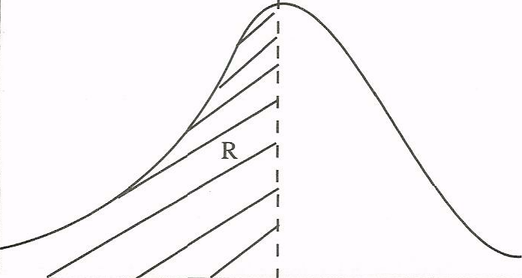
O
(axis)

S (axis)
(4 marks)
State what is represented by P and S axes, and letters R and Q.
20. The following information was extracted from the books of Helen Traders;
1/1/2008 31/12/2008
Shs Shs
(i) Salaries pre-paid 24,800 52,400
(ii) Salaries paid - 48,200
Prepare a salary expense account using the above information. (5 marks)
21 State four circumstances under which one may decide to start a personal business. (4 marks)
22 Highlight four ways in which a business idea can be implemented. (4 marks)
23 Outline five measures that a manager can take to improve the working environment in the office. (5 marks)
24. Highlight four challenges that a person may encounter when using a cellphone (mobile phone)
(4 marks)
25. The diagram below represents the long-run equilibrium of a firm under monopolistic competition.
Price

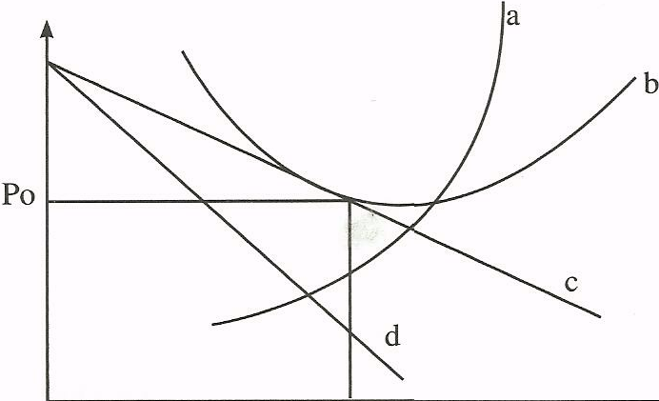
Quantity
O Qo
Name the curves represented by the letters a, b, c, and d (4 marks)

BUSINESS STUDIES 2010

PAPER 2

1. (a) Explain five features that differentiate a Public Limited Company from a partnership form of business. (10 marks)
(b) With the aid of a diagram, explain the behaviour of average cost curve in the short run for a firm with fixed production capacity. 10 marks)
2. (a) Explain five challenges that may be experienced by a country whose population is made up of a large proportion of young people. (10 marks)
(b) On 1 September 2006. Igonji had Sh55 000 in hand and Sh 250 000 at bank. During the month, the following transactions took place:
September 2 Cash sales banked Sh 35 260
3 Bought ribbons in cash Sh 4 500
8 Paid Wangila, a creditor Sh 94 000 by cheque in full settlement of his account after deducting 6% cash discount
12 Received a cheque for Sh 58 800 from Wetu after allowing her a cash discount of Sh 1200
15 Paid salaries Sh 34 000 in cash
25 Withdrew Sh 50 000 from bank for office use
28 Anyango, a debtor paid her account of Sh 75 000 by cheque less 10% cash discount.
30 Deposited all the cash into bank except Sh 13 700

Prepare a three column cash book and balance it off. (10 marks)
3. (a) Explain five ways in which effective management practices may contribute to the success of a business. (10 marks)
(b) Explain five reasons why an effective filing system is important in an office.
(10 marks)
4. (a) Explain five circumstances that would influence a producer to use wholesalers in distributing farm produce. (10 marks)
(b) Memon Traders does not keep a complete set of accounting records. The following information relates to the year ended 3 1 December 2006.
(i) Extract of cash summary- was:
Cash receipts
Cash sales 420,200
Commission received 36,400

Cash payments
Purchases 260,000
General expenses 50,000
Insurance 14,800

(ii) Extract of assets and liabilities:
1.1.06 31.12.06
Sh. Sh.
Stock 65,000 92,500
Insurance paid in advance 16,200 4,000
Commission receivable 8,400 10,200
Unpaid General expenses 48,000 70,000
Additional information
Included in credit sales are drawings of stock valued at Sh 25 000.
For the year ended 3 1 December 2006, determine the following:
(i) Total sales
(ii) Total purchases
(iii) Commission receivable
(iv) Insurance expense
(v) General expenses (10 marks)
5 (a) Describe four measures that the Government may put in place to reduce the amount of money in circulation. (8 marks)
(b) Explain six circumstances under which a country may restrict international trade.(\2 marks)
6 (a) Explain four circumstances in which a trader may offer after sales service to the buyer. (8 marks)
(b) The following balances were extracted from books of Simba Traders for the year ended 3 I December 2006.
Shs
Debtors 1 30,200
Motor vehicles 750,000
Creditors 260,000
Furniture 160,500
Drawings 60,800 '
Salaries 322,600
Rent 14,800
Bank loan 200,000
Discount received 14,500
Gross profit 210,000
Stock 45,600
Additional information
(i) Motor vehicle is depreciated by Shl87 500 while furniture is to be depreciated by Shl6 050 per year.
(ii) Interest on loan is charged at 18% per year. This interest was still owing on 31 December 2006.
(iii) Rent unpaid on 31 December 2006 was Sh 2400
Prepare
(a) Profit and loss account for the year ended 31 December 2006
(b) Balance sheet as at 31 December 2006. (12 marks)

BUSINESS PAPER 1
2011

1 Identify the types of wholesalers described in the statements given below: (4 marks)
(a) A wholesaler who trades in maize grain only.
(b) A wholesaler who supplies goods to most of the traders in Kitui, Mbooni and Machakos districts in the Eastern part of Kenya.

(c) A wholesaler who buys tomatoes from farmers in rural areas and sells the same to other wholesalers in urban areas.

(d) A wholesaler who trades in a wide variety of human medicine.
2 Outline four factors that should be considered before buying office equipment. (4 marks)
(a) ....................................................
(b) ...............................................
(c) ..............................
(d) .............................
3 Outline four malpractices by traders against which consumers may need protection by the
government. (4 marks)
(a) ........................
(b) ...............................
(c) ............................................
(d) ...........................
4 State three features of an insurable interest. (3 marks)
(a) ...................................................
(b) .........................................
(c) .........................................................
10.Indicate the reward associated with each of the factors of production in the table below.
(4 marks)
 | Factor of Production | Reward
a | Land
b | Labour
c | Capital
d | Entrepreneurship
11 . Outline four circumstances under which a co-operative society may be dissolved. (4 marks)
(a) .......................
(b) .........................................
(c) ..........................
(d) .................................,................
12 Highlight four features of a bonded warehouse. (4 marks)
(a) ..........................
(b) .....................
(c) ...............................
(d) ........................
13 Outline four factors that may be considered when measuring the size of a firm.
(4 marks)
(a) .....................
(b) ......................
(c) ..............................................................................
(d) .....................................
14. The following transactions were extracted from the books of Sarah Traders for the month of March 2006.
March 10: Purchased goods on credit worth Ksh 200,000 from Salim Traders
March 25: Sold goods on credit worth Ksh 420,000 to Shah Traders
Record the above transactions in the ledger accounts below: (4 marks)
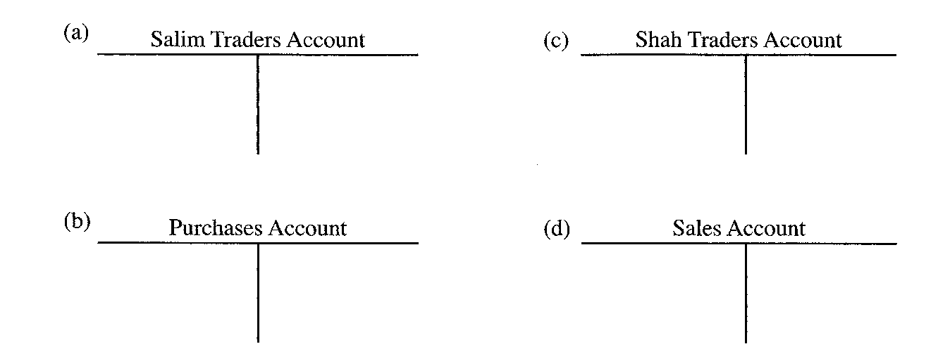
15. On 2nd November 2006, Oromo received an invoice for Ksh 12,000. Terms of payment were
trade discount 5% and cash discount 10%, if payment is made within 30 days.
Determine the amount paid if payment was made on 28th November 2006. (4 marks)

16 The following balances were extracted from the books of Nafula Traders as at 31st December 2005.
Ksh
Current Liabilities 150,000
Net profit 50,000
Total assets 500,000
2 years Bank loan 100,000
Calculate the rate of return on capital. (4 marks)

17 The information given below was extracted from the books of Amina Traders on 31st December 2006.
Ksh
Purchases 260,000
Opening stock 75,000
Carriage on purchases 12,500
Closing stock 27,500
Goods were sold at a mark-up of 25%.
Using the information given above, prepare Amina Traders' Trading Account. (4 marks)

18 State four benefits that a farmer may get by transporting produce to the market by road.
(4 marks)
(a) .................................................................................................
(b) .............................. .................................................................
(c) .............................. .................................................................
(d) .............................. ..................................................................

19 . The table given below represents the supply schedule of sukuma wiki (kales) for eight weeks in the months of January and February 2009.
WEEK | 1 | 2 | 3 | 4 | 5 | 6 | 7 | 8
QUANTITY (METRIC  TONNES) | 505 | 485 | 430 | 375 | 340 | 290 | 215 | 195

(4 marks)

Outline four causes of the trend in the table.

(a) .............................
(b) ............................
(c) .......................
(d) ...........................................
20 Outline four ways in which households contribute to national income of a country.
(4 marks)
(a) .............................................................................................
(b) .....................................
(c) .........................
(d) .......................
21 Outline four circumstances in which a trader may use oral communication. (4 marks)
(a) ..........................
(b) ..........................................
(c) ........................
(d) .......................................
22 Outline four reasons why a firm may remain small. (4 marks)
(a) ...........................
(b) ...........................
(c) ................................................................................................
(d) ..................................................,.....................................................

23 On 1st January 2007, Muthoni Traders Cash Book showed a credit balance of Ksh 150,000 at the bank and a debit balance of Ksh 25,250 in hand. During the month, the following transactions took place:
January 5: Made cash sales for Ksh 21,500
January 16: Received a cheque for Ksh 360,000 from a debtor.
January 28: Paid a creditor Ksh.100,000; partly by a cheque of Ksh 80,000 and the
balance in cash.
Prepare a Two-column Cash Book for the month. (5 marks)

MUTHONI TRADERS CASH BOOK

CR
DR
Date | Details | Cash  (Kshs) | Bank  (Kshs) | Date | Details | Cash  (Kshs) | Bank  (Kshs)

24 State four benefits that a trader may get by advertising products in a newspaper. (4 marks)
(a) ................................ ...........................................................................
(b) ....................... ....................................................................................
(c) .............................................................................................................
(d) ...............................................................................................................

25 The cost of consumer goods and services for a representative basket of an average family is given below.
Year 2006 2007
Prices Ksh 1200 Ksh 1600
Determine the increase in Consumer Price Index using 2006 as the base year. (4 marks)

BUSINESS PAPER 2
2011
1. (a) Explain the following types of inflation:
(i) demand-pull inflation
(ii) cost-push inflation
(iii) imported inflation
(iv) structural inflation. (8 marks)
(b) Explain six factors that may hinder the development of a country. (12 marks)
(a) Explain five circumstances under which containerization may be used to transport
goods. (10 marks)
(b) (i) Explain the procedure for making an insurance claim. (5 marks)
(ii) A farmer's house valued at Ksh. 1,200,000 was insured against fire for
Ksh. 900,000 under the "with average clause". Fire occurred and damaged the
house causing a loss of Ksh. 500,000. Determine the value of compensation due
to the farmer. (5 marks)
(a) Discuss five factors that may be considered when choosing a method for promoting a
product. (10 marks)
(b) Describe five features of economic resources. (10 marks)
(a) Explain five benefits that may accrue to an organization that adopts an open office plan.
(10 marks)
(b) Discuss five circumstances under which a partnership may be dissolved. (10 marks)
(a) Amboseli Roses is a horticultural company producing flowers. Explain six factors that
may influence the choice of a channel for distributing its products. (12 marks)
(a) Give four reasons for maintaining books of original entry. (8 marks)
(a) Discuss five causes of unfavourable balance of payment for most developing countries.
(10 marks)
(b) The following balances were extracted from the books of Rehema Traders on 1st January, 2007.
Kshs.
Capital 600,000
Creditors 180,000
Motor van 200,000
Furniture 200,000
Stock 60,000
Debtors 80,000
Cash 240,000
The following transactions took place during the year ended 31st December, 2007:
(i) Sold furniture worth Ksh. 60,000 for which Ksh. 40,000 cash was received and the balance was due at the end of the year.
(ii) Purchased goods worth Ksh. 100,000 for which cash of Ksh. 70,000 was paid and the balance was still outstanding at the end of the year.
(iii) Cash Ksh. 10,000 was taken from the business by the proprietor to settle the spouse's hospital bill.
Required:
Draw Rehema Trader's balance sheet as at 31st December, 2007 showing the items in
their relevant classes. (10 marks)

