K.C.S.E YEAR 2010
PAPER 1
- State the name give to the study of:
- The cell (1 mark)
- Micro--organism. (1 mark)
- The diagram below shows a transverse section of a plant organ.

- Name the plant organ from which the section was obtained. (1 mark)
- i) name the class to which the plant organ was obtained (1 mark)
ii) Give a reason for your answer in (b) (i) above (1 mark)
- Name the part labeled X. (1 mark)
- State the function of:
- Ribosomes (1 mark)
- Lysosomes (1 marks)
- The diagram below shows a specialized plant cell.

- i) Name the cell (1 mark)
ii) Name the parts labeled D and E. (2 marks)
- state the function of the part labeled C. (1 mark)
- state three ways in which a respiratory surface is adapted to its function. (3 marks)
- State one function for each of the following:
- Cerebellum (1 mark)
- Medulla oblongata (1 mark)
- Distinguish between haemolysis and plasmolysis. (2 marks)
- State three external differences between chilopoda and diplopoda. (3 marks)
- State two ways in which chiroplasts are adapted to their functuions. (2 marks)
- State two advantages of hybrid vigour. (2 marks)
- The diagram below shows a transverse section of leaf.

- Name the habitat of the plant from which the leaf was obtained. (1 mark)
- Give one reason for your answer in (a) above. (2 marks)
- The diagram below illustrates the structure of bread mould.

- Name the part labeled J (1 mark)
- State the function of the structure labeled K (2 marks)
- What is meant by the following term?
- Habitat; (1 mark)
- Ecosystem (1 mark)
- Explain why is not advisable to be in a poorly ventilated room with a burning charcoal. (3 marks)
- A potted plant was kept in the dark for 48 hours. Two leaves X and Y were treated as shown in the diagram below.

The experimental set-up was kept in sunlight for 6 hours after which a starch test was carried out on the two leaves.
- What were the results of the starch test on leaves X and Y? (2 marks)
- Give reasons for your answers in (a) above. (2 marks)
- What is the role of bile salts in humans? (2 marks)
- The following is the dental formula of a certain mammal:
i 0/3 c 0/1 pm 3/3 m3/3
- State the likely mode of feeding for the mammal. (1 mark)
- Give a reason for your answer in (a) above. (1 mark)
- Give two reasons why animals have specialized organ for excretion as compared to plants (2 marks)
- State the changes that occur in arterioles in the human skin during thermoregulation. (2 marks)
- State two advantages of internal fertilization in humans. (2 marks)
- The diagram below represents part of the human skeleton.

- Name the part labeled P (1 mark)
- i) Name the bone the articulates with the part labeled Q. (1 mark)
ii) What type of joint is formed between the part labeled Q and the bone named in (b) (i) above?(1mk)
- What is the function of the following structure in the human reproductive organ?
- Fallopian tubes. (1 mark)
- Epididymis. (1 mark)
- Scrotl sac (1 mark)
- Explain three ways in which red blood cells are adapted to their function. (3 marks)
- .
- State two ideas proposed by Lamark in his theory of evolution. (2 marks)
- Why is Larmark’s theory not acceptable? (1 mark)
- State three factors that contribute to the deceleration phase in the population curve of an organism (1 mark)
- State one survival value for each of the following in plants:
- Thigmotropism in stems; (1 mark)
- Geotropism in roots. (1 mark)
- .
- What is meant by the term non-disjunction? (1 mark)
- Give an example of a genetic disorder caused by:
- Non-disjuction; (1 mark)
- Gene mutation ( 1 mark)
- State three structural differences between arteries and veins. (3 marks)
- The diagram below represents a female cone.

- Name the subdivision of the plant from which the cone was obtained. (1 mark)
- Other than the presence of cone, name two other external features that identify plants in the subdivision named in (a) above. (2 marks)
- What is meant by the apical dominance? (3 marks)

K.C.S.E YEAR 2010
PAPER 2
SECTION A (40 MARKS)
Answer all the questions in this section in the spaces provided.

- In an experiment, disinfection soaked bean seeds were put in a vacuum flask which was then fitted with a thermometer as shown in the diagram below.
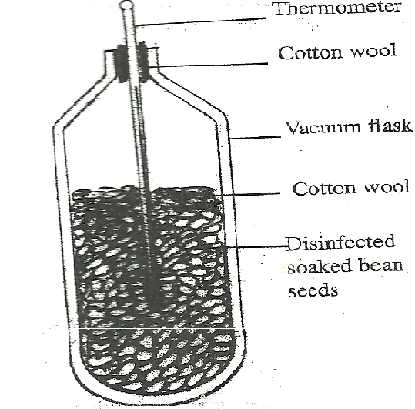
The temperature readings were taken every morning for three consecutive days.
- Which process was being investigated? (1 mark)
- i) what were the expected results? (1 mark)
ii) account for the answer in (b) (i) above? (2 marks)
- Why were the seeds disinfected? (2 marks)
- Why was a vacuum flask used in the set-up? (1 mark)
- How would a control for this experiment be set? ( 1mark)
- The diagram below shows blood circulation in a mammalian tissue.
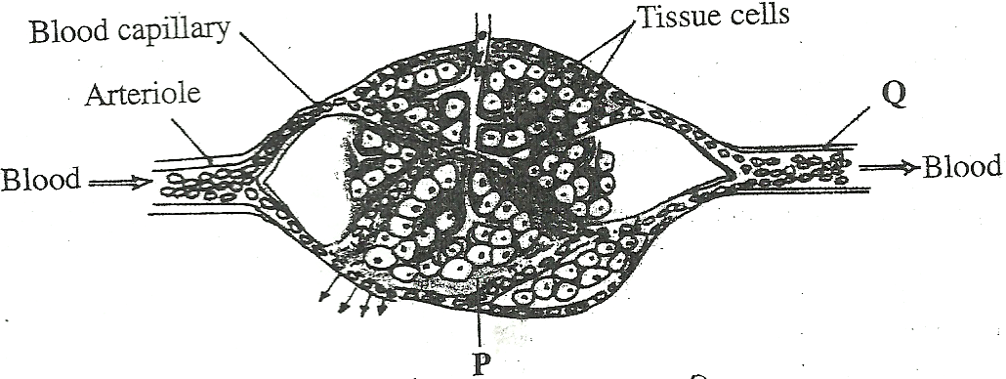

- Name the part labeled P and Q (2 marks)
- Name the substance that are:
- Required for respiration that move out of capillaries; (2 marks)
- Remove from tissue cells as a result of respiration (2 marks)
- Explain how substances move from blood capillaries into the tissue cells. (2 marks)
- Name one component of the blood that is not found in the part labeled P (1 mark)
- The diagram below represents a food web in certain ecosystem

Hawks

Lizard Small Birds

Small insects Large insect

Caterpillars

Earthworms Green plant

Decaying leaves

- Name the trophic level occupied by each of the following:
- Caterpillas (1 mark)
- Small insect. (1 mark)
- From the food web, construct two food chains which end with lizards as a tertiary consumer. (2 marks)
- i) Which organisms have the least biomass in this ecosystem? (1 mark)
ii) Explain the answer in (c)(i) above. (3 marks)
- The diagram below shows how the iris and pupil of a human eye appear under different conditions.
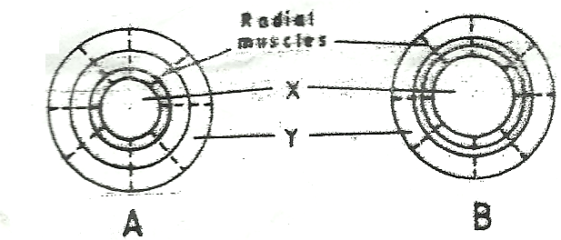

- Name the structures labeled X and Y (2 marks)
- i) State the condition that leads to the change in appearance shown in the diagram labeled B (2 marks)
ii) Describe the change that lead to the appearance of the iris and pupil as shown in the diagram labeled B. (4 marks)
iiii) What is the significance of the change described in (b) (ii) above? (1 mark)
- When pure breeding black guinea pigs were crossed with pure breeding white guinea pigs, the offsring had a coat with black and white patches.
- Using letter G to represent the gene for black coat colour and letter H for white coat colour, work out the genotypic ratio of F₂.
- State the phenotypic ratio of F₂. (1 mark)
- i) Name the term used when two alleles in heterozygous state are fully expressed phenotyically in an organism. (1 mark)
ii) Give an example of a trait in human beings where the condition whose term is named in (c) (i) above expresses itself. (1 mark)

Answer question 6 (compulsory) and either question 7 and 8 in the space provided after question 8

- In an experiment to investigate a certain physiological process, a boiling tube labeled A and a test tube labeled B were covered with cotton wool. The two tubes were simultaneously filled with hot water and fitted with thermometers. The experimental set-up was as in the diagrams below.
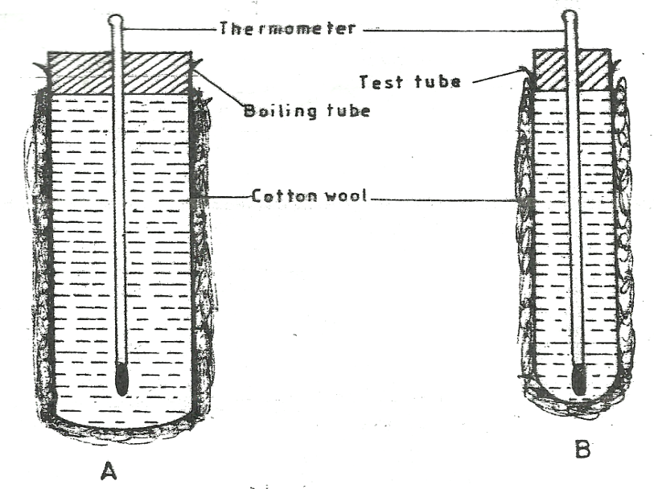
The temperatures reading were taken at the start and after every two minutes for twenty minutes. The results were as shown in the table below.

Time  (minutes) | Temperature (⁰C)
 | Boiling tube A | Test tube B
0 | 60 | 60
2 | 59 | 54
4 | 57 | 50
6 | 55 | 46
8 | 53 | 43
10 | 52 | 40
12 | 51 | 37
14 | 49 | 35
16 | 48 | 33
18 | 47 | 32
20 | 46 | 30

- Using the same axes, draw graphs of temperature against time. (6 marks)
- i) Work out the rate of heat in the boiling tube labeled A and test tube labeled B between the 5th and 15th minutes.
ii) Account for the answers in (b) (i) above. (2 marks)
iii) How does the explanation in (b) (ii) above apply to an elephant and a rat? (2 marks)
- i) State the role of the cotton wool in this experiment. (1 mark)
ii) Name two structures in mammals that play the role stated in (c) (i) above (2 marks)
- State three advantage of having constant body temperature in mammals. (3 marks)
- Describe the process of fertilization in flowering plants. (20 marks)
- Describe how a finned fish such as Tilapia moves in water. (20 marks)

BIOLOGY
PAPER 1
- Name two kidney diseases.
2. (a) Write the dental formula of an adult human.
3. Give three reasons for classifying organisms.
4. State one use for each of the following apparatus in the study of living organisms.
(a) Pooter
(b) Pitfall trap
5. The figure below illustrates a food web in a certain ecosystem.
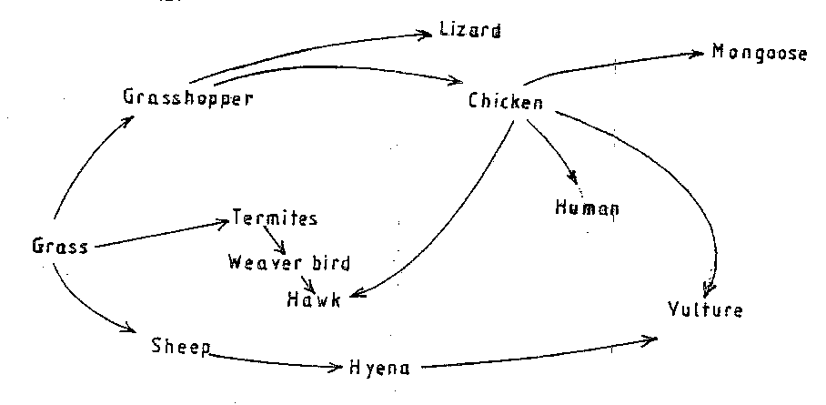
From the food web:
- Draw the shortest food chain;
- identify the organisms with the highest
(i) Number of predators
(ii) Biomass
6. What is meant by the following terms?
(a) Ecology
(b) Carrying capacity
7. The diagrams below show an experiment set up to investigate a certain process in a plant tissue.
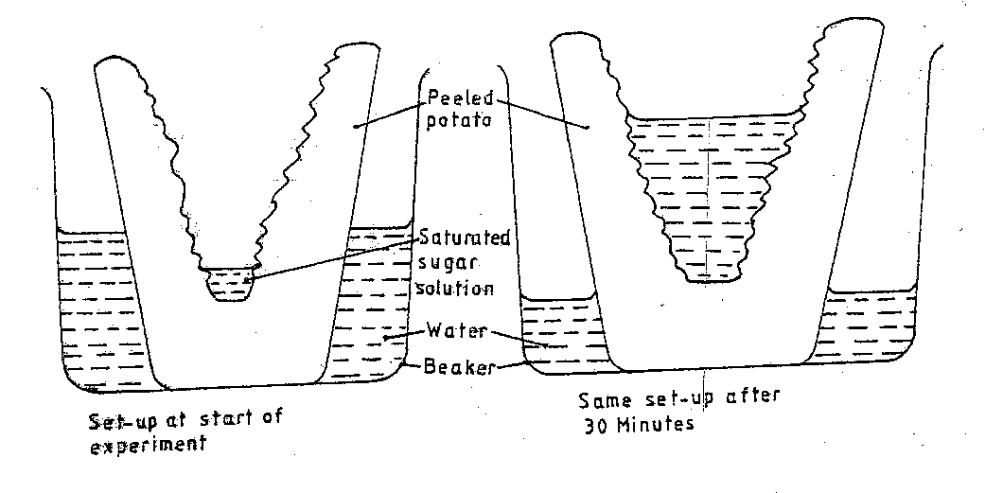
Explain the results obtained after 30 min.
8. State three characteristics of the class crustacean.

9. The diagrams below illustrate the organs of some flowering plants.
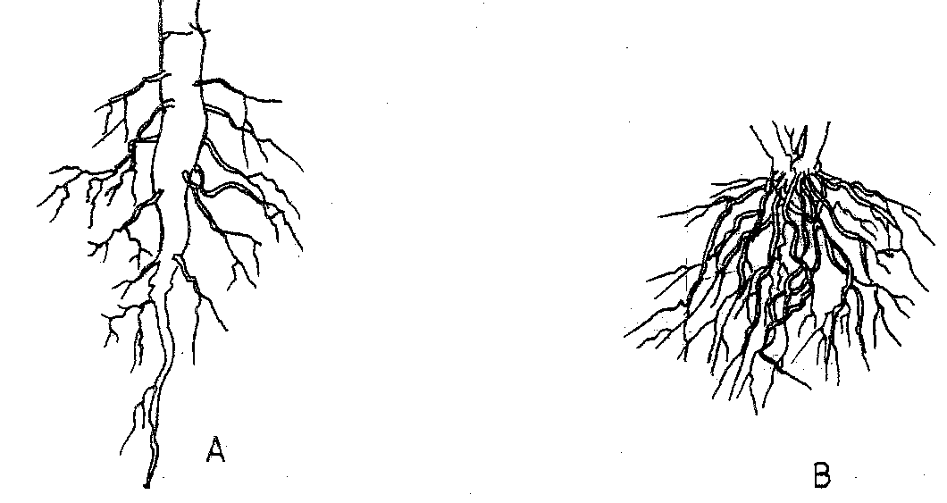
State the classes of plants to which each belong.
A
B
10. (a) give two differences in the products of anaerobic respiration between plants and animals.
(b) Name the site of anaerobic respiration in a cell.
11. State two functions of the following parts of a light microscope.
Fine adjustment knob
Stage
12. The diagram below represents a certain organism.
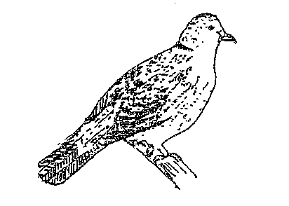
State the phylum and class of carbohydrates in the human body.
14. The diagram below represents a certain plan.
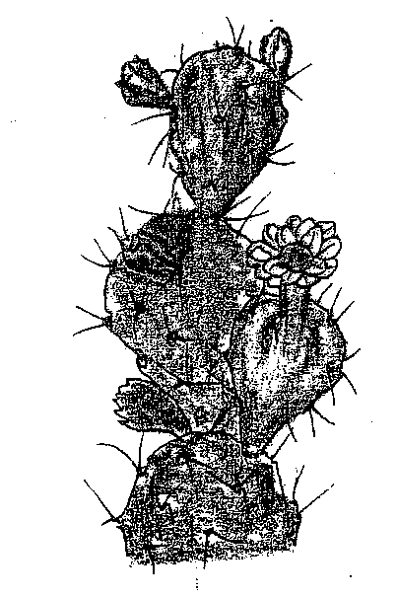
- What is the likely habitant of the plant?
- Give two reasons for your answer in (a) above.
15. Give reasons for carrying out the following procedures when preparing temporary wet mounts of plant tissues.
(a) Making thin plant sections
(b) Adding water on the plant section.

16. (a) describe the condition known as varicose veins.
(b) What is the role of blood platelets in the clotting process?
17. The diagram represents part of the human digestive system.
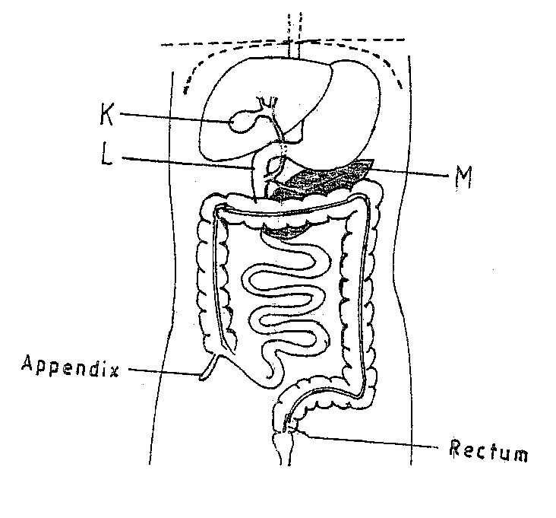
- Name the organs labeled L and M.
L

M
- (i) Name the substance named in b (i) above.
19. (a) Apart from the lungs, name two gaseous exchange surfaces in a frog.
(b) Write an equation that summarizes the process of aerobic respiration.
20. The number of stomata on the lower and upper surface of two leaves from plant X and Y were counted under the field of view of a light microscope. The results were as shown in the table below.

Leaf | Number of stomata
 | Upper surface | Lower surface
X | 4 | 12
Y | 20 | 23

- Which of the leaves would be expected to have a lower rate of transpiration?
- Given a reason for your answer in (a) above
21. (a) what is meant by convergent evolution?
(b) State two limitations of fossils as an evidence of evolution.
22. State the difference in content of oxygen and carbon (IV) oxide in the air that enters and leaves the human ling.
23. The diagram below represents a transverse section of an ovary from a certain flower.
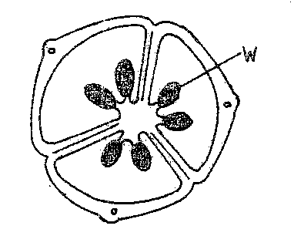
- (i) name the structure labeled W
(ii) name the type of plantation illustrated in this diagram.
24. (a) Difference between the following terms:
(i) dominant gene and recessive gene;
(ii) continuous variation and discontinuous variation
- What would be the expected results from a test cross?
25. State one economic importance of each of the following plant excretory products.
(a) Tannin
(b) Quinine
(c) Caffeine
26. Name the gamete cells that are produced by the ovaries.
27. The diagram below represents features of a joint mammal.
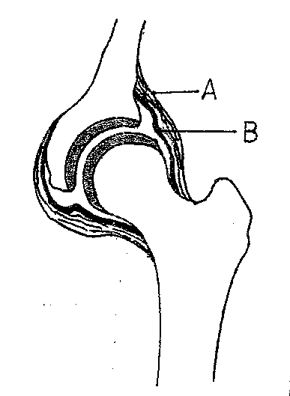
- Name the part labeled A
- State the function of the part labeled B
28. (a) What is a tropic response?
(b) State two ways by which auxins regulate growth in seedlings
29. State four reasons why water is significant in seed germination

BIOLOGY PAPER 2
QUESTIONS
- The set-up below illustrates a procedure that was carried out in the laboratory with a leaf plucked from a green plant that had been growing in sunlight. 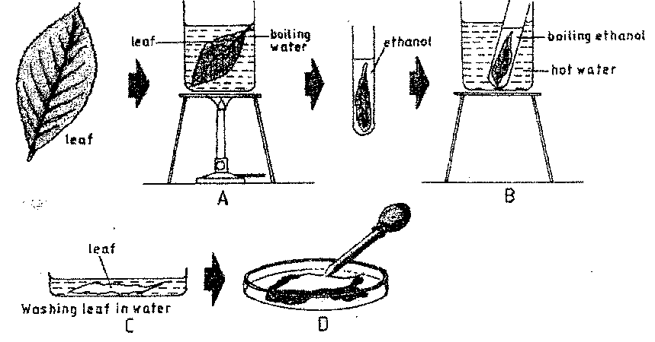
- What was the purpose of the above procedure ?

1 (mark)
- Give reasons for carrying out step A,B and C in this procedure. (3marks)

(iii) Name the reagent that was used at the step labeled D . (1mark)

(iv) State the expected result on the leaf after adding the reagent named in (iii) above.
Stain dark blue/ Blue dark

In humans,hairly ears is controlled by agene on the Y Chromosomes .
- Using letter Y^{H} to represents the chromosome carrying the gene for hairly ears, work out a cross between a hairy eared man and his wife.
(4 marks)

(b) (i) What is the probability of the girls having hairly ears? (1 mark)

(ii)Give reason for your answer in (b (i) above. (1mark)

(c) Name two disorders in humans that are determined by sex linked genes (2marks)

(d) Explain how comparative embryology is an evidence for organic evolution . (2marks)

3. (a) Name the causative agent for the following respiratory diseases. (2marks)
(i) whooping cough.

(ii) Pneumonia

(b) Describe how oxygen in the alveolus reaches the red blood cells . (4marks)

(c) How are the pnematophores adapted to their function ? (2marks)

4. (a) the diagram below represents a section of the human brain.
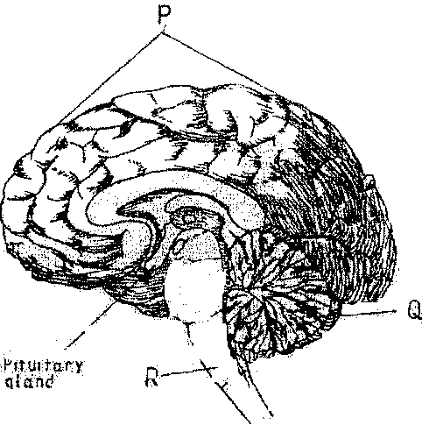
- Name the structure labeled Pand R.

- State two functions of the part labeled Q

(b) (i) Name two reproductive hormones secreted by the pituitary gland in women. (2marks)

(ii) State one function of each of the hormones named in (b)(i) above (2marks)

5.(a) The diagram below represents a flower.
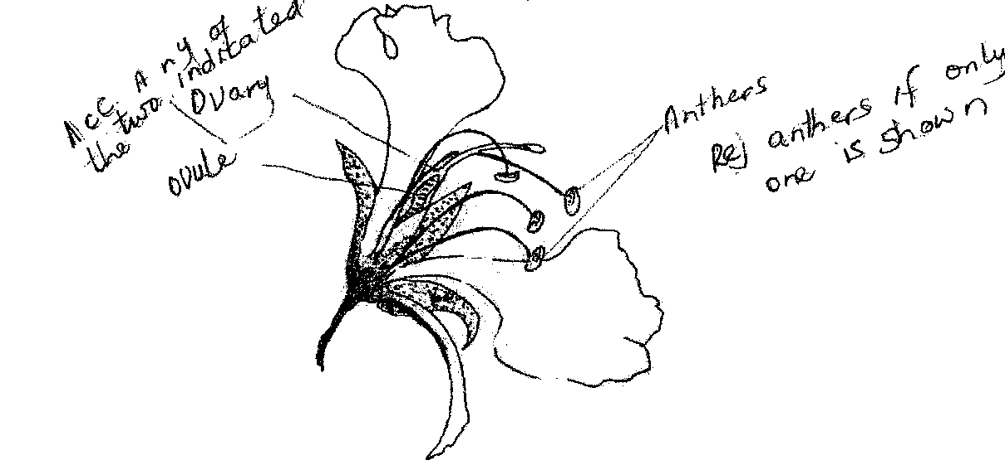
(i)On the diagram , name two structures where meosis occurs. (2 marks)
………………………………………………………………………………………………………..
…………………………………………………………………………………………………………
(ii) How is the flower adapted to prevent self-pollination?

(b)The diagram below represents a human reproductive organ.

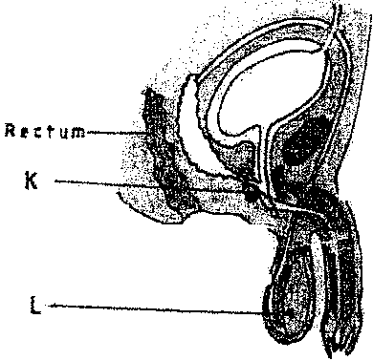

(i)Explain two adaptations of the structure labeled L to its functions (2 marks)

Explain the role of gland labeled K

SECTION B (40 MARKS)
Answer 6( compulsory) and either question 7 or 8 in the spaces provided after question 8.
6. (a)An experiment was carried out to investigate the population of a certain micro-organism. Two
petri-dishes were used . into the petri-dish labeled m ,60cm³of a culture medium was placed while 30cm³ of the same culture medium was placed in petri-dish labeled N.Equal numbers of the micro- organisms were introduced in both petri-dishes . The set-ups were then incubated at 35⁰c. The number of micro-organisms in each petri-dish was determined at irregular intervals for a period of 60 hours . The results were as shown in the table below
Relative number of micri-organisms | M | 40 | 40 | 180 | 280 | 1200 | 1720 | 1600 | 1840 | 1560 | 600
 | N | 40 | 40 | 120 | 200 | 680 | 560 | 560 | 600 | 600 | 400
Time in hours |  | 0 | 5 | 10 | 15 | 23 | 30 | 35 | 42 | 45 | 60

- On the same axes , draw the graphs of relative number of micro-organisms against time on the grid provided.
( 7 marks)

(ii)After how many hours was the difference between the two populations greatest ? (1 mark )

(iii)Work out the difference the two populations at 50 hours (2 marks)

- With a reason state the effect on the population of micro-organisms in petri-dish M if the temperature Was raised to 60⁰c after 20 hours . (2marks)

(v)Account for the shape of the curve for population in petri-dish N between 46hours and 59 hours. (3marks)

(b) Explain how osmotic pressure in the human blood is maintained at normal level. (5marks)
When the osmotic pressure of the blood increases beyond the normal level ( osmoreceptors)hypothalamus detects this and stimulates the pituitary gland to /secrets / release more ADH vasopressins which make kidney tubules more permeable to water ; and more water is reabsorbed into the blood ; reducing the osmotic pressure to the normal level ; Acc reverse
When osmotic presser falls below the nomal level the (osmoreptors) in the hypothalamus detect this the pitituary gland is less stimulated Non /little /less permeable to water hence less water is absorbed into the blood ; increasing the osmotic level
when op is high
when there is too much Na⁺_{(aq)} – the blood adrenal cortex responds by secreting less aldosterone; which causes less Na⁺_{(aq)} to be absorbed from the kidney tubules into the blood; lowering the sodium ions level
when op is low
when there is too low Na⁺ ions /or Na⁺_{(aq)} in the blood adrenal cortex responds by secreting more adolsterone which causes more Na⁺ to be reabsorbed from the kidney tubules into the blood ; raising the Na⁺ level

7.(a) Explain how structural features in terrestrial plants affect their rate of transpiration . (13 marks)

(b)Explain how the human skin brings about cooling of the body on a hot day . (7marks)

8.(a)Describe the exoskeleton and its functions in insects . (13marks )

(b) Describe how accommodation in the human eye is brought about when focusing on a near object . (7marks)

