  - WOODWORK (444)

30.15.1 Woodwork Paper 1 (444/1)

1.
- Wash the cut very well with anticeptic soap and water to remove all dust.
- Cover the wound with the cleanest material available.
- Raise the injured part of the body to lessen pain.
- Change the dressing often. (4 x ½ = 2 marks)

2. (a)
- Destruction by animals.
    - Fire.
    - Harsh weather conditions.
    - Creeping plants.
    - Plant diseases.
    - Human destruction.
    - Parasitic plants.
    - Insect attack. (6 x ½ = 3 marks)

(b) Moisture content = (wet weight – dry weight) x 100%
dry weight
= × 100% = 32
= (x – 40) 2.5 = 32
=2.5x – 100 = 32
2.5x =132
=52.8g (2 marks)
3. (a)
    - Tape measure/steel rule.
    - Try square.
    - Bevel square.
    - Marking gauge.
    - Tenon saw/cross-cut.
    - Pencil. (4 × ½ =2 marks)

- Marking:-
    - Mark the given dimensions 60 mm and 20 mm.
    - Gauge 25 mm round the piece.
    - Adjust the bevel from 60 mm to 20 mm.
    - Mark the bevel line.

Cutting:-
    - Cut along the grain but in the waste piece
    - Cut across the grain along the bevel line (6 x½ = 3mark)

4.
Classification | Example
Bench planes | Smoothing plane  Jack plane  Try plane  Fore jointer  Bench rebate
Special purpose  Planes | Block plane/Router plane  Circular plane  Shoulder/bullnose plane/plough plane
(3 marks)

5. (a) Countersinking is the preparation of the top of a pilot hole to facilitate the driving of a countersunk screw flush or slightly below the wood surface . (2 marks)

(b)
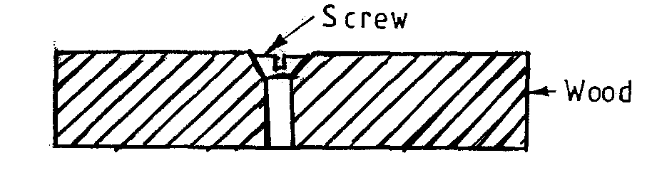 (2 marks)

- The tool is dragged towards the body in the direction of the grain while inclined at an angle. This produces thin shavings which result in an even surface.

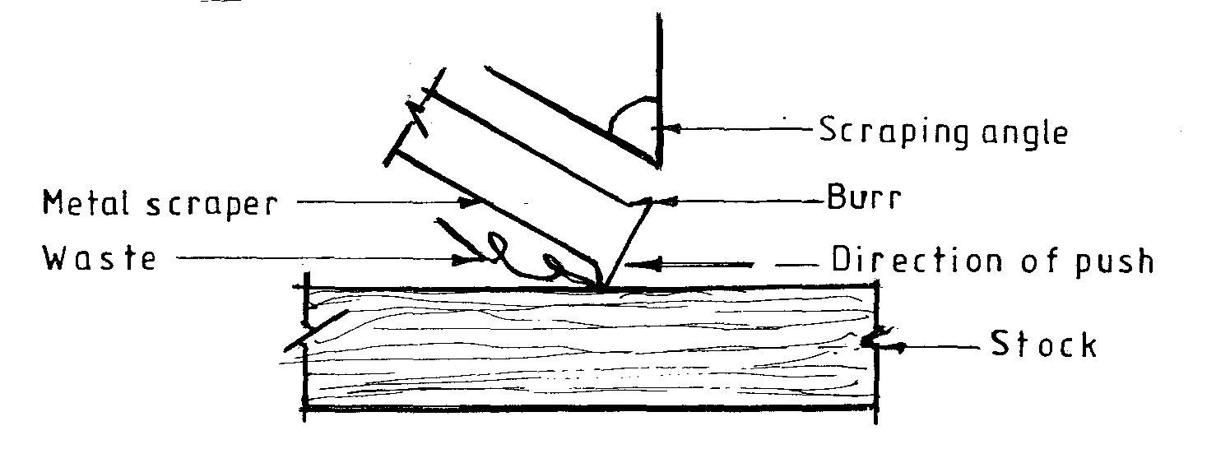 (4 marks)

7.
- Using Nails: Use panel pins or fine nails depending on the size of the joint. Glue the pieces first and when set, sink the nail head and disguise the holes using matching coloured filler.

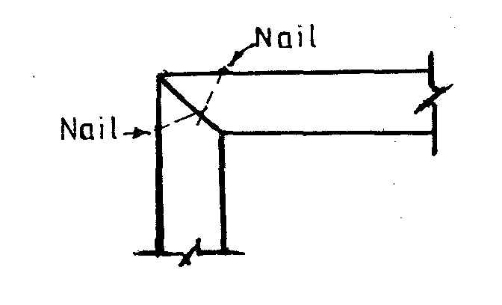

- Using splines: For small joints veener or plywood splines are set in sawcuts made across the corner. The cuts may be perpendicular or angled for additional strength. Glue the splines into the sawcuts and trim them flash when set.

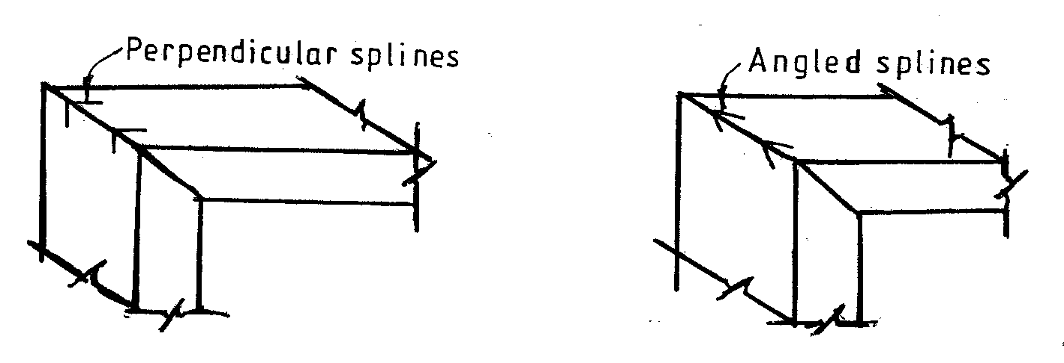

- Using a loose tongue: For larger mitres a loose tongue or key can be fitted. Glue a loose tongue and plane it flush when set.

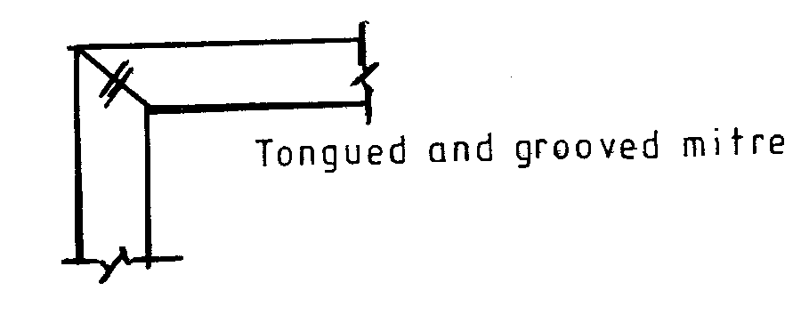

- Using Dowels: Drill the dowel holes to the required depth. Apply glue to the jointing faces and into each hole. Dip the ends of the dowels in glue as they are inserted into the holes. Tap them home with a mallet and assemble on cramps.

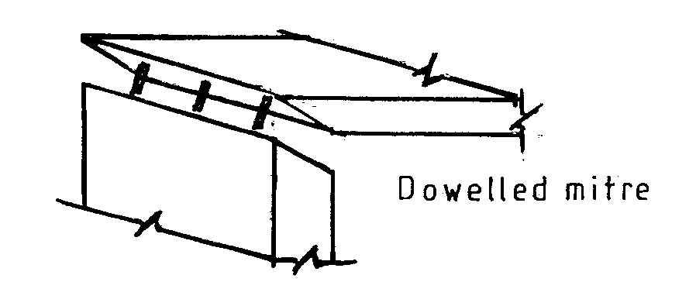 (6 marks)

8. (a)
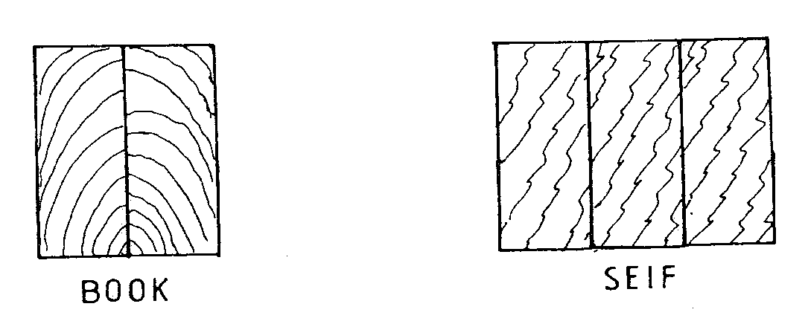
(b)
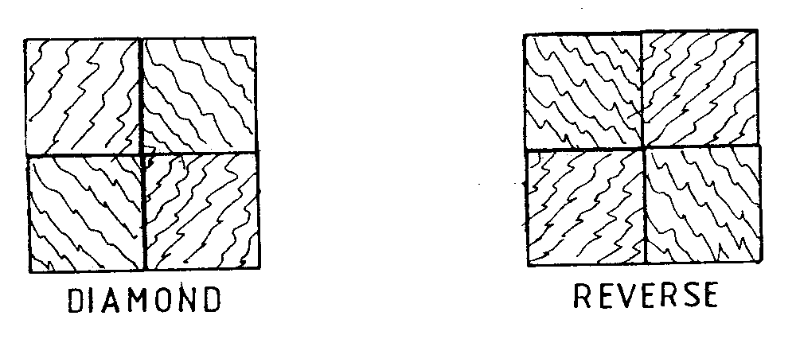 (2 marks)

9. (a)
- Competition from established industries.
- Competition amongst the artisans themselves.
- Lack of marketing skills.
- Insecure working environments.
- Lack of standardization.
- Lack of effective organizations to lobby for sale of products and procurement of imports.
- Bias of customers.
- Variation in quality of products. (6 x ½ = 3 marks)

(b)
- Teeth tips shinning.
- More pressure/strength used for cutting.
- Failure to achieve a clean cut.
- More time required to complete a task. (2 x ½ = 1 mark)

10.
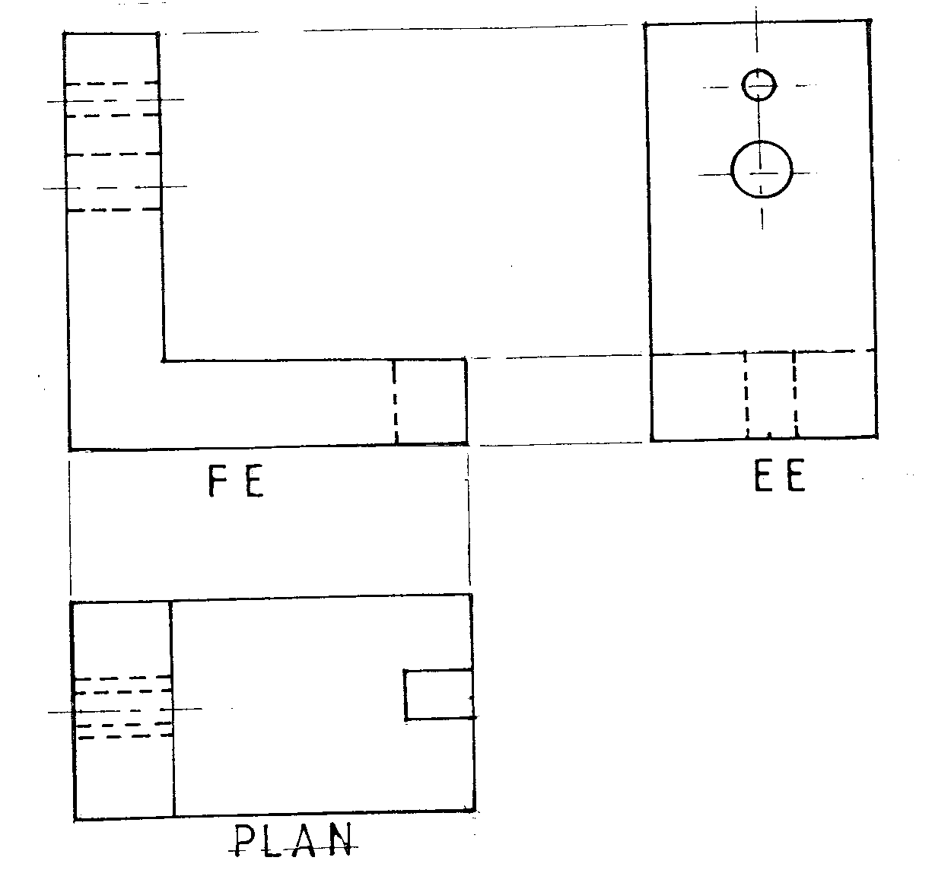

 | P.E | F.E | Plans
Faces | 1 | 1 | 2
Hidden details | 3 | 2 | 2
(5 marks)

11.
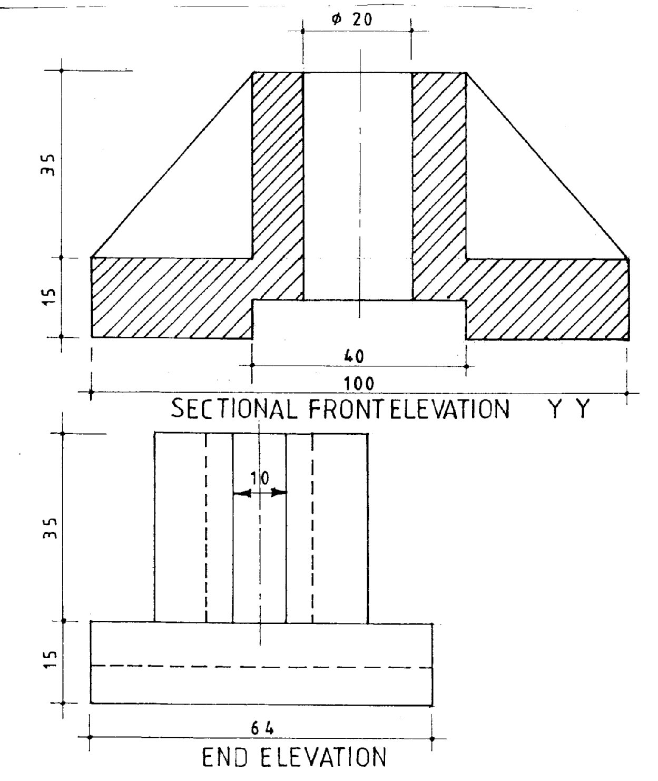
(15 marks)
12. (a)
- Select the best face side and using a jack plane, plane a face side straight and out
    - of twist.
    - Label the side with a face mark.
- Plane a face edge straight and square to the face side.
- Gauge to width ensuring that the stock of the gauge is held firmly against the face edge at all times then plane down to the gauge line.
- Gauge and plane to thickness. (4 x 1 = 4 marks)

(b)
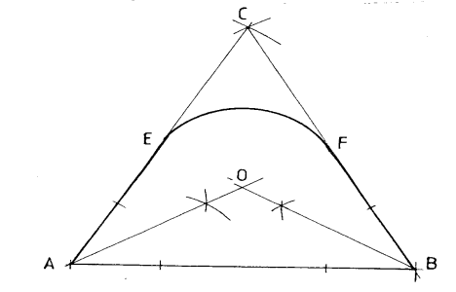

- Draw line AB = 60 mm – with points A and B as centres and a radius R equal to the length of line AB.
- Draw intersecting arcs to locate point C or construct 60◦ angles at A and B.
- Join A to C and B to C.
- Bisect angles A and B to meet at O or draw a perpendicular bisector of AC and BC to meet at O.
- With centre O and radius EO or FO, draw EF.
- Join AE, EF, FB and BA to obtain the required outline. (11 marks)

13. (a)
- Apply liberal quantity.
- Allow to dry for 10 – 30 minutes.
- Rub in with a fine water proof paper along the grain.
- Wipe off across the grain with clean cloth then along grain to remove excess oil.
- Leave to dry for 24 hours.
- Repeat all the above procedures till desired gloss is attained. (5 marks)

(b) (i)
1:- Bark.
2:- Phloem (inner bark or bast).
3:- Cambium layer.
4:- Sapwood.
5:- Heartwood.
6:- Medullary rays.
7:- Pith.
8:- Annual rings. (8 x ½ = 4 marks)

(ii)
1 - Bark:- Forms the outer skin that protects the tree.
2 - Phloem:- Thin moist layer under the bark along which the plant food travels
3 - Cambium layer:- A thin layer steaves located between sapwood and bast. These cells are responsible for the tree growth. Cells are subdivided and new cells are added to the sapwood and bast.
4 - Sapwood:-Thick layer which consists of live wood the sap rises along this layer from the root to the leaves.
5 - Heartwood:- Dead part of the tree. It is the area which provides stability to the tree.
6 - Medullary ray:-Transfers toxic substances from the tree and deposits them outside the trunk. (6x1=6 marks)

14 (a)
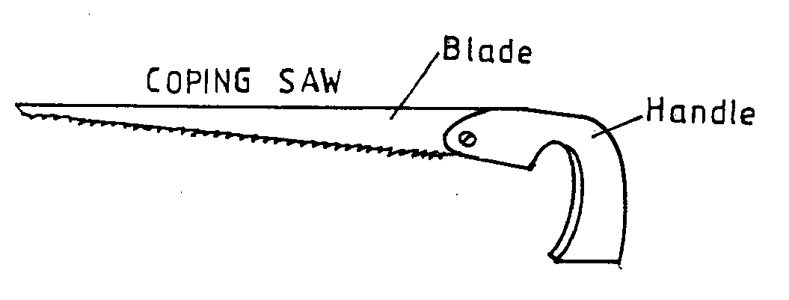 (2 ½ marks)

(b)

Classification | Examples (Saws) | Function
Hand saws | - Rip saw.  - Cross-cut saw. | - Cutting with grain.  - Cutting, across grain.
Backed Saws | - Tennon saw.  - Doetail saw. | - Cutting tennons and general bench work.  - Cutting dovetails and fine work.
Framed Saws | - Bow saw.  - Copping saw. | - Cutting curves in heavy sections.  - Cutting curves.
Narrow Balde Saws | - Compass.  - Pad saw. | - Cutting curves in heavy and large work.  - Enclosed cuts piercing, piercing panels.
(8 marks)

(c)
- In laying: Decorating furniture by embedding wood or other materials on wood surfaces.
    - Rounding: Process of shaping an axis, or an end of a piece of work ‘round and smooth’.
    - Curving: Process of shaping by cutting and removing materials on wood along a line that is not straight.
    - Edge moulding: Cutting patterns at the edges of beads, v shapes. (4½ marks)

15. (a)
Item | Description | Size | Quantity
1 | Backboard (Top) | 1000 x 600 x 20 | 1 pc
2 | Formica | 1000 x 600 | 1
3 | Legs | 50 x 40 x 450 | 4
4 | Rails | 60 x 20 x 1000 | 2
5 | Rails | 60 x 20 x 600 | 2
6 | Lipping | 5 x 20 x 3200 | 1
(11 marks)

(a) Project details: The details here include the project name, grade/class, date started and date completed.
- Materials list: Prepare a detailed list of materials to include size, description of material(s), unit cost and the total cost.
- Tools and machines: Gives a comprehensive list of tools and machines that are required for the project.
- Procedure/steps: List down a detailed information on how to carry out the project. The list should be sequential. (4 marks)

