30.18.2 Power Mechanics Paper 2 (447/2)

Station 1
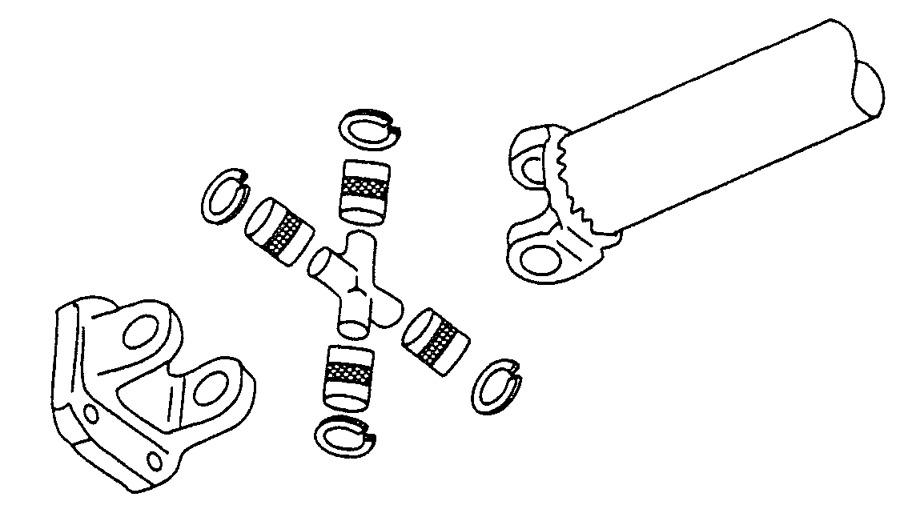

(10 marks)
Station 3

 | Item | Material | Use
A | Exhaust Gasket. | Asbestos with copper or aluminium. | Seals between block and exhaust maniforld.
B | O ring. | Neopene rubber. | Prevents leakage between shafts and housing.
C | Brake fluid. | Vegetable oil. | Transmission of force in braking system.
D | Grease. | Mineral oil. | Lubrication of gears.
E | Oil strainer. | Steel. | Filter oil.

(10 marks)

Station 6

Part | Name | Engine System | Identified Fault | Possible Cause
J | Commutator end. | Charging. | Worn carbon. | Normal wear and tear.
K | Mechanical fuel pump. | Fuel. | Inlett value wrongly installed. | Wrong assembly.
L | Shock absorber. | Suspension. | Worn out. | Excessive use.
M | Engine mounting. | Chasis. | Worn out or broken. | Excessive vibrations.
N | Tie rod end. | Steering. | Worn out. | Rough ride.
(10 marks)
Station 8

- Material A: Filler rod used to fill joint when brazing or welding.
B: Flux used to clean metals and prevents oxidation or corrosion.
(2 marks)

Station 9

(a) (i) Depth of keyway.
(ii) Length of keyway. (2 marks)

- (i) Diameter of crankpin.
(ii) Diameter of camshaft. (2 marks)

- Crankshaft teeth.
Camshaft teeth. (4 marks)

Ratio :

