**30.5.2 Physics Paper 2 (232/2)**

1. BC is total absence of light; or umbra.

Rays of light are completely blocked from this region by the object. **(2 marks)**

1. The leaf in A falls some distance while the lead in B rises some distance; the two leaf electroscopes share the charge. **(2 marks)**

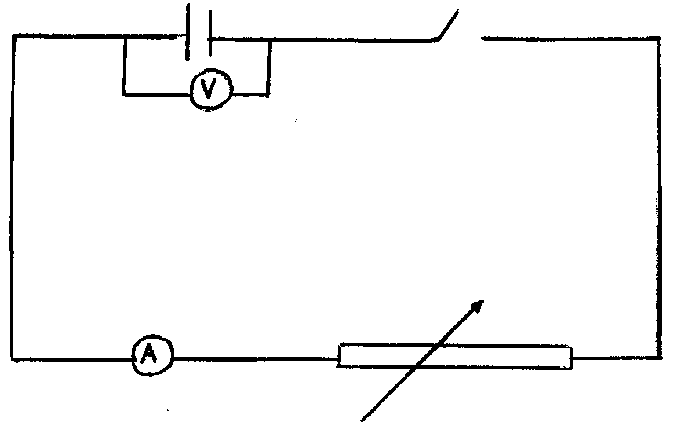 **(1 mark)**

1. Hammering causes the domains in the rod to vibrate; when settling, some of the domains align themselves in the North-south direction due to the earths field; causing magnetization. **(2 marks)**

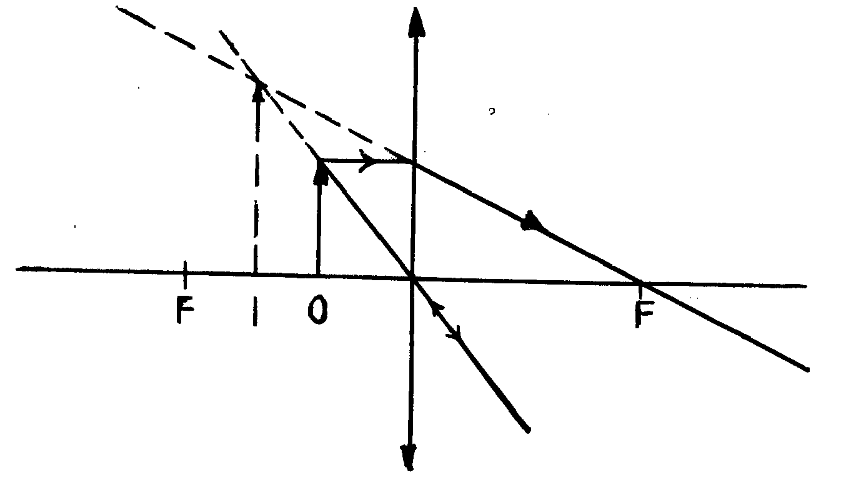 **(1 mark)**

1. When the switch is closed so that current flows, the iron core in the solenoid is magnetized attracting the flat spring; this causes a break in contact at the contact point disconnecting the current; so the magnetism is lost releasing the spring and repeating the process. **(3 marks)**
2. Movement equals 1.75 D

So period T =  S = 045S

f = . **(2 marks)**

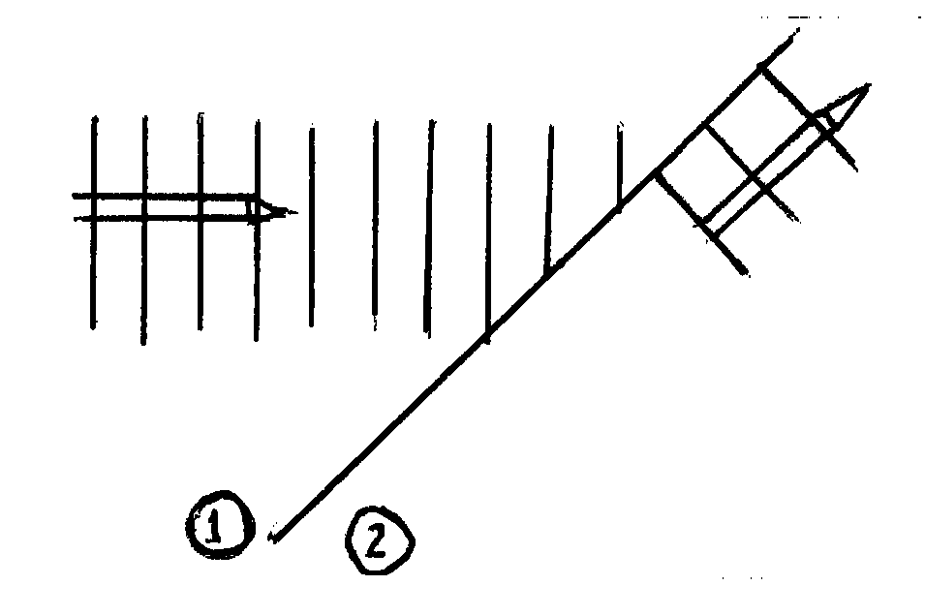 **(2 marks)**

1. (i) V = 0v (since no current).

Reason: no current.

(ii) Reason: Current flows in the resistor V = 3V. **(2 marks)**

1. P = ; R =  P =  = 84 JS-2 **(3 marks)**
2. Defect: Short sightness.

Cause: Extended eyeball. **(1 mark)**

1. The spot moves up and down. **(1 mark)**
2. The frequency of the X-rays increases;

(accept become hard, wavelength decreases). **(1 mark)**

1. Radiation: Beta particle;

Gain of an electron. **(2 marks)**

1. (a) Temperature, density (any one). **(1 mark)**

(b) i) 46.5m; (accept 46m to 47m) **(1 mark)**

ii) 



 **(3 marks)**

iii) For maximum internal, observer is at one end and so distance = 2L

337 × 4.7 = 2L

L = 792 m. **(3 marks)**

(c) i) Distance moved by echo from sea bed = 98 × 2m.

 **(3 marks)**

ii) Distance = v × t

=  **(2 marks)**

1. (a) Light must travel from denser to less dense medium. Angle of incidence in the

denser medium must exceed the critical. Angle of incidence in the denser medium must exceed the critical angle. (mark the two independently). **(2 marks)**

(b)

|  |  |
| --- | --- |
| Since I = 90˚, r = θ | Alternative method      **(2 marks)** |

(c)

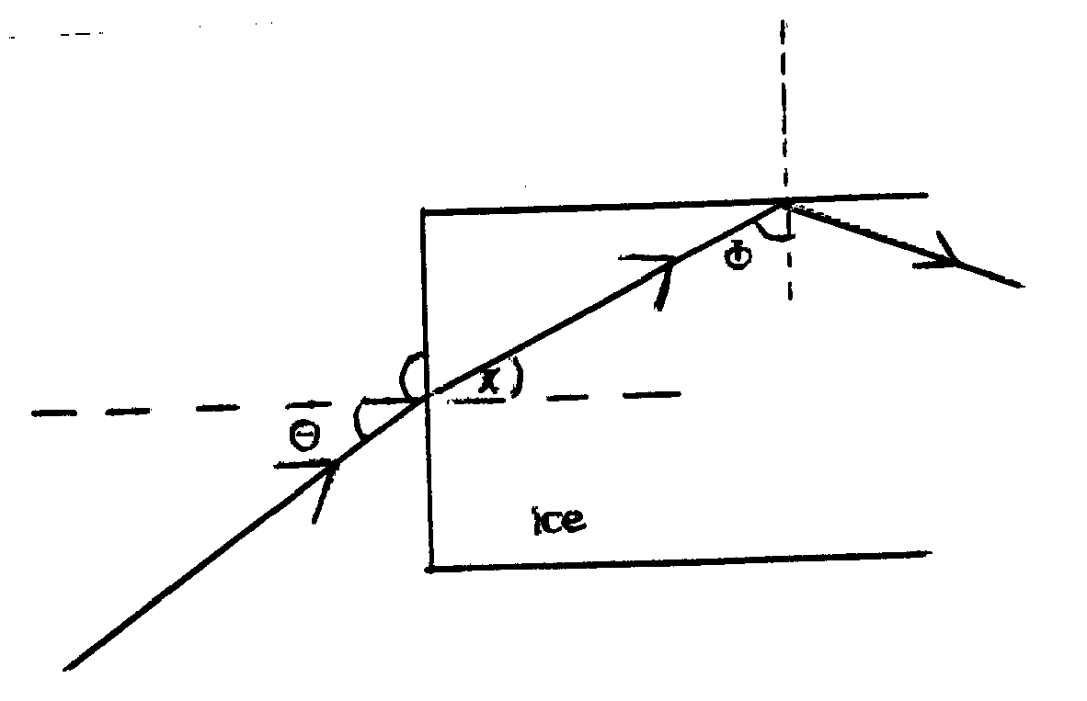

At the greatest angle θ, the angle must equal the critical angle of the medium.

1. Sin θ = sinc =

 = 49.8˚. **(2 marks)**

1. X = 90 -  = 40.2˚. **(1 mark)**
2. 

Sin θ = 1.31 sin 40.2 = 0.846˚

θ = 57.8˚ **(2 marks)**

17. (a) i)

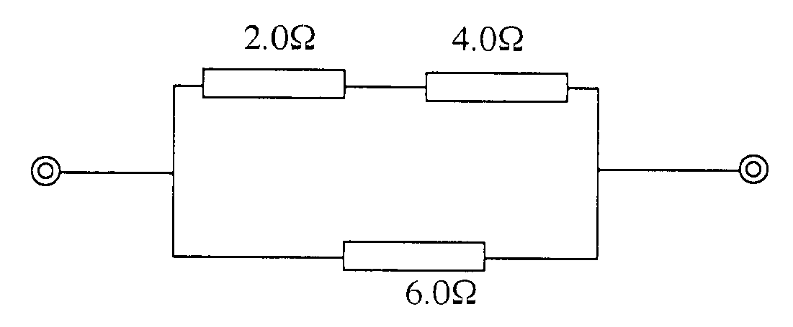

ii)

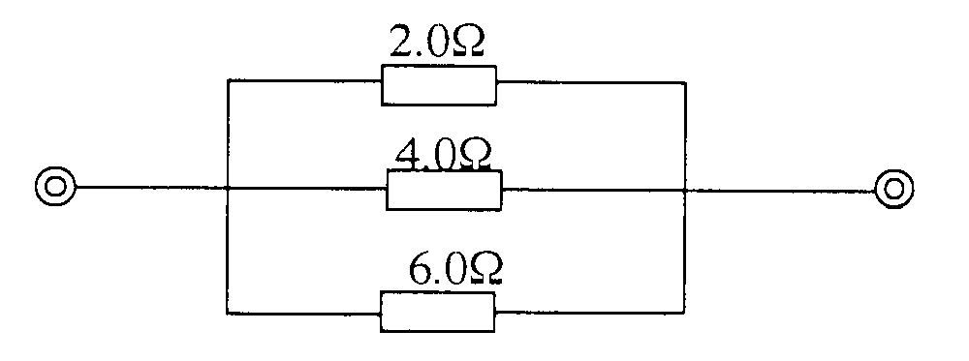

(b) i) emf = open circuit pd = 2.1V. **(1 mark)**

ii) The difference in pd is the pd across the internal resistance r.

2.1v – 1.8v = 1r = 0.1r

0.1r = 0.3v

 **(3 marks)**

ii) When current is being drawn from the cell, the pd across the external

circuit is the one measured.

* 1. × R = 1.8v

R **(2 marks)**

18. (a) When the switch is closed, flux in the coil on L.H.S. grows and links the other

coil inducing an emf; when the current is steady no flux change and hence no induced emf; when the switch is opened, the flux collapses even in the coil on R.H.S. inducing current in opposite direction.

(b) (i) Soft-iron reduces losses due to hysteresis (or magnetic losses); this is

because the domains in soft iron respond quickly to changes in magnetic field (or have low reluctance). **(2 marks)**

(ii) Laminated core reduces losses due to eddy currents; this is because

laminating cuts off the loops of the eddy currents reducing them considerably. **(2 marks)**

(c) (i) 



Np = 2000 Ns = 200

Vs = 40v

Power = VsIs = 800 w.

 **(4 marks)**

(ii) Pp = Ps = 800w = 400 × 1p

1p = 2A **(2 marks)**

19. (a) (i) Hard – X-rays.

(ii) They are more penetrating (or energetic).

(b) (i) A – Electronic beam/cathode rays/electrons.

B – anode (copper anode).

(ii) Change in Pd across PQ changes filament current. This changes the

number of electrons released by the Cathode hence intensity of X-rays.

(iii) Most of the kinetic energy of the electrons hitting target is converted to heat.

(iv) High density.

(c) Energy of electrons E = QV

= 1.6 × 10-19C × 12000v

Energy of X-rays = hf

Equating 6.62 × 10-34JS × f = 1.6 × 10-19C × 12000v

f = 2.9 × 1018 Hz **(4 marks)**