* 1. **PHYSICS (232)**

**30.5.1 Physics Paper 1 (232/1)**

1. 5.0 x 10-6 kg. ***(1 mark)***

2. Since  

For water 

For liquid 

 ***(2 marks)***

3. (a) R = Reaction force Iar to surface

F = Friction parallel to surface

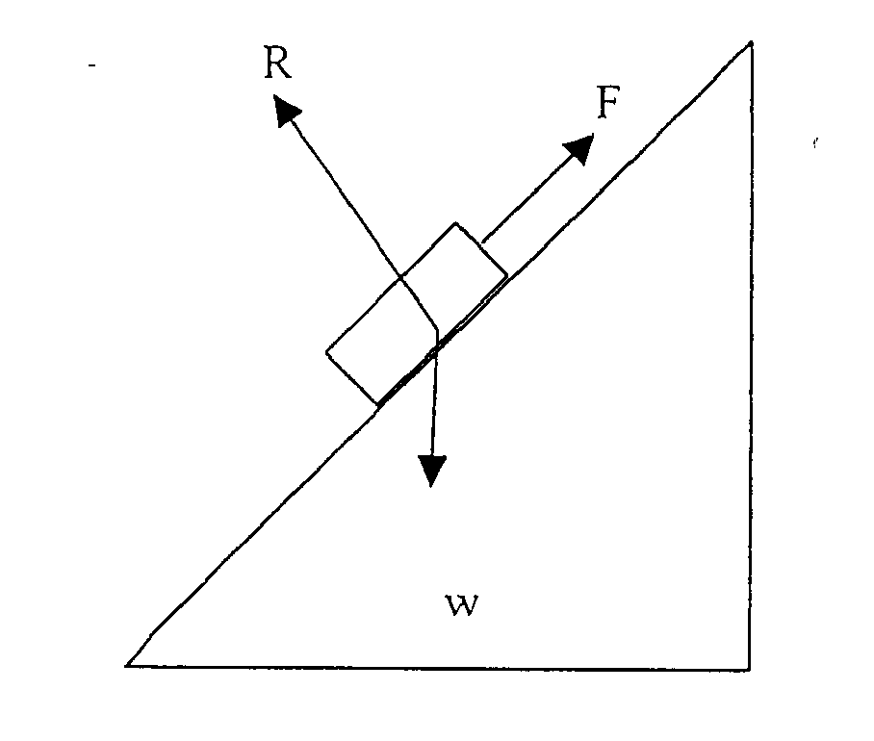

(b) When θ reduces, R increases (approaches w) while F reduces. ***(2 marks)***

4.

* Atmospheric pressure is higher than normal.
* Presence of impurities in water/Addition of impurities. ***(2 marks)***

5. When flask is cooled it contracts / (volume reduces), but due to poor conductivity the material of glass; subsequently as both cool the contraction of water is greater than that of glass. ***(3 marks)***

6.

* Heat conductivity/rates of conduction. ***(1 mark)***
* Thermal conductivity.

7. Cross-sectional area of the metal rods. ***(1 mark)***

8. Pressure in liquids = ρgh

= 1200 × 10 × 15 × 10-2

= 1800 Pa

Total pressure = (8.4 + 0.18) × 104 Pa = 8.58 × 104 Pa ***(3 marks)***

9. Intermolecular distances are greater/ larger in gas than in liquids. Forces of attraction in liquids are higher/stronger/larger/greater than in gases. ***(2 marks)***

10.

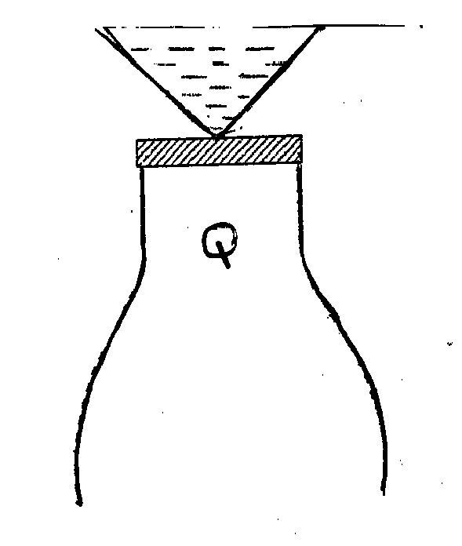 ***(1 mark)***

11. ***Stable equilibrium***: When it is slightly tilted. C.O.G rises/is raised. When released it recovers.

/comes to its original position ***(2 marks)***

12. Fast stream of air reduces pressure inside the tube. Pressure from outside is greater than inside, hence collapse. ***(2 marks)***

13.

* Diameter of the coils different.
* Wires have different thicknesses. no. of turns per unit length.
* Length of spring differs. ***(1 mark)***

14. Heated water has lower density, hence lower upthrust. ***(2 marks)***

15. (a) The rate of change of momentum of a body is (directly) proportional

to the( resultant external )force producing the change, and takes place in

the direction of the force. ***(1 mark)***

or F ∝ 

 ***(3 marks)***

(ii) V = u + at

= 0 + 2 x 7 = 14 ms-1. ***(2 marks)***

(c) (i) Vertical motion



***(2 marks)***

(ii) Horizontal velocity

 ***(2 marks)***

= 5.1ms-1

16. (a) Heat capacity of a body is the energy required to raise the temperature of the body by 1 degree centigrade or 1 Kelvin. ***(1 mark)***

1. Measurements:

Initial mass of water +calorimeter = Mi

Final mass of water + calorimeter = Mf

Time taken to evaporate (Mi– Mf) mass of steam = t

----------t.

Mass of calorimeter ----------Mc

Heat given out by heater = heat of vaporization

Pt = (Mi- Mf) L

 ***(6 marks)***

(c) (i) ***Heat gained by the calorimeter***

Heat capacity × ΔT ***(2 marks)***

= 40 (34 – 25) = 40 × 9 = 360J

(ii) ***Heat gained by water***

MwxCw × ΔT

= 100 x 10-3 × 4.2 × 103 (34 – 25)

= 3780 J ***(1 mark)***

(iii) ***Heat lost by metal block***

Mm Cm (100-34) ***(1 mark)***

(iv) 150 × 10-3 × Cm (100-34)

= 360 + 3780

= 4140



= 418  ***(3 marks)***

17. (a) Absolute zero temperature is the lowest temperature theoretically possible. ***(1 mark)***

(b)

* Mass of the gas
  + - Pressure of the gas ***(2 marks)***

(c) (i) 4.0 × 10-5 m3 ***(1 mark)***

(ii) -277°C ***(1 mark)***

(iii) A real gas liquefies and finally solidifies since molecules lose Kinetic energy with more cooling. ***(2 marks)***

(d)



***(4 marks)***

18. (a)

 ***(1 mark)***

(b) (i) Pressure in liquid is transmitted equally through out the liquid. ***(1 mark)***

(ii) When plunger is moved through d’ volume of oil = d x a

When ram piston is displaced by dist D

Volume of oil displaced = D × A

Since no compression occurs



 ***(4 marks)***

(c) (i) M.A = Load

Effort

=  ***(2 marks)***

(ii) Efficiency = 

= 74% ***(2 marks)***

(iii) Work to overcome friction

= 100% - 74% = 26% ***(1 mark)***

19. (a) When an object is in equilibrium, the sum of the anti clockwise moments about any point is equal to the sum of the clockwise moments about that point. ***(1 mark)***

(b) (i) Volume = 100 × 3.0 × 0.6

= 180 cm3

Mass = volume x density

= 180 × 2.7 = 486g

Weight = mg = 486 × 10 = 4.86N

1000 ***(3 marks)***

(ii) 20F = 15 × 4.86

F = 15 × 4.86 = 3.645N

20

F = 3.65N

R = F + W = 8.51N ***(3 marks)***

(iii) F

Show increase;

(iv) ***Reason***: As x increases the distance between F and Pivot reduces so F has to increase to maintain equilibrium. ***(2 marks)***