30.16 METALWORK (445)

    - Metalwork Paper 1 (445/1)

1. (a)
    - To protect eyes.
    - To protect feet.
    - To protect hands.
    - To protect clothes . (4 × ½ marks)

(b) Public: are manufacturing industries which are either partially or wholly owned by the government. Private: are industries owned by individuals (sole proprietor) or a group of individuals. (2 marks)

2. (a)
- Length.
- Cut.
- Shape. (cross section)
- Grade. (3 × ½ marks)

(b) (i) Cross cut
- Cutting square holes.
- Making slots.
- Making key ways.
- Making channels.

(ii) Half round
- Filing flat surfaces.
- Filing concave surfaces. (Any 4 × ½ marks)

3. (a)
    - Drawing circles and radii where ordinary compasses are too small.
    - Bisecting long lines.
    - Transfer of measurements.
    - Marking parallel lines to an edge.
    - Stepping equal distances. (Any 4 × ½ marks)

(b)
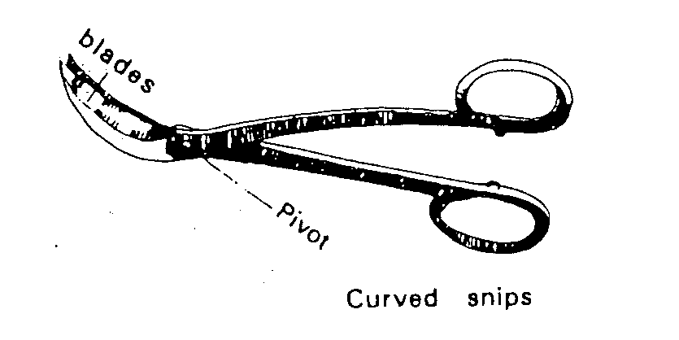 (1 ½ marks)
4. Physical :-Characteristics of metal which do not influence the strength of metal for example:- Colour, density, conductivity. Mechanical:- Characteristic of metal which influence its strength for example:- Hardness, turfness, brittleness, malleability, elasticity etc. (4 marks)

5. (a)
(i)
- Backfire:-a condition whereby the flame momentarily recedes back into the tip before being expelled with a loud sound.
- Causes:-
- Weak acetylene frame.
- Leaks.
- Overheated torch.
- Dirty tip.
- Tip coming into contact with molten pool. (Any 2× ½=1 marks)
(ii)
- Flashback:- the torch stays lit instead of expelling the frame. It tends to travel in the torch body.

- Causes:-
- Improper pressures.
- Faulty mixing chamber.
- Overheating of torch.
- Faulty tip.
- Kinked hoses. (Any 2× ½=1 marks)

6.
- Taking external measurements
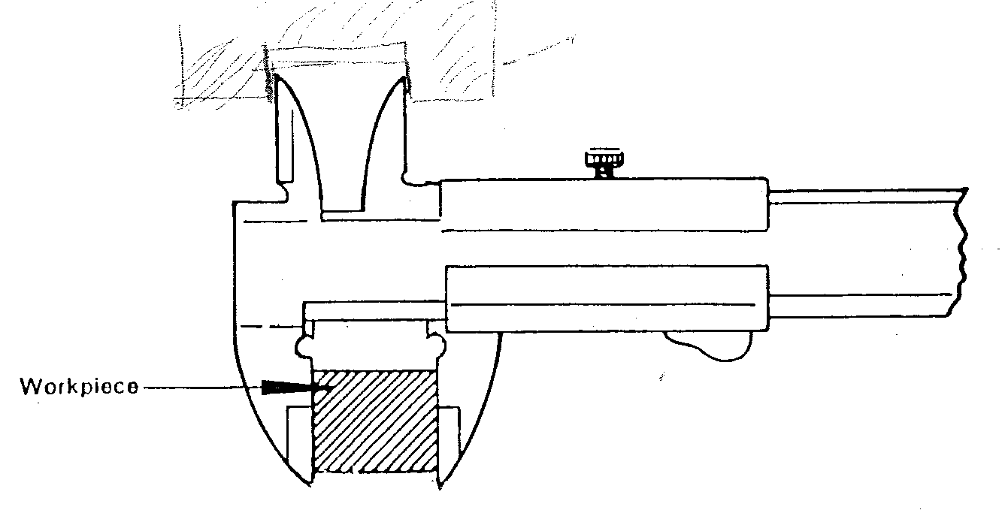 (1 ½ marks)

- Taking internal measurements
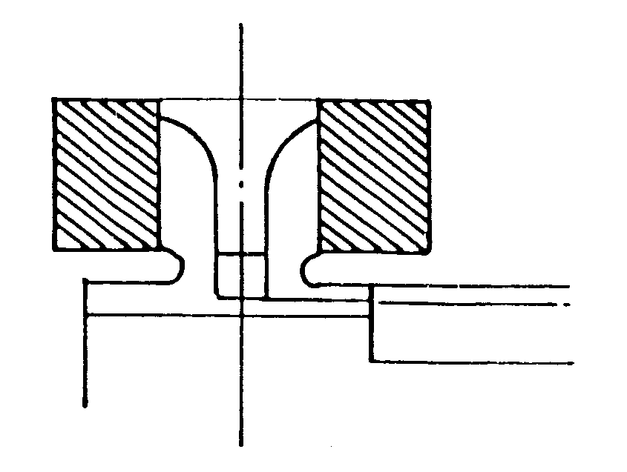 (1 ½ marks)

- Taking depth measurements
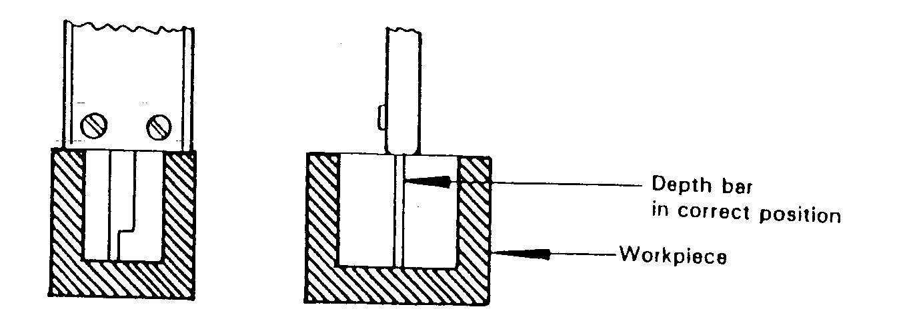 (1 ½ marks)
- Taking stepped measurements
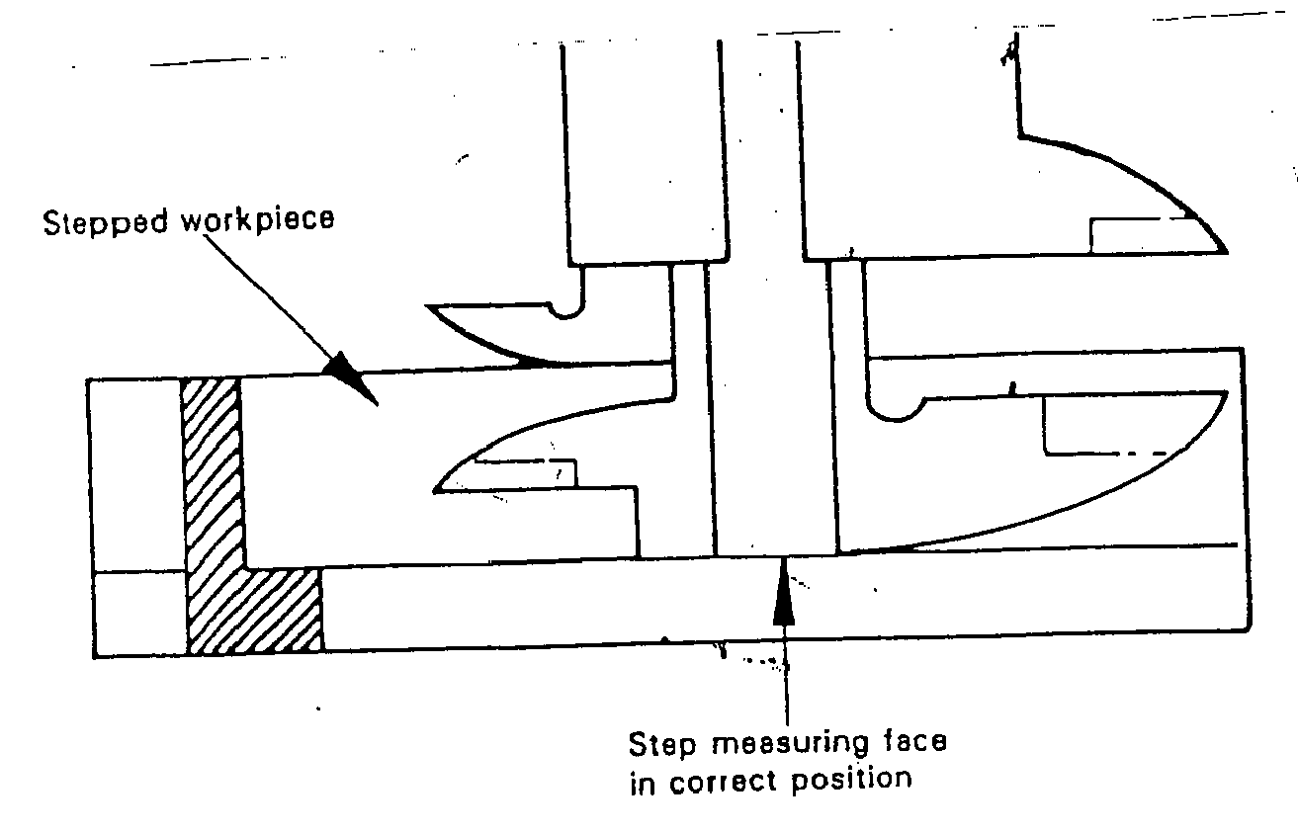 (1 ½ marks)
7.
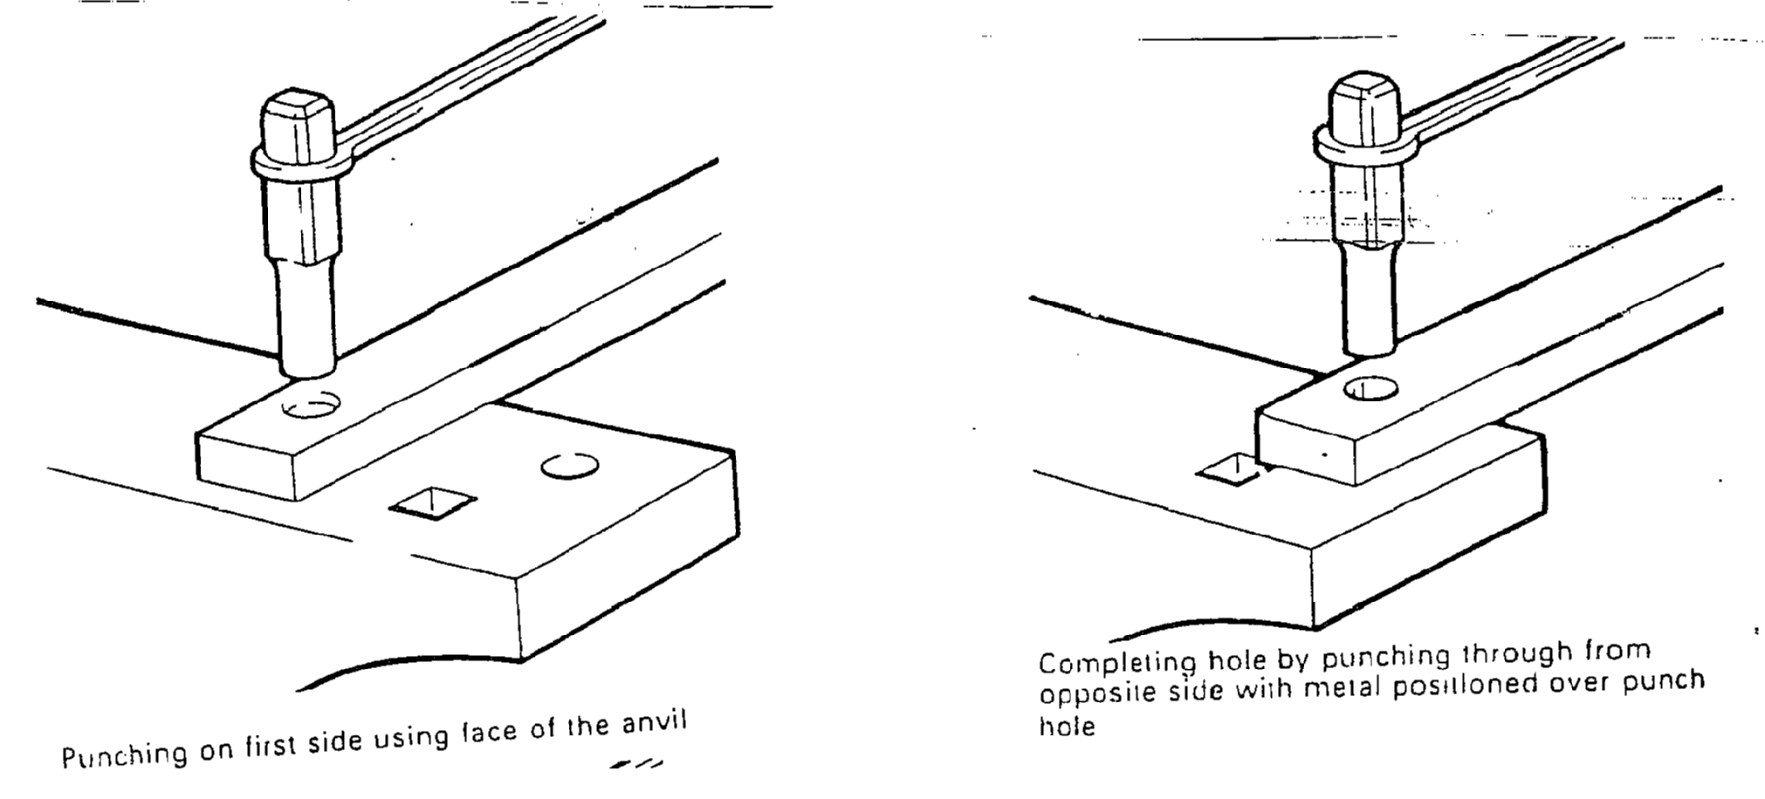 (3 marks)

8. (a)
- Both use - different working temperature.
- different filler rod.
- Soldering - different flux.
- Brazed joint is stronger than soldered. (2 marks)

(b)
- By bending and flattening.
- By wire edging (bend over a wire and retain it).
- By heading (bend over wire and remove it). (3 marks)

9. (a)
    - Pop rivet faster to install than snap rivet.
    - Pop rivet is done from only one side. (2 marks)

(b)
- Protects surfaces from damages.
- Provides additional beauty.
- Protection from corrosion/rusting. (1 ½ marks)

10.
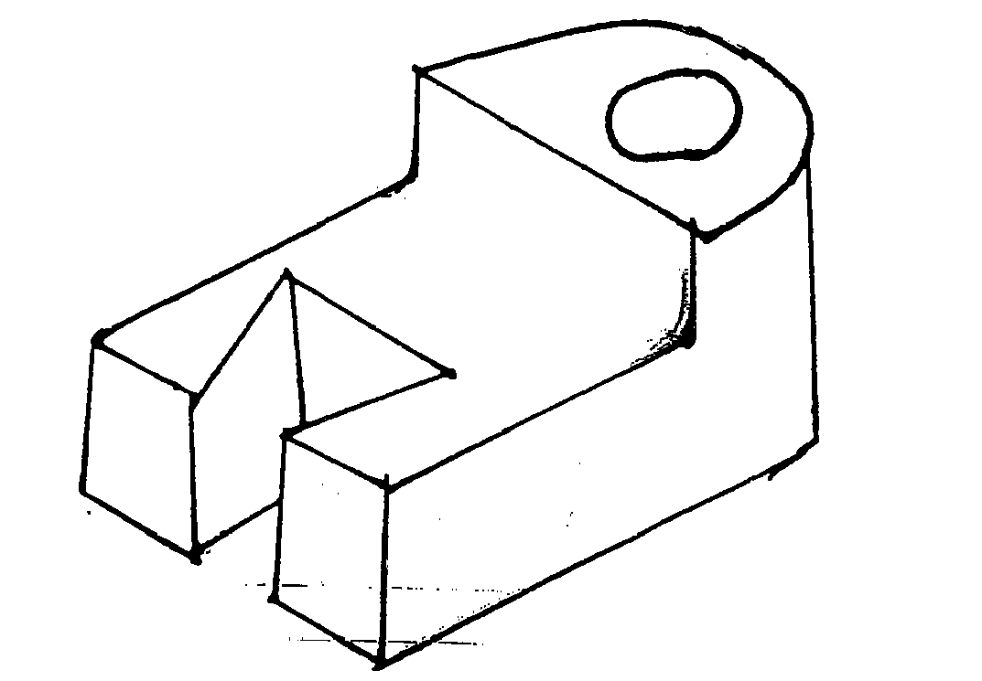 (5 marks)

11.
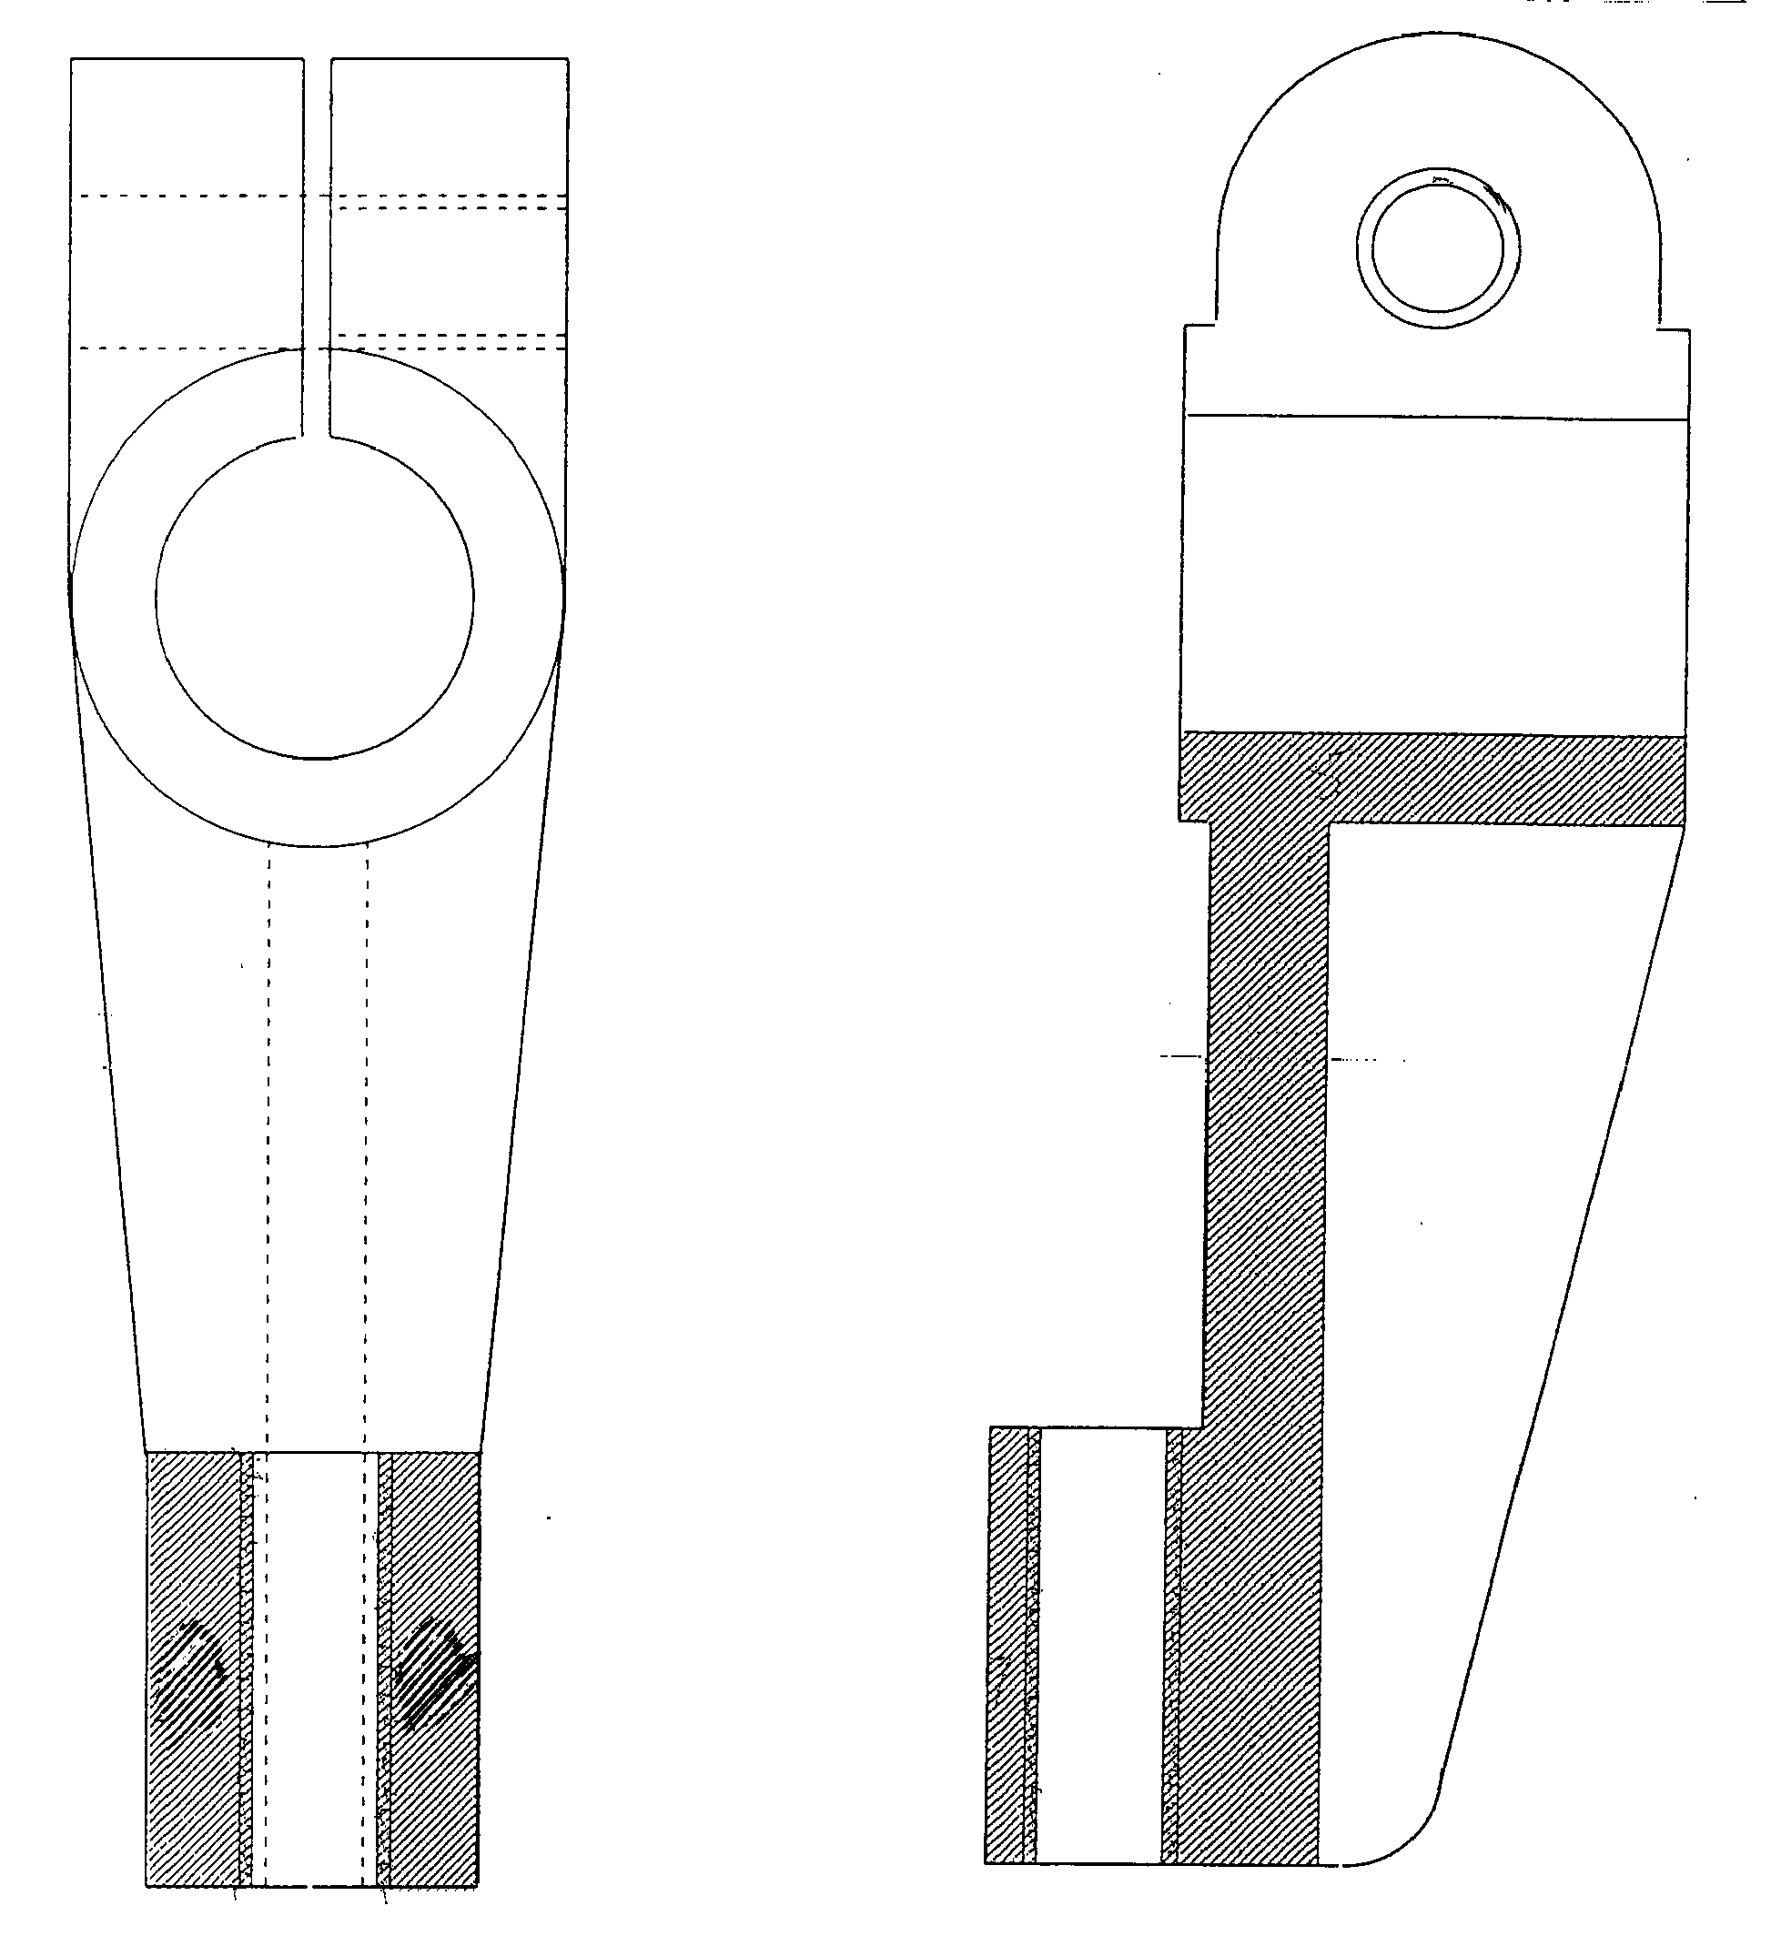
(15 marks)

12. (a)
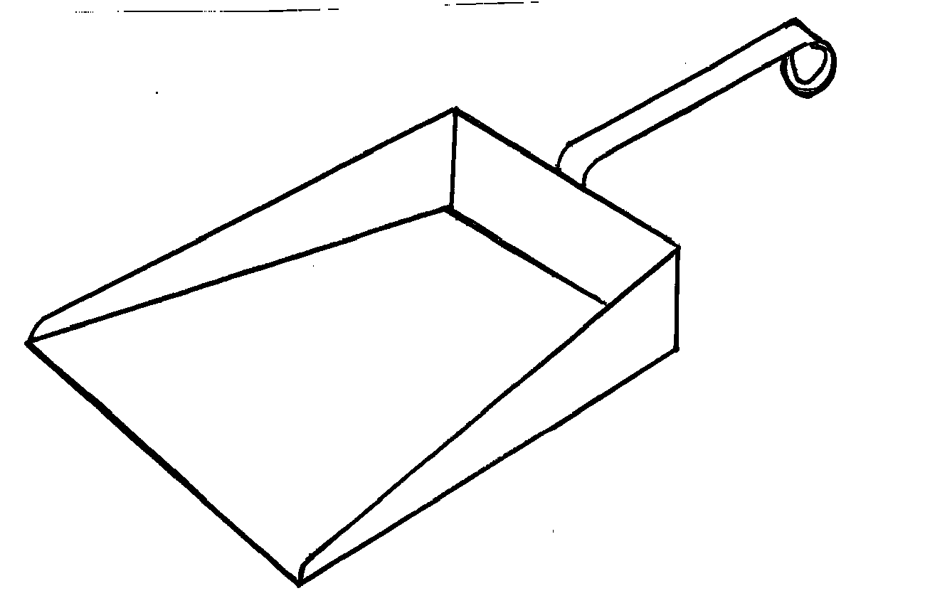 (5 marks)
(b) (i)
  - Mark out the development as shown in the diagram.
  - Cut and file to shape and size.
  - Using a mallet and folding bars, bend the two sides.
  - Bend the back over the sides
  - Bend the flaps.
  - Deburr the work piece.

(ii)
- Cut the required length of the flat bar.
- From a loop (eye) on one end of the handle.
- Bend the second end to correct shape and angle.
- Deburr the handle.

(iii)
- Clean the surfaces to be braced.
- Align the body and handle and lamp together.
- Open the cylinders and set the gas to correct pressure.
- Light and set the torch to correct flame.
- Heat the brazing rod and dip it into flux.
- Heat the joint to melting point of the rod.
- Braze the joint.
- Put off the flame.
- Clean the joint to remove excess flux.
- Shut off the cylinders and release the system pressure. (10 marks)

13. (a) (i) Alloy of tin and lead: Should have:
- Low melting temperature.
- Low surface tension.
- High capillarity resistance to corrosion.

(ii) Cast iron: Should be:
- Self lubricating.
- Hard surface.
- Easy to make.

(iii) High speed steel: Should be:
- Resistance to rust and wear.
- Retain hardness even at high temperature.
- Hard. (4½ marks)

(b)
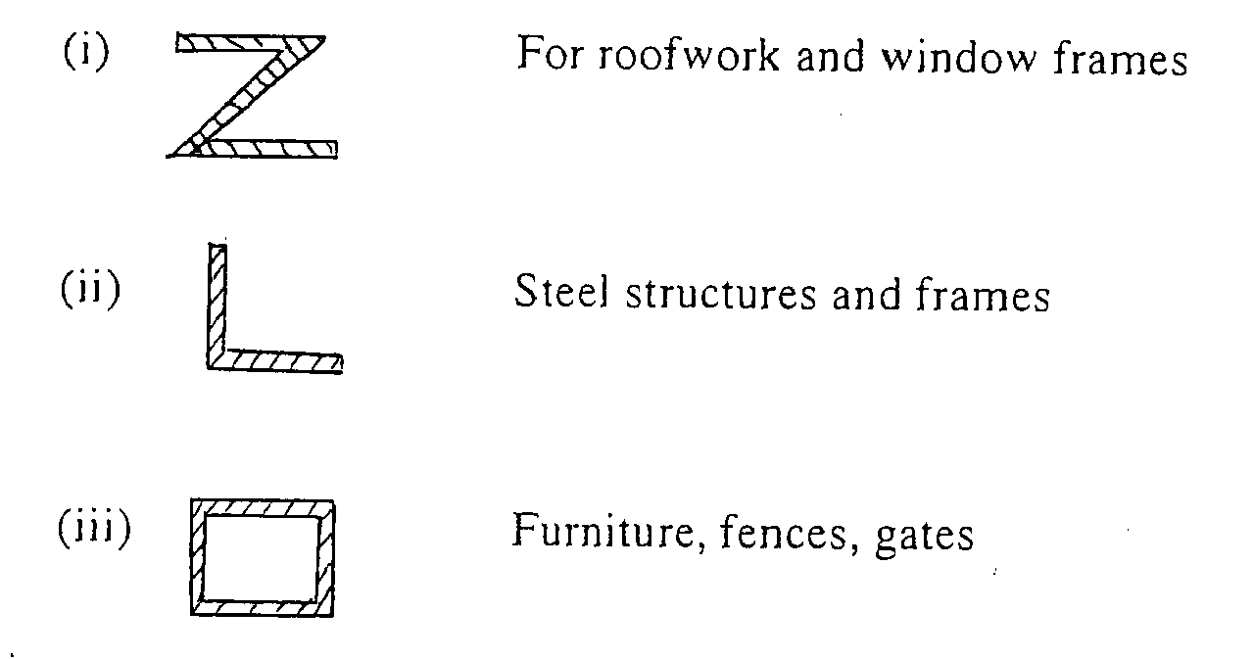 (3×1½ marks)

(c)
- Bluing:- A method of finishing metal articles using heat to achieve a corrosion resistant surface. Done by heating until colour changes to blue then dip the work into light oil and allow to cool. (2 marks)
- Lacquering:- A process of metal finishing using lacquer for preservation and beauty. The types of lacquer used include hot, gum cellulose and synthetic and is applied using a brush, dipping or spraying. (2 marks)
- Planishing:- Is a process of finishing by making even decorative dents on sheets metal using a planishing hammer and stake. The process includes annealing, picking buffing and cleaning. (2 marks)

14. (a) (i) Shank diameter
Ø = 1½ thickness = ³/₂ × 4 = 6 mm

(ii) Shank length = 2 × thickness + 1½Ø = (2 × 4) + (⅔ × 6) = 8 + 9 = 17

(iii) Edge distance A = 1½D = ³/₂ × 6 = 9

(iv) pitch distance = 3D = 3 × 6 =18 (6½ marks )

(b)
    - Strength of the joint.
    - Thickness of the joint.
    - Appearance.
    - Where used. (1½ marks)

(c)
    - Mark the holes and drill one hole on cover plate.
    - Drill a hole on one of the plates to be joined.
    - Debur the plates.
    - Cut the rivet to correct size.
    - Align the pieces and insert rivet.
    - Close the plates using rivet set.
    - Spread the tail of the rivet shank.
    - Form the head with ball pen.
    - Finish with rivet snap.
    - Drill the second hole and rivet.
    - Align the second plate.
    - Drill the holes for second plate.
    - Rivet the second plate.
    - Finish. (14×½ marks)

15. (a)
    - Cold forging procedures better finish than hot forging.
    - Cold forging work hardens and leaves the work stressed.
    - Cold forging requires ductile material and of small cross-section unlike hot forging. (3 marks)
(b) (i)
Eye: D where D=20+3+3=35
35=×35=110
Straight part: 120-=102-20.5=99.5
Total length = 110+99.5=209.5 mm (3 marks)

(ii)
- Mark the required for the eye.
- Bend the rod to 90°.
- Form the eye on anvil by start, further and closing.
- Hammer the eye on the anvil flatten. (3 marks)

(iii)
- Hold the work piece in the vice.
- Chamfer the end to be threaded.
- Select the correct die M6.
- Fix the die in the die stock.
- Adjust the die to maximum opening.
- Fit the die square at the end of the bar.
- Apply cutting the thread.
- Continue cutting and reversing to beak the chips.
- Remove the die.
- Adjust the depth of the cut.
- Repeat thread cutting until the right depth is achieved. (6 marks)

