**30.3.2 Mathematics Paper 2 (121/2)**

1.

|  |  |
| --- | --- |
| No | Log |
| 6.3730  0.6944 | + |
|  |  |
|  | 1.8128    64.98 |

***(3 marks)***

2.



***(2 marks)***

3.

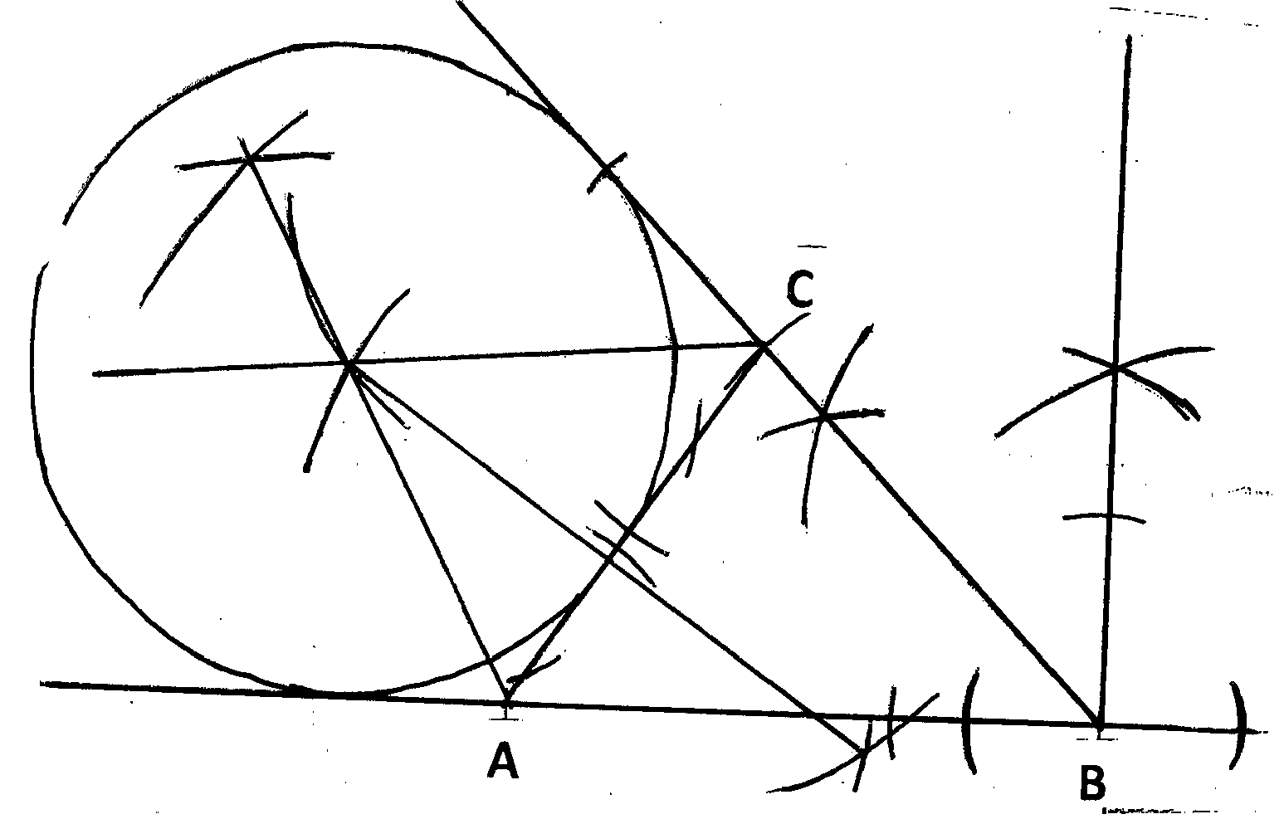

***(3 marks)***

4.



***(3 marks)***

5.



***(3 marks)***

6.

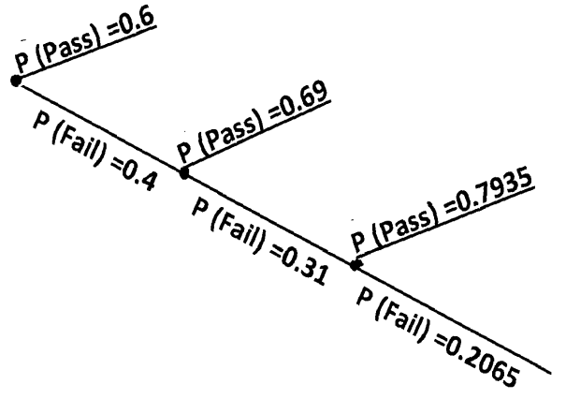



***(3 marks)***

7.

(i) Distance=

(ii)



***(3 marks)***

8.

(a)



(b)



***(4 marks)***

9.



***(3 marks)***

10.



***(4 marks)***

11.



***(3 marks)***

12.



***(3 marks)***

13.



***(3 marks)***

14.

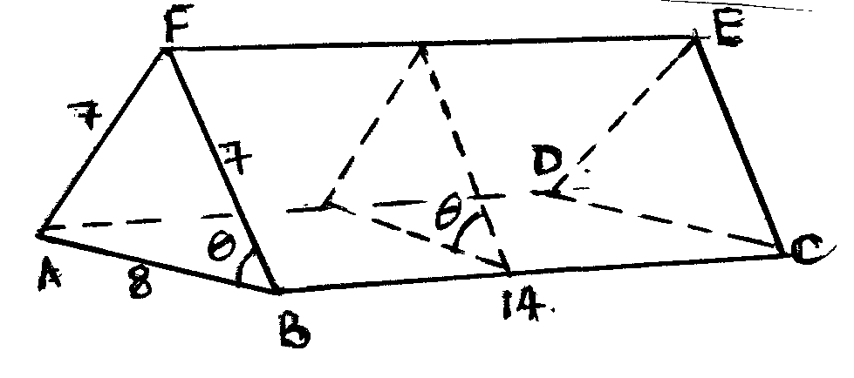



***(3 marks)***

15.



***(3 marks)***

16.



***(4 marks)***

17.

(a)



(b)



(c)



***(10 marks)***

18.

(a)



(b)



(c)

(i)



(ii)



***(10 marks)***

19.

|  |  |  |  |  |  |  |  |  |  |
| --- | --- | --- | --- | --- | --- | --- | --- | --- | --- |
| *x*˚ | 30˚ | 60˚ | 90˚ | 150˚ | 180˚ | 240˚ | 270˚ | 300˚ | 330˚ |
| sin 2*x* | 0.87 |  | 0 | -0.87 |  |  | 0 | -0.87 | -0.87 |
| 3 cos *x*-2 |  | -0.5 |  | -4.60 | -5 | -3.5 | -2 |  | 0.60 |

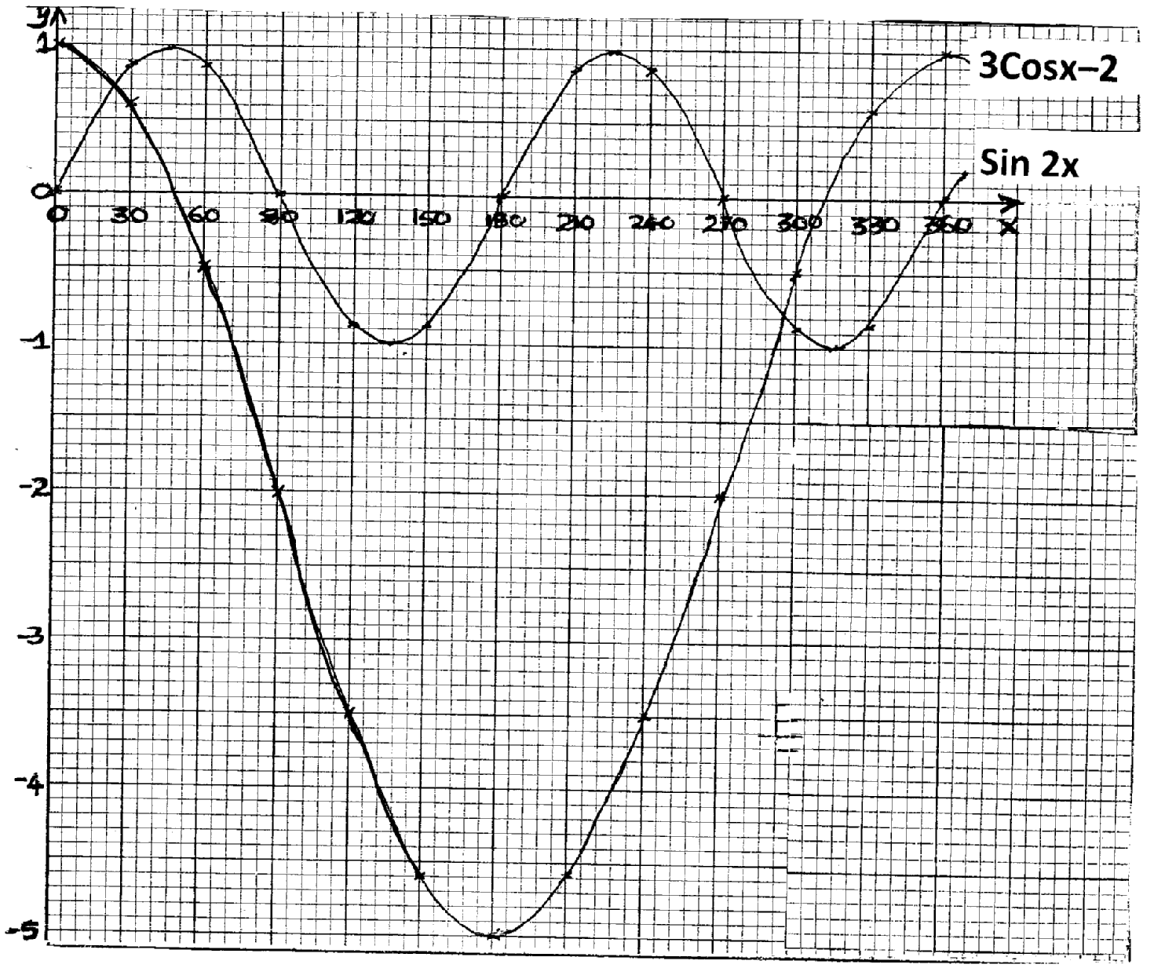

***(10 marks)***

20.

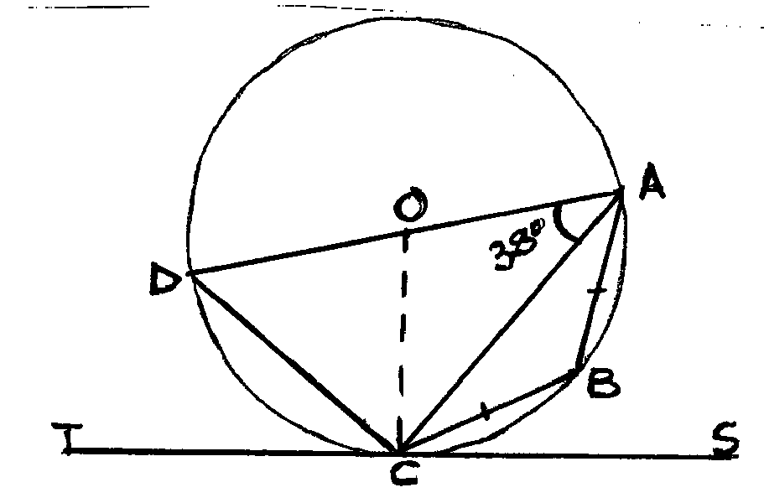

(a)

(i)



(ii)



(b)

(i)



(ii)



***(10 marks)***

21.

(a)

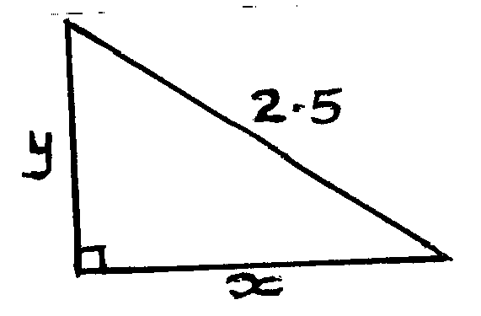

(b)

(i)



(ii)



(iii)



***(10 marks)***

22.

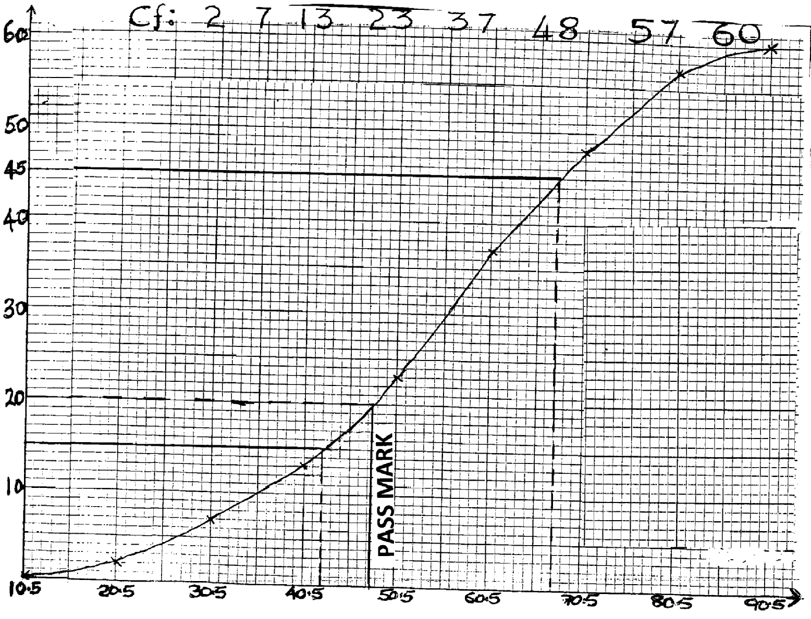

***(10 marks)***

23.

(a)



(b)

(i)



(ii)



(c)



***(10 marks)***

24.

|  |  |  |  |  |  |  |  |
| --- | --- | --- | --- | --- | --- | --- | --- |
| *x* | -4 | -3 | -2 | -1 | 0 | 1 | 2 |
| *y* | -12 | 0 | 0 | -6 | -12 | -12 | 0 |

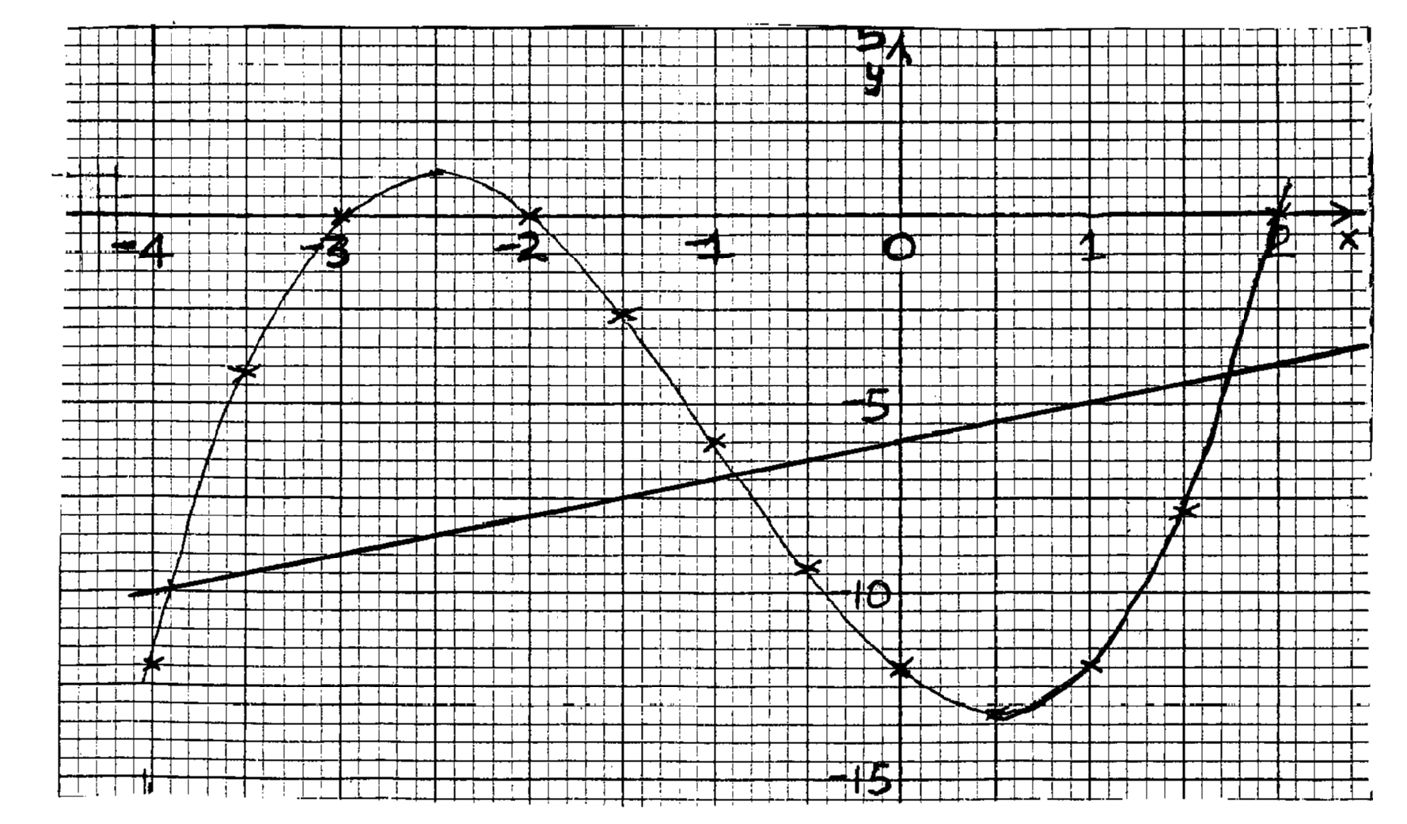



***(10 marks)***