**30.3 Mathematics (121)**

**30.3.1 Mathematics Paper 1 (121/1)**

1.



***(2 marks)***

2.



***(3 marks)***

3.



***(3 marks)***

4.



***(2 marks)***

5.

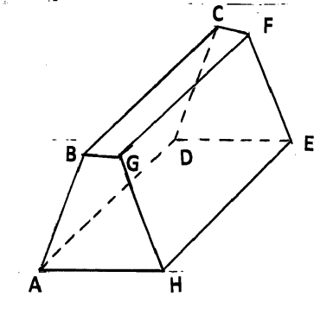 ***(3 marks)***

6.



***(3 marks)***

7.



***(3 marks)***

8.

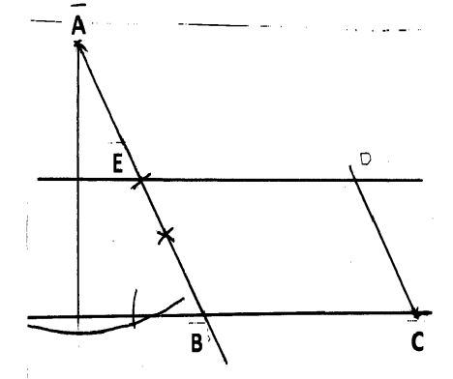



***(4 marks)***

9.



***(3 marks)***

10.



***(4 marks)***

11.

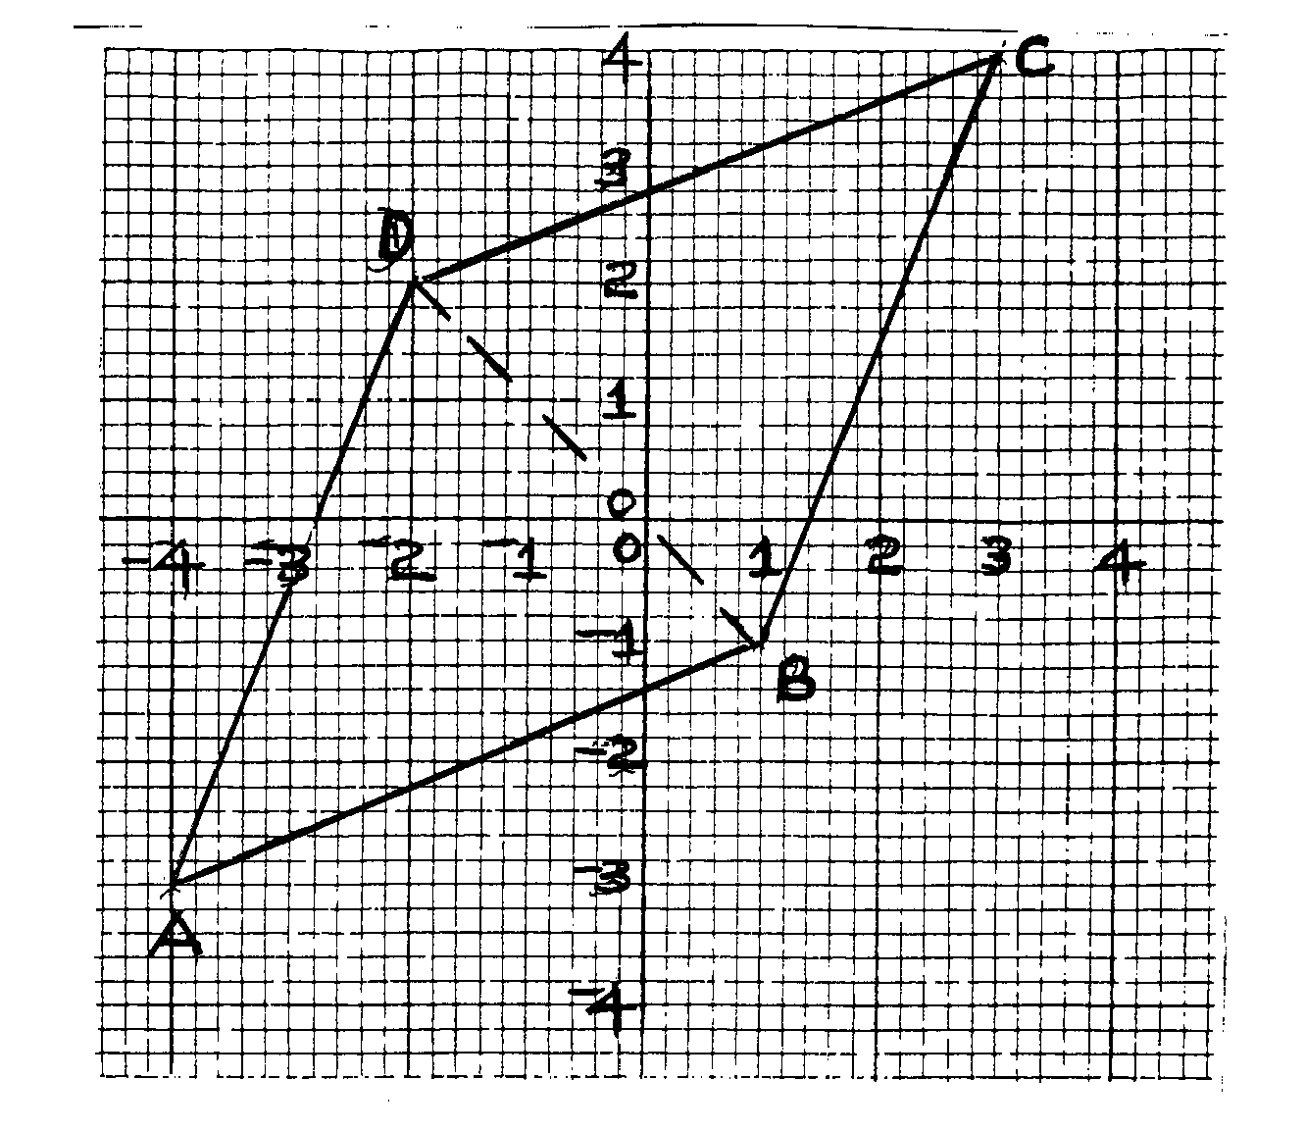



***(4 marks)***

12.



***(3 marks)***

13.



***(3 marks)***

14.



***(3 marks)***

15.



***(3 marks)***

16.

2 cos 2θ = 1

cos 2θ = ½

2 θ = 60˚, 300˚

420˚, 660˚

θ = 30˚, 150˚

210˚, 330˚

***(4 marks)***

17.

(a) Juma’s earnings before increase:



Akinyi’s earnings before increase:



Increase in Akinyi’s earnings



% increase in Akinyi’s earnings



(b) No. of bags bought





Ratio 5700:8400 = 19:28



Total earning for Akinyi:



***(10 marks)***

18.

(a) Trapezium Rule:

|  |  |  |  |  |
| --- | --- | --- | --- | --- |
| *x* | -2 | -1 | 0 | 1 |
| *y* | 7 | 5 | 5 | 7 |



(b) Mid-ordinates

|  |  |  |  |  |  |
| --- | --- | --- | --- | --- | --- |
| *x* | -2.5 | -1.5 | -0.5 | 0.5 | 1.5 |
| *y* | 8.75 | 5.75 | 4.75 | 5.75 | 8.75 |



***(10 marks)***

19.

(a) (i) 

(ii) 

(iii) 

(iv)



(b) (i)





(ii)



***(10 marks)***

20.

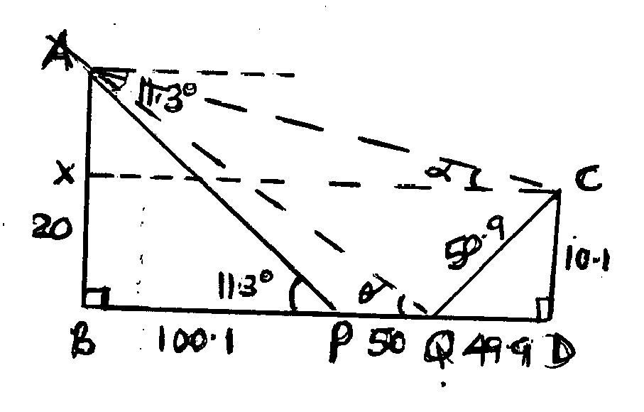

(a)



(b)



(c) (i)



(ii)



***(10 marks)***

21.

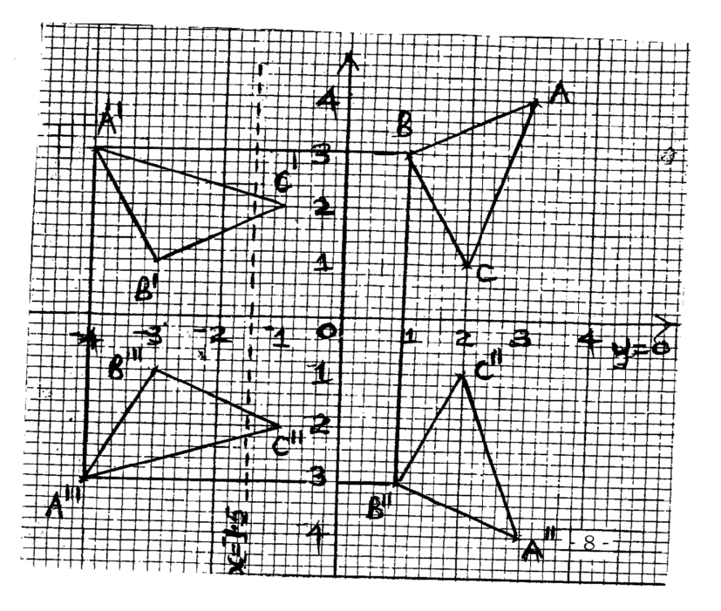

(a) 

(b) 

(c) 

(d) 

(e)



***(10 marks)***

22.

(a) 

(b) (i)



(ii)



(iii)



***(10 marks)***

23.

(a) Let the original number be 

Amount per member originally =

Amount per member after withdrawal of 40 =





1. New total contribution by members



1. Actual cash contribution by members



***(10 marks)***

24.

(a)



(b)



When t=3, s=33-6x32+9x3+5=5

When t=1, s=13-6x1+9x1+5=9

(c)

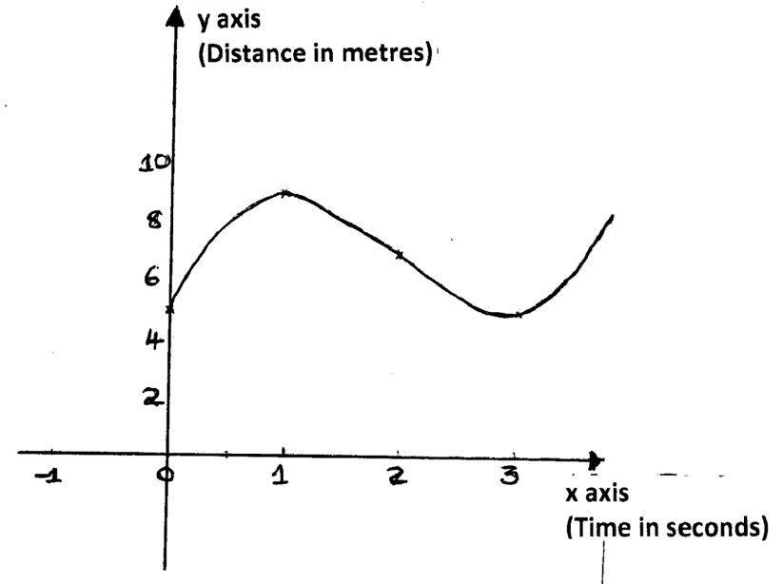

***(10 marks)***