  - GEOGRAPHY (312)

    - Geography Paper 1 (312/1)

1. (a)
    - It explains the current position of the continents/ theory of continental drift.
- It enables one to understand the creation of structural landforms.
- It explains the destruction of structural landforms.
- It helps one to understand how the earth maintains balance/isostasy.
- It explains the causes of earthquakes/ volcanicity. (3 marks)

(b)
    - Divergency /extension/constructive.
    - Converging/compressional/destructive.
    - Transform/conservative. (2 marks)

2. The diagram below shows a six’s thermometer.

(a) P: Mercury.
Q: Alcohol.
R: Metal index. (3 marks)

(b)
(i) the diurnal range of temperature for Tuesday.
27 – 18 = 9˚C (1 mark)

(ii) the mean temperature for Saturday.
29 + 21 = 25˚C (1 mark)
2

3. (a)
    - Coal, Nitrates, graphite, sulfur, potash.
- Asbestors, Sodium, diamond, silicon.
- Petroleum.
- Fluorspar. (2 marks)

(b) Because it is the hardest mineral/it does not break easily. (1 mark)

4. (a)
    - Dust particles.
    - Pollen grains.
    - Gases.
    - Salt particles/sodium chloride.
    - Smoke. (2 marks)

(b) (i)
    - Height.
    - Shape/form.
    - Appearance. (2 marks)

(ii)
    - Cumulo – nimbus.
    - Cumulus.
    - Nimbostratus. (2 marks)

5. (a) V: The sun
W:The moon (2 marks)

(b)
    - The gradual emergence of a ship approaching the shore.
    - Circumnavigation of the earth along a straight path leads one to the starting point from the opposite direction.
    - The different times during which the sun rises and sets in different parts of the world.
    - The appearance of the middle pole to be relatively higher than other poles placed along a straight line on a level ground at equal distances/ curved horizon.
    - The circular shape of the earth seen on photographs taken from satellites.
    - The circular shadow cast by the earth during a lunar eclipse.
    - The earth is a planet and all planets are spheres. (4 marks)

6. (a) (i) 35º 15´ E to 35º 25´ E (1 mark)

(ii) Map scale 1: 50, 000
that is, 1 cm represents 50,000 cm
50,000cm = 50,000 Km
100,000
= 0.5 km
Statement scale is 1cm represents 0.5 km/½ km (2 marks)

(iii) Just over 2120m/below 2140m (2 marks)

(iv) 10.5 – 11.0 km² (2 marks)

(b) (i)
    - Scrubs.
    - Woodland.
    - Scattered trees.
    - Thicket.
    - Papyrus/papyrus swamp vegetation. (3 marks)

(ii) 305º (2 marks)

(iii)
    - All weather road loose surface.
    - Dry weather road.
    - Motorable tracks/ main tracks.
    - Foot paths/other tracks. (3 marks)
(c)
    - There are few settlements/labour lines within the tea estates and no settlements in forested areas.
- To the north and west of Kericho-Lumbwa road, the settlements form a dispersed pattern.
- To the north of Tugenon river, there are few or no settlements.
- There are nucleated settlements in the market/shopping centres/labour lines/villages.
- Some areas such as the steep slopes and river valleys have few or no settlements.
- Kericho town is the main settlement area/forms a large cluster of settlement/ dense settlement. (4 marks)

(d)
    - The high relief as evidenced by contours that rise between 1900 - 2400m modifies temperatures making the area suitable for the growing of tea bushes.
- The relatively undulating slopes as evidenced by widely spaced contours allow proper drainage of soils making it ideal for tea farming/ allow mechanization.
- Presence of forests/ many permanent rivers and high relief show that the area receives high rainfall which is suitable for tea growing.
- The area has fairly dense settlements which indicates availability of labour needed in tea farming.
- The area is well served by all weather roads which are needed for the transportation of tea from the farms to the factor/transportation of labour. (6 marks)

7. (a) Magma is the molten rock material which originates from the interior of the earth, cools while below the earths surface and has large crystals while lava is the molten rock materials that has reached the surface, has solidified and has small crystals. (2 marks)

(b) E : Dyke
F : Lopolith
G : Sill (3 marks)

(c) (i) A crater

- Eruption of lava through a central vent causes building up of a cone.
- The lava in the vent cools and contracts.
- The cool lava withdraws into the vent leaving a shallow depression at the top of the cone.
- Gas explosions may blow away surface rocks causing a crater on the surface.

Examples:- Mt Longonot, Menengai, Mt Suswa, Lake Chala, Central island of lake Turkana and Mt Marsabit (3 marks)

(ii) A geyser

    - Rainwater percolates down through cracks in the rocks.
- The water gets into contact with hot igneous rocks.
- The water is super heated and gases/steam form.
- Pressure builds up in the cracks.
- The pressure causes steam and water to be ejected explosively as jets to the surface.
- The water and steam are emitted intermittently as pressure level changes.

Example: Lake Bogoria (5 marks)

(iii) A lava plateau

- It is formed when magma reaches the surface of the earth through a single vent or series of vents/fissures.
- The lava is extremely fluid/ultra-basic.
- The lava spreads evenly over a large area.
- The lava cools slowly and solidifies.
- Successive eruptions lead to more and more layers building up the landscape into a plateau.

Example:- Yatta plateau, Uasin Gishu plateau, and Laikipia plateau. (4 marks)

(d)
    - Volcanic highlands/mountains are sources of rivers which provide water for domestic/agriculture/industrial use.
    - Volcanic rocks weather down to form fertile volcanic soils which support agriculture.
    - Volcanic rocks are important building materials in the construction industry.
    - Volcanic features are tourist attractions which promote tourism.
    - Volcanic mountains/highlands have forests which provide valuable timber used in building and construction industries.
    - Volcanic mountains/highlands influence formation of relief rainfall which encourages agricultural activities.
    - Volcanic highlands/mountains modify temperatures making them attractive to human settlements.
    - Volcanic features such as steam jets and geysers provide suitable sites for geothermal power generation.
    - Volcanic features act as barriers to development of transport lines.
    - Some volcanic pipes have valuable minerals which can be mined.
(8 marks)
8. (a) (i)
    - Lakes.
- Melting ice/snow.
- Springs.
- Swamps.
- Surface run off. (2 marks)

(ii)
Youthful stage:-
- Rapids/water fall/cascades/catarcts.
- V-shaped valleys/canyons/gorges.
- Potholes.
- Plunge pools.
- Interlocking spurs. (2 marks)
Mature stage:-
- Meanders.
- River cliff/bluff.
- Slip-off – slopes.
- Alluvial fans.
- Wide v-shaped valleys.
- Braids. (2 marks)

Old stage:-
- Meanders.
- Ox-bow lakes.
- Braided channel/isles.
- Flood plain.
- Levees.
- Deferred tributaries.
- River terraces.
- Distributaries/deltas.
- Bluffs/ meander scars. (2 marks)

(b)
- Traction process:- the large and heavy loads of the river are rolled/dragged along the river bed by the force of the moving water and gravity.
- Saltation:- some large fragments that cannot remain suspended in the water are momentarily lifted and dropped by water turbulence. The series of leaps and hops move the load down the river.
- Suspension:- light insoluble materials such as sand and silt grains are carried and maintained within the water by river turbulence and transported downstream.
- Solution process: the soluble minerals/materials are dissolved in the river water and carried away. (6 marks)

(c) (i) Dendritic pattern:-
- It developes in areas where rocks have uniform structure.
- The direction of flow is influenced by the slope of the land.
- The tributaries join the main river at acute angles.
- The tributaries converge on the main river forming a shape like that of a tree and its branches. (3 marks)

(ii) Trellis pattern:-
- The pattern develops where soft and hard rocks alternate vertically.
- The tributaries join the main river at right angles.
- The consequent streams are parallel to the main river.
- Some obsequent streams flow to the opposite direction from the main river.
- The main river and its tributaries form a rectilinear pattern. (3 marks)

(d) (i)
- Observation/digging up the deposits to expose the inner layers.
- Collecting samples.
- Taking photographs.
- Interviewing. (2 marks)

(ii)
- It enables one to collect first hand information.
- It promotes development of practical skills.
- It promotes application of acquired knowledge.
- One is able to develop skills of data analysis.
- It makes the study of rivers more interesting.
- It creates awareness of the environment. (3 marks)

9. (a) (i)
- Due to low temperatures, water vapour freezes and forms snow.
- Snow falls and accumulates on the mountain top/higher slopes.
- Snow continues pilling and new layers exert pressure on the lower layers.
- Lower layers become compressed as air is expelled from the spaces between snow particles.
    - The compacted layers are ice. (3 marks)

(ii)
    - Ice caps.
    - Cirque glaciers. (2 marks)

(b) (i)
- Glaciers move faster in summer/when the temperatures are higher because the ice melts due to the warm conditions, whereas in winter/when temperatures are low, ice movement is slow due to cold conditions.
- The temperature of the bottom of the valley glacier rises with increased pressure thereby thawing and enabling its movement down slope. (2 marks)

(ii) When the channel is wide, ice movement is slow, that is, because ice spreads out forming a thin layer, hence there is less pressure to cause thawing that would facilitate ice movement/when the channel is narrow. (2 marks)

(c) (i)
A corrie:-
- Is a deep rock basin.
- Has steep sides.
- Is arm-chair in shape/semi circular.
- Has a high back wall.
- Has a reverse slope on the lower side. (3 marks)

(ii)
A pyramid peak:-
- Has steep sides.
- Is surrounded by cirques.
- Is a sharp rock pinnacle/horn.
- Has a radiating system of arêtes. (3 marks)

(iii)
A fiord (fjord):-
- Has steep walls.
- Is narrow sea inlets.
- Is u-shaped.
- Has hanging valleys.
- Has deep waters.
- It is shallow seawards / deeper landwards. (3 marks)

(d) (i) M: Hanging valley.
N: Water fall.
P: U-Shaped valley/glacial trough. (3 marks)

(ii)
- A large block of rock stands on the path of on coming glacier.
- The moving ice plucks off/erodes weak rock fragments from the upper side of the rock.
- As the ice moves round and over the resistant rock it carries the eroded materials to the lee side.
- The lee side does not experience erosion.
- Eroded materials are deposited on the lee side of the rock.
- With time the moving ice smoothens the side of the on coming ice while deposited materials increase on the lee side.
- The resistant rock is the crag while the materials deposited on the lee side form the tail. (4 marks)

10. (a) (i) H: Trough
J: Crest
K: Swash (3 marks)

(ii) It is the return flow of water down the beach to the sea after a wave has broken. (2 marks)

(b)
- Rock fragments carried by waves are used as a tool to grind against the cliff face as the waves break./Rock fragments carried by the back wash erodes the sea floor.
    - The solvent and chemical action of the sea water dissolves and removes the soluble minerals that are found in the cliff/sea floor especially where there are limestone rocks.
    - The swash/breaking waves hit against the cliffs shattering the rocks./ The force of breaking waves compress air into the cracks/joints in the cliff face. This enlarges the cracks and parts of the rocks may break off.
    - Particles that are carried by waves are constantly colliding against each other. This wears them into smaller sizes. (Any 3x2=6 marks)

(c) (i)
- A shore with a gentle gradient reduces the velocity/speed of the flow of the backwash causing the waves to deposit the load on the shore.
- Where the shore is steep, the velocity/speed of flow of the backwash will be higher causing the sediments to move from the shore back into the sea. There will be little or no deposition at the shore. (4 marks)

(ii) Shallow water causes waves to break thus encouraging deposition because the swash is stronger than the backwash. Where the sea is deep, there is less deposition because the sea bed is not in contact with the waves carrying deposits
(4 marks)

(d)
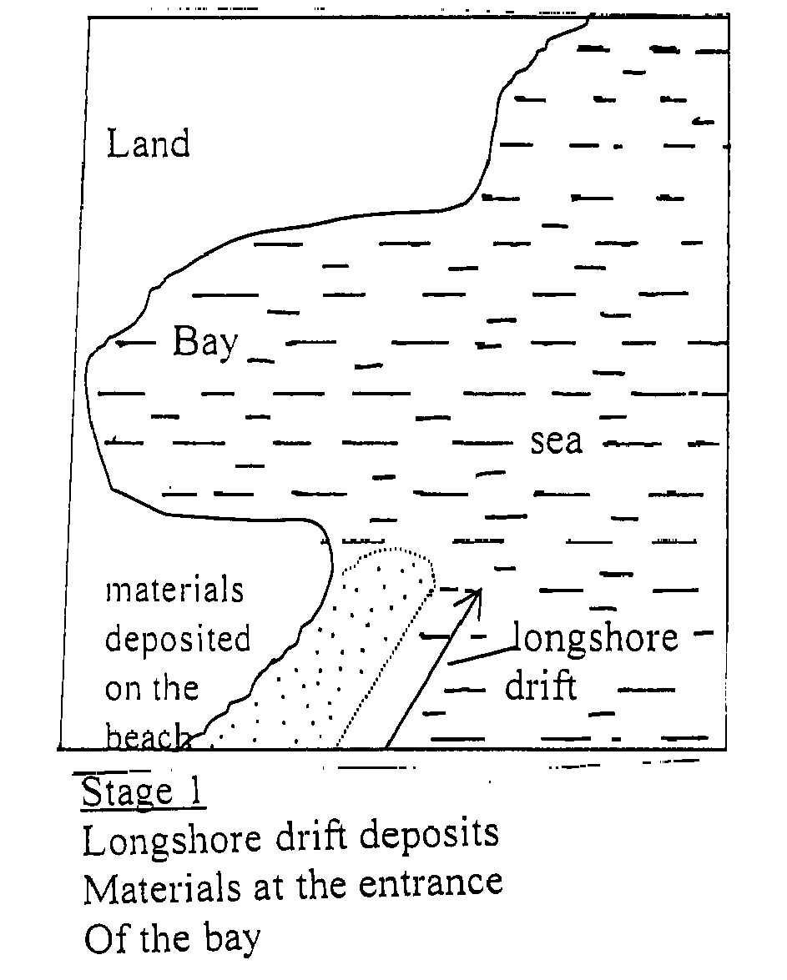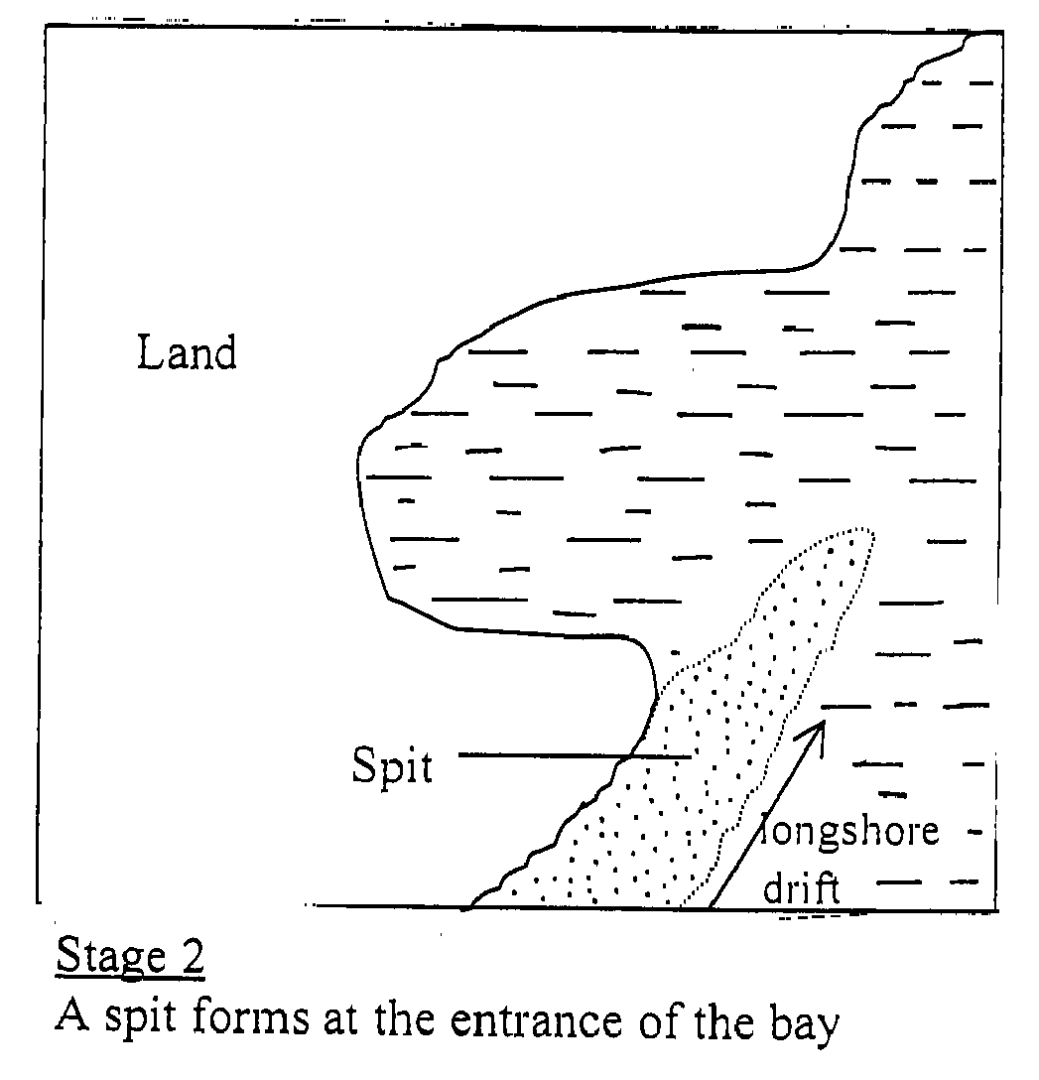

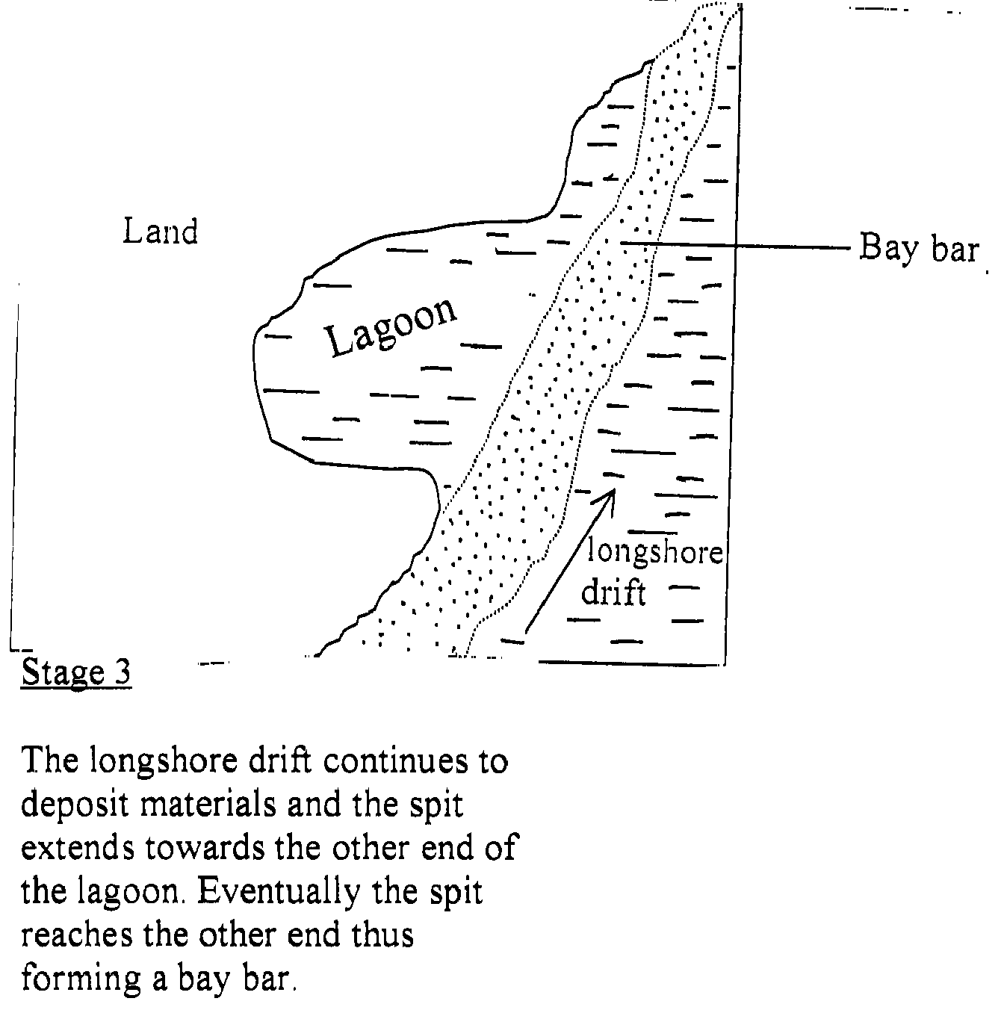
(6 marks)

