**30.19 ELECTRICITY (448)**

**30.19.1 Electricity Paper 1 (448/1)**

1 (a)

* Never switch on an electric source if a person is leaning on the equipment.
* Don’t use such tool in damp areas.
* Ensure the tool is earthed.
* Remove plug from the socket when equipment is not in use.
* Ensure all electrical connections are safe. ***(Any 3x½ = 1 ½ marks)***

(b)

* Avoid storage in excessive heat.
* Avoid dampness.
* Remove dry cells.
* Screen from magnetism.
* Avoid dusty environment. ***(Any 3x½=1 ½ marks)***

(c) Artisan, Craftsman, Technician, Engineer. ***(4x ½ =2 marks)***

2. (a) File will remove tin coating thus causing copper to dissolve in hot solder. ***(1 mark)***

(b) (i) ***Short circuit***:- load cannot draw current because it is bypassd by a conductor.

(ii) ***Overload***:- the current through the load is too large because resistance is too low for the rated load. ***(2x1 marks)***

(c) (i) ***Resistance***:- impedes or reduces current in a cirtuit.

(ii) ***Inductance***:- opposes change of current. ***(2x1 marks)***

3. (a)

* Are lighter than copper cables.
* Are cheaper than copper cables.
* Are more corrosion resistance than copper. ***(Any 2x1=2 marks)***

(b) Current for solar panel is 



No. of days required for full charge is



***(4 marks)***

4. (a) 

***(4x½ =2 marks)***

(b) Length of the wire is given.



***(5 marks)***

5. (a) Iron, Nickel, Cobalt, Aluminium, Copper. ***(Any 2 x½=1 mark )***

(b) Done by placing the magnet inside a solenoid through which current is flowing. With the current still flowing, the magnet is slowly withdrawn from the solenoid.

***(2x1=2 marks)***

6. (a) Electric power is transmitted at high voltage in order to reduce current and therefore reduce cable sizes, power loss and cost. ***(2 marks)***

(b)

* ***Isolation***:- switching off all conductors connecting to the supply.
* ***Circuit protection***:- automatically disconnects installation when current exceeds normal.
* Protection against leakage of current to earth. ***(3 x1=3 marks)***

7. (a)

* ***Communicator segments***:- copper.
* ***Slip ring***:- brass.
* ***Brushes***:- carbon or copper.
* ***Armature core***:- iron lamination. ***(4 x½=2 marks)***

(b)

* Due to low resistance excess current would flow damaging the motor.
* There would be very low current in field coils causing the armature to race. This can lead to damage due to centrifugal forces.
* The would be no back e.m.f. causing excess current to flow and possibly damaging the motor. ***(3x1=3 marks)***

8. (a) Find the terminal which shows continuity with the tab.

(b) With ohmmeter lead on collector, touch the negative lead on each of the other terminals. Terminal showing low resistance in the base.

1. The emitter is the terminal showing open circuit condition with the collector.

***(3x1=3 marks)***

9. (a)

* Increasing the number of its coil.
* Using stronger magnet.
* Using weaker hairspring or a wire suspension.
* Using a long beam of light as a pointer. ***(3x1=3 marks)***

(b) (i)

* Loose control knob.
* Faulty thermostat element.
* Incorrect wiring. ***(2x ½ =1 marks)***

(ii)

* Check the temperature control knob for tightness.
* Open the iron box and check the thermostat.
* Check the wiring for correctness.
* Logical sequence. ***(4x ½=2 marks)***

10. (a) ***Detail drawing*** shows the parts with their sizes, materials, shapes etc.

(b) ***Exploded drawing*** shows the sequence in which all the parts are put together in the final assembly. ***(2x1=2 marks)***

**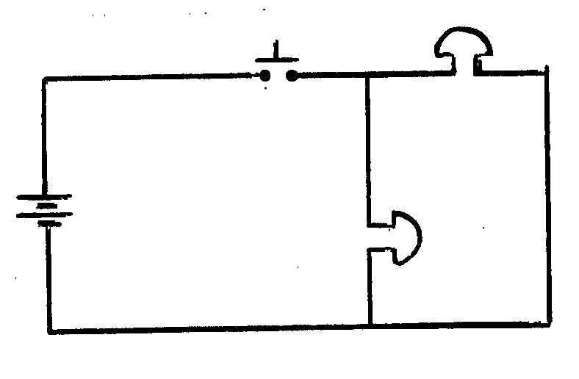 *(5 marks)***

11. (a)

* Assuming the motor has been operating at moderate speed, when it is suddently subjected to a heavier load, the first effect is to slow down the motor.
* Slowing the motor reduces back emf generated because back emf is directly proportional to speed.
* Reduced back emf makes the line voltage to push more current through the motors’ field coils.
* More current in the field coils produces a stronger magnetic field.
* Because torque depends on the product of both magnetic field and flux, both will therefore increase and so will the torque. ***(5x1=5 marks)***

(b) (i) Transformation ration  ***(1 mark)***

(ii) Is  ***(1 mark)***

1. Primary impendence  ***(1 mark)***

Secondary impendence  ***(1 mark)***

 ***(1 mark)***

1. No. of secondary coil turns

 ***(2 marks)***

12 (a) V-1 curve of rectifier diode

**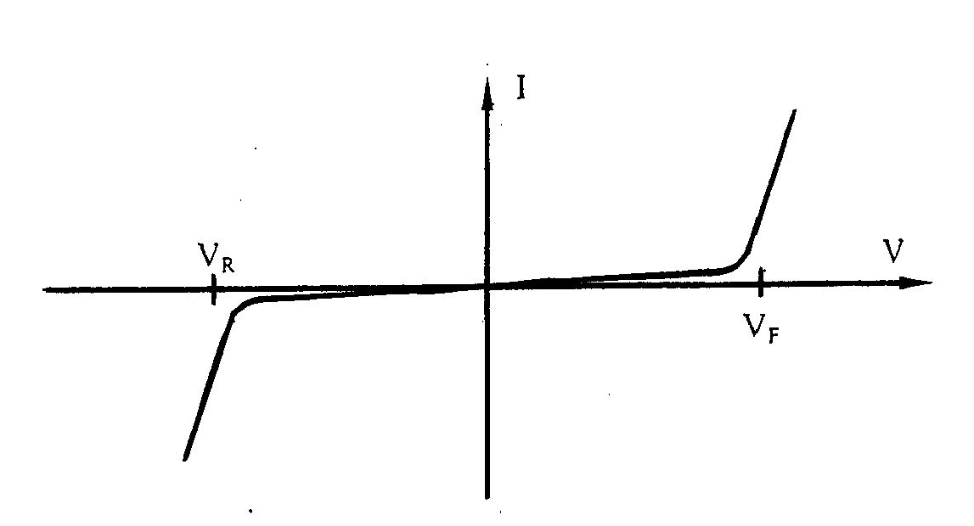 *(4 marks)***

(b) (i) Value of resistor

 ***(1 mark)***

 ***(1 mark)***

 ***(2 marks)***

(ii)

* Since VZ remains constant VR decreases
* IL remains constant
* Iz decreases ***(3x1=3 marks)***

13. (a) ***Stroboscopic effect***: is a phenomenon whereby reversing discharge of ions and electronics by the lamp concides with the speed of a revolving machine such that the machine appears to be stationary. ***(2x1=2 marks)***

(b) (i) Starter switch operated fluorescent lamp

**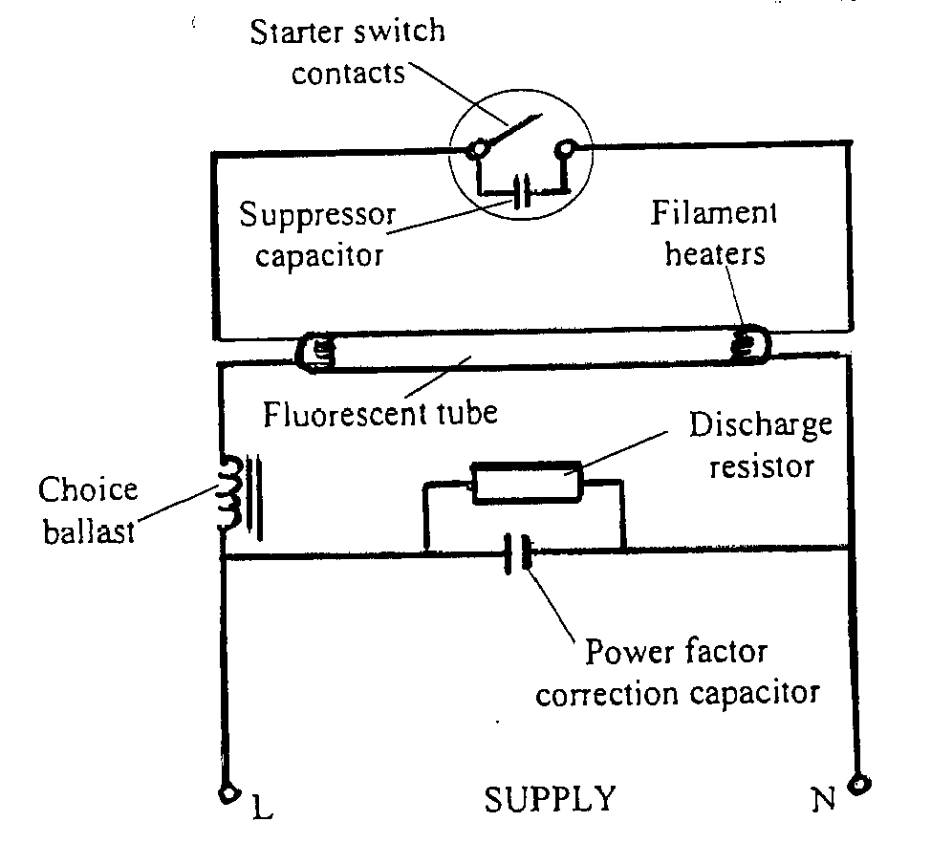 *(7 marks)***

* 1. ***Choke***: induces a high voltage which enables a discharge to be initiated between the electrodes of the tube when the starter contacts open. It also keeps the discharge and lamp current at a steady value when lamp is in operation.

***Flourescent Powder***: converts the ultra violet light emitted by the discharge and melting mercury to drop to a shadowless white or coloured light.

***(2 x 1 ½ marks)***

14. (a) (i) When S is open

I Voltage VA  ***(1 mark)***

 ***(1 mark)***

 ***(1 mark)***

II Current I6 = ***(1 mark)***

 ***(1 mark)***

(ii) No current flows because a balanced wheatstone bridge is formed ***(1 mark)***

(b) (i) Equivalent capacitance, CT

CT =  ***(1 mark)***

=  ***(1 mark)***

=  ***(1 mark)***

(ii) Current in the circuit, *i*

*i =*  ***(1 mark)***

***=***  ***(1 mark)***

=  ***(1 mark)***

= *i*=11.5mA ***(1 mark)***

15. (a)

* Draw for schematic diagram of the circuit.
* Draw the PCB artwork.
* Transfer artwork to copper side of the board.
* Etch the board.
* Drill holes for the component.
* Position the components and connectors.
* Solder the components and connectors.
* Dress the PCB that is, cut out the tails and close PCB surface. ***(8x ½ =4 marks)***

(b)

**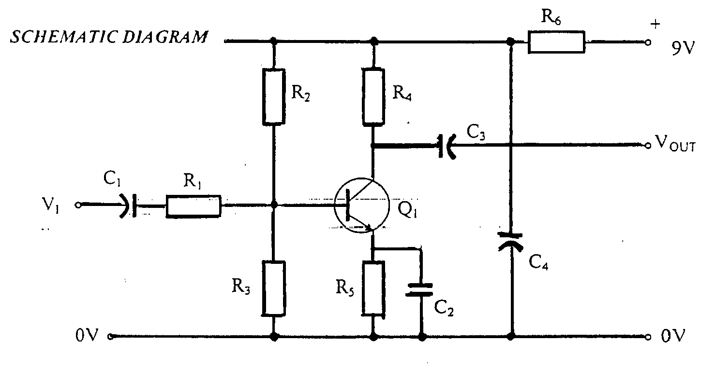 *(8 marks)***