30.20.1 Drawing & Design Paper 2 (449/2)

1.

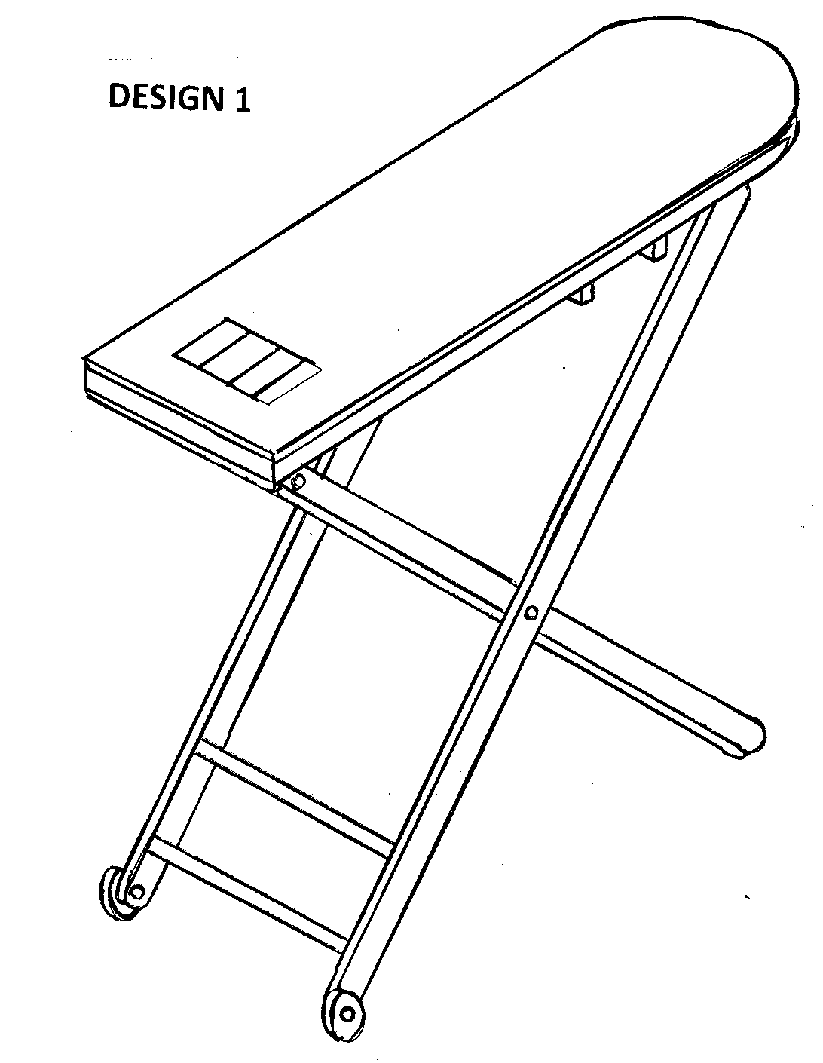

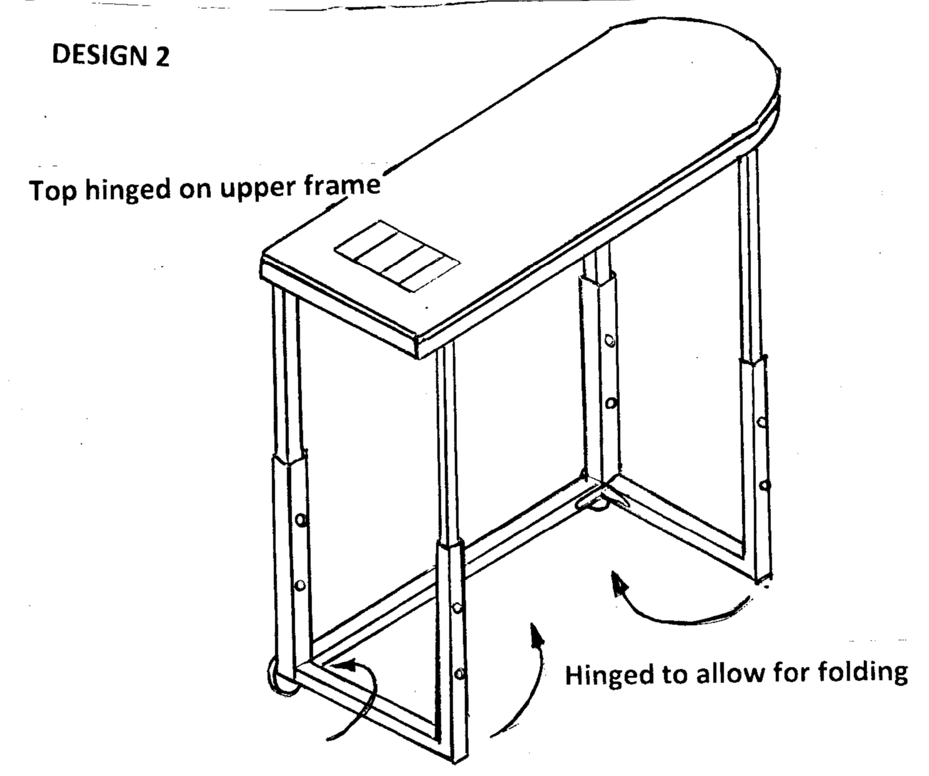
(6 marks)

2.
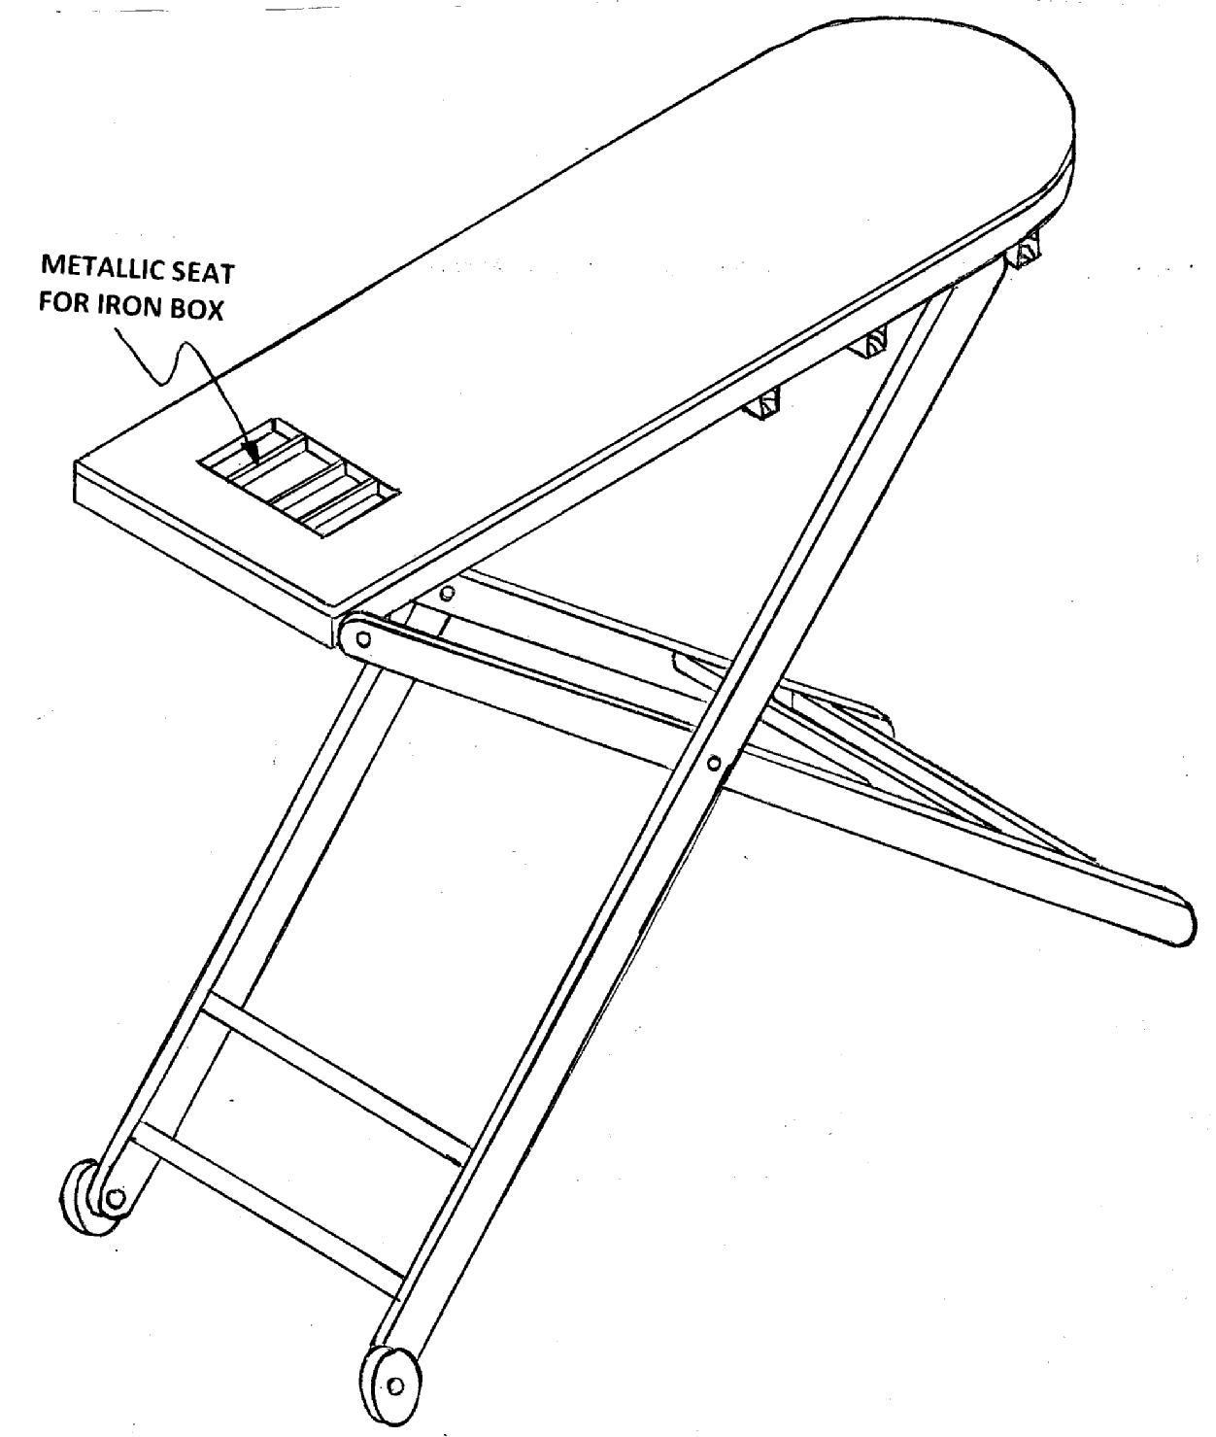
(13 marks)
3.

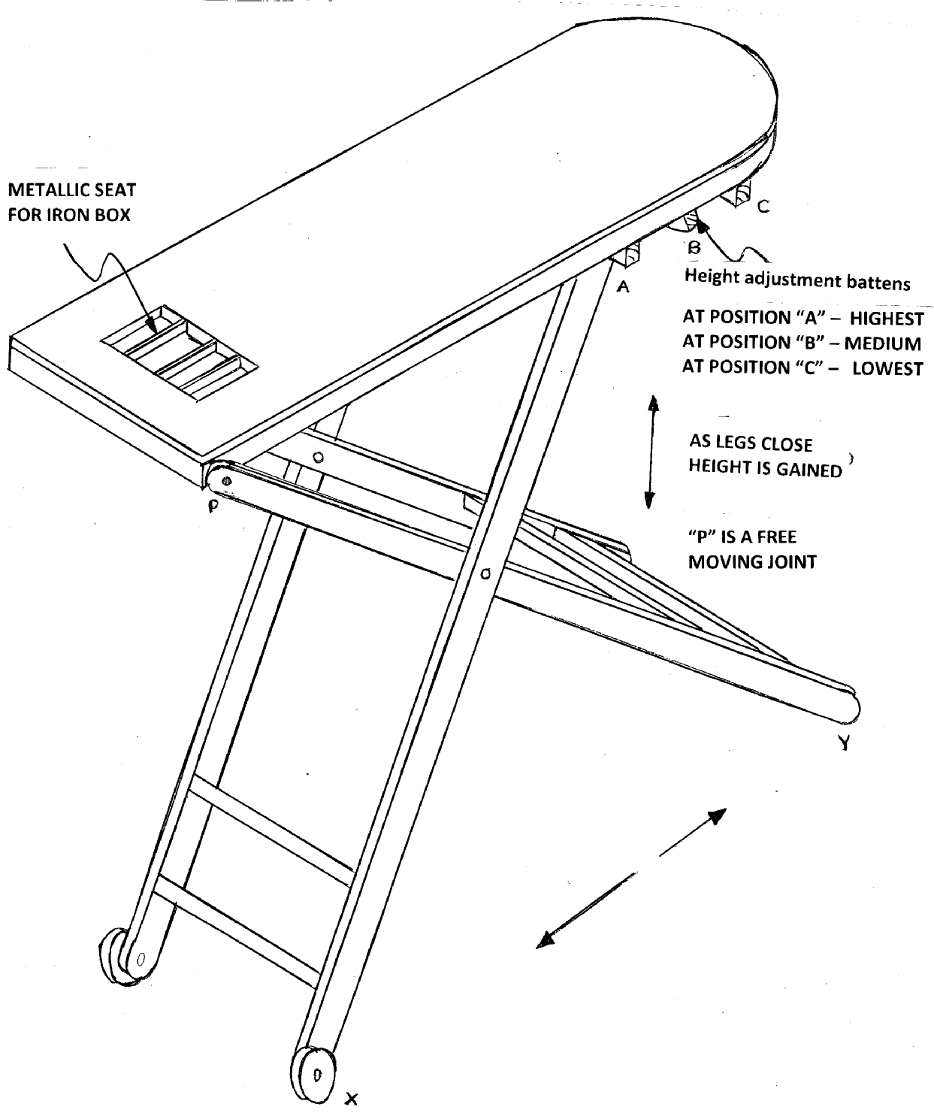
(14 marks)

4.
- Soft Pad / Cloth: used on top of the board.
Blockboard: used to support the soft pad.

- Soft Pad / Cloth:to apply some cushion for quality ironing.
Blockboard: to provide a flat base when ironing. It is also easy to use tack nails to join the pad to the board. (4 marks)

5.

- Tack nails.
- Bolt: to join the two frames in order to allow for some oscillating movement.
- Contact glue: to join the pad to the board so as to remain flat through out.
(3 marks)

