30.20 DRAWING AND DESIGN (449)

30.20.1 Drawing and Design Paper 1 (449/1)

1. (a) Grid paper : used in the initial setting of a drawing by tracing. It saves time.
Tracing paper: used for copying or developing existing drawings. It saves time.
(2 ×1=2 marks)
(b) Engineer
- Designs structures and components.
- Makes engineering and management decisions.

Technician
- Implements management and engineering decisions.
- Draughts and details drawings. (2 ×1=2 marks)

2. (a)
- Identification of needs.
- Definition of problem.
- Search for possible solutions.
- Analysis.
- Decisions and specifications. (Any 3 × ½ =1 ½ marks)
(b)
- North point orientation.
- Stop valve.
- Cartridge fuse.
- Power point. (Any 4 × ½ =2 marks)

3. (a) Soft soldering: process of joining thin metal using filler material (solder) that
melts at a lower temperature than the parent metal.

(b) Brazing: joining base metals together using a filler rod which has a lower melting point than the metals. The filler rod is made to flow into the joint to provide a strong bond.

(c) Welding: joining by melting base metals and allowing them to fuse together.
(3 ×1=3 marks)
4.
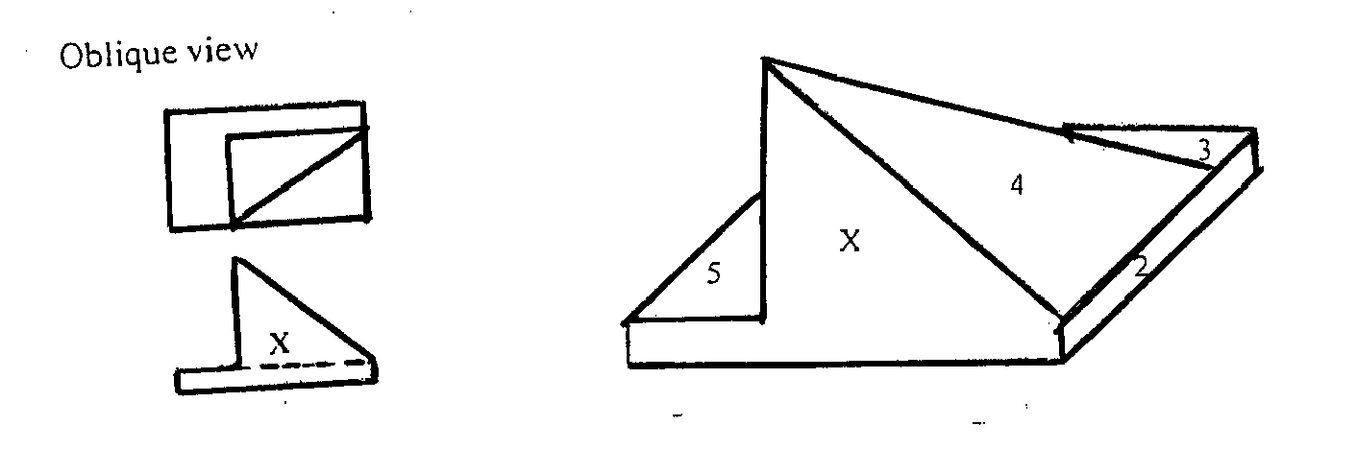 (4 marks)

5.
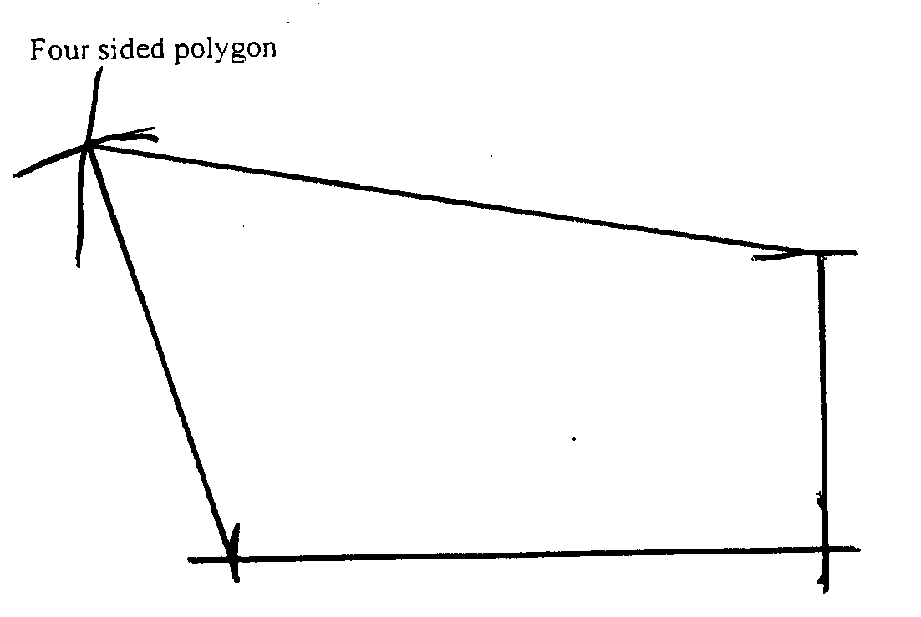
(3 marks)
6.

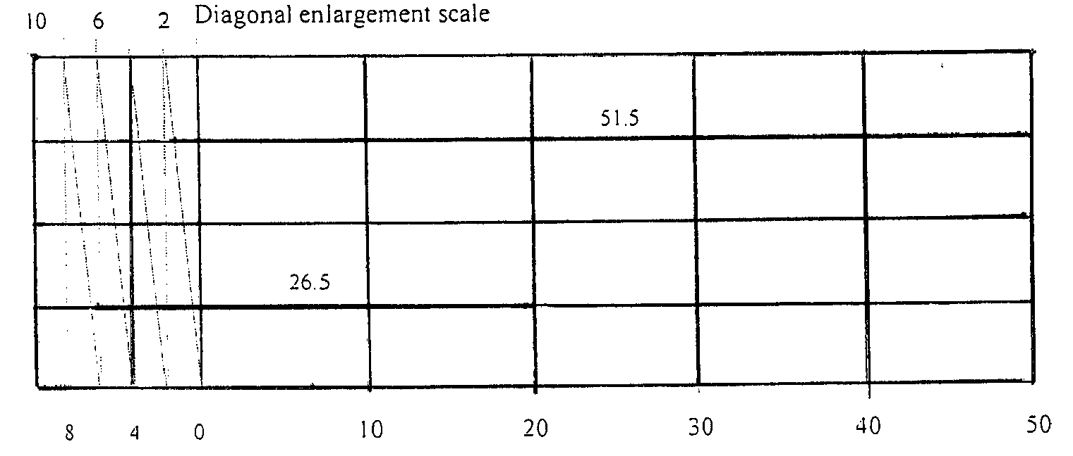
(4 marks)
7.
(a)

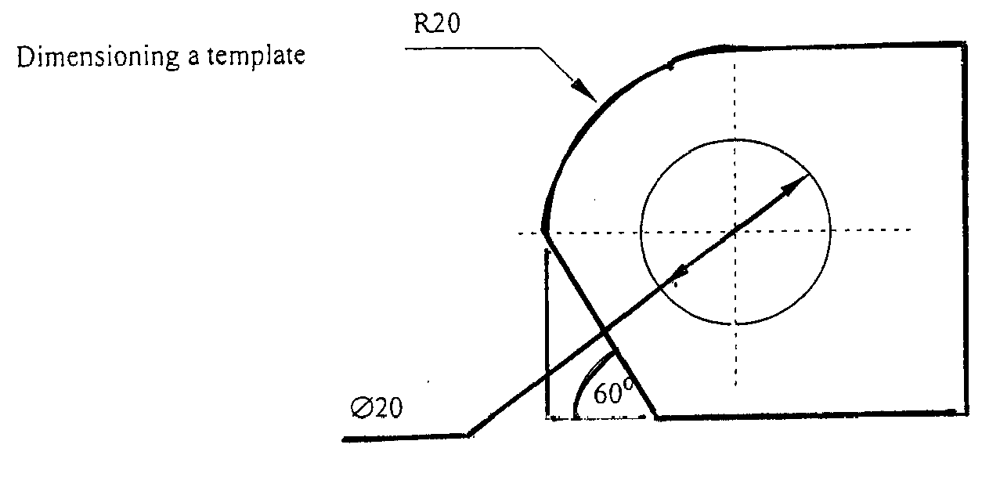

(3 marks)

(b)
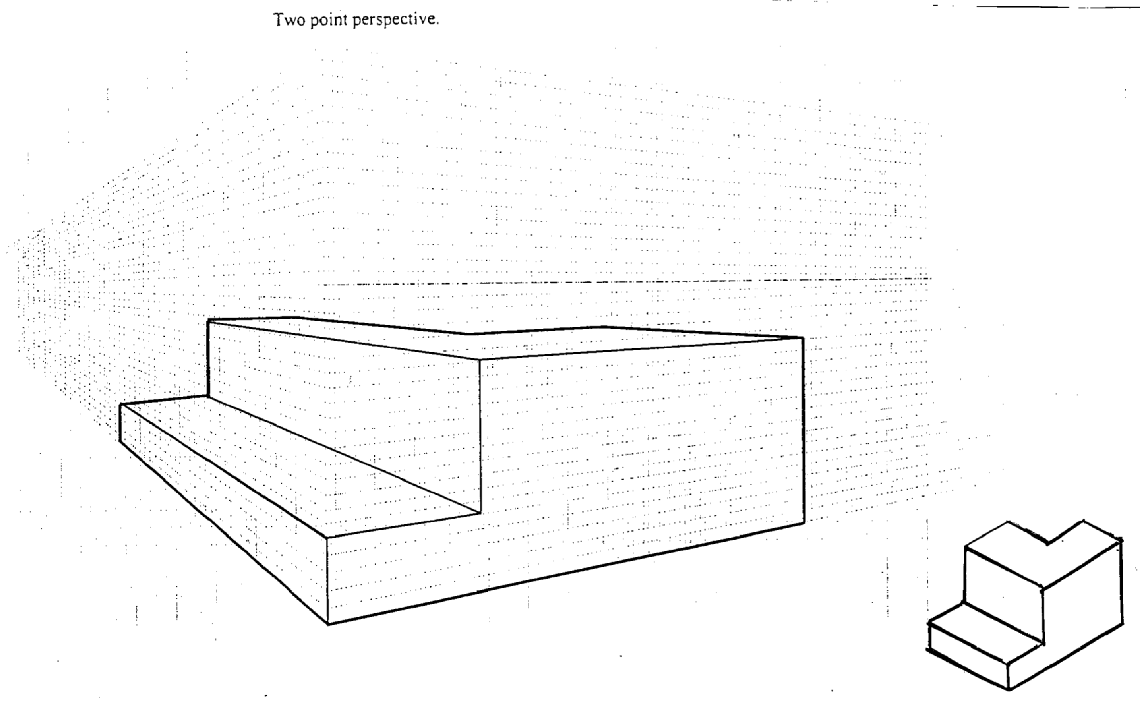
(3 marks)
8.
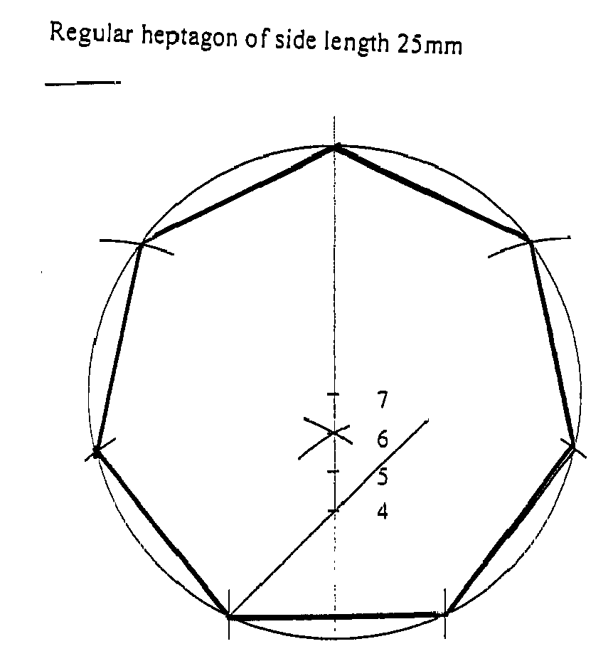
(4 marks)
9.
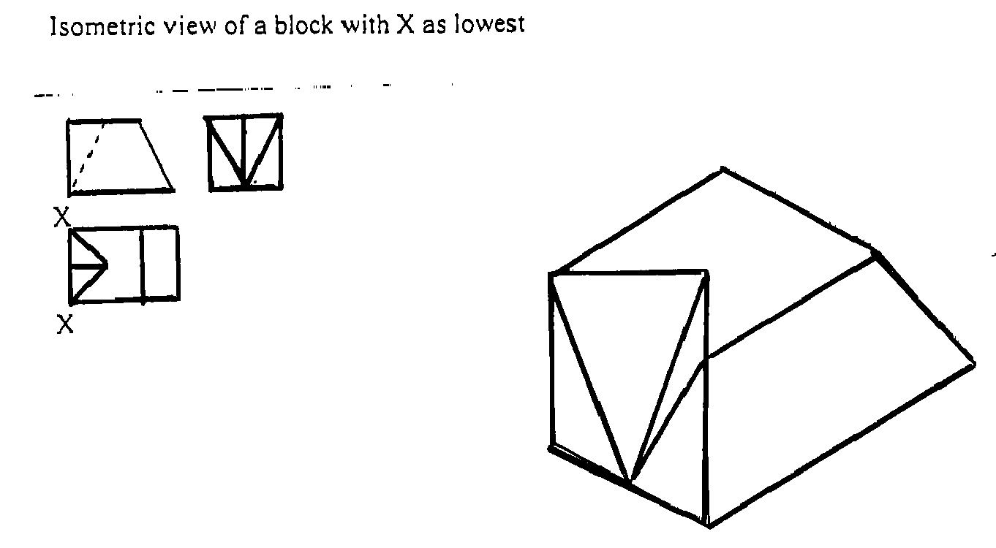

(3 ½ marks)

10.
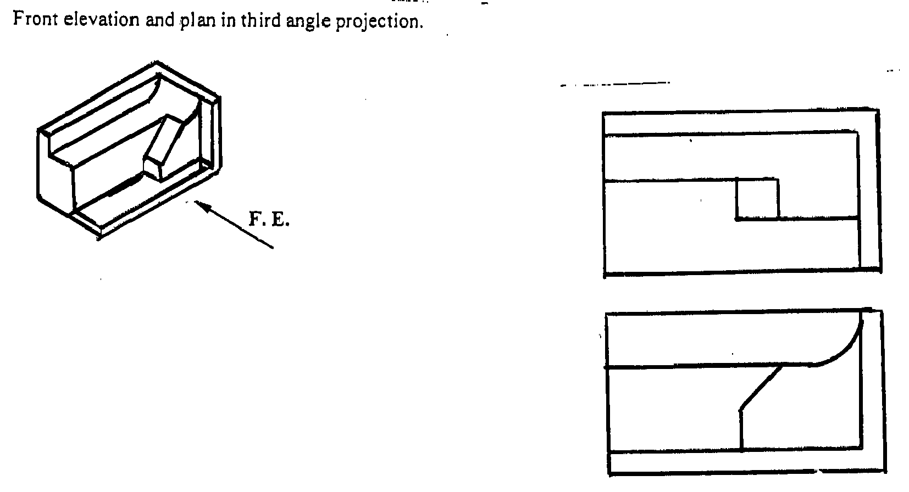
(5 marks)
11.
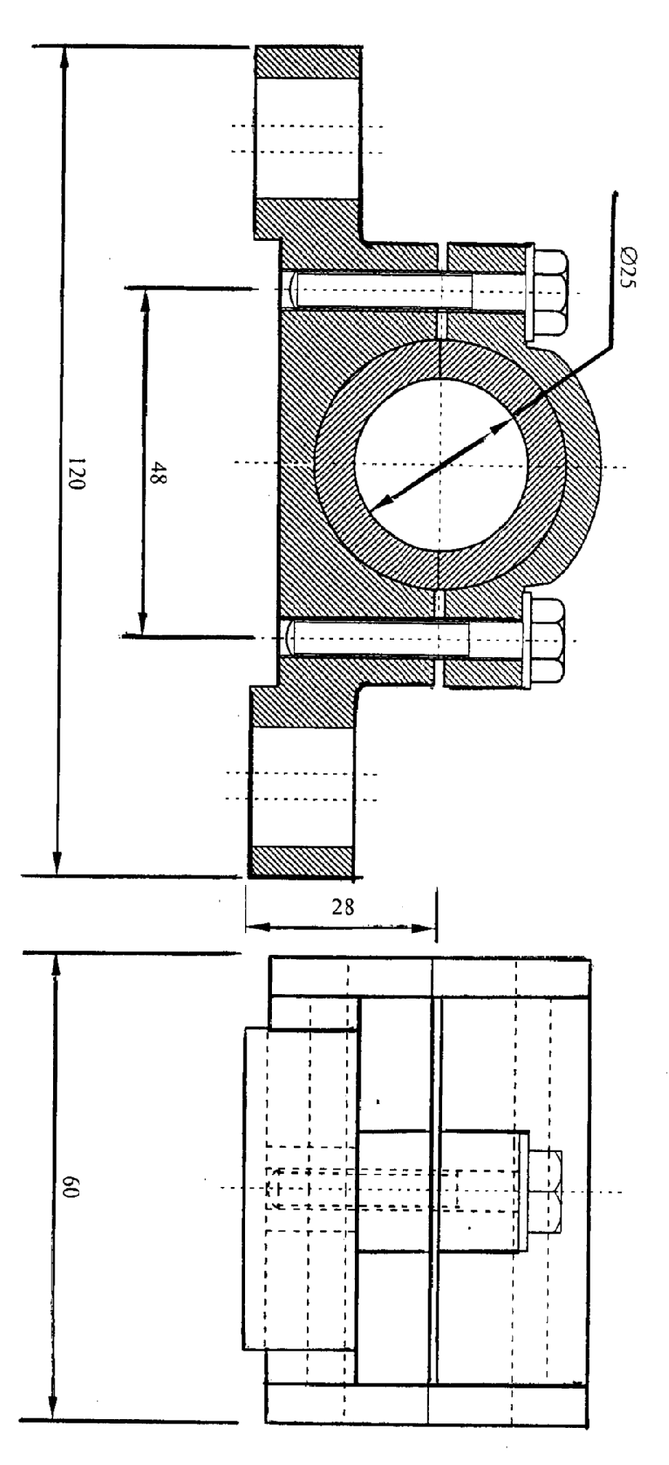
(30 marks)

12.
(a)
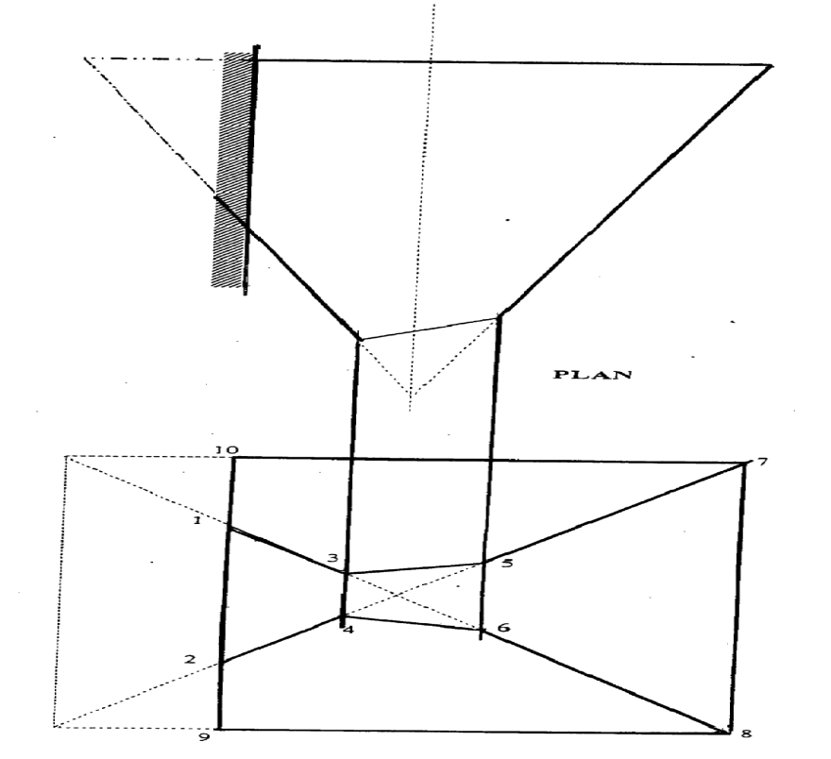

(b)
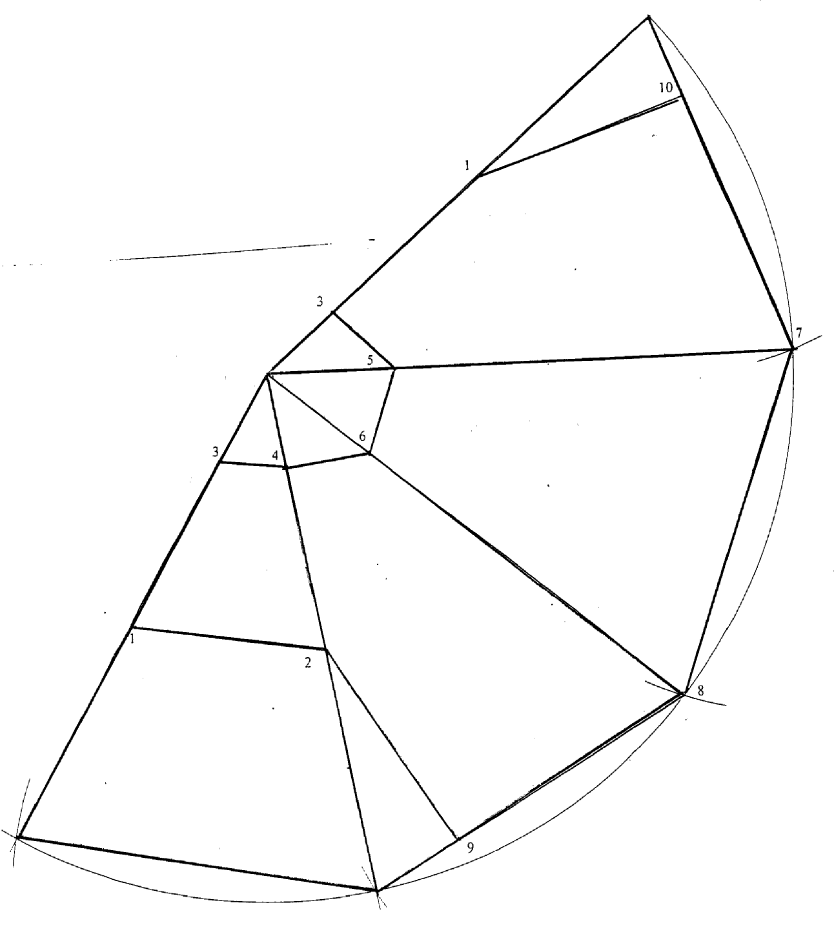

(15 marks)

13.
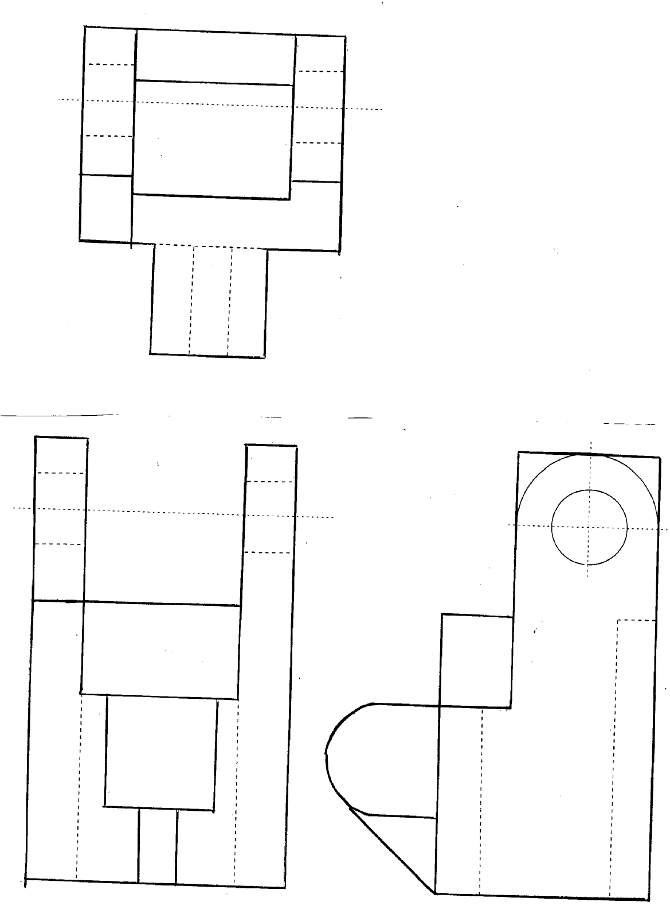
(15 marks)

14.
(a) (b)

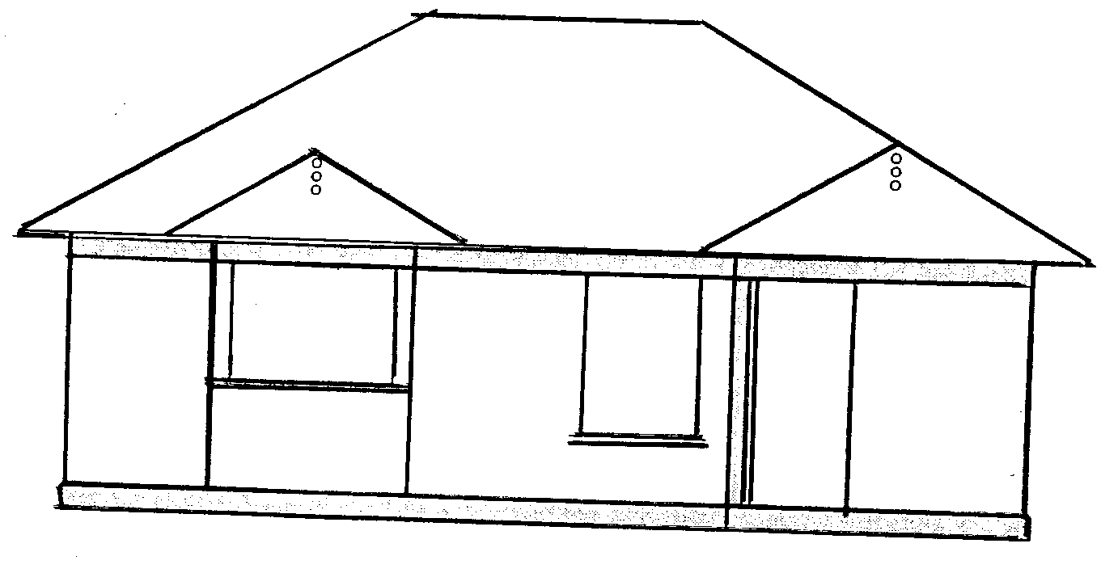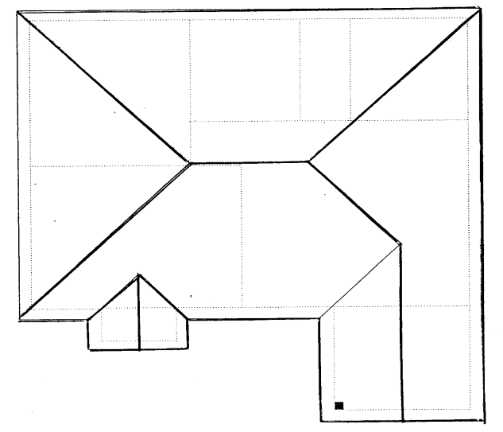
(15 marks)

