* 1. **CHEMISTRY (233)**
     1. **Chemistry Paper 1 (233/1)**

1. Observations:

* + - Crystal dissolves
    - Purple colour spreads in the way

***Explantion***: The crystal break into small particles of potassium manganate (VII) which move in all directions. ***(2 marks)***

2. Mass of hydrated salt=(33.111 – 30.296) =2.815g

Mass of anhydrous salt =(32.781- 30.296) = 2.485g

Mass of water =(2.815 – 2.485) =0.330g

33.111 – 32.781 = 0.330 g ***(3 marks)***

CaSO4 : xH2O

Mass 2.485 0.330

Moles  

Ratio =1 =1

Formula CaSO4H2O ***(3 marks)***

3. I The red litmus paper turns white/the litmus paper is bleached.

II Put a filter paper dipped in acidified potassium dichromate (VI) into the gas.

III The bromine water is decolourised. ***(3 marks)***

4. (a) C13H27COO-Na+ or C14H27ONa+

1. Soap detergent or Soap

(c) (C13H27COO-)2Ca2+ or (C13H27C00-)2 Mg2+ ***(3 marks)***

5. R.M.M of Ca3(PO4)2

Ca=40 × 3 = 120

P=31 × 2 = 62

O=16 × 8 =

H3PO4  H=1 × 3 = 3

P=31× 1 = 31

O=16 × 4 = 64

98

I mole Ca3(PO4)2 gives 2 moles of H3PO4

310g of Ca3(PO4)2 gives 2 × 98g of H3PO4 = 196g

Therefore 155 x 1000g 

=98000g

=98kg ***(2 marks)***

6.

* Propanol ***(2 marks)***
* Butanoic acid

7. (a) Atoms of the same element having different masses.

(b) (18-8)=10 neutrons ***(2 marks)***

8. (a) A black solid.

(b) FeS(s) + 2HCI(aq) FeCl2(aq) + H2S(g)

(c) The powder has a larger surface area than the iron fillings hence the reaction is faster. ***(3 marks)***

9. Zn(s) + H2SO4(aq) ZnSO4(aq) + H2(g)

Zn(s) + 2H2SO4(1) ZnSO4(aq) + 2H2O(1) ***(2 marks)***

10. Magnesium burns in air to form MgO and Mg3N2

Mg3N2 reacts with water to liberate ammonia gas ***(2 marks)***

11. (a) Ionic or Electrovalent

1. ***W:*** has 7 electrons in its outermost energy level and hence easily gains an electrons to complete the octet. ***(3 marks)***

12. (a) Oxygen

1. The pH decreases

HOCI decomposes to give more HCI in the mixture. ***(3 marks)***

1. Pass product E over anhydrous copper (II) Sulphate (1) which turns from white to blue.

**Or**

(Use Cobalt Chloride (anhydrous) which turns from blue to pink. ***(2 marks)***

14. (a) G

(b) A1 ***(2 marks)***

15. ***J:*** the solubility of the substance decreases with increase with temperature. ***(2 marks)***

16.

* Heat the metal in air to form the oxide (CuO).
* Add excess dcl HCI to the oxide to get CuCl2.
* Concentrate the filtrate and leave to crystalise.
* Filter and dry the crystals at room temp/between pieces of filter paper. ***(3 marks)***

17. (a) Amphoteric

(b) Lead, Zinc, and aluminium ***(3 marks)***

18. (a) Position for silicon.

|  |  |  |  |  |  |  |  |  |
| --- | --- | --- | --- | --- | --- | --- | --- | --- |
|  |  | | | | | | |  |
|  |  |  |  |  |  | **R** | **S** |  |
| **N** | **Q** |  | **V** |  |  | **T** | **U** |
| **P** |  |  |  |  |  |  |  |  |
|  |  |  |  |  |  |  |  |  |
|  |  |  |  |  |  |  |  |  |

1. U

(c) 2Q(s) + T2(g) 2QT2(g) ***(3 marks)***

19. (a) Zn(s)/Zn//Ag/Ag(s)-

Cu(s)/Cu//Ag/Ag(s)

* + The solution changes to blue because Cu metal dissolves to form

Cu

* + Metal silver is deposited on the sides of beaker because Ag+ reduced to

Ag(s) ***(3 marks)***

20. (a) At constant temperature and pressure, the rate of diffusion of a gas is inversely proportional to the square root of its density.

(b) 

 =

RX=7.24cm3S-1 ***(3 marks)***

21. (a) Cu2+(1) moving towards the cathode .

(b) 40H- – 4e 2H2O(1) +)2(g)- ***(3 marks)***

22.

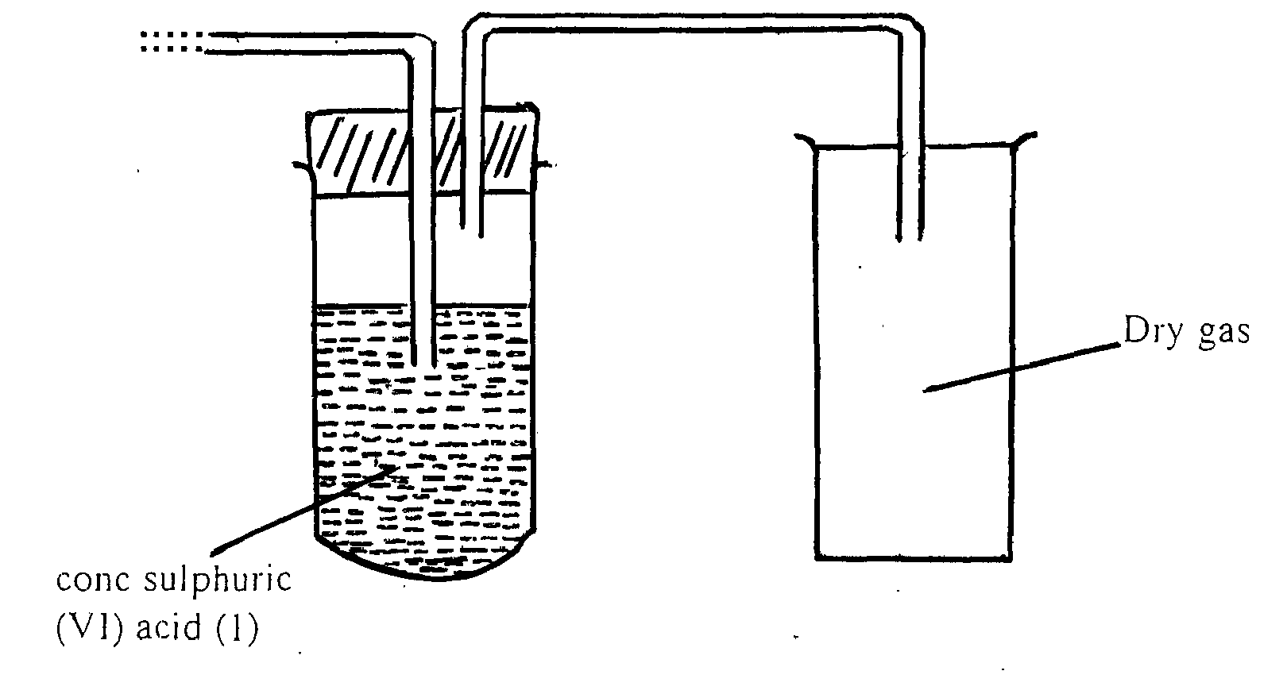 ***(3 marks)***

23. The brown colour of the mixture intensifies/increases and the green colour of the mixture fades/decreases. Iron (II) is converted to Fe3+ ***(2 marks)***

24. (a) He

(b) (i) Z1 = 235,(½) Z2=54

(ii) Nuclear fission ***(3 marks)***

25. (a) Cooling

1. Latent heat of fusion ***(2 marks)***

26. (a) I – Pb2+

II – CO

(b) PbO(s) +2H Pb+ H2O(1) ***(3 marks)***

27. (a) Mg(0H)2(ag) + 2HCI (aq)MgCl2(aq) + H2O(1) or mole ratio

No of moles of acid = 0.0023

Moles of Mg(OH)2 in antacid

=0.00115 × 58=0.067g

(b) % of Mg(OH)2 in anticid

Mg(OH)1 2 =×100=13.4% ***(3 marks)***

28. (a) (i) C-1Cryolite

(ii) D-1 Electrolysis ***(2 marks)***

(b)

* + Good conductor.
  + Meleable.
  + Light.
  + Does not corrode easily.
  + High melting point.
  + Does not rust. ***(1 mark)***

29. (a) Gas syringe/graduated gas cylinder.

(b) (i)  
 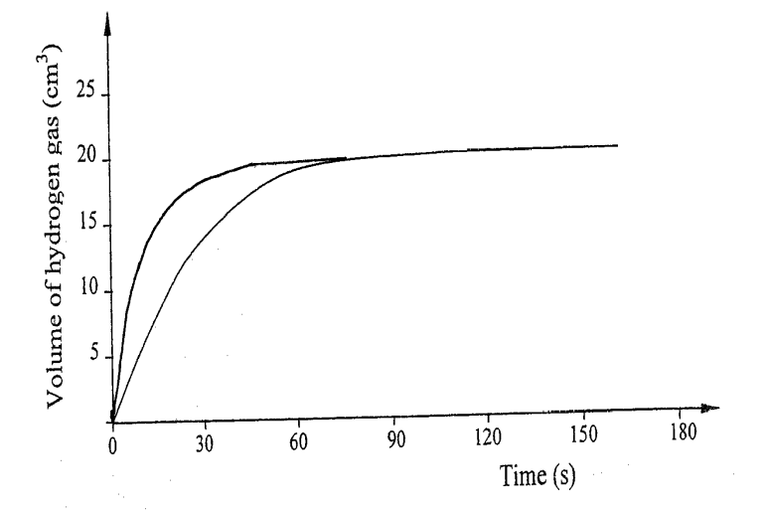

(ii) The molecules of the reactants have higher energy the reaction is faster.

***(3 marks)***

30. It burns to form SO2 which is a pollutant as it causes breathing problems and acid rain. ***(1 mark)***

31. (a) Neutralization

(b) (i) Calcium hydrogen carbonate.

(ii) Drying agent. ***(3 marks)***