30.21.2 Aviation Technology Paper 2 (450/2)

Station 1

Item | Description | Quantity
1  2  3  4  5  6  7  8  9  10  11  12  13  14 | Crankshaft  Piston  Connection rod  Gudgeon pin  Compression rings  Oil rings  Scraper rings  Bolts  Nuts  Bush bearing  Half bearing  Circlips  Washers  Connecting rod cap | 1  6  6  6  6  6  6  12  12  6  12  12  12  6
(10 marks)
Station 3

(a)

Weather Condition |  | Cause | Hazard
D | Lightning | Thunderstorm | Interference in radio / electric systems
E | Tornado or swirl wind | Several thunderstorms | Aircraft becomes uncontrollable
F | Fog | Condensation of air near the ground | Visibility is marred
(9 × ½ =4½ marks)
(b)
(i) The feather swings freely and then settles at the direction where blown from.
(1 mark)
- Wind vane / anemometer: which is used to indicate the direction of the wind.
(1 mark)
Airport, Airstrip or Airfield ( ½ marks)

- To guide the pilot during take off and landing on the direction of the wind.
(1 mark)
Station 4

- Correct type
- Area of use
- Material
- Size (4 ×½ =2 marks)

Station 5

(a) (i) G: Cylinder
H: Spart plug
J: Compression ring

(ii) Aeropiston engine (4 ×½ =2 marks)

- (i) As per sampled data.
- Tapered or Parallel. (2 × 2 = 4 marks)

- H: Correct gap for S.P as per sample data.
J: Correct gap for ring as per sample data. (2 × 1 = 2 marks)

(d) Too large:
- Loss of power.
- Hard start.

Too small:
- Excessive smoking.
- Excessive oil consumption. (4 ×½ =2 marks)

Station 6

(a)

Part | Name | Defect
M | Disc type brake | Burnt
N | Wheel cylinder piston | Worn out
(3 marks)
(b) (i) Mechanical gear pump

(ii)
- Red: suction port.
- Blue: discharge.
- Black: driver gear.
- Green: driver gear.
- Brown:pump housing. (6 ×½ =3 marks)

- Lubrication system.
Hydraulic system. (2 ×½ =1 mark)

(c) (i)

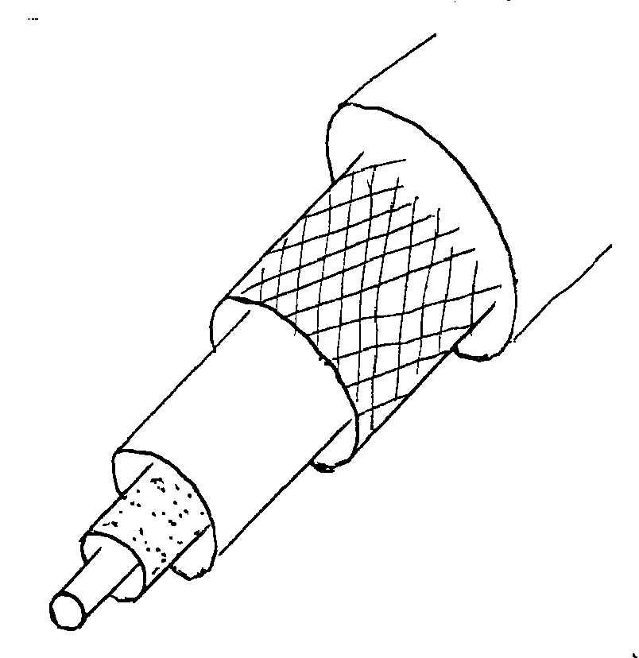 (5 ×½ =2 ½ marks)

(ii) Common defects:
- frying
- chamfing (½ mark)
Station 8

(a) (i) K attracts M. (1 mark)
(ii) L is not attracted by M. (1 mark)
- K is magnetized while L is not. (1 mark)

(b) (i) J rotates and seeks the magnetic north.
(ii) The assembly floats and settles at magnetic north.
(iii) Assembly is attracted to the sides of the basin.
(iv) Pins attracted by the magnet. (4 × 1 = 4 marks)

(c) Systems:
- Navigation.
- Monitoring of component wear in a/c oil system. (2 × ½ = 1 mark)

(d) Maintenance aspects:
- Compass swing.
- Soap (spectrometric oil analysis programme. (2 × 1 = 2 marks)

Station 9

(a) (i)
- Correct length;
- Correct diameter;
- Correct distance across flats;
- Correct thread pitch as per sample.

(ii)
- Correct method;
- Correct material;
- Correct thread type;
- Correct spanyer size. (8 × ½ = 4 marks)

(b) Correct measurement
(i) Inside diameter.
(ii) Depth . (2 × 1 = 2 marks)

(c) Rejection criteria:
- If fiber is worn.
- Subjected to high temperature. (2 × ½ = 1 mark)
(d)

Item | Name | Maintenance Check
X | Non Return valve | Sticking spring
Y | Roller bearing | Corrosion & free ball movement
Z | Perspex | Crazing or breakage
(6 ×½ =3 marks)
Station 10

(a) (i) As per sample data.
(ii) As fan rotates slowly, set up moves backwards.
- Fan moves faster: set up moves faster.
- Fan moves fastest, so does the set up. (7 ×½ =3 ½ marks)

(b) Fan accelerates air forward movement increases with fan speed. (2 marks)

(c) Law: Newton’s 3rd Law of motion.
Principle: For every action there is equal and opposite reaction. (2 × 1 = 2 marks)

(d) Aircraft propeller. (½ mark)

(e)

Position
0 | Engine is off | No thrust
1 | Minimum thrust | Idling
2 | Normal power | Cruising
3 | Maximum power | Take off
(4 × ½ = 2 marks)

