30.21 AVIATION TECHNOLOGY (450)

30.21.1 Aviation Technology Paper 1 (450/1)

1. (a)
- Inadvantent selection of landing gear.
- Selection of landing on ground.
- Pressurizing of aircraft on the ground.
- Firing of ammunition on the ground.
- Selection of anti icing system. (Any 3x½ =1 ½ marks)

(b)
  - Pilot is calling the tower and gives registration of aircraft as 5YZBT.
  - Pilot is reporting that a/c is ready for take off.
  - Tower responds and repeats registration number 5YZBT.
  - Tower instructs the pilot to proceed on runway 19 on the right hand side.
(4 x ½=2 marks)

2. (a)
- Lead acid.
- Nicket cadmium. (1 mark)

(b)
- Maintains dc system voltage under transient conditions.
- Supply power for short term heavy load when the generator or ground power is not available.
- Supply limited amount of power to operate essential services in case of an emergency. (3x1=3 marks)

3. (a) (i) Pilot has to decide whether to land or overshoot.
(ii) Pilot has to decide to stay on ground or change route if weather conditions are adverse. (2 x 1 marks)

(b) (i) Wind: horizontal movement of air relative to surface of the earth.
(ii) Cloud: visible clusters of water droplets or ice particles in the atmosphere.
(2 x ½=1 mark)

4. (a) Skin Friction :-Resistant force between molecules of the air and the surface of the aircraft skin. Can be minimized by polishing and painting the skin.

(b) Form Drag:- Resistance force caused by shape of the aircraft as the air flows. Minimized by streamlining the shape of the aircraft. (4 marks)

5.
- To soften metal (annealing).
- To harden/to resist wear (hardening).
- To remove some extreme brittleness (tempering).
- To refine structure after it has been disturbed by hammering (Normalizing).
(4x1=4 marks)

6.
- Compressor: A series of blades or airfoils some rotating (rotors) some stationery (stators) that draw air and compresses.

- Combustion chamber: Circular container consisting of flame tubes, burners, igniters etc. in which atomized fuel and air are ignited for combustion.

- Turbines: devices comprising rotors and stators which gain tongue from expanding gases to turn the compressor and other accessories. (3x1½ = 4½ marks)

7. Semimonocoque

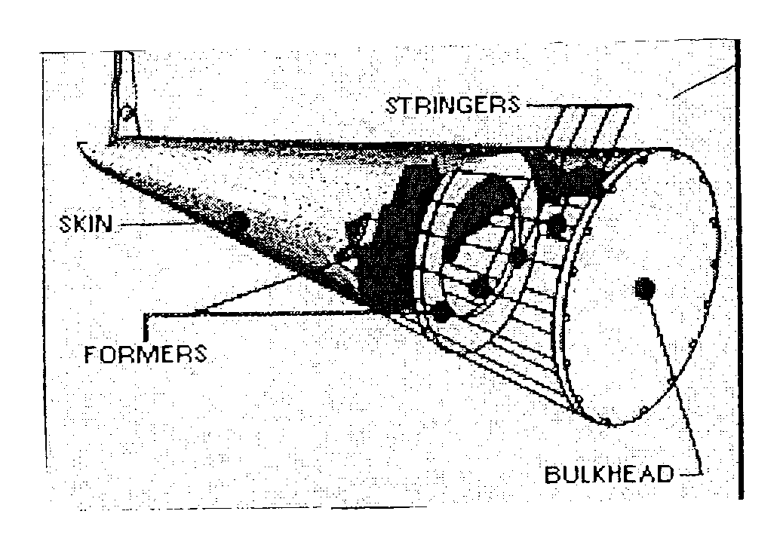
(3 marks)
Semimonocoque literally means half a shell.
- It comprises internal braces which include longitudinal and vertical members.
- Longitudinal members are stringers and or lengerons.
- The skin provides cover and carries most of fuselage strength. (4 x ½ =2 marks)

8. (a) (i) Acuating cylinder: Converts hydraulic power to mechanical power.
(ii) Selector valve: Determine the direction of movement of the actuator.
(2 x 1=2 marks)

(b)
- When operators moves the handle, allow pressure to form in the chamber of the pump.
- Since the reservoir liquid is greater, the liquid is forced around the check valve from the reservoir line.
- When the pump handle is moved in opposite direction, a positive pressure will form in the pressure chamber causing the check valve to close on reservoir side.
- Since the liquid is incompressible, it is forced out through the outlet check valve to the system line. (4 x ½=2 marks)

9. (a)
- Strength.
- Material.
- Size and tolerance.
- Finish. (4 x ½=2 marks)

(b)
- Corossion resistance.
- Tensile strength.
- Temperature resistance.
- Weight to strength ratio. (4x ½ =2 marks)

10.
- Shape: presented as view, from various standard directions.
- Dimension: size of the object presented in accepted units.
- Material: indicates what it is made of.
- Tolerance: allowable variations for each dimension.
- Finish: specifies the surface quality of the item. (Any 4x1=4 marks)

11.
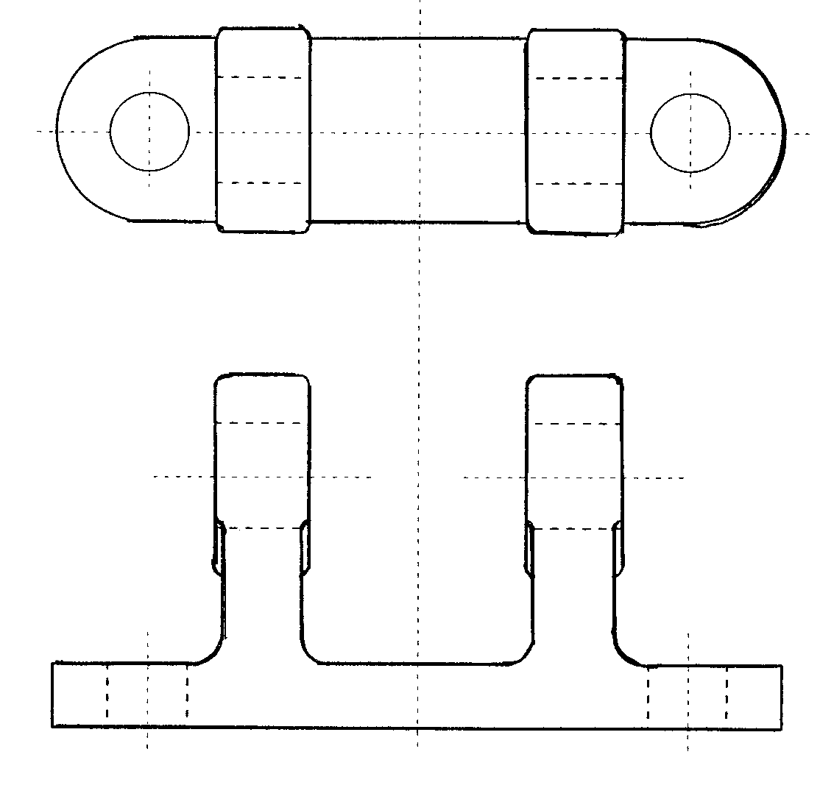 (15 marks)
12. (a)

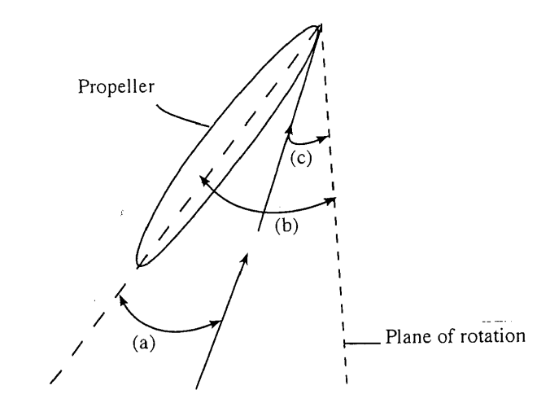 (2 marks)
Chord line
a - angle of attack
b - pitch or blade angle
c - helix angle

(a) Between the chordline and relative wind flow.
(b) Is the angle that the chordline of aerofoil makes with the plane of rotation.
(c) Is the angle between rotation plane and relative wind. (3x1=3 marks)

(b) Operation of A/C Propeller: Propeller consists of blades which are aerofoil section and is rotated by the engine.

- The propeller converts engine power into aerodynamic forces.
- The portion of the force acting forward is thrust power.
- The portion acting in the plane of rotation is the propeller torgue.
- The thrust conversion efficiency depends on the configuration and aircraft forward speed.
- The simple fixed pitch configuration is inefficient at most speeds while the variable pitch, constant speed propeller is reasonably efficient at most ac speeds.
(6 x 1=6 marks)

(c)
Fine pitch propeller:
- Has low blade angle, will move forward a small distance through the air and will take a small volume of air.
- Requires relatively low power to rotate, allows high propeller speed to develop and achieves only limited airspeed.

Coarse pitch propeller:
- Has high blade angle, will advance a long distance through the air and will take large volume of air.
- Has high blade angle, will advance a long distance through the air and will take long volume of air.
- Requires greater power to rotate, limits propeller speed that can be developed and achieves high airspeeds. (4x1=4 marks)

13. (a) Dynamic Stability: The aircraft responds to momentarily disturbance which is associated with its inherent degree of stability built in by the designer in each of the three axes. The net sum of all the forces equals to zero. (3x1=3 marks)

(b) Expression of AC stability.
Is expressed in relation to each axis: that is,
- Lateral or stability in roll.
- Directional or stability in yaw.
- Longitudinal or stability in pitch.
Where lateral and directional are inter-dependent. (3 marks)

(c) Degree of dynamic stability

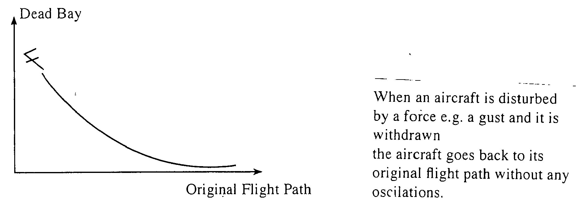

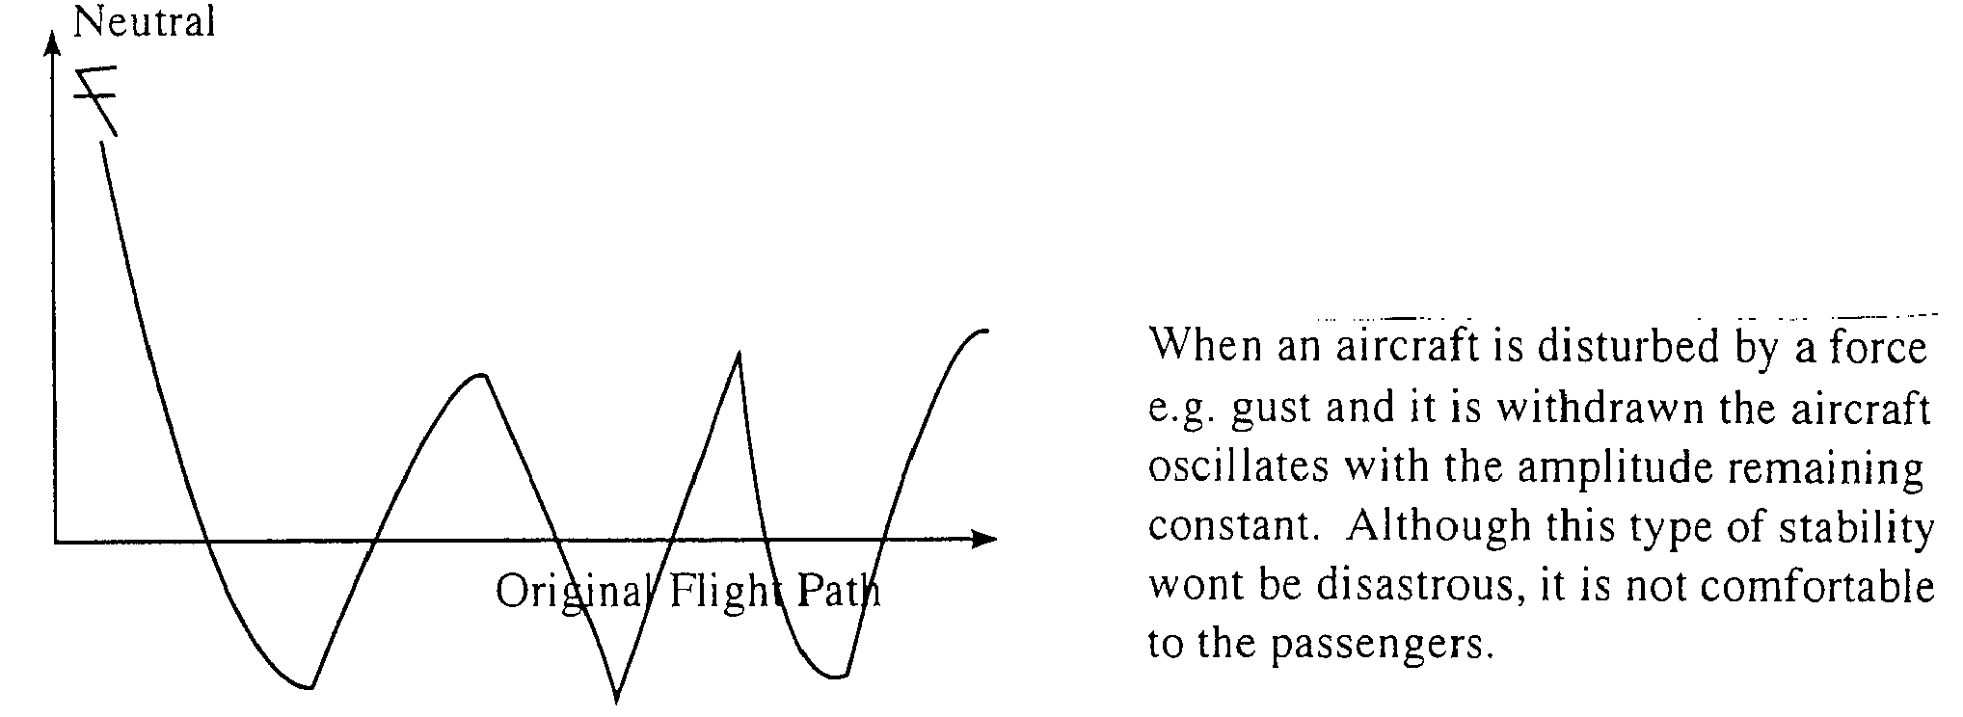

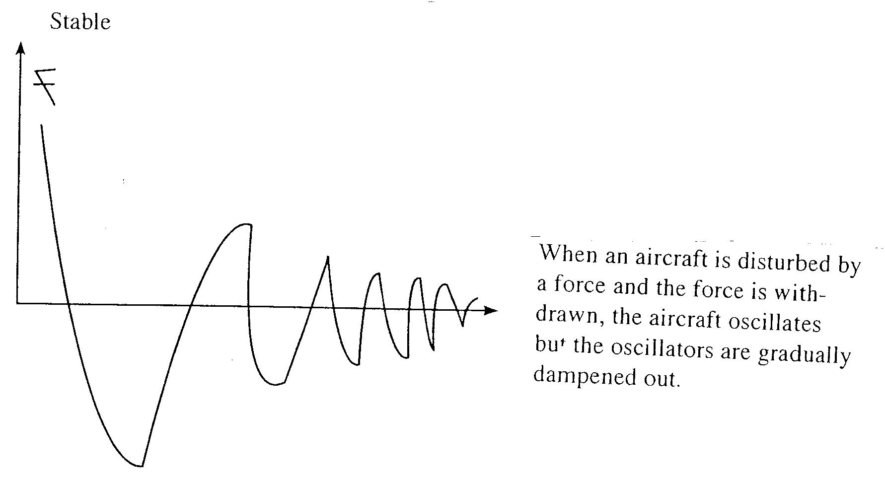
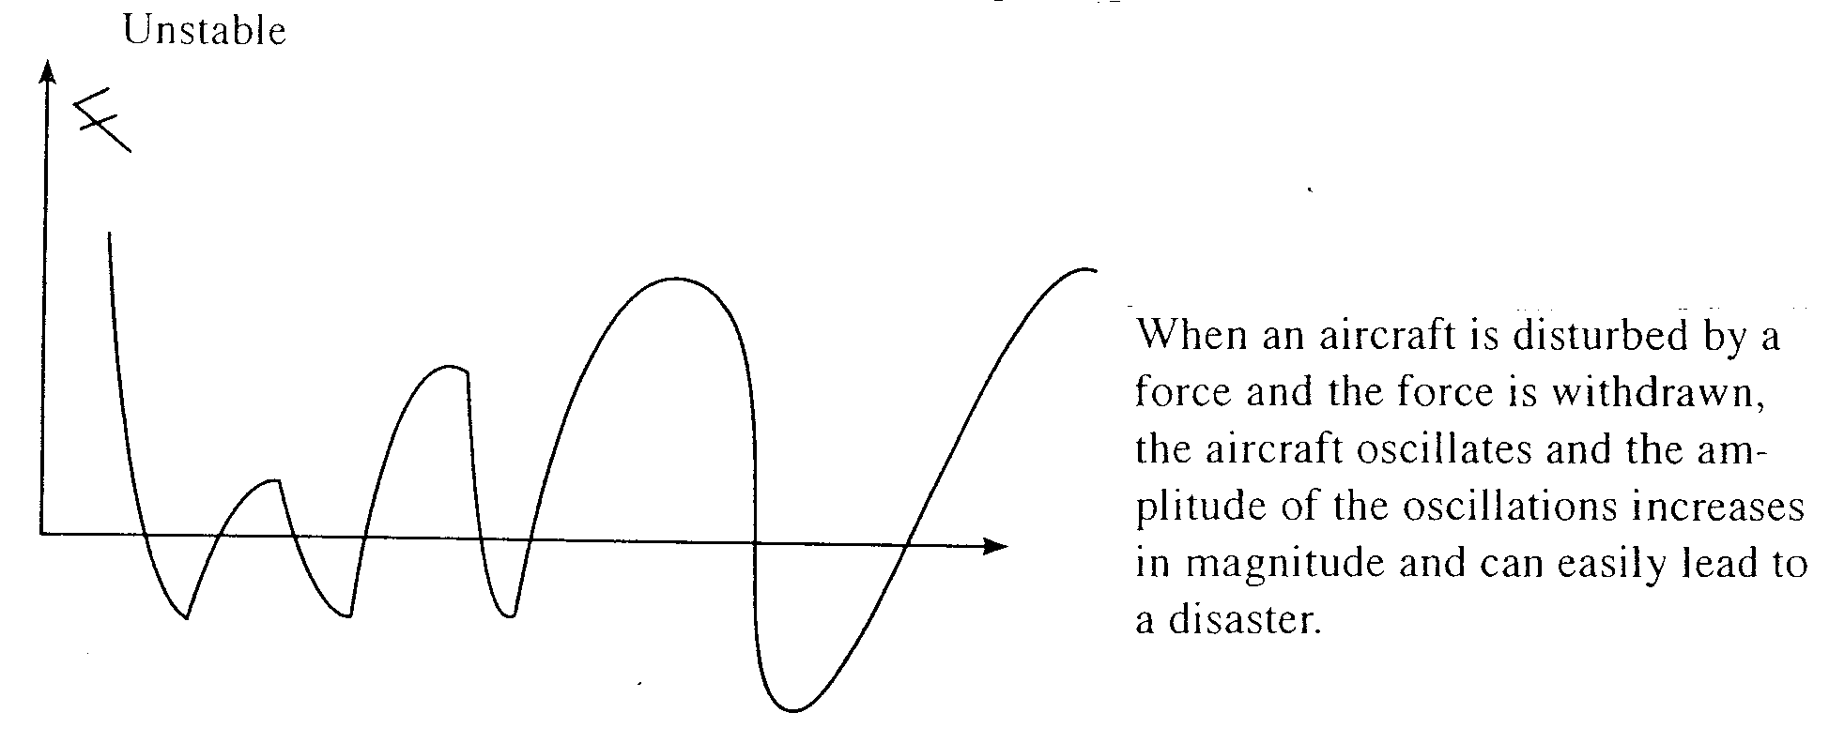

(4 x 1½ = 6 marks)
14. (a)
    - Position the aircraft in the painting hanger.
    - Earth or bond the aircraft.
    - Mask areas not to be painted.
    - Remove the old paint.
    - Clean the aircraft surfaces to be painted.
    - Inspect and rectify any defects.
    - Pretreat the surface.
    - Prepare and apply the primer.
    - Prepare and apply the paint.
    - Polish the surface.
    - Unmask the aircraft.
    - Remove the earthing/bonding.
    - Complete the documentation.
    - Discharge. (14 x ½= 7 marks)

(b)
(i) Technical defect: Can result in failure of entire aircraft. Failure of navigation and other equipment.
(ii) Weather : May lead to pathological (uncontrollable) condition. Can cause instant failure, for example:- lightening strike.
(iii) Servicing error: Unknown engineer fault. Failure to conform to preventive maintenance schedule.
(iv) Pilot error can lead to: Wrong decision or action. Omission or incompetence.
(4 x 2=8 marks)

15. (a) Aircraft Systems.

- Oxygen: Provides oxygen for breathing to permit normal activities.
- Air conditioning: Provides a moderately habitable atmosphere within the cockpit and cabin for the aircrew and passengers.
- Aircraft pressurization: Enables same ambient atmospheric pressure at higher altitudes by compensating for lowered pressures.
- Radar: Detects and reports reflections of aircraft weather and objects with a given range in the sky.
- Communication: Sends and receives information between an aircraft and the ground.
(5 x 1=5 marks)

(b)
- VOR (very high frequency omni range) provides guidance on any track to or from the station.
- DME (Distance measuring equipment) provides information on distance between the ground and the aircraft.
- ADF (Automatic direction finder) means of identifying positions, homing, tracking in navigation approach procedures.
- RMI (Radio magnetic indicator) provides bearing and heading indications in relation to magnetic north.
- Compass assists the pilot to know the direction in relation to the true north.
- Course Deviation indicator shows the pilot how far from the heading the plane has drifted.
- Artificial horizon – shows the pilot the attitude of the aircraft in relation to the horizon (ground). (Any 5 x 2=10 marks)

