30.14.2 Agriculture Paper 2 (443/2)

1.
- Ambient temperature/humidity.
- Level of production/amount of work done by the livestock.
- Species of the livestock/breed/type of animal.
- Weight/size/age of livestock.
- Physiological status, for example:- health and pregnancy.
- Type of feed taken by the livestock. (4 x ½ =2 marks)

2.
- Active ingredients of acaricide/ability to kill ticks.
- Persistence of the acaricide/stability of the acaricide/ability to remain effective after fouling with hair, mud, dung and dirt.
- Concentration of the acaricide in the mixture/dilution.
- Weather condition during application.
- Thoroughness/skill of application/method of application (3 x ½=1½ marks)

3. Angora goat. (½ mark)

4. Homogenization is the mechanical breakdown of large fat globules in milk into smaller fat particles which are then evenly distributed in milk, while Pasteurization is the heating of milk to a certain temperature followed by chilling in order to kill harmful bacteria that spoil the milk. (1x1=1 mark)
5.
- Wire strainer.
- Monkey strainer. (1x ½ =½ mark)

6.
- Driving wedges in when splitting wood.
- Braking/crushing big stones/Demolishing farm structures. (1 x ½=½ mark)

7. The application of antibiotics into the teat canals of the cow’s udder after drying off the cow to prevent mastitis/bacteria infection. (1 x 1=1 mark)

8. Increased vigour and performance as a result of crossing two unrelated breed.
(1 x 1=1 mark)

9.
- Age of the equipment.
- Wear and tear/use.
- Lack of maintenance practice.
- Exposure to weather/improper storage.
- Wrong use of the equipment.
- Obsolescence/change in technology. (4 x ½=2 marks)

10. For the attachment of trailed implement. (1 x ½=½ mark)

11.
- The oil bath air cleaner/wet air cleaner.
- The dry type air cleaner. (2 x ½=1 mark)

12.
- To prevent the germinal disc from sticking on the egg shell which may lead to death of the embryo.
- To make sure warmth is distributed evenly around the egg for uniform embryotonic development. (1 x ½ = ½ mark)

13. Caecum. (1 x ½= ½ mark)

14.
- Reinforcing with concrete.
- Cutting the top of posts at a slope.
- Covering the top of posts with metal plate.
- Charring/sling burning of posts.
- Applying wood preservatives scopper sulphate, cresole, pentach.
- Painting.
- Apply old engipe oil.
- Seasoning/propen diedrin/sodium dicronate drying tarnex. (2 marks)

15.
- Spray race.
- Footbath.
- Housing/shed.
- Fences.
- Crush.
- Plunge dip. (4 x ½=2 marks)

16. Mothering ability refers to that ability of the dam (mother) to take care of the offspring until weaning whereas Prolificacy is the ability of the female animal to give birth to many offspring at the same time, for example:- a litter. (1 x 1=1 mark)

17.
- Zygote implanation is facilitated.
- Facilities production of more ova.
- Increases conception rate.
- Increases lambing percentage/encourages multiple births in ewes. (1 mark)

18.
- It is used for cooking.
- Facilitates production of more ova.
- Increase conception rate.
- Increase lambing percentage/encourages multiple births in ewes. (3 × ½ =1 ½ marks)

19. Birna virus/virus. (½ mark)

20. (a) By restricting animal movements and their products from and into the affected areas in the event of an outbreak of a notifiable disease thus preventing the spread of the disease. (1 x 1=1 mark)

(b) By preventing the occurrence of the disease using preventive drugs. (1 mark)
21
- To avoid deficiency diseases.
- Make the animal robust/strong enough to be able to resist disease attack.
(2 x ½=1 mark)
22.
- Age of animal:- older animals are more prone.
- Stage of lactation period:- more prone at the beginning and also at the end.
- Udder attachment/large penclulous udders are more prone.
- Incomplete milking.
- Mechanical injury on the teats.
- Poor sanitation.
- Poor milking technique. (4x½=2 marks)

23.
- Cause irritation.
- Damage the wool (due to scratching/lower quality of wool.
- Cause retarded growth.
- Cause anaemia.
- Bites and injuring the skin/create wounds. (2x 1 = 2 marks)

24. (a) Landrace. (1 mark)
(b) Hereford. (1 mark)

25. (a) B1:- Milk secretory cells/alveoli cells/lactiferous alveoli.
B2:- Milk duct/mammary duct/lactiferous duct.
B3:- Gland cistern/milk/lactiferous sinus. (3 marks)

(b)
- For milk secretion.
- For milk synthesis. (1 mark)

(c) The lining of teat cistern/sinus/Teat canal. (1 mark)

26. (a)

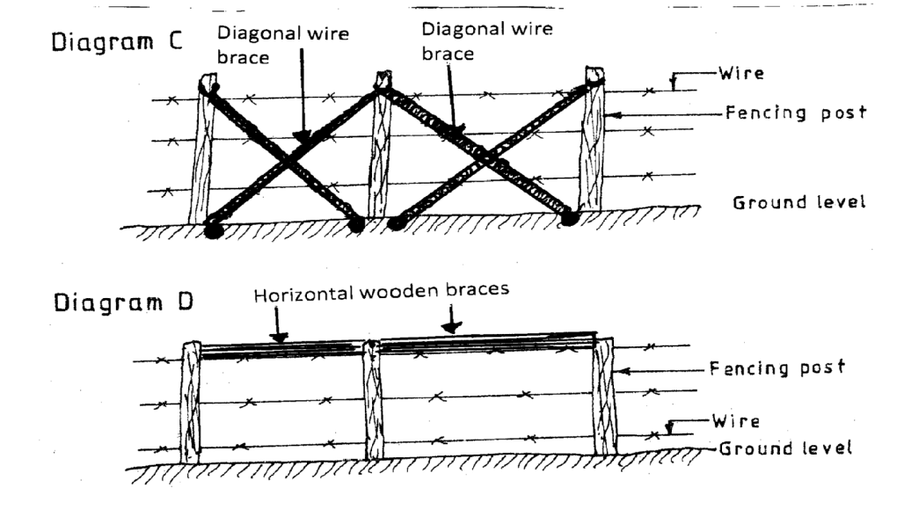 (2 marks)

(b) (i) E:- Cannula
F:- Trocar (1 mark)

(ii) Used to relieve bloat in animals/accumulation of gases in rumen.(1×½= ½mark)

(iii)
- Both equipment are inserted at the apex of the enlarged area, on the left side of the animal/plate/sublumbar renion.
- The trocar is then withdrawn while holding the cannula until the bulk of the gas escapes.
    - Remove the cannula there after. (2 marks)

27. (a) G:- Fan.
H:- Fin/Radiator Fins.
J:- Head tank.
K:- Thermostat. (2 marks)

(b)
- G (Fan):- used for blowing cool air current through the fins to assist in cooling hot water coming from the engine block as it moves to the head tank for further circulation.
- J (Head tank):- Holding/storing water for the cooling system.
- K (Thermostat):- used for regulation of the temperature of water in the engine.

28. (a)
- Stage 1:- The eggs on the ground hatch into larvae which emerge and climb onto the host and feed on blood.
- Stage 2:- The engorged larvae moult into nymphs which emerge and feed on blood.
- Stage 3:- The engorged nymphs moult into adult which emerge and feed on blood of host.
- Stage 4:- The engorged adults mate and the female drops to the ground. (4 marks)
(b) A one-host tick. (½ mark)

29. (a)
- Claw hammer: - For driving nails into the wood during construction and removing of nails from wood.
    - Tinship:- For cutting sheet metal.
    - Pliers:- For cutting wire.
    - Mallet:- For hitting the chisel when cutting grooves in wood.
    - Wood chisel:- For cutting grooves in wood or beveling.
    - Jack plane:- For smoothening wood.
    - Tape measure/rule:- For measuring lengths of materials to be used.
    - Marking gauge:- Marking line on wood.
    - Spirit level :- Determine the vertical/horizontal straightness.
    - Hand saw/rip saw:- For cutting wood into pieces required.
    - Clamp:- For holding pieces of wood together when cutting or joining wood.
    - Screw driver:- For driving screws in wood or removing screws from wood.
    - Scriber:- For marking lines or metal sheets.
    - Try square:- To measure or determine the right angles. (10 marks)

(b)
- Cost of the materials to be used.
- Availability of required skills/labour.
- Availability of capital for the kind of material
- Availability of materials required.
- Environmental conditions such as presence of pests, soil type climate.
- Durability/quality/strength of material.
- Type of the dairy shed-whether temporary or permanent.
- Toxicity of the materials to do the work in question.
- Toxicity of the materials to the animal, for example:- use of non-toxic painting materials like the white wash.
- Workability/applicability of the material.
- Farmers tastes and preferences. (10 marks)

30 (a)
- Ensure the calf suckles the cow within the first 8 hours to get colostrums.
- Feed the calf on colostrums for the first four days.
- Feed the calf 2-3 times per day for the first 4 weeks.
- Introduce the feeding of whole milk/milk substitutes after the 4th day.
- Feed the calf on correct amount of milk up to weaning.
- Feed the calf with warm milk to avoid calf scours/milk should be fed at appropriate temperature and at regular intervals.
- Provide adequate clean water to the calf from the 3rd week.
- Introduce palatable dry feeds such as concentrates/calf pellets/calf pencils and good quality cut grass for the 3rd week.
- Any change in feeding should be done gradually to avoid nutritional disorders.
- Clean equipment should be used for feeding calf.
- Calf should be trained to suck the milk from the bucket/bucket feed. (10 marks)

(b)
- Milking equipment should be clean.
- Clean milking parlour/shed.
- The udder should be cleaned before milking.
- The milkman should be clean and healthy.
- The cows should be tested for mastitis before milking.
- Cows with mastitis should be milked last and milk disposed of.
- The milk should be sieved/filtered after milking.
- The milk should be stored in a cool dry place/proper storage.
- Cow should be healthy/check the cows regularly for milk-borne disease.
- The milk should be covered after milking.
- Feeds that can taint milk should be avoided/equipment that can taint milk should be avoided.
- Milk should be cooled immediately to reduce bacterial multiplication
- Chip hair around udder and flank. (10 marks)

31 (a) (i)
- Is used to attach the trailed or mounted implements on a tractor.
- Lower links are hitched to the lower links of the implement.
- The adjustable top link is attached to the top link of the implement.
- The top link lifts the implement through the hydraulic power system when in operation or during transportation.
- The lower links hold the implement in place to provide stability.
- The check prevent the implement from getting into the tractor tyres when the tractor is moving. (6 marks)

(ii)
- PTO is used to transmit power to operate various mounted and stationary implements/the short splined shaft/the tub shaft of the PTO at the rear of the tractor transmits power from the tractor to the implement.
- The extension shaft has a universal joints at both ends which are used of adjusting the distance between the tractor and the implement.
- The short splined shaft at the rear of the tractor is also used for attaching/coupling to the implement. (4 marks)

(b)
- In this system the battery or generator supplies sparks which are required for ignition to take place.
- The ignition coil changes the low voltage from the battery to a high voltage current required in the spark plug in petrol engine.
- The condenser absorbs self induced current in the primary circuit hence preventing the contact breaker points from excessive pitting.
- It stores electric for a short time.
- The condenser passes on the electric current to the distributor which distributes the high voltage current to the spartk plugs.
- This causes the spark to occur at each cylinder in the required firing order.
- The contact breakers’ function is to interrupt the normal flow of current in the primary circuit.
- An electric spart from the plug then ignites the air-fuel mixture in the cylinder, then the tractor engine starts. (10 marks)

