18. WILDLIFE AND TOURISM
This topic entails:
- Definition of wildlife, tourism and ecotourism
- Distinction between:
(a) Game reserves, National Parks, and Sanctuaries
(b) Domestic tourism and International tourism
- Explaining factors influencing;
(a) The distribution of wildlife in East Africa.
(b) Tourism in Kenya
- Location of national parks, major game reserves and sanctuaries on a map of East Africa.
- Identification and discussion of tourist attractions in Kenya.
- Discussion of the significance of wildlife in East Africa.
- Discussion of:-
(a) Problems facing wild life in East Africa.
(b) Problems facing and associated with tourism in Kenya.
- Discussion of the management and conservation of wildlife in East Africa.
- Discussion of the future of tourism in Kenya.
- Comparison and contrast between tourism in Keya and Switzerland.

1. Use the map of East Africa below to answer questions (a) (i)
MAP OF EAST AFRICA
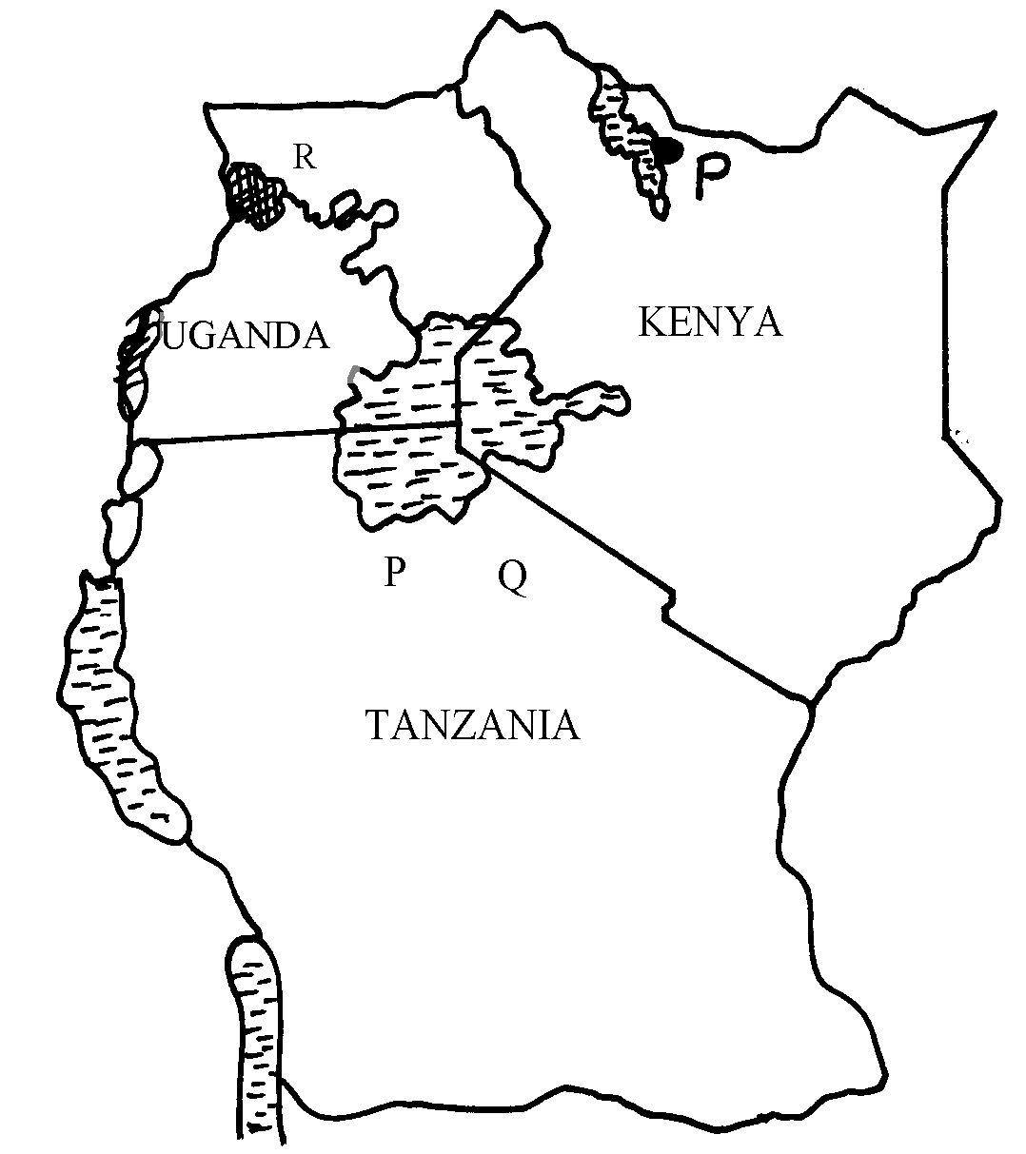

i) Name the national parks marked P, Q, and R
2. (a) State two differences between a National Park and a Game Reserve
(b) State three measures being taken to conserve wildlife in Kenya
3. (a) Differentiate between game reserves ands game parks
(b) State three ways in which human activities are a threat to wildlife
4. (a) What is balance of payment?
(b) Identify three problems that face traders dealing with primary goods
5. (a) Why are some parts of Kenya not developed for tourism?
(b) State two factors that hinder domestic tourism in Kenya.
6. (a) State three problems facing wildlife conservation in Kenya.
(b) State two human factors that have made Switzerland a major tourist destination.

