LIVESTOCK PRODUCTION III
(LIVESTOCK REARING PRACTICES)

This topic entails the following:
- Raising young stock
- Milk and milk components
- Milk secretion and milk let-down
- Correct milking techniques
- Marketing of milk and beef.

The following relevant questions and their answers in this topic will greatly motivate and help
the user to comprehend and understand the required concepts and practices:

1. What is “calf crop” in beef production?
2. a) Describe the procedure of hand milking in a dairy cow
b) Explain the practices observed in clean milk production
3. Give two reasons for washing a cow’s udder with warm water before milking
4. Give two roles of uterus in egg formation process
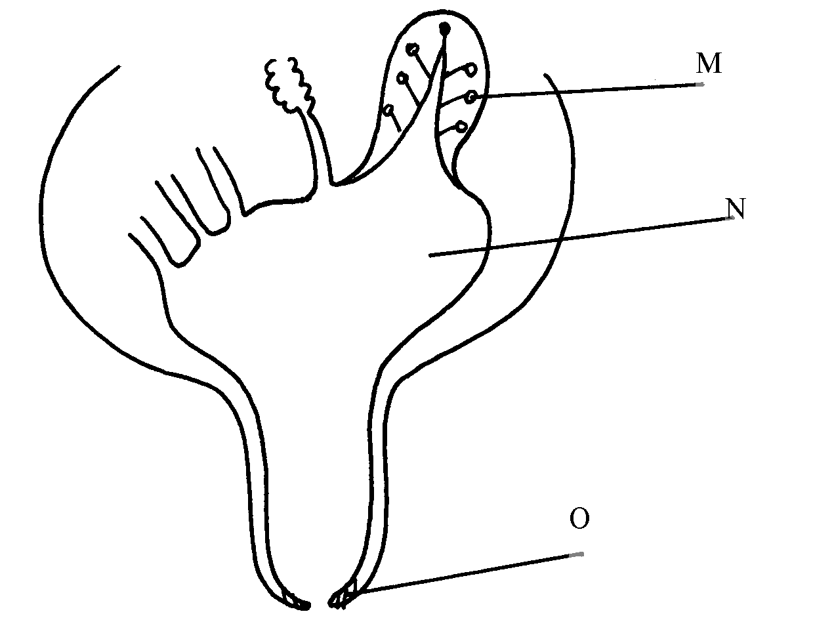
5. The diagram below is a structure of part of a cow’s udder

O

(i) Name the parts labeled M, N, and O on the diagram above
(ii) State the functional difference between the following hormones which influence milk
let-down;
(a) (i) Oxytoxin
(ii) Adrenalin
(b) Mention three qualities of clean milk
6. Give four characteristics of clean milk
7. State three maintenance practices carried out on a milking machine
8. State four reasons for feeding Colostrums to calves immediately after calving
9. Give three ways of stimulating milk let down in a dairy cow
10. a) Describe the operational differences of a disc plough and mould board plough
b) Explain six marketing problems affecting dairy farming in Kenya
c) State four reasons for culling a boar
11. List three advantage of artificial method of calf rearing
12. State three methods that may be used to improve milk production in a breed
of indigenous goats
13. (a) Outline ten physical characteristics between a good layer and a poor layer in a deep
litter house
(b) Describe five factors that influence milk production in a dairy herd
14. a) State two reasons for washing the udder of a cow with warm water before milking.
b) Name the hormone that causes each of the following in dairy cows:.
i) milk letdown.
ii) lactogenesis
15. State four methods of increasing the depth of penetration of a disc harrow.
16. List four farm machines implements that obtain power from P.T.O shaft of a tractor
17. List two tractor drawn implements used for breaking hardpan in a crop field

18. State any three machines which are used for harvesting crops

19. a) describe the daily maintance and servicing of a tractor before use
b) State one function of each of the following parts of a tractor engine.
i) Fly wheel
ii) Ignition coil
iii) Thermostat
iv) Injector
v) Piston

