WATER SUPPLY, IRRIGATION AND DRAINAGE

This topic entails the following:
- Hydrological cycle
- Sources of water on the farm
- Water collection and storage
- Pumps and pumping of water
- Types water pipes
- Water treatment
- Uses of eater of the farm.
- Types of irrigation advantages and disadvantages.
- Importance and methods of drainages
- Water pollution causes and prevention.

The following relevant questions and their answers in this topic will greatly help and motivate the user to comprehend and understand the required concepts and practices:

1. State two reasons for treating water for us on the farm
2. State three reasons for draining swampy land before growing crops
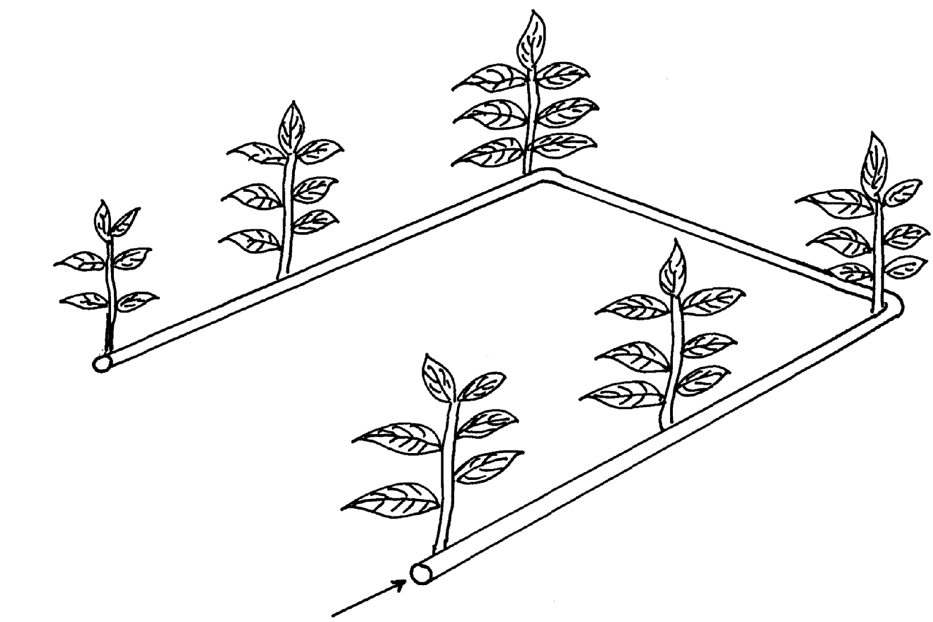
3. Use the diagram below of irrigation method to answer the questions that follow.

a) Identify the method of irrigation
b) State four advantages of the above irrigation system
c) State three factors that determine the type of irrigation on the farm
d) State two disadvantages o f the above system of irrigation
4. a) What is irrigation
b) Outline three methods of irrigation
5. a) List four use of water on the farm
b) Give four methods of harvesting water on the farm
c) Outline the stages involved in water treatment process
6. List any four uses of water in the farm
7. State two types of irrigation used in Kenya
8. Outline four disadvantages of cambered beds
Describe the process of water treatment
9. Give four roles of drainage as a method of land reclamation
10. Name two types of water pumps which can be used in the farm
11. Name any four examples of working capital in maize production
12. List four types of water pumps which can be used in the farm
13. State four methods of drainage
14. Distinguish between a dam and a weir
15. How do the government control prices of essential farm produce
16. What is the difference between pumping and piping of water in the farm?
17. List four reasons of draining water logged soils before planting.
18. Give three Agricultural practices which lead to water pollution
19. The diagrams below illustrate some methods of irrigating crops in the field. Study the diagrams
and answer the questions that follow:
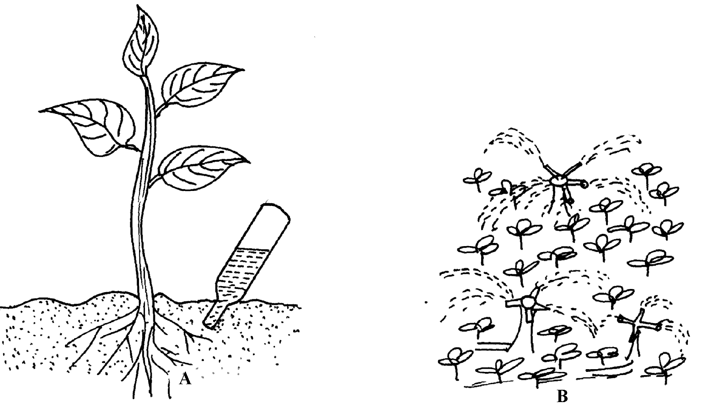

(a) Identify the methods used ; (i) A (ii) B
(b) State two advantages of method A over method B
(c) What material should be inserted at point T
b) Name two farming practice that cause water pollution
20. Give four reasons for practicing irrigation
22. a) State four importance of water to plants
b) State four reasons for treating water before use c) Describe water treatment system in a chemical treatment plant
23. Name four diseases caused to man by drinking untreated water
24. State the functions of the following chemicals as used in water treatment;
(a) Chlorine.
(b) Aluminum sulphate (AIlum)
21. The diagrams labeled S and T illustrate some methods of draining waterlogged fields; use it to
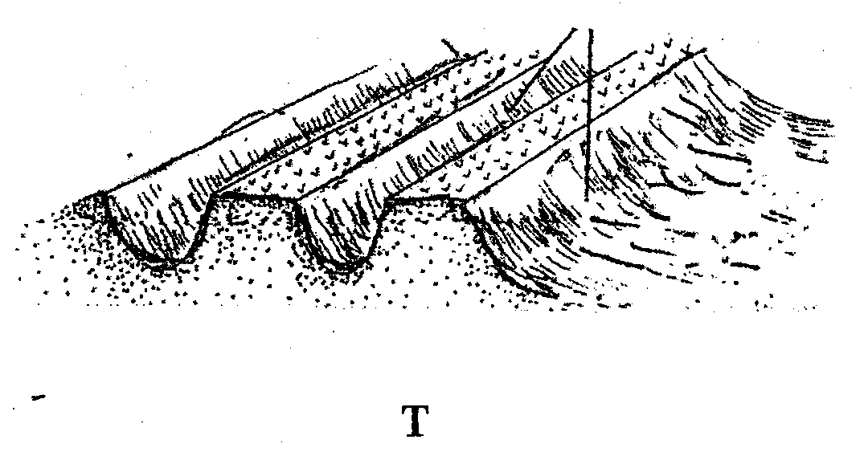
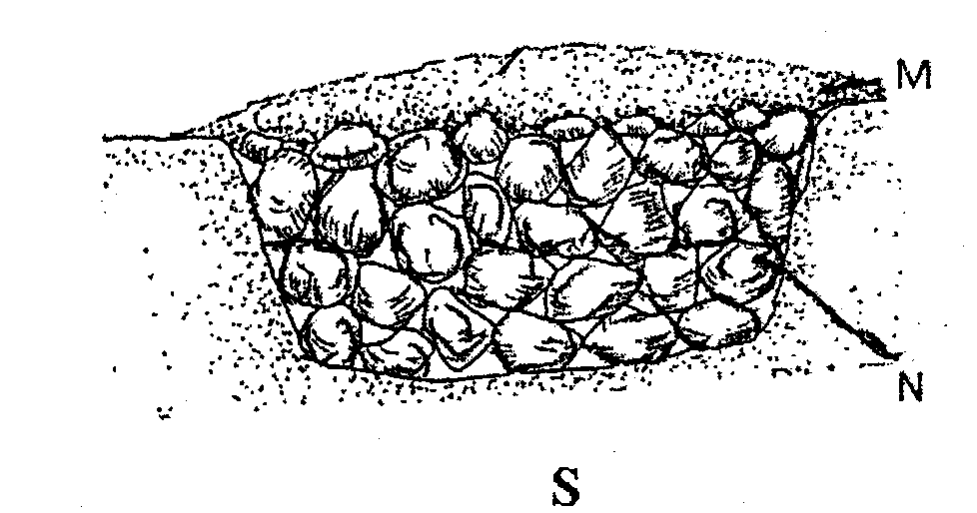
answer the questions that follow:

(a) Identify the methods illustrated
(b) What are the materials in S labeled M and N
(c) Name two types of crops that can be planted in the field instead of carrying out the practice
illustrated in S and T
(d) What is the importance of carrying out land reclamation?

WATER SUPPLY, IRRIGATION AND DRAINAGE
1. State two reasons for treating water for us on the farm
- Remove chemical impurities
- Remove foreign material
- Remove disease earning organisms
Remove bad smell & taste
2. State three reasons for draining swampy land before growing crops
- Increase soil volume
- Improve aeration
- Increases activities of micro organisms
- Control erosion
Reduce toxic substance in soil
3 . a )Sprinkle irrigation
b) four advantages of the above irrigation system
- Little water required
- Done on nay topography
- Control weeds between rows
- Water under low pressure
- Prevent fungal diseases
c) three factors that determine the type of irrigation on the farm
- Where tree crops are planted
- Little water supply
- Enough capital for the method is available
- Slope land 3x ½ = 1 ½ mks
d) two disadvantages o f the above system of irrigation
- Difficult to carry field mechanization
- Require a lot of capital
- Require clean water
- Regular repair of broken pipes and blocked pipes
Applicable where tree plants are grown
4. a) Artificial√ application of water to the soil surface for purpose of supplying enough
moisture√ for plants growth(mark whole)
b) Surface,
overhead,
subsurface,
drip/trickle
5. a) four use of water on the farm
- Irrigation
- Domestic use
- Diluting chemicals
- Construction work
- Watering livestock and washing buildings
- Processing farm produce(1/2x4=2mks)
b) four methods of harvesting water on the farm (2mks)
- roof cantonment
- weirs
- rock cantonment
- dams
- ponds

c) the stages involved in water treatment process
- filtration of water intake
- softening
- coagulation and sedimentation
- filtration in tanks
- chlorination storage (1/2x6=3mks)
6. four uses of water in the farm.
- For diluting chemicals used to control pests.
- For watering livestock.
- For watering plants e.g. irrigation.
- For washing utensils, calf pen bully sheds.
- For domestic use e.g. drinking, cooking.
- For rearing fish.
- For recreation
- Processing of farm produce.
- In construction of buildings.
7. two types of irrigation used in Kenya.
- Overhead / sprinkler.
- Surface / Flood / furrow/ basin.
- Drip/ trickle.
8. Four disadvantages cambered beds
- High cost of maintenance
- Provides breeding ground for vectors of malaria
- Prevents proper mechanization of the farm
- Labour intensive
(c) Stage I: Filtration of water intake.
- Water from source river is made to pass through a series of sieves.
- Large particles of impurities are trapped by the sieves.
- Water then enters into the large pipe to be directed to the mixing chamber.
Stage II: Softening of the water.
- Water circulates in the mixing chamber and doses of soda ash to soften the water.
Stage III: Coagulation and sedimentation
- Water is passed through coagulation tank where fresh air enters to remove bad smell/ chloride of lime used.

- Water stays for 36 hours thus solid particles settle and bilharzias causing organisms killed.
- Alum added to coagulated solid particles which settle at the bottom.
Stage IV: Filtration
- Water is passed through filtration tank with layers of sand and gravel to filter it.
- Water leaving the filtration tank is clean.
Stage V: Chlorination
- Water is passed through chlorination tank where chlorine is added.
- Micro-organisms in the water are killed by chlorine.
Stage VI: Storage
- The treated water is stored in large overhead tanks before distribution and use.
9. - Improves soil aeration
- Raises soil temperature
- Increases activities of micro- organisms
- Increases soil volume
- Prevent accumulation of poisonous substances in the soil
10. - Semi-rotary
- Hydram
- Piston/ reciprocating
- Centrifugal
- Rotary
11. Four examples of working capital in maize production are;
- Seeds
- fertilizer
- Herbicides
- Pesticides
- Fuel fragticides
- Casual labour (4x ½ = 2mks)
12. four types of water pumps which can be used in the farm
- Centrifugal/rotadynathic pumps
- Piston/reciprocating pump
- Semi-Rotan pump
- Hydram pump
13. four methods of drainage
Open ditches
- Under ground drain pipes
- French drains
- Cambered beds
- Pumping
- Planting of trees/planting of trees such as Eucalyptus
14. A dam is a barrier constructed a cross a river or a dry valley to hold water and raise its level
to form a reservoir or lake
- A weir is a barrier constructed across a river to raise the level of water and still allow water to flow over it
15. - Giving subsidies by reducing the cost of production inputs
Fixes prices of the related products
16. – Piping is the conveyance of water through pipes from one place to the other while pumping is the lifting of water from one point to another by use of mechanical force;
17.
- To facilitate the action of soil living organisms
- To check or reduce leaching
- To moderate or increase soil temperature
- To reduce accumulation of dissolved soil salts
- To reduce erosion rate of top soil
- To improve soil structure
- To increase effectiveness of phosphorous fertilizer and conserve soil nitrogen
- As a way of reclaiming areas such as coastal plains and the river belts which may have high water tables
- In rice fields, water should be controlled by draining the water for a different crop cycle.
18.
- Allowing livestock to graze near water sources often results in organic waste products being washed into the water ways.
- Fertilizer application
- Pesticides
- Over grazing
- Irrigation
- Over cultivation
- Use of farm machinery
19. a) i) A – Drop/ trickle irrigation
ii) B – Sprinkler/ overhead irrigation
b) Two advantages of method A over method B
- Conserves water
- Does not damage flowers, leaves
- Does not cause splash/ splatter irrigation
- Does not encourage spread of fungal diseases from crop to crop
- Does not encourage the growth of weeds all over the field
- Agro- chemical can be dissolved in the water and directly applied to the crop
c) i) Cotton wool
ii) Rough sand
21. four reasons for practicing irrigation
- Increase crop production by applying adequate moisture
- To reclaim dry areas
- To meet moisture requirement of crops
- To produce and benefit from off season crops
- Growing of paddy vice
23. - to prevent rotting
-For processing
- For long storage
- Prevent pest and disease attack
24. (a) Kill germs
(b) For sedimentation
21. S- French drainage T- Vambedred peds M – soil- stones

