11. VEGETATION
The topic entails:
- Definition of vegetation
- Discussing the factors influencing the distribution of vegetation
- Identifying and describing the characteristics of major vegetation regions of Kenya and the world
- Discussing the significance of vegetation and explain their uses within the local environment

1. a) Name two areas of the world with temperate grasslands.
(b) Explain how the characteristics of the vegetation in climate B are adapted to the.
environmental conditions

2. The diagram below shows mountain vegetation zones, use it to answer the questions that follow.

(a) (i) Name the vegetation zone marked X,Y,Z.
(ii) Give four char characteristic of tropical savannah vegetations
(b) Explain how the following factors influence vegetation:
(i) Aspect
(ii) Human activities
(c) Name the specific countries of the world where the following grassland vegetation types are
found:-
(i)Velds
(ii) Pampas
(iii) Dawns
(d) Explain three factors that have led to a decline of natural grassland in Kenya

3. (a) (i) Define the term ‘natural vegetation’
(ii) State thee climatic factors influencing distribution of vegetation
(b) (i) Give two zones of the temperate grasslands
(ii) State five characteristics of coniferous forests
(c) Explain four ways in which vegetation of the Nyika region of Kenya has adapted to the
region of Kenya has experienced in the area
(d) Give five factors that have led to a decline of the natural grasslands in Kenya

4. The map below shows major vegetation zones of the world. Use it to answer the questions
that follow:

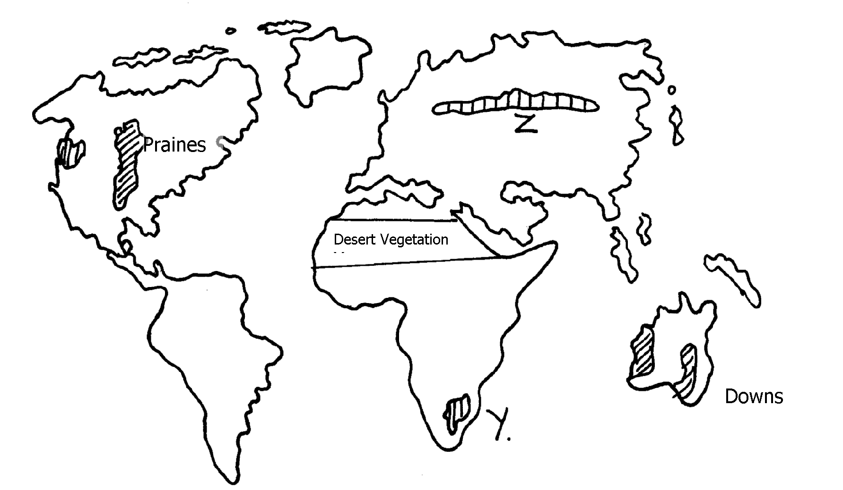

X

(a) Identify the temperate grasslands marked Y and Z
(b) Explain four ways in which desert vegetation are adapting to the extremely harsh
conditions
5. The map below shows the location of some vegetation regions of Africa. Use it to answer
the questions that follow:

5. (a)i) Name the grassland region marked L
ii) Describe the characteristics of the natural vegetation found in the shaded area P
b) i) Explain four ways in which the vegetation found in the area marked Q adapts to the
environmental conditions of the region
c) i) Give two reasons why the mountain top has no vegetation
ii) State two ways in which vegetation is of significance to the physical and human
environments
6. (a) (i) Name two types of vegetation
(ii) Give two physiographic factors influencing vegetation distribution
(b) The diagram below shows vegetation zones of a S. Africa mountain. Use it to answer
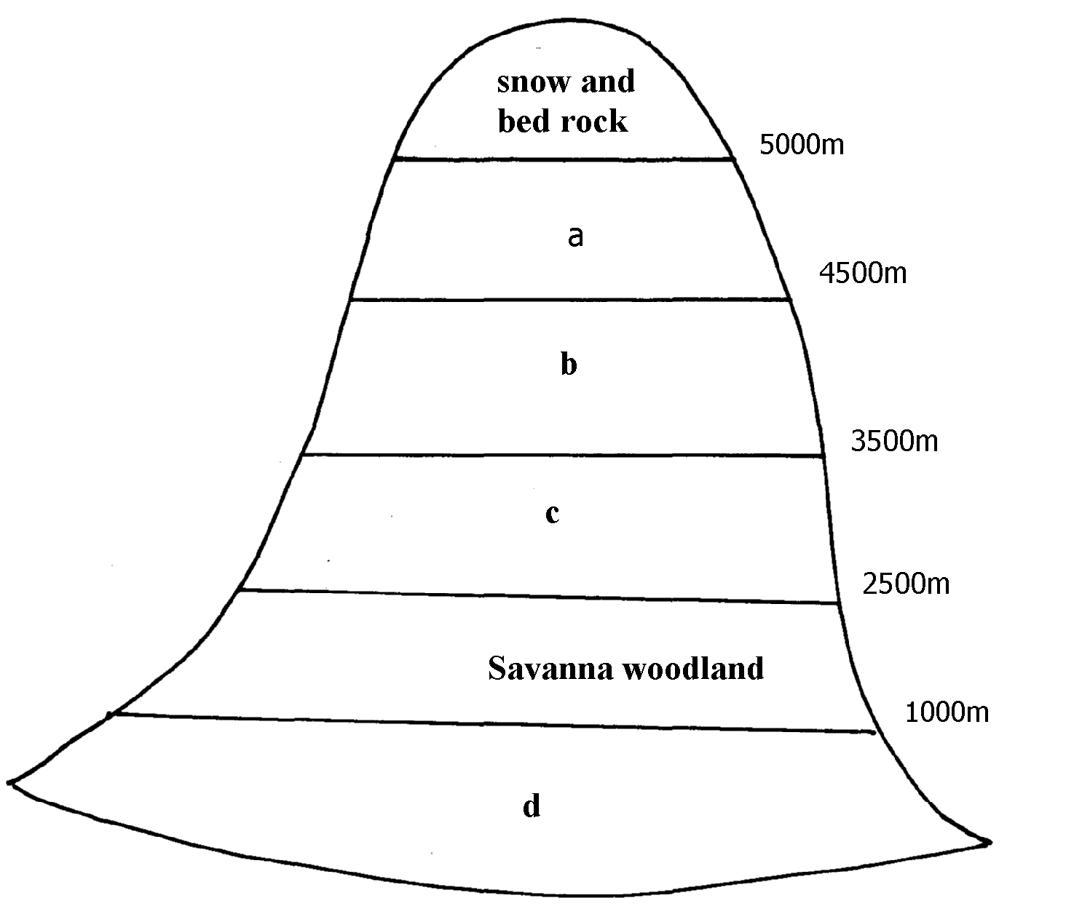
the question below:-

(b) (i) Name the zones a, b, c, d
(ii) Give one reason why there is no vegetation cover on to p of the mountain
(c) (i) State the names given to temperate grassland vegetation in:-
- North America
- Argentina
(ii) Explain three used of Savanna vegetation
(d) Explain four characteristics of Tropical desert vegetation

7. (a) The map below shows the grasslands of the world. Use it to answer the questions that follow:-

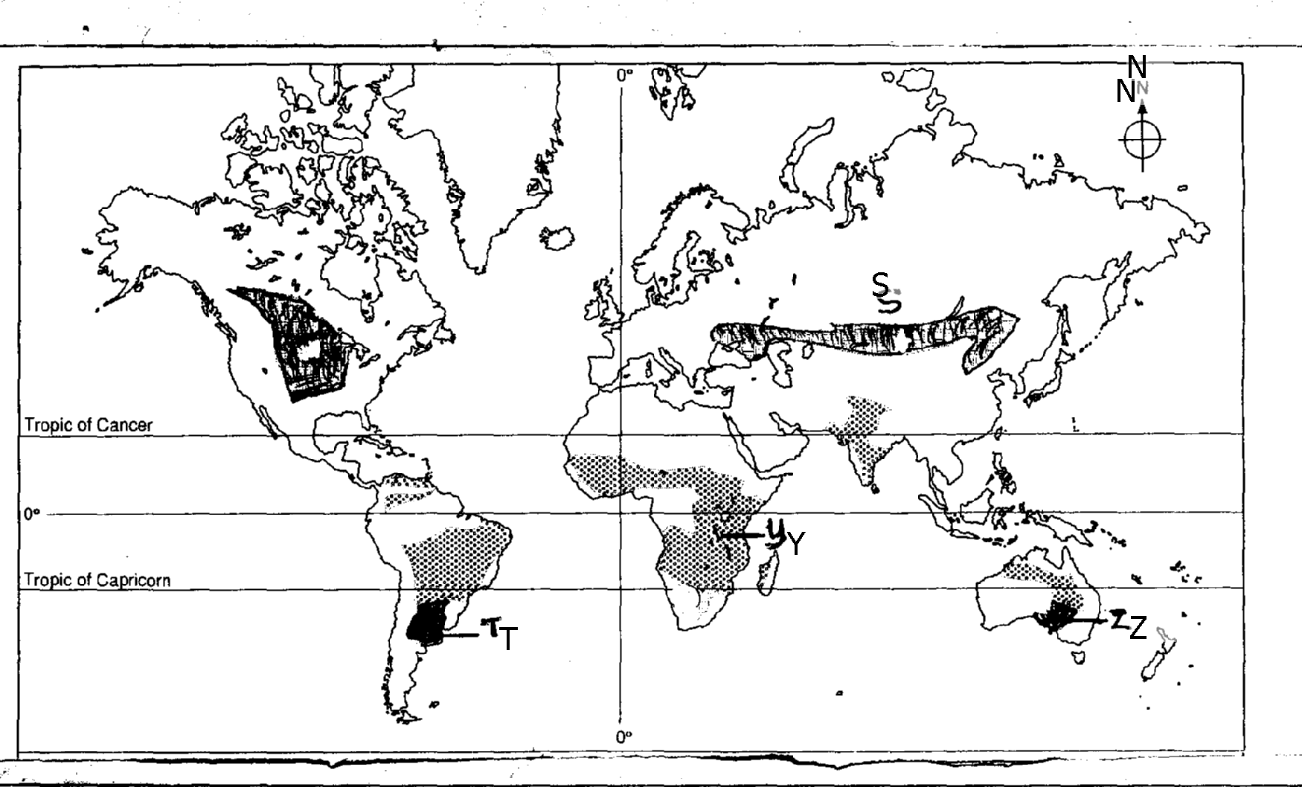

(i) Name the grasslands marked S, T, Y and Z.
(ii) State any four characteristics of temperate grasslands.
8. (a) (i) What is meant by derived vegetation?
(ii) Mention three factors that influence the vegetation of a place.
b) i)Give three natural vegetation zones on mount Kenya
ii) Name three temperate grasslands found in the world
iii) Describe the characteristics of the hot desert vegetation
9. a) Explain three causes of the decline of the areas under forests in Kenya
(b) Explain four factors that limit the exploitation of tropical rain forests in Africa.

