21. TRANSPORT AND COMMUNICATION
This topic entails :-
- Definition of transport and communication
- Identifying modes of transport and types of communication.
- Location of major lines of transport in Africa.
- Outlining the role of transport and communication in economic development of Africa.
- Discussing problems facing transport and communicationin Africa and the efforts being made to solve them.
- Explanation of the role of the Great Lakes and the St. Lawrence Sea Way in the conomies of USA and Canada.

1. (a) (i) State four factors that influence transport and communication
(ii) State three problems facing transport and communication in Africa

(b) The diagram below shows the Great Lakes & St Lawrence Seaway:
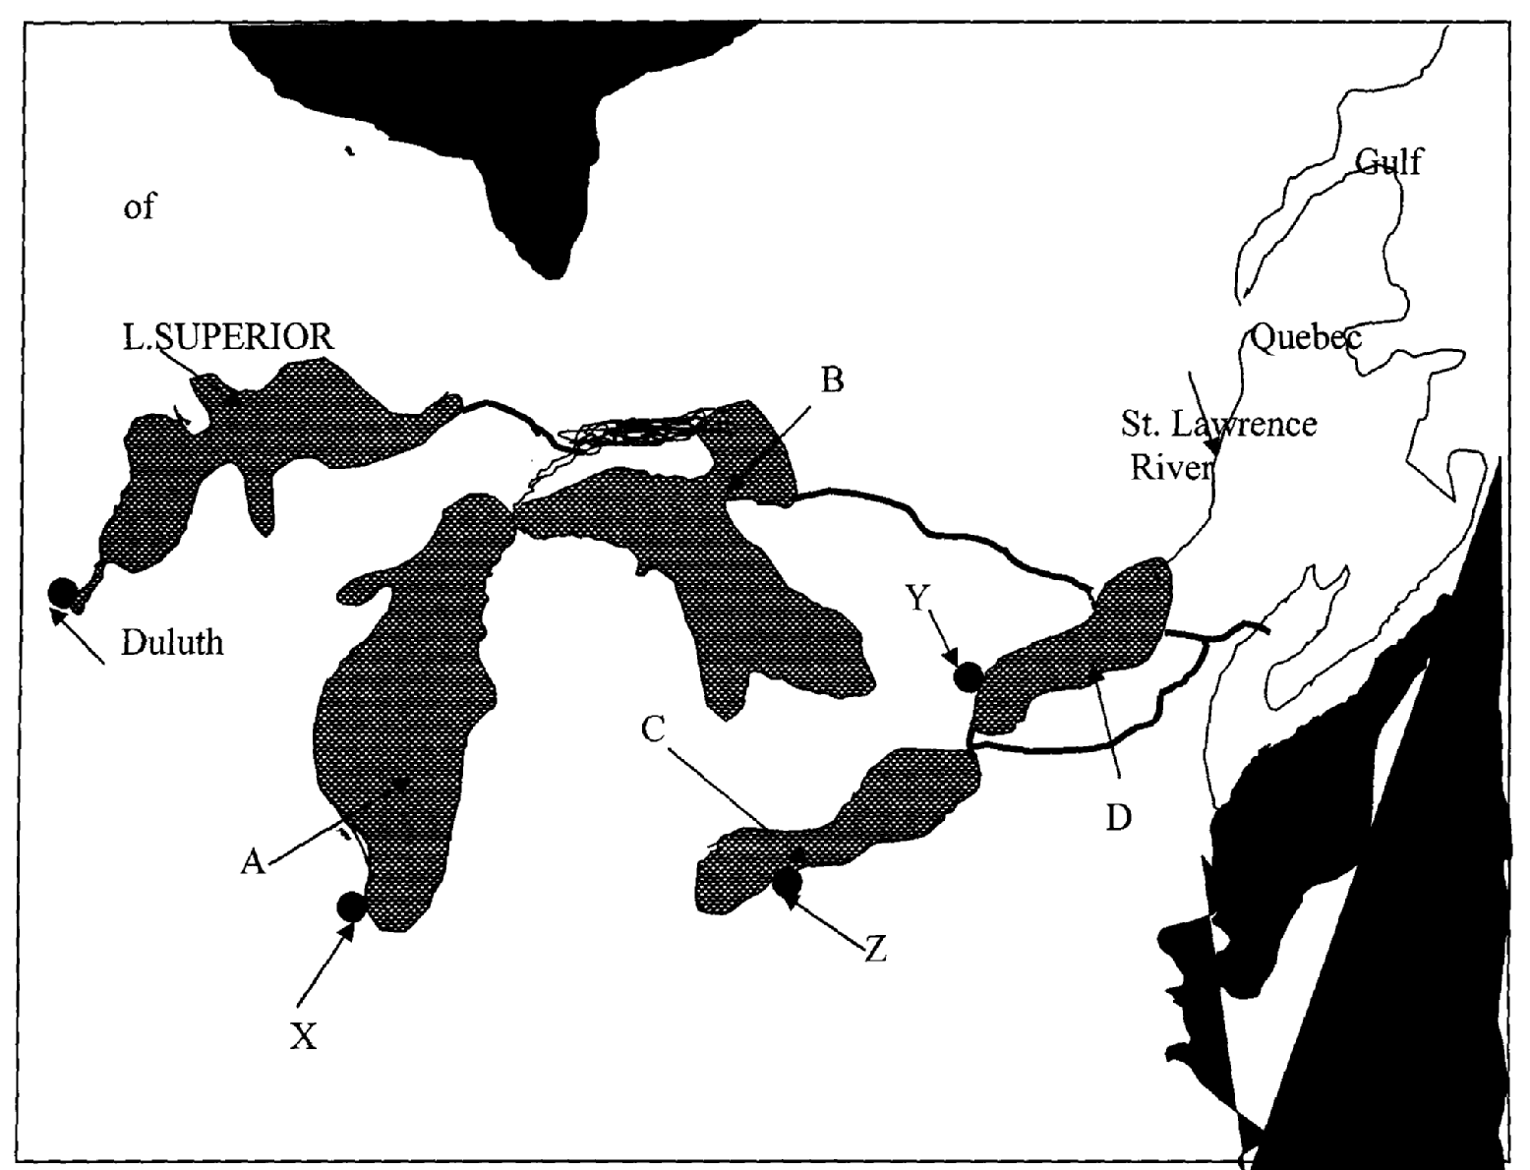

(i) Name the lakes marked A, B, & C .
(ii) Why was the St. Lawrence Sea way constructed between the Great Lakes and the
Pacific Ocean?
(iii) Identify the problems that initially existed along the seaway and how they were solved (c) State four advantages of the Mombasa-Nairobi pipeline.
(d) Discuss the role of transport and communication in development

2. (a) (i) What is transport?
(ii) Name three forms of land transport commonly used in Kenya
(b) Below is a sketch map of the Great Lakes and St. Lawrence Sea Way. Use it to answer
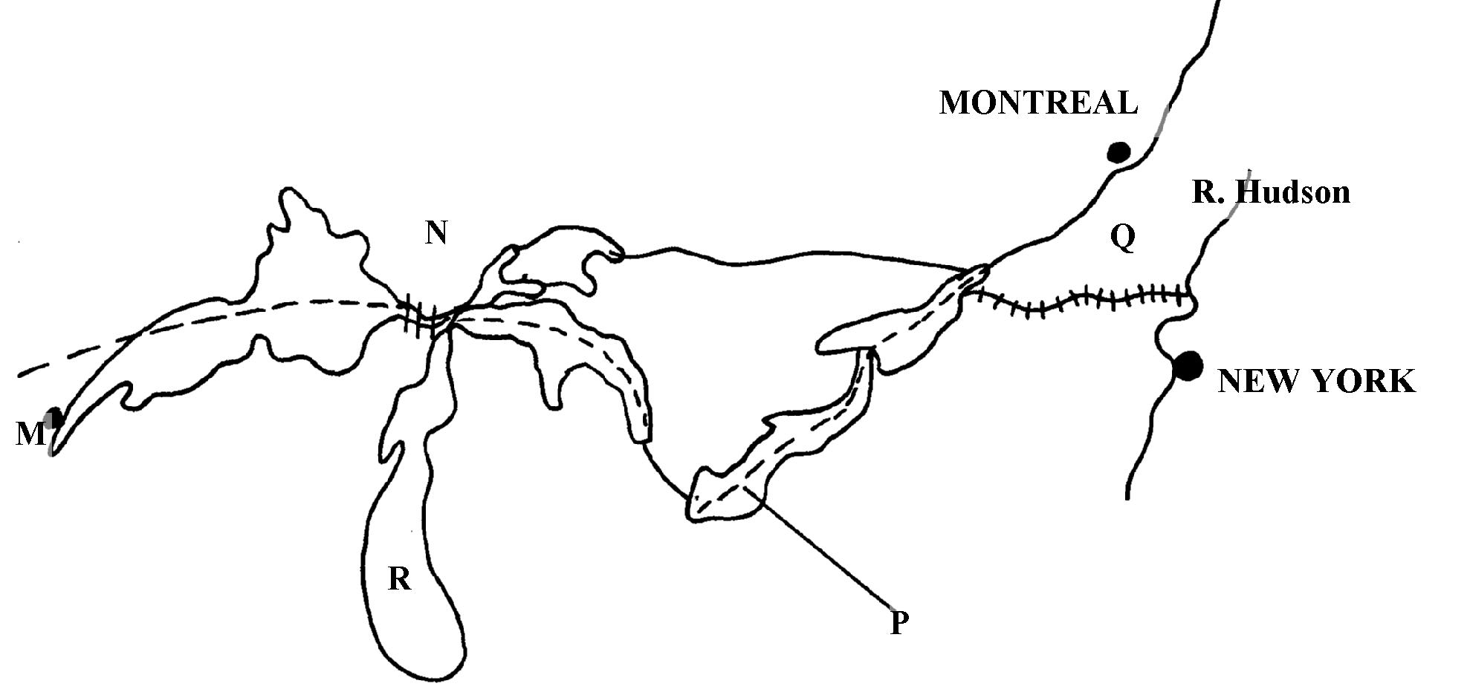
question (i) below:

(i) Name;
- The Canals marked N and Q
- The lakes marked R and P
- The port marked M
(ii) Explain four ways in which the Great lakes and St. Lawrence Seaway has contributed
to the economies of U.S.A and Canada
(c)State four ways in which communication has contributed to economic development of Kenya
(d) State any four problems facing air transport in Africa

3. (a) Define the term communication
(b) State two recent developments that have taken place in Kenya to improve communication
(c) State two problems facing telephone as a means of communication in Kenya

4. a) State three benefits that Kenya would derive from road linkage with the rest of East
African countries
(b) Give two major problems experienced by users of Kenyan roads

5. (a) (i) Give two forms of land transport
(ii) State any four disadvantages of water transport
(b) Explain any five ways in which transport and communication is important to the economy (c) Explain three attempted solution to African transport and communication problems
(d) (i) Define canal transport
(ii) Name the two major canals of the world

6. The table below shows the number shows the number of passengers that used railway
transport in selected countries in 1966 and 1977. Use it to answer questions (a) and (b)
COUNTRY | PASSENGERS IN MILLIONS
 | 1966 | 1977
CANADA | 4,800 | 6,000
U.S.A | 27,800 | 16,600
ARGENTINA | 14,100 | 12,000
INDIA | 96,000 | 160,800
JAPAN | 258,400 | 310,900
(a) (i) Using a scale of 1cm to represent 20,000 million passengers, draw comparative bar graphs
based on the data above
(ii) State two advantages of using bar graphs in representing data
(b) Calculate the percentage increase in railway passenger transport in Canada between
1966 and 1977
(c) Explain three factors that hinder the development of railway links among African countrie
(d) One of the problems facing road transport is the high frequency of accidents. Explain three
conditions of roads in Kenya that may lead to accidents

7. (a) (i) Name three types of communication mainly used in Kenya
(ii) State two advantages of pipelines as a means of transport
(b) (i) Whys is air transport not very commonly used in Kenya?
(ii) Explain four roles of transport and communications in the economic development of Africa
(c) (i) State three objectives of constructing the St. Lawrence Seaway
(ii) Name two canals on the St. Lawrence Seaway

8. Below is a sketch map of the great lakes and St. Lawrence sea way. Use it to answer
question (a)
(a) Name:- (i) The Lake marked P
(ii) River marked Q
(iii) Canal marked R
(iv) The port marked S
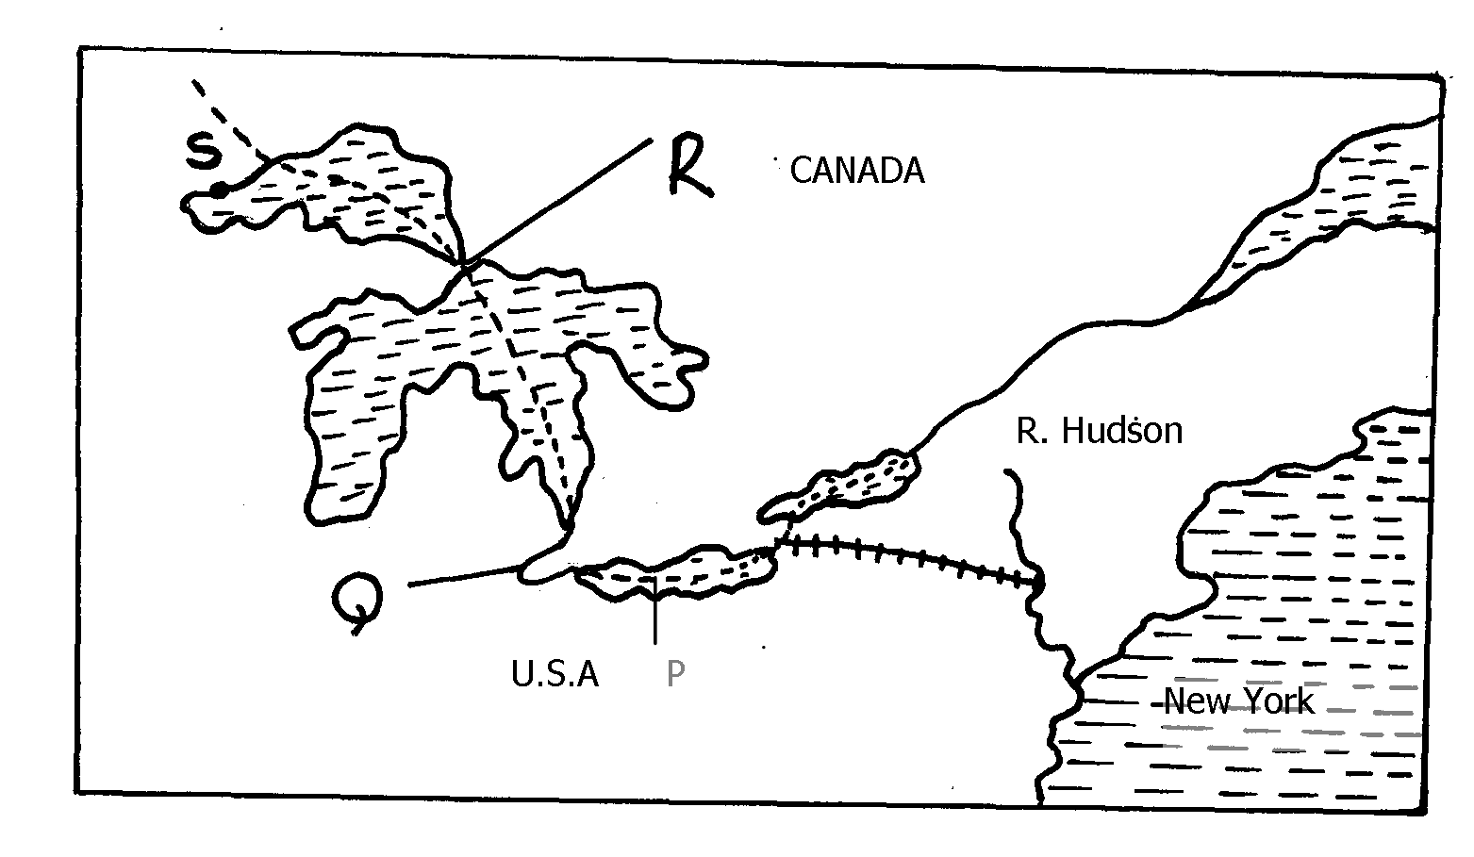

P

(b) Explain three ways in which the great Lakes and St. Lawrence seaway has contributed
to the economy of Canada and United States of America (U.S.A)
(c) Explain the factors that hinder the development of river transport in Africa
(d) (i) State three recent developments that have taken place in Kenya to improve communication
(ii) Explain three problems facing telephone as a means of communication in Kenya

9. (a) Define the term containerization
(b) State three advantages of containerization

10. (a) (i) Explain three economic importance of using mobile phones
ii) State four problems associated with the use of mobile phones in Kenya
b) Give four reasons why water transport is poorly developed in Africa
c) Explain three measures that have been taken to solve transport problems in Africa

