2. THE EARTH AND THE SOLAR SYSTEM
The topic entails:
- Definition of Solar System.
- Explaining the origin of the earth
- Explaining the effects of rotation and revolution of the earth.
- Description of the structure of the earth

1. The diagram below represents the earth on its axis. Use it to answer question (a)

a) i) Name the latitude marked G
ii) What is the angle of inclination of the earth’s axis from its orbit
b) i) State two effects of the rotation of the earth
ii) When the local time is 2.00 p.m at longitude 45°E, what is the longitude of a place
whose local time is 10.30 a.m
c) Name two local winds experience around lake Victoria region
2. The table below represents rainfall and temperature figure for a town in Kenya .Use it to
answer the questions that follow:-

MONTH | J | F | M | A | M | J | J | A | S | O | N | D
Temp (ºC) | 27 | 28 | 28 | 28 | 27 | 25 | 25 | 24 | 25 | 26 | 27 | 26
Rainfall(mm) | 25 | 38 | 99 | 140 | 277 | 439 | 277 | 69 | 142 | 201 | 71 | 25

a)i) calculate the annual range of temperature for the town
ii) Calculate the total annual rainfall for the town (1mk)
b) State three characteristics of the climate experience in the town
3. a) What is a solstice
b) State three effects of the revolution of the earth
4. (a) (i) Give two theories that explain the evolution of the solar system and the origin of the earth
(ii) Identify the force that causes the earth to bulge at the equator
(b) Give two reasons that support the belief that the interior of the earth is very hot
5. a) State two theories that are used to explain the origin of the earth
b) What is solar “system”?
6 a). Name two planets without natural satellites in the solar system
(b) (i) What is a time zone?
(ii) Give the reason why the International Date Line is significant. (2mks)
(c) State any two characteristics of Latitudes.
7. (a) What is the solar system
(b) Give three reasons why the interior of the earth is very hot
8. (a) The diagram below represents an eclipse. Use it to answer the following questions:
(i) Name the type of eclipse

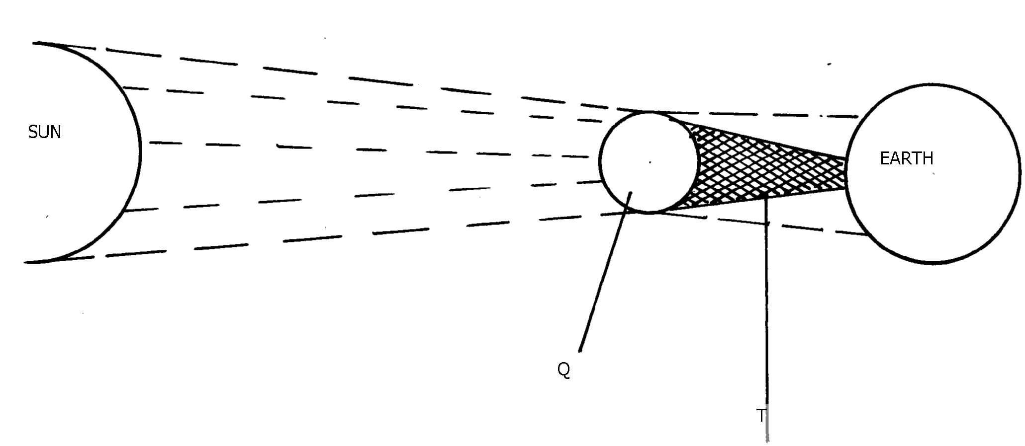

(ii) Identify the parts marked Q and T
(b) State three effects of the rotation of the earth
9. a) State three reasons why the interior of the earth is known to be very hot
b) Give two effects of the elliptical shape of the earth
10. (a) (i)What is an equinoxal date?
(ii) Name two equinoxal dates
(iii) State two changes caused by the earth’s revolution around the sun
11. The diagram below represents the internal structure of the earth. Use it to answer question (a.)

a)Name the arts named u, v and x
b) Describe the characteristics of
i)Crust ii) Core

