4. STATISTICAL METHODS
The topic entails:-
- Defining statistics
- Identifying types and sources of statistical data
- Identifying and describing methods of collecting and recording data.
- Analysis, interpretation and presentation of statistical data using appropriate graphical methods.
- Explaining the advantages of each method of data presentation.

1. Study the table below and answer questions that follow:-

CROP | 1978 | 1979 | 1980 | 1981 | 1982
COFFEE  TEA  PYRETHRUM  MAIZE | 1000  750  300  500 | 990  700  250  450 | 870  650  350  550 | 830  700  400  600 | 840  600  450  350

(a) (i) Using 1cm to represent 500 tons, draw a compound bar graph to represent the data.
(ii) Give two disadvantages of using the method to represent statistical data.
2. The table below shows leading import crops by value (Kshs. Million). Use is to answer
questions a – c

 | CROP
Year | Un milled wheat | Maize | Rice | Wheat flour
2000 | 6,989 | 4,664 | 1,968 | 180
2001 | 7,515 | 3,342 | 2,619 | 639
2002 | 5,577 | 229 | 2,104 | 237
2003 | 6,099 | 1,417 | 2,981 | 168
2004 | 6,754 | 4,647 | 3,659 | 200
(a) (i) Using a scale of 1cm represents 100,000 , draw a comparative bar graph to represent
the data in the table above
(ii) Give three advantages of suing comparative bar graphs
(b) Explain three reasons why Kenya is a producer of the commodities shown in the table
above yet she imports the same

3. The table below shows milk production in ‘000 units in selected Districts
District | 1982 | 1992 | 2002
Trans nzoia | 24 | 26 | 40
Kiambu | 23 | 25 | 31
Meru | 25 | 27 | 32
Bungoma | 12 | 14 | 20
a) i) Using a vertical scale of 1 centimeter to represent 10,000 units, draw a compound
bar graph to represent the above given data
4. Study the figure below and use it to answer question 6. The figure depicts proportional
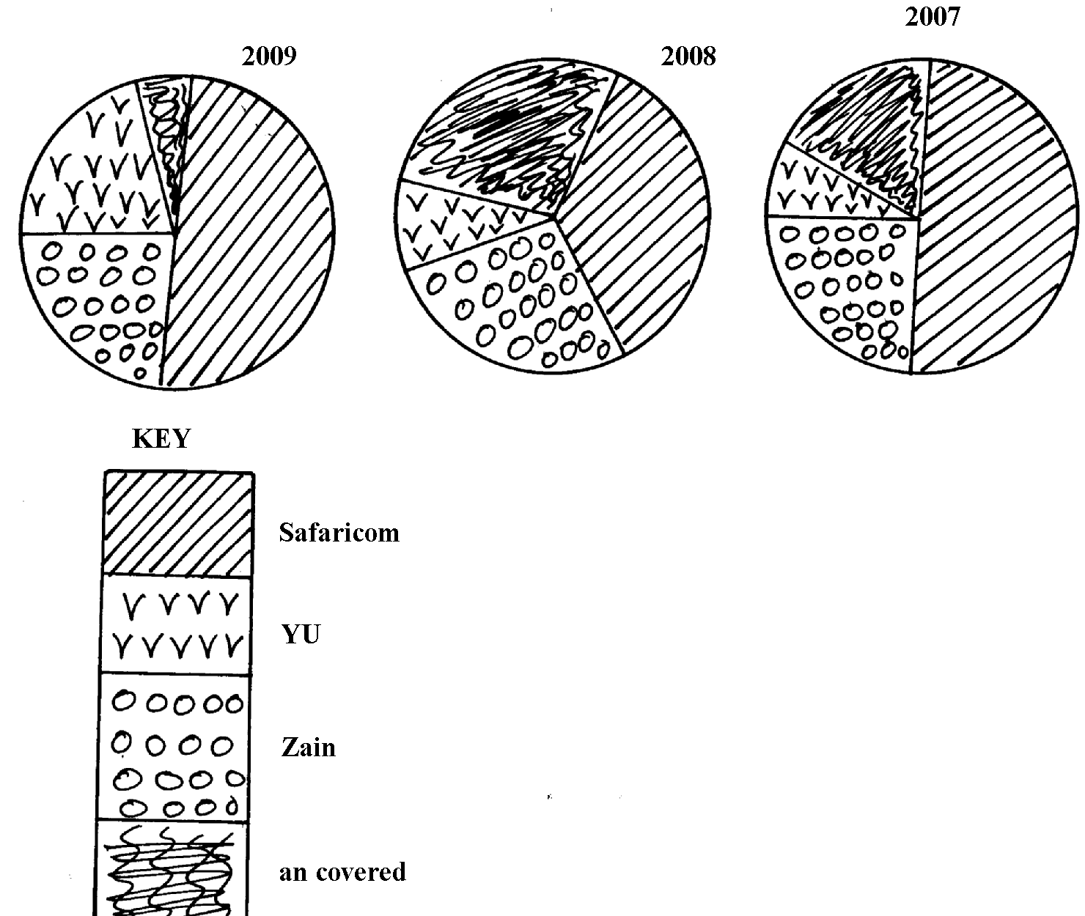
divided circles showing the extend of network coverage in Kenya between 2007 and 2009

Uncovered

a) i) State four deductions that can be made from the above representation
ii)State three advantages of using proportional circles in representing data

5. The table below shows four principal crops produced in Kenya in the years 2000 and 2001.
Use it to answer questions.
CROP AMOUNT IN METRIC TONS
YEAR | 2000 | 2001
Wheat  Maize  Coffee  Tea | 70,000  200,000  98,000  240,000 | 13,000  370,000  55,000  295,00
(a) (i) Using a radius of 5 cm, draw a pie chart to represent crop production in the year 2000.
(ii) State two advantages of using pie charts.
(b) Calculate the percentage increase in wheat production between the years 2000 and 2001.

6. Study the data given and use it to draw a pie chart showing mineral production in Kenya;

Mineral | Amount (000 tonnes)
Gold | 26
Flouspar | 14
Soda ash | 32
Zink | 28

(a) Using a radius of 5cm, draw a pie chart to represent the above data
(b) List three advantages of using a pie chart in representing data

