SOIL FERTILITY II (IN ORGANIC FERTILIZERS)

This topic entails the following;
- Essentials elements required by cops
- Classification of essential elements
- Role o micro-nutrients
- Deficiency symptoms of macro-nutrients and micro-nutrients.
- Identification and classification of fertilizers.
- Soil sampling and testing methods of fertilizer application.
- Effect of soil acidity/alkalinity air crops
- Fertilizer rate calculations

The following relevant questions and their answers in this topic will greatly help and motivate the user to comprehend and understand the required concepts and practices:

1. State four advantages of applying lime in clay soil
2. a) Give the form in which the following elements are absorbed by crops
i) Sulphur
ii) Nitrogen
iii) Carbon
iv) Magnesium
b) List three effects of nitrogen to plants
3. Mr. Malombe of Shinyalu village prepared to top dress 10 hectares of nappier grass using
sulphate of ammonia (21%N). Sulphate of ammonia is applied at rate of 150kg per hectare.
Calculate
a) The quantity of sulphate ammonia fertilizer the farmer will need for 10 hectares
b) The number of 50kg bags of fertilizer he will purchase
4. Give two disadvantages of using farmyard manure
5. State four factors which influence the stage at which the crops are harvested
6. A form four student was given a sample of a fertilizer with the following characteristics:
(i) Grey in colour
(ii) It is granular
(iii) Causes no corrosion
(iv) It is highly hygroscopic
(v) It is neutral
(a) Identify the fertilizer
(b) At what stage of growth of maize should it be applied?
(c) Calculate the amount of K₂O contained in 400kg of a compound fertilizer 25:10:5
7. State two pieces of information that soil sample should have before being taken to the laboratory
for testing
8. A compound fertilizer bag has the labels 20-20-0. What do the figures stand for?
9. Give four functions of sulphur in crops
10. State four advantages of lining as a measure of soil improvement
11. State two methods of increasing soil PH
12. (a) State three factors that determine the amount of inorganic fertilizers needed to be applied
to crops
(b) What are the necessary precautions observed when carrying out soil sampling?
13. List three functions of nitrogen in crops
14. (a) Distinguish between fertilizer grade and fertilizer ratio
(b) List four elements whose deficiency results into chlorosis in plants
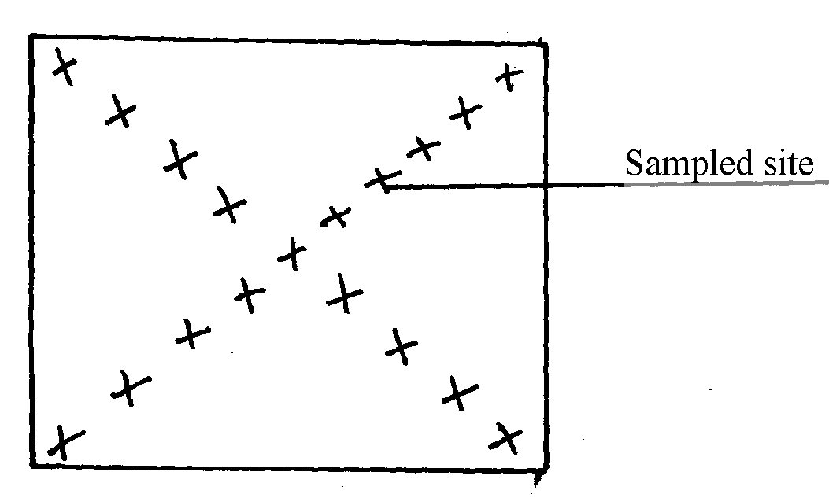
15. The diagram below shows a method of soil sampling

(a) Name the method illustrated in the diagram
(b) State three precautions taken when collecting the soil for testing using the above method
(c) Give four reasons why soil from the farm is tested
16. A farmer was advised to apply compound fertilizer 20-20-10 on an orchard measuring
20m X 10m at the rate of 80kg/ha. Calculate the amount of fertilizer the farmer would require
for the orchard. (Show your working)
17. a) A compound of fertilizer has a fertilizer grade of 25:10:5.calculate the a mount
of phosphorus fore sent in 400kg of this fertilizer
b) The diagram below illustrate methods of collecting soil sample from a field

i) Identify the methods illustrated 1-
ii) xx
iii) State three importance of carrying out soil sampling and testing
18. (a) What is an incomplete compound fertilizer?
(b) State four reasons why a maize crop continued showing deficiency of potassium despite
applications recommended amount of potassic fertilizer

19. The diagram below shows a soil sampling method.
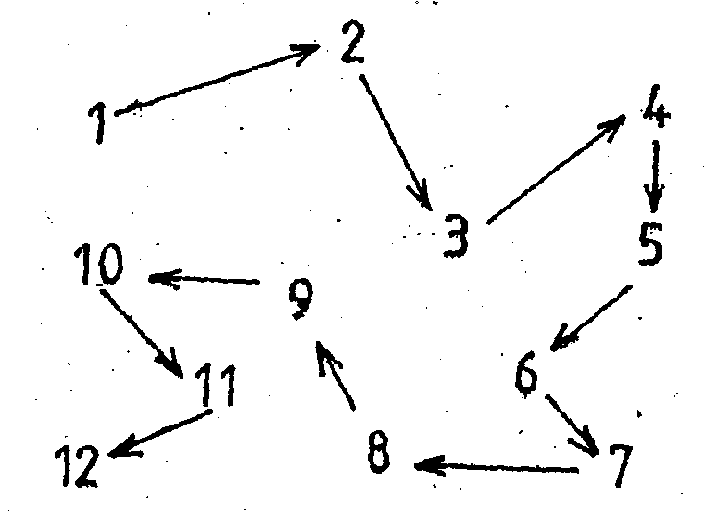

(a) Identify the method illustrated above
(b) Name any two spots in a farm that should be avoided during sampling
(c) Describe the steps followed while carrying out the exercise in (a) above

