PHYSICS FORM THREE PP1 MARKING SCHEME

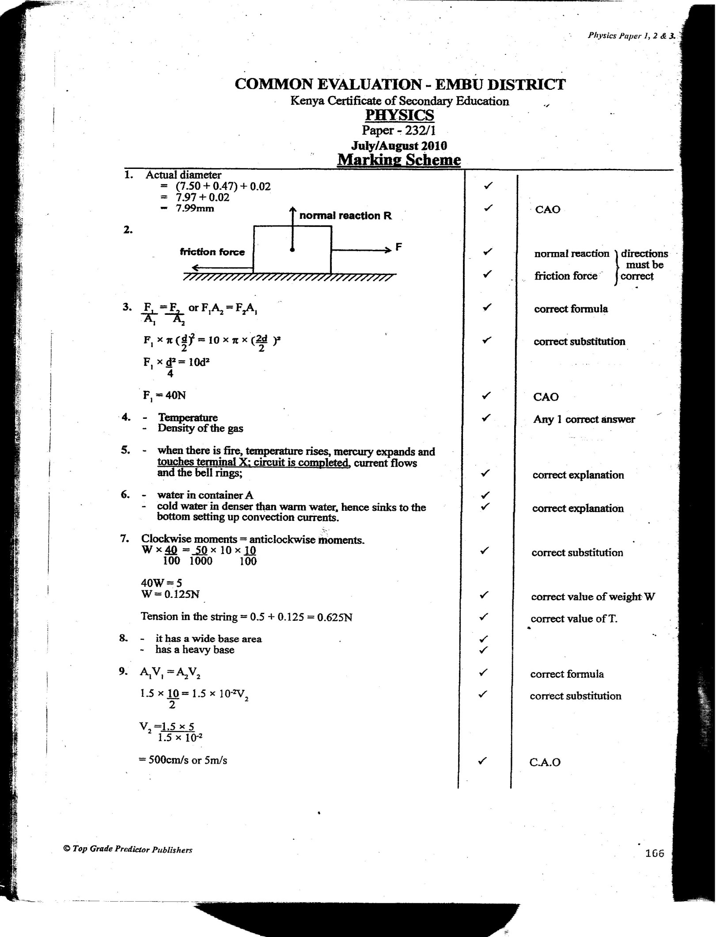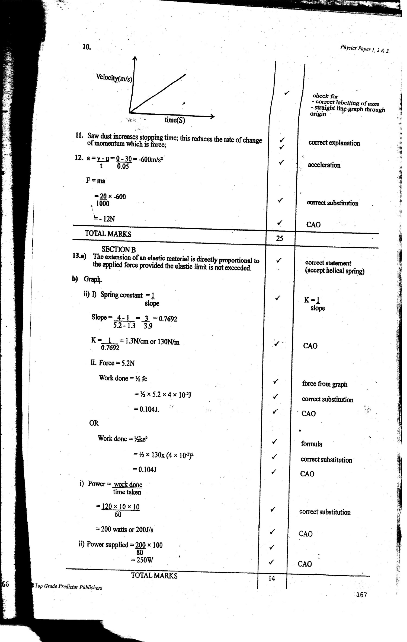

SECTION B 55MKS
- The extension of a spring is directly proportional to the force applied provided the elastic limit is not exceeded.
b i
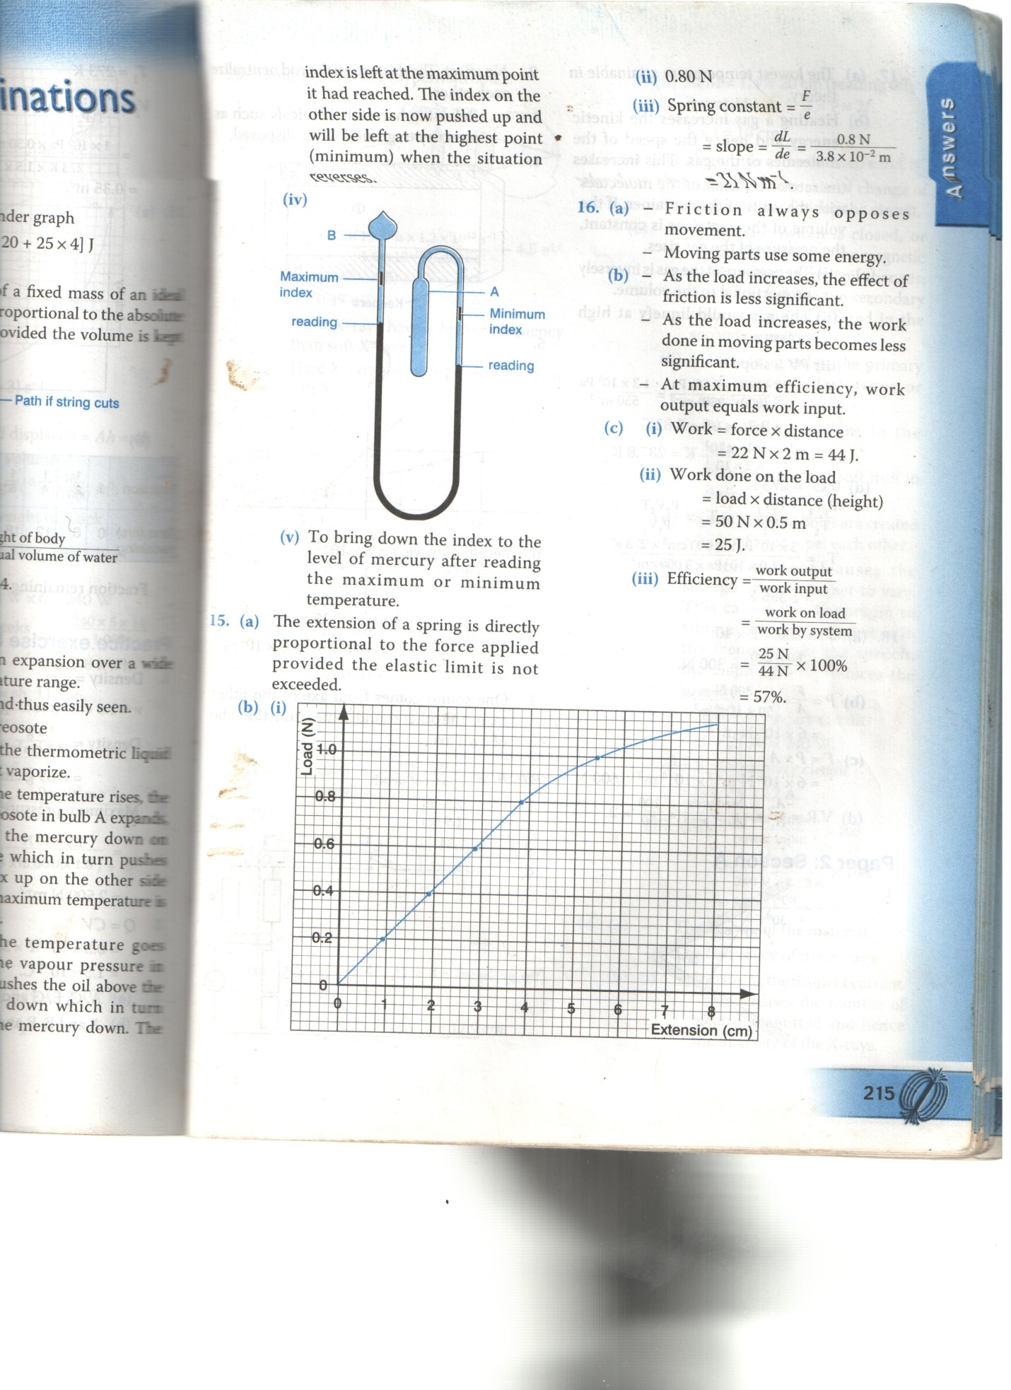
A - 1mk
S – 1mk
P – 2mks
L – 1mk

ii 0.80N
iii) Spring constant =
= slope = = 0.8 N
3.8 x 10⁻² m
= 21N m⁻¹

- A flow in which every particle of fluid passing a point follows the path of the preceeding particle.

b i)
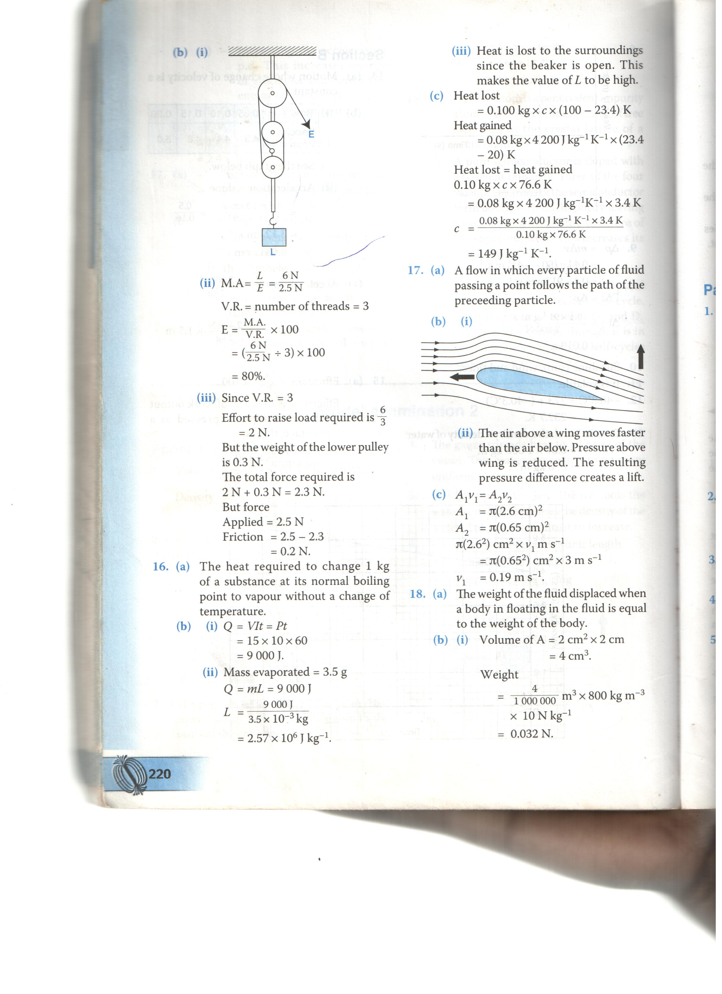
ii) The above awing moves faster than the air below. Pressure above wing is reduced. The resulting pressure difference creactes a lift.
c) A₁v₁ = A₂v₂
A₁ = π(2.6cm)²
A₂ = (0.65cm)²
π(2.62)cm³x v₁ m s⁻¹
= π(0.652)cm² x 3m s⁻¹
v1 = 0.19m s⁻¹

- a) When one sucks from the straw the pressure inside the straw is reduced. This allows the atmospheric pressure on the surface of the milk topush the milk up the straw and into the mouth.
b i) oil is incompressible
ii) When the driver steps on the foot pedal, the force is transmitted through the level system to the piston in the master cylinder. The pressure produced in the master cylinder is transmitted through the fluid to the wheel (or slave) cylinders where the pistons in turn push the brake shoes outwards. When the brake shoes are pushed out, the brake-lining presses on the rotating wheel causing the car to slow down or to stop.
iii) Air is compressible and so the force exerted would be partially used to compress the air instead of pushing out the break shoes.
c)Pressure in both cylinders is the same\
pressure in the plunger (small piston)
= 500N (1mk)
0.026² π m²
force in larger piston = PA

500N Nm⁻² x 0.16² π m² (1mk)
= 0.026² π m²

= 18935N (1mk)

- a) i) Fast moving air molecules move continuously and randomly and collide with the smoke particles.
ii) Larger particles may not be moved much by the fast moving air particles.
iii) Increase in air temperature would increase the speed of air molecules and hence the number of collisions would be more.
b i) Volume of the oil drop
= π³ = x 3.14 x 0.035³ cm³ (1mk)

let the thickness be = x
volume of the patch = π R²x
= 3.14 x (37.5)² cm² × x

Volume of the patch = volume of the oil drop.(1mk)

3.14x (37.5)² cm² × x = x 3.14 x (0.035)³ cm³

x = x (0.035)³ cm³ x 1 (1mk)
(37.5)²
= 4.066 x 10⁻⁸cm
= 4.066 x 120⁻¹⁰ m
= 4.1 x 10⁻¹⁰ m. (1mk)
ii) – the oil does not evaporate
- the oil spreads to a one molecule thick layer.

- n = (1mk)
= 3 x 10⁸
1.88 x 10⁸ (1mk)
= 1.596
= 1.6 (1mk)

b i)

ii Sin C = (1mk)

= (1mk)

C = 38.8° (1mk)

c) n = sin θ (1mk)
sin r
1.596 = sin θ (1mk)
sin 21.2
θ = 35.25 (1mk)

- period (T) = 1.65

ii) Amplitude = 4cm

iii) = fy
^=
f = = = 0.625 (1mk)

^

= 6.4 m (1mk)

