NAME:……………………………………………………… ADM NO……………….

CLASS:………………………………………………….... DATE:………………….

PHYSICS
FORM II
TIME: 2 ½ HOURS

TERM 1

INSTRUCTIONS TO CANDIDATES
- Write your name and admission number in the spaces provided above.
- This paper consists of TWO sections: A and B
- Answer All questions in section A and B in the space provided.
- Show all the steps in your calculations, giving your answers at each stage in the spaces below each question.
Take: Acceleration due to gravity g = 10m/s²
Density of water 1 g/cm³
Density of mercury 13.6 g/cm³

NB: Candidates should check the question paper to ascertain that all the pages are printed as indicated and that no questions are missing.
SECTION A (50 MARKS)
- Draw a vernier caliper scale to show a reading of 3.36cm (2 mks)

- The figure below shows the change in volume of water in a measuring cylinder when an irregular solid is immersed in it.

- 100
- 80
- 60
- 40
- 20
- 80
- 60
- 40
- 20

Given that the mass of the solid is 567g determine the density of the solid in Kg/m³. (Give your answer correct to 2 d.p) (3 mks)

- A small drop of oil has a volume of 5 x 10⁻⁸m³. When it is put on a surface of some clean water, it forms a circular film of 0.1m² in area.
- What is the size of a molecule of oil (3 mks)

- State 2 assumptions you made in your calculations (2 mks)
…………………………………………………………………………………………………………………………………………………………………………………………………………………………………………………………………………………………………………………………………………………………………………………………………………
- A body weighs 600N on the surface of the earth and 450N on the surface of another planet. Calculate the value of g in that planet (g on the earth = 10 N/Kg) (3 mks)

- The diagram below shows the behaviour of mercury in a capillary tube. Explain this observation
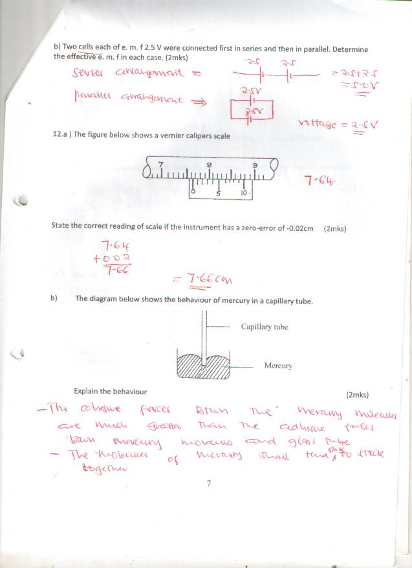
(3 mks)

…………………………………………………………………………………………………………………………………………………………………………………………………………………………………………………………………………………………………………………………………………………………………………………………………………………………...………………
- How does temperature rise and impurities affect the surface tension of water (2 mks)
…………………………………………………………………………………………………………………………………………………………………………………………………………………………………………………………………………………………………………………………………………………………………………………………………………………………...………………
- The diagram below shows a soap film trapped in a wire loop with a loose thread passing through
A
Soap film

Wire loop
Thread

The film is then ruptured at point A

- Redraw the diagram to show how the thread is affected (2 mks)

- Explain why the thread behaves in this manner (2 mks)
………………………………………………………………………………………………………………………………………………………………………………………………………………………………………………………………………………………………………………………………………………………………………………………………………………………………
- The reading on a mercury barometer at Mombasa is 760mm. calculate the pressure at Mombasa (density of mercury = 1.36 x 10⁴ Kg/m³) (3 mks)

- Explain the reason why a person moving from lowland to highland is likely to suffer a hose bleeding
(3 mks)
……………………………………………………………………………………………………………………………………………………………………………………………………………………………………………………………………………………………………………………………………………………………………………………………………………………………………………………………………………………………………………………………………………….……
- Describe a simple experiment to show that pressure in liquid increases as depth increases (3 mks)

- Distinguish between the three states of matter in terms of particle spacing and kinetics (3 mks)
………………………………………………………………………………………………………………………………………………………………………………………………………………………………………………………………………………………………………………………………………………………………………………………………………………………………………………………………………………………………………………………………………………………………………………………………………………………………………………………………
- Explain why the blades of a panga feels colder than the wooden handle when touched with a finger after exposure to low temperatures (2 mks)
…………………………………………………………………………………………………………………………………………………………………………………………………………………………………………………………………………………………………………………………………………………………………………………………………………………………………………
- The figure below shows a ray of light being incident on a mirror

48⁰
What is the angle of reflection (3 mks)

- The diagram below shows a “couple” in action
20N

20N

Given that the diameter of the wheel is 0.6m, determine the moment to the couple (3 mks)

- State the basic law of magnetism (2 mks)
……………………………………………………………………………………………………………………………………………………………………………………………………………………………………………………………………………………………………………………………………………………………………………………………….…………………………………………
- Draw the magnetic field pattern for the magnets shown below (2 mks)
S
N

- Explain the reason why a freely suspended bar magnet comes to rest pointing in the N – S direction
(3 mks)
…………………………………………………………………………………………………………………………………………………………………………………………………………………………………………………………………………………………………………………………………………………………………………………………………………………………………………………………..…
- Explain why repulsion is the only sure test for magnetism (2 mks)
…………………………………………………………………………………………………………………………………………………………………………………………………………………………………………………………………………………………………………………………………………………………………………………………………………………………………………

SECTION B (50 MARKS)
- The figure below shows an electromagnet
Core

A B

Insulated copper wire windings

- Explain why the core is made up of iron and not steel (2 mks)
…………………………………………………………………………………………………………………………………………………………………………………………………………………………………………………………………………………………………………………………………………………………………………………………………………
- On the same diagram indicate the direction of the current flow when the switch is closed
(1 mk)
……………………………………………………………………………………………………………………………………………………………………………………………………
- When the current is allowed to flow through the electromagnet it is magnetized. Identify the poles of the magnet (2 mks)
……………………………………………………………………………………………………………………………………………………………………………………………………
……………………………………………………………………………………………………………………………………………………………………………………………………
- Give the name of the law you have used to determine the poles and state it (3 mks)
…………………………………………………………………………………………………………………………………………………………………………………………………………………………………………………………………………………………………………………………………………………………………………………………………………
- Explain what would happen if the current is allowed to flow for a long time (2 mks) …………………………………………………………………………………………………………………………………………………………………………………………………………………………………………………………………………………………………………………………………………………………………………………………………………
- Brownian motion of smoke partides can be studied by using the apparatus shown below. To observe the motion, some smoke is enclosed in the smoke cell and then observed through the microscope as shown below
Microscope
Lens
Lamp
Smoke cell

Bench

- Explain the role of the smoke particles, lens and microscope in the experiment (6 mks)
…………………………………………………………………………………………………………………………………………………………………………………………………………………………………………………………………………………………………………………………………………………………………………………………………………………..…………
………………………………………………………………………………………………………………………………………………………………………………………………………………………………………………………………………………………………………………………………………………………………………………………………………………………….……
- State and explain the nature of the observed motion of the smoke particles (3 mks)
………………………………………………………………………………………………………………………………………………………………………………………………………………………………………………………………………………………………………………………………………………………………………………………………………………………………
………………………………………………………………………………………………………………………………………………………………………………………………………………
- State what will be observed about the motion of the smoke particles if the temperature surrounding the smoke cell is raised slightly (1 mk)
………………………………………………………………………………………………………………………………………………………………………………………………………………
- a) State the principle of moments (2 mks)
…………………………………………………………………………………………………………………………………………………………………………………………………………………………………………………………………………………………………………………………………………………………………………………………………………………………………………
- The diagram below shows a uniform wooden beam of length 6m and mass 30kg pivoted as shown below

How far from the pivot will the 65kg mass be for the beam to be in equilibrium (3 mks)

- A uniform metre rule of weight 100N is suspended horizontally by two vertical springs P and Q placed 20cm and 30cm from its ends respectively. Calculate the force (tension) in each string
(5 mks)

- In an experiment to determine the density of a soil using a density bottle, the following measurements were recorded.
Mass of empty density bottle = 42. 9g
Mass of density bottle full of water = 66.1g
Mass of density bottle with some soil = 67. 2g
Mass of density bottle with soil filled up with water = 82.0g
Use the above data to determine the:-
- Mass of water that completely filled the bottle (2 mks)

- Volume of water that completely filled the bottle (1 mk)

- Volume of the density bottle (1 mk)

- Mass of soil (1 mk)

- Mass of water that filled the space above soil (1 mk)

- Volume of soil (1 mk)

- The density of the soils (2 mks)

- The figure below shows the features of a dry cell (lenclanche). Use the information in the figure to answer the following questions.
A

B

C
D

- Name the parts (4 mks)
A……………………………………………………………………………………………………..
B……………………………………………………………………………………………………..
C……………………………………………………………………………………………………..
D……………………………………………………………………………………………………..
- Explain the purpose of B (2 mks)
………………………………………………………………………………………………………………………………………………………………………………………………………………………………………………………………………………………………………………………………………………………………………………………………………………………………
- State 2 defects of a dry cell and give their remedies (4 mks)
………………………………………………………………………………………………………………………………………………………………………………………………………………………………………………………………………………………………………………………………………………………………………………………….……………………………………
…………………………………………………………………………………………………………………………………………………………………………………………………………………………………………………………………………………………………………………………………………………………………………………………………………….…………………

