PHYSICS FORM THREE PP2 MARKING SCHEME
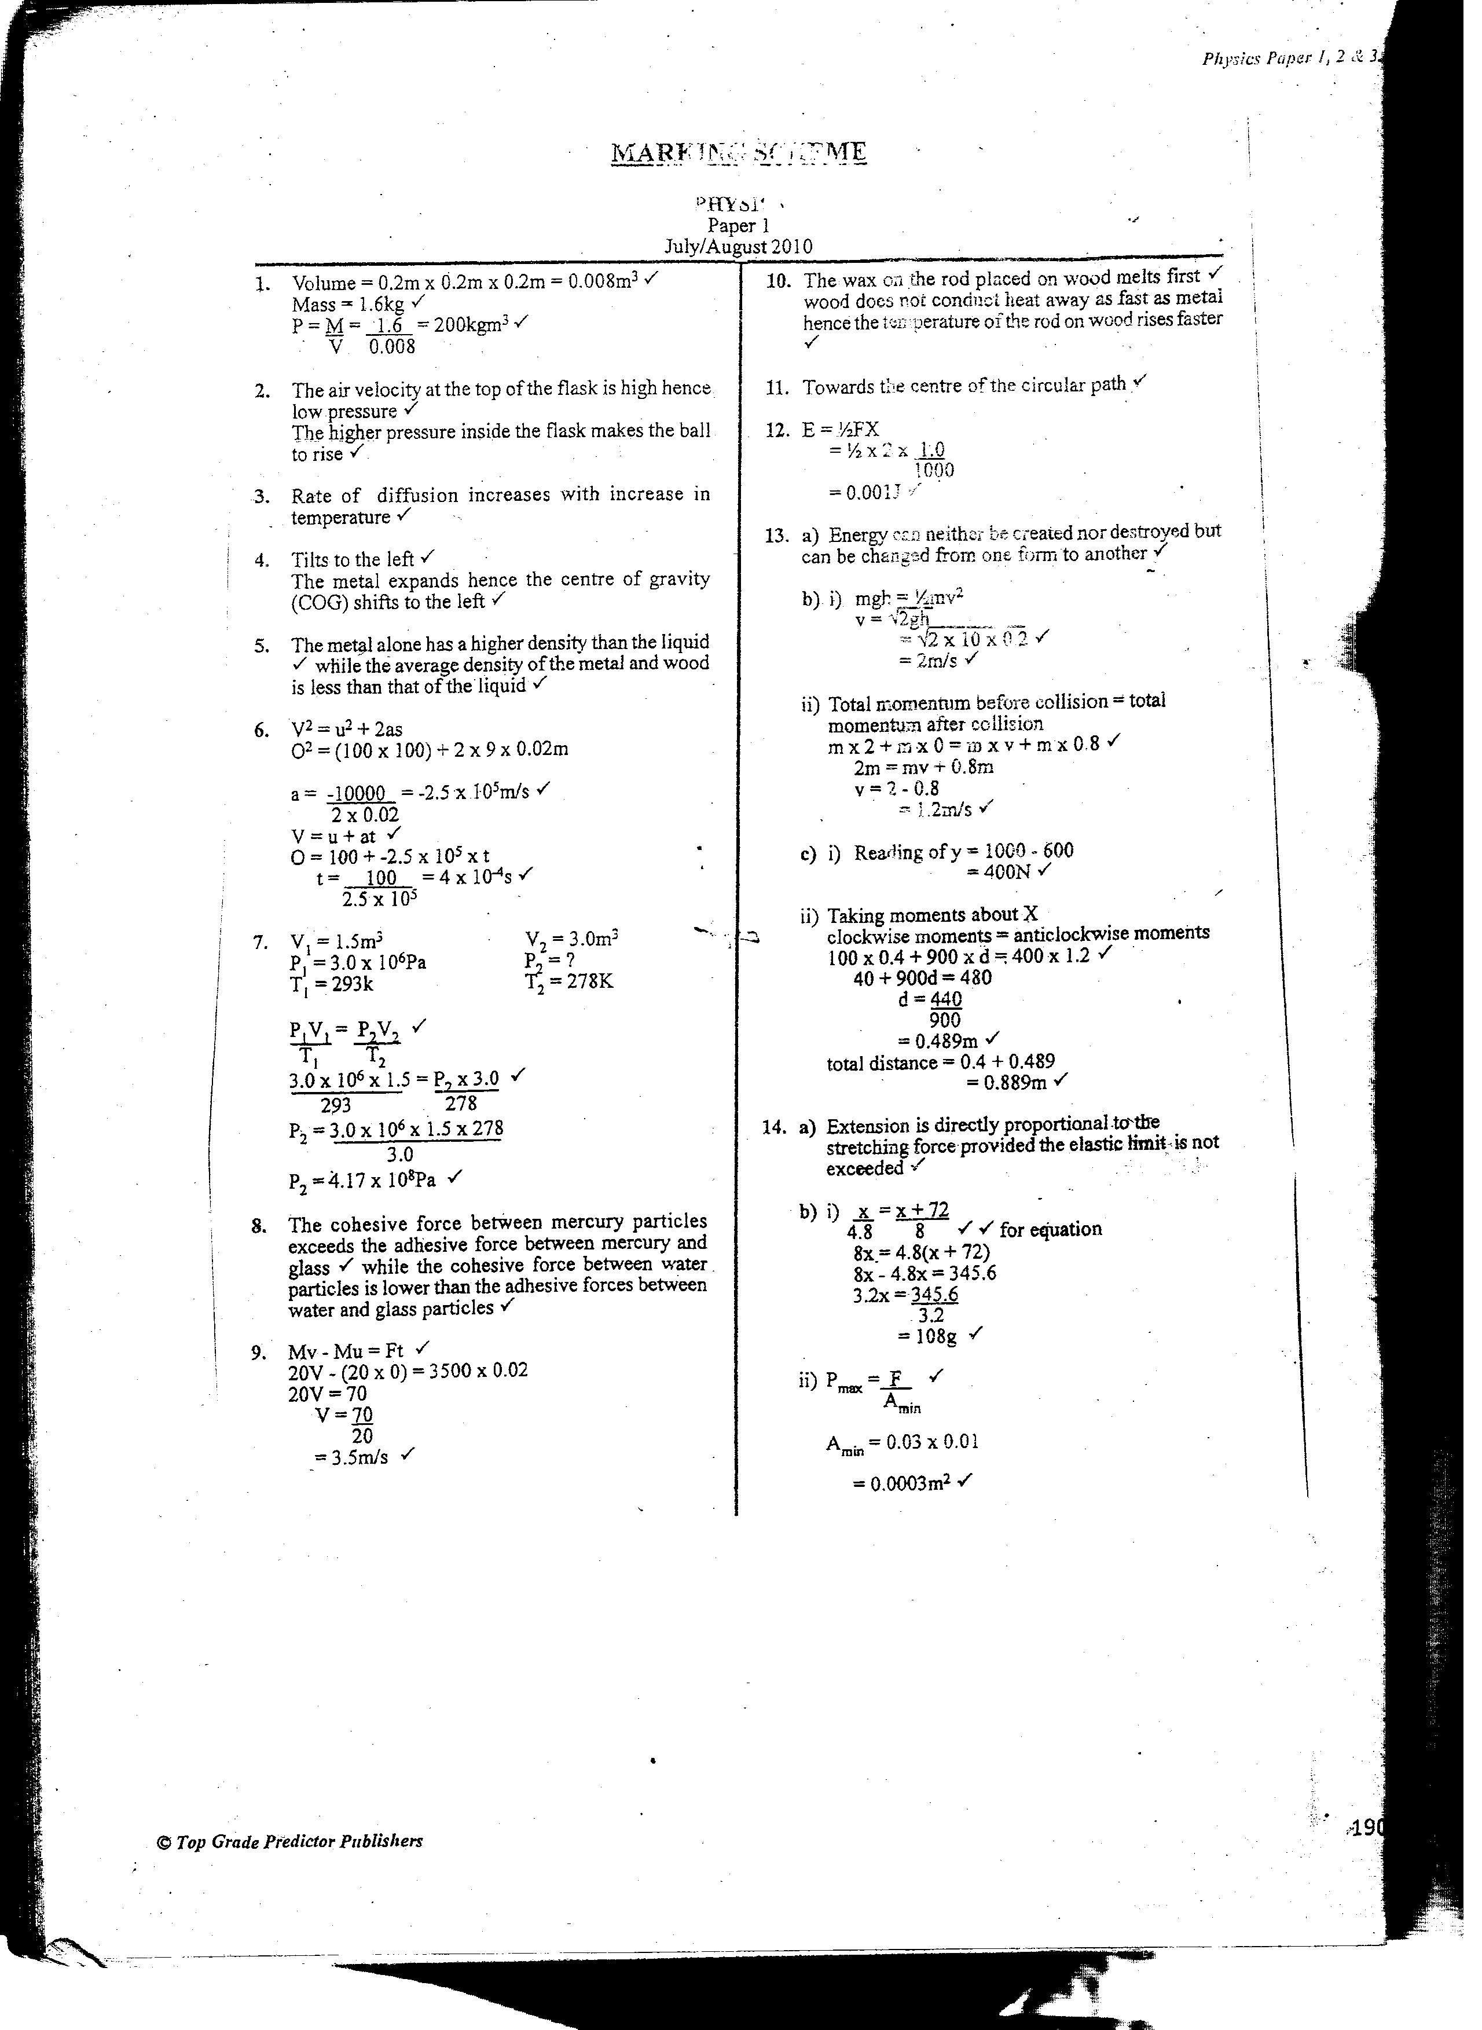
- a) Velocity is the rate of change of motion in a specificed direction

b) i) a = slope of graph
= 30m s⁻¹ (1mk)
30 x60s
= 0.016m s⁻² (1mk)
between C and D
a= -30m s⁻¹ (1mk)
10 x60s
= 0.05m s⁻² (1mk)
ii) Distance = area under graph
=30ms⁻¹ x ( 100 + 60) x 60s
2
= 144 000m.

iii) V_{av} = total distance
total time
= 144 000m (1mk)
100 x 60s
= 24ms⁻¹ (1mk)

c) S = ½ gt² (1mk)
1.8m = ½ x 10m s-1 x t²
t2 = 0.36s²
t = 0.6s (1mk)
s = vt (1mk)
= 15m s⁻¹ x 0.6s =9m (1mk)
- a) Momentum before collision = momentum after collision (1mk)
M₁U₁ +M₂ (-U₂) = (M1 + M₂) V
(2000 x 5)² +5000 x (-7) = 7000V (1mk)
V = -25000
7000
= -3.571 ms-1 √1 (1mk)

b) Ft = M(V-U)
f = m(V –U) (1mk)
t
F = 5000 ( -3.571 – (-7) (1mk)
0.1

F = 171,450 N (1mk)
c) initial K.E = ½ M₁U₁² + ½ M₂ (-U₂)²
= ½ x 2000 X 5² + ½ x 5000 x (-7)²
= 25,000 + 122, 500
= 147,500J (1mk)

final K.E + ½ (M₁ +M₂) V²
= ½ (2000 + 5000) (-3.571)²
= 44,632 J (1mk)
Change in K.E = K.E lost – final K.E – Initial K.E
= (44,632- 147,500) J
= - 102,868J (1mk)
d) The change /lost K.E is converted into heat, sound, light and spent in deformation (1mk)
- a) Particles of the transmitting medium vibrate in the direction of the wave for a longitudinal wave, but at right angles for a transverse wave.
b i) –wavelength = 4cm (1mk)
-Amplitude = 2cm (1mk)
ii) O to A = 9cm containing 2 ¼ waves
Time = 0.045 (1mk)
2 ¼
f =
= 1
0.04s / 2 ¼

f = 56.25Hz. (1mk)

v = f^ (1mk)
= 56.25 x 0.04
=2.25ms⁻¹ (1mk)

c) i) s = 2d
t
= 2 x 400
2.5
= 320m s⁻¹

ii) 2(x - 400) = (2.5 +2)s (1mk)
x = 1120m (1mk)

- a) image – real and inverted
f = 2.4 ± 0.1cm.
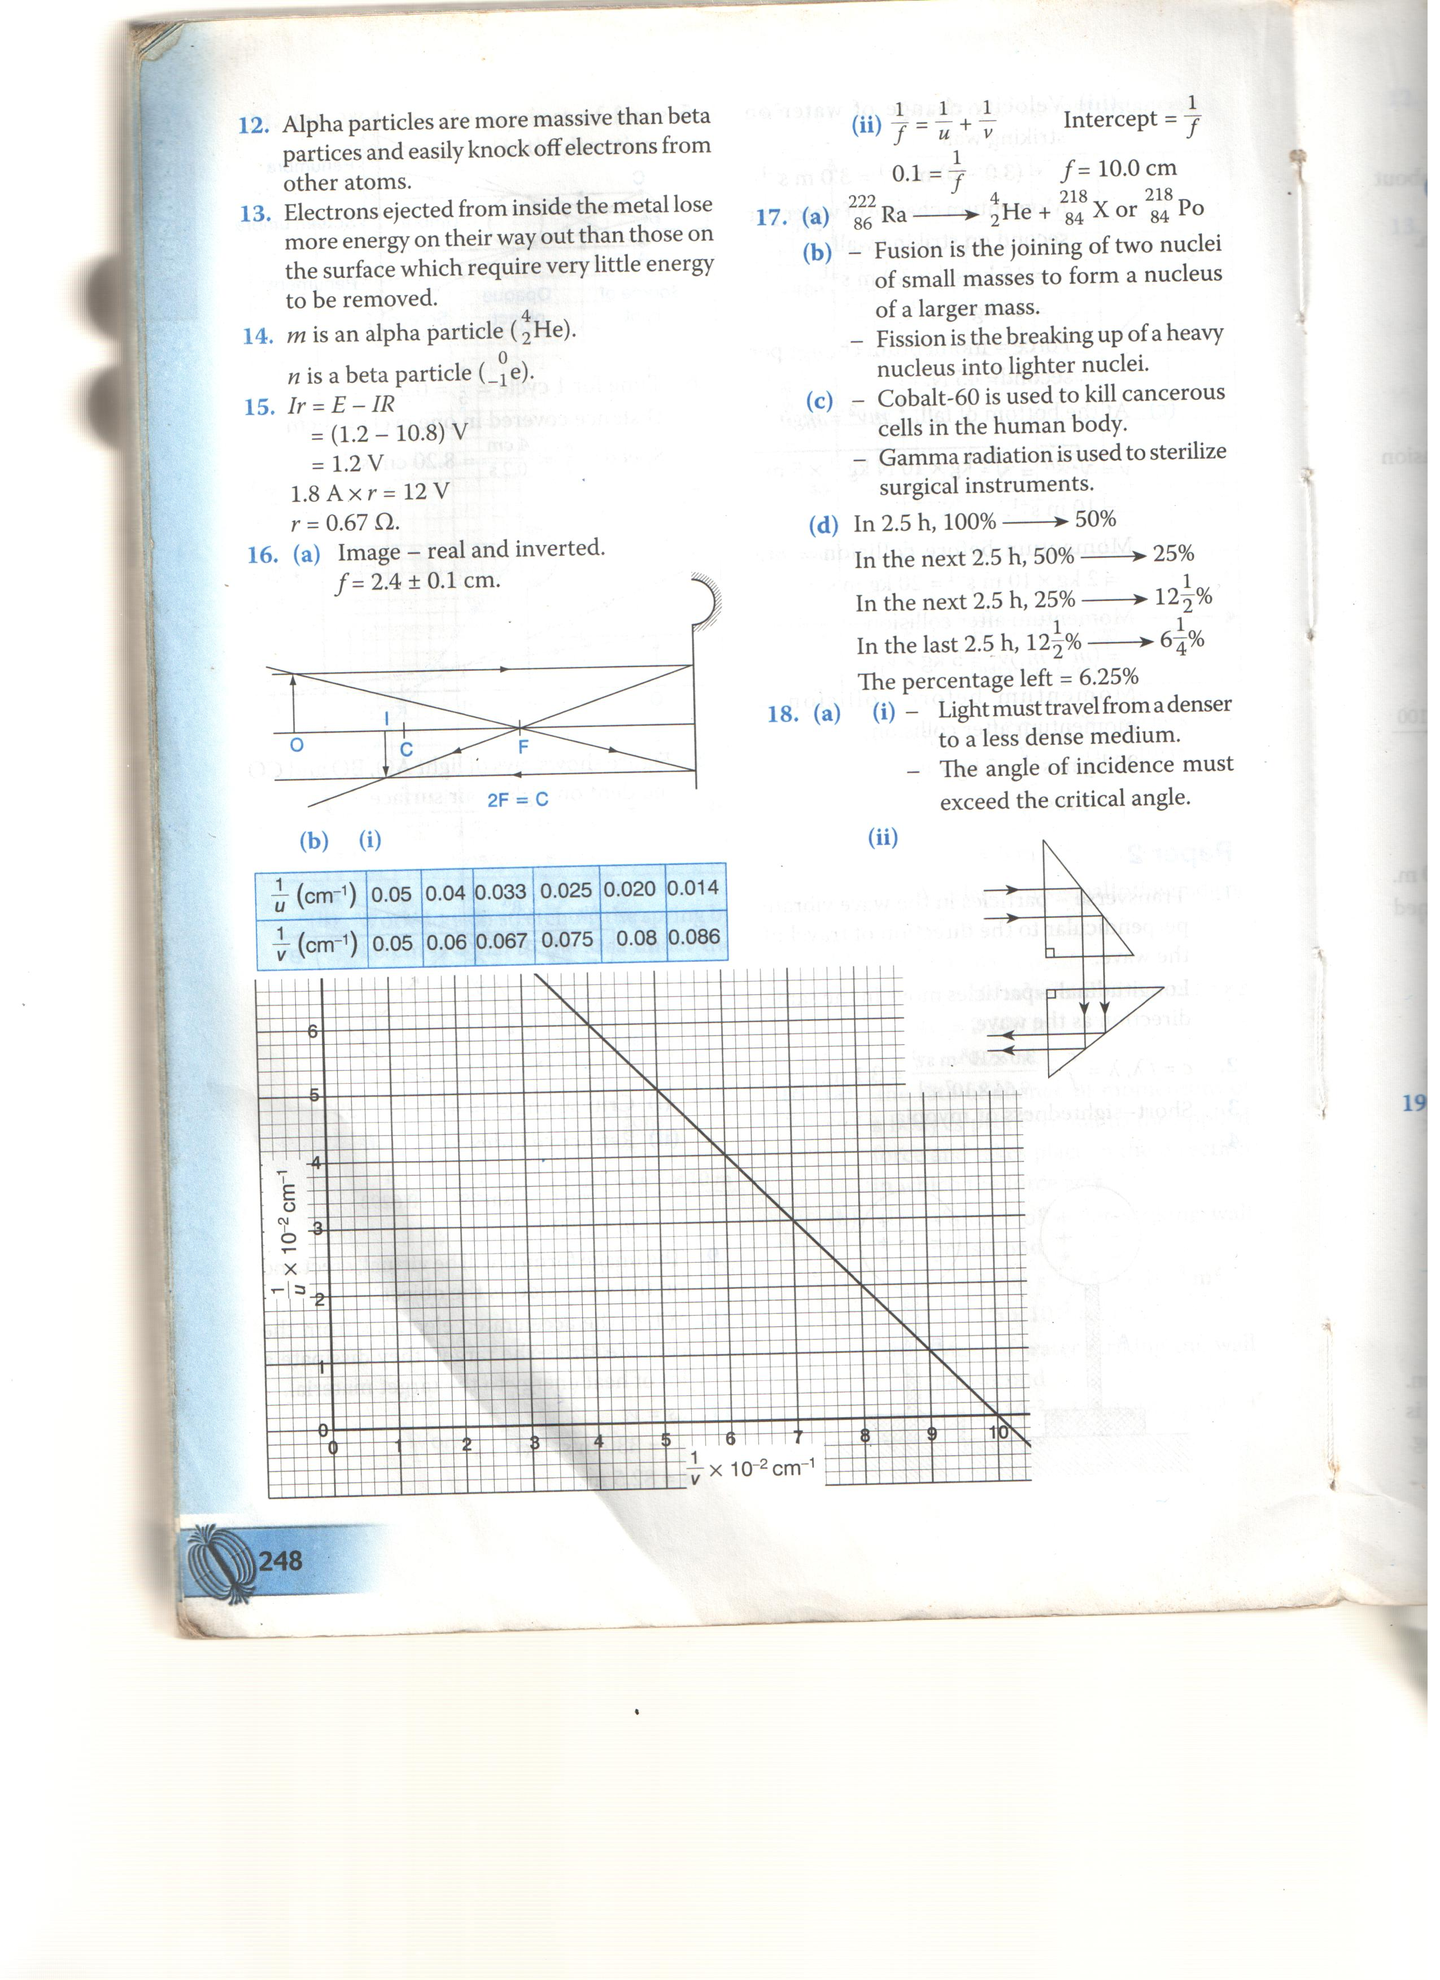
- 2rays with arrows (2mks)
- inverted image (1mk)
bi)
(cm⁻¹) | 0.05 | 0.04 | 0.033 | 0.025 | 0.020 | 0.014
(cm⁻¹) | 0.05 | 0.06 | 0.067 | 0.075 | 0.08 | 0.086

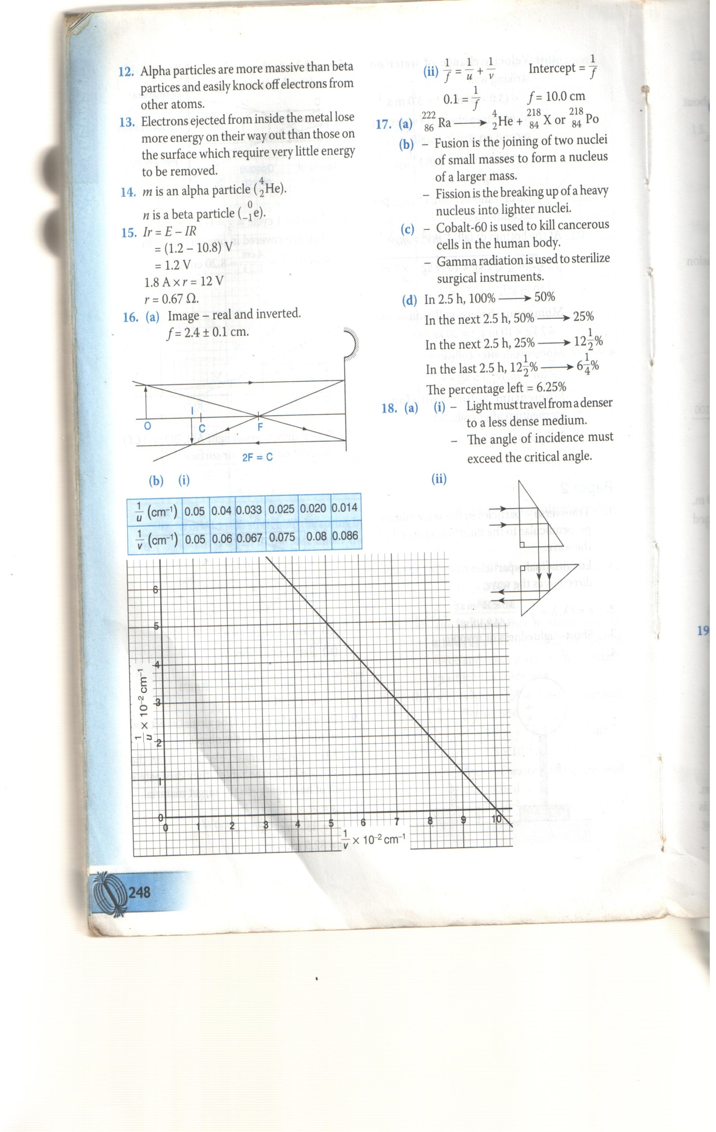
A – 1mk
S – 1mk
P – 2mk
L- 1mk
ii) = + intercept = (1mk)
0.1 = (1mk)
f = 10cm (1mk)
- i) 0.04M (1mk) correct reading
(1mk) correct units
ii) 2cm (1mk)
iii) F = (1mk)
(1mk)

= 100HZ (1mk)

