PHYSICS FORM 2
TERM 1

MARKING SCHEME

SECTION A
4
3
2
1
0

0
10
Check for correct drawing
Main scale 3.3 √
Vernier scale 0.06 √
- Volume of water displaced = 100 – 60 = 40cm³
Volume of water displaced = Vol. of stone = 40cm³ √

√

- Volume of drop = 5 x 10⁻⁸ M³
- Area of circular film = 0.1M²
V = A x H

√

Check for correct units.
- Atoms are spherical √
Mass uniformly distributes √
- Weight on Earth = 600N
Weight on Planet = 450N
Weight, W = Mg

√

Correct substitution √
Correct answer with correct units √

- The force of cohesion within the mercury is greater than the force of adhesion between mercury and glass √. The mercury therefore sinks down √the tube to enable mercury molecules to keep together√.
- Temperature rise and impurities lower the surface tension of water √
- a)
Check for correct drawing √
Check on the curvature √

b) The unbalanced √ surface tension√ pulls the thread tight
- h = 760mm
p = 1.36 x 10⁴ Kg/m³
p = ?
p = pgh

Check on the conversion √
Correct substitution √
P = 103,360 N/M²
Accept P = 103,360 pa √ check for correct units
- The external pressure (atmospheric) is lower than the internal pressure √: therefore the capillaries break √.
- The bottle with hole experiment – if diagram used; check for labeling√: Procedure, observation and conclusion√.

√
Lowest jet has highest pressure
Liquid

- Solid – particles very close, hence low kinetic energy√.
Liquids – particles fairly free, moderate kinetic energy √
Gases – particles very free, high kinetic energy √
- The metal blade conducts heat from the hand but the wood cannot √

90 – 48 = 42⁰ √
42⁰
Drawing a normal
42⁰
48⁰
48⁰
- (20 x 0.3) + (20 x 0.3) √ or 20 x 0.6
6 + 6 = 12NM√
Check for correct units
- Unlike poles attract while like poles repel√
Reject – unlike charges attract while like charges attract
Reject – unlike terms attract while like terms attract
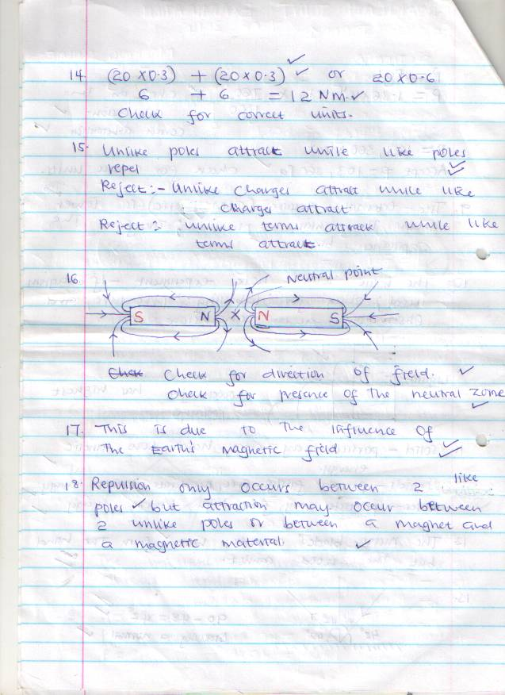

Check for direction of field √
Check for presence of the neutral zone√
- This is due to the influence of the Earth’s magnetic field√
- Repulsion only occurs between 2 like poles√ but attraction may occur between 2 unlike poles or between a magnet and a magnetic materials√

SECTION B
- i. Iron is a soft magnetic material it can easily acquire magnetism and can easily lose magnetism.
- Check for correct direction

A B

- A – North pole√
B – South pole √
- Right hard grip rule√
It states that if a coil carrying current is grasped in the right hand such that the fingers point in the direction of current then the thumb points in the direction of North Pole√.
- It would cause overheating on the electromagnet√. This adversely affects the magnetism of the electromagnet√.
- i. Smoke particles – smoke particles are larger than air molecules and light enough to move when bombarded by air molecules √
Lens – focuses the light from the lamp on the smoke particles, causing them to be observable
Microscope – enlarges/magnifies the smoke particles so that they are visible √
- Smoke particles more randomly/zigzag √
Air molecules bombard the smoke particles
Air molecules are in random motion
- The speed of motion of smoke particles will be observed to be lighter/faster/speed increases√.
- a) Principle of moments states that for a system in equillbrium, the sum of clockwise moments must be equal to the sum of the anticlockwise moments.
b)
6M

3M
C.O.G
1.5M
30Kg

Clockwise moments = Anticlockwise moments
300 x 1.5 = X x 650√ (correct substitution 1mk)

√

X = 0.69M√
c)
50

30cm

Taking moments about P
Distance between P and Q = 100 – (20 + 30)
= 100 – 50√
= 50cm
= 0.5m

F2 x 0.5 = 0.3 x 100√

Clockwise moments = Anticlockwise moments
F1 + F2 = 100N√
F1 + 60N = 100N
F1 = 100N – 60N
F1 = 40N√

- a) Mass of water = 66.1 – 42.9√
= 23.2g√

= 23.2cm³√
Working must be shown
- Volume of density bottle = volume of water
Volume of bottle = 23.2cm³√
- Mass of soil = 67.2 – 42.9
= 24.3g √
- Mass of water that filled the space above the soil
= 82.0 – 67.2
= 14.8g √
- Volume of soil
Volume of water √

= 14.8cm³√
Volume of soil = 23.2 – 14.8
= 8.4cm³√
- The density of the soil
√
= 2.893g/cm³√
- a) A – Seal and insulator√
B – Zinc case√
C – Mixture of carbon and manganese (IV) oxide√
D – Carrbon rod √
- Zinc case acts as a negative electrode√
- i) Polarisation√
Remedy – Adding a depolarizer e.g potassium dichromate√
ii) Local action√
Remedy – By amalgamation√
Accept – use of pure zinc or coating zinc with mercury √

