MARKING SCHEME
PHYSICS - FORM 2
TERM 2

1. M.S.R. = 2.20
V.S.R. = 6 x 0.01
= 0.06
Reading = 2.26cm

2. Volume of 15 drops = 15 x 0.15
= 2.25cm³

New level of liquid = 32.0 + 2.25
= 34.25cm³

3. The force of cohesion within the mercury is greater than the force of adhesion between mercury and glass. The mercury therefore sinks down the tube to enable mercury molecules to keep together.

4. Mass on the earth’s surface = 600
10
= 60Kg

Value of g in the other planet = 450
60

= 7.5N/Kg

5. The steel needle floats due to surface tension of water. The detergent which is an impurity breaks the surface tension hence the needle sinks

6. Solids practices are closely packed together in an organized way.
Liquids particles are further apart
Gases - particles are further apart and have increased random motion compared to those in the liquid state.

1

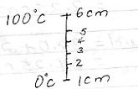
7. 5cm = 100⁰C
1cm = 100 x 1
5
= 20⁰C

Therefore, a length of 4cm corresponds to a temp. of 60⁰C

8. Reading shown is 9.5
+ 0.23
9.73mm

Actual thickness = 9.75
+ 0.19
9.92mm

9. Hard Magnetic materials are materials that are difficult to magnetise but once magnetized, they retain their magnetism for long, while soft magnetic materials are materials that are easily magnetized but do not retain their magnetism for long.

10. Using a nail, make three holes A, B and C of the same diameter along a vertical line on one side of the tin.
Fill the tin with water and observe the jests of water from the holes A, B and C.

11. (a) For a helical spring or other elastic material, the extension is directly proportional to the stretching force, provided elastic limit is not exceeded.

2
(b) (i) A GRAPH OF FORCE AGAINST EXTENSION
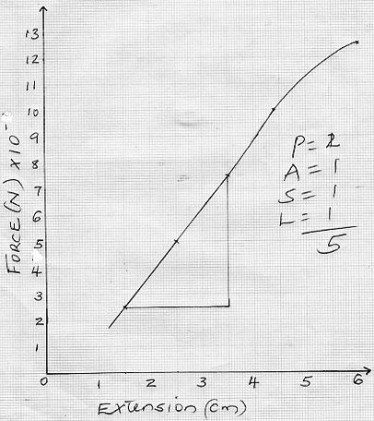

(b) (ii) K = F
E

= 0.75 - 0.25
3.5 - 1.5

= 0.5
2

3

= 0.25N/cm

(iii) 1.0N

(c) Combined spring constant for A and B
= 150 x 2
= 300N/m

Extension produced by A and B

60
300
= 0.2m

Extension produced by C = 60
150
= 0.4m

Total extension = 0.2 + 0.4
= 0.6m

12. (a) Pressure applied at one part in a liquid is transmitted equally to all other parts of the enclosed liquid.

(b) F₁ = F ₂
A₁ A₂

5.0 = M
0.0005 0.25

= 25000N

(c) Pg = pgh + Pa

= 0.8 x 13600 x 10 + 100000
= 208800Nm⁻²

13. (a) (i) To focus the light to the smoke cell

4
(ii) Bright specks in continuous random motion

(iii) The motion is caused by the uneven bombardment/collision between the
invisible air molecules and the smoke particles.

(iv) The motion will increase.

(c) (i) V = 4 II R³
3

= 4 x 3.142 x 0.02³
3
= 0.0335cm³

(ii) A = IIr2
= 3.142 x 0.2²
= 0.125cm²

(iii) d = V
A

= 0.0335
0.1256

= 0.2667cm

14. (a) Light travels in a straight line

(b) hi = v
ho u

ho = 2.5 x 20000
5
= 10000cm or 100m
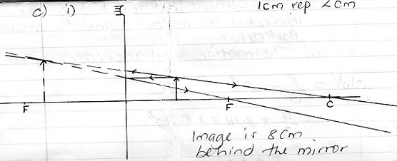

(ii) M = v
u

5
= 8
5

= 1.6

15. (a) For a system in equilibrium, the sum of clockwise moments about a point must be equal to the sum of the anticlockwise moments about the same point

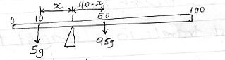

(b)

F₁ d₁ = F₂ d₂

5 X x = (40 - x) 95
5x = 3800 - 95x

100x = 3800
= 38cm

The pivot is at 48cm mark from the 0cm mark

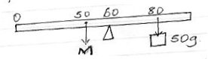
(c)

Let M be the mass of the metre rule

M x 10 = 20 x 50

6

M = 20 x 50
10

M = 100g

16. (i) Iron is a soft magnetic material while steel is a hard magnetic material

(ii) Current flow in the anticlockwise direction

(iii) A North pole
B South pole

- Size of current
Number of turns of the wire
Shape of the core
Length of the solenoid

7

