10. PHOTOGRAPH WORK
The topic entails:-
- Identifying types of photographs
- Describing parts of a photograph
- Estimating the sizes of features appearing on photographs
- Making sketch form photographs
- Identifying and interpreting features on photographs.

1. Study the photograph (a) and (b) and use them to answer the questions below:-
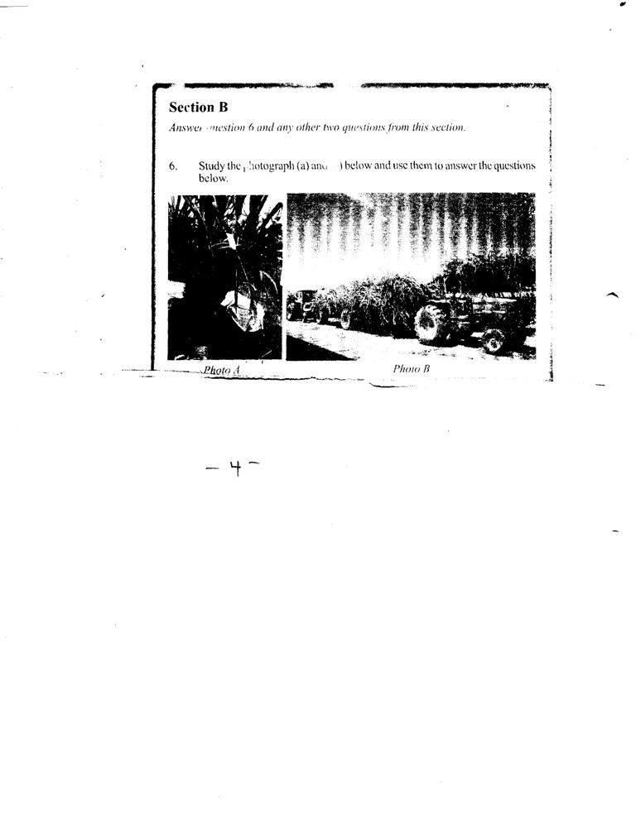

Photo B
Photo A

(a) (i) Name the type of photograph shown in the figure (b)
(ii) Name three human activities carried out in photographs (a) and (b)
(b) If the two photographs were taken from western province, name four districts in the
province the photographs are likely to have been taken from?
(c) Explain five physical conditions that encourage the growth of crops in photograph (a)
(d) State five problems facing farmers of this crop in Kenya
2. (a) (i) State three characteristics of the animal breeds
(ii) Explain why the above activity is mainly located in the highlands in Kenya

