LIVESTOCK PRODUCTION V
(POULTRY)
This topic entails the following:

- Identification of parts of an egg.
- Selection of eggs for incubation
- Identification of suitable sources for chicks.
- Descriptions of broodiness
- Description of condition for incubation
- Description of rearing systems
- Categories of poultry feds according to age-of birds
- Stating causes of stress and vices in poultry and control measures.
- Marketing of eggs and poultry meat.
- Selection, sorting and grading of eggs.

The following relevant questions and their answers in this topic will greatly motivate and help the user to comprehend and understand the required concepts and practices.

1. A deep little poultry house measures 9mx3m. Suppose the amount of space allowed for one
bird is 0.27m².Calculate the number of birds that can be kept comfortably in the house. Show
your working
2. Give two functions of isthmus in female bird
3. Give four features of a good laying nest
4. State four qualities of marketable eggs
5. Study the diagram showing the behaviour of chicks in a brooder and answer the questions that
follow:-
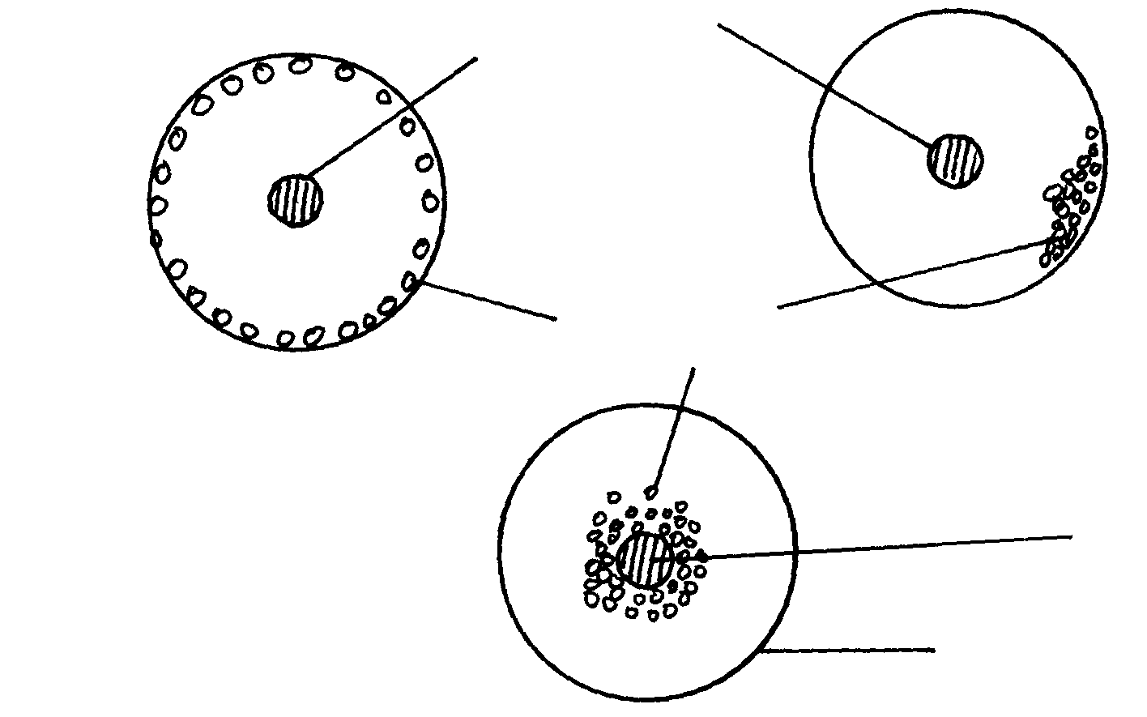
Heat source

B
Chicks

Heat source
A

C
Brooder guard

(a) State the behaviour of chicks in A, B and C
(b) Explain why the brooder guard is rounded as shown in the diagram
6. Mention six characteristics of an egg selected for incubation
7. Describe the management of layers in deep litter system
8. State four reasons for egg breaking and drinking by layers in a deep litter rearing system
9. Below are diagram showing condition of eggs seven days after incubation study them and answer
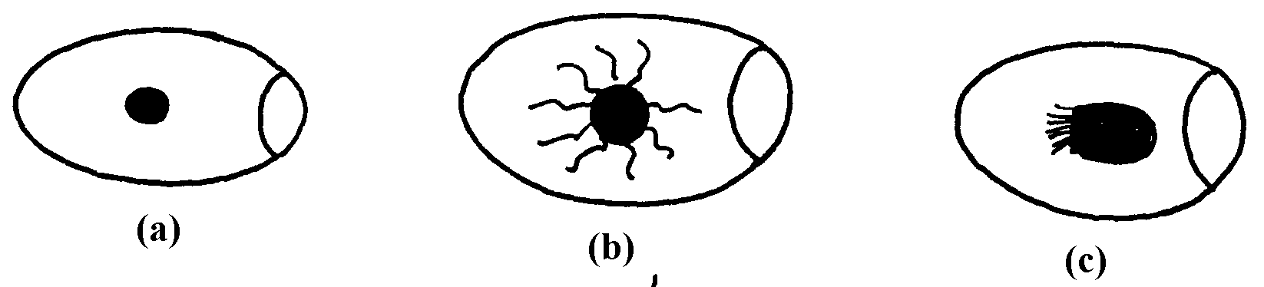
the questions

a) Identify the conditions of eggs
b) Identify the egg which suitable for incubation and give a reasons for your answer
c) Name the practice which used to determine the state of eggs above
10. The diagram U below illustrates an activity carried by a poultry farmer keeping layers. Study the
diagram carefully and answer the questions that follow

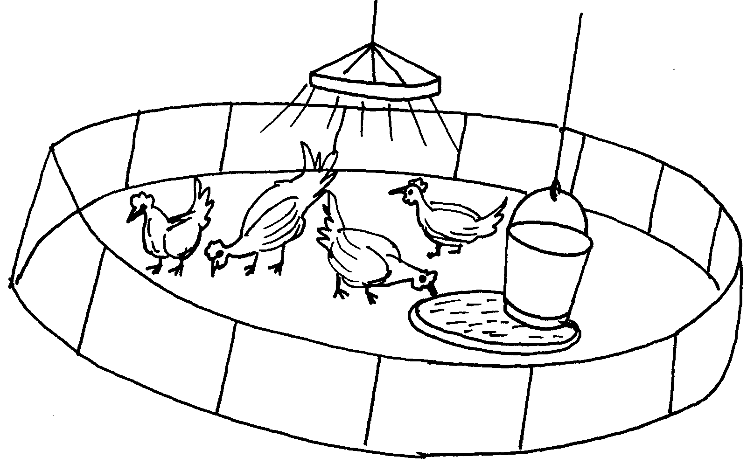

a) Identify the activity carried out using the set up illustrated in diagram U
b) List down four preparations that should be carried out structure U before arrival of
day old chicks
c) List down one behaviouristic activity which would indicate that the chicks are under stress

11. Give two reasons for using litter in a poultry house
12. Give two reasons why it is important to castrate animals when they are still young
13. (a) Give two reasons why dehorning is carried out in farm animals
(b) State four methods of dehorning livestock
14. State four abnormalities of eggs that can be detected during egg candling.
15. Describe the management of day old chicks in a deep litter system from preparation of brooder up
to eight (8)weeks old
16. a) Describe the management practices of a gilt from weaning to the time of furrowing
b) State five factors to consider in selecting a gilt for breeding stock.
17. Study the diagram of an egg be1ow and answer the questions that fol1ow:

i) Name the parts labeled N, O and P
ii) State the functions of the parts M and L
iii) Why should the egg be turned during incubation
18. State three reactions of chicks in a brooder which has higher temperature than normal.
19. Give three types of bedding material a poultry farmer may use in deep litter rearing of layers
20. Give two properties of good eggs for incubation

LIVESTOCK PRODUCTION V
(POULTRY)
1. One bird occupies 0.27m²
Area available 9m x 3m= 27m²
1 bird 0.27m²
? 27m²
= 27m² = 100 birds 1x2=2mis
0.27m²

2. Functions of isthmus.
- Shell membranes formed/ determines shape of egg;
- Water mineral salts and vitamins added;

3. Features of a laying nest.
- Dimly lit; dark;
- Spacious / large enough to accommodate bird comfortably;
- Dry clean beddings;
- Have lockable doors;
- Kept in secluded parts of the house;
- Have slanting roofs to prevent birds from perching on;
Have an appropriate height from floor;

4. Qualities of marketable eggs.
- Smooth texture;
- Right shape, colour, size and weight;
- Right shell hardness;
Clean and fresh;

5. (a) A - Too high temperature
B- draught C chilliness from left side
C – Inadequate heat supply /low temperatures ( ½ x 3 = 1 ½ mk)
(b) Explain why the brooder guard is rounded as shown in the diagram
To avoid overcrowding in the corners which can lead the suffocation and death

6. - Fertilized
- Medium size (55-60gm)
- oval shaped
- free form abnormalities e.g. double yolk/ blood spots
- Be freshly collected (not more than 1 week)
- Have smooth shells
- Be free from cracks in the shells
- Be clean

7. Adequate space
- Litter to be kept dry and free form dust
- Turn the liter frequently
- Perches and rosters should be adequate and well spaced
- Adequate waterers
- Well distributed waterers
- Provide clean and adequate water
- equipment to be kept clean
- Replenish soft litter in the nest
- ensure the nest is dark
- Collect eggs regularly
- Feed the birds well
- Supply gut to assist in digestion
- Keep the birds busy by hanging greens
- Curl the birds and pool layers
- De-beak birds to prevent cannibalism
- Vaccinate birds regularly
- Check birds for disease symptoms
- control parasites
- Avoid stress factors
- Discourage broodiness
- Maintain and repair the houses
- Provide enough fed troughs
- Keep proper records
- Dispose off dead birds

8. four reasons for egg breaking and drinking by layers in a deep litter rearing System Bright light in the laying boxes/over corroding/few laying boxes
- Poor feeding without mineral rich feeds
- Undebeaked birds
- Irregular egg collection

9. a) a-infertile (clear)
b-fertile egg
c-damage yolk
b) Identify the egg which suitable for incubation and give a reasons for your answer Egg b-it is fertile and will develop into a chick
c) Name the practice which used to determine the state of eggs above
Candling

10. a) Brooding of chicks (1x1=1mk)
b) four preparations that should be carried out structure U before arrival of day old chicks
cleaning the house and brooder with disinfectant
- dusting with chemical to kill etoparasites
- placing the polythene paper on fresh and clean saw dust
- fixing and setting of sources of heat and light
- Fixing the feed and water troughs and putting fresh feed and water.
c) List down one behaviouristic activity which would indicate that the chicks are under stress Moving away or close to the heat source
- Fighting
- Cannibalism

11. - Litter gives comfort and warmth to the birds
- Helps in drying dropping
- keeps birds bust
12. Reasons for castrating animals when young
- Less pain
- Quick healing
- Little loss of blood

13. a) Reasons for dehorning farm animals
- Reduce space occupied by animal
- Making handling easier
- To reduce destruction of farm structures
- To make them
- To reduce risk, injury to farmer and other animals 2x ½ = 1 mark
b) Methods of dehorning livestock
- Use of caustic potash stick (Potassium hydroxide)
- Use of dehorning iron
- Use of dehorning saw or wire
- Use of rubber ring and elastrator
- Use of dehorning collation
14. four abnormalities of eggs that can be detected during egg candling. (2mk)
- Absence of yolk.
- Double / triple yolk.
- Air space in wrong position.
- Excessively large air space.
- Cracks on egg shell.
- Blood / meat spots.
- Deformed / broken yolk.
15. The management of day old chicks in a deep litter system from preparation
of brooder up to eight (8)weeks old (20mks)
- ensure brooder is working well 2-3days before arrival of chicks
- provide brooded with litter for warmth and moisture absorption
- provide heat source
- put wire gauze around the heat source
- make holes on the brooder to provide fresh air
- provide dim light to prevent cannibalism
- cover litter with polythene sheet or newspaper and place feeds on them to discourage chicks from eating litter
- check the temperature at above 15cm above the floor to ensure that the temperature is appropriate
- from 4th -6th week withdraw the heat source gradually
- feed chicks on chicks mash
- provide plenty of clean water
- vaccinate against Newcastle disease after 2-3 weeks
- keep proper records
- dust birds with insecticide to control external parasites
- at 6 weeks introduce growers mash
- isolate sick birds from healthy ewes
- remove and treat sick birds
- clean and disinfect the house
- provide greens
- remove dead chicks from the house
- provide foot bath with disinfectants

16. (a)- Piglets are weaned at the age of 8 weeks and feet on sow and weaner meal.
- Deworming should be done to control internal parasites.
- Vaccinate to control diseases e.g African swine Fever.
- Spray to control external parasites
- Identification is done by ear notching
- Take it to pork when it shows signs of being heat
-Trim over grown hooves.
- Gestation period is 4 months
- Prepare furrowing pen by disinfecting the walls
- Sow brought to furrowing pen 3 days to.

(b) -Age
-Mothering ability be good
-Physical fitness
-Health of gut
-Body confirmation
-Temperament of behaviour
-Adaptability
-prolificacy

17. (i) M- Chalaza L- Space
N- Yolk O- Inner shell membrane P- Shell
(ii) M- Hold the yolk in position at centre of the egg.
L- Air trappd in this space used by developing embryo
(iii) – To avoid germinal disc sticking on the egg shell

18. - Move away from the source of heat to the periphery

19. -saw dust
Wood shavings
Crushed maize cobs
Coffee husks
Rice husks
20.
- Be fertilized
- Should be medium in size i.e 50-65 gm in weight
- Have smooth shells
- Be oval in shape
- Be free of any cracks in shells
- Be clean to ensure that pores are clean
- Not have any fresh i.e collected withine one week
- Should be fresh i.e collected within one week

