LIVESTOCK PRODUCTION I
COMMON LIVESTOCK BREEDS
This topic entails the following:
- Reasons of keeping livestock
- Parts of a cow
- Characteristics of indigenous and exotic cattle breeds
- Dairy cattle breeds
- Beef cattle breeds
- Dual purpose cattle breeds
- Pig breeds
- Sheep breeds
- Goat breeds
- Rabbit breeds
- Camel breeds

The following relevant questions and their answers in this topic will greatly help and motivate the user to comprehend and understand the re1quired concepts and practices:
1. State two reasons for treating water for us on the farm
2. State four advantages of applying lime in clay soil
3. State four ways by which Re-afforestation help in land reclamation
4. Give two distinguishing features between the following breeds of rabbits; Kenya white
and California white
5. Give four reasons why most farmers keep livestock in Kenya
6. Give three ideal conformation features of beef cattle
7. (i) Name a dual purpose cattle breed reared in Kenya
ii) State three uses of a rotavator
8. Name a pig breed with the following features:
White body colour, erect ears, dished snout, big in body size
9. What does the term ‘epistasis’ mean in livestock improvement?
10. (a) Explain the role of livestock industry in Kenya’s economy
(b) Outline the general characteristics of indigenous cattle
11. Below is a diagram of a cattle. Study it an answer the questions that follow:-
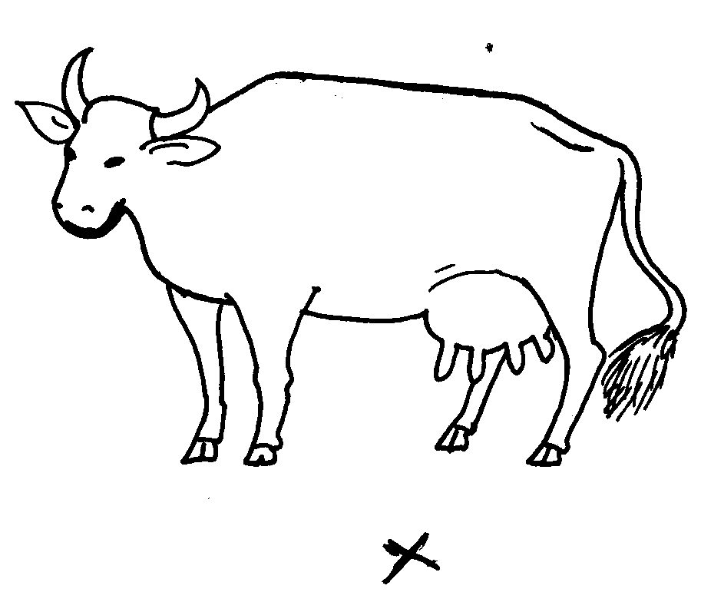

(i) What type of animal is represented above?
(ii) If you stand at a point marked X, state five characteristics that tells you that the animal belong
to type name in (i) above?
(iii) State three areas on the body of a cow where ticks are commonly found
12. Name four breeds of dairy goats
13. List two distinguishing characteristics of Californian breed of rabbit
14. Name the common milk breed of goats reared in Kenya
15. Name four dairy cattle breeds reared in Kenya.
16. Differentiate between ‘breed’ of animal and ‘type’ of animal.
17 Name the camel breed that is adapted to cooler regions and has a woolly body covering
18. State any two channels through which beef is marketed in Kenya.

LIVESTOCK PRODUCTION I
COMMON LIVESTOCK BREEDS
1. two reasons for treating water for us on the farm
- Remove chemical impurities
- Remove foreign material
- Remove disease earning organisms
Remove bad smell & taste

2. four advantages of applying lime in clay soil
- Lower soil acidity
- Increase calcium content
- Hastens decomposition of organic matter
- Improve soil structure/ improve drainage
- Facilitates availability and absorption of nitrogen and phosphorous
- Improve legume nodulation and nitrogen fixation
Increase multiplication of micro- organisms

3. four ways by which Re-afforestation help in land reclamation
- Add organic matter from falling leaves
- Recycles soil erosion
- Control soil erosion
- Improve drainage of swampy areas
Play part in hydrological cycle

4. Distinguishing feature between Kenya white and California Kenya white is white all over the body, has pink eyes California white is white with black nose and eras; has black/ brown eyes

5. Reasons why farmers keep livestock in Kenya
- Source of food
- Source of income
- Cultural uses e.g. paying dowry, recreation
- Provide source of power e.g. oxen
- Provides raw material to the industries

6. Ideal conformation features of beef cattle
- Blocky/ square/ rectangular
- Deep well flashed bodies
- Short strong legs to support their heavy bodies
- Compact body

7. (i) Dual purpose cattle in Kenya.
- Sahiwal;
- Red Poll;
- Simmental;
(ii) Uses of Rotavator.
- Mixes trash and the soil;
- Cuts the furrow slices and harrows them; 92 in one pass).
- Break up large soil clods into smaller ones / performs 2⁰ tillage;
- Cut the furrows slices / primary tillage;

8. Large white is the pig with such characteristics

9. Epistasis is s combination of genes which on their own could have been inferior on undesirable(1mk)

10. (a) The role of livestock industry in Kenya’s economy
- Provision of food; various livestock products such as milk, eggs, meat and honey are used as food
- Source of labour: some livestock can be used to provide power for carrying out various activities e.g. oxen, donkeys and camels
- Provides employment; Several people are employed in the livestock industry ether directly of indirectly e.g. those employed by KMC
- Social cultural uses: depending on the culture of the society e.g. dowry, status, symbol e.t.c
- Source of income when livestock and livestock products are sold either locally or internationally: income is earned whish is used for national development which is used for national development
- Industrial development, various products are processed n industries which are taxable to raise income or national development
(stating any 5pts = 1mk x 5; Explanation each 1mk x 5pts =5mks (10mks)
(b) The general characteristics of indigenous cattle
- they have large thoracic humps for storing fat
- they are tolerant to high temperatures
- They are able to resist tropical diseases e.g East Coast fever
- They have relatively long calving interval (beyond one year)
- They have a slow growth rate and mature rate
- They have smooth and short coat of hair
- They have along and narrow head
- they have a relatively short lactation period
- they can walk for long distances without serious loss in condition
- They are relatively small in size even when mature (1mk each for any 10pts = 10mks)

11. (i) Dairy cattle
(ii) five characteristics that tells you that the animal belong to type name in (i) above?
- Straight top line
- Large udder/well develop udder
- Prominent milk vein
- Large swell develop head quarter
- Triangular shape
- Large stomach capacity (any 5x1=5mks)
(iii) three areas on the body of a cow where ticks are commonly found (1½mk)
- Base of ear/inside the ears
- Neck
- Flanks
- Tail switch/tail
- Belly
- Brisket/dew lap (any 3x ½ =1 ½ mks)

12. 4 dairy goats
- Saanen
- Jamnapari
- Anglo- Nubian
- Toggenburg
- British Alphine

13. two distinguishing characteristics of Californian breed of rabbit
- White body
- Black ears /nose/paws/tail (2x ½ =1mk)

14. two common milk breed of goats reared in Kenya
- British Saaren
- The Toggenburg
- Anglo-Nubian
- Jamnapari
- The British alpine ( ½ x2=1mks

15. four dairy cattle breeds reared goats in Kenya.
- Ayrshire
- Friesian
- Guernsey
- Jersey (4x ½ =2mks)

16. Differentiate between breed of animal and type of animal. (2mk)
- Breed-group of animals with similar characteristics and common origin.
- Type –the purpose for which the animal is kept. (2x1mk = 2mks) (mark as whole)
- smothers weeds
- Regulate soil temperature
- Conserve moisture

