SOIL AND WATER CONSERVATION
This topic entails the following:
- Definition of soil erosion
- Explanation of various factors which influence erosion.
- Agents of erosion
- Description various methods of erosion
- Description of various methods of erosion control
- Description of micro-catchments and then uses.

The following relevant questions and their answers in this topic will greatly motivate and help the user to comprehend and understand the required concepts and practices:

1. Name three human activities that may influence soil erosion
2. Below is a diagram showing soil erosion control method
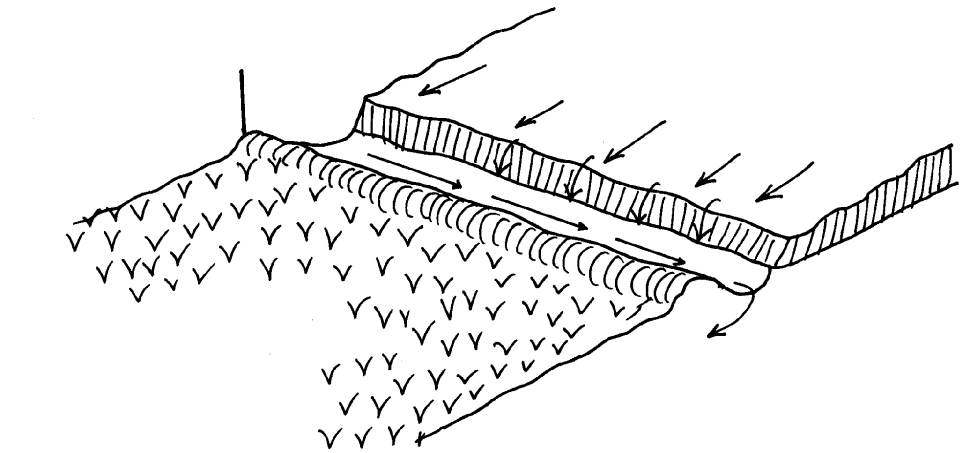
Soil
Uncultivated land
Water movement

Cultivated land with crops

a) Identify the structure used to control soil erosion
b) What is the function of the structure made
c) Why was soil not put on the upper side of the trench made
d) State four effects if water was allowed into the cultivated land
3. Give two roles played by Grassley in soil erosion control
4. List three materials that may be used for constructing a gabion
5. State one factor that would determine the width and depth of a cut off drain
6. Explain five ways by which grass helps to conserve soil
7. Give four farming practices that help in reducing the effects of water shortage in crop production
8. Name two types of terraces
9. Name two forms of gully erosion
9 -V- shaped
-U – shaped
10. Explain the cultural methods of soil erosion control
11. Mention four control measures of river bank erosion
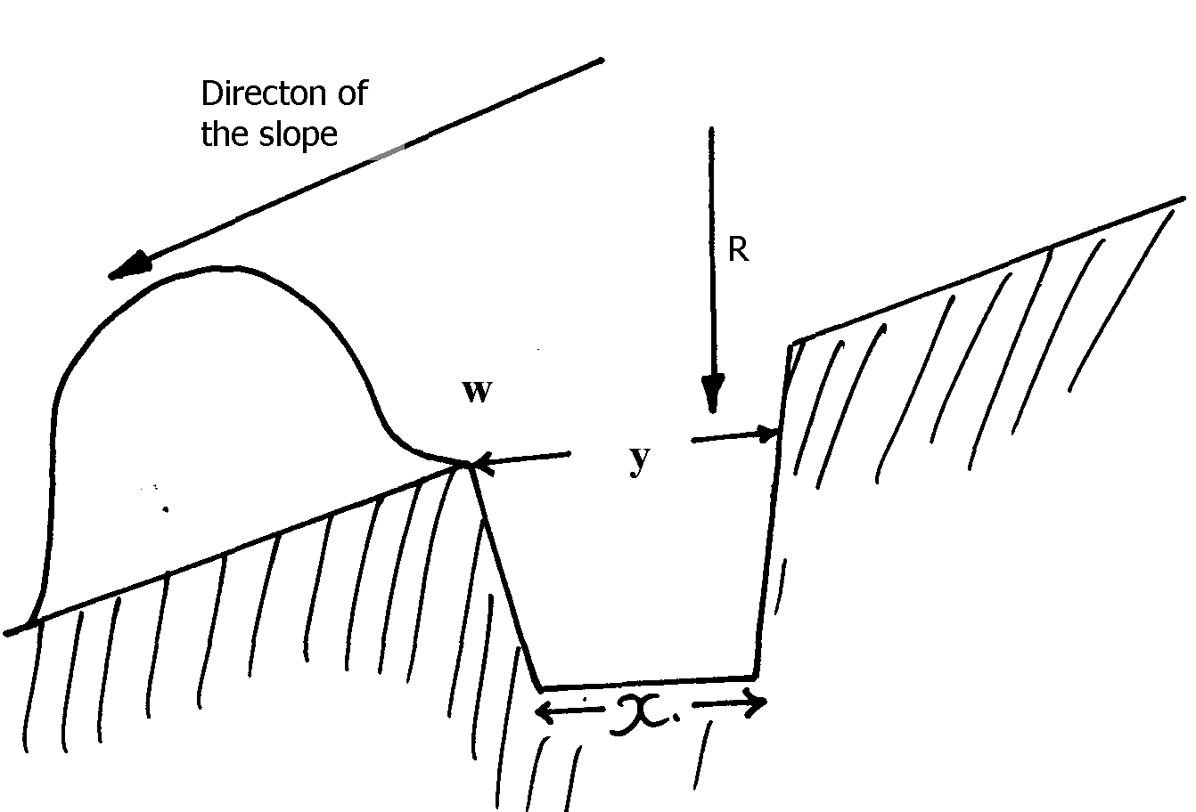
13. The figure below represents a physical soil and water conservation measure used on various slopes

a) Identify the measure represented above
b) Describe the construction of the identified measure above
15. a) What is soil erosion
b) Give four types of water erosion
c) Explain factors which influence soil erosion
d) State any seven cultural ways of controlling weeds
16. Give two ways through which gabions control soil erosion

SOIL AND WATER CONSERVATION
1. Three human activities that may influence soil erosion
- Ploughing up and down slope
- Over cultivation
- Planting annual crops on slopes
- Overstocking/ burning vegetation/ clean weeding
Over irrigation
2. a)Cut off drain 1x1=1 mk
b)Collect water from uncultivated land and drain it into a water bay 1x1=1 mk
c)Will be washed by water back to the trench, filling it then to cultivated land
d) four effects if water was allowed into the cultivated land
- Will wash top fertile soil away
- Will uproot planted crops
- Expose unproductive soil
Soil washed will cover crops on the lower end of the farm

3. two roles played by Grassley in soil erosion control (1mk)
- Improves soil structure by holding loose particles together
- Provides ground cover to prevent exposure of soil to agents of soil erosion
- Reduce movement of surface run off
4. three materials that may be used for constructing a gabion.
- Wires.
- Stones.
- Concrete/ sand/ cement/ water/ ballast.
- Wood/ poles/ metal pegs/ rods.
5. one factor that would determine the width and depth of a cut off drain.
- Expected volume of run – off.
- Bed rock / soil type.
6. (a) - Reducing the speed of surface run-off – hence reducing the runoffs water erosive power.
- Trap soil from surface run-off/ filter out soil.
- Reduce the impact of rain drops on the soil thus reducing splash erosion.
- Grass holds soil particles together hence reducing soil erosion.
- Soil structure is improved by organic matter from grass thus rate of water infiltration increases.
- Water stays for 36 hours thus solid particles settle and bilharzias causing organisms killed.
- Alum added to coagulated solid particles which settle at the bottom.
Stage IV: Filtration
- Water is passed through filtration tank with layers of sand and gravel to filter it.
- Water leaving the filtration tank is clean.
Stage V: Chlorination
- Water is passed through chlorination tank where chlorine is added.
- Micro-organisms in the water are killed by chlorine.
Stage VI: Storage
- The treated water is stored in large overhead tanks before distribution and use.
7. Four farming practices that help in reducing the effects of water shortage in crop production are:- -Mulching
- Early planting
- Planting early maturing crops
- Practice land fallowing
- Contour cropping/Contour farming
8. - Fanya juu terraces
- Broad base terraces
- Bench terraces
- Narrow based terraces
- Fanya chini terraces
10. The cultural methods of soil erosion control are:
- Planting cover crops – The more the soil is covered by a crop or grass, the less erosion will occur
- Early planting- Established an early ground cover by crops thus reducing the risk of soil erosion
- Inter-cropping – Increases the ground cover protecting the soil from erosion
- Crop rotation – improves soil structure where the rotation includes a grass
- Strip cropping/contour/field strip cropping – This is the growing of alternate strips of different crops in the same field with the purpose of interrupting the continuous flow of water or wind
- Weed or disease and pest control – This ensures a good crop stand that covers the soil more
- Harvesting procedures that leave crop residues on the field
- Mulching- The covering of the soil with organic or inorganic materials
- Contour farming follows the contours during ploughing, ridging and planting which reduces surface run off
- Grass strips formed by either leaving narrow strips of land un ploughed or planting grass on strips along the contour
- Afforestation and reafforestation
- Fallowing – leave the land uncultivated for same time (any 10x2=20mks)

12. - Construction of dams
- Construction of dykes
- Planting trees along river bank to hold soil together
Observing government regulation on leaving a sizeable strip of an uncultivated land along
the river bank
13. a) Bund
b) It is constructed along the contours
- A channel is dug with the upper width (y) 1.5cm and bottom width (x) 90cm
- Excavated soil is put on the lower part of the channel leaving the part (W) the ledge
- The steeper the slope the closer the bunds
14. a) It is the process by which top soil is detached, removed and carried away from one place to
another place where it is not useful
b) four types of water erosion
- rain drop/splash erosion
- sheet erosion
- rill erosion
- gully erosion
c) factors which influence soil erosion
  - Amount and intensity of the rainfall
  - Excess water run off take with it loose soil articles
  - Slope of the land (topography)
  - Sped of water as it flows to determine by the slope of the land .the steeper
  - The slope the higher the rate of erosion
  - Type of soil
  - Some soils drain water faster than the other as sandy soil is easily eroded than sandy soil
  - Soil depth
  - Shallow soil become saturated with water quickly than deep soils
  - Vegetation cover
  - Forests protect soil against erosion than bare soil
  - Overstocking
  - Overstocking increase soil erosion
  - Deforestation
  - Cutting down of trees expose soil to agents of erosion leading tom soil erosion
  - Planting annual crops in steep slope
  - It leads to frequent cultivation hence exposure soil to erosion
  - Indiscriminate burning of vegetation before cultivation
  - The land is exposed to erosive forest of rain and wind
  - Clear weeding
  - This leaves the soil less protected against water erosion
  - Pruning up and down the slope
  - Increase soil erosion
d) seven cultural ways of controlling weeds
i)matching-matching smother weeds
ii)cover cropping-cover crop smother weeds
iii) Crop rotation-some weed only grow well when in association with certain crops
e.g. Striga grow only where some cereal crops and sugar cane are growing .when
these crops are rotated with dicots, striga does not germinate
iv) Timely planting-crops establish early before weeds thus smothering them
v) use of clean seed/planting material-prevents the introduction of weeds to the form land
vi) Proper spacing-helps to create little space for weed growth
vii) Clean seedbed-this starts off the crops on a clean bed so that they effectively compete
with weeds
viii) flooding-mainly practiced in rice fields
15. -Slow down surface run – off
-Filter soil particles from surface run off

