9. INTERNAL LAND-FORMING PROCESSES
This area covers :-
- Earth Movements
- Folding
- Faulting
- Vulcanicity
- Earth Quakes

It entails:
  - Definition of earth movements
  - Explaining the causes of horizontal and vertical earth movements.
  - Explaining theories of continental drift and plate tectonics
  - Defining folding, faulting and vulcanicity and earthquakes.
  - Explaining the
  - Description of types of folds, faults, and forms of vulcanicity
  - Explaining the resultant features due to folding, faulting and vulcanicity
  - Explain causes of earth quakes.
  - Describing how earth quakes are measured
  - Account for the world distribution of earth quake ones, fold mountain systems and features resulting from faulting and vulcanicity
  - Explaining the significance of the resultant features of folding, faulting, vulcanicity and the effects of earth quakes.

1. a) Composite volcano
b)i)What are earthquakes?
ii) Name two types of earthquakes waves
iii) Explain three ways in which volcanic mountains positively influence human activities

2. a) Using well labeled diagrams, distinguish between a simple symmetrical fold and an
asymmetrical fold.
b) i) Name two fold mountains of the Alpine Orogeny
ii) With the aid of well labeled diagrams, describe how a fold mountain is formed.
c) Explain three positive effects of folding on the physical & human environment.

3. (a) State three ways in which the earth’s crust is affected by the earthquakes
(b) State two evidences of continental drift theory
(c) Name three types of plate tectonic boundaries

4. (a) (i) What are tectonic plates
(ii) Give any two examples of oceanic plates:-
(b) Describe how the following cause earth movements:
(i) Isostatic adjustment
(ii) Magma movement in the crust
(iii) Convectional currents in the mantle.

5. (a) Give any two natural causes of earthquakes
(b) Name three characteristics of the rift valley lakes of Kenya

6. (a) State three characteristics of the rift valley lakes of Kenya
(b)(i) What are earth quakes?
(ii)Name three types of earth quake waves
c). Differentiate between extension boundaries and compression boundaries.

7 a. i) What is an earthquake
ii) Give two ways in which earthquakes can be predicted
b) State two ways in which faulting interferes with transport and communication lines.

8. The diagram below represents a feature resulting form faulting
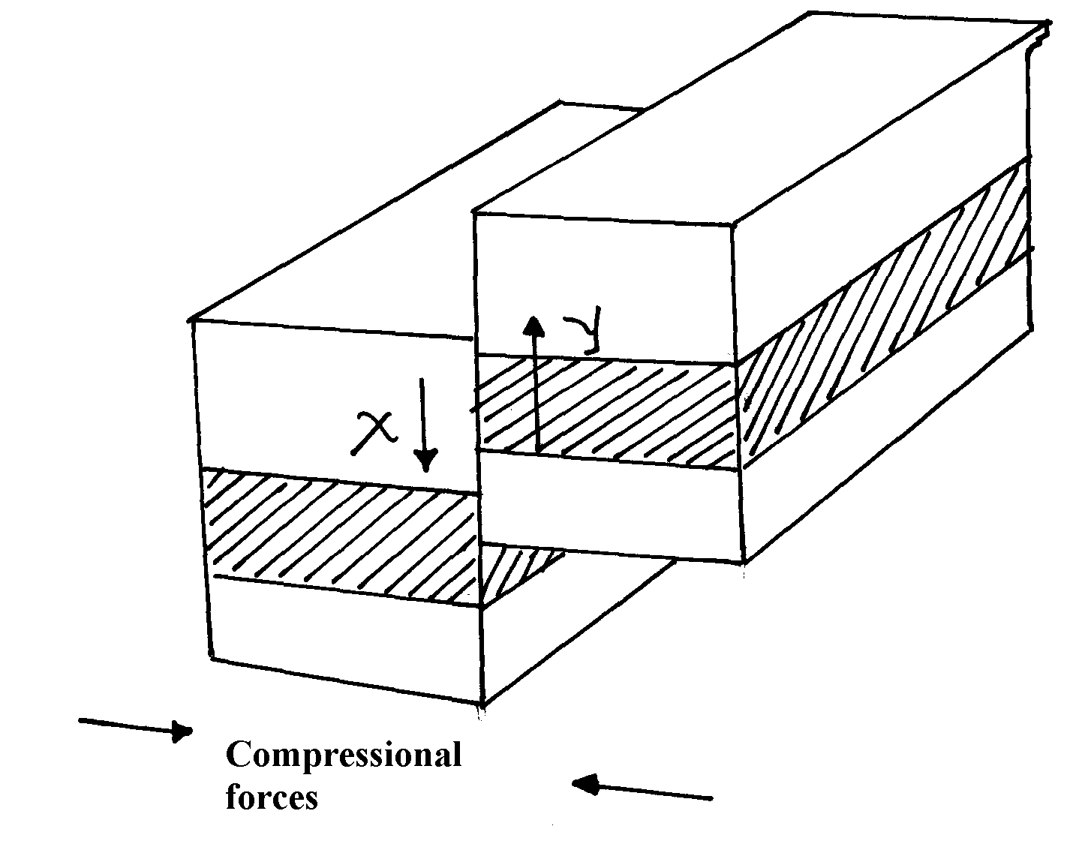

(a) Name the feature
(b) Name part x and y
(c) Give three negative of an earthquake
9. (a) Differentiate between hot springs and geysers
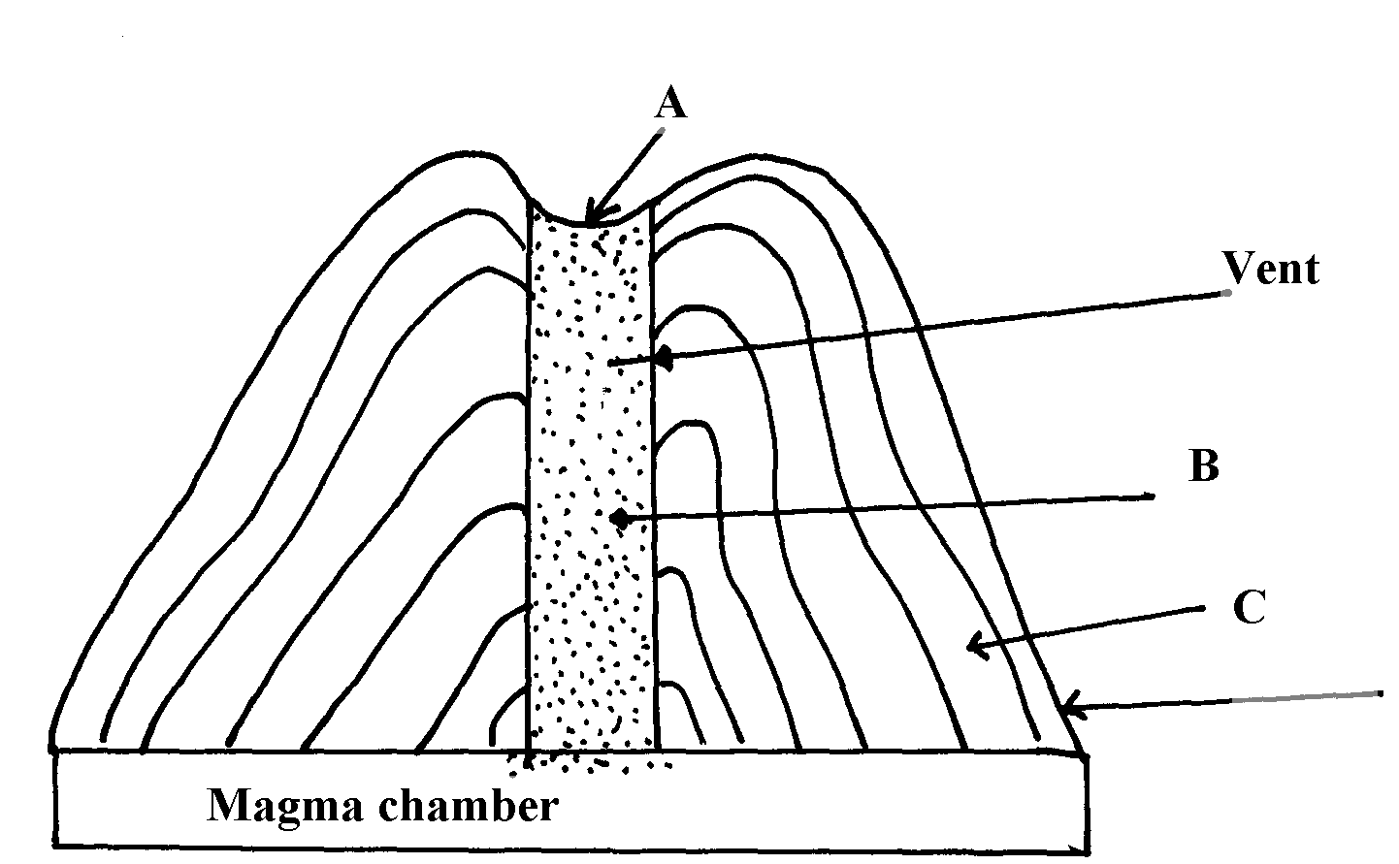
(b) The feature below show an extrusive landform in a volcanic area

(c) Using well labelled diagrams, describe how the following are formed:
(i) An anticlinal fault
(ii) An overthrust fold
(d) (i) Explain any three ways in which features resulting from volcanicity are a problem
to people
(ii) Describe how subsidence can lead to formation of a caldera.

10. (a) What is the plate tectonic theory ?
(b) Name three types of tectonic plate boundaries .
(c) Explain two evidences that support continental drift theory.

11. (a) (i) Name two fold mountains in Africa apart from Atlas mountains
(ii) Differentiate between symmetrical and asymmetrical folds
(iii) Apart from symmetrical and asymmetrical folds, name other types of folds
(b) (i) With the aid of well labeled diagrams explain the formation of fold mountains
(ii) Give two-examples of fold mountains in North America

12. a) Effects of the elliptical shape of the earths orbit
b) Mention three causes of the earth movements

13. a) List two characteristics of destructive plate boundary
b) Outline three natural causes of earthquakes
b) State two effects of earthquakes on crystal rocks

14. a) List two factors that determine the degree of folding in rocks
b) State three effects of faulting on drainage systems

15. (a) State any one evidence that support the theory of the drifting of continents
(b)(i) Apart from Africa, name any two other continents that form the Gondwanaland
(ii) What is panthalassa?

16. a) Give two reasons why hardwood trees species in Kenya are in danger of extraction
b) State three problems that affect forestry in Canada

17. The diagram below shows a simple fold
(a) (i) Name the part marked A, B and C
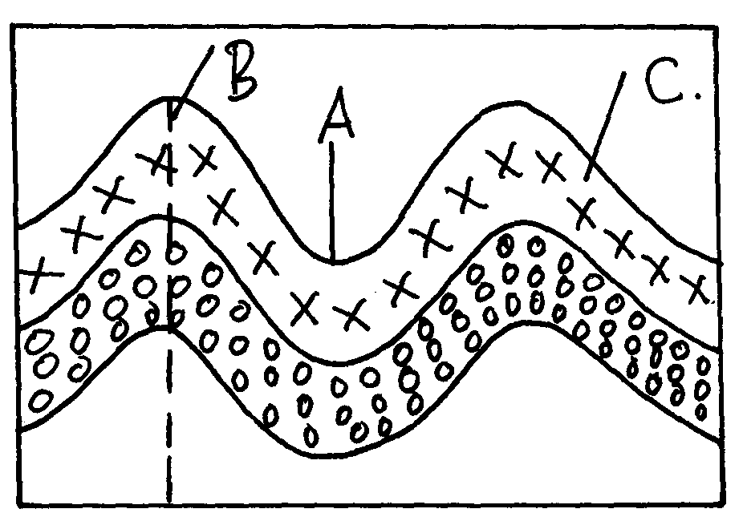

(ii) Name two fold mountains outside Africa
(iii) Give thee landform associated with folded regions
(b) With the aid of well labeled diagram describe the process of formation of Fold Mountain
(c) Explain four ways in which folding influences human activities

