9. INTERNAL LAND-FORMING PROCESSES
1. a) - it has vertical vent/pipe
- compose of alternating layers of ash/pyrodast and lava
- it is conical in shape /steep sided
- it has side vents
- it has conelets/parasitic cones on the sides
- at the peak, it may have a caldera /crater/plug
b i) Earth quakes are sudden earth movement which cause vibrations/trembling within the crust√√
ii) - primary/push/p-waves s
- secondary/shear waves/shake waves/s-waves
- longitudinal/L-waves/lore waves/Raleigh waves

iii) - volcanic mountains re sources of rivers which provide water for
domestic/agricultural/industrial use
- volcanic mountains have forests which provide valuable timber used in building and construction industries
- volcanic mountains influence formation of relief rainfall which encourages agricultural activities
- volcanic mountains modify temperatures making them attractive to human settlements

2. a)

- Formed when compressional forces of equal magnitude and of moderate strength act on crustal rocks
- The rocks bend evenly and the anticline is symmetrical about its axis

Axis

- Results from unequal compressional forces acting on crustal rocks
- One of the forces is slightly stronger than the other resulting to limbs that are assymetrical about the axis
b i) - Atlas mountains of Africa
- Alps mountains of Europe
- Himalayas mountain of Asia
- Rockies of N. America
- Andes of S. America
b ii) - An extensive depression called a geosynclines is formed on the surface of the earth - The geosynclines is then filled with water to form a sea

- The surrounding land masses are eroded and resultant materials deposited in the geosyncline in layers
- Accumulation and weight of sediments causes the floor of the geosycline to subside further
- Further subsidence of the geosynclines triggers off compressional forces drawing higher grounds close
- The layers of sediment in the geosynclines are the folded bending upwards form mountains

c) - Fold mountains are often forested on their windward slopes and provide valuable
timber for construction
- The windward slopes receive rainfall hence supports agriculture
- Heavy rainfall and snow that collects in some fold mountains give rise to rivers which
in turn provide water for both domestic &industrial use
- The process of folding could bring valuable minerals to the surface cutting down the
cost of mining e.g. coal in Appalaction
- The unique mountains landscape attracts tourist thus earning the country foreign
exchange

3. a) - earthquakes causes lateral and vertical displacement of rocks
- they cause raising and lowering and down warping of parts of the sea floor
- it causes landslides/slumping
- it leads to faulting of the c rust
- they lead to volcanic eruptions
b) - The jig saw fit of continental magins e.g. Southern Africa and Southern America
- Spreading of the ocean floor- rocks are younger at the oceanic trenches and younger
outwards
- Geological evidence i.e. the rock structure in some continents are similar e.g. South Africa and South America meaning that they were together
- Palaeoclimatic evidence, similar fossils/ remains have been found in different continents
c) - Extension boundary/ divergence
- Comprisin/ convergence
- Transform fault boundary
- Conservative boundary

4. a i) Tectonic plates are seirigid blocks that form the earth’s crust
ii) - Pacific plate
- Nazca plate
. b i) This disrupts the balance between the sial and sima causing movement of continental
masses
ii) This force themselves in cracks/crevices displacing crustal rocks
iii) These cause frictional drug/pull on the crustal rocks causing their movement

5. a) -Isostatic adjustments
-Gravitation pressure
-Tectonic movement
-Magma movement (volcanic activities)
-Energy release in upper mantle
. b) -primary (P) waves
-secondary (S) waves
-surface longitudinal waves
6. a) -they are long deep and narrow
-most of them are salty
-they are fault lakes
b)i) -They are sudden earth movement which cause trembling/vibration within the earth’s
crust.
(ii) - Primary/ puse waves/p. waves.
- Secondary/shear/S. waves
- Longitudinal/love/L. waves
c ) Extension boundaries are zones where tectonic planets diverge or move away from
each other. Space may be created and magma fill the space found in between. While
compress ional boundaries are zones where tectonic plates moves towards each other.
There is thus destruction of materials found at the edges

7. a i) - Is a sudden and rapid movement/tremor of the earth crust.
ii)- Use of change of velocity of seismic waves
- Use of exotic pre-quake signals.
b) - Faulting causes disjointing of the land which results in disruption of transport and
communication lines.
- The presence of fault scarps can cause difficulty in construction of transport and
communication lines.
- It is expensive to construct and communication lines in faulted region.

8. a) reverse fault
b) X-up throw
Y-down throw
. c) - Fire outbreaks
-destruction of transport and communication lines
-loss if life and properties/collapse of buildings
- Change directions of rivers flow

9. a) -hot springs are place where hot water or steam is emitted from the ground while
geysers are jep of hot water or steam and gasses which are ejected explosively
from fissure in the ground
b) A-crates B-plug C-strato volcano
c) i) - Crustal rock layers are subjected to compressional forces
- This leads to formation of a massive article /up fold
- Further compression to the same crustal rocks causes stress/tension at the crest of the anticline
- Eventually a crack/fault and around the crust of the anticline called an anticline fault
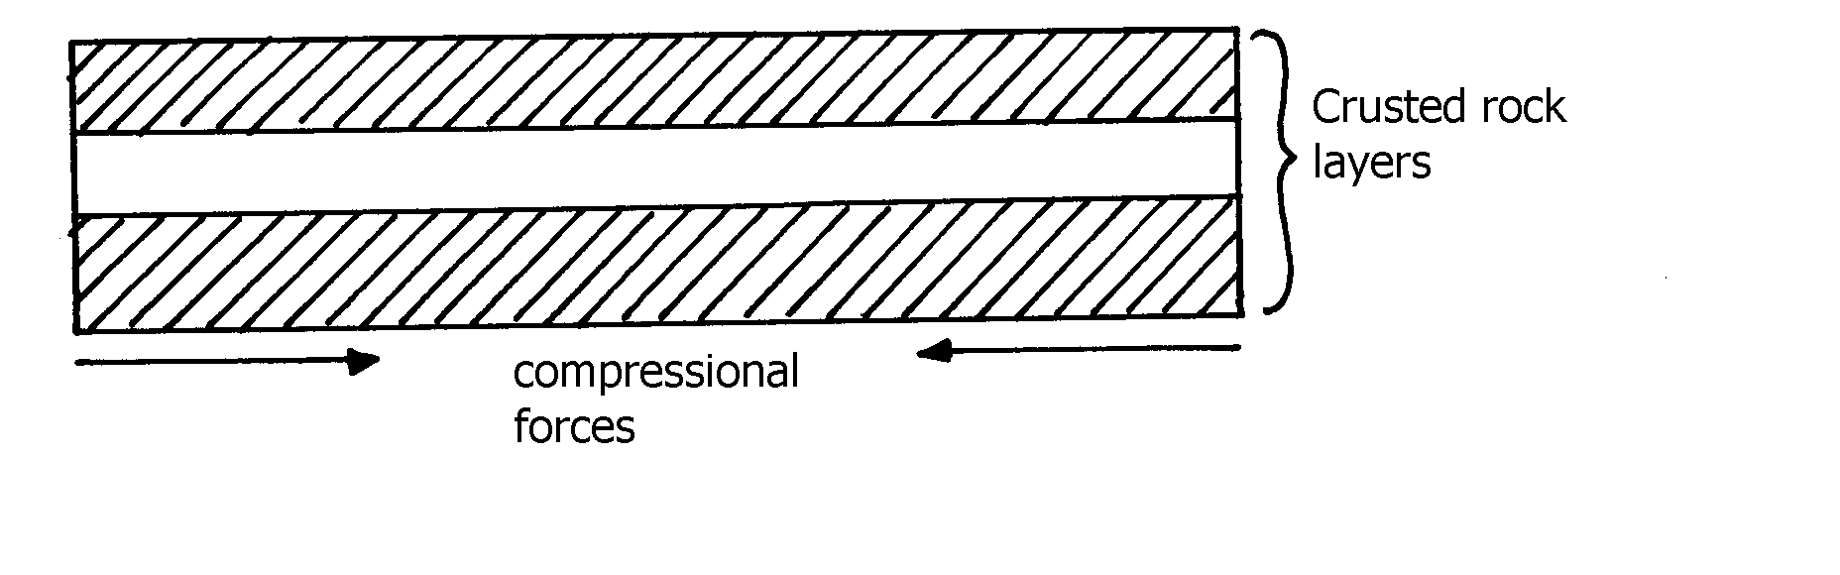

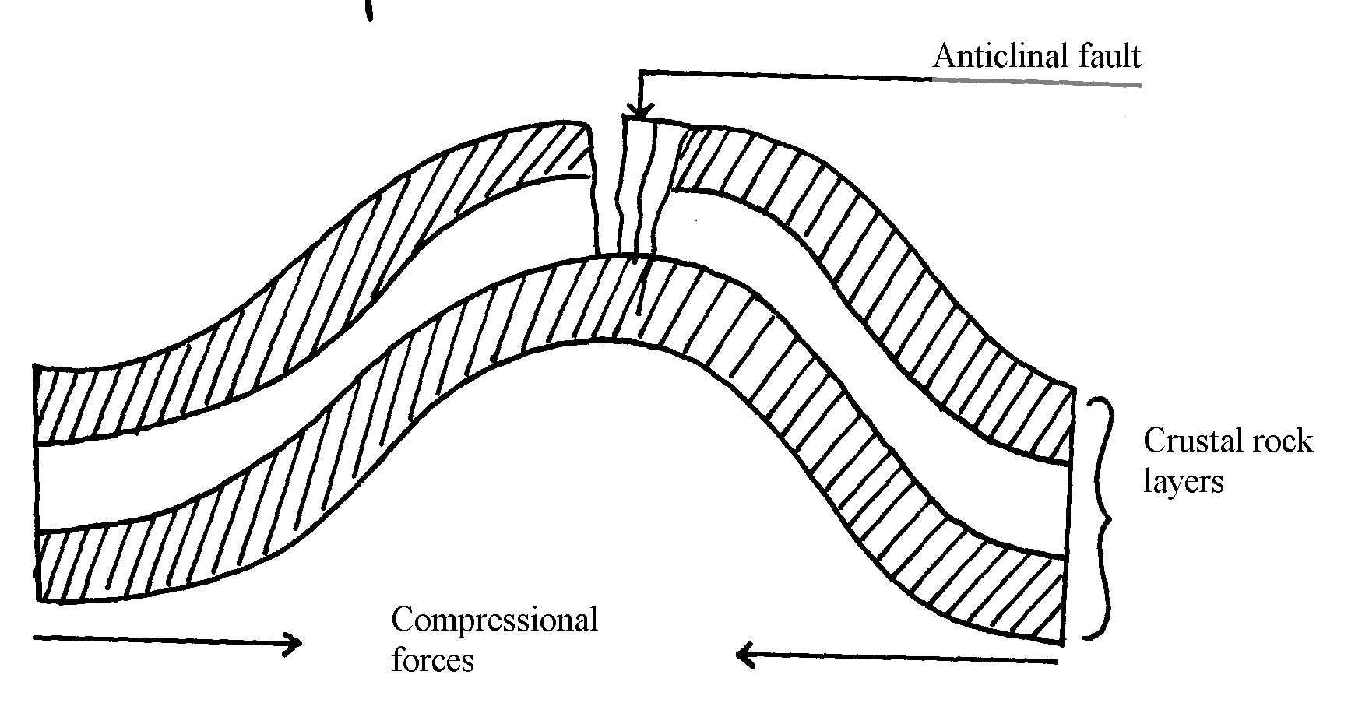

. c ii) - Crustal rock layers are subjected to compressional forces
- Intense folding results into formation of an overfold
- With increased pressure the over fold is compressed further to form a recumbent fold
- When pressure if very great, a fracture occurs along the axis producing a thrust plane
to form an overthrust fold
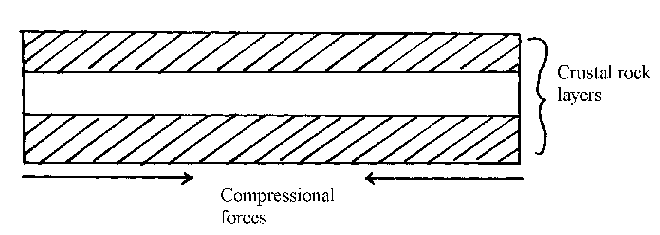

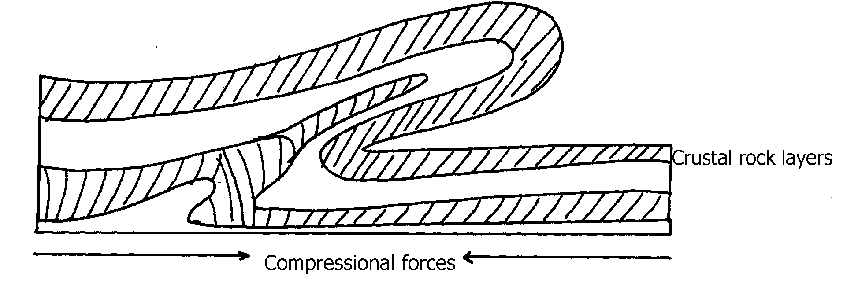

d i) - Volcanic mountains experience low rainfall on their leeward slopes making them
unsuitable for agriculture/settlement/forestry
- Volcanic mountains have steep slopes which hinder transport and communication
- Some volcanic features like moffetes, solfataras steam jets produce poisonous which
pollute the environment/are harmful to people
- Some volcanic rock weather to form infertile solid unsuitable for agriculture/forestry
d ii) - Outpouring of Lava forms a volcanic cone
- When the pressure beneath stops, a hollow, void is left beneath
- The weight of the overlying cone leads to collapse of the top of the cone into the how-
/void beneath
- This leaves a wide depression at the top of the volcano called a caldera

10. a) - It is a theory that states that the crust is divided into blocks of land (plates) that
float and move towards, away or parallel
b) - Compressional boundary
- Extension boundary
- Transform fault boundary
c) - Geological evidence – Rock similarities in structure, age and type of rocks found in
various continents e.g. in Eastern coast of S. America and Western coast of Africa
- Jig- saw- fit – of continental coastlines. Some coastlines can fit each other when pulled together e.g. Western coast of Africa can fit with Eastern coast of South America
- Ancient glaciations – All the four Southern continents reveal signs of a period of large scale glaciations at one time. It is evidenced by presence of glacial deposits – Tillites produced by ice sheets in Southern continents
- Archeological evidence – Some plant and animal remains found in various continents show a striking similarity

11. a i) - Atlas
- Cape ranges
- Akwapim
ii) - Atlas
- Cape ranges
- Akwapim
iii)- Symmetrical folds have limbs dipping uniformly about the axis while asymmetrical
fold one limb is steeper than the other about the axis
. b i)

b i) - Extensive shallow depression called geosynclinal develop
- Sediments from high areas are deposited in the geosyncline
- Compression on either side push towards geosyncline
- Sediments compress to form fold mountains which rise above sea level to form fold
mountains
b ii) - Over fold
- Recumbent folds
- Nappe or overthrust fold
- Anticlinical/ synclinal fold
- Isoclinal

12. a) - Causes seasons
- Varying lengths of day and night time
- Changes in the position of the mid-day sun at different times of the year
- Causes eclipses
b) - Movement of magma within the crust
- Gravitational force towards the center of the earth
- Convectional currents in the mantle
- Isostatic adjustment of sial and sima layer

13. a) - Frequent earthquakes
- Presence of faults
- Presence of fold mountains
b) - Tectonic movements
- Volcanicity
- Gravitative pressure
- Isostatic adjustment
- Energy release in the mantle
14. a) - Nature and age of the rocks
- Intensity of compression forces
. b) - May cause a river to disappear
- Changes the rivers direction of flow
- Forms depressions hat are filled with water forming lakes
- Faulting across a river forms waterfalls

15. a) - The jig-saw fit√
- Glaciatean/ancient glaciation√
- The coal deposits√
- Sea floor spreading√
b i) - Australia√
- South Africa√
ii) this was the water body that occupied the region surrounding the pangae

16. a) - High demand for hard wood has led to over exploitation
- They take long to mature hence can not match the exploitation rate
- Population pressure has led to cutting trees to give room for settlement and agriculture
b) - Accidental fires which destroy the forests
- The Northern part is inaccessible (during winter) for exploitation of the forests
- Over exploitation in some areas
- Trees take long to mature due to cold climate
- Rugged landscape especially mountainous landscape makes exploitation difficult

17. (a) i) A-axis B-syncline C-limb of a fold
ii) - The rockets
- Andes
- Himalayas
- Alps
- Appalachians
iii) - fold mountain
- cuesta
- escarpment
- plateus
- basins

b) - Geosynclines are formed on the earths surface
- prolonged and extensive erosion occurs on the surrounding higher grounds
- sediments are deposited in the geosyncline forming thick layers

- the weight of the sediments causes subsistence of the geosyncline leading to
accumulation of more sediments
- further subsidence of the geosyncline triggers off compressional forces which draw the
higher grounds closet forming fold mountains

c) - Fold Mountains are water catchments area. They brap rainfall which rivers which that
provide water for domestics use
- fold mountains are often forested and provide valuable timber used in construction
and building industry(due to high rainfall)
- some fold mountains have valuable mineral deposits such as coal and petroleum for mining
- fold mountains influence transport system enter as barriers or as passed

