TOPICS COVERED
 | TOPIC | QUESTION PG | ANSWER PG
 | Introduction to Geography | 3 | 53
 | The earth and the solar system | 3 | 53
 | Weather and climate | 5 | 55
 | Statistical methods | 8 | 60
 | Maps and map work | 10 | 61
 | Field work | 14 | 69
 | Minerals and rocks | 17 | 76
 | Mining | 18 | 77
 | Internal Land-Forming Processes | 20 | 82
 | Photograph work | 23 | 89
 | Vegetation | 24 | 90
 | Forestry | 27 | 94
 | External land forming processes | 28 | 99
 | Soils | 34 | 117
 | Agriculture | 36 | 124
 | Land reclamation and Rehabilitation | 39 | 135
 | Fishing | 41 | 142
 | Wildlife and tourism | 43 | 146
 | Energy | 44 | 148
 | Industry | 46 | 153
 | Transport and communication | 46 | 153
 | Trade | 49 | 159
 | Population | 50 | 161
 | Settlement | 51 | 164
 | Management and conservation of the environment | 53 | 167

1. INTRODUCTION TO GEOGRAPHY
The topic entails:
- Definition of Geography and Environment
- Description of the branches of Geography
- Explaining the importance of studying Geogrpahy and its relationship with other disciplines.

1. Explain why the study of Geography is beneficial in the management and conservation of the
environment.

2. THE EARTH AND THE SOLAR SYSTEM
The topic entails:
- Definition of Solar System.
- Explaining the origin of the earth
- Explaining the effects of rotation and revolution of the earth.
- Description of the structure of the earth

1. The diagram below represents the earth on its axis. Use it to answer question (a)

a) i) Name the latitude marked G
ii) What is the angle of inclination of the earth’s axis from its orbit
b) i) State two effects of the rotation of the earth
ii) When the local time is 2.00 p.m at longitude 45°E, what is the longitude of a place
whose local time is 10.30 a.m
c) Name two local winds experience around lake Victoria region
2. The table below represents rainfall and temperature figure for a town in Kenya .Use it to
answer the questions that follow:-

MONTH | J | F | M | A | M | J | J | A | S | O | N | D
Temp (ºC) | 27 | 28 | 28 | 28 | 27 | 25 | 25 | 24 | 25 | 26 | 27 | 26
Rainfall(mm) | 25 | 38 | 99 | 140 | 277 | 439 | 277 | 69 | 142 | 201 | 71 | 25

a)i) calculate the annual range of temperature for the town
ii) Calculate the total annual rainfall for the town (1mk)
b) State three characteristics of the climate experience in the town
3. a) What is a solstice
b) State three effects of the revolution of the earth
4. (a) (i) Give two theories that explain the evolution of the solar system and the origin of the earth
(ii) Identify the force that causes the earth to bulge at the equator
(b) Give two reasons that support the belief that the interior of the earth is very hot
5. a) State two theories that are used to explain the origin of the earth
b) What is solar “system”?
6 a). Name two planets without natural satellites in the solar system
(b) (i) What is a time zone?
(ii) Give the reason why the International Date Line is significant. (2mks)
(c) State any two characteristics of Latitudes.
7. (a) What is the solar system
(b) Give three reasons why the interior of the earth is very hot
8. (a) The diagram below represents an eclipse. Use it to answer the following questions:
(i) Name the type of eclipse

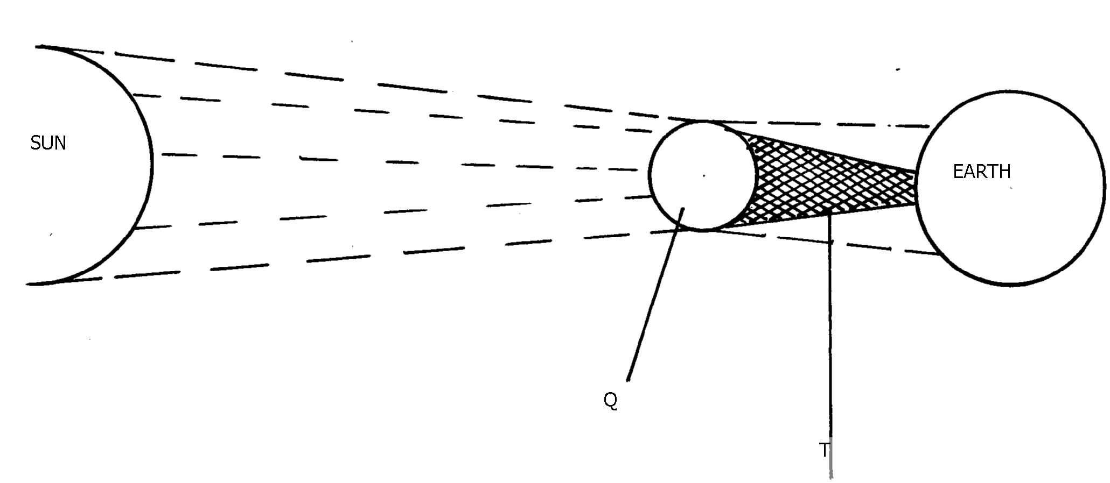

(ii) Identify the parts marked Q and T
(b) State three effects of the rotation of the earth
9. a) State three reasons why the interior of the earth is known to be very hot
b) Give two effects of the elliptical shape of the earth
10. (a) (i)What is an equinoxal date?
(ii) Name two equinoxal dates
(iii) State two changes caused by the earth’s revolution around the sun
11. The diagram below represents the internal structure of the earth. Use it to answer question (a.)

a)Name the arts named u, v and x
b) Describe the characteristics of
i)Crust ii) Core
3. WEATHER AND CLIMATE
The topic entails:-
- Defining weather and stating its elements
- Explaining conditions necessary for siting a weather station.
- Use instruments to measure elements of weather
- Analyse and interpret data on weather conditions
- Description of the structure and composition of the atmosphere
- Explain factors influencing weather
- Carrying out a field study on weather station
- Distinguish between weather and climate
- Explain the factors that influence climate
- Description of the characteristics of the climatic regions of Kenya.
- Description of characteristics of major climatic regions of the World.
- Accounting for the causes of aridity and desertification
- Explaining the effects and possible solutions to aridity and desertification
- Discussing the causes and impact of climate change on physical and human environment

1. State three causes of desertification.
2. a)i) Differentiate the term aridity and desertification
ii) Differentiate between weather and climate
b) State two causes of temperature inversion
c) Explain the occurrence of a land breeze
3. a) Give three characteristics of the inter- tropical convergence zone
b) (i) State three natural causes of climate change
ii) Explain four consequences of climate change on the physical environment
c) Give four reasons why some areas within the equatorial belt do not experience true
equatorial climate
4. (a) Describe the climatic conditions experienced in the Kenya highlands
(b) Explain four effects of folding to human activities
5. (a) Distinguish between weather and climate
(b) State six characteristics of equatorial climate
6. (a) Explain how the following factors influence climate:
(i) Ocean currents
(ii) Altitude
(b) Study the map of Africa below and answer the following questions:
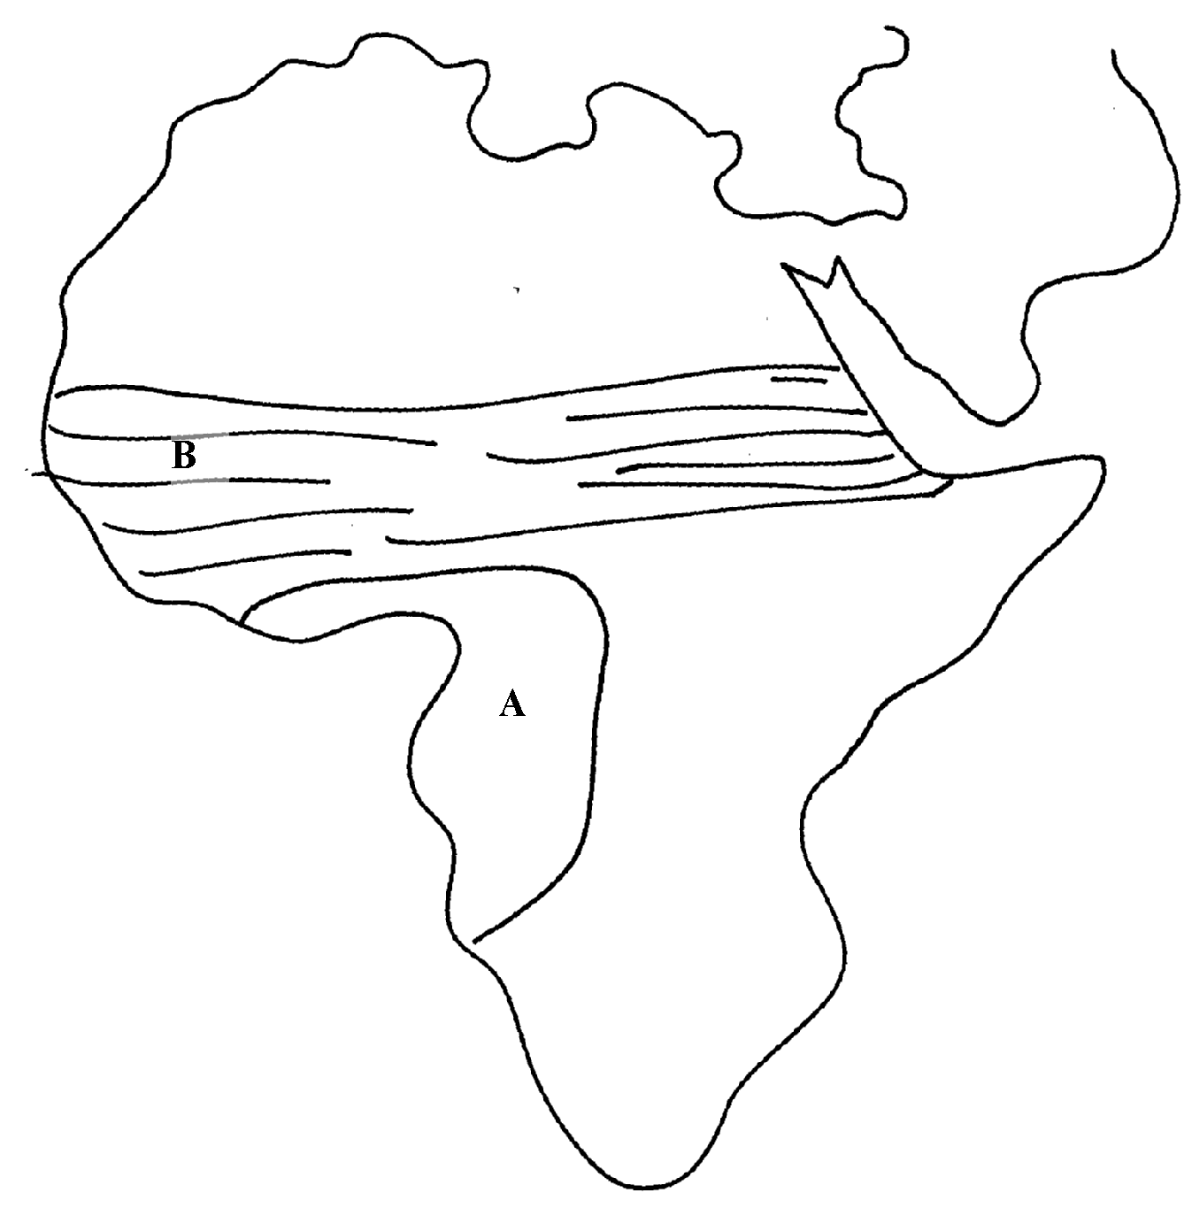

(i) Describe the characteristics of climate marked A.
7. (a) State three conditions necessary for the formation of dew
(b) State two climatic reasons why the government should evict settlers from the Mau
forest complex in the Rift valley of Kenya
8. (a) (i) What is a fog?
(ii) State any two conditions necessary for the formation of fog.
(b) Name any two isothermic layers of the atmosphere.
9. (a) What is an air mass?
(b) Give two climatic characteristics of the Inter-Tropical Convergence Zone (ITCZ)
10. (a) Describe two characteristics of a mountain climate
(b) (i) State two human causes of climate change
(ii) Explain three consequences of climate change
(c) Four classes intend to visit a weather station near your school to study the instruments
for measuring weather element:-
(i) Describe how you would use a rain gauge to measure rainfall
(ii) Name two instruments you would find inside a Stevenson screen
11. a) What do you understand by:
i) Micro- climate
ii) Green house effect
b) Name two weather recording instruments that are placed in a Stevenson’s screen
12. (a) What is an air mass?
(b) What two conditions favour formation of air mass?
13. (a) What is the Inter-tropical convergence Zone?
(b) Account for any four characteristics of tropical rainforests.
14. (a) What is an air mass?
(b)Study the diagram below and name the air masses marked A, B , C and D

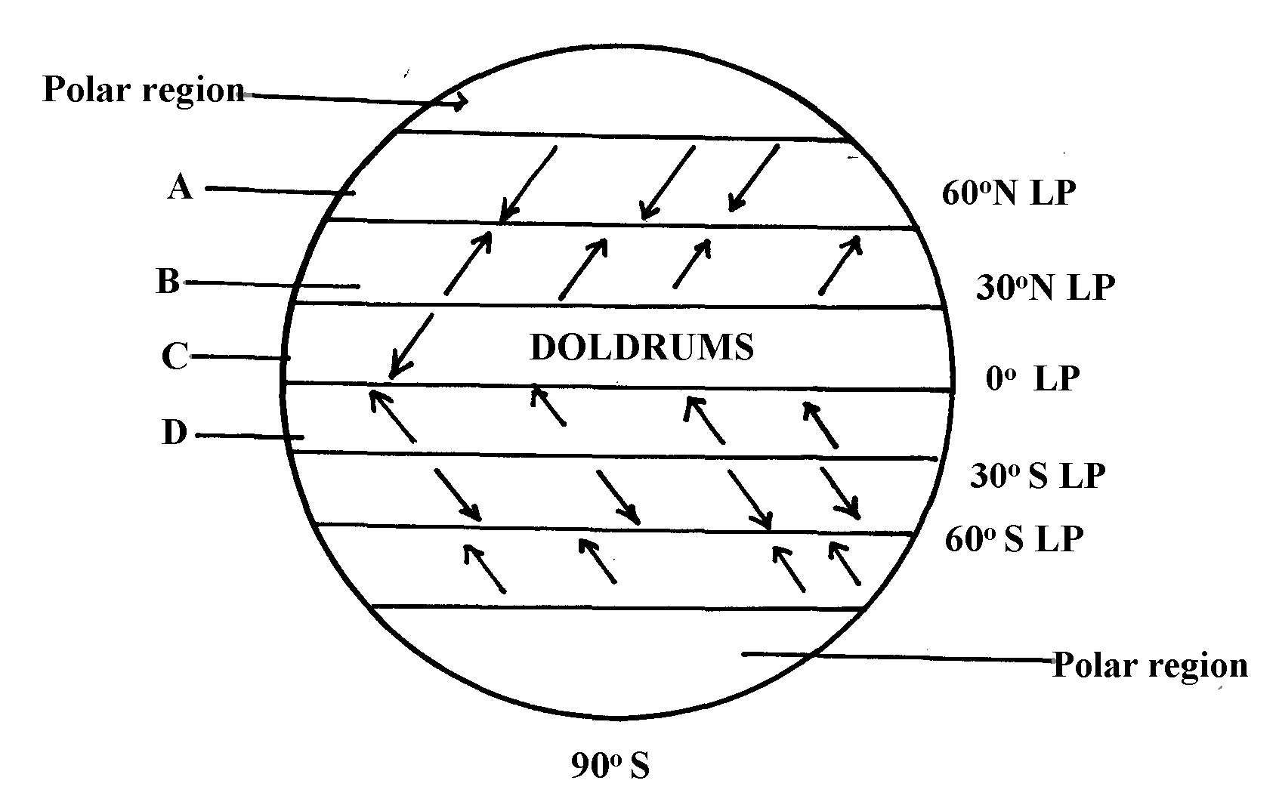

Key
LP- Low Pressure
HP- High Pressure

15 (a) (i) What is global warming?
(ii) Give any four causes of climate change.
(iii) Name four Green house gases
(b)(i) Explain five effects of climate change
(ii) Identify with evidence two climatic aspects that could have influenced the distribution
of vegetation
16. (a Differentiate between:
(i) Aridity and desertification
(b) Give three reasons why the recording of weather data at a weather station may be inaccurate
(c) State two qualities that makes Stevenson screen suitable for its work

17. The map below shows the climatic regions of Kenya
(a) Use it to answer the question a and b
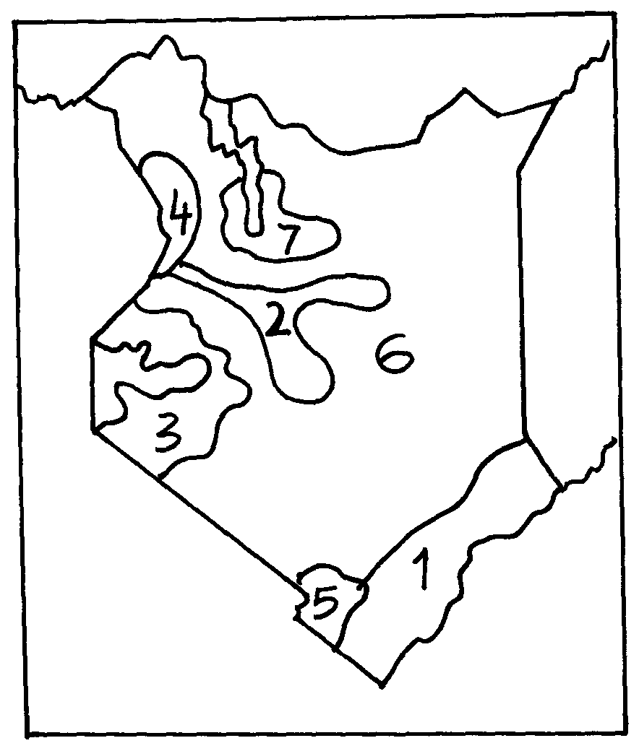

. (a) Name the climatic region name 2 and 3
(b) State three characteristics of climatic region marked 7
18. The map of Africa below shows the different climatic regions of Africa. Use it to answer
question 18.(a).

a )i)Identify the climatic types marked X and Y
ii) Name any four characteristics of the climate marked Z
b) i) Briefly explain the green house effect and the global warming
ii) Explain three effects of climatic change on the physical environment
c) Explain how the following factors influence climate
i) Altitude
ii) Continentality
iii) Ocean currents

4. STATISTICAL METHODS
The topic entails:-
- Defining statistics
- Identifying types and sources of statistical data
- Identifying and describing methods of collecting and recording data.
- Analysis, interpretation and presentation of statistical data using appropriate graphical methods.
- Explaining the advantages of each method of data presentation.

1. Study the table below and answer questions that follow:-

CROP | 1978 | 1979 | 1980 | 1981 | 1982
COFFEE  TEA  PYRETHRUM  MAIZE | 1000  750  300  500 | 990  700  250  450 | 870  650  350  550 | 830  700  400  600 | 840  600  450  350

(a) (i) Using 1cm to represent 500 tons, draw a compound bar graph to represent the data.
(ii) Give two disadvantages of using the method to represent statistical data.

2. The table below shows leading import crops by value (Kshs. Million). Use is to answer
questions a – c

 | CROP
Year | Un milled wheat | Maize | Rice | Wheat flour
2000 | 6,989 | 4,664 | 1,968 | 180
2001 | 7,515 | 3,342 | 2,619 | 639
2002 | 5,577 | 229 | 2,104 | 237
2003 | 6,099 | 1,417 | 2,981 | 168
2004 | 6,754 | 4,647 | 3,659 | 200
(a) (i) Using a scale of 1cm represents 100,000 , draw a comparative bar graph to represent
the data in the table above
(ii) Give three advantages of suing comparative bar graphs
(b) Explain three reasons why Kenya is a producer of the commodities shown in the table
above yet she imports the same

3. The table below shows milk production in ‘000 units in selected Districts
District | 1982 | 1992 | 2002
Trans nzoia | 24 | 26 | 40
Kiambu | 23 | 25 | 31
Meru | 25 | 27 | 32
Bungoma | 12 | 14 | 20
a) i) Using a vertical scale of 1 centimeter to represent 10,000 units, draw a compound
bar graph to represent the above given data

4. Study the figure below and use it to answer question 6. The figure depicts proportional
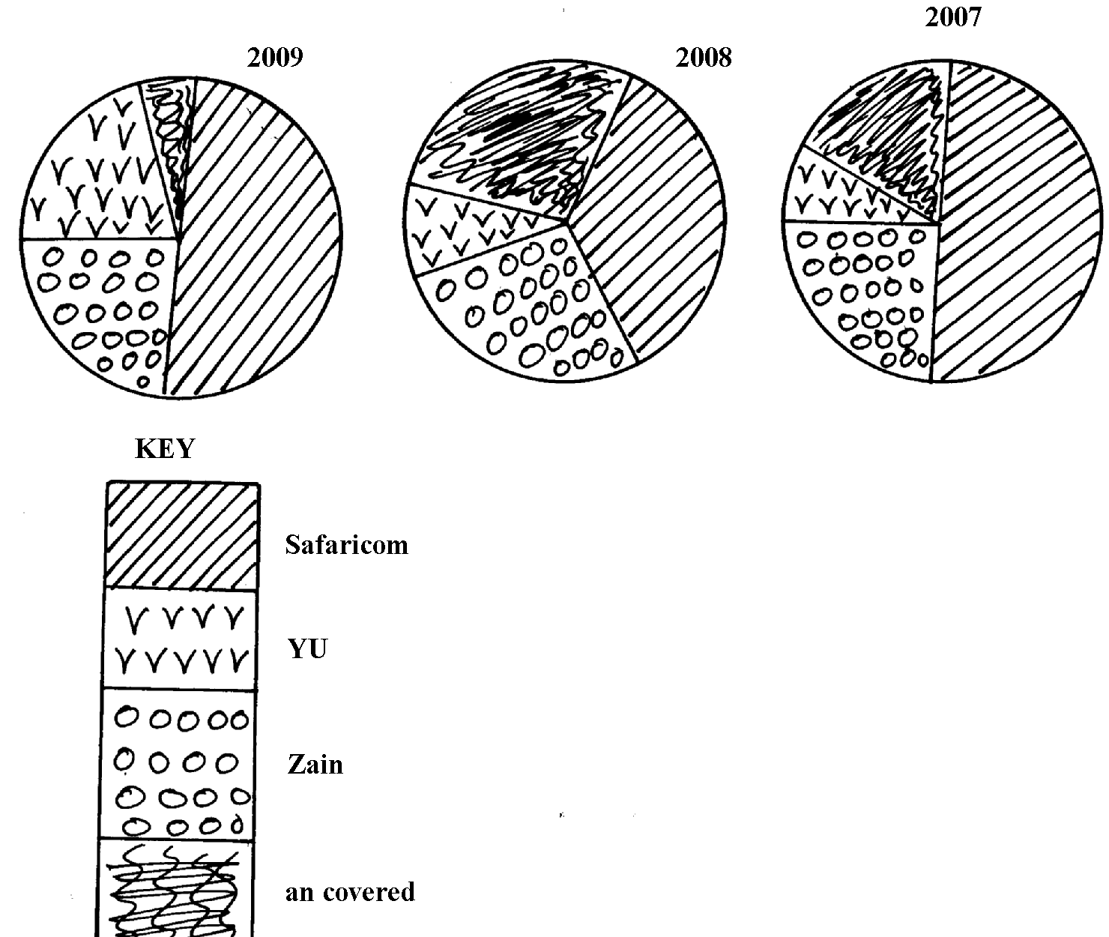
divided circles showing the extend of network coverage in Kenya between 2007 and 2009

Uncovered

a) i) State four deductions that can be made from the above representation
ii)State three advantages of using proportional circles in representing data

5. The table below shows four principal crops produced in Kenya in the years 2000 and 2001.
Use it to answer questions.
CROP AMOUNT IN METRIC TONS
YEAR | 2000 | 2001
Wheat  Maize  Coffee  Tea | 70,000  200,000  98,000  240,000 | 13,000  370,000  55,000  295,00
(a) (i) Using a radius of 5 cm, draw a pie chart to represent crop production in the year 2000.
(ii) State two advantages of using pie charts.
(b) Calculate the percentage increase in wheat production between the years 2000 and 2001.

6. Study the data given and use it to draw a pie chart showing mineral production in Kenya;

Mineral | Amount (000 tonnes)
Gold | 26
Flouspar | 14
Soda ash | 32
Zink | 28

(a) Using a radius of 5cm, draw a pie chart to represent the above data
(b) List three advantages of using a pie chart in representing data

5. MAPS AND MAP WORK
The topic entails:
- Definition of pictures, Plans and maps
- Explaining the relationship between pictures, plans and maps
- Identifying types of maps and stating their uses.
- Identifying and use of marginal information on maps
- Identifying types and uses of scales
- Determining distances and areas using scales
- Distinguishing direction and bearing
- Identifying traditional and modern methods of locating places and features
- Locating places and features on maps using various methods.
- Description of different methods of representing relief on topographical maps.
- Enlargement and reduction of topographical maps
- Drawing cross-section from topographical maps
- Calculation and interpretation of vertical exaggeration and gradient
- Determination of indivisibility.

1. (a) Identify any two adjoined map sheets to the area covered by the map
(b) (i) Give two features of the map which shows that the area to the south east of the area
covered by the map receives high amount of rainfall(cite evidence)
(ii) Name two physical features found in grid square 4548
(c) (i) Reduce by a half the area covered by easting 23 to 30 and northing 47 to 53
(ii) On the reduced area mark and label the following:-
All weather road loose surface
District boundary
(d) (i) Describe the drainage of the area covered by the map to the south of northing 50
(ii) Citing evidence from the map give three economic activities carried out in the area
covered by the map
2. (a) (ii) What is the latitudinal and longitudinal location of shopping centre at grid square 5863
(ii) Name the continuous man made feature along Road B1
(b) (i) Apart from spot height, give two other methods which have been used to show
relief on the map
(ii) Measure the length of the road D313 between Northing 68 and Northing 70.
Give your answer in kilometers
(iii) Calculate the bearing of the culvert in grid square 6066 from river confluence in
grid square 6269
3. (a) (i) Draw a cross-section along Easting 67 from Northing 67 to Northing 71.
(Use a vertical scale of 1cm rep. 80m)
On the cross section you have drawn, mark and name:
- Hill
- Pass
- Road D313
(ii) Calculate the vertical exaggeration of the cross section you have drawn

4. Study the map of Belgut 1:50,000 (sheet 117/3) provided and answer the following questions
a)i)Give the general direction of the flow of river Itare
ii) What is the bearing of a trigonometrical station 117S 13 at grid reference 443512 from
a tea nursery found at grid reference 443447?
iii) Name two types of trigonometrical station that have been used to show the relief in
the area covered by the map
iv) Calculate the area that s found on the western side of river Sondo. Give answers in meters
b)i) Using a vertical scale of 1cm to represent 100 meters draw a cross-section from grid
reference 260520 to grid reference 340520
ii) On the cross-section, mark and label the following
- A hill
- A provincial boundary
- All weather road, loose surface
- Riverine trees
iii) Calculate the vertical exaggeration of the cross-section
c) Students from Chemamul School set out to carry out field work in the area of Belgut
i) With evidence, name two crops they found being grown in the area

Use the diagram below to answer questions 5
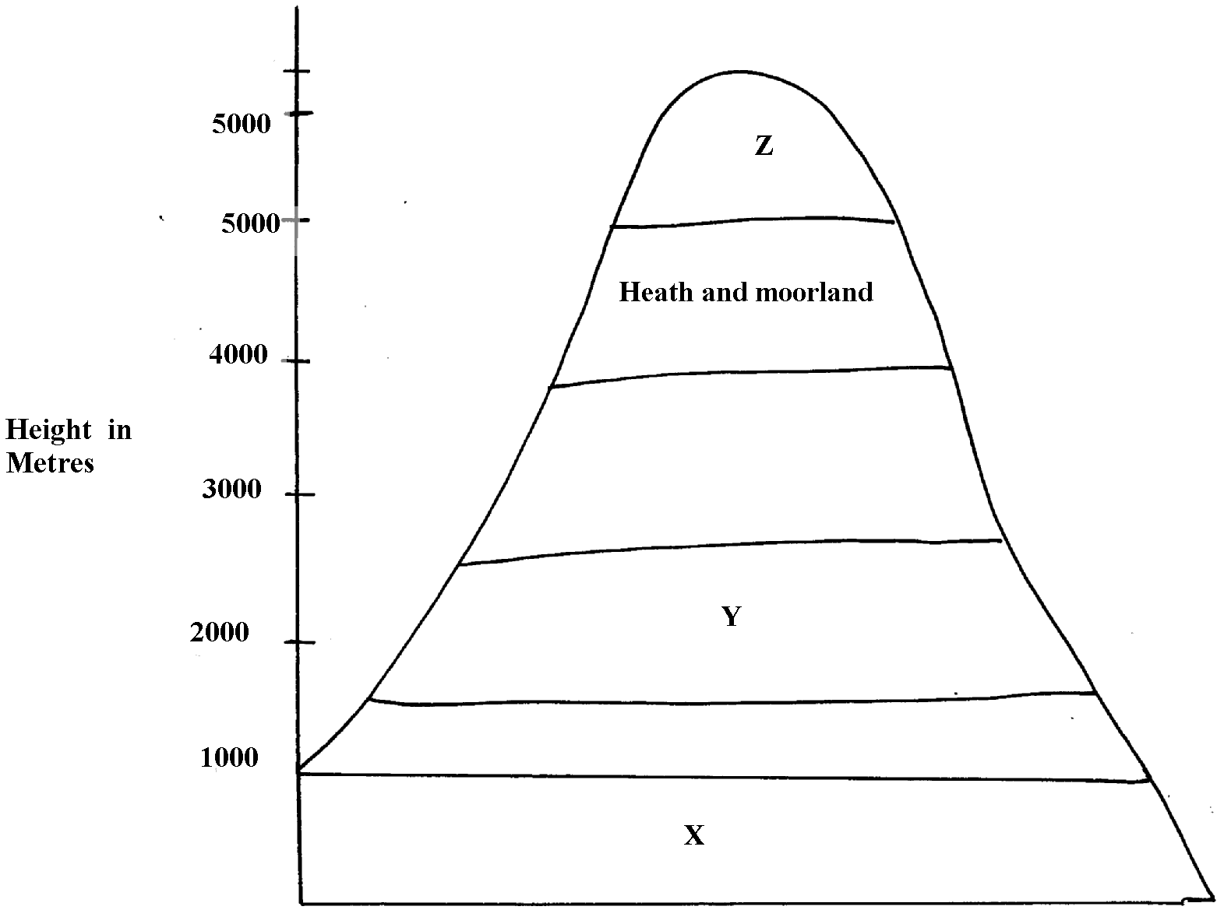

5. (a) Name the vegetation types marked X and Y
(b) Give two reasons for the absence of vegetation at Z
(c) Name any one part in Kenya represented by this diagram
6. Use the map of Kericho (1:50,000) to answer the questions
Study the map of Belgut 1: 50000 (sheet 117/3) provided and answer the following questions
. (a) (i) What is the height of the highest contour in the area covered by the map?
(ii) Give the longitudinal extent of the area covered by the map.
(iii) Calculate the area of the part of Kisii district shown on the map.
(iv) What is the six figure grid reference of the junction at Marumbasi?
(b) (i) Draw a rectangle 10cm by 14cm to represent the area between easting 30 and 40
(ii) On the rectangle mark and name the following:-
- A plantation
- River Yurith
- A seasonal swamp
- The bridge at Kabirigut
(iii) Calculate the new scale of your reduction
(c) Describe three ways in which physical factors have influenced the construction of all
weather roads in the area.
(d) (i) Citing evidence from the map, explain three factors that favour the growing of tea in Belgut.
(ii) With evidence from the map name any other crop grown in the area other than tea.

7. Study the map of Belgut: 1:50000 (sheet 117/3) provided and answer the following questions
. a) i) Convert the scale of the map into statement scale
ii) Give the longitudinal extend of the area covered by the map
iii) Calculate the bearing of the posho mill at Kiptule from the spot height at Kiptere
b) Apart from forests name other vegetation types in the area covered by the map
c)i) Draw a rectangle measuring 15cm by 8cm o represent the area south of northing 50 and
West of easting 30. On the rectangle mark
- River Sondo
- Coffee mill
- All weather road loose surface
- Wood land
ii) Describe the drainage of the area covered by the map
d) What factors on the map can promote trading activity
8. Study the topographic map of Belgut provided and use it to answer this question
(a) (i) Name the two provinces covered in the area by the map
(ii) What is the general direction of Ikamu school from Chemamul school?
(iii) Write the six figure grid reference of the Posho Mill at Kiptule
(b) (i) Measure the distance of all weather road (bound surface) from Kapsuser shops to
its ends in the North-East to Kericho. Give your answer in Kilometers
(ii) Identify two methods used in the map to locate places
(iii) Name three types of natural vegetation found in the area
(iv) Citing evidence from the map, name three agricultural activities carried out in Belgut area
(c) Citing evidence from the map, explain three physical factors which have influenced
settlement in the area
(d) Describe the drainage of the area covered y the map

9. a i) What type of map is Belgut sheet?
ii) Give two methods used in representing relief on the map extract.
b i) What is the length of the Murram road from Marumbasi to Kiptere Sunchen
(Give your answer in Km)
ii) Name the main crop planted under plantation from the map
c i) Explain how relief has influenced settlement in the area covered by the Map
ii) Citing evidence from the map, give two social – economic activities carried out in the
area covered by the map.
d i) Using a vertical scale of 1 cm to represent 100 metres, draw a cross section from the
East 440000 to easting 500000 on the cross section label:
- Road
- River
- Forest

10. Study the map of BELGUT 1:50,000 provided and answer the following questions
a)i) Give the longitudinal extent of the area covered by the map
ii) Convert the scale of the map into a statement scale
iii) Name two methods that have been used to represent relief on the map
b) i) Draw a cross-section between grid references 29050 and 33050. Use scale of 1cm
to represent 20 meters
ii) On the cross-section Mark and name:.
- papyrus swamp
- All weather road loose surface
iii) Calculate the vertical exaggeration

11. a) Describe the drainage of the area covered by the map
b) Citing evidence from the map, give three economic activities carried out in the area
covered by the map
c) State two functions of the tea factory to the population around.
d) Give three reasons to show the area covered in the map receives high rainfall. The evidence
should be deducted from the map

12. Study the map of Belgut 1:50,000(sheet 117/3) provided and answer the following questions
(a) (i) What type of a map is Belgut ?
(ii) Give the grid square in which Matongo school is found
(iii) Calculate the area enclosed by Kendu-Kisii, all weather roads (bound surface) to
the West of the map
(iv) Citing evidence from the map, identify four social activities taking place in the map
(b) (i) Draw a cross-section along Northings 54 between Eastings 26 to 32. Use vertical scale of
1cm to represent 20m. On it mark and name:-
(I) River
(II) Loose surface road
(III) Swamp
(ii) Calculate the vertical exaggeration
(c) Describe the drainage of the area covered by the map
(d) Citing evidence from the map, explain two conditions that favour cattle rearing in the
area covered by the map

13. Study the map of Kericho (1:50,000) sheet 117/4 provided and answer the following questions
(a) i) What is the bearing of the secondary trigometrica station 2173 around Kapcheptoror
school form the dry weather road junction at Kipchimchim school
(ii) Give a six-figure grid reference of the trigometrical station (other) 1811 near
Poiywek school
(iii) Convert the scale of the map into a statement scale
(iv) Using liens of latitudes and longitudes give the position of Keongo school at gird
square 5662
(v) Give two methods used in representing relief in the are covered by the map
(b) Citing evidence from the map, state:-
(i) Two social functions of Kericho Municipality
(ii) Two economic activities carried out in the area covered by the map
(c) Using a vertical scale 1cm represents 20m
(i) Draw a cross section form grid reference 550640 to 590660
(ii) On the cross-section, mark and name the following:-
- A river
- Dry weather road
- A hill
(d) Describe the drainage of the are covered by the map
14. Study the map of Belgut (117/3) provided and answer the questions that follow:
(a) Identify two provinces covered by the map of Belgut
(b) (i)Using a vertical scale 1cm represents 50m, draw a cross section from grid reference
260590 to 330560. on it mark and name;
  - All weather loose surface roads
  - Marshes
  - River
(ii) Calculate the vertical exaggeration of the cross section.
(iii) What type of map is Belgut?

15. Study the map of BELGUT (1:50000 sheet 117/3) provided and answer the questions below:
a)i) Give the six figure grid references of the confluence of the river Itare and river Kitoi.
ii) Measure the length in kilometers of all weather roads loose surface from the junction
at grid square 3957 to the junction at Kipmaso grid square 3751.
iii) Give the name to the adjoining sheet found in the North East of Belgut .
b) i) What is the longitudinal extent of the area covered by the map?
ii) What is the approximate height of the school at kiptere grid square 3658?
c) i) Describe the drainage of the area covered by the map.

ii) Using a vertical scale of 1cm to represent 40 metres draw a cross-section along northing
53 from easting 24 to 29.
On it mark and name
- regional boundary
- Foot path
- main track (motorable)
d) i) Describe the distribution of the settlement of the area covered by the map.
ii) Citing evidence from the map, explain two factors that may favour trading activities
in the area covered by the map.

6. FIELD WORK
The topic entails:-
- Definition of field work
- Stating different types of field work
- Explaining the importance of field work
- Explaining the procedure to be followed during field work
- Identifying possible problems during field work
- Carrying out field work within the local environment.

1. a) Form four students of your school carried out a field study on beef farming in Narok District.
(i) State four objectives of their study.
(ii) Give four follow up activities they carried out.
(b) Students of Kakao secondary school intend to undertake a field study of Olkaria I geothermal
power generating project. Answer the following questions;
(i) State three objectives they would write down for the field study
(ii) List three preparations they would undertake before the actual field study
(c) Your class visited a biogas digester near your school;
(i) Describe how it was constructed
(ii) List three raw materials the class may have identified which are used in the production
of biogas

2. a) You are planning to carry out a field study on soil in an arid region.
i) What are some of the characteristics you would observe?
ii) Why would you prepare a working schedule for the study?

3. a)i)Give three natural vegetation zones on mount Kenya
ii) Name three temperate grasslands found in the world
iii) Describe the characteristics of the hot desert vegetation
b) Explain three causes of the decline of the areas under forests in Kenya
c) You are supposed to carry out a field study of a weather station near your school
i)What preparations would you make for the study
ii) What instruments are you likely to find within the Stevenson box

4. (a) You are required to carry out a field study on vegetation within the local environment;
(i) Apart from identifying different types of plants, state other activities you will carry
during the field study
(ii) How will you identify the different types of plants
(b) Form four students from Kisumu west district carried out a field study in an area of soil
erosion in Machakos district
(i) State three causes of soil erosion they could have identified
(ii) Name two effects of soil erosion they have identified
(iii) State any one objective for their study

5. (a) Students from Kisumu West secondary school carried out a field study in the area
covered by the map
(i) What three preparations did they make?
(ii) State any null hypothesis for the study
b) Your class intends to carry out a field study on weathering within the vicinity of the school
i) State the type of information you are likely to collect
ii) State two follow up activities you are likely to carry after the study

6. (a) Students from Kericho school set out to conduct a field study on the relationship between
climate and vegetation of the area covered by the map.
(i) What preparation did they carry out for the study?
(ii) State three evidences they would identify to support climate change.
(iii) State two possible alternative hypotheses for the study
(b) Students are planning to carry out a field study in the area affected by climate change;
(i) State three ways in which observation would be the best method of data collection.
(c) Citing evidence from the map, explain three factors that have influenced settlement in the
area covered by the map.

7. (a) Students of Chepkosilen school carried a field study on economic activities in the
area covered by the map.
(i) Give two preparations they made before the study.
(ii) State two hypotheses for their study.
(iii) Citing evidence, identify three economic activities that they studied.
(iv) What type of map is Belgut?

(b) Students from your school have conducted a field study on a Lake in Kenya
(i) In their study they identified some of the problems affecting the lake to have been
caused by nearby industries and deforestation in the surrounding areas. Explain how
each of the two could have affected the lake.
(ii) Name any two methods they might have used to collect the data.
(iii) State any two reasons why it would be important to do follow-up after the study
(d) You are required to carry out a field study on soil erosion around your school
(i) State two methods you would use t record data
(ii) Give three problems you may encounter during the field study

8. a) Students of Masabot School carried out a field study of Changoi tea factory.
i) Name two types of roads they used to travel to Changoi tea factory.
ii) What preparations they were likely to make for the study
b)(i) Suppose you were a student in the school at Tegat and you plan to carry out a day’s
field study of Changoi tea factory. Design a working programme (schedule) you would
use during the day of study
. ii) Your class is required to carry out a field study of a river. What would be the advantages
of dividing the class into groups according to the stages of the long profile of the river ?

9. a) You intent to carry out a field study on a desert landscape.
i) Apart from conducting oral interviews, state two other methods you would use to
collect information
ii) State two problems that you are likely to encounter in the field
b) You are provided to carry out a field study of the vegetation within the local environment;
i) Apart from identifying the different types of plants, state three other activities you
will carry out during the field study
ii) How will you identify the different types of plants?

10. a) Your class went for a field study in Samburu.
i) List three methods they are likely to have used to present their findings
b) i) State three activities they would be involved in.
ii) Identify three problems they are likely to encounter.

11. (a) You are required to carry out a field work on soils around your school:-
(i) State three objectives for your study
(ii) State two reasons why it would be necessary to carry samples back to school
(b) You carried out field work ion soils around your school:-
(i) State three preparations you made before the actual day of field work
(ii) State any three problems you encountered during the field work

12. (a) You are to carry out a field study on rivers near your school:-
(i) Name three methods you will use to collect your data
(ii) Why is it important to carry out a pre-visit
(iii) How will your findings be useful to the local community?

13. (a) A field study was carried out around the rift valley lakes:-
State two characteristics of the lakes they would have identified
b) You intend to go for a field study to a region where folding has occurred.
i) State three reasons why you would conduct a pre-visit.
ii) Identify two methods you would use to record data.
c)i) State two problems they may face during their study
ii) State two follow up activities they may have been involved in after the field study

14. The table below shows the crops produced in Kenya between the years 2000 to 2002

CROPS ‘000’ | 2000 | 2001 | 2002
WHEAT | 22 | 37 | 83
MAIZE | 131 | 255 | 325
BARLEY | 12 | 26 | 47
TOTAL | 165 | 318 | 455
(a) (i) Calculate the percentage of wheat production in the year 2000
(ii) Using a scale of 1cm rep 200 units, draw proportional circles to show the production
of crops each year. Show your calculations
(b) Explain three physical conditions which favour wheat growing in Kenya
(c) Compare wheat growing in Kenya and Canada under the following:-
(i) Mechanization
(ii) Marketing
(iii) Size
(d) State four uses of wheat
15. (a) Use the following information to answer the questions below:
Type of energy | No. of families using each type | Average monthly income per family (Kshs.)
Fire wood  Kerosene  Charcoal  Liquid Petroleum Gas  Saw dust  Hydroelectricity | 13,400  11,200  9,100  5,300  4,000  2,000 | 900  1600  1000  3000  900  4500
Total | 45,000 | 11,900

(i) Draw a pie-chart with a radius of 4cm to represent the number of families using each type
of energy. Show your calculations
(b) Students from Matungu district went to study gold mining in Kakamega South district
(i) State any two main preparations made before field study visit
(ii) Give any two follow-up activities they engage in after the study
(c) Suppose you were to conduct a field study in Kakamega forest
(i) State three problems that are likely to hinder your work
(ii) How could you determine the following:-
-Heights of a tree
-Diameter of stem
-Tree of the same species
(d) You have been asked to conduct field study on land pollution in an urban set up;
(i) State three problems that you may encounter;
(ii) Your class carried out a field study on forests in your area. List four measures you
would recommend to conserve forests in the area

7. MINERALS AND ROCKS
The topic entails:-
- Defining minerals and rocks
- Stating the characteristics of minerals
- Classification of rocks according to mode of formation
- Stating the characteristics of rocks
- Accounting for the distribution of major types of rocks in Kenya.
- Explaining the significance of rocks
- Identifying major types of rocks and their uses within the local environment.

1. (a) State two formations in which mineral ores occur
(b) Give three negative effects of open cast mining on the environment
2. a) Briefly describe how minerals occur in veins and lodes
(b) Describe how coral rocks are formed
3. State three classification of sedimentary rocks based on their mode of formation
4. a) A part from Thermol Metamorphism, name two other types of metamorphism
b) Describe the following types of rocks
i) Calcareous rocks
ii) Carbonaceous rocks.
iii) State three examples of rocks that are dominant at the coast of Kenya.
c) i) Explain how sedimentary rocks are formed through the following processes.
Mechanical Process
ii) Chemical Process
5. (a) Give three ways through which rocks may be metamorphosed. (3 mks)
(b) Name two examples of plutonic rocks
c) State three conditions that favour the formation of an artesian basin.
8. MINING
This topic entails
- Defining mining
- Explaining the factors influencing:-
-The occurrence of minerals
-Mining activities
- Describing methods of mining
- Locating major minerals on the map of East Africa
- Explaining the significance of minerals in Kenya
- Accounting for the problems facing the mining industry in Kenya.
- Explaining the effects of mining on the environment in Kenya.
- Describing the occurrence of specific minerals and their exploitation in selected countries.

1. (a) (i) What problem has been brought about by uncontrolled mining of minerals in Kenya?
(ii) Where is fluorspar mined in Kenya?
(iii) Describe how trona is mined and processed in Magadi
(b) (i) List two ways in which mining leads to loss of biodiversity
(ii) List two ways in which mining leads to pollution
2. (a) (i) Name three methods of mining.
(ii) State five factors that influence the exploration of minerals.
(iii) State three ways in which mining derelicts can be reclaimed.
3. (a) State two ways in which gold in South Africa occurs. (2mks)
(b) Give three ways in which abandoned mined sites could be rehabilitated.
4. (a) Name two countries in Africa where oil is mined
(b) State two by-products of crude oil
5. (a) (i) Define the term ‘mining method’
(ii) Explain how the following factors influence mining:-
- Technology
- Quality of the ore
(b) Use the map of East Africa below to answer question (i)

MAP OF EAST AFRICA
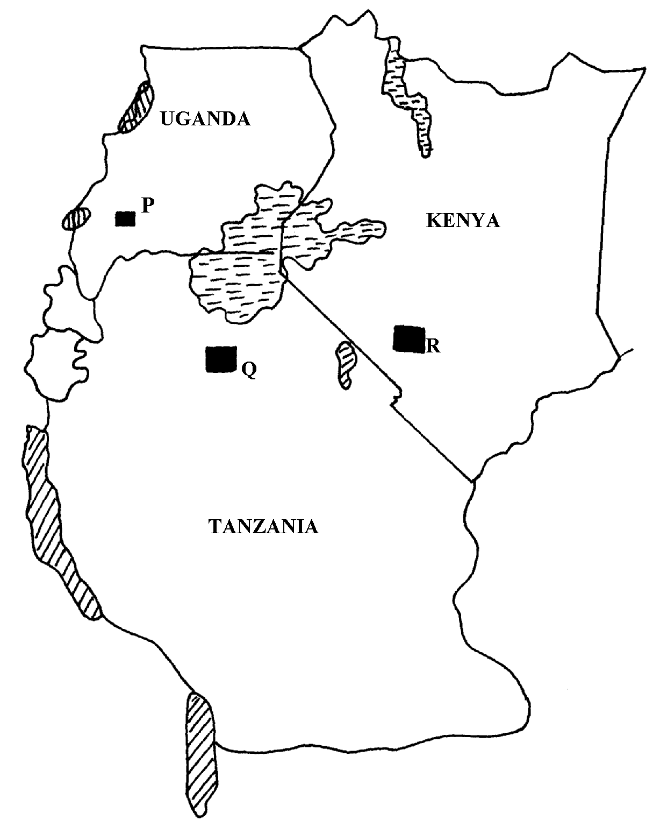

(i) Name the minerals found in the areas marked P, Q, R
(ii) Name two areas in South Africa where diamonds are mined
c) Open-cast method of mining.
d) Benefits of trona to Kenya.
e) Problems facing the mining industry in Kenya.

6. Use the map of East Africa below to answer question (a) (i)

(a) (i) Name the minerals mined in the areas marked W, X, Y and Z
(ii) Give four ways in which minerals occur
(b)Identify any five factors that influence the exploitation of minerals
(c) Explain any four problems associated with mining
(d) List any four main minerals mined in Kenya

7. (a) Give three main methods of mining
(b) The following data shows the value of minerals exported from Tanzania between the
years 2000-20003. Use it to answer the following questions:
Value of mineral exports in millions of Tshs.
 | 2000 | 2001 | 20002 | 2003
Gold | 680 | 700 | 500 | 400
Diamonds | 1000 | 800 | 700 | 900
Mica | 400 | 100 | 400 | 100
(i) Calculate the percentage decline in the value of diamond exports between 2000 and 20001.
(c)Explain any four ways in which trona mining contributes to the growth of the economy
in Kenya

8. (a) (i) State three methods used in mining
(ii) Name the mineral found in the following areas;-
- Magadi
- Mwandui
- Kasese
(b) Describe the following factors influence mining of minerals
(i) Technology
(ii) Quality of ore
(iii) Accessibility
(c) Explain four problems facing the mining of Gold in South Africa
(d) (i) List two leading to oil producing countries in the middle East
(ii) State three uses of petroleum
(e). State three problems of land dereliction

9. The diagram below shows

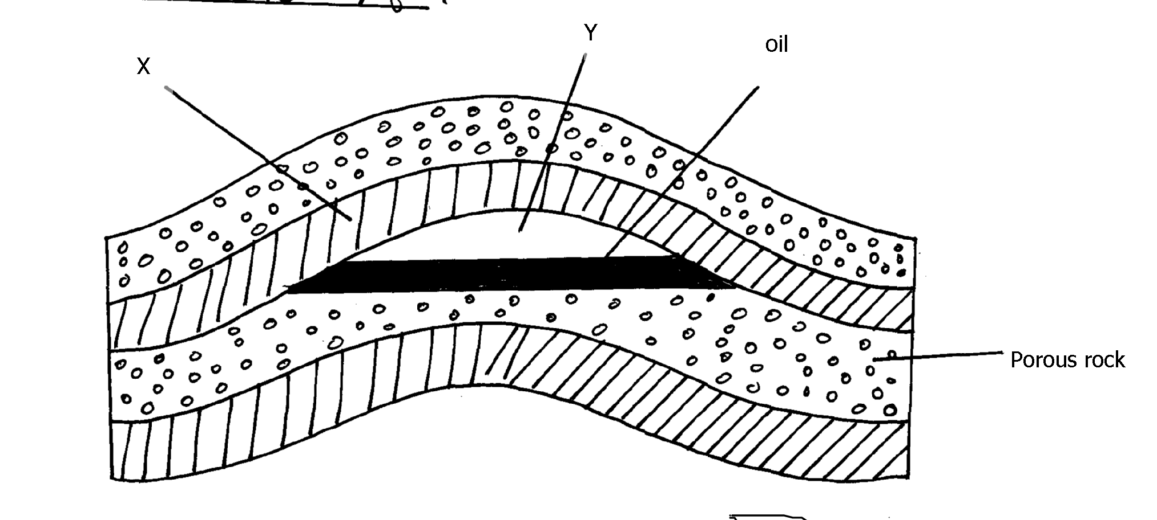

(a) Identify the parts marked X and Y
(b) Give three reasons why Kenya imports petroleum in crude form and not as refined
by-products
10. (a) Differentiate between veins and lodes
(b) State three effects of land dereliction
11. (a) (i) Give three methods of mining.
(ii) Name two places where gold is mined in Tanzania.
(b) Explain four factors which influence the exploitation of minerals.
(c) State four negative effects of mining on the environment.
(d) (i) Describe how solution mining is carried out.
(ii) State three ways n which mining contributes to the economy of Kenya.
12. (a) (i) Name three methods of mining
(ii) Explain three ways in which soda ash contributes to the economy of Kenya
(iii) Identify four problems facing gold mining in South Africa
(b) (i) State three conditions necessary for the formation of petroleum
(ii) Give two by-products obtained when crude oil is refined
(c) What three benefits would Kenya get if the current prospecting for oil yields good results
(d) (i) Name two minerals mined in the Southern Highlands of Tanzania
(ii) Name two ports through which minerals from East Africa are exported through

9. INTERNAL LAND-FORMING PROCESSES
This area covers :-
- Earth Movements
- Folding
- Faulting
- Vulcanicity
- Earth Quakes

It entails:
  - Definition of earth movements
  - Explaining the causes of horizontal and vertical earth movements.
  - Explaining theories of continental drift and plate tectonics
  - Defining folding, faulting and vulcanicity and earthquakes.
  - Explaining the
  - Description of types of folds, faults, and forms of vulcanicity
  - Explaining the resultant features due to folding, faulting and vulcanicity
  - Explain causes of earth quakes.
  - Describing how earth quakes are measured
  - Account for the world distribution of earth quake ones, fold mountain systems and features resulting from faulting and vulcanicity
  - Explaining the significance of the resultant features of folding, faulting, vulcanicity and the effects of earth quakes.

1. a) Composite volcano
b)i)What are earthquakes?
ii) Name two types of earthquakes waves
iii) Explain three ways in which volcanic mountains positively influence human activities

2. a) Using well labeled diagrams, distinguish between a simple symmetrical fold and an
asymmetrical fold.
b) i) Name two fold mountains of the Alpine Orogeny
ii) With the aid of well labeled diagrams, describe how a fold mountain is formed.
c) Explain three positive effects of folding on the physical & human environment.

3. (a) State three ways in which the earth’s crust is affected by the earthquakes
(b) State two evidences of continental drift theory
(c) Name three types of plate tectonic boundaries

4. (a) (i) What are tectonic plates
(ii) Give any two examples of oceanic plates:-
(b) Describe how the following cause earth movements:
(i) Isostatic adjustment
(ii) Magma movement in the crust
(iii) Convectional currents in the mantle.

5. (a) Give any two natural causes of earthquakes
(b) Name three characteristics of the rift valley lakes of Kenya

6. (a) State three characteristics of the rift valley lakes of Kenya
(b)(i) What are earth quakes?
(ii)Name three types of earth quake waves
c). Differentiate between extension boundaries and compression boundaries.

7 a. i) What is an earthquake
ii) Give two ways in which earthquakes can be predicted
b) State two ways in which faulting interferes with transport and communication lines.

8. The diagram below represents a feature resulting form faulting
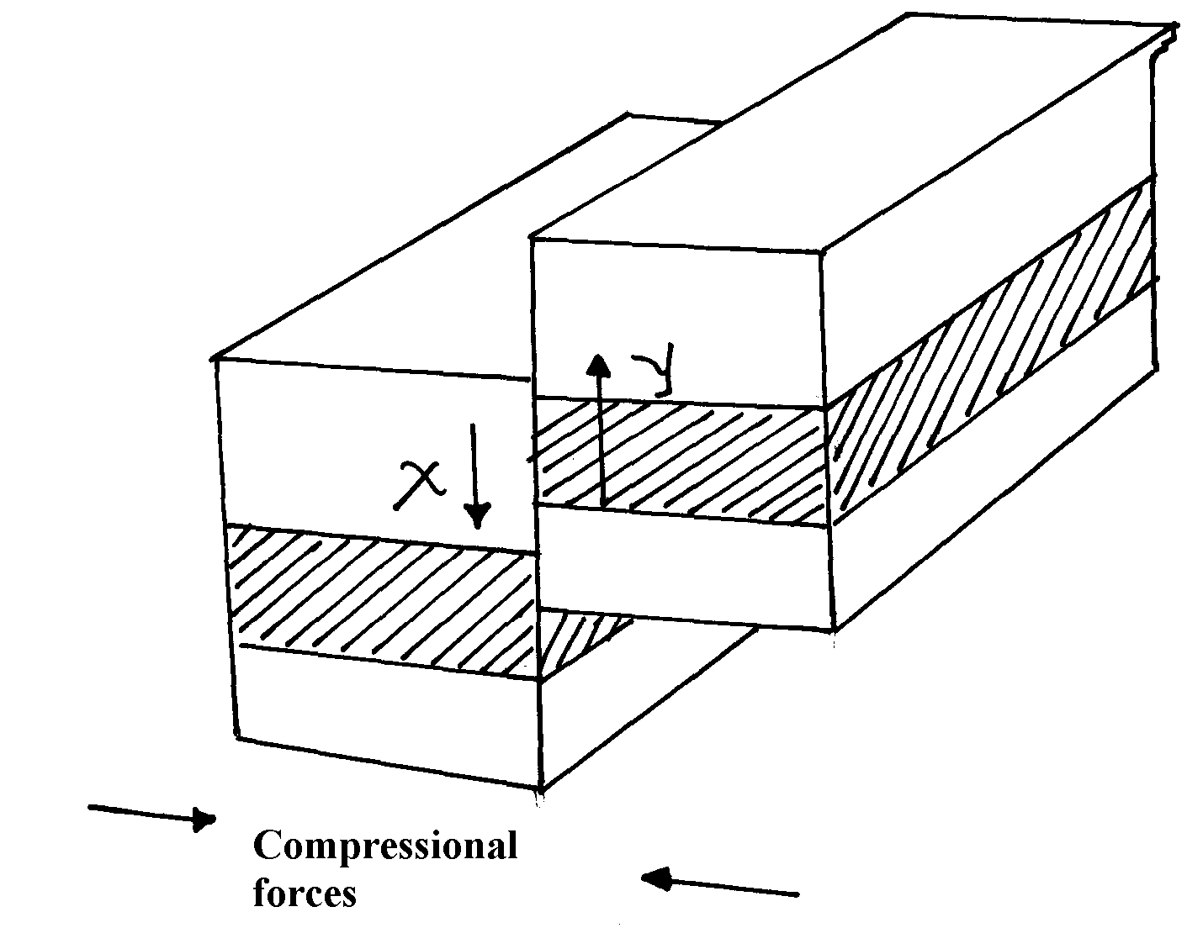

(a) Name the feature
(b) Name part x and y
(c) Give three negative of an earthquake
9. (a) Differentiate between hot springs and geysers
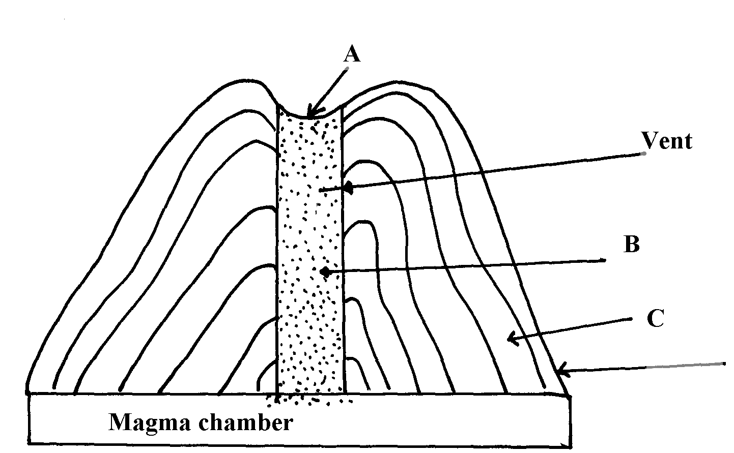
(b) The feature below show an extrusive landform in a volcanic area

(c) Using well labelled diagrams, describe how the following are formed:
(i) An anticlinal fault
(ii) An overthrust fold
(d) (i) Explain any three ways in which features resulting from volcanicity are a problem
to people
(ii) Describe how subsidence can lead to formation of a caldera.

10. (a) What is the plate tectonic theory ?
(b) Name three types of tectonic plate boundaries .
(c) Explain two evidences that support continental drift theory.

11. (a) (i) Name two fold mountains in Africa apart from Atlas mountains
(ii) Differentiate between symmetrical and asymmetrical folds
(iii) Apart from symmetrical and asymmetrical folds, name other types of folds
(b) (i) With the aid of well labeled diagrams explain the formation of fold mountains
(ii) Give two-examples of fold mountains in North America

12. a) Effects of the elliptical shape of the earths orbit
b) Mention three causes of the earth movements

13. a) List two characteristics of destructive plate boundary
b) Outline three natural causes of earthquakes
b) State two effects of earthquakes on crystal rocks

14. a) List two factors that determine the degree of folding in rocks
b) State three effects of faulting on drainage systems

15. (a) State any one evidence that support the theory of the drifting of continents
(b)(i) Apart from Africa, name any two other continents that form the Gondwanaland
(ii) What is panthalassa?

16. a) Give two reasons why hardwood trees species in Kenya are in danger of extraction
b) State three problems that affect forestry in Canada

17. The diagram below shows a simple fold
(a) (i) Name the part marked A, B and C
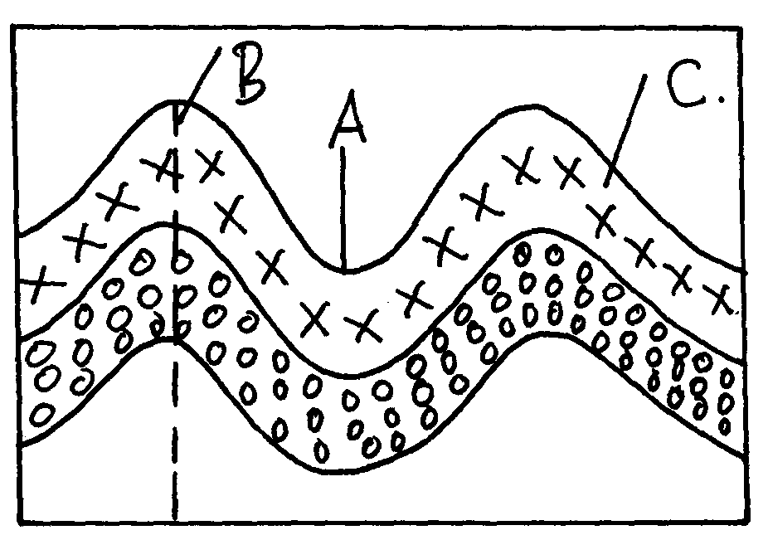

(ii) Name two fold mountains outside Africa
(iii) Give thee landform associated with folded regions
(b) With the aid of well labeled diagram describe the process of formation of Fold Mountain
(c) Explain four ways in which folding influences human activities

10. PHOTOGRAPH WORK
The topic entails:-
- Identifying types of photographs
- Describing parts of a photograph
- Estimating the sizes of features appearing on photographs
- Making sketch form photographs
- Identifying and interpreting features on photographs.

1. Study the photograph (a) and (b) and use them to answer the questions below:-
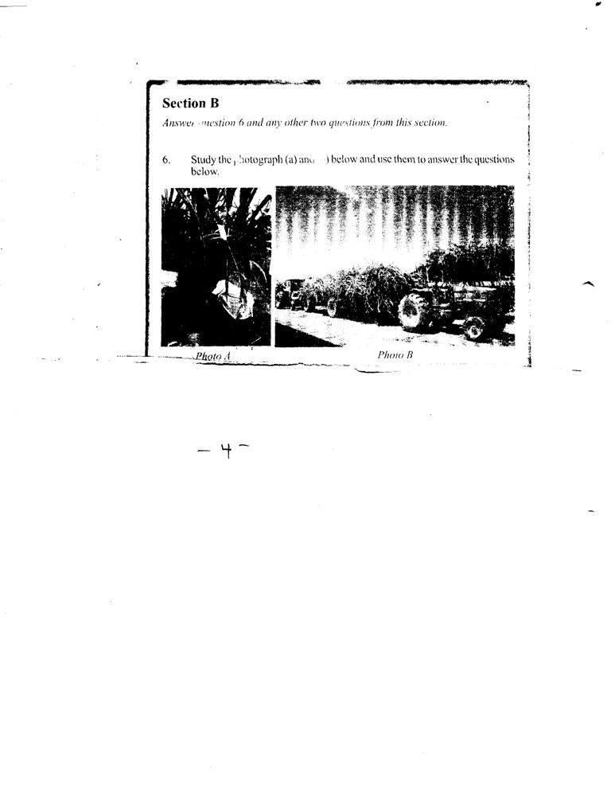

Photo B
Photo A

(a) (i) Name the type of photograph shown in the figure (b)
(ii) Name three human activities carried out in photographs (a) and (b)
(b) If the two photographs were taken from western province, name four districts in the
province the photographs are likely to have been taken from?
(c) Explain five physical conditions that encourage the growth of crops in photograph (a)
(d) State five problems facing farmers of this crop in Kenya
2. (a) (i) State three characteristics of the animal breeds
(ii) Explain why the above activity is mainly located in the highlands in Kenya

11. VEGETATION
The topic entails:
- Definition of vegetation
- Discussing the factors influencing the distribution of vegetation
- Identifying and describing the characteristics of major vegetation regions of Kenya and the world
- Discussing the significance of vegetation and explain their uses within the local environment

1. a) Name two areas of the world with temperate grasslands.
(b) Explain how the characteristics of the vegetation in climate B are adapted to the.
environmental conditions

2. The diagram below shows mountain vegetation zones, use it to answer the questions that follow.

(a) (i) Name the vegetation zone marked X,Y,Z.
(ii) Give four char characteristic of tropical savannah vegetations
(b) Explain how the following factors influence vegetation:
(i) Aspect
(ii) Human activities
(c) Name the specific countries of the world where the following grassland vegetation types are
found:-
(i)Velds
(ii) Pampas
(iii) Dawns
(d) Explain three factors that have led to a decline of natural grassland in Kenya

3. (a) (i) Define the term ‘natural vegetation’
(ii) State thee climatic factors influencing distribution of vegetation
(b) (i) Give two zones of the temperate grasslands
(ii) State five characteristics of coniferous forests
(c) Explain four ways in which vegetation of the Nyika region of Kenya has adapted to the
region of Kenya has experienced in the area
(d) Give five factors that have led to a decline of the natural grasslands in Kenya

4. The map below shows major vegetation zones of the world. Use it to answer the questions
that follow:
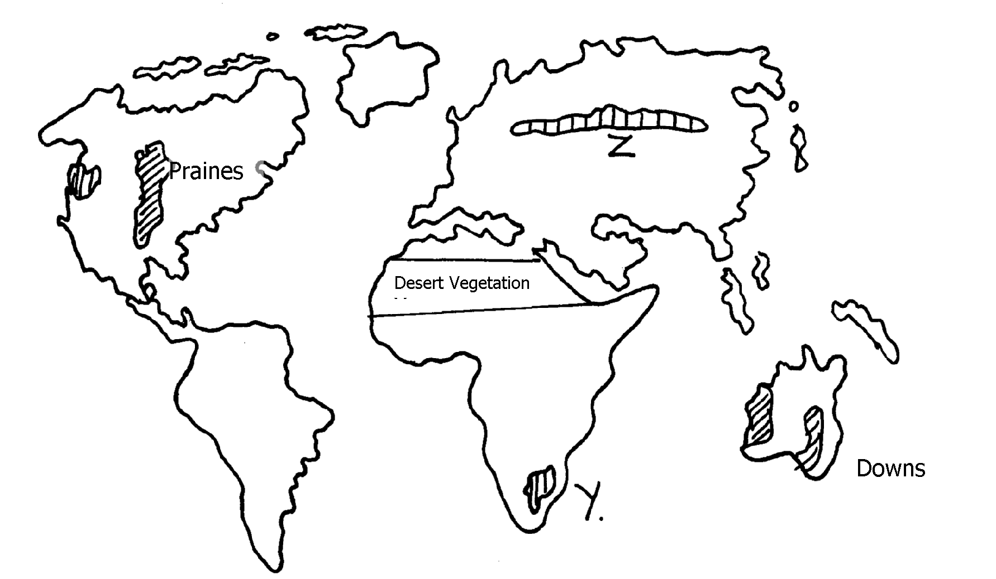

X

(a) Identify the temperate grasslands marked Y and Z
(b) Explain four ways in which desert vegetation are adapting to the extremely harsh
conditions
5. The map below shows the location of some vegetation regions of Africa. Use it to answer
the questions that follow:

5. (a)i) Name the grassland region marked L
ii) Describe the characteristics of the natural vegetation found in the shaded area P
b) i) Explain four ways in which the vegetation found in the area marked Q adapts to the
environmental conditions of the region
c) i) Give two reasons why the mountain top has no vegetation
ii) State two ways in which vegetation is of significance to the physical and human
environments
6. (a) (i) Name two types of vegetation
(ii) Give two physiographic factors influencing vegetation distribution
(b) The diagram below shows vegetation zones of a S. Africa mountain. Use it to answer
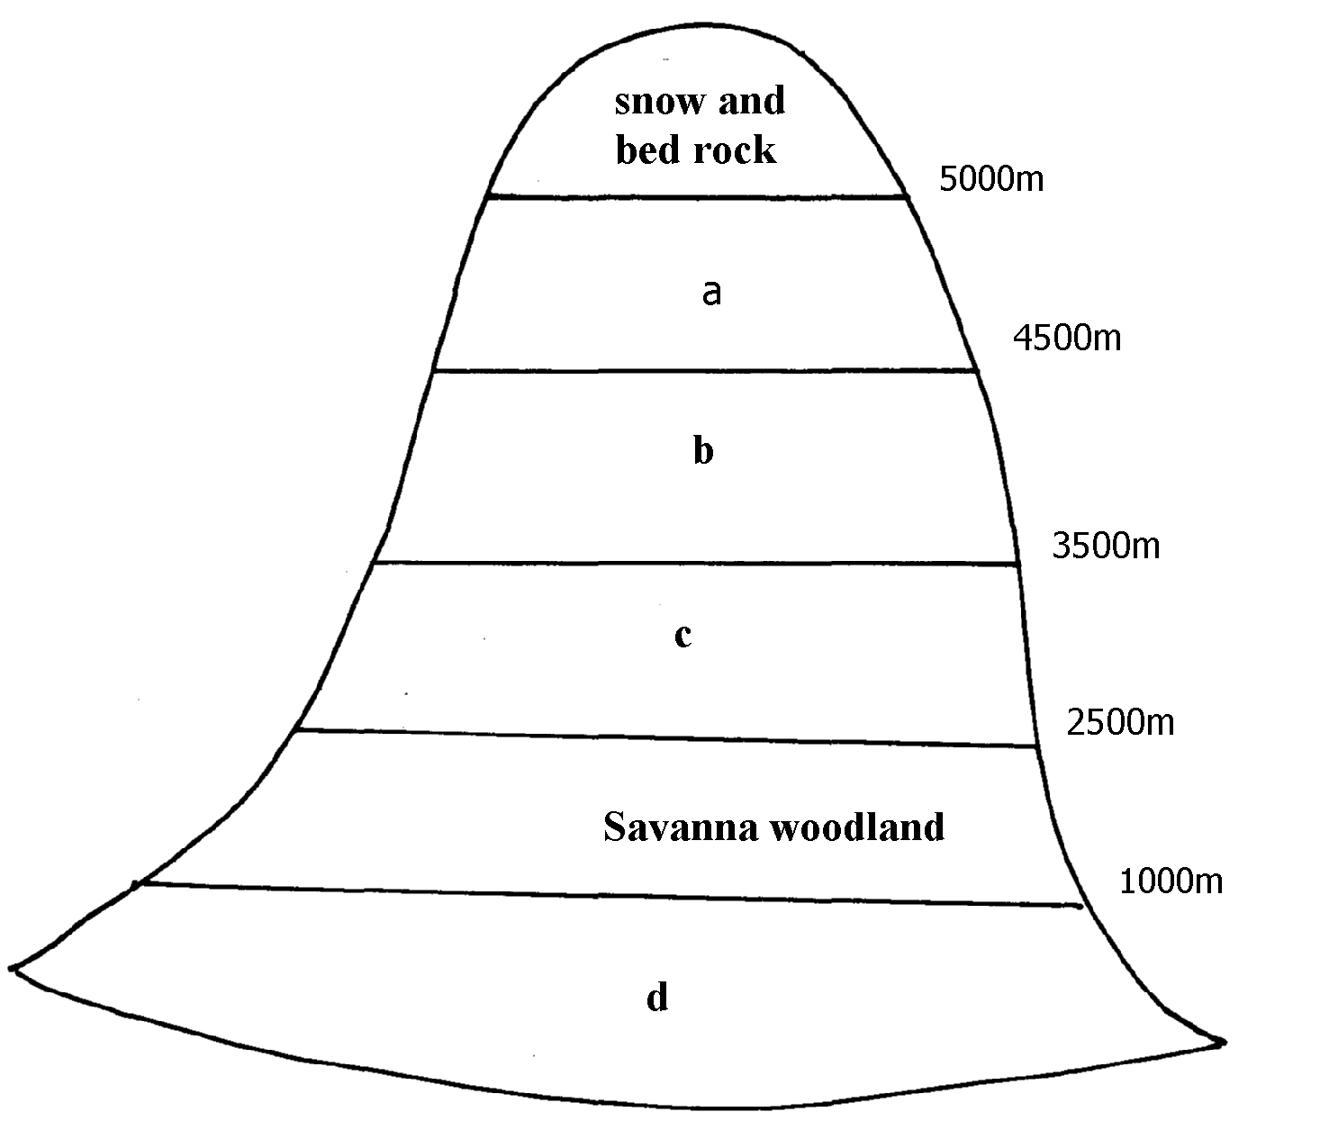
the question below:-

(b) (i) Name the zones a, b, c, d
(ii) Give one reason why there is no vegetation cover on to p of the mountain
(c) (i) State the names given to temperate grassland vegetation in:-
- North America
- Argentina
(ii) Explain three used of Savanna vegetation
(d) Explain four characteristics of Tropical desert vegetation

7. (a) The map below shows the grasslands of the world. Use it to answer the questions that follow:-

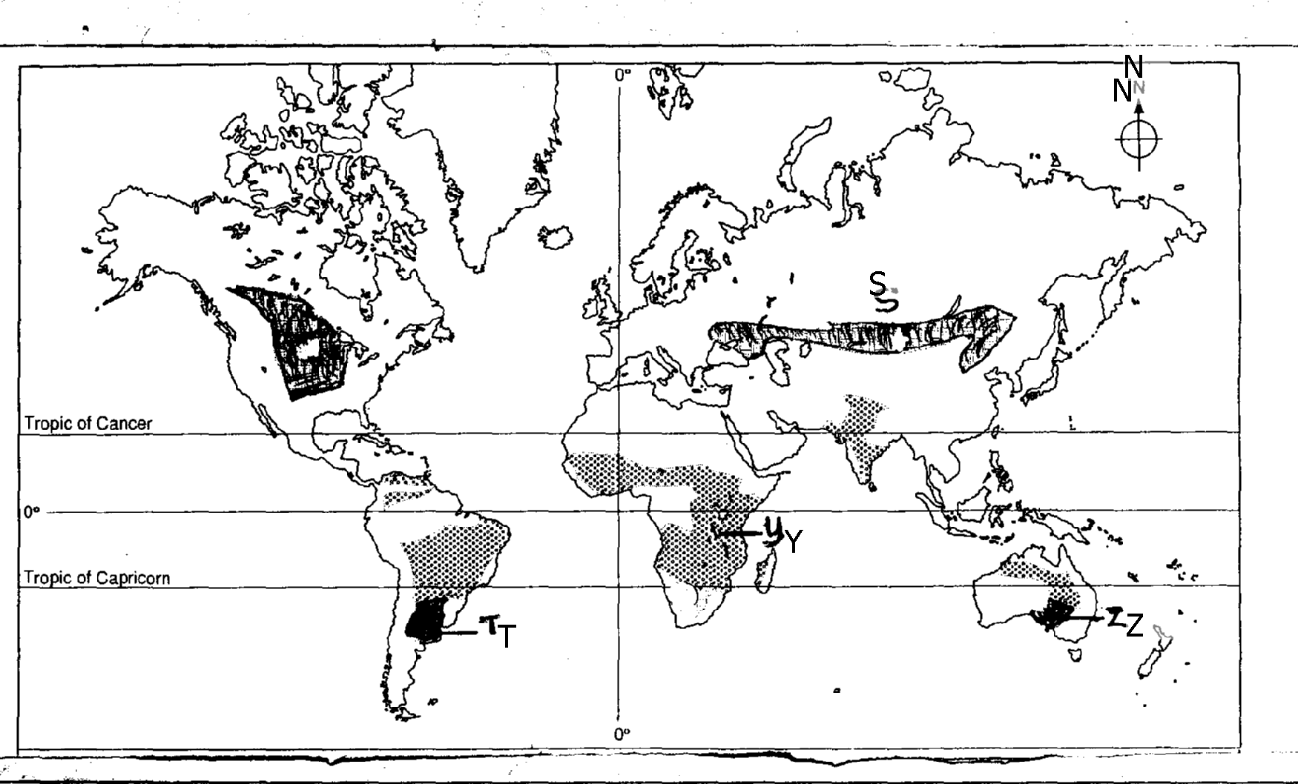

(i) Name the grasslands marked S, T, Y and Z.
(ii) State any four characteristics of temperate grasslands.
8. (a) (i) What is meant by derived vegetation?
(ii) Mention three factors that influence the vegetation of a place.
b) i)Give three natural vegetation zones on mount Kenya
ii) Name three temperate grasslands found in the world
iii) Describe the characteristics of the hot desert vegetation
9. a) Explain three causes of the decline of the areas under forests in Kenya
(b) Explain four factors that limit the exploitation of tropical rain forests in Africa.

12. FORESTRY
The topic entails:-
- Definition of forest and forestry
- Discussing factors influencing the distribution and types of natural forests.
- Discussing the significance of forests and forest products in Kenya
- Identifying and explaining problems facing forestry in Kenya
- Discussing ways and means of managing and conserving forest.
- Comparing and contrasting softwood forests in Kenya and Canada.
- Demonstrating the ability to manage and conserve forests and forest resources.

1. (a) Give three reasons for over-exploitation of hardwoods in Africa.
(b) State four measures taken to conserve forests in Kenya.
(c) (i) Name two major lumbering maritime provinces in Eastern Canada.
(ii) Explain the factors that have favoured forestry in Canada.
(d) Explain three differences between softwoods in Kenya and Canada.

2. (a) (i) What is agro-forestry?
(ii) State four reasons why agro-forestry is being encouraged.

3. (a) (i) Distinguish between pure and mixed forests
(ii) Show how natural forests differ from planted forests in Kenya
(c) (i) State three measures that are being taken in Kenya to conserve forests
(ii) Explain three factors favouring the exploitation of softwoods in Canada

4. (a) Define agro forestry
(b) Outline four benefits of agro forestry
(c) Explain how the following factors influence growth of forests;
(i) Altitude
(ii) Aspect
(d) Explain three measures being undertaken to conserve forests in Kenya
(e) Give four consequences of forest depletion in Kenya

5. (a) (i) Distinguish between indigenous and exotic forest
(ii) Explain four ways in which natural forests differ from planted forests
(b) Explain three factors that influence the distribution of forests in Kenya
(c) State three measure that are being taken to conserve forests

6. (a) (i) What is forestry?
(ii) Explain three factors that favour the growth of natural forests on the Kenya highlands
(b) Explain five problems hindering the exploitation of tropical hardwood forests
(c) (i) Explain three measures that the government of Kenya is taking to conserve forests
in the country
(ii) State three factors that have led to the reduction of the area under forest in Mau forest

7. (a) (i) Distinguish between forestry and forest
(ii) Discuss the influence of the following factors on the destruction of natural forests
a) Climate
b) Human activities
c) Topography

8. (a) Explain three measures which have been taken to manage forests in Kenya
(b) Give the differences between the soft wood forests in Kenya and
Canada, under the following headings:
(i) Species
(ii) Problems
(iii) Marketing
(d) Your class intends to carry out a field study on the erotic trees of the Kenya highlands:-
(i) Name two types of tree species they are likely to observe
(ii) Identify three methods you will use to record the data in the field

9. (a) Define the term agro-forestry
(b) Name three topical hardwoods found in Kenya
(c) Name one indigenous soft wood found in Kenya

13. EXTERNAL LAND FORMING PROCESSES
The topic entails ;-
- Definitions of :
- Weathering
- Mass weathering
- Hydrological cycle and action of rivers
- Oceans, Seas and their Costs
- Action of wind and water in Arid areas
- Action of water in Limestone areas
- Glaciation
- Lakes
- Distinguishing between oceans and seas
- Description of water movements in oceans and seas
- Explaining the external land forming processes and the resultant features
- Identifying the sources of under ground water
- Discussing the significance of the resultant physical features to the environment
- Carrying out field work of land forms within the local environment

1. (a) Name two rivers in Kenya West of the Rift Valley that cause frequent flooding
(b) State three factors that lead to frequent flooding in the Lake region of Kenya

2. (a) i) Other than seif dunes, name two other types of sand dunes
ii) Give five characteristics of seif dunes
iii) State four factors that facilitate the formation of the sand dunes
b) Describe how a desert rock pedestal is formed
c) Explain four positive effects of desert features to human activities

3. a) i)Give three reasons why there are no ice sheets in Kenya
ii) Explain three factors that influence the movement of ice from the place of accumulation
b) Describe the process through which the following features are formed.
i)an arête
ii) A crag and tail
c) Explain four positive effects of glaciation in lowland areas

4. a)i) Give the dates in a year during which the number of hours of darkness is equal in
both the north and the south poles
ii) Why do the lengths of days and nights vary from one part of the earth to another?
b) State two effects of the rotation of the earth on its axis

5. a)What is a lake ?
b) State three ways through which lakes are formed

6. a) i) What is desertification
ii) Differentiate between wind deflation and wind abrasion
iii) Describe how wind transports its materials through the following processes:
I) Saltation
II) Suspension
III) Surface creep
b) Describe how the following features are formed
i) Zeugens
ii) Oasis
7. a) State two ways in which glacier moves
b) State three differences between a young river valley and a glaciated valley

8. The diagram below represents the action of waves on the coastline. Use it to answer
questions (a) and (b)

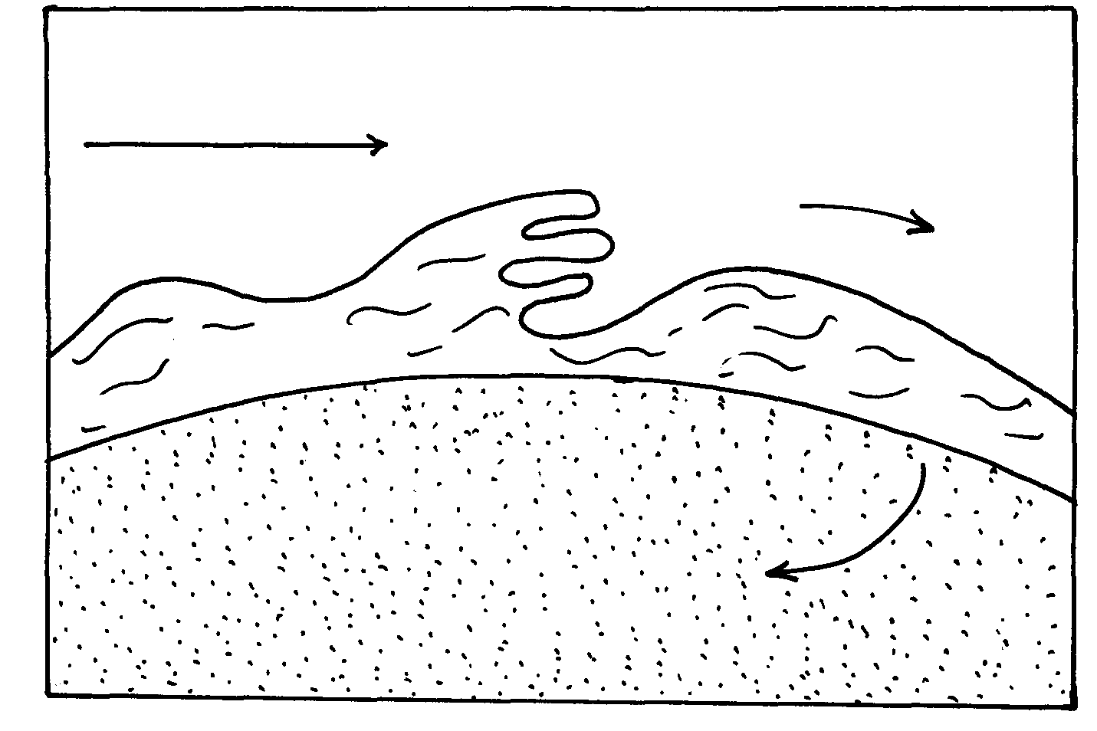

a) Name the features marked X and Y.
b) List three ways in which waves erode the coastline.

9. Name two sources of underground water.

10. a)i) What is chemical weathering
ii) State five factors that affect the rate of chemical weathering in equatorial regions
b) Explain the following chemical weathering process
i) Carbonation
ii) Hydrolysis
c) Explain four economic importance of weathering to physical and human environments

11. a) Name two types of tides
b) Give three ways in which the shape of the landmasses may influence movement of ocean
waters
(c) State four sources of underground of water
(d) State five ways in which springs occur
(e) Account for four ways in which desert vegetation adopt to the climate of their environment

12. (a) Hamada and Erg
(b) Explain three processes of wind erosion
(c) With the aid of well labeled diagrams, describe the formation of:
i) A Barchan
(ii) Rock pedestal
(iii) An oasis
(d) Name three features resulting from water deposition in desert
13. State three reasons why wind erosion is predominant in desert areas.
(b) Describe three processes by which wind erodes.
(c) With aid of well labeled diagrams, describe the formation of the following desert features;
(i) Rock pedestal.
(ii) Zeugen.
(d) State four ways in which desert land forms influence man’s activities.
14. (a) Differentiate between oceans and seas.
(b) Explain three sources of salinity in the oceans .
(c) State three features on the ocean floor.

15. (a)(i) What is the difference between a sea and an ocean?
(ii) Explain any three ways in which islands are formed.
(b) (i) Describe how Lake Victoria was formed.
(ii) Explain any three ways in which Lake Victoria has influenced the climate of
surrounding areas
(c) (i) Distinguish between aridity and desertification
(ii) Explain any three physical causes of aridity and desertification

16. (a) (i) What is chemical weathering?
(ii) Name any three surface features that result from carbonation.
(b) The diagram below shows a feature resulting from weathering. Use it to answer the
questions that follow:-
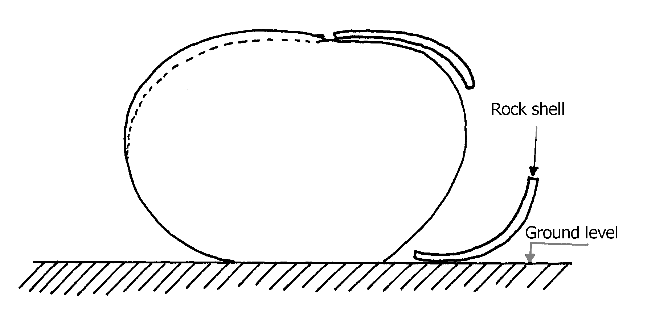

(i) What is the name of the feature?
(ii) Describe how the feature is formed.
17. (a) Differentiate between a river system and a river regime.
(b) The diagram below shows a drainage pattern. Use it to answer the questions that follow:-

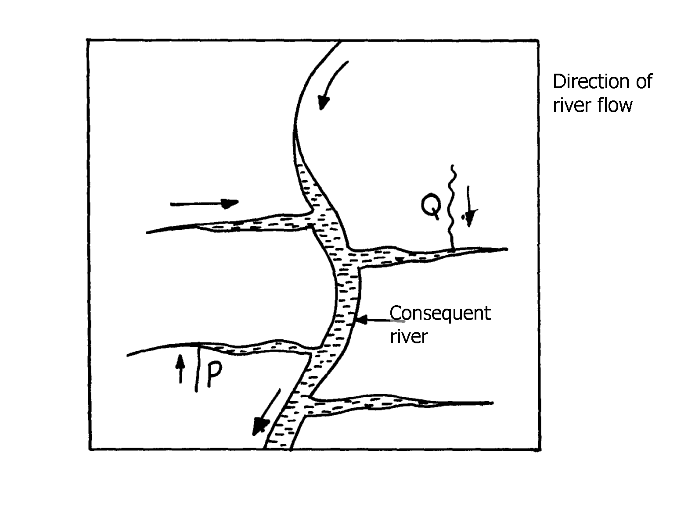

(i) Name the drainage pattern.
(ii) Name the parts labelled P and Q

18. (a) Name any two features deposited by glacier in lowland areas.
(b) Describe how a roche moutonee is formed.

19. (a) The diagram below shows zones of underground water. Use it to answer the questions
that follow:-

(i) Name the parts labelled U and V.
(ii) Name the surface water feature likely to form at the part labelled W.
(b) Explain how the nature of underground rocks influences the existence of underground water

20. (a) (i) State two ways in which wind erodes the surface of the earth
(ii) Explain three ways thorough which wind transports its load
(b) Using well labeled diagrams, describe how the following desert features re formed:-
(i) Zeugen
(ii) Rock pedestal
(c)(i) Give the name given to rocky desert in the Sahara
(ii) Explain three positive effects of desert features to both human and physical environment

21. (a) What is a lake?
(b) (i) Name two types of lakes formed due to vulcanicity
ii) explaining how lake Victoria has influence the climate of the surrounding area
(c) (i) State four main reasons why lakes within the Rift valley are salty
(ii) Name any three fresh water lakes in Kenya which are within the rift valley
(d) Explain any four economic significance of lakes to Human activities

22. (a) Name three types of tides
(b) Differentiate between oceans and seas

23. (a) (i) Differentiate between aridity and desertification
(ii) Describe three ways through which wind erodes the desert areas
(b) Using well labelled diagrams describe how the following desert features are formed:
(i) Rock pedestals
(ii) Yardangs
(c) State five uses of desert features

24. (a) State four factors which may cause a waterfall to form
(b) (i) Describe how river braids are formed
(ii) Name three features resulting form river rejuvenation
(c) Describe how a river capture occurs
(d) Give two reasons as to why Lake Naivasha is a fresh water lake

25 . Give three ways through which rocks may be metamorphosed

26. (a) (i)State two processes though which the wind erodes the surface.
(ii) Explain three ways though which wind transport its load
(b) Describe how the following desert features are formed :
(i) Oasis
(ii) Zeugen
(c) Explain four ways in which desert land forms are of significance to human activities

27. (a) (i)Name two ways in which ice moves
(ii) State two factors which facilitate the movement of ice
(b) Identify two erosional features in glaciated lowlands
(c) Describe how the following features are formed:
(i) Outwash plain
(ii) Moraine-dammed lake
(d) Explain four ways in which a glaciated landscape is of significance to human activities

28. (a) Differentiate between mechanical and chemical weathering
(b) State three factors which influence weathering

29. a) Differentiate between a spring and well.
b) With aid of a well labeled diagram, show the three Zones of ground water.
c) List four candidates necessary for the formation of an artesian well.
d) Explain three ways in which ground water is of significant to human activities.
e) i) Define the term Karet scenery
ii) Give two conditions for the development of Karet landscape
iii) Outline the significance of Karet landscape to human activities.

30. (a) Use the diagram below to answer the following questions
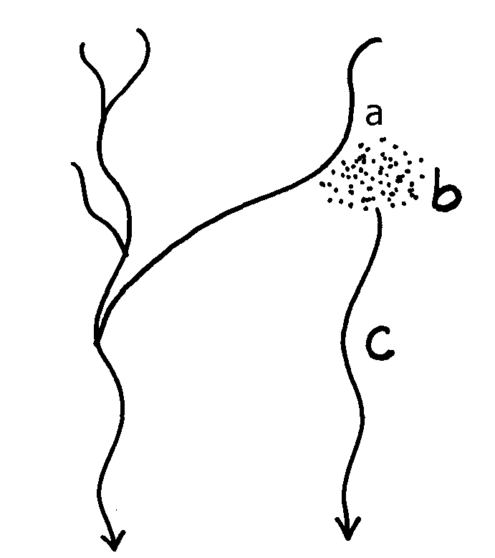

(i) Name the parts labelled :-
(ii) State four causes of river rejuvenation

31. a i) Differentiate between denudation and mass wasting.
ii) Explain two reasons why chemical weathering is dominant in humid tropics.
b) Explain three factors that influence mass wasting.
c) With aid of a diagram, explain the process of solfluxion.
d) i) State four negative effects of mass wasting.

Name the:
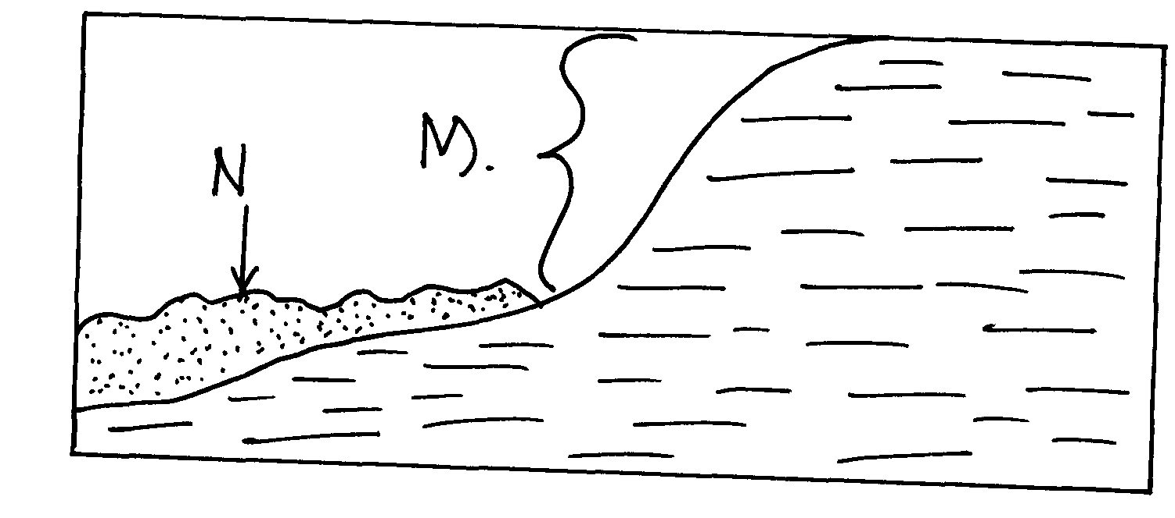
i) Type of mass movement shown

iii) Features M and N
iv) State the factor that influenced the process above

32 a) State three reasons why wind is a major agent of land sculpture in the desert.
b) Explain any two processes of wind erosion in deserts.
c) With and of well labeled diagram, explain how a deflation hollow is formed.
d) State four characteristics of a seif dune.

33. a) State two causes of coastal submergence.
b) Name three conditions necessary for the growth of coral polyps.

34 a) State two ways in which wind transport it’s load
b) Highlight the factors that influence the formation of a desert sand dune

35. a) Name three sources of lake water.
b) State three factors that determine the size of a lake.

36. a) i) What is a river?
ii) Distinguish between a river confluence and a river tributary
b) Describe how a river erodes its channel by the following processes
i) Hydraulic action
ii) Abrasion
37. a) Describe the process of a river capture
b)State five characteristics of a flood plain

38. a) i) Name four features resulting from water action in deserts
ii) State three factors which contribute to the development of deserts
iii) Name three types of deserts according to the nature of their surfaces
b) i)Explain three factors which influence wind transportation in deserts
ii) How is an oasis formed?

39. (a) What is the difference between swash and backwash
(b) Why is wave cut platform and cliff line in Mombasa found above the sea level?

40. (a) Define the term river capture
(b) The diagram below shows a river capture, name the features marked X, Y, Z

41. (a) Differentiate between accordant and discordant drainage systems
(b) State three factors that facilitate formation of deltas

42. a) i) What is a desert
ii) Name three types of desert landscapes
b) i) Name two processes of wind erosion responsible for sculpturing desert landscapes
ii) Using well labeled diagrams describe how a zeugen may be formed
c) i) Name four desert landforms found in deserts associated with the action of water
ii) What is the significance of desert landforms

43. (a) (i)Name three processes of wind erosion in desert
(ii) State three factors which influence the rate of wind transportation
(b) With the help of a well labeled diagram describe the formation of the following features:-
(i) Rock pedestal
(ii) Oasis
(c) (i)List three external land forming processes which lead to the formation of lakes
(ii) Explain three ways in which lakes influence the natural environment
(d (i) With the aid of a well labelled diagram, Describe how limestone pillars are formed
in Karst scenery
(ii) Explain three significance of resultant feature in limestone areas to human activities

14. SOILS
The topic entails:-
- Definition of soil, soil profile, soil cartena, soil degradation and soil erosion
- Discussing the composition of soil and soil forming processes
- Description of properties and characteristics of soils
- Description of soil profile and soil cartena
- Explaining soil degeneration
- Classifying soils according to soil order
- Discussing the significance of soils
- Discussing ways and means of managing and conserving soils.
- Identifying different types of soils and their uses within the local environment
- Demonstrating the ability to manage and conserve soils.

1. a) Differentiate soil profile from soil catena
b) Name three types of soil types according to soil structure
c) i) Beside planting of trees state any other three measures that can be used to control
desertification.
ii) Explain how trees help in the conservation of the soil.

2. a) i) What is soil?
ii) Differentiate between soil catena and soil profile.
b)i) Explain how the following factors influence soil formation;
- Climate
- Living organisms
ii) Give three factors that determine the colour of the soil.

3. a) Briefly explain the factors that influence the development of soil catena.
(b) (i) Define the term soil profile
(ii) Draw a simple diagram of soil catena
(iii) Give any four soil forming processes
(iv) State four causes of soil degeneration

4. a)i) Define the term soil
ii) Name three components of soils
b)i) Apart from living organisms state four other factors that influence soil formation
ii) Explain how living organisms influence soil formation
c) i) Distinguish between soil air and soil texture
ii) Describe the process of podzolisation
iii) State the characteristics of soils in grassland areas

5. (a) Draw a diagrammatic representation of vegetation zones on a slope common in tropical
land
(b) (i) What is soil catena?
(ii) Draw a labeled diagram to show a well developed soil profile.
(iii) State three characteristics of the soils found in the arid regions of Kenya.
(b) Give three factors that determine the colour of soil.
(c) Describe how laterization occurs.
(d) Explain how the following farming practices cause soil erosion;
(i) Burning.
(ii) Continuous application of fertilizer on farm lands.
(iii) Monoculture.

6. (a) (i) Apart from latosols name any two other types of zonal soils
(ii) Describe how lateritic soils are formed
(iii) State any two characteristics of azonal soils
(b) (i) Explain any three ways in which rain water can lead to degeneration of soils.
(ii) Apart from growth of plants, state any three other ways in which soils are beneficial
to people

7. (a) (i) Differentiate between a soil profile and soil catena
(ii) State two processes of soil formation
(b) Explain how the following factors influence soil formation:
(i) Climate
(ii) Living organisms
(iii) Topography
(c) (i) What is soil degeneration
(ii) Explain three ways through which vegetation naturally protects and prevent soil erosion
(iii) Give two sound farming methods that help conserve soil erosion

8. (a) (i) What is soil Catena?
(ii) State three factors which influence the development of a soil catena
(b) Explain five negative effects of soil erosion
(c) Describe how podzolization occurs in soils
9. (a) Name three components of soil
(b) Explain how the following factors influence the formation of soil :
(i) Climate
(ii) Parent material
(c) (i) Explain three ways in which human activities contribute to soil degeneration
(ii) Draw a well labeled diagram to show a mature soil profile

10. a) What is a lake?
b) State three ways through which lakes are formed

11. a) Define the term “Soil”
b) Explain how the following factors influence the formation of soil
i) Climate
ii) Topography
c) i)State two ways in which humus improves the quality of soil
ii) State four characteristics of desert soils
d) Describe how the following types of erosion occur
i) Sheet erosion
ii) Gulley erosion
iii) State two economic uses of soils

12. (a) What is soil conservation?;
(b) State three methods that assist in soil conservation

15. AGRICULTURE
The topic entails:-
- Definition of Agriculture
- Discussion of factors influencing Agriculture
- Explaining types of Agriculture
- Location of major cash crops on the map of Kenya
- Discussing the selected crops in respective countries
- Identifying and explaining similarities and differences between selected crop farming in Kenya and that of other parts of the world.
- Discussing Pastoral farming in Kenya
- Comparing and contrasting:
(a)Dairy farming in Kenya and Denmark
(b) Bee farming in Kenya and Argentina
- Carrying out field work on agricultural activities in the local environment

1 (a) (i) State the difference between land reclamation and land rehabilitation.
(ii) Other than tree planting, give three other methods employed in rehabilitation of land.
(b) (i) State three objectives that led to the establishment of Mwea Irrigation Scheme in Kenya
ii) Explain four human problems that face irrigation farming in Kenya.

2. (a) Describe the stages followed in the reclamation of land from the sea in Netherlands
(b) State four benefits of the delta plan to the Netherlands.

3. (a) (i) Name two districts in Rift valley where maize is grown in plantations.
(ii) Describe maize production from planting to harvesting.
(b) Outline the significance of maize growing in Kenya.

4. Explain three problems facing maize farmers in Kenya.

5. (a) Name two exotic breeds of dairy cattle reared in Kenya.
(b) Give three reasons why the Kenya highlands are suitable for dairy farming.

6. (a) Name two horticultural crops grown in Kenya
(b) State three reasons why horticulture is more developed in the Netherlands than in Kenya.

7. (a) Name two horticultural crops that are produced in Kenya
(b) Explain two reasons why horticultural produce is exported by air

8. (a) (i) What is nomadic pastoralism?
(ii) State three characteristics of nomadic pastoralism

9. a)i) Name three exotic breeds of dairy cattle kept in Kenya
ii) Apart from milk name three other dairy products
b)i) State three factors which favour the rearing of dairy cattle in Kenya highlands
ii) Explain four problems facing dairy farmers in Kenya
c) i) Compare dairy farming in Kenya and Netherlands
ii) Name two dairy plants in Kenya

10. (a) Name two dairy breed found in the lowlands of Kenya
(b) State three problems that have hindered the dairy activities in the Kenya highland

11. a) State three physical factors that favour wheat farming in Kenya
b) Give three problems facing wheat farming in Kenya

12. (a) Name ;
(i) Three provinces in Kenya where wheat is grown on commercial scale
(ii) Three wheat producing provinces in Canada
(b) Explain three conditions that favour wheat farming in Kenya
(c) Explain five factors which enable Canada to produce more wheat than Kenya
(d) State three importance of wheat to the economy of Canada

13. (a) Name three districts in Kenya where wheat is grown on large scale
(b) Account for any four physical conditions needed for the growth of wheat
(c) Describe the cultivation of wheat under the following:-
(i) Processing of wheat
(ii) Marketing of wheat
(d) (i) Explain two problems facing wheat farmers in Kenya
(ii) Give two reasons why Canada produces more wheat than Kenya (2mks)

14. (a) State three physical conditions that favour sugarcane cultivation in Western Kenya
(b) Give two reasons why we need to encourage dairy farming in Kenya

15. (a) (i) Apart from Ghana name two other countries that produces cocoa in Africa
(ii) State three physical conditions that favour large scale cocoa farming in Ghana
(b) Outline the stages cocoa goes through from harvesting to the time it is ready for export
(c) Explain three problems experienced by cocoa farmers in Ghana

16. (a) (i) What is horticulture
(ii) Horticulture is more developed in the Netherlands is more developed in the Netherlands
than in Kenya. Give four reasons for this
(iii) Give three reasons why the growing of flowers in green house is preferred in Kenya

17. Give four physical factors favouring wheat –growing in Kenya
18. (a) State two physical conditions favoring dairy farming in the Kenya highlands
(b) Compare dairy farming in Kenya and Denmark under the following headings:-
(i) Feeding of the animals
(ii) Marketing of the products

19. (a) Name two exotic breeds of beef cattle reared in Kenya
(b) State three physical conditions that favour beef farming in Argentina

20. (a) The figure below shows wheat growing province of Canada
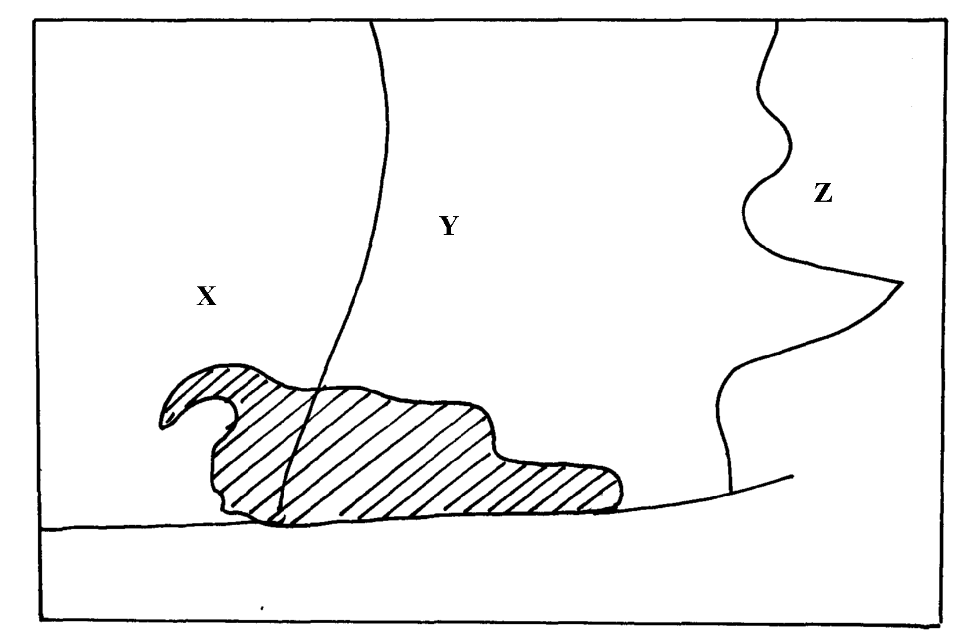

(i) Name the provinces marked X , Y and Z
(ii) State two physical factors favouring wheat farming in the named provinces above
(b) Give one province where coffee is grown on large scale in Kenya

21. a) Differentiate between horticulture and market gardening
b) State three factors that favour horticultural industry in Kenya

22. a) Define nomadic pastoralism
b) Give three characteristics of pastoral farming in Kenya

23. a) Give four reasons why there has been a steady increase of milk production in Kenya in
the recent past
b) Give similarities between dairy farming in Kenya and Denmark
c) Explain three benefits of dairy farming in Kenya

24. The table below shows horticultural crop production in Kenya
Crop | Quantity in tonnes
flowers | 42, 500
oranges | 22, 600
tomatoes | 20, 300
carrots | 15, 400
(a) (i) Draw a divided rectangle 15cm long to represent horticultural crop production in
Kenya in the year 2000 using the data above.
(a) (i) Calculate the range of the above data
(ii) What is the percentage of horticultural crop with the lowest tonnage?
(b) (i) State two advantages of using divided rectangle to represent geographical information.
(ii) State two climatic conditions that favour horticultural crops in Kenya
(c) Explain four problems facing horticultural farming in Kenya

25. (a) Name three main breeds of dairy cattle reared in Kenya
(b) State three benefits of dairy farming in Kenya

26. (a) Name two leading export commodities from Kenya
(b) State three problems facing trade in Kenya

27. (a) State any three roles played by livestock in the economy
(b) Identify any two solutions to problems facing pastoralists in the Northern part of Kenya

28. (a) List two economic factors that influence Agriculture
(b) (i) List two uses of cocoa
(ii) State one economic problem experienced in cocoa farming in Ghana

29. (a) Differentiate between horticulture and market gardening
(b) Name two main types of flowers grown in Kenya
(c) What problem do farmers in Kenya face in carrying out this activity?

30. (a) State three ways in which drought affect the agricultural sector in Kenya.
(b) State three reasons why the government of Kenya is encouraging bee keeping in the
country?

31. (a) List three social factors that influence Agriculture.
(b) State two factors that favour mechanization of wheat farming in Canada.

32. (a) State three climatic factors that favour the growing of oil palm in Nigeria.
(b) State any two products obtained from oil palm.

33. (a) Define the term pollution as used in Geography.
(b) Dither their air pollution name three forms of pollution.
(c) State physical conditions required for the growing of tea in Kenya.
(d) Explain four problems experienced in small scale to production in Kenya.

34. (a) Name two exotic beef cattle breeds in Kenya.
(b) State three steps taken by the government to improve beef farming in Kenya.
(c) State three problems facing beef farming in Kenya.
(d) (i) Explain three physical conditions that favour beef farming in Argentina.
(ii) Explain two ways in which beef farming contribute to the economy of Argentina.

16. LAND RECLAMATION AND REHABILITATION
This topic entails :-
- Definition of land reclama;tion and land rehabilitation
- Discussing:
(a) The factors that influence the location of the selected irrigation schemes in Kenya
(b) The significance of irrigation of farming in Kenya
(c) The problems experience in irrigation farming in Kenya
- Description of the methods used in land reclamation and rehabilitation in Kenya
- Comparing the methods of land reclamation in Kenya and the Netherlands

1. (a) Apart from Mwea, name three other large irrigation schemes in Kenya
(b) (i) Explain four conditions that made Mwea-Tebere a suitable location for an irrigation
scheme
(ii) Explain four problems facing farmers in Mwea irrigation scheme
(c) State six benefits which Kenya derives from irrigation farming
2 (a) A part from draining swamps, state two other methods used to reclaim land in Kenya.
(b) State three benefits that resulted from the reclamation of Yala Swamp.

3. (a) (i) Distinguish between land reclamation and land rehabilitation
(ii) Name any three methods of irrigation.
(iii) State two advantages of irrigation over natural water supplies
(b) (i) Why was Mwea Tebere irrigation scheme initiated?
(ii) Explain four physical conditions that favoured the establishment of Mwea Irrigation
Scheme
(iii) Give three problems that are faced in Mwea Irrigation Scheme
(c) (i) What is a polder.
(ii) Describe how land is reclaimed and prepared in the Netherlands
(iii) Give any three benefits of the delta plan
(d) How does the above activity differ from that in Denmark?

4. Explain three problems caused by a large aging population

5. a) i) Apart from rice name two other crops grown under irrigation at mwea Tabere irrigation
scheme
ii) Explain four factors that favoured establishment of Mwea Tabere irrigation scheme
b) Give four problems associated with irrigation farming on R.Thiba & Nyamindi
c) Explain three benefits of Mwea Tabere irrigation scheme
d)i) Name two other irrigation schemes in Kenya apart from Mwea Tabere
ii) State three benefits of rice farming

6. (a) Differentiate between land reclamation and land rehabilitation
(b) Explain four methods of land reclamation in Kenya
(c) Explain any two methods used in land reclamation and rehabilitation in Netherlands
(d) State four factors which influenced the establishment of Perkerra Irrigation Scheme

7. (a) Explain two significance of irrigation farming in Kenya
(b) State three benefits of syader see projects

8. (a) Name any three crops grown under irrigation farming in Kenya
(b) (i) Explain four conditions that made Mwea Tebere a suitable location for irrigation farming
(ii) Outline two aims of the tsetseflies control project in the Lambwe valley of Kenya
(iii) State four efforts being made to conserve water catchment areas of Kenya

9. (a) (i) What is a polder
(ii) Name three crops grown in the polders.
(b) Describe the stages involved in the reclamation of land from the sea in the Netherlands
(c) Explain four ways that the Netherlands benefited from the delta plan project
(d) State six problems experienced in irrigation farming in Kenya

10. a) A part from Mwea name three other large irrigation schemes in Kenya
b) Explain four conditions that made Mwea a suitable location for irrigation scheme
c) Explain four ways through which tenants have benefited from Mwea irrigation scheme
d) Explain three problems faced by farmers in Mwea Tabere irrigation scheme

11. (a) (i) Differentiate between land reclamation and land rehabilitation
(ii) Name two methods of rehabilitating land in Kenya
(b) (i) What is a polder
(ii) Name two crops grown in the polders
(c) Describe the stages of reclamation of land from the sea in the Netherlands
(d) (i) State three physical factors that influence the establishment of Pekerra irrigation scheme
(ii) Explain four significance of irrigation farming in Kenya

12. (a) (i) Differentiate between land reclamation and land rehabilitation
(ii) List three ways in which tsetse fly menace was controlled in the Lambwe valley
(b) (i) Name two areas in Kenya where swamps have been reclaimed
(ii) State four factors which influenced the establishment of Perkerra irrigation scheme
(c) Explain three problems facing irrigation farming in Kenya
(d) List four benefits of the Delta plan project in Netherlands

13. (a) State two methods used to reclaim land in Kenya
(b) Outline the stages through which land is reclaimed from the sea in the Netherlands

14. (a) List four types of wasteland that can be reclaimed
(b) Give two advantages of irrigation farming compared to rain fed farming

17. FISHING
The topic entails:
- Definition of fishing and fisheries.
- Explaining the factors influencing fishing
- Accounting for the location of the major fishing grounds of the world.
- Describing type sand methods of fishing
- Discussing fresh water and marine fisheries in East Africa
- Assessing the significance of the fishing industry in Kenya
- Discussing problems facing fishing in Kenya and their possible solutions
- Comparing and contrasting fishing activities in Keya and Japan
- Explaining ways and means of managing and conserving fresh water and marine fisheries.

The map below shows some major fishing grounds n the world. Use it to answer questions below:

1. (a (i) Name the countries marked P and Q
(ii) Explain four conditions that favour fishing in the shaded coastal water

2. (a) The diagrams below represent some fishing methods

(a) (i) Name methods R and S
(b) Describe how each of the two methods are used in fishing
(c) Explain three measures used to conserve fish in Kenya

3. (a) (i) What is fish farming?
(ii) Explain three measures that have been undertaken by the government of Kenya
to encourage fish farming.
(b) Explain four problems which face marine fishing in Kenya.
(c) (i) Name three fishing grounds in the Northern Hemisphere.
(ii) Explain three physical factors that favour fishing in Japan.

4. (a) Differentiate between veins and lodes.
(b) State the effects of dereliction

5. (a) (i) Name two methods of fishing.
(ii) Name two types of fish caught along the Eastern Coast of Canada.
(b) Explain how the following factors favour fishing:-
(i) Indented Coastline
(ii) Ocean Currents
(c) Explain four ways in which fisheries in Kenya can be conserved.

6. (i) Give three methods used to preserve fish.
(ii) Explain three problems experienced by fishermen in Lake Victoria.

7. State four reasons why marine fisheries in Kenya are under-developed

8. (a) (i) Name three types of nets used in modern fishing
(ii) Identify the two main fishing grounds of the Pacific Ocean
(b) Explain any four problems facing fishing in East Africa
(c) Explain any four ways in which fishing is significant to Kenya
(d) Name four areas where fish farmers in Kenya can obtain fingerlings

9. a) i)State the three categories of fish communities
ii) Explain four reasons why North East Atlantic is one of the most extends
iii) State four measures taken by the Kenyan government in the management and
conservation of fisheries

10. (a) A part from trawling, name two other modern methods of fishing
(b) State two reasons why the Western Coast of Africa has high concentration of fish than
the Eastern Coast.

11. (a) Name two commercial fishing methods commonly used in Atlantic fishing ground
(b) State three problems Kenyan fishermen face while fishing in Lake Victoria

12. (a) State two measures that have been taken to conserve fish in Kenya
(b) Give three reasons why Norway is a great fishing nation

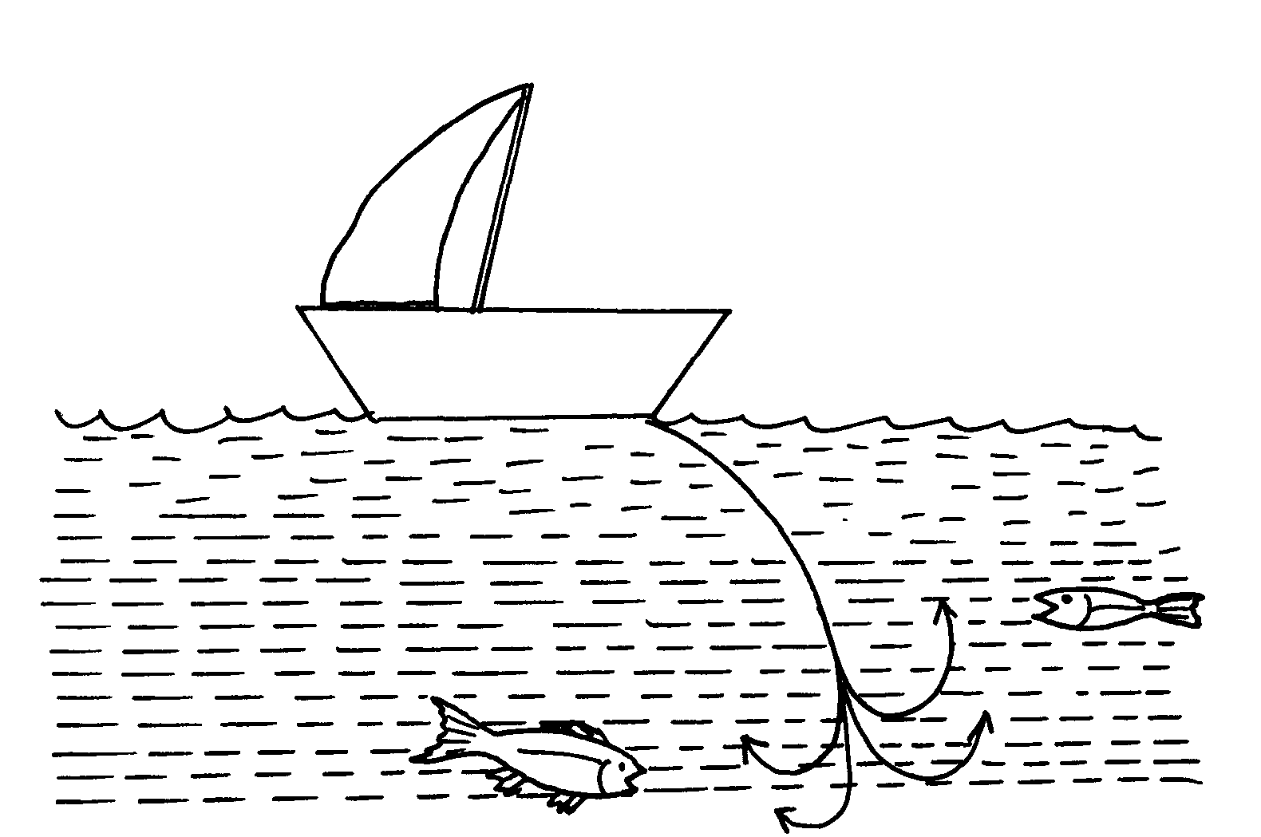
13. (a) Name commercial methods of fishing shown in the diagrams below:

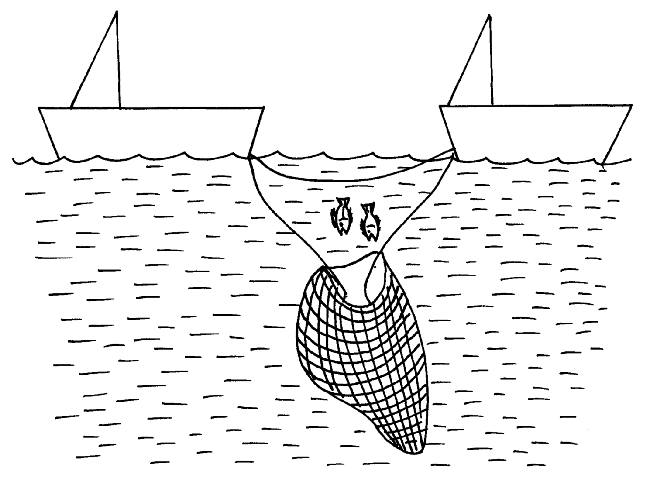

(b) State three reasons why marine fisheries in Kenya are underdeveloped

14. (a) Differentiate between pelagic fish and demersal fish?
(b) Identify two problems facing the fishing industry in Kenya.

18. WILDLIFE AND TOURISM
This topic entails:
- Definition of wildlife, tourism and ecotourism
- Distinction between:
(a) Game reserves, National Parks, and Sanctuaries
(b) Domestic tourism and International tourism
- Explaining factors influencing;
(a) The distribution of wildlife in East Africa.
(b) Tourism in Kenya
- Location of national parks, major game reserves and sanctuaries on a map of East Africa.
- Identification and discussion of tourist attractions in Kenya.
- Discussion of the significance of wildlife in East Africa.
- Discussion of:-
(a) Problems facing wild life in East Africa.
(b) Problems facing and associated with tourism in Kenya.
- Discussion of the management and conservation of wildlife in East Africa.
- Discussion of the future of tourism in Kenya.
- Comparison and contrast between tourism in Keya and Switzerland.

1. Use the map of East Africa below to answer questions (a) (i)
MAP OF EAST AFRICA
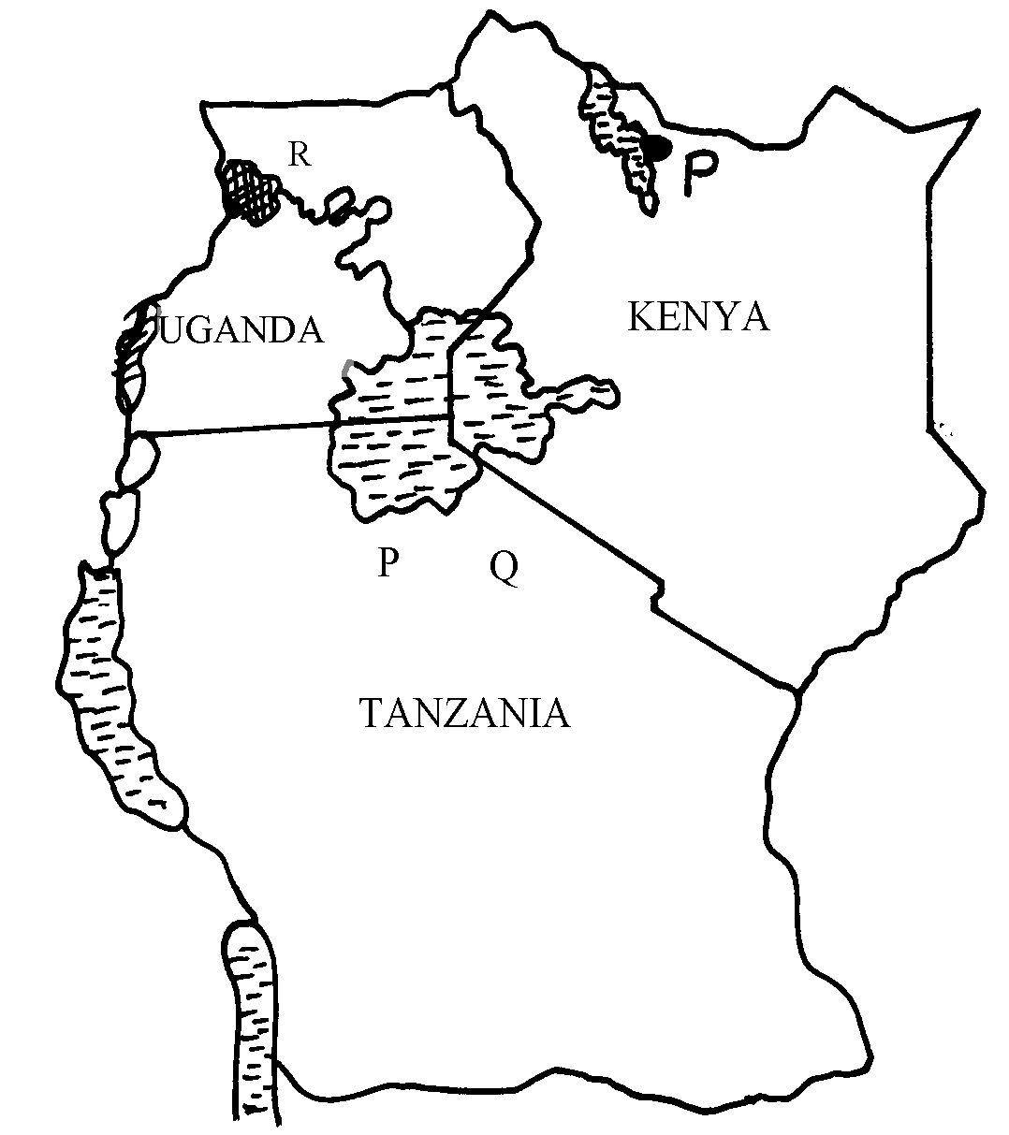

i) Name the national parks marked P, Q, and R
2. (a) State two differences between a National Park and a Game Reserve
(b) State three measures being taken to conserve wildlife in Kenya
3. (a) Differentiate between game reserves ands game parks
(b) State three ways in which human activities are a threat to wildlife
4. (a) What is balance of payment?
(b) Identify three problems that face traders dealing with primary goods
5. (a) Why are some parts of Kenya not developed for tourism?
(b) State two factors that hinder domestic tourism in Kenya.
6. (a) State three problems facing wildlife conservation in Kenya.
(b) State two human factors that have made Switzerland a major tourist destination.

19. ENERGY
This topic entails:
- Definition of energy
- Discussion of sources and types of energy.
- Discussion of the development of electric power projects in Kenya and Uganda.
- Identifying and locating other power projects in Africa
- Explaining the significance of energy
- Explaining the impact of the energy crisis in the world.
- Discussing ways and means of managing and conserving energy.
- Identifying sources and uses of energy within the local environment.

1. (a) Name two oil producing countries in the midddle East
(b) Give three contributions of oil to the economies of Middle East countries

2. (a) What is a multi-purpose project?
(b) Name two multi-purpose projects in Africa

3. (a) (i) Name five renewable sources of energy
(ii) State three disadvantages and three advantages of wind as source of energy

(b) (i) What is geothermal power?
(ii) Name two areas in Kenya which have a potential for producing geothermal power
(d) Explain three measures taken by the Kenyan government to conserve energy

4. a) i) What is energy crisis
ii) State four causes of energy crisis
b) i) Name three non- renewable sources of energy
ii) Apart from seven forks Dam project name two other hydro electric plants in Kenya
iii) Explain four factors that favoured the establishment of seven forks dam project
c) State two effects of energy use on environment

5. (a) Give three advantages of suing solar energy
(b) Identify the hydro-power stations marked P, Q and R in the diagram

(c)Explain any five ways in which energy contributes to the growth of the economy
(d) (i) Explain any three problems associated with energy crisis
(ii) Suggest any three ways to minimize energy wastage

6. (a) Define the term renewable sources of energy.
(b) (i) Explain four physical factors influencing the generation of hydro-electric power.
(ii) Outline three limitations in the production of geothermal power in Kenya.
(c) (i) Explain any four negative effects of the energy crisis in the world.
(ii) State four possible methods that the government of Kenya can use to conserve energy.

7. (a) Explain the impact of the oil crisis to Kenya
(b) What measures has the Kenyan government carried out to conserve energy

8. a) What is energy crisis?
b) State three environmental impact of energy crisis in Kenya

9. (a) Name two sources of thermal electricity
(b) Explain four benefits Kenya would get by striking oil in Isiolo
(c) Explain three measures taken by the Kenya government to manage and conserve energy
(d) Form four students of Nyabisawa Girls carried out a field study at Olkaria Geothermal
pour stations

10. (i) State three preparation they made prior to the study
(ii) State three methods of data collection they could have used
(iii) State three uses of Geothermal energy they learnt

11. (a) (i) Name two non-renewable sources of energy
(ii) Explain four physical factors that influence the location of hydroelectric power station
(b) (i) What is energy crisis?
(ii) State three causes of energy crisis
(iii) Explain two effects of energy crisis

12. (a) List two renewable fossil fuels
(b) Identify any three functions of hydro power reservoir other than power generation
(c) State three reasons why Kenya spent so little on importing maize during the year 2002
(d) (i) Name two provinces in Kenya where maize is grown on large scale
(ii) State any two uses of maize

13. (a) Name the dams marked E, F and G
(b) Differentiate between renewable and non-renewable sources of energy.
(c)Explain three factors that influenced the location of Owen falls dam in Uganda
(d) Explain four problems that hinder development of Hydro-electric power projects in Africa

20. INDUSTRY
This topic entails :-
- Definition of industry and industrialization
- Explaining the factors that influence the location and development of industries
- Describing types of industries
- Accounting for the distribution of industries in Kenya
- Explaining the significance of industrialization to Kenya
- Discussing the problems of industrialization and possible solutions
- Comparing and contrasting aspects of industrialization in selected countries.
- Carrying out field work on an industry in the local environment.

1. Give five effects of liberalization of the oil industry in Kenya.

2. (a) Define the term “industrial inertia.”
(b) State three factors that make industrialists prefer to locate their plants near already
established industries.
(c) Explain three benefits that would result from rural electrification in Kenya

3. (a) Define the term industrial inertia
(b) State three negative effects of industrialization

4. (a) Differentiate between a factory and industry
(b) Name any three types of tertiary industry

21. TRANSPORT AND COMMUNICATION
This topic entails :-
- Definition of transport and communication
- Identifying modes of transport and types of communication.
- Location of major lines of transport in Africa.
- Outlining the role of transport and communication in economic development of Africa.
- Discussing problems facing transport and communicationin Africa and the efforts being made to solve them.
- Explanation of the role of the Great Lakes and the St. Lawrence Sea Way in the conomies of USA and Canada.

1. (a) (i) State four factors that influence transport and communication
(ii) State three problems facing transport and communication in Africa

(b) The diagram below shows the Great Lakes & St Lawrence Seaway:
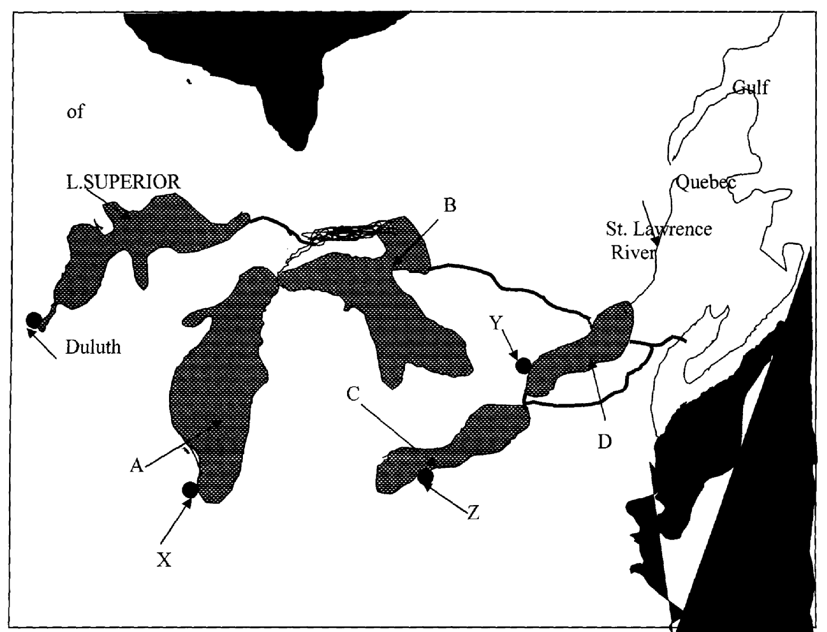

(i) Name the lakes marked A, B, & C .
(ii) Why was the St. Lawrence Sea way constructed between the Great Lakes and the
Pacific Ocean?
(iii) Identify the problems that initially existed along the seaway and how they were solved (c) State four advantages of the Mombasa-Nairobi pipeline.
(d) Discuss the role of transport and communication in development

2. (a) (i) What is transport?
(ii) Name three forms of land transport commonly used in Kenya
(b) Below is a sketch map of the Great Lakes and St. Lawrence Sea Way. Use it to answer
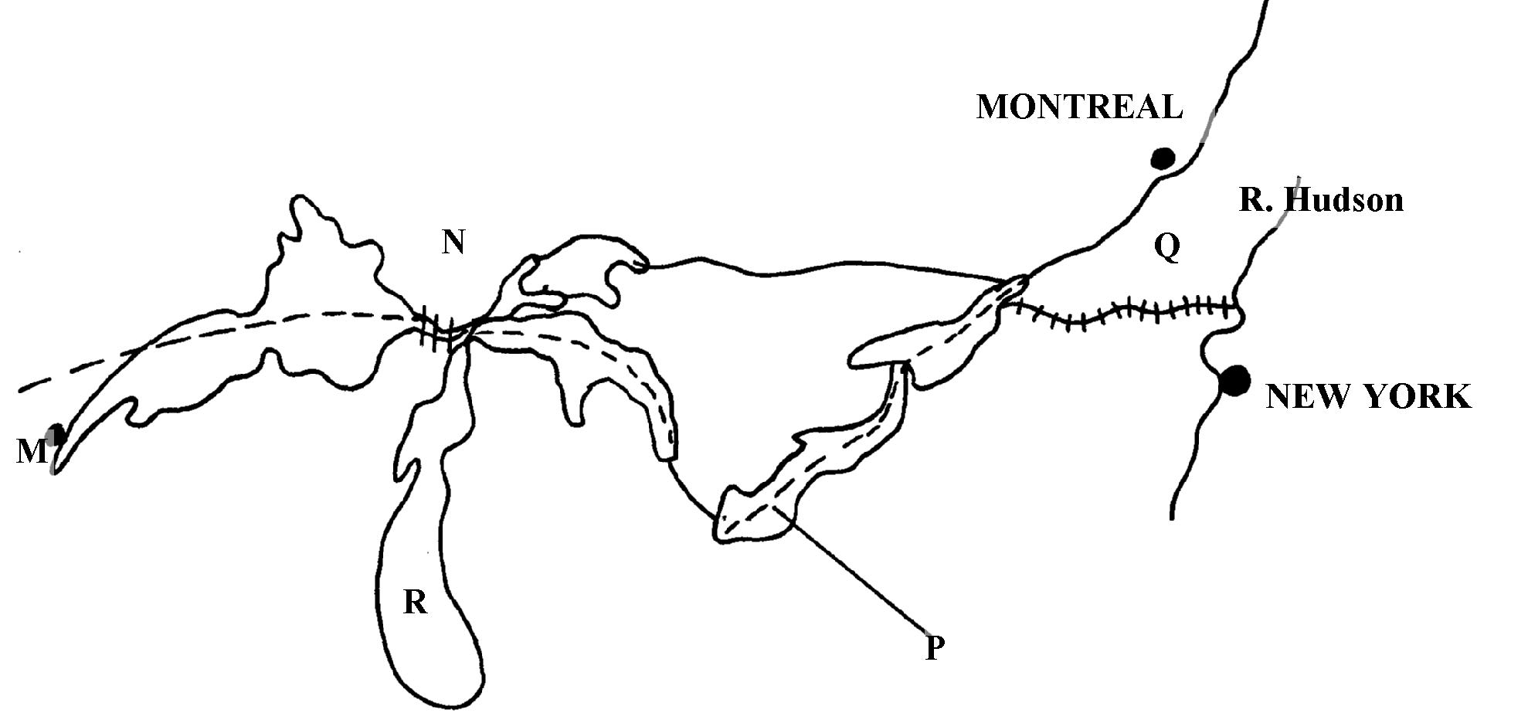
question (i) below:

(i) Name;
- The Canals marked N and Q
- The lakes marked R and P
- The port marked M
(ii) Explain four ways in which the Great lakes and St. Lawrence Seaway has contributed
to the economies of U.S.A and Canada
(c)State four ways in which communication has contributed to economic development of Kenya
(d) State any four problems facing air transport in Africa

3. (a) Define the term communication
(b) State two recent developments that have taken place in Kenya to improve communication
(c) State two problems facing telephone as a means of communication in Kenya

4. a) State three benefits that Kenya would derive from road linkage with the rest of East
African countries
(b) Give two major problems experienced by users of Kenyan roads

5. (a) (i) Give two forms of land transport
(ii) State any four disadvantages of water transport
(b) Explain any five ways in which transport and communication is important to the economy (c) Explain three attempted solution to African transport and communication problems
(d) (i) Define canal transport
(ii) Name the two major canals of the world

6. The table below shows the number shows the number of passengers that used railway
transport in selected countries in 1966 and 1977. Use it to answer questions (a) and (b)
COUNTRY | PASSENGERS IN MILLIONS
 | 1966 | 1977
CANADA | 4,800 | 6,000
U.S.A | 27,800 | 16,600
ARGENTINA | 14,100 | 12,000
INDIA | 96,000 | 160,800
JAPAN | 258,400 | 310,900
(a) (i) Using a scale of 1cm to represent 20,000 million passengers, draw comparative bar graphs
based on the data above
(ii) State two advantages of using bar graphs in representing data
(b) Calculate the percentage increase in railway passenger transport in Canada between
1966 and 1977
(c) Explain three factors that hinder the development of railway links among African countrie
(d) One of the problems facing road transport is the high frequency of accidents. Explain three
conditions of roads in Kenya that may lead to accidents

7. (a) (i) Name three types of communication mainly used in Kenya
(ii) State two advantages of pipelines as a means of transport
(b) (i) Whys is air transport not very commonly used in Kenya?
(ii) Explain four roles of transport and communications in the economic development of Africa
(c) (i) State three objectives of constructing the St. Lawrence Seaway
(ii) Name two canals on the St. Lawrence Seaway

8. Below is a sketch map of the great lakes and St. Lawrence sea way. Use it to answer
question (a)
(a) Name:- (i) The Lake marked P
(ii) River marked Q
(iii) Canal marked R
(iv) The port marked S
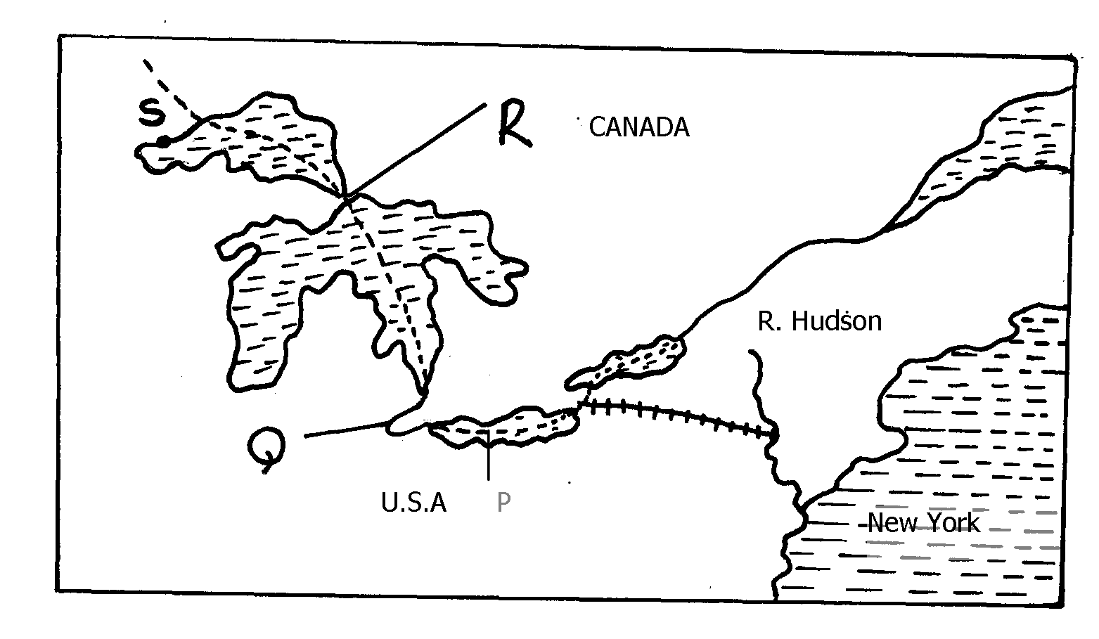

P

(b) Explain three ways in which the great Lakes and St. Lawrence seaway has contributed
to the economy of Canada and United States of America (U.S.A)
(c) Explain the factors that hinder the development of river transport in Africa
(d) (i) State three recent developments that have taken place in Kenya to improve communication
(ii) Explain three problems facing telephone as a means of communication in Kenya

9. (a) Define the term containerization
(b) State three advantages of containerization

10. (a) (i) Explain three economic importance of using mobile phones
ii) State four problems associated with the use of mobile phones in Kenya
b) Give four reasons why water transport is poorly developed in Africa
c) Explain three measures that have been taken to solve transport problems in Africa

22. TRADE
This topic entails :-
- Identifying and defining types of trade
- Discussing factors influencing trade
- Identifying major exports and imports of Kenya
- Discussing significance of trade to Kenya
- Discussing problems facing trade in Kenya
- Role played by selected trading blocks in the economies of their respective regions.

1. Use the diagram below to answer question 5a and 5b

a) Identify the type of trade shown above
b) State problems country X is likely to face in the trade shown above

2. (a) Give two types of international trade
(b) State two reasons why there is less trade between Kenya and other African countries

3. (a) State two problems facing trade in Kenya.
(b) Give three benefits of regional trading blocs.

4. (a) Outline two objectives of the common market for Eastern and Southern Africa (COMESA)
(b) State two efforts made by the Kenya government to enhance external trade

5. a) i) Differentiate between visible and invisible exports
ii) Name three invisible exports from Kenya
b)i) Apart from the Economic Community of West African States (ECOWAS) name two
other regional trading blocks in Africa
ii) Identify three member countries of ECOWAS
iii) Explain five economic benefits of the Economic Community of West Africa
states (ECOWAS)

6. (a) What is balance of payment?
(b) Identify three problems that face traders dealing with primary goods

7. (a) Distinguish between visible and invisible export.
(b) State three negative effects of a country over relying on import goods.

23. POPULATION
This topic entails :-
- Definition of population
- Explaining the factors influencing population distribution in East Africa
- Explaining the factors influencing population growth.
- Prescribing population structure
- Analysis of the consequences of population growth and structure
- Comparing and contrasting population tends between Kenya and Sweden.
- Presentation of population data using relevant statistical graphs.

1. The table below shows the population of a county in Western Europe in 1000.use it to
answer part a-c
Age group | male | female
0-4 | 450 | 455
5-9 | 447 | 449
10-14 | 448 | 450
15-19 | 454 | 458
20-24 | 480 | 472
25-29 | 630 | 632
30-34 | 635 | 639
35-39 | 642 | 671
40-44 | 670 | 638
45-49 | 636 | 568
50-54 | 562 | 641
54-59 | 633 | 639
60-64 | 631 | 634
65-69 | 451 | 452
70-74 | 470 | 468
75-79 | 460 | 459
80+ | 451 | 453
(a) Using a scale of 1cm to 100,000 people, draw a population pyramid from the above data
(b) State five characteristics of the above population structure as shown by the pyramid
(c) Explain four problems likely to be experienced due to the population trend in the
above country
(d) (i) What is mortality rate?
(ii) State five measures that have been taken in Kenya to reduce infant mortality in Kenya

2. a) Name two primary sources of population data
b) Explain four reasons that led to rapid population growth in Kenya in the 1980’s
c) State four reasons for increased infertility in Kenyan women today
d) Give measures taken by the government to combat child mortality

3. (a) Distinguish between population distribution and population density
(b) State any three problems associated with high population growth rate in Kenya
4 (a) (i) What is life expectancy?
(ii) Give three types of information which can be derived from a population pyramid.
(b) (i) Describe three ways in which population of Sweden differs from that of Kenya.
(ii) Explain four causes of rural-rural migration in Kenya.
(c) Explain three problems which result from the high population growth rates in the
East African countries

5. (a) Define the term secondary fertility
(b) (i) Apart from HIV/AIDS give two other causes of mortality in East Africa
(ii) State two ways in which the spread of HIV/AIDS in Kenya may slow down
economic development
c) State five problems facing regional trading blocks in Africa

6. a)i) What is dependency ratio?
ii) State three causes of a high dependency ratio in a population
b) i) Explain four factors that have led to the high population density around Lake Victoria
ii) Explain three problems associated with high population growth rate in Kenya
c) Give three reasons for the low birth rate in Sweden

7. a) What is population census
b) State three reasons why countries conduct population census

8. (a) Differentiate between immigration and emigration
(b) State three effects of rapid population increase in Kenya

9. (a) Define the term population explosion
(b) State three reasons why countries conduct population census.
(c) Give two measures the Kenya government has taken to check on high population growth.

24. SETTLEMENT
This topic entails :-
- Definition of settlement and urbanization
- Explaining the factors influencing settlements and settlement patterns
- Accounting for the distribution and functions of selected towns in Kenya
- Explaining the growth an functions of selected towns in Kenya
- Comparing and contrasting selected urban centres in Kenya with those of other parts of the world.
- Discussing the effects of urbanization

1. The diagram below shows part of the urban set up. Use it to answer part (a) and (b)
(a) Name the parts labeled ABC
(b) Give three characteristics of the part labeled A
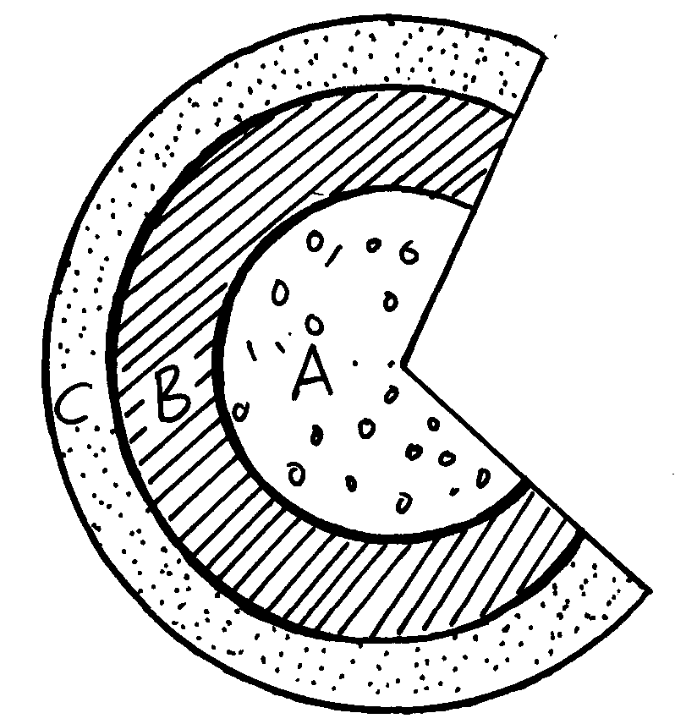
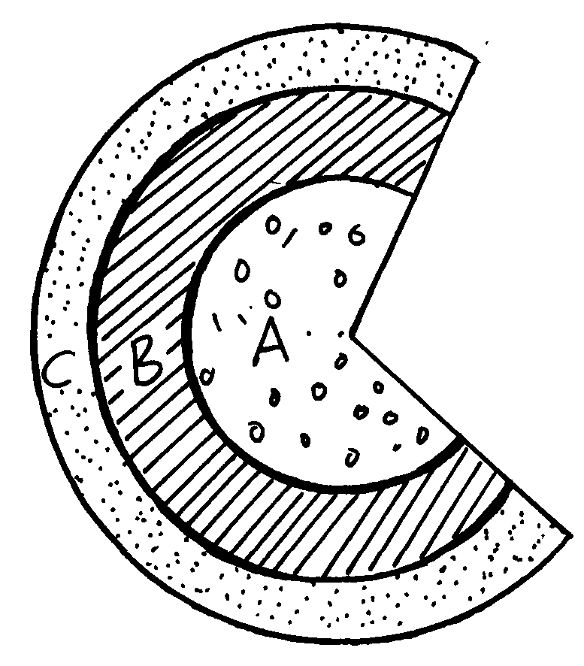

2 a) Name two settlement patterns common in rural areas in Kenya
b) The diagram below shows the internal structure of an urban centre. Name the sectors
labeled 1, 2, 3

25. MANAGEMENT AND CONSERVATION OF THE ENVIRONMENT
This topic entails :-
- Definition of management and conservation
- Explaining why it is necessary to manage and conserve the environment
- Naming/identifying environment hazards
- Assessing the impact of selected environmental hazards and suggesting measured for combating them.
- Discussing the measures taken in managing and conserving the environment.

1. i) Define the term land pollution
ii) Explain four causes of land pollution
iii) Explain four effects of land pollution

2. a ) Reasons why National parks are located in marginal areas.
(b) Explain three ways in which water pollution affect wildlife
(c) (i) State three causes of floods in Kenya
(ii) Explain two methods used to control flooding in Kenya
(d) State six reasons why it is important to manage and conserve environment

3. (a) Give three causes of sound pollution
(b) State two major health effects caused by sound pollution

4. (a) Apart from flooding, name three other environmental hazards experienced in Kenya
(b) (i) Name two rivers to the west of Rift valley which causes large scale flooding
(ii) Explain four problems caused by floods
(c) Explain three effects of land pollution on the environment
(d) (i) State three ways through which land pollution can be controlled
(ii) Give three effects of wind as an environmental hazard in Kenya
5. Use the map of Kenya below to answer question (a)

(a) (i) Name the wildlife conservation areas marked S, T, and U
(ii) Identify the Marine National Park marked V
(b) (i) Apart from Marine and Wildlife name three other tourist attractions along the coastal
strip of Kenya
(ii) Give four reasons for wildlife conservation in Kenya
(iii) Explain four problems facing wildlife conservation in Kenya

6. (a) Give three reasons why it was necessary to conduct a pre-visit before the actual study (3mks)
(b) State three measures that they could propose to be taken to promote domestic tourism
in Kenya (3mks)

7. (a) Apart from floods, name any other environmental hazard experienced in Kenya
(b) State two causes of desertification
(c) Give two reasons why it is necessary for Kenya to conserve her environment

8. (a) Differentiate between management and conservation of the environment.
(b) Give four reasons why we need to manage and conserve the environment.
(c) Explain four effects of air pollution on the environment.
(d) (i)Give five measures that can be put in place to combat pollution.
(ii) Identity three human characteristics you may learn from the garbage;

9. (a) Define the term pollution as used in Geography.
(b) Dither their air pollution name three forms of pollution.

10. Apart from desertification, name two other environmental hazards experienced in Kenya

ANSWERS SECTION I & II

1. INTRODUCTION TO GEOGRAPHY
1. - It creates awareness /understanding in the people of the environment in which they live
hence the need to manage, and use resources sustainability.

2. THE EARTH AND THE SOLAR SYSTEM
1. a i) i) Tropic of cancer
ii)) 66 ½ º
b i) - Causes day and night
- Causes high and low tides
- Causes deflection of winds and ocean currents
- Causes time difference between longitudes
- Causes pressure difference on the earths surface
ii) Time difference = 1400 hrs – 1030hrs
= 0330 hrs
= 3½ hrs
∴Difference in longitude is
⁷/₂ x a5 = 52.5
52.5 – 45
Longitude is 7.5W
(c) - Sea breeze
- Land breeze
- Anabatic
- Katabatia

2. a i) - 28ºC-24ºC = 4ºC
ii) - 1803mm
b) - the town experiences high temperature throughout the year (24ºC-28ºC)
- the annual range of temperature is small
- rain fall throughout the year/there is no marked dry season
- the rainfall patter has double maxima
- the wettest month is June/the driest month are December and January
- the rainfall is high i.e. 1803mm
3. a) Solstice is when the sun’s overhead position is over the tropic of caner and Capricorn
b) - Causes seasons i.e. spring, summer, autumn & winter
- Varying lengths of day and night at different times of the year
- Changes in the position of the midday sun at different times of the year
- Changes in the position of the midday sun at different times of the year
4. a i) - Passing star theory
- Nubular cloud theory
ii) Centrifugal force
b) - Layers of the overlying rocks exerts pressure hence the interior is hot
- After formation of the earth the interior cooled slowly compared to the exterior, thus the
interior still retains much of its original temperature
- Radioactivity – mineral elements with the interior react with each other thus exploding
to produce heat
5. a) - Passing star/ the big bang theory
- Nebula cloud theory
b)- The solar system is the group of heavenly bodies comprising the sun and the eight known planets which orbit the sun
6 .a) - Mercury
- Venus
b) (i) A time zone is a group of neghbouring countries that use the same standard time
ii) - On crossing this line from east to West,, a day is gained / the clock has to be
adjusted backwards by 24hours
- On crossing this line from West to East a day is lose/the clock has to be adjusted
forward by 24hours.
c) - They are circular.
- They decrease in length Northwards and Southwards
- They are measured North and South of the equator
- There values increase Northwards and Southwards
- They are parallel to each other
7. a) - It is the sun and the planets orbiting around it.
b) - The radio activity process taking place in the interior leads to a lot of energy
production.
- This keeps the temperature in the interior very hot.
- The overlying materials exert a lot of pressure to the interior resulting to higher
temperature.
- When the earth was being formed the mantle and the core cooled at a slower rate than
the crust.
- As a result the temperature in the interior are still hot.
8. a i) -Solar/eclipse of the sun
. ii) - Q-moon
- T-umbra
b) -it cause days and night
-it causes high and low tides
-it causes the deflection of winds and oceans currents
-it causes time difference between longitudes

9. a) - Cooled at a slower rate than the outer exposed part
- Due to the process of radio- activity where atoms break releasing heat
- Weight of the overlying material that exerts pressure on the core
b) - Causes seasons
- Varying lengths of day and night
10. a i) It is the date when the sun is overhead at the equator at mid day
ii) 21st march√
23rd September√
iii) - causes four seasons i.e. winter, summer, autumn and spring√
- causes varying lengths of day and night at different times of the year√
- causes changes or altitude of the mid-day sun at different times of the year√
11. a) - U-mohorovicic discontinuity
- V-the mantle/asthenosphere
- X-Gutenberg discontinuity
. b i) - it is made up of solid rocks
- composed of two layers /sial and sima/continental crust and oceanic crust
- sial is rich in silica and a aluminum
- sima is rich in silica and magnesium
- sima rocks are like plastic/more flexible
- the top layer of the sima is made of sediments and volcanic lava
- the bottom layer of sima is made up of basalt/igneous rocks
- the sima is made up of the basaltic/igneous rocks
- sima is made up of dense rocks /2.8-3.0 gm/cc
- the sial is made up of granites/sedimentary/metamorphic rocks
- the sial rocks are rigid/brittle
ii) - the core is composed of two parts i.e. inner core and outer core
- the main mineral of the outer core are iron and nickel
- the main mineral of the inner core is iron
- the inner core has a high density i.e. 16-17gm/cc than the outer core i.e. 10.5gm/cc
- the inner core is made up of a solid rock mass
- the outer core is molten

3. WEATHER AND CLIMATE
1. -population pressure leading to clearing of forest
- climatic changes/global warming/destruction of ozone layer
- accidental fires
- poor methods of farming /overgrazing
2. a i) Aridity refers to a state of dryness or deficiency of rainfall in an area while
desertification refers to the encroachment of desert like conditions into
productive or arable land √√
ii) Weather atmospheric condition of a place over a short period of time
Climate- Average weather condition of a given place over a long period
b)- Moist warm air meets dry cold air mass
- Mountain slopes adjacent to a valley cause anabatic and katabatic winds
c) - Sea heats faster than the land during the day
- Air over the sea rises creating low pressure over the sea
- Cooler air over the land blows towards the sea
- Cool air from the land is called land breeze
3. a) - Zone of low pressure
- High temperature
- High convectional rainfall
- Trade winds converge here
- Moves with movement of the sun
(b)i) -Variation of solar output
- Volcanic eruption
- Variations in the earth’s orbital characteristics
- Variation in atmospheric carbon dioxide
iii) - Increase in temperature causing rise in sea level due to melting ice
- Changes in wind speed causing erosion
- Changes in seasons leading to severe drought
- Increase in precipitation causing flooding of large areas
c) - Relief features such as high mountains influence temperature and rainfall pattern
- Presence of large water bodies that modify temperatures of the surrounding lands through breezes
- Continentality- many regions are in the interior of the continents making them receive low amounts of rains
- Winds- some areas are influenced by cold onshore winds that lower temperature of the surroundings
4. (a) - Temperature varies between 17C to 24C
- Lower slopes have higher temperatures than upper slopes
- Mean annual range of temperature is between 3C to 5C
- Rainfall is received throughout the year
- Rainfall is high 1000 -15000 mm
- Rainfall is double maxima
- Rainfall is relief- orographic
- High rain on the wind ward slopes
- Rainfall is caused by S.E trade
- Coolest months are between June and August
(b - Fold mountains receive heavy rainfall/ snow falls give rise to many rivers for
HEP, irrigation, water for domestic and industrial use
- Wind wards sides receive high rainfall which promote agriculture/ forest growth
- Leeward side have violent wind which destroy crops
- Folding leads to exposer of some minerals or bring minerals near surface for mining
- Folding hinders construction of communication
- Folding acts as barriers during wars
- Folding offer sceneries which attract tourists hence foreign exchange
- Folds mountains make visibility poor hence hindering air transport
5. a) Weather is the daily condition of atmosphere taken in short period usually 24hrs
while climate is the average weather condition taken for a period of 30 – 35 yrs
b) - High rainfall/ no marked dry season/ (1500mm – 2000 mm)
- High temperatures throughout the year/ (24º– 27º)
- High humidity throughout the year with relative humidity about 80%
- Rainfall throughout the year
- Small temperature range/ 4ºC
- Double maxima (March – May and Oct – Nov)
- Major winds are South East and North East
- Low pressure all the year/ Doidrums/ Equatorial low
- Rainfall mainly convectional falling in the afternoon accompanied with lightening and thunderstorm
- Thick cloud cover all the year/ thick cumulonimbus clouds
6. (a) i) - Warm ocean currents raise temperature of the adjustment land/ warm current
increase rainfall
- Cold ocean current lower temperature of the regions/ lower rainfall/ create dryness
ii) High areas have low temperatures/ Mt areas receive high rainfall
Mountain sides facing sun are warmer than sides facing away from sun (Aspect)
b i)- Rainfall of double maxima
- High temperatures throughout the year about 270°C
- Low temperature range
- Rainfall falls throughout the year
- Rainfall is high average 2000mm
- Low pressure due to over head sun
- Rainfall is mainly convectional
- High humidity content
7. a) - Air should be calm so that it can remain in contact with the ground long
enough to be cooled below dew point
- Day time should be warm to speed up evaporation and provide a lot of water in the air
- There should be cloudless nights
b) - To increase precipitation in the area
- To regulate in the area
- Forest to help air purification
8. a) i) A fog is a mass of water droplets suspended in the lower atmosphere which limits
visibility to less than a kilometer
ii) - Air must have abundant moisture
- The night should be clear/cloudless to facilitate terrestrial radiation
- The air should be clam/gentle air currents to help the water droplets in suspension
b) - Troposphere
- Stratosphere
- Mesopause
9. a) -it is a large volume of air whose temperature and humidity are fairly uniform
and covers an extensive surface area
b) -it experiences high temperature
-it is a zone of low pressure and the doldrums
-the zone migrates to the north and south of the equator with apparent movement of
the overhead sun
-it is a zone where the S.E and N.E trade winds converge
-it is associated with convectional rain and thunderstorms
10. a) - Temperature decreases with increase in altitude.
- Rainfall increases with height upto 300m then it starts to decrease
- Windward slopes are wetter than leeward slopes.
- Atmospheric pressure decreases with increasing altitude.
- Local winds are common, they blow up slope during the day and down slope
during night.
- In temp. regime slopes facing the equator are warmer than those facing the poles
b) i)- Increases air pollution from industrial activities.
- Deforestation /uncontrolled logging.
ii) - Widespread changes in the natural ecosystem with grasslands and deserts areas
expanding as forested areas shrinks.
- Possible rise in temp. may increase evaporation rates leading increased rainfall
in some areas.
- Increased rainfall will cause flooding of low lying areas.
- Water stored in polar glacier will melt leading to rise in sea levels and flooding of
coastal lands.
- In temperate regions, winters are likely to be wetter and summer drier.
- Wetter & warmer conditions may increase pests & diseases thereby affecting humans,
crops & livestock.
- Change in climate is likely to cause extinction of various plants and animal species.
- Possible drought might increase in most parts of the world.
- Cause in change in agricultural activities & massive crop failure leading to food
shortage.
c i) - A rain gauge consists of a funnel, metallic cylindrical container and a collecting jar.
- When it rains, water from direct rain drops collects into the jar through the funnel
- The water collected is then poured into a graduated (in mm) measuring cylinder.
- The readings taken & recorded.
c ii) - Thermometers /√six thermometers.
- Hygrometer.
11. a i) - This is climatic conditions in a restricted area due to small differences of aspect
slope, vegetation and human landscapes
ii) It is a condition where the incoming solar radiations pass through the atmosphere
while the outgoing terrestrial radiation is blocked by gases/ clouds/ atmosphere
making the earth retain the terrestrial radiation/ re-radiation. (This makes earth to
be warmer than it would have been)/ it is a condition where the atmosphere
balances the incoming and outgoing terrestrial radiation making the earth to
retain optimum heat
b) - A thermometer / maximum and minimum/ six’s thermometer
- A hygrometer/ wet and dry bulb thermometers
12 a) -body of air/wind with uniform conditions moving in a given direction
b) -same temperature
-air pressure-move from H.P to L.P
-earth’s movement
13. (a) Tropical convergence zone is a low pressure belt that lies between the tropics
where the North East and South East trade winds converge
b) - The forest is evergreen due to high rainfall and abundant sunshine
- The trees grow tall to complete for sunlight
- Trees have broad leaves to encourage water loss through evapo-transpiration /
transpire excess water due to high rainfall
- these are mainly hardwoods due to abundant sunshine
- Trees have buttressed roots to support their great heights and large trunks in the
wet soils.
- Tree roots go deep into the ground for anchorage
- There are many tree species due to the tropical conditions.
- The forest has little underground because the canopies block sunlight from reaching the
ground
- The forests have numerous lianas/climbers which twine around the tall trees to reach
sunlight in the dense forest.
- Trees grow rapidly due to the high temperatures and high rainfall
14. a) It is large volume of air/ wind with similar/ uniform temperature humidity and covers
over a large area and flows over along distance
b) A- North East polar winds
B- South West westerlies/ S. West winds
C - North east trade winds
D - South East trade winds
15. a i) - Global warming is the increase of average temperatures on earth as result of green
house effect/ gases reflecting back to earth part of heat radiation
ii) - The orbital position of the earth or effect of the distance of the earth from
the sun
- High amount of carbon dioxide in the air from industries
- The volcanic emption raise heat/ temperature
- High amount of solar radiation reaching the earth due to depletion of Ozone layer
iii) - Carbon dioxide (CO₂)
- Chlorofluorocarbons (CFS)
- Methane
- Nitrous oxide (N₂O)
b)(i) - Change in the ecosystems with grass land and deserts expanding while
forests shrink
- Rise in the sea level due to thawing of glaciers that leads to flooding of coastal low lands
- Rise in global temperatures leading to increased rainfall due to increased evaporation
- Wetter winters and dry summers in temperature regions
- Shrinking water bodies e.g. lakes, rivers and drying up of streams
- Reduced animal and plant species due to adaptation difficulties
- Extinction of some species of flora and fauna
- Low production of food due to failing soil fertility and absence of rain/ too much of rainfall
in other areas
(ii) - High rainfall evidenced by many permanent rivers
- Cool temperatures from high altitudes e.g. 2000m
16. a) Aridity is dryness/ insufficient rainfall, while desertification is the expansion/
encroachment of desert conditions
b) - Use off defective instruments√
- Personnel my have inadequate /limited skills√
- Vagaries of nature such as earth tremous√
c) - painted white to prevent over heating√
- raised to a height of 121m to prevent contact with direct radiation from the
earth’s surface√
- it has louvers at the side to allow free air circulation√
17. a)- 2-modified tropical climate of the highland
- 3-modified equatorial climate of the lake basin
b) - it receives very low rainfall of less than 250mm annually
- the mean annual temperature are high above 29ºc
- large diurnal range of temperature
- day temperature are high
- humidity is low
- sand storms are common occurrence
- there are occasional floods caused by sporaduram
- the region is under the influence of dry north east trade winds
19. a i) X – Mediterranean
Y – Equatorial climate
ii) - Rainfall is low/ below 250mm per year
- Rainfall is erratic/ unreliable
- Occasional flash floods
- Temperatures are high throughout the year
- Intense solar radiation
- Diurnal range of temperature is large/ extreme hot days and cold nights
- High rates of evaporation
- Skies are clear/ high terestial radiation
- Low humidity
- Strong dusty winds
b i)- Green house effect is general increase of the temperatures of the globe due
to increase in the level of CO₂ and other green houses gases. This result into
a condition where the incouncy solar radiation passes through the atmosphere
while the outgoing terrestrial radiation s blocked by the gases and the clouds
ii) Increase in temperature
Effects
- Rainfall increase
- Melting of ice caps
- Rise in sea level
- High evaporation
- Abnormal growth of plants
Change in rainfall pattern
Effects
- Floodings
- Rise in sea level
- Drought
- Soil erosion by water
Change in seasonal patterns
Effects
- Severe winter/ short summer
- Drought
- Shifting of vegetation zones
- Extinct of some species
Change in winds
-More frequent & more destructive
- High waves
- Flooding
- Wind erosion/ wind storms
c i) - Temperature decreases with increasing height above sea level. This is because
atmospheric air at low altitude is denser than high above. Heat loss is greater at high
altitude than at lower altitude
- Rise in altitude cause fall in temperature and a cooling effect that causes condensation of moisture in the air. This leads to precipitation forming at high altitude
- Atmospheric pressure is higher at low altitude and lower at high altitude. This is because the weight of the atmospheric air at low altitude is more than at high altitude
ii) In summer, coastlands are relatively cooler than in land areas. This is because the
winds bring the cooling effect of the sea to the land, by the time winds reach inland
they are heated by warm land resulting in higher temperature over the interior of
the land
In winter the onshore winds bring the warming effect of the sea into the land causing a rise in temperature. By the time these winds reach the interior of the land, they are cooled by cold land thus enhancing the low temperature
Onshore winds cause a lot of rain in the coastal areas throughout the year. This is because the wind picks up moisture over the sea and drop it on the nearby land. The continental interiors receive less rain, mainly in summer, because the winds have dropped mot of the moisture in the coastal lands
iii) Ocean currents
- Cold ocean currents bring about the cooling effect in the temperature
- Also bring a dry effect because the cold air is not able to rise
Warm ocean currents
- Bring a warm effect (rise in temperature)
- Heavy rainfall because the warm air is able to rise and condense to form rainfall

4. STATISTICAL METHODS
1. a ii) - Relatively more difficult to draw/time consuming.
- Long bar not easy to compare.
- Number of components to be represented is limited
- Fluctuation in production over a period of time are not easy to see at a glance
2. (a) ii) - A better impression of totality and individual contribution.
- Differences in quantities are easier to see.
- Easy to read the bars as they start from a common baseline.
- The value of each bar is easily determined.
b) - Kenya is not self sufficient in the commodities due to the high population.
- Frequent drought which lead to crop failure cause food shortage thus importation to supplement local produce
- Increased cost of farm inputs leading to low production hence the need to import.
- Occasional illegal imports/smuggling /hoarding of the commodities creates artificial shortage hence the need to import these commodities.
- Pests and diseases reduce the amount of grain harvested thus the need for importation.
- The requirements to maintain the trading quotas among the countries African trading blocks that Kenya imports some of the commodities in exchange of her own imports
3. a i)
DISTRICT / YEAR | 1982 | CT | 1992 | CT | 2002 | CT
TRANS NZOIA  KIAMBU  MERU  BUNGOMA | 24  23  25  12 | 24  47  72  84 | 26  25  27  14 | 26  51  78  92 | 40  31  32  20 | 40  71  103  123
Milk production in 000 units in selected Districts in Kenya
4. a i) - The year 2009 recorded the highest network coverage in the country
- The year 2007 held the lowest network coverage and uncovered areas respectively
since 2009
- Safaricom network has been the leading in terms of network coverage since 2007
to 2009
- YU network has been the least in terms of network coverage
ii) - Suitable for absolute totals in different periods
- Gives a good visual impression of the totality
- Easy to interpret
5. a ii) – It’s easy to compare the various components within a circle.
  - They are simple to construct after angles have been calculated.
  - Give clear visual impression of individual components.
- It’s easy to determine the value of each component since the size, the sector is
proportional to the value it represent.
b) = 130,000 – 70,000 = 60,000 √1 mk
% increase = 60,000 x 100 = 600
70,000
= 85 ⁵/₇ % √1 mk
6. a) Gold = ²⁶/₁₀₀ x 360 = 93.6 = 94⁰√ 1
Fluorspar = ¹⁴/₁₀₀ x 360 = 50.4 = 50⁰√ 1
Soda Ash= ³²/₁₀₀ x 360 =115.2 =115⁰√ 1
Zinc= ²⁸/₁₀₀ x 360 = 100.8 = 101⁰√ 1
b) - Good in showing variant types of data√
- Easy to draw√
- Easy to interpret √
- Easy to make comparisons√
5. MAPS AND MAP WORK
1. a i) - Kisumu east 116/2
- Muhoroni 117/1
- Lumbwa 117/2
- Nyakach 116/4
- Kericho 117/4
- Kisii 130/2
- Chemagel 131/1
- Chapatarakwa 131/2
b i) - Presence of tea plantation-tea grows under heavy amount of rainfall
- Presence of forest cover
- presence of permanent river
b ii) - R. Kibol
- Scrub vegetation
- Tea plantation

c i)

d i) - the major river is R.yurith
- river are permanent
- the river are few
ii) - Farming
- Forestry
- Mining

3. a) (i)- 0º20¹S35º¹91E
ii) - Power transmission line
b i) - Trigonometrical station
- Contours
- Hunhures e.g. along road in grid square 6867
ii) - 3.9Km ± 0.1 (3.8km – 4.0km)
iii) - 180 + 35 = 215º ±1º = (214º – 216º)
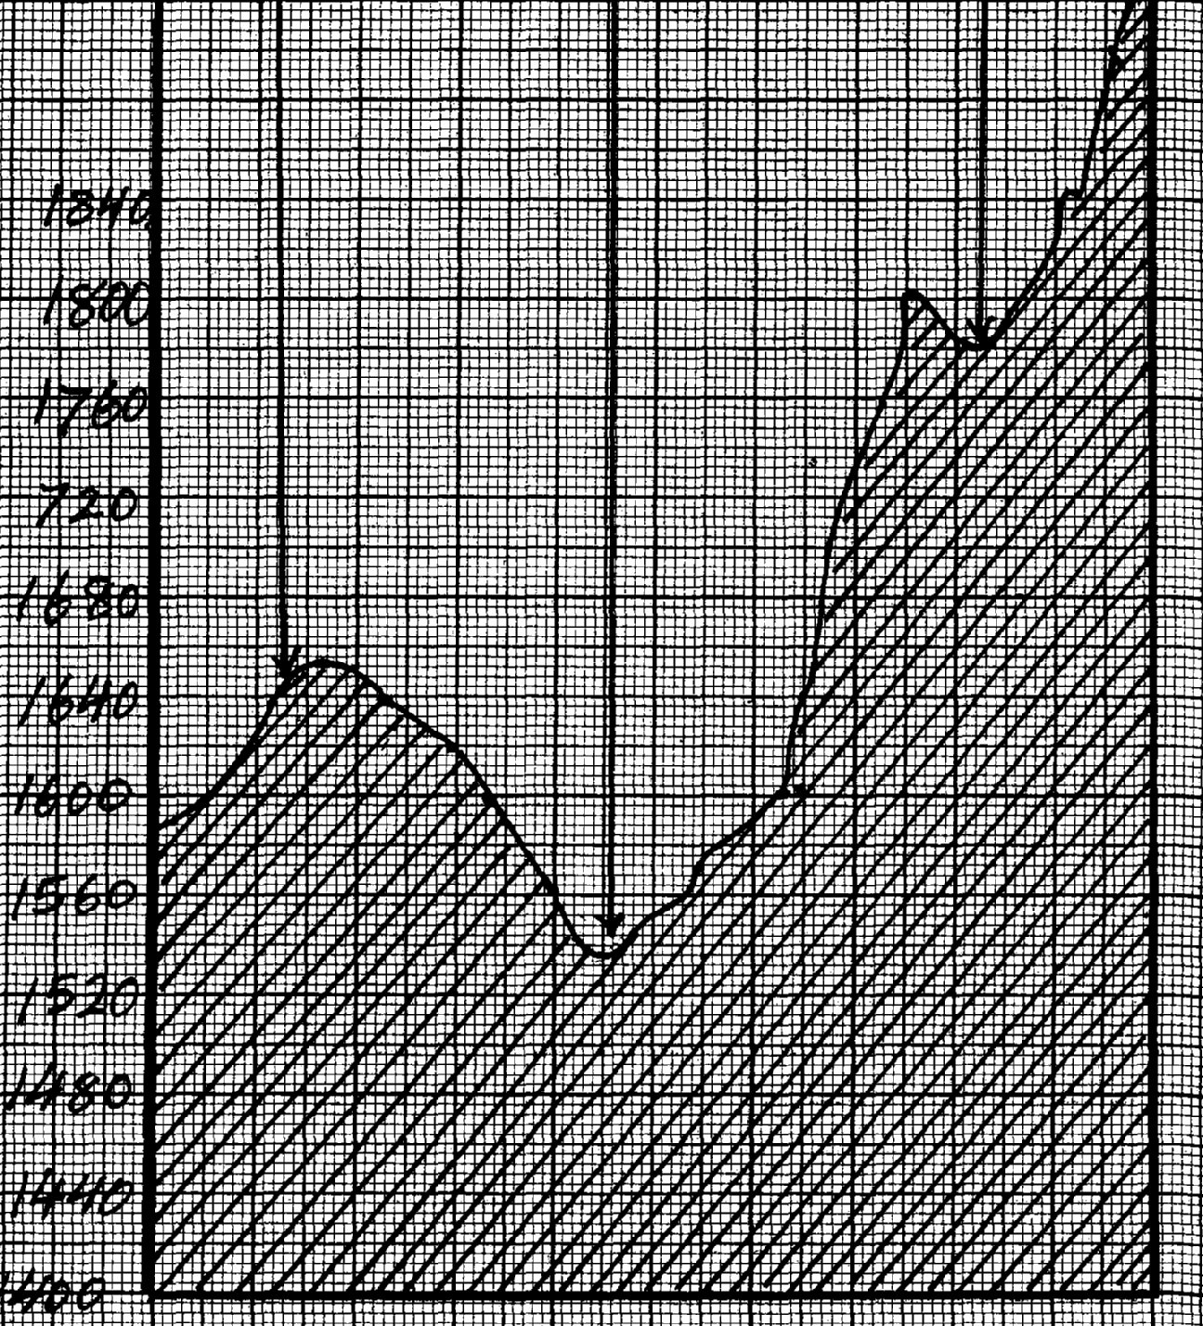
3. a)

ii) VE = ^{VS}/_{HS} = ¹/₈₀₀₀/¹/₅₀₀₀₀ = ¹/₈₀₀₀ x ⁵⁰⁰⁰⁰/₁

4. a i) - north west√√
ii) - 000º/360º√√
iii) - trigonometrical station: secondary√
- trigonometrical station :other√
iv) full squares=28
½ squares=26x ½ =13
41x1000m=41,000metres√√
b iii) V.E=VS
GS
= 1
10,000
1
50,000
= 1 X 50,000
10,000 = 5√

c).
CROP | EVIDENCE
-coffee  -Grains(maize, millet, sorghum  -tea | -coffee mill (2347)  -mills, posho mill (4255)  -tea estate, tea nursery, tea factory.(1x2=2mks)
c.

5. a) X – Savanna grass land
Y – Tropical rain forest
b) - Has very low temperature
- Thin soils and bare rock
- Soil is permafrost
c)- Mt.Kenya
6. a i) - 2020m
ii) 15’ (35º00’ to 35º15’)
iii) 36.0km² (35 to 37km²)
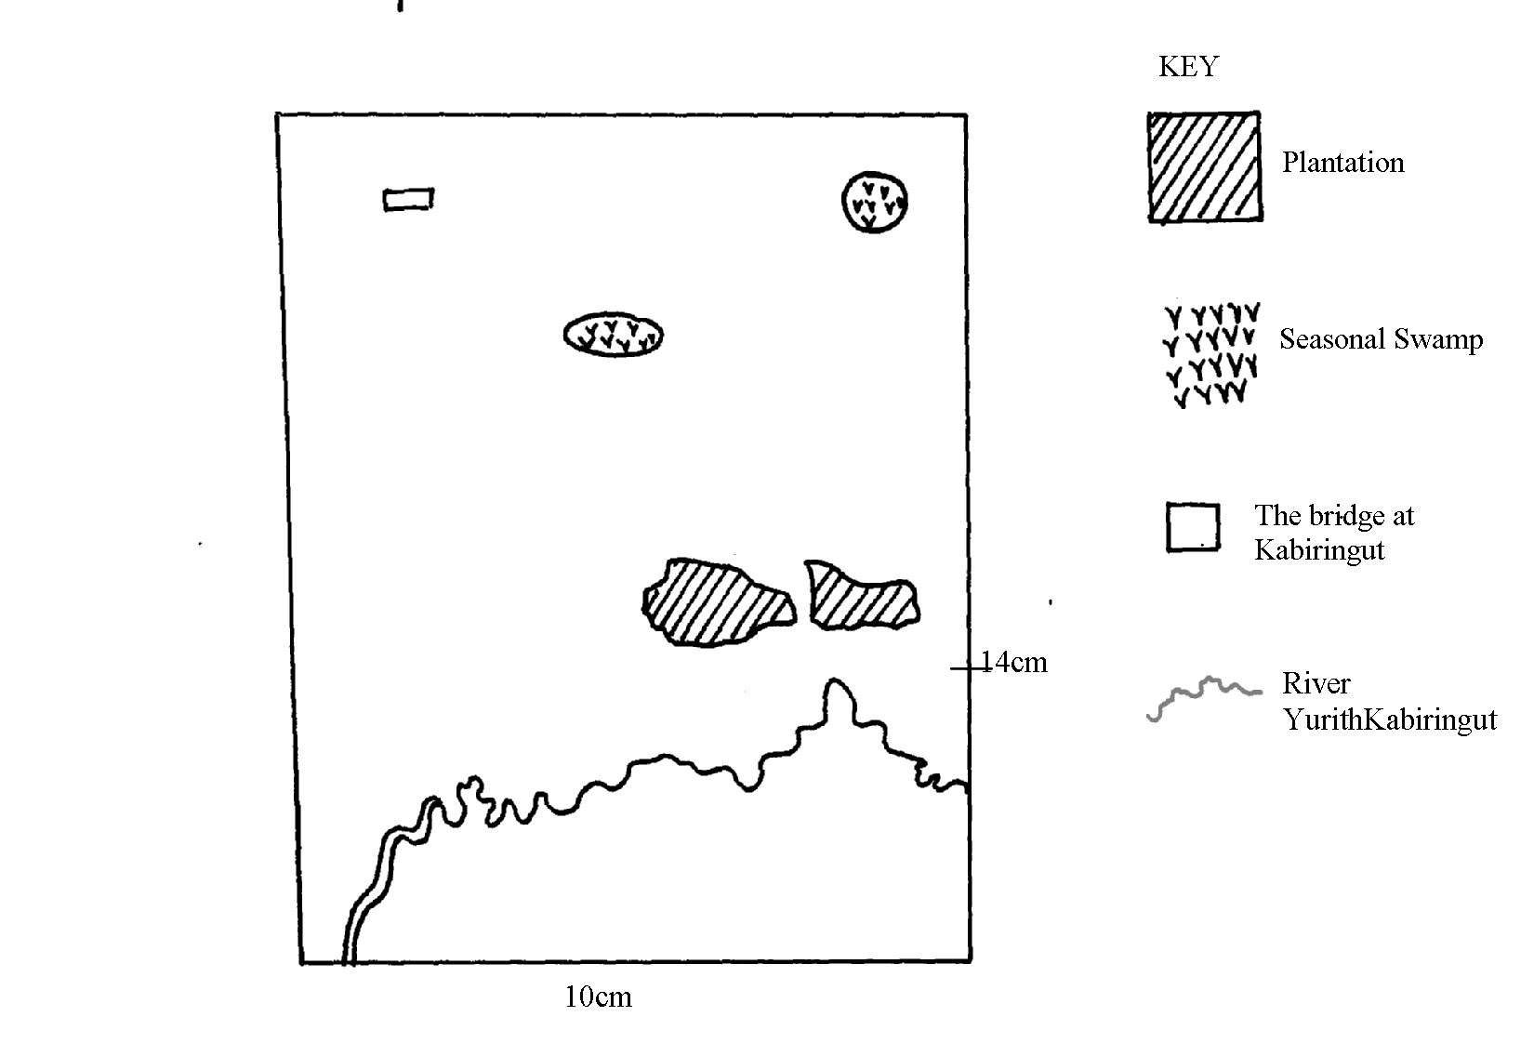
iv) 28755548
. b i) & ii)

iii) New scale = map scale x scale factor of reduction
= ¹/ _{500m}x ½ = ¹/₁₀₀₀₀₀= 1: 100000
c) - The forestal area has few/no all weather roads because it is reserved for the
growing of trees
- The all weather roads avoid high hills/steep slopes because construction on/along steep slopes is difficult for example the road from Maraboi through Tamungo to Marumbasi detours to avoid steep slopes and hills.
- The roads avoid swamps because of their water-logged conditions for example the road from Ainaboi through kabionga to Kiptula avoids the papyrus swamp
- the roads avoid river valleys and only crosses them unavoidable
- the roads are constructed on gentle slopes as it is easier to construct them as seen by
the construction of roads on the gentler slopes to the East and no all weather roads
on the ridge east of river Sondo
- All weather roads are constructed on ridges/spurs/water sheds due to the gentleness of
the slopes for example the road from Maragwa to Maraboi/the road from Ainabkoi
to Kerenga
d i) - Cool temperature as evidenced by the high relief – over 1700metres makes the area
suitable for growing of tea bushes.
- The gentle/indulating slopes as evidenced by widely spread contours allows for proper
drainage of soils/mechanization making it ideal for tea farming.
-The high rainfall as evidenced by forest vegetation/many permanent rivers originating from the area which is suitable for ea growing
- Presence of labor as seen by the fairly dense settlement/labour lines to work in the
tea farms
- Transport is avoidable as seen by all weather roads for transportation of tea from the
farms/transportation of labour
d ii) Coffee evidence coffee mill in grid square 2347
7. a i) 1: 50,000
10000cm represent 1 km
= 50,000 = 0.5
100000
1 centimeter represents 0.5 kilometers
ii) - 35º00¹ – 35º15E
iii) - 120º + 1º
. b) - Wood land
- Riverine trees
- Papyrus
- Scattered trees
- Scrub

c ii) - River Sondo is the main river
- River Yurith flows S. westwards
- Papyrus swamp present to the north and south
- Yurith river has meanders
- Rivers are permanent
- Most rivers show a dendritic pattern
- Dams in grid square 4349 and 4954
d) - Shops and trading centre
- Presence of roads foot paths
- Dense settlements provide market
- Police post for security
8. a i) -Rift valley
-Nyanza
ii) -south west direction
iv) 420557
b i) - 4.00km=0.1(3.9 to4.1)km
ii) -use of place names
-grid reference
-compass direction
iii) -forest
-woodland
-scrubs
-riverine trees
-papyrus swamp
iv) -Tea growing-evidenced by tea factory/tea estates
-live stocks keeping-evidence by veterinary livestock centre
-cereal crops growing-evidenced by posho mill
(c)-Gentle have dense settlement due to gentle gradient which encourages settlement as
evidence by spaced contours.
-Relatively flat areas have little or no settlement due to pour drainage as evidenced by papyrus swamp
-Areas with steep slopes in the western area hear Kebenet have few settlements as evidence by closely spaced contours
-There has dense settlements due to fertile soil as evidenced by the growing of tea in estates
(d) -there are several permanent rivers in the area
-rivers Sondu and Yurith are the major rivers in the area
-rivers with their tributaries for dendritic drainage pattern
-there is a seasonal swamp in grid square 3656
-in the west, rivers flow north-west wards in the south they flow westwards
-there are fewer rivers in the north than in the south-
9. a i) - topographical map.
ii) - Contours
- Trigonometrical stations.
b i) 1.3 cm 1 km 100000 cm
1 km = 100,000 cm 13 cm 1cm X 100000 = 0.000013km
13
ii) - Tea. Evidence by changoi tea factory and tea nursery.
- Coffee, evidence by coffee mill
c i) - The plains are densely settled as the land is flat/gentle land.
- The basins have been avoided as they land is water logged/flooded/swampy.
- Steep slope/escarpment have been avoided because they are unstable for construction of houses/for farming.
- There are few settlement on hilly areas because slopes are gentle.
ii) - Education/schooling evidenced by Gekonge school, Matongo school, Cheboan school,
Kakibei school e.t.c
- Trading evidenced by Health centres, Dispensaries
- Social work evidence by labour lines.
- Transportation evidence by murram, Dry –weather roads.
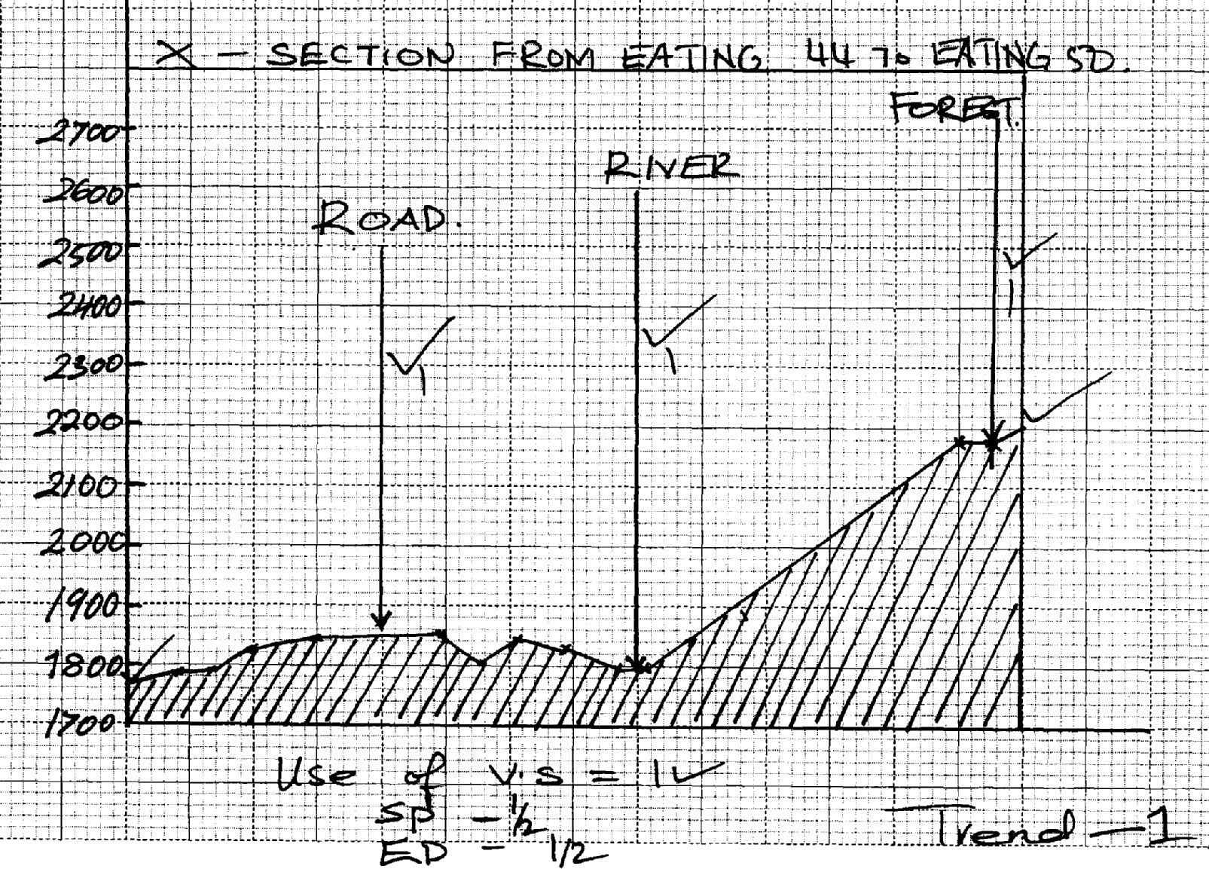
- Road
- River
- Forest

10. a i) 35°00¹ - 35°15¹
ii) Map scale 1:50000 i.e. 1cm represents 50000 cm
50000cm = 50000
100000 km
= 0.5km/ ½ km
Statement scale is 1cm represents 0.5km/ ½ km
iii) Contours
Trigonometrically stations
b iii) VE = VS
HS
= ^{1/2000}/ _{1/50000}
= 50000 x 1
1 2000
= 25

11 . (a) - The drainage consists of rivers papyrus swamps, ponds and lakes
- River Yurith is the main river
- River Yurith generally flow West wards
- The river has many meanders
- River Yurith has two main- tributaries Itare and Kitoi
- The area covered by the map are numerous
- River Yurith has many tributaries that form a dendrific pattern along the course
- The river yurith is Permanent River
- There are many disappearing rivers
b)
ECONOMIC ACTIVITY  Transportation  Trading  Crop farming | EVIDENCE  Roads/ main tracks/ foot paths  Dry weather roads, All weather roads:. Bound surface and loose surface), Air strip  Shops, Coffee mill/ tea factory/ posho mill factory  Tea nursery/ tea plantation
c) - Employment to people work there is provided.
- Facilitates agriculture in the regions around.
- Processing of tea, ready for use.
- Transportation of people evidence by all weather road e.t.c
d)- Presence of tea that requires high rainfall.
- Forest
- Many permanent rivers.
- Presence of many factories that use a lot of water.

12. a i) Topographical.
ii) 24 54
iii) Calculate the area enclosed by Kendu Kisii. All weather roads bound to the West
of the map.
7.5 km² = (7.00 – 8.00 km²).
iv) - Education - evidence school.
- Medical care – evidence hospital.
- Administration – evidence Chief’s Camp, DC’s, D.O’s office.
- Recreation.

b) ii) Vertical scale
Horizontal scale
= 1 x 50,000 = 1
25
20 1 5,000
V.S = 2500

c) - There are several permanent rivers like Itare and Kitoi.
- River Yurith is the main river.
- Rivers flow from North Eastern to North Western.
- There is a swamp / tree swamp around Kabiaga farm.
- Rivers form dendritic pattern
d) - The scrub vegetation shows availability of pasture for cattle.
- The many rivers (like R. Yurith, Itare and Kitoi) in the area shows that there is adequate
water for cattle.
- The high altitude of above 1800m above the sea level indicate cool conditions ideal for
cattle keeping.

13. a i) 020º
ii) 556711
iii) map scale 1:50,000
1 cm rep 50,000cm
50,000=50,000√1
100,000
=0.5 Statement scale is 1cm rep 0.5km/ ½ km
iv) 0º 19’S 35º 18’E
v) -contours
-trigonometrically stations/pillars
b i) -education-school/college
-recreational-club/race course
-Health-hospital
. b ii) - tea growing –tea estate/tea factory
- Trading-shop/markets
- Transportation-all weather roads/dry weather roads, murram roads
- Quarrying-quarry
d) -the main river is tugenon
-There are many permanent rivers
-River Kipkwes and its tributan’s form Dendntic drainage pattern
-River north of northing 69 flow generally towards the north
-River south of northing 60 flow towards west/south west
Mashes
All weather loose surface road

14. a)- Rift Valley province - Nyanza province
b i)
1800

ii) V.E = ^{VS}/_{HS} = ¹/_{50m} = ¹/_{50000cm}
VE = 10 √ 2
iv) – Topographical
15. a i) i) - 402488
ii) - 7.1 ± 0.1 Km
iii) - LUMBWA
. b i) - 35°00¹E to 35°15¹E
ii) - 1844 – 1847 m
. c i) - The southern part of the area covered by the mp is well drained as evidenced by
presence of many permanent rivers
- The main river is Yurith that flows South Western wards
- There is a seasonal swamp in the northern part of the area covered by the map
- There are several dams along river Kitoi
- River Sondo and its tributaries form dentric drainage pattern
- River Kitoi and Kimugung re in their youthful stages
ii)

d i) ) - Steep slopes e.g. along the escarpment have been avoided. There are more
settlement on gently sloping regions
- Forested areas e.g. to the south eastern part of the map have been avoided
- Swampy areas have no settlement
- Plantation forms have no settlement inside, people tend to settle around the forms
- There are linear settlements along all weather road loose surface especially in the north eastern part of the area covered by the map
d ii) - Presence of well developed transport network in the area ensures movement of goods
and Services
- Presence of scattered houses in the area ensures there is market provided by those in
the houses
- Tea factories and tea plantation farms is likely indication that people are employed in
the area and therefore have better living standards

6. FIELD WORK
1. a) - To find out where farmers get their livestock/hides
- Find out the significant of beef produce to the local areas.
ii) - Displaying the filled questionnaires.
- Displaying photographs taken.
- Giving a lecture on beef farming.
- Carry out group discussions.
- Drawing proper sketches.
b i) - To find out the various ways in which the power plant benefits the surrounding
communities
- To discover the amount of power generated by the plant
- To find out the problem facing geothermal power generation in Kenya
- To find out the power generation potential of the rift valley area
b ii) - Formulator of objectives before actual field study
- Write to Kengen to seek permission to visit Olkaria
- Collect all the necessary writing materials
- Conduct a reconnaissance to the site
- Prepare a questionnaire for use on the day of study
- Prepare a working schedule
c) i) - A pit is dug not too deep or shallow
- The pit is cemented and sealed to prevent gas from escaping
- Pipes are connected to carry the biogas to the burners
- Pour the dung and other waste into the digester and mix with water
- Anaerobic bacteria feed on it giving off biogas
ii) - Saw dust
- Agricultural wastes
- Wood
- Dung

2 . a i) - Soils are light in colour
- Soils are sandy/ stony
- Soils are loose in texture
- Soils are thin
- Soils have low moisture content
ii) 2 columns of time & activity
Time of departure
Two activities indicating data collection
Time back to school
TIME  8 a.m  8.30  9.00  4 p.m | ACTIVITY  Departure from school  Arrival at the field  Testing or feeling of soil texture  Measuring the alkalinity of soil  Carrying out experiment on water retention  Observing of the soil e.t.c.  Going back to school
3. a i) - Savanna vegetation
- Rainforest
- Bamboo forests
- Health and moorland
ii) - prairies
- steppes
- downs
- veld
iii) - some have thick/fleshy/succulent leaves /barks
- some have long tap roots
- some have no leaves /have thin/spiky/waxy/needle like leaves
- some plants have thick/hard barks
- some plants have thorns
- some plants are stunted/dwarf like
- shrubs are common
- some plants spout during wet seasons (short time)
b) - fire-often ,large areas of forests are destroyed by accidental and sometimes intended
fire. such forests takes long to recover
- diseases causes by pests and parasites attack mainly the planted forests causing many trees to die
- human activity /settlement /charcoal burning/logging have destroyed many forests areas of which are transformed in to farms and grasslands
- over-exploitation leads to depletion of certain tree species such as Meru oak, camphor and Elgon teak. these trees take long to mature
- government policy of degazetting of some forests made people free to clear many forested areas
- prolonged droughts lead to degeneration of forests some of which take long to recover
ci) - Conduct a previsit
- Collect the tools and equipments needed for the study
- Prepare a working schedule
- Read secondary sources at information
- Formulate the objectives and hypothesis
- Decide on the method of data collection
ii) - Hygrometer (wet and dry bulb thermometer)
- Ordinary thermometer
- Six’s thermometer (max & min thermometer)

4. a i) - Stating either activities to be carried out during the field
- Recording the data an types of vegetation
- Collecting data on vegetation types and conditions favoring their growth.
- Drawing the structure of plants leaves
- By classification and characteristics of leaves of different plants.
- Observing types of roots and stem of the different plants
b i) - high population increase
- poor grazing methods
- poor management of bench terraces
- nature of the landscape
- charcoal burning
ii) - loss of top soil
- siltation of water reservoirs and H.E.P dams on Tana river
- deposit of sand along river leading to sand harvesting
- intensification of soil conversation awareness in the district
iii)- to find out the cause of soil erosion in machakos district
- to find out the effect of soil erosion in machakos district

5. a i) - formulation of hypothesis /objective
- reconnaissance survey
- prepare route map
- prepare a working schedule
- carry out secondary research(content analysis)
- seek permission from relevant authority
- prepare necessary stationery
- make travel arrangement
ii) - the residents of the area covered by the map sheet do not have access to tea products
meant for export
- The tea plantation does not stretch outside the Belgut district boundary
b i) - Factors that influence weathering
- Types and processes of weathering
- Effects of weathering on physical and human environment
ii) - Draw sketches of features
- Data analysis
- Data interpretation
- Discuss the findings

6 .a) i) - Pre – visit/ reconnaissance
- Preparing equipments to be used
- Asking permission from relevant authorities
- Setting objectives/ hypothesis
- Preparing map of the place/ route map
- Discussion before the field day
ii) - Climate of the area have direct influence on vegetation
- The vegetation of the area changes with the change of climate
b i) - Reduced amount of vegetation cover
- Reduced mountain shows in the tropical highlands
- Severe wind and soil erosion
- Presence of strong winds
- Failing of crop yield
- Reduced size of water bodies
- High localized temperatures
- Low plant/ animal population densities

i) - First hand information would be collected
- Data collected would be reliable
- It is a quick method of data collection

. c) - Relief – steep slopes have no / sparse settlements evidenced in western side (KEBEWET AREA) since such slopes are not ideal for erection of houses/ gently sloping slopes have dense settlements as is in control part of near (Chemalul, Kablanga, Kapwaso) areas
since they form ideal sites for erection of structures
- Vegetation areas with thick vegetation e.g. forests, plantations have scarce settlements (Tea estates and forests in S.E). Such vegetation discourages settlement
- Drainage – poorly drained places like mashes have no settlements since the places cannot provide firm sites for erection of houses/ well drained places have dense settlements such sites provide water for a domestic use and provide firm sites
- Transport lines – Areas with good road network have dense settlements for easy transportation of people and goods e.g. along loose surface roads

7. a i) - Reading from secondary sources
- Carrying out reconnaissance
- Formulation of hypotheses and statement of objectives
- Division of class into smaller groups
- Asking permission from relevant authorities
ii) - Most of the crops grown are cash/ most crops grown are subsistence
- Crop farming is more dominant than livestock keeping
- Most of the economic activities take place in areas with good transport network
iii)
ACTIVITY  - plantation farming  - Livestock farming  - Manufacturing  - Transport  - Trade | EVIDENCE  - Existence of estates  - Existence of dips  - Tea factory (4647)  - Existence of roads  - Shops
iv) – Topographical

b i) INDUSTRIALIZATION
-Has led to disposal of industrial wastes into the lake contaminating /polluting the
water and interfering with aquatic life
- Agro-chemicals/industrial effluents washed into the lake has promoted weed loons
- causing the lake to be colonized by weeds/water hyacinth
DEFORESTATION
- Has exposed soils to agents of erosion; the eroded soils have been carried and deposited
in the lake siltation. This had diminished the depth of the lake.
- Deforestation in water catchment areas has interfered with the water cycle causing low
rainfall and less water from feeder rivers. this has led to drying of the lakes
ii) - observation
- Taking photographs
- Taking measurements
- Collecting samples
- Interviewing/asking questions
- Reading from secondary sources
iii) - In order to write the report/summarize the data
- So as to a group/process/ analyze the data collected
- so that the various groups can report/discuss the findings from the field
- So as t display any collected samples
- So as to assess the importance of he information collected I the field
- To test samples collected from the field
. c i) -note taking
-filling in questionnaire
-tabulation
-field sketching/drawing maps
-tallying
-photographing
-tape recording
-labelling samples
ii) -bad weather-raining
-in accessibility of some area
-lack of sufficient data
-illiterate respondent
-arrogant respondents

8. a)i)- All weather road.
- Loose surface road.
- Dry weather road.
ii )- Formulate hypothesis/objectives.
- Makes a short survey/reconnaissance of the area to be studied.
- Preparation of route map.
- Carrying out literature review/secondary information.
- Organize into groups.
- Make transport arrangements.
- Prepare the necessary stationery and equipment required.
- Prepare a working schedule.
- Seek permission from relevant authorities.
. b)(i) - Assemble equipment
- Depart for the area of study
- Report to the factory authorities
- Embark on data collection
- Report back to the factory authorities
- Report back to school
ii) - The class will be able to study the entire course of the river
- It will enable them to obtain detailed information on each stage of the river
- It will save on time
- It will enable the study to be carried out in an orderly way
- It will encourage participation of all the members of the class/ encourage individual roles
- It will facilitate more interaction among the group members

9. a i) - Administering questionnaire observation
- Collecting samples of rocks/ deposits
- Drawing sketches/ diagrams/ maps
- Measuring/ calculating
- Taking photographs
- Reading secondary materials/ content analysis
ii) - The hot/ scotching sun would make it difficult to collect data
- Torrential rain/ flash floods/ dust storms would disrupt data collection
- The rugged terrain would make it difficult to reach certain features
- Attack by wild animals
b i)- Measure distances/ estimation of distances/ heights
- Collect samples of plants
- Draw sketches/ transects
- Record/ take notes
- Take photographs of plants/ area
- Count plants
ii) - By their appearance
- Their colour
- By their leaf size/ pattern/ arrangement/ type
- By their age
- By the nature of their barks
- By the texture of their leaves

10 . i)- Graphs
- Pie charts
- Preparing a written report.
- Displaying rock samples
- Displaying photographs.
- Drawing maps showing distribution of area underlying desertification.
. b i ) - Breaking the rocks.
- Digging the rocks.
- Collecting samples.
- Tasting the rocks
- Observing the rocks
ii)- Tiredness because of rugged /steep terrain.
- Lack of testing Material.
- Inadequate resource materials.
- Accidents e.g slipping/getting cut by rocks.
- Hindrances by poor /harsh weather conditions.
- Attack by wild animals.
- Difficulty in carrying heavy rock samples.
- Difficulty in climbing /ascending steep rocks.

11. a i) - To determine the type of soil
- To find out the soil colour.
- To establish the use of the soil
ii) - Inadequate time for detailed study.
- For further analysis in the lab.
- Keeping for future reference in the geography room.
(b) i) -carried out a reconnaissance /persist
-identified the tools to be used during the fieldwork
-prepared a working schedule
-asked for permission from relevant authorities
-held discussions in groups
-state the objectives/hypotheses
ii) -hostile weather due to heavy rains
-attacks by wild animals
-lack of resource pesos
-some areas were inaccessible

12. a) i) -direct observation
-administering questions
-taking photographs
-taking measurements
-interviewing the local people
ii) -to identify the route
-to prepare time schedule
-to ask for permission from the local community
-to identify the particular features location
iii) -can be advised on ways of controlling flooding
-can be advised on several uses of the river and need to conserve it

13. a ) - long and narrow
- some are salty
- some are fresh
- some have underground outlets e.g Naivasha
- deep
b i) – Helps the researcher to decide on appropriate method of data collection
- Helps in identifying the appropriate tools to be used during the study
- Helps the researcher to design a working schedule
- Helps the researcher identify problems likely to be identified
- Helps the researcher estimate the cost to be incurred
- Helps the researcher to familiarize with the area
ii) - Note taking
- Filling in questionnaire
- Mapping
- Photography
. c)i) - the area is too wide/extensive
- some areas are inaccessible-steep slopes
- harsh weather/weather changes
- field study can take too long
c) ii) - report writing
- class discussions
- displaying of collected samples
- asking/answering questions
- reading more abut the topic
- analysis photographs/tape recorded work/collected samples

14. a i) 22 x 100 = 13.33
105
= 13.33%
ii) 2000 2001 2002
165 000 318 000 455000

= 406.20 = 563.914 = 674.536
r . 2.0 r 2.81 r 3.37

b) - Moderate to high rainfall/500 – 1270 mm p.a. for growth.
- Dry spell for harvesting.
- Warm to hot temps/15 – 20⁰c to facilitate growth/maturity.
- Well drained volcanic soils increases yield.
- Gentle/undulating topography to facilitate mechanization..
c i) In Canada cultivation is highly mechanized while Kenya in Kenya its less.
ii) In Canada wheat is mainly for export while in Kenya its mainly for local consumption.
iii) The farms in Canada are more extensive and wide while in Kenya the cultivation is
done mainly in small scale.
d) - Used in industries to make alcohol and glue.
- Wheat flour is food /bread/ cake.
- The wheat stalks are livestock feed.
- Straws are used for making papers/ straw gourds/ bedding in cow sheds.

15. a i) Firewood - 13400 x 360 =107.20
45000
Kerosene - 11200 x 360 = 89.60
45000
Charcoal - 9100 x 360 = 72.79
45000
Liquid petroleum gas - 5300 x 360 = 42.40
45000
Saw dust - 4000 x 360 = 32.00
45000
Hydro electricity - 2000 x 360 = 15.99
45000

b i) - Previsit/ reconnaissance
- Literature review
- Class discussion
- Data collection instruments
- Preparation of working schedules
- Obtain permission
- Transport arrangement
b ii) - Discussion of findings
- Write better notes/ draw better diagrams
- Display photographs/ maps/ diagrams

c) i) - Inaccessibility of some parts the to presence of tendrils.
- Wild animals’ attack/insects sites.
- Unfavourable weaken conditions/cold conditions.
- Rainfall
ii) Height of a tree measure the shadow then calculate.
Diameter of the stem – use a tape measure.
Trees of the same species – study leaf structures.

d i) - Foul smell
- Garbage may habour smokes which are dangerous.
- Paths may be blocked.
ii) - Tree forming should be practiced in the area √
- Agro – forestry should be practiced √
- People should be encouraged to use alternative sources of energy/ energy saving jikos √
- Mature trees felled should be replaced immediately √
- Villagers/ people should be educated on importance of trees √
- Nurseries should be established to provide seedlings √
- Indigenous trees should be planted √

7. MINERALS AND ROCKS
1. a) - Veins and loads
- Beds and seems
- Weathering products
- Alluvial/places deposits
b) - causes soil erosion/encourages soil erosion
- derelict landscape/make landscape ugly
- destruction of bio-diversity
- creating hiding outs of thugs/thieves
- create breeding grounds for mosquitoes if the pits are filled with water

2. a) - That is when minerals occur in crevices, crack or faults
- If they occur in small quantities in cracks or crevices then they are referred to as veins while those in large quantities are said to be in lodes
- They are formed when minerals in molten form solidify in cracks and faults or crevices
b) - tiny marine organisms called coral polyps live in colonies in the sea
- polyps extract calcium from the sea water to make their shells
- the polyps die and their hard skeletons of calcium carbonate accumulate into solid mars
- successive colonies grow
- space between the dead corals polyps are cemented by Algae to form coral rocks

3. - Mechanically formed sedimentary rocks.
- Organically formed sedimentary rocks.
- Chemically formed sedimentary rocks.

4 a ) - Dynamic/Regional/Kinetic
- Contact
i)- They are sedimentary rocks which are formed from the hard parts of
shells/skeletons of Marine. The rocks are rich in calcium.
ii)- Are sedimentary rocks which are formed from the remains of plants that were buried
deep in many years. The plants are transformed into rock because of pressure of
crystal rocks and resultant heat.
iii)- Coral limestone/dolomite/calcite/chalk/colite
- Sandstone
- Gypsum
- Quartzite
c i) - Particles are derived from existing rocks through process of weathering /Erosion.
- They are then transported by water/wind/ice and are deposited on land/large water bodies.
- They are deposited in layers.
- Over a period of time, they are compacted by pressure to form rocks such as acluvial, clay,
sand, conglomerates.
ii) - Minerals are dissolved from land and are carried in solution into bodies such as
cakes/sea.
The mixing of water of different types may result in chemical reactions followed by precipitation leading to accumulation at bottom of water body and are compressed into a rock OR
Dissolved minerals can also be precipitated directly from water through evaporation.
This happens in very hot regions where there are constricted/shallow bays of lakes/seas ,such rocks are known as evaporates.
5. a) -due to pressure changes/dynamic metamorphism
-due to intense heat/thermal metamorphism
-due to a combination of heat and pressure/thermal-dynamic metamorphism
b) -Granite
-Diorite
-Peridotite
-Gabbro
-Syenite
c) - The aquifer must be sandwiched between impermeable rocks so that it can retain water
- The aquifer must outcrop in a region which is a source of water
- The mouth of the well must be lower than the intake area to allow water to be forced out
by pressure
- The aquifer must dip from a region of water intake and the rock layers must form a
broad basin

8. MINING
1. (a) i) Mining has led to exhaustion of most mineral mines in Kenya e.g. Gold in macalder
ii) Flourspar is mixed in Kerio Valley√
iii) Trona is mined on Lake Magadi through redging
- The dredger accumulates and digs out the minerals√
- Inside the dredger, trona is crushed into crystals from the lake bed√
- It is then mixed with lake liquor and pumped to the factory on the lake shore√
- At the factory, the trona is mixed with water to clear it of impurities√
- It is then dried and send to dessicators for heating√
- After heating it is allowed to cool√
- After cooling it is then crushed into soda ash √
b( i) - Mining results in the destruction of various species of vegetation√
- The destruction of plant like destroys the habitat for wildlife√
ii) - Mining leads to emission of toxic gases from underground√
- When it rains, such gases and chemicals are washed into rivers and lakes hence affecting aquatic life√
- Heavy machinery used in mining causes noise pollution√
- Heavy machinery and trucks used raise a lot of dust that causes air pollution

2. a i) - Open cast mining.
- Underground mining.
- Alluvial mining.
ii) - The value of minerals.
- The rise of the mineral deposit.
- Methods of mining.
- Technology.
- Capital.
- Market.
- Transport cost.
- Security.
iii) - By filling the pits or the holes using the heaps of soils.
- Through planting trees and keeping a wide range of animals thus creating a tourist centre.
- By changing the pits or holes into a man made lake which could serve as in land
fisheries or a sporting centre.

3. a) - As veins and lodes
- As alluvial deposits
b) - By planting trees in the area
- By filling up the pits with fresh soils
- By upgrading the abandoned mine into a tourist attraction
- By keeping a wide variety of animals in the area to restore its natural ecosystem

4. a) Angola - Nigeria
Libya - Chad
Sudan
. b) Wax - Bitumen/Tar/Pitch/Osphel
Sulphur - Petro – Chemicals
Lubricants e.g grease

5. (a) (i) - method used to extract mineral and fossil fuels from the ground
ii) - Availability of skills and relevant modern machines are important for specialized mining
operators.
- If the skills /technology is inadequate then there would be need to bring in foreign experts mini therefore becomes dependent on foreign control.
- High quality ores are economical to extract as they yield a large amount metal/low quality ores are rarely extracted for their metal content is very low.
- Some rare minerals e.g uranium are exported despite their ores having low mineral content because they are important

b i) P – Copper
Q – Gold
R – Trona
b ii) - Kimberley
- Pretorca
- Jagers Foutein
- Koffie fontein
- Unwanted materials /overburden is removed.
- Excavators are used if surface materials are soft but if they are hard then explosive are used to loosen the materials.
- Excavators are used to dig up the mineral deposits.
- The extracted ore is loaded into lorries using excavators and transported to the processing plant.
- Kenya earns foreign exchange from the exportation of trona. This is used to import other essential items like machinery.
- Trona mining has created employment opportunities for many Kenyans thus improving their living standards.
- It has led to the development of related industries e.g glass making industries in Nairobi, Mombasa e.t.c.
- It has led to the provision of social amenities which have improved the living conditions of the people around e.g schools.
- It has stimulated construction of transport lines e.g the Magadi – Konza railway live.
- Has led to the growth of Magadi town.
- Provision of water for both the domestic and industrial use within the area. This has improved the living standards of the people.
- Government earns revenue through taxation.
- Air pollution by dust and smoke emitted from blasting, quarrying & processing of the ores.

- Derelict land is dangerous to both people and animals.
- Wastage of agricultural and settlement land as the mine holes become useless.
- Inadequate skilled personnel who are required for the industry leading to reliance on imported skilled workers.
- Insufficient capital for the exploitation of minerals.
- Inaccessibility of some minerals due to hilly or mountains landscape.
- Pollution of groundwater sources as well as rivers by water leakage from processing plants

6 a i) W- Fluorspar X – Gold Y – Diamonds Z – Copper
ii) - Veins/ lodes
- Beds/ seams
- Weathering products
- Alluvial deposits
b) - Mode of occurrence
- Value/ cost of mining
- Size of deposit
- Level of technology
- Capital availability
- Labour supply
- Transport
- Government policy
- Market availability

(c) - Land dereliction – waste agricultural land/ makes land ugly/ limits town expansion
- Health and accident hazards – collapse of mines/ fall in open pits/ drowning in water filled pits/ toxic gases and dust
- Unemployment/ depressed economy – after exhaustion of the minerals
- Conflicts – cross boarder minerals
- Loss of biodiversity – clearing vegetation for mining
- Soil erosion – clearing of vegetation
d) - Trona/ soda ash
- Flour par/ Fluorite
- Limestone/ lime
- Carbon dioxide
- Gold

7. a) - Under ground/ shaft/ adit/ solution
- Alluvial/ panning/ placer/ dredging/ hydraulic
- Open cast/ strip

b i) 1000 – 800 = 200√
²⁰⁰/₁₀₀₀ x 100 = 20%
c) - Exported to earn foreign exchange for economic development
- Creates employment opportunities reducing unemployment/ crime/ improving living standards
- Provides raw materials for industries leading to industrialization
- Leads to development of transport networks improving transportation trade
- Leads to development of social amenities improving the living standards
- Led to growth of town – magadi
- Led to growth of tourism – revenue
- Provides revenue through taxation for provision of facilities

8. a i) - Underground mining
- Open-cast mining
- Alluvial/place mining
(ii) –trona
-gold
- copper
b i) - Availability of technology skills and modern machines are important for specialized
mining operations
- Inadequate skills, lead to importation of expatriates
- Mining operations may up becoming dependent on foreign control
ii) - High quality ores economical to extract as they yield a large amount of metal
- Low quality ores have low metal content and are rarely extracted
- Rare metals e.g. uranium are exploited despite the ore having a low mineral content
iii) - Minerals in remote areas with poor transport systems are less likely to be exploited
- Almost all ores are heavy and bulky and are therefore costly to transport. it becomes
hard to exploit them in the absence of good transport systems
- Deposits at or neat ports enjoy cheap transportation compared to inland deposits
- Deposits near the ports are likely to be more exploited

c ) - Exhaustion of the mineral because gold is non re-newable and the old mines in the rand
are being depleted
- The gold grade being worked now is of poorer quality that of some years back
- The mines are becoming deeper hence mining costs have escalated and also required
new technology which is more costly
- Inadequacy of water for processing gold due to seasonal rainfall received and
increased population on the rand
- High cost f labour because of increased demand for higher wages and competition from
other factors of the economy
(e). - Ugliness – all the natural beauty of the landscape has been lost
- Health hazard- mineral exploitation can create open pits that become breeding grounds for mosquitoes
- Lost productivity – the soil left behind after mining may not be able to support any meaningful economic activity

9. a) x – Non porous rock.
y - Porous gas.
b) - It is cheaper to transport oil in crude form.
- Oil refining creates employment opportunities to most Kenyans.
- Some of the refines by-products are exported to land locked countries in East & Central
Africa thereby earning foreign exchange.
- Oil refining has led to establishment of industries e.g. oil refinery at Changamwe and
other related industries such as fertilizer manufacturing, plastic making e..t.c.

10. a) A vein is a small crack containing minerals deposited in crystalline form wile a lode
is a large crack containing minerals in crystalline form
b) - waste of Agricultural land
- Waste of industrial land
- Lightness where land has lost its beauty
- Health and accident hazards)

11. a i) - Shaft/underground
- Open cast mining
- Placer/alluvial/panning/slope boring
- Adit/drift/horizontal/hill dredging
- Submarine mining
ii) - Geita
- Mpanda
- Irambal/Sekenke
- Musoma
- Mabuki
. b) - The value of mineral-valuable minerals e.g. gold will be mined since it earns
higher profits
- Size of the deposits – should be large enough to justify mining
- Capital- mining needs a lot of money to pay workers and purchase machinery
- World market prices which are controlled by international bodies when prices are high more minerals will be mined
- Transport cost- it is economical to extract ores near major industrial centres because of good transport routes

c) - Mining leads to pollution of air/water/land/noise
- Mining leads to depletion of land
- Mining disrupts/lowers the water table
- Mining leads to loss of biodiversity /plants and animals
- It leads to soil erosion/degeneration of soil
d i) - Apply where mineral is dissolved by water
- A well vertical shaft is sunk to reach the mineral
- Pipes are laid down though this vertical shaft
- Superheated water is pumped into the deposits of mineral
- Mineral dissolves in hot water and form a solution
- Solution is pumped to the surface where it is evaporated and the mineral is extracted
ii) - Exported to earn foreign exchange
- Generates employment opportunities
- Has led to development of settlement
- Has led to establishment of industries
- Earning higher income hence better living standards

12. a i) - Alluvial mining√
- Under ground mining√
- Open cost mining√
ii) - Creation of employment opportunities which helps in reducing unemployment√√
- When exported it earns foreign exchange which is used in other sectors√√
- Development of related of related industries that helps increase the wealth of the country√√
- Leads to provision and improvement of social facilities√√
- It helps in the development of infrastructure e.g. roads√√
iii) - Water shortage for power supply and processing√
- Labour shortage and competition from other industries/ sectors√
- Increase depth of mines makes mining expensive and risky√
- Decreasing quality of one √
b)(i)- Presence/ deposition of remains of flora and fauna fossils over a long period of time
- Presence of non- porous rocks under neath the deposits of flora and fauna√
- Deposition of other layers of rocks/ non- porous rocks over the remains of flora and fauna√
- Compression of the remains of fauna and flora due to folding of the layer of rocks√
ii) - Bitumen/ pitch/ asphalt√
- Grease/ lubricants√
- Resin/ petro chemicals√
c) - Employment opportunities√
- Saving of foreign exchange√
- Earning of foreign exchange from exports√
- Industrial development√
- Earnings would raise the standards of living/ raise the per capita income√
d) i) - Coal√
- Iron ore√
ii) - Kilindini√
- Dar- es- salaam√
- Tanga √

9. INTERNAL LAND-FORMING PROCESSES
1. a) - it has vertical vent/pipe
- compose of alternating layers of ash/pyrodast and lava
- it is conical in shape /steep sided
- it has side vents
- it has conelets/parasitic cones on the sides
- at the peak, it may have a caldera /crater/plug
b i) Earth quakes are sudden earth movement which cause vibrations/trembling within the crust√√
ii) - primary/push/p-waves s
- secondary/shear waves/shake waves/s-waves
- longitudinal/L-waves/lore waves/Raleigh waves

iii) - volcanic mountains re sources of rivers which provide water for
domestic/agricultural/industrial use
- volcanic mountains have forests which provide valuable timber used in building and construction industries
- volcanic mountains influence formation of relief rainfall which encourages agricultural activities
- volcanic mountains modify temperatures making them attractive to human settlements

2. a)

- Formed when compressional forces of equal magnitude and of moderate strength act on crustal rocks
- The rocks bend evenly and the anticline is symmetrical about its axis

Axis

- Results from unequal compressional forces acting on crustal rocks
- One of the forces is slightly stronger than the other resulting to limbs that are assymetrical about the axis
b i) - Atlas mountains of Africa
- Alps mountains of Europe
- Himalayas mountain of Asia
- Rockies of N. America
- Andes of S. America
b ii) - An extensive depression called a geosynclines is formed on the surface of the earth - The geosynclines is then filled with water to form a sea

- The surrounding land masses are eroded and resultant materials deposited in the geosyncline in layers
- Accumulation and weight of sediments causes the floor of the geosycline to subside further
- Further subsidence of the geosynclines triggers off compressional forces drawing higher grounds close
- The layers of sediment in the geosynclines are the folded bending upwards form mountains

c) - Fold mountains are often forested on their windward slopes and provide valuable
timber for construction
- The windward slopes receive rainfall hence supports agriculture
- Heavy rainfall and snow that collects in some fold mountains give rise to rivers which
in turn provide water for both domestic &industrial use
- The process of folding could bring valuable minerals to the surface cutting down the
cost of mining e.g. coal in Appalaction
- The unique mountains landscape attracts tourist thus earning the country foreign
exchange

3. a) - earthquakes causes lateral and vertical displacement of rocks
- they cause raising and lowering and down warping of parts of the sea floor
- it causes landslides/slumping
- it leads to faulting of the c rust
- they lead to volcanic eruptions
b) - The jig saw fit of continental magins e.g. Southern Africa and Southern America
- Spreading of the ocean floor- rocks are younger at the oceanic trenches and younger
outwards
- Geological evidence i.e. the rock structure in some continents are similar e.g. South Africa and South America meaning that they were together
- Palaeoclimatic evidence, similar fossils/ remains have been found in different continents
c) - Extension boundary/ divergence
- Comprisin/ convergence
- Transform fault boundary
- Conservative boundary

4. a i) Tectonic plates are seirigid blocks that form the earth’s crust
ii) - Pacific plate
- Nazca plate
. b i) This disrupts the balance between the sial and sima causing movement of continental
masses
ii) This force themselves in cracks/crevices displacing crustal rocks
iii) These cause frictional drug/pull on the crustal rocks causing their movement

5. a) -Isostatic adjustments
-Gravitation pressure
-Tectonic movement
-Magma movement (volcanic activities)
-Energy release in upper mantle
. b) -primary (P) waves
-secondary (S) waves
-surface longitudinal waves
6. a) -they are long deep and narrow
-most of them are salty
-they are fault lakes
b)i) -They are sudden earth movement which cause trembling/vibration within the earth’s
crust.
(ii) - Primary/ puse waves/p. waves.
- Secondary/shear/S. waves
- Longitudinal/love/L. waves
c ) Extension boundaries are zones where tectonic planets diverge or move away from
each other. Space may be created and magma fill the space found in between. While
compress ional boundaries are zones where tectonic plates moves towards each other.
There is thus destruction of materials found at the edges

7. a i) - Is a sudden and rapid movement/tremor of the earth crust.
ii)- Use of change of velocity of seismic waves
- Use of exotic pre-quake signals.
b) - Faulting causes disjointing of the land which results in disruption of transport and
communication lines.
- The presence of fault scarps can cause difficulty in construction of transport and
communication lines.
- It is expensive to construct and communication lines in faulted region.

8. a) reverse fault
b) X-up throw
Y-down throw
. c) - Fire outbreaks
-destruction of transport and communication lines
-loss if life and properties/collapse of buildings
- Change directions of rivers flow

9. a) -hot springs are place where hot water or steam is emitted from the ground while
geysers are jep of hot water or steam and gasses which are ejected explosively
from fissure in the ground
b) A-crates B-plug C-strato volcano
c) i) - Crustal rock layers are subjected to compressional forces
- This leads to formation of a massive article /up fold
- Further compression to the same crustal rocks causes stress/tension at the crest of the anticline
- Eventually a crack/fault and around the crust of the anticline called an anticline fault
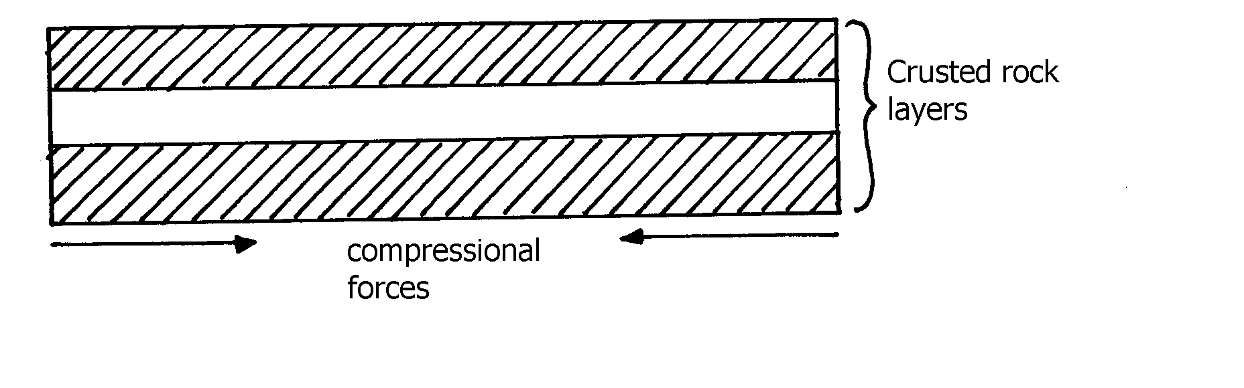

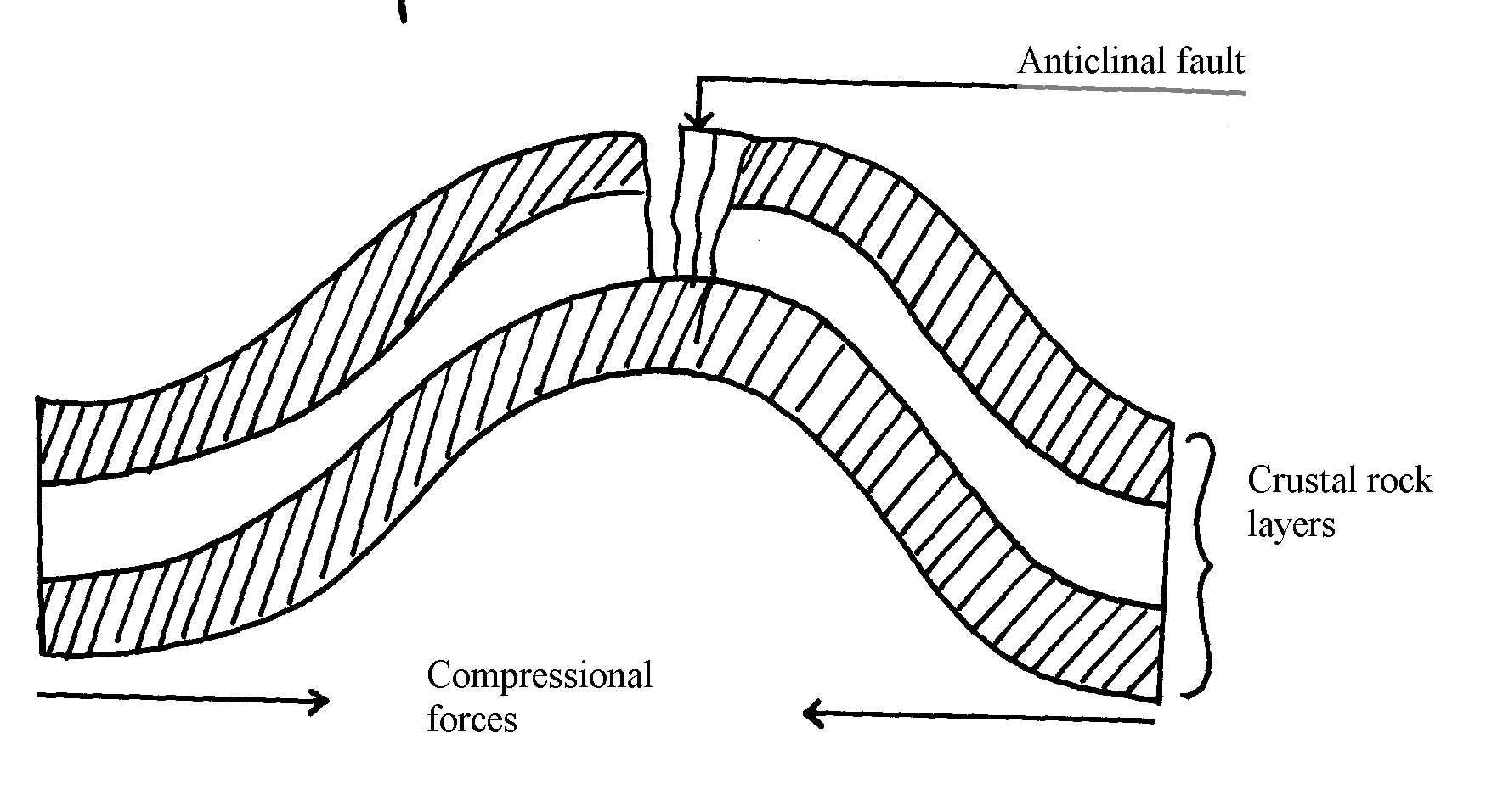

. c ii) - Crustal rock layers are subjected to compressional forces
- Intense folding results into formation of an overfold
- With increased pressure the over fold is compressed further to form a recumbent fold
- When pressure if very great, a fracture occurs along the axis producing a thrust plane
to form an overthrust fold
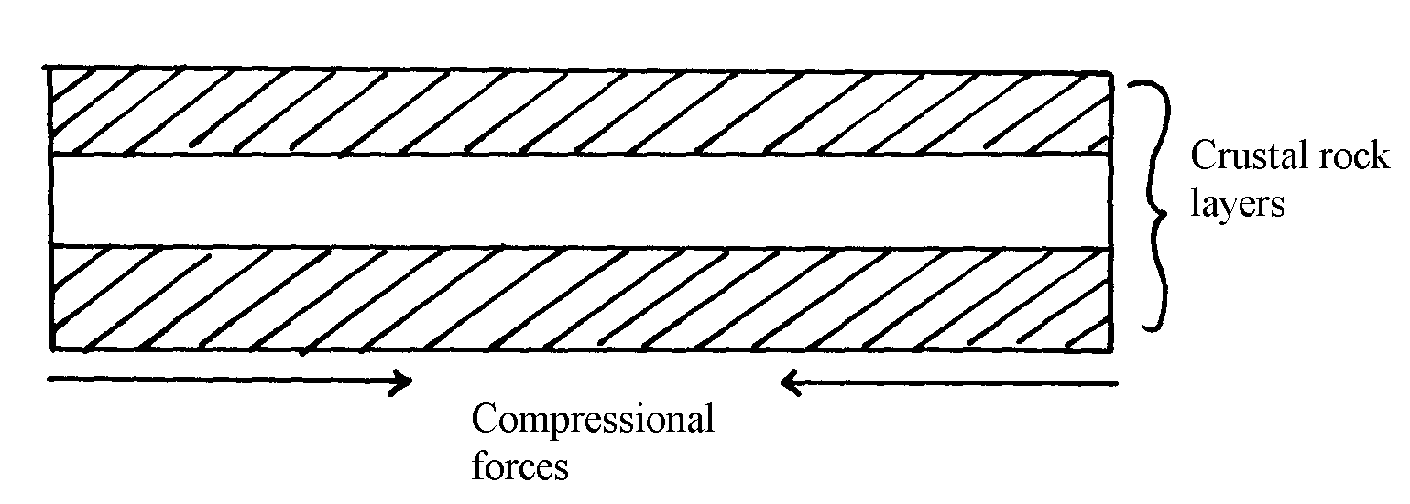

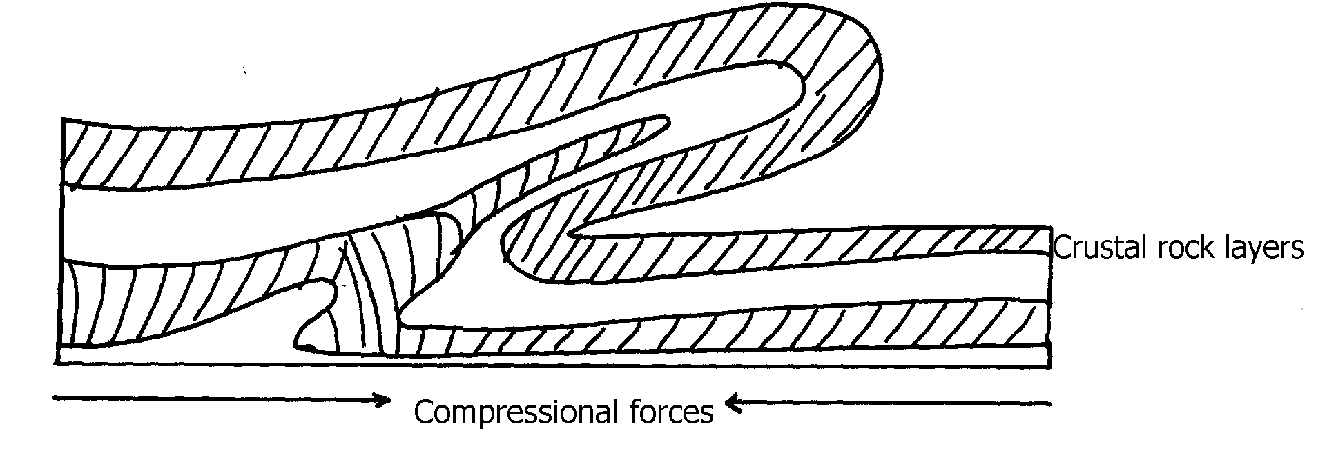

d i) - Volcanic mountains experience low rainfall on their leeward slopes making them
unsuitable for agriculture/settlement/forestry
- Volcanic mountains have steep slopes which hinder transport and communication
- Some volcanic features like moffetes, solfataras steam jets produce poisonous which
pollute the environment/are harmful to people
- Some volcanic rock weather to form infertile solid unsuitable for agriculture/forestry
d ii) - Outpouring of Lava forms a volcanic cone
- When the pressure beneath stops, a hollow, void is left beneath
- The weight of the overlying cone leads to collapse of the top of the cone into the how-
/void beneath
- This leaves a wide depression at the top of the volcano called a caldera

10. a) - It is a theory that states that the crust is divided into blocks of land (plates) that
float and move towards, away or parallel
b) - Compressional boundary
- Extension boundary
- Transform fault boundary
c) - Geological evidence – Rock similarities in structure, age and type of rocks found in
various continents e.g. in Eastern coast of S. America and Western coast of Africa
- Jig- saw- fit – of continental coastlines. Some coastlines can fit each other when pulled together e.g. Western coast of Africa can fit with Eastern coast of South America
- Ancient glaciations – All the four Southern continents reveal signs of a period of large scale glaciations at one time. It is evidenced by presence of glacial deposits – Tillites produced by ice sheets in Southern continents
- Archeological evidence – Some plant and animal remains found in various continents show a striking similarity

11. a i) - Atlas
- Cape ranges
- Akwapim
ii) - Atlas
- Cape ranges
- Akwapim
iii)- Symmetrical folds have limbs dipping uniformly about the axis while asymmetrical
fold one limb is steeper than the other about the axis
. b i)

b i) - Extensive shallow depression called geosynclinal develop
- Sediments from high areas are deposited in the geosyncline
- Compression on either side push towards geosyncline
- Sediments compress to form fold mountains which rise above sea level to form fold
mountains
b ii) - Over fold
- Recumbent folds
- Nappe or overthrust fold
- Anticlinical/ synclinal fold
- Isoclinal

12. a) - Causes seasons
- Varying lengths of day and night time
- Changes in the position of the mid-day sun at different times of the year
- Causes eclipses
b) - Movement of magma within the crust
- Gravitational force towards the center of the earth
- Convectional currents in the mantle
- Isostatic adjustment of sial and sima layer

13. a) - Frequent earthquakes
- Presence of faults
- Presence of fold mountains
b) - Tectonic movements
- Volcanicity
- Gravitative pressure
- Isostatic adjustment
- Energy release in the mantle
14. a) - Nature and age of the rocks
- Intensity of compression forces
. b) - May cause a river to disappear
- Changes the rivers direction of flow
- Forms depressions hat are filled with water forming lakes
- Faulting across a river forms waterfalls

15. a) - The jig-saw fit√
- Glaciatean/ancient glaciation√
- The coal deposits√
- Sea floor spreading√
b i) - Australia√
- South Africa√
ii) this was the water body that occupied the region surrounding the pangae

16. a) - High demand for hard wood has led to over exploitation
- They take long to mature hence can not match the exploitation rate
- Population pressure has led to cutting trees to give room for settlement and agriculture
b) - Accidental fires which destroy the forests
- The Northern part is inaccessible (during winter) for exploitation of the forests
- Over exploitation in some areas
- Trees take long to mature due to cold climate
- Rugged landscape especially mountainous landscape makes exploitation difficult

17. (a) i) A-axis B-syncline C-limb of a fold
ii) - The rockets
- Andes
- Himalayas
- Alps
- Appalachians
iii) - fold mountain
- cuesta
- escarpment
- plateus
- basins

b) - Geosynclines are formed on the earths surface
- prolonged and extensive erosion occurs on the surrounding higher grounds
- sediments are deposited in the geosyncline forming thick layers

- the weight of the sediments causes subsistence of the geosyncline leading to
accumulation of more sediments
- further subsidence of the geosyncline triggers off compressional forces which draw the
higher grounds closet forming fold mountains

c) - Fold Mountains are water catchments area. They brap rainfall which rivers which that
provide water for domestics use
- fold mountains are often forested and provide valuable timber used in construction
and building industry(due to high rainfall)
- some fold mountains have valuable mineral deposits such as coal and petroleum for mining
- fold mountains influence transport system enter as barriers or as passed

10. PHOTOGRAPH WORK

1. a) i) - Ground close up
ii) - Photograph (A) – Harvesting of sugarcanes
- Photograph B - Transportation of sugarcane
. b) - Kakamega district
- Busia district
- Bungoma district
- Mumias district
. c) - it requires high rainfall of about 1270mm and rainfall should reduce towards harvesting
Twice to allow for concentration of sugar
- It requires hot climate with temperatures ranging from 20ºC to 27ºC throughout the year
-- It requires a dry sunny period for ripening and harvesting
- It requires well drained soils, with nutrients
- It is grown on fairly level gentle sloping land. This allows for the use machines during ploughing, planting and harvesting
d) - Small farm sizes
- Pests and diseases e.g. ratoon stunting lowering the yields
Corruption in factory management over production
- Delayed payment kills the morale of the farmers
- Low earnings form sugarcane production
2. (a) i)- Well developed udder
-Have wide hind quarters, big stomach and small chests
-Have big milk veins
-Short legs well set to support their heavy bodies
ii) - The highlands have high population that offers ready market for the product
- They have well established infrastructure which is a major factor in dairy farming activity
- Reliable rainfall and constant supply of water
- The region has low temperature best for exotic breeds. Survival
- There is humid condition
- High quality cover of grass due to fertile soils in the region
- The high nutrient pasture characteristic

11. VEGETATION
1. a) - Pampas of Argentina
- Veldt of S. Africa
- Downs of Australia
- Steppe of Asia
- Prairies of N. America
b) State three characteristics of temperate grasslands.
b) - Almost airless except along water courses
- Grass is tall and nutritious in most areas
- Grass is shorter, tougher & less nutritious in drier areas
- Grass withers in autumn
- It sprouts in spring
ii) - Some trees are umbrella shaped to reduce evaporation below the stems
- Some plants have long roots to reach the water table below
- Some plants have thick/ fleshy/ succulent leaves to store water
- Some plants/ grass wither in absence of rainfall but have abiding to recover quickly when rain falls
- Some plant seeds remain dormant for long periods awaiting the start of rainfall
- Some plants have thin leaves/ spiky/ waxy needle like leaves to reduce water loss

2. a i) X-rainforest
Y-bamboo forest
Z-heath and moorland
ii) - it consist of a mixture of tree and grass
- in wetter areas the grass are tall and close to each other
- in drive areas the grass are shorter and tufted
- grass dominate the vegetation
- trees are shorter and more scattered
- trees are umbrella shaped
- acacia trees are a dominant species
- some trees i.e. bamboo have thick barks
- river valleys have trees and thick bushes
- during drought grass withers/trees shed their leaves

b i) Areas on leeward slope of mountains have different vegetation from those on wind
ward slope because they received different amount of rainfall√√
ii) Settlement, farming and mining interferes with original vegetation leading to growth of
secondary and dissertation√√
c i) south Africa√
ii) Argentina√
iii) New Zealand√
. d) The frequent outbreak of bush fires destroys the grass retarding its regeneration√√
the increasing human population is encroaching into the grasslands replacing them with settlement and cultivated land√√
pests such as army worms /locust destroy the grass and the vegetation degenerations into a semi- desert type√√
wild and domestic animals overgraze and cause stunted growth of grass√√

3. a i) -Natural vegetation is the plant cover that exists in an area without the interference
of external modifying influence especially people and their animals
ii) -Temperature
-Precipitation(rainfall)
-Sunlight
-Wind
b i) -The prairies (of N. America)
-The veid (of S Africa)
-The pampas (of Argentina)
-The downs (of Australia and New Zealand)
ii) -They are conical in shape
-They have needle-shape leaves
-In most coniferous forests a thick carpet of mosses occur
-Forest species are generally few and large tracts of forests can consist of only one or
two species of tree(occurs in pure stands)
-Most of the species are softwoods which mature faster
-Most species are evergreen but a few she their leaves eg fir,pine and larch.
- Trees have a widely spread shallow root system for utilizing moisture from the top soil
since most of the time subsoil is permafrosted
c) -some plants have thick leaves and banks for storing water.
-some plants produce seeds which lie dormant for along time and germinates when the
rain falls
-some plants sheds leaves during the onset of the dry season to reduce loss of water
through transpiration
-trees in the region have long rots to tap water from the water table below
-tress in the region are umbrella shaped to provide shade that reduces the rate of
evaporation around the stem
. d) - Frequent outbreak of bush fires destroy grass and retard its regeneration
-frequent drought destroy the grass and so the vegetation degeneration into a semi-
desert type.
-overgrazing of domestic and wild animals causes stunted growth of grasses
-human activities due to increased population which encroaches grasslands
-pests such as army worms and locusts destroy the grass, thus reducing the rate of
growth

4. a ) X - Veldt
Z - Stepper
b) - Some plants have a short life-cycle this enables them to survive during the short
period of wetness.
- Most are salt tolerant (Halophytes) to enable them survive in the saline soils of the
deserts.
- Most plants have succulent leaves that store water to enable them survive the long
drought period.
- Some plants have fibrous stems which they use as breathing surface.
- Most have deep roots to reach the deeper water table.
- Some have spines/thorns which protect them from browsing animals.
- Some are drought resistant & deciduous which enable them shed their leaves during
dry season.

5. a i) L is savanna (park savanna)
ii) - The vegetation is tropical rainforest/ equatorial forest
- The forest consist of mixed variety of tree species
- The trees shed their leaves at different times of the year/ ever green
- The trees are tall with large trunks
- The trees have broad; leaves/ drip tipped leaves
- The trees take long to mature
- The tree species are mainly hard woods
- The forest trees grow close together
- The forest has numerous lianas/ climbing plants/ epiphytes
- Some of the trees have buttress roots
- The forest has crowns that form three distinct canopies/ layers
b i) - Some plants have thick/ fleshy/ succulent leaves/ barks to enable them store water
- Some have long roots to tap the ground water
- Some have no leaves/ have thin/ spiky/ waxy/ needle- like leaves to reduce transpiration
- Some plants have shiny surfaces to reflect light
- Plant seeds remain dormant awaiting the short rains
- Some plants have thick/ hard barks to reduce transpiration
- Some plants wilt in the absence of moisture that have a quick recovery ability
- Some plants have thorns to protect themselves from browsing animals
- Most plants are stunted/ dwarf like due to the harsh conditions
- Some plants are quick sprouting to take advantage of the short lived desert rays
- Some plants have underground bulbs that remain dormant awaiting short the rains
c i) - The temperatures are too low to support vegetation
- The surface is mainly bare rock, so no soil has formed to support vegetation
- Water is always in a frozen state, i.e. snow, so it is not available to plants
ii) - Vegetation is of aesthetic value as it adds beauty to the landscape
- Vegetation binds soil together using its roots. Its aerial parts reduce the impact of raindrops on the soil. In this way, it protects the soil against erosion
- Plant remains decay to become humus. This improves the fertility of the soil
- Some plants are of medicinal value to people. Their leaves, barks or roots are extracted and prepared into medicines, both traditional and modern
- Some trees are used in the manufacture of paper while others are used for the manufacture of plywood, veneer or production of timber
- Some plants are eaten by people e.g. bamboo shoots

6. a i) - Natural vegetation
- Derived vegetation
- Cultivated vegetation
ii)- altitude√
- aspect√
- terrain and drainage
b i) A-health and moorland
B-bamboo forest√
C-rain forest√
D-savanna grassland
ii) -too cold for plants to survive covered by snow√
-rocky surface
c i) prairies
Pampas

ii) - Grazing the plenty tall and short grasses are used for grazing livestock and wild
animals
- Reduces soil erosion-savanna vegetation act as soil cover hence reduces soil
erosion
- Habitat for bees and wild animals-trees in savanna are habitat for bees which provide honey and home foe wild animals e.g. gazelles, giraffe
- Some shrubs and herbs growing in the savanna are used as medicine
- Fuel-trees provide wood fuel and fuel wood for the people in the tropics
- Gross increases humus in the soil making areas suitable for cereal farming e.g.
wheat and maize

d )- some plants have long roots to enable them tap water far deep the ground√√
- some pants have shallow root system which enables them to take moisture from the
soil layers
- some plants have sunken stomata and waxy leaves to reduce rate of
transportation√√
- some plants have succulent stems to allow them store water√√
- some plants are short lived i.e. Complete their cycle within the short wet period√√
- some plants e.g. tubers and corns remain dormant during dry spell until wet period
stimulate
7. a i) S- Steppes
T- Pampas
Y – Savanna
Z – Downs
ii ) - the vegetation consists of a continuous cover of grass, the grass is tufted
- The grass is interspersed/mixed with bulbous/leguminous plants/shrubs
- The grass is nutritious. Grass is tall in moist area
- The grass is short and tough in drier areas about 15-30cm in height
- The grass is green in spring/brownish yellowish and strow like in summer/Grass
withers in autumn and die in winter/rare grass sprouts in spring/Trees are only found
along rivers/ rive rine trees/ trees found in hollows where rain water collects.
- common grass varieties are gamma graze/buffalo grass
- In drier, areas, the short grasses form bunches separated by bare soil
- Tress found along river courses are temperate trees like popler, willo adler

8. a i) - It is a plant cover existing naturally in a place but has been interfered with by man
ii) - Altitude
- Aspect
- Soil
- Climate/ temperature/ rainfall
- Man’s activities

b) i) - Savanna vegetation
- Rainforest
- Bamboo forests
- Health and moorland
ii) - prairies
- steppes
- downs
- veld
iii) - some have thick/fleshy/succulent leaves /barks
- some have long tap roots
- some have no leaves /have thin/spiky/waxy/needle like leaves
- some plants have thick/hard barks
- some plants have thorns
- some plants are stunted/dwarf like
- shrubs are common
- some plants spout during wet seasons (short time)

9. a) - fire-often ,large areas of forests are destroyed by accidental and sometimes
intended fire. such forests takes long to recover
- diseases causes by pests and parasites attack mainly the planted forests causing many trees to die
- human activity /settlement /charcoal burning/logging have destroyed many forests areas of which are transformed in to farms and grasslands
- over-exploitation leads to depletion of certain tree species such as Meru oak, camphor and Elgon teak. these trees take long to mature
- government policy of degazetting of some forests made people free to clear many forested areas
- prolonged droughts lead to degeneration of forests some of which take long to recover
(b) Rain forest have closely set trees with these districts canopies.
  - This crowns and closeness of the trees form a dense shade for the lower layer which makes arvesting cumbersome.
  - Most trees are tall, and have huge trunks. This makes them cumbersome to be harvested and most of them are heavy to be transported.
High amount of rainfall.
  - This forest lies within the equatorial climatic region where high amount of rainfall is
received throughout the year.
  - This means that harvesting of trees can not take place throughout the year because of the very dump condition in the forest and general disturbance caused too much rains.
Tree species are not found in pure stands
  - Rainforest do not have pure stand and this become a problem if one need to harvest only one species meaning moving from one part of the forest to another as one harvest.
Majority of the species are hardwood.
- These species are hard to be cut and also heavy to be transported

12. FORESTRY
1. a) - High demand for hardwoods
- Population pressure which has led to increased deforestation in creation of room for farming and settlement
- Hardwoods take too long to mature and this doesn’t match the rate of felling
b) - Agro forestry programme
- Public awareness and education through mass media
- Creation of forest reserve
- Recycling of waste papers to make newsprint
- Enacting law governing forest conservation
- Forest research stations to conduct research on new tree species
- Establishment of government tea zones at the edge of forests to act as buffer zones
c i) - New found land
- Nova Scotia
- Prince Edward Island
- New Bruswick
ii) - The landscape is rugged hence does not favour agriculture
- High rainfall thoughout the year favours forest growth
- Coastal location favour establishment of ports for timber exportation
- Constant supply of H.E.P for industrial use due to many rivers with water falls
- Plenty/abundant water supply for processing purposes e.g. bleaching of pulp
- Ready market in Canada and U.S.A for forest products
- Cheap means of transport or rivers like Ottawa, Fraser e.t.c
- Low temperatures in the highlands discourage settlement hence forestry is the main use of land
d) - In Canada they grow naturally while in Kenya they are planted
- In Canada they cover extensive areas while in Kenya they cover small areas
- In Canada they exist in a wide variety while in Kenya the species are limited
- In Canada they are indigenous while in Kenya they are mainly exotic

2. (a) i) - This is a collective term used to cover a variety of land uses that combine tree
growing, pasture and crop production practices on the same piece of land for
the purpose of increasing or improving the output of the soil.
ii) - Remedy to deforestation.
  - Source of income.
  - Environmental benefits.
  - Aesthetic saving.
  - Labour saving especially for women who spend more time fetching firewoods.

3. a i) - Pure forest is composed of trees of two or more species
ii)
Natural forest | Planted forests
- consists of hardwood  - mixed the species  - random occurrence with different canopies  - take long time to mature | - mainly softwoods  - - pure woods  - Planed in rows and of same height  - Take 15-30years mature
.
b) - High rainfall in Kenya highlands favours tree growth
- Kenya Highlands experiences cool temperatures ideal for coniferous forests
- High market for wood products and timber encourages forestry
- Forestry areas are rugged and steep, discouraging settlement and agriculture
c i) - Tree planting /re-a forestation
- People are required to seek permits if they have to cut trees
- Forests reserves have been ser aside to conserve indigenous forests
- Forestry department carry out research to produce and distribute seedling
- People are educated through mass media importance of the conservation
- People are being encouraged to use of alternative source of energy/saving jikos

ii) - Presence of cool to cold climate enhances growth
- High rainfall promotes growth of trees
- Step and rugged landscape discourages agriculture
- High local and international market for forest products
- Low population density in Canada provides more land for forestry

4. a) Agro-forestry involves cultivation of both crops and trees on the same piece of land
. b) - Provides source of firewood and charcoal
- Source of income to farmers after selling tree products like fruits
- Trees act as windbreakers
- Trees create micro-climate within the farm
- Some trees are of medicinal value
- Trees leaves decomposes to form fertile soils
c i) - Tree growth is limited to altitudes below 3500 because beyond this level
- the temperatures are too low for tree growth
- Lower level of tropical mountains have rainforests, which give way to
- coniferous forests and then to bamboo thickets, with increase in altitude
- In highland areas where the slope is too steep trees do not grow because the so
is thin due to heavy erosion
c ii) - Windward slopes of mountains are generally wetter than the leeward slopes thus
more fores
- The forest zone starts at a much lower altitude on the windward than on the
- leeward slopes
- In the northern Hemisphere, southwards facing slopes are warmer with
- luxuriant forests, while North facing slopes are in the sun’s shadow, cooler and
with less vegetation
. d) - People are being encouraged to plant trees and food crops in the same farms
- Regions which previously were devoid of trees are being planted with trees
- Tree farming is practiced in many parts with the aim of raising trees for future use
- Mature trees felled are replaced immediately
- The reduction of wastage e.g. the use of waste paper to produce newsprint
- People are required to seek permits if they have to cut trees. This reduces the rate of tree felling
- The forest reserves are patrolled by guards to ensure that fires are reported promptly and also ensure unlicensed people do not cut down trees
- Forest reserves have been set aside to conserve indigenous species
- Forestry department carries out research to produce and distribute seedlings to ensure the extension of forts
- People are encouraged to use alternative sources of energy or energy saving jikos
- People are educated through mass media on the importance of trees
e) - Desertification
- Soil erosion/ degradation
- Extinction of some tree species
- Loss of plants with medicinal value
- Loss of aesthetic value
- Decrease in wild animals
- Decline in employment for those in forestry related areas

5. a i) Indigenous forest are those trees which have been traditionally growing in the
country while exotic forest consists of tress that have been imported into the country.
ii) - Natural forest grows in the wild while planted forests are tended by man.
- Planted forests are usually softwood while national forest are mainly hardwood.
- Natural forest takes a longer time to nature as compared to planted forest.
- In natural forest, trees are scattered while planted forest are found in rows/lines.
- Natural forest here mixed species of tree while planted forest have pure strand in a given area.
b) - Temperature (10⁰c – 35⁰c)
- Tropical Ban forest domestic high temperature areas (21⁰ – 35⁰c)
- Human activities
- Altitude
- Rainfall.
- Soils
c) - Afforestion /Reafforestion
- Legislation
- Research.
- Education
- Alternative sources of energy use.
6. a i) Is the science of cultivation development and managing forests
ii)- availability of deep fertile volcanic soils in the highlands has led to the growth
of thick Forests
- the high reliable rainfall throughout the year in the highland has promoted the growth
of thick forests
- their location in the low latitude region which experience high temperature has led to
faster growth and early maturity for most of the trees
- government’s efforts to protect destruction of the natural forests and protect them
from human settlement
b) - there is a wide variety of tree species in a given are. This makes exploitation of
valuable species difficult
- the valuable trees are scattered not in pure stands. this makes exploitation difficult
and expensive.
- The buttress roots make the falling cumbersome
- The dense undergrowth/thick forest any quick generation of plants hinder accessibility
- Humid climate makes working condition unfavourable
- The forests form a habitat for dangerous could animals which make the exploitation
insecure
- The hot humid conditions climate encourage pests and disease which are harmful to
man and trees
- The heavy rainfall thought the year results in muddy roads-which makes exploitation
difficult
- Inadequate capital limits the use of modern techniques in the exploitation of forests
- River transport is hindered by waterfalls and rapids. this make transportation expensive
c i) - carrying out public campaigns on the value of trees forests through mass media
e.g. Radio
- carrying out research on suitability of soils and the effects of pests diseases on
forests
- Established of training institution dealing with forestry e.g. lodiani
- reduction of wastage in the forestry industry by recycling waste to produce other
products
- employment of forests guard and officers to guard against destruction of forests
- creation of forest measure with the aim of protecting indigenous tree
c ii) - frequent outbid of bush forest destroying forests
- increasing human population encroaching in to the forests
- pests and diseases destroying some species of trees
- frequent drought experience in the country destroying the vegetation
- wild animals and domestic animals destroying vegetation causing stunted growth

7. a i) Forest is a continuous growth of trees and under growths covering a large tract of
land while forestry is the science of developing and managing forests including
cultivating them
ii a) - Mainly temperature and precipitation
- Proper growth of tree can only take place where there is heavy precipitation
throughout the year.
- Different plants require different amount of warmth e.g. in tropical regions where
rainfall is very high, big trees are common very low temperature discourage tree
growth.
b) - Human beings have destroyed any natural forests to create room for subsistence
agriculture and settlement. Deforestation has been rampant while collecting wood
fuel.
At the same time human being are conserving and maintaining trees in other area
c) - Forests do not grow on steep mountains where the surface is bare rock, the soils are
thin and temperatures are low
- The windward slopes of high mountains like Kilimanjaro usually receive higher rainfall
and are therefore forested. the lee ward slopes are covered with scrub vegetation

8. (a) - Research is being carried out on soil requirements for different species of trees
which enables foresters to plant trees in suitable areas
- Public campaigns on the importance of forests are always being conducted through mass media
- Alternative sources of energy are increasingly being encouraged to minimize over-dependence or wood fuel e.g. sun, wind, biomass, water, oil, kerosene, and natural gas
- Introduction and promotion of energy saving stores to reduce the amount of wood fuel being used
- Timber merchants and those involved in logging are being enlightened on how to improve their cutting practices through rational and selective felling and replanting to replace the ones cut.
- Improving the infrastructure within he forested area by improving roads and providing roads and providing machinery, saw mills, tractors and seed beds
- Control of pests and diseases which attacks trees
- Establish of training and research institutions which specifically deal with forestry e.g. londiani forestry training college
- Government has enacted laws that enable effective management of forests e.g. forest bill 2000
- Creation of forest reserves to protect the indigenous trees and other plant species from extinction
- Posts for forest guards have been set up within the forest to protect against illegal tree felling
. c)
i)species  Kenya  There are both exotic and indigenous softwoods  ii)problems  large tracts of forests especially exotic trees are affected by pests and diseases e.g. Aphids  iii)marketing  most of the wood products are sold locally but some are exported to Arabian countries, USA and Europe | Canada  The main species are of coniferous type (2mks)  Large tracts of forests are destroyed by fires and diseases(2mks)  Most of the wood products have ready markets in Canada, USA, Britain and Europe

di) - Pines
- Cypress
- Eucalyptus
ii) - Note taking
- Field sketching
- Photographing /filming
9. a) It is the growing of trees together with crops on the same piece of land at the same
time √
b)- Meru oak√
- Elgon teak√
- Mvule√
- Elgon olive√
- Camphor√
- Mangrove√
. c) - African pencil √
- Cedar √
- Podo √

13. EXTERNAL LAND FORMING PROCESSES
1. a) - River Nzoia√
- River Nyando√
b)- Heavy rainfall from the highlands √
- When a river contains excess water that it cannot hold in its channel √
- Cultivation along river banks √
- Deforestation in the surrounding areas √
2. (a) i) - barchans
- transverse/wake dunes
ii) - they lie parallel to each other
- they rise up to 100m/high and their length can exceed 100km/long
- they lie parallel to the direction of the prevailing wind
- they have a sharp knife like crest
iii) - availability of sand
- strong winds blowing in one direction for a long time
- presence of obstacles e.g. rocks or vegetation
- occasional rainfall hardening the ground causing deposition
- presence of ground water reaching the surface
- human activities like mining, heaping materials on the surface that acts as anchors for sand deposits
b) - there is existence of a rock out crop of alternative layers of hard and soft
rock/heterogeneous
- the rock lies on the path of a wind carrying weathered materials
- through abrasion, the softer parts of the rock are eroded faster than the hard parts
- wind is more effective near the ground surface
- the irregular shaped feature is a rock pedestal
c) - desert features like zeugen dunes etc attract tourists
- deflection hollow as/oasis contains water used for irrigation and other domestic uses
- loess is deposited in water areas is fertile and used for farming
- dwelling are curved out of loess which provide warm and cool home stead during winter and summer respectively
- desert land forms are ideal for military training testing of weapons and space craft experiments
- the seasonal streams can be dammed to supply water for domestic use
- desert features provide suitable scenery for film making

3. a i) - Kenya experience high temperature under which ice-sheets cannot form
- Most parts of Kenya have low attitudes
- Kenya is found at low latitudes
ii) - gradient of the land-ice moves faster when the slope is steep
- temperatures-higher temperatures result in to thawing leading to faster movement of ice
- nature of the slope-when the surface on which ice is moving is rough, it causes friction lowering the speed of the movement of ice
- size/thickness of glacier-large masses of ice exerts pressure which leads to melting of ice underneath. this increases the speed of ice movement.

3. b i) - two adjacent hallows on a mountain side
- the two hallows are filled with ice
- the ice erode the side through plucking and deepens the hollow through abrasion
- through erosion, the back walls of the hollows slowly recede
- eventually the hollows(cirques)are separated by a knife-edge ridge
- the ridge is called an arête
b ii) - a large block of rock stands on the path of on-coming glacier
- the ice plucks off /erode rock fragments from the upper side of the block
- as the ice moves round and over the resistance rock, it carries the eroded materials to the lee-ward side
- the lee side does not experience erosion
- deposits materials on the lee-ward and together with weak rocks forms
- flat corridors separate them from each other
- they occur I groups
- the width of the corridors vary from 25m to 50m
- where the wind blows from the same direction for long, dunes become gentle on the wind ward and steep on the lee ward
c) - glacial till provides fertile soils for arable farming
- ice sheets in their scouring effect reduces the land surface and depth to expose mineral seams which become easy to extract
- out wash plains comprise of sand and gravel which are used as materials for building and construction
- lakes formed through glaciations can be exploited for various uses such as fishing, transportation or as tourist
- glaciated feature are tourist attractions
- glaciated lowlands are generally flat due to erosion and deposition and these are ideal

4. a)- 21st March - 23rd September
ii)- because the earth is titled on its axis
- because of the movement of the sun within the tropics
- because of the revolution of the earth
b) - it causes the occurrence of day and night
- it causes the deflection of winds and ocean currents
- it causes the rising and falling of ocean tides
- it causes the variation in time at different longitudes
- it causes differences in the atmospheric pressure on the earth’s surfaces
5. a)- An accumulation of water in a wide hallow or depression
b) - by erosion
- by earths movements
- by vulcanicity/volcanic activity
- by deposition
- by human activity
- falling meteorites
- mass movements e.g. land slides
- weathering by solution

6. a i) - Desertification is the process through which marginal lands are degraded through
climatic variations and human activities/ or encroachment of arid conditions into
formerly productive areas
ii)- Wind deflation is the removal of loose unconsolidated materials by a lifting and
rolling action of wind
- Wind abrasion is the process whereby wind picks loose materials and uses it to scratch
and grind the earth surface

I. Wind transportation through saltation: larger fragments of rock are lifted from the
ground in a series of hops and jumps within the wind currents
II. The fine dust are lifted clear off the ground and eventually are blown away by wind
currents
III. Heavy materials are dragged along the ground by wind currents
b i) - Zeugens are formed in desert areas where alternating layers of hard and soft rocks occur
- The top layer of hard rock is jointed
- Weathering opens up the joints
- Wind abrasion erodes the joints widening and deepening them to reach the soft layer
of rocks
- Deflation blows away the loose broken materials
- Furrows are formed and gradually widened as abrasion continues on the soft rock
- The hard rock forms the ridges separately the furrows
ii) - A pre- existing depression is formed through faulting
- Wind eddies remove unconsolidated materials through deflation
- As deflation continues, the depression is deepened and enlarged resulting into a wider depression
- The process of deflation is aided by weathering and abrasion
- With continued deflation, the level of water table is reached
- Water comes out of the ground and collects into the depression to form an oasis
7. a) - Plastic flowage
- Basal slip
- Extrusion flow
b)
Young river valley | Glaciated valley
Has interlocking spur | Has inundated spur
Has gently sloping cliff | Has steep rock cliffs
Has a V- shaped | Has a U shaped
Follows a winding course | Flat on the floor

8. a) X – Swash Y – Back wash
b) ) - Hydraulic action
- Corrosion
- Solution
- Attrition

9. - Rainwater
- Melt water
- Lake and sea water
- Magmatic water

10. a i) - Chemical weathering- is the breakdown or disintegration of rocks as a result of
chemical reaction or changes that cause decay of rocks
ii) - Chemical composition of rocks
- Presence of moisture/ water
- Presence of gases
- Temperature changes
- Rock permeability
- Vegetative matter
b i) - Water in air combines with carbon to form a weak carbonic acid
- Carbonic acid reacts with calcium carbonate to form soluble calcium bicarbonate
- Solution is washed away causing weathering to take place
ii) - Water enters the rocks
- Water breaks down into ions which combine with minerals
- Rocks break down to form completely new compounds e.g. fluorspar with clay
c) - Produces clay that is vital in brick making
- Weakens rocks making them easier to exploit i.e. mining
- Important in soil formation
- Weathered rocks provide scenery for tourist attraction
- May break down large rocks hence leveling the landscape for settlement

11. a) - Spring tides
- Neap tides
- Perigan tides
- Apogean tides
b) - Change direction of flow
- May force currents to flow along the coastline of the land mass
- May split currents into two parts and flow in different directions
c) - Rainfall that infiltrate into the ground
- Melt water from the thawing ice
- Manmatic water that are trapped in the rock
- Lakes and seas/ oceans that sink into the ground
d) - When permeable rock overlie on top of an aquifer
- When well jointed rocks form a hilly country absorb water via joints which later spring out when water table meet surface
- When dyke cuts across a layer of permeable rock
- When a limestone or chalk locupement is under long impermeable layers
- When urgently sloping layer of permeable rock alteranateS with layers of impermeable rock
e) - Some plants have long roots to reach water table
- Some have small leaves to reduce transpiration
- Some have thick stem/ barks to store water
- Some are leaflets to minimize water loss
- Some have leathery leaves to reduce water loss

12. a ) Hamada is rocky desert while an erg is sandry desert
b) - Deflation – wind remove dry and unconsolidated materials like dust and sand by
lifting
- Abrasion – wind use materials like sand as erosive tool, where particles are hurled n rock surface causing undercutting
- Attrition – materials carried by wind rub against each other and against rocks producing
rounded land grains
c i) A Barchan

- An obstacle on path of wind e.g. rock/ bush block wind causing deposition
- Materials continue to built until windward side is smooth and leeward side steep forming
a moon shaped feature called barchan

c ii)

c iii)

- Pre- existing depression/ localized fault attacked by wind eddies
- Depression is excavated by removal of unconsolidated materials/ wind erosion by
deflation
- When water bearing rock is reached/ aquifer water oozes out to collect in depression
and an oasis is formed
d) - Alluvial fan
- Bajada
- Salinas

13. a ii) - Presence of loose unconsolidated gravel/ stones/ soil particles that can easily
picked by wind
- Presence of little or no vegetation on the surface of desert
- Presence of strong prevailing winds in deserts
b) - Deflation – it is the blowing away of any dry unconsolidated materials like dust and
fine particles by rolling them on the ground and lifting them up in the air
- Abrasion – materials carried by wind such as sand scratch and grind rocks and
ground surface
- Attrition – particles carried by wind hit against each other and rocks and reduce in size
in the process
c i) - Rock outcrops with alternate layers of hard and soft layers project above the surface
- The softer rocks are eroded by abrasion faster than the hard rock. They are worn out more rapidly than resistant ones. This results in an irregular rock with protruding layers that alternate with hollows called pedestal

c ii) - Formed where hard and soft rocks lie horizontally
- Weathering attacks the soft layer leading to the formation of cracks
- Wind abrasion deepens the cracks deepening them forming furrows
- These furrows separate the ridges forming Zengens

d) - Desert land forms e.g. Zeugeus, dunes yardang attract tourists who bring foreign
exchange
-Oases provide water for domestic use/ irrigation/ livestock
- Oases attract settlements
- Loess provide fertile land for agriculture use
- Rocky and sand surfaces can hinder communication and transportation

14. a) - An ocean is a large/ extensive body of salive/ salty water occupying large basins
between continents while a sea is a large body of salice/ salty water boarding a continent
. b - Volcanic materials from the ocean flour add salts to the water
- Some salt is dissolved by sea water from the underlying rocks it is in contact with
- Some salt is added by rivers that have dissolved it from the land
- Most of the salt is thought to have been present when water bodies were formed
c) - Ocean deeps
- Continental shelf/ continental slope
- Ocean ridges
- Deep sea plains
- Islands

15. a i) A sea is a mass of saline water occupying depressions at the margins of
continents whereas an ocean is a mass of saline water occupying depressions in
between continents
ii) - As the coastline retreats due to marine erosion resistant rocks are isolated as islands.
- Deposition of materials across bays, river mouths and lagoons build up barriers which
project above the water level as islands.
- Volcanic eruptions within the sea/ocean builds up islands when materials pile up above
the water level.
- Accumulation of coral into reefs form coral islands
- When upland coasts sub-merge valleys are drowned leaving ridges /hills above the
water level as islands.
b i) - Earth movements led to crustal downwarping.
- A shallow depression was created
- The areas around the depression underwent uplifting
- The uplifting reversed the direction of rivers such as river Kagera
- Water from the rivers and from rain eventually filled the depression forming a lake
ii)- Evaporation from the lake leads to high relative humidity in the area
- Evaporation from the lake increases moisture in the atmosphere leading to
increased/high rainfall in the area
- Evaporation from the lake leads to convectional rainfall
- The lake encourages formation of lake breezes which have a cooling effect on the
areas at the lake shores
- Regular land and lake breezes modify the temperatures of surrounding areas keeping
the diurnal range low
- The breezes cause reversal of local winds/diversion of prevailing winds such as the
Congo air moss

c i) Aridity is the state of land being deficient of moisture leading to scarcity/lack of
vegetation. while desertification is the slow but steady encroachment of desert-like
conditions onto formally productive agricultural land
ii) - Continentality/distance from the sea;- Onshore winds drop most of their moisture along
the coast reaching the interior as dry wind leading to aridity and desertification
- Relief barriers/Rain shadow effect; - Rain bearing winds drop a lot of moisture on the windward side of mountains. They thus reach the leeward side of with less moisture as dry winds causing aridity and desertification
- Cold ocean currents; where on shore winds cross over cold ocean currents, the moisture content of the winds is lowered by the chilling effect f cold currents, the winds thus drop moisture over the sea reaching the land as dry winds that cause aridity and desertification.
- High pressure systems;- Areas with stable, high pressure systems with low humidity and descending air/diverging winds experience aridity since moist air has to rise for condensation to take place.
- Dry wind system;- Hot and dry winds from land like the harmattan constantly blowing over some regions cause a drying effect the land resulting in development of arid conditions
- High temperature:- Areas constantly experiencing high temperature have high rates of evaporation leading to arid conditions
- Insufficient rainfall:- Areas that constantly receive rainfall less than 250mm annually have scanty vegetation, immature soils making the land barren

16. a i ) Chemical weathering is the breakdown/deeny/decomposition insitu of rocks after
reaction with other minerals, water or air
ii) - Grikes and clints
- swallow –holes
- Dry valleys
- Dolines
- urala
- Polje
- Gorges
(b) i) Exfoliation dome
ii) - In hot climate, where rocks high day temperatures cause the surface of the rocks to
expand
- Low night temperatures cause the surface of the rocks to contract
- The inner parts remain cool as the expansion and contraction only takes place on the rock surface because rocks are poor conductors of heat.
- As the process is repeated over a long time a curved sheet of the tock/rock shall from the upper part break away from the upper part break away peeling off like onion peels.
- *This leaves a round rock mass called an exfoliation dome

17. a) A river system refers to a river and all its tributaries while a river regime is the
seasonal fluctuation/variation in the volume of water in a river
b i) Trellis/ Trellised/ Rectilinear pattern
b ii) P – Obsequent river Q- Secondary consequent river

18. a) - Erratics’
- Boulder train
- Till
- Drumlins
- Eskers
- Karme
. b) - Glacier in a low land area comes across a resistant rock
- As the glacier passes over the resultant rock it erodes its upstream side by abrasion
smoothening it
- The downstream side is eroded by abrasion giving it a rugged nature
- When the ice retreats a rock outcrop with a gentle smooth upstream side and a rugged
steep downstream side is exposed called a roche moutonee

19. a) i) U – Zone of permanent saturation /phreatic zone
V- Zone of intermittent /seasonal saturation
ii) W - Spring /river source
Underground water
- An impermeable rock layer sand witching an aquifer leads to accumulation of
underground water

20. a i) -Deflation
-Abrasion
ii) – Suspension -fine particles are lifted, cleared off the ground
saltation -larger fragments of sand particles are lifted from the ground by eddy action
-The sand particles are moved in a series of hops/jumps within the wind current
surface creep√/traction
-The heavy materials /small stones/pebbles are tracked along the ground.
-these materials are rolled for short distance in a process called surface creep
b i) -zeugen are formed in desert areas where alternation horizontal layers of hard
and soft rock occur, -the top layer of hard rock is jointed/has cracks√
-wind abrasion opens up the joints deepening and widening them to reach the soft layer
of rocks√
-deflation blows away the loose broken materials√
-furrows formed and gradually widen as abrasion continuous in to the soft rocks√
-the hard rock form ridges separating furrows√
-this process creates a ridge and furrows landscape called Zeugen
ii) -an outcrop rock eg eroded by wind from all sides
-the rock has alternating horizontal hard and soft rocks
-hard layers s eroded at a lower rate while soft layer is eroded faster
-continual erosion through abrasion make hard layer left outstanding
-near the ground more erosion narrow the base
-the protruding layer are the bands f resistance rock while the hallows are the areas
where the soft layer were positioned

c i) Hamada
. c ii) loss region have very fertile alluvial soils which are used for agriculture√√
-desert features such as rock pedestals yardages and sand dunes are tourist attraction√√
-salty fats are economically used for salt production especially in north Africa√√
-extensive and bare desert are used as testing grounds for car and jets engines√√
-desert landscape provides good site for testing military weapons e.g. nuclear bombs

21. a) a lake is a large mass of water in a depressions
b i) -crater lakes
-lava dammed lakes
b ii) -lake Victoria modify the climate of the lake region due to convention rainfall
- Lake Victoria brings cooling effect on the surrounding area due to Lake Breeze
-convectional rainfall experienced around the lake is occasionally accompanied by
thunderstorms
-land breeze and sea breeze are due to low and high pressure system√
c i) -some lakes lacks outlets
-rock over which lake water is in contact may contain mineral salts
-some water river to pour into them
-surface run-off and rivers may dissolve a lot of salt from rocks on while they flow
-excessive exploration in areas where temperature are high
c ii) - Naivasha
- Baringo
- Turkana
. d) -some lakes provide water for both domestics and industrial uses√√
-some lakes forms tourist attraction site and thus earning the country foreign
exchange√√
-some lakes provide building materials eg sand√√
-some lakes provide water for irrigation hence enhancing agriculture√√
-some lakes provide transport routes√√
-some lakes are sources of minerals eg magadi
-some lakes provide water for the generation of H.E.P√√
-some lakes are sources of fish (food) which is a source of protein for man

22. a) - spring tides
-neap tides
- Perigian tides
- Apogean tides
b) Ocean is a large extensive body of saline water occupying a basin between
continents whereas, sea is a large body of saline water on margins of continents

23. a i) -acidity is the state of land being deficient in moisture leading to scanty vegetation
which desertification is the slow but steady encroachment of desert like conditions
into formerly productive land
ii) -abrasion-winds uses the transported materials as tools to grid/scrap the rock
surfaces
-deflation-wind blows away unconsolidated materials by rolling and lifting them up
the air.
-attrition-the materials carries by the wind rub against each other, breaking and
becoming Smaller
b i) -a rock pillar of with differing degree of hardness lies in the path of moving wind
-the rock is acted by abrasion and weathering.
-the soft layer is worm out more rapidly than the resistant ones
-an irregular mass of rock with protruding layers is formed
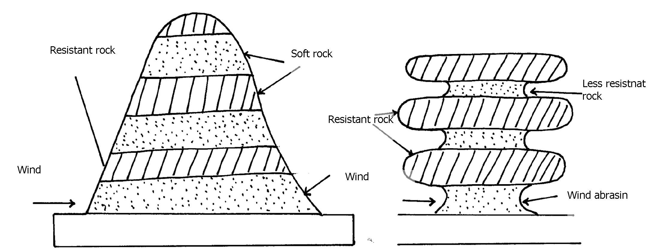
-the base of the rock pillar is thinner because wind abrasim is more intense at lower level.

ii) -Massive rocks consisting of alternating layers of hard and soft rocks lie vertically to each
other.
-these layers lie parallel to the direction of prevailing winds
-wind abrasim acts directly on the soft rocks
-wind deflations removes the worn-out parties
-large furrows between the hard layers and formed
- The hard layers are left standing as small ridges known as yardages

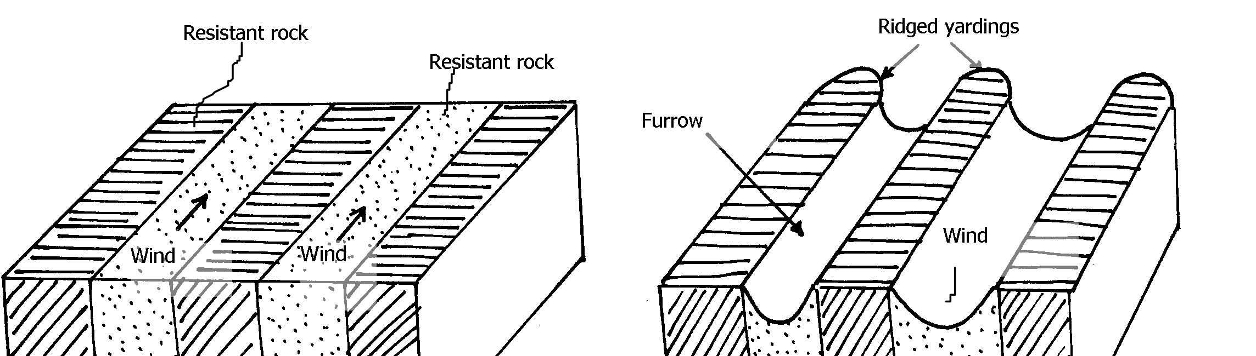

. c) -features like dunes, yardages are tourist attractions
-extensive and bare desert surfaces are used as testing grounds for military weapons
-salty flats are used for salt production
-the loess soils are fertile alumna deposits used for agriculture
-the loess begins of china have caved dwellings in the rocks which warmer during winter

24. a) -a difference in the resistance of the rock into which the river cuts
-a river may descend over a sharp edge of a plateau
-a river may descent over s fault scarp
-a river descends a cliff into the sea.
-a river descends a lava barrier
-a river descends a hanging valley into a flaccid trough
b i) -at the mature /old stage of a river, The river channel is wider and shallow
-the river flows sluggishly at low velocity due to due gradient.
-heavy load is deposited on the river bed
-the alluvial deposit grow into island/shoals-the river is blocked and sub-divided into
small channels called distributaries
-the water joins again later.
-the several channels intertwining each other forms river braids
-the small islands in between them are called aits /eyots /isles
ii) -knick points
-river terraces
-incised meanders
-abandoned meanders/meanders score
-rejuvenation gorges
. c) -two rivers adjacent to each other share a common divide
-one river is more powerful than the other due to high volume of water from a pirate river.
-the pirate river erodes vertically and laterally faster than the weaker river.
-the valley of the pirate river becomes deeper and wider so as the river flows at a lower level than the weaker river.
-the stronger river extends its valley backwards by head ward erosion
-eventually the pirate river joins the valley of the weaker river.
-the head wards of the weaker river are diverted into the stronger river hence a river
capture occurs
d) -has underground drainage
-rivers from its surrounding have fresh water which dilutes the salts

25. - Due to pressure changes/dynamic metamorphism.
- Due to intense heat/thermal metamorphism.
- Due to a combination of heat and pressure/thermal-dynamic metamorphism

26. a i) - Deflation.
- Abrasion.
- Attrition
ii) - Suspension. The fine dust and particles are lifted off the ground. Eventually they
are blown away by wind currents.
- Saltation: Large fragments / sand particles are lifted from the ground by eddy currents.
They are moved in a series of hips/jumps within the wind currents. The particles are
moved along the ground surface through leaping or bouncing.
- Surface creep/Traction:The large materials / small stones/pebbles are dragged along the ground by wind currents. These materials are rolled along to desert due to their weight
b i) - A pre existing depression formed through faulting or otherwise is exposed to wind erosion.

- Wind eddies remove unconsolidated materials through deflation.
- As deflation continues, the depression is deepened and enlarged.
- The process of deflation is aided by weathering and abrasion.
- With continued deflation, the level of the water table is reached.
- Water oozes out of the ground and collects into the depression to form as oasis.
b ii) - They are formed in desert areas where alternative horizontal layers of hard rock &
soft rocks occur.
- The top layer of hard rock is jointed / has cracks weathering opens up the joints.
- Wind abrasion erodes the joints deepening and widening them to reach the soft layer of rocks.
- Deflation blows away the loose broken materials.
- Furrows are formed and gradually widens as abrasion continues into the soft rock.
- The hard/resistant rock forms ridges separating the furrows
c) - The loess regions have very fertile soils which are used for cultivation thus giving food
to those living in that region.
- Desert land forms like rock pedestals, yardangs and sand dunes are tourist attraction
by earning foreign exchange in a region.
- Extensive and bare desert surfaces are used for testing grounds for car and sit
engine/they provide good site for testing military weapons.
- Some deflat on hollows provide oasis which provide water for nomadic

27. a i) - Plastic flowage.
- Basal slop
- Extrusion flow
ii) - Step slopes/gradient.
- Summer season/high temperature.
- Less fraction
- Presence of thick and heavy glacier.
b) - Ice –eroded plains
- Depression.
- Roche mountonee
- Crag and tail
. c i) - Large ice sheets halt their movements on gently sloping low lands. They melt at the
terminus (snow line) - The melt water from the surface and sub glacial parts of ice sheet flow beyond the
terminus carrying along fine materials.
- The melt water deposits fine materials as it flows over gentle land.
- Pre-excusting valleys and depressions are eventually burried by these fluvio glacial
deposits.
- When ice sheet retreats it leaves behind an undulating plain of unconsolidated clay, silt,
sand and gravel which is called an outwash plain
ii) - Glacial erosion widens a valley.
- When glacier reaches its terminus it begin to melt.
- Ice remains stagnant at the point of melting for several years.
- Moraine is deposited across widened valley to form a ridge of terminal moraine.
- Glacier begins to retreat towards snow field as it melts.
- The melt water accumulates behind the ridge of terminal moraine to form a moraine dammed lake.
d) - The warm glaciated valleys are suitable for livestock farming.
- Glacial upland areas have magnificent features like pyramid peak, an arête which
encourage tourism and recreation.
- Water falls which form at hanging valleys are exploited for generation of hydro electric
power.
- Some U-shaped valley form natural route ways and are suitable for settlement and
agriculture.
- Some fiords form deep, well, sheltered natural harbour and good fishing grounds.
- Glaciated mountains discourage human settlement, hence growth of forests and
lumbering practiced.
28. a) Mechanical weathering is the physical break up of rock material without any
alterations in its chemical composition while chemical weathering involves changes
in the chemical composition of minerals making up the rock. It’s the actual decay or
decomposition of rocks.
b) ) - Climate.
- Topography
- Nature of the rocks.
- Plants and animals.
- Time factor.
29. a)- A spring is appoint or a place where underground water flows out naturally onto the
land. While a well is a dug in the ground, often with the purpose of getting water

b)- Zone of non-saturation– lies nearest to the surface. Water passes through this zone as it
makes it’s way downwards.
- Zone of intermittent saturation – contains water only in wet seasons or after heavy rain.
- Zone of permanent saturation – contains water both wet and dry seasons.

River

. c) - The aquifer must be sandwiched between impermeable rocks so that it can retain water.
- Aquifer must outcrop in a region which is a source of water e.g Rain y area/beneath a lake.
- Aquifer must be dip from a region of water intake and the rock layers must form a broad
syncline/basin.
- Mouth of well must be lower than the intake area. This allows water to be forced to the
surface by pressure with no need of pumping it.

. d) - Acts as sources of rivers.
- Acts as source of water- wells, springs, boreholes, oases which provide water used in homes
and industries.
- Used for irrigating agricultural land e.g Sahara desert, where dates grow near oases, Taveta-
cotton and bananas are grown using water from springs.
- Settlement – in dry areas, people tend to settle near the springs due to the availability of fresh
water.
- Provision of hot water- water from hot springs may be tapped and pumped into houses
through pipes to heat up houses during cold seasons e.g Iceland.
- Tourist attraction – Hot springs e.g Olkaria, Lake Bogoria etc, valuable mineral salt are
deposited and people exploit them for economic gain.
e i) Is any rugged landscape whose surface rocks are limestone or dolomite and which ahs
been acted on by carbonation and solution by rain and river water to produce features
typical of limestone surfaces.
e ii) - Rocks should be hard and well jointed.
- Hot and humid climate.
- The surface rock and rock beneath should be thick limestone/dolomite/chalk.
- The water –table in the limestone rocks should be deep below the surface.
. e iii) - Tourist attraction
- Discourage settlement
- Limestone blocks are used for building houses.
- Provide a row material for cement manufacturing

30. a i) a. Elbow of capture
b. Wind cap
c. Misfit/small valley.
ii) - Change in the base level.
- Drop in sea level.
- Regional of local uplift.
- Un equal regional subsidence of the land.
- Increase in the river discharge.
31. a i)- Denudation refers to all external land forming process such as weathering, glaciations action of water, wind and wave action which modifies the original landscape. While mass wasting is the down slope movement of weathered materials under influence of gravity
ii) - High temperature accompanied by moisture found in the area accelerate chemical
reaction thus speeding decaying of rocks.
- High rainfall and combines with carbon dioxide to form carbonic acid which make some
minerals in rock soluble.
- Secretion of animals in such areas also contribute in dissolving of certain types of rocks.

. b) - The steeper the slope, the faster the movement.
- In bare surfaces, Mass movement is faster than in an area with vegetation cover.
- The heavier the material, the faster the movement.
- Human activities eg Mining, quarrying, road construction accelerate mass movement.
- Earth movements eg vulcanicity, folding, faulting accelerate the movement of the materials.
. c) - It’s a slow type of mass wasting that occurs on gently sloping land.
- Occurs in areas with alternative winter and summer.
- During summer, melt water results to saturate soil, gravel and weather rock to move
downslope as a mass over the still frozen ground on mountain region.
- Melting of snow lubricates the movement.
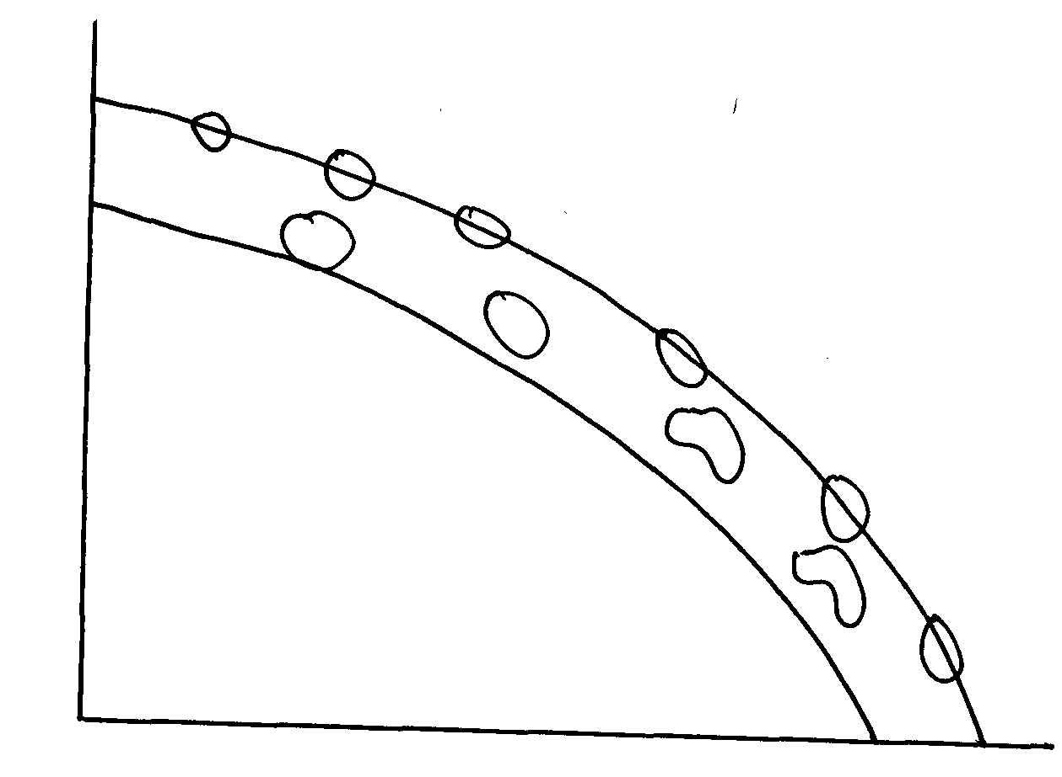
Ice

fore ground

di) - Leads to loss of life and destruction of property.
- Destruction of transport and communication lines.
- Accelerate soil erosion on steep slopes.
- Leaves permanent scars on the landscape/derelict.
- It may change the rivers course thus affecting the people and aquatic animals down stream.
- Discourage settlement in areas prone to landslide.
d ii) Rockfall
d iii)- M- cliff
- N-Rock debris (talus)
d iv) - Rainfall

32. a)- Wind is strong/moving at high velocity.
- Absence of intervening obstacles/absence of vegetation cover/flat land.
- Presence of large quantities of loose unconsolidated materials eg sand, gravels.
b)- Attrition – Materials carried by the wind hit against rocks each and in the process are reduced in size.
- Abrasion – Materials/load carried by wind is used to scratch and grind rocks and ground surface.
- Deflation – materials/load carried by wind is lifted and rolled on the ground hence erodes the surface.
. c)- Dry unconsolidated materials are removed from the surfaced by wind.
- Coarse materials /heavier are swept away by wind and erodes a pre-existing fault/crack by
deflation process.
- Heavier material move along the surface in swirling slops.
- Continued eddying of winds leads to erosion and creation of a hollow called deflation hollow.
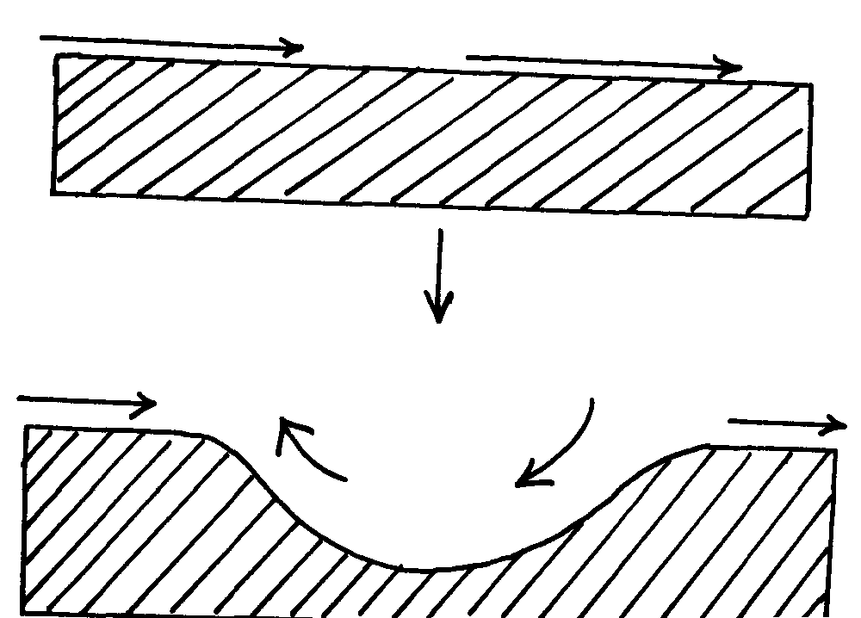
wind
land

wind

Eddying wind

. d)- They lie parallel toe ach other.
- Rise up to 100 m and about 100 km
- Lie parallel to the direction of prevailing wind.
- Have a sharp knife like crest.
- Separated by flat corridors.
- Occur in groups.
- Where wind blows from the same direction for long, dunes become gentle on the wind-ward side and steep on leeward side.
33. a)- Melting of ice caps and sheets due to global warming and climate change.
- Uplift of the coastal land due to tectonic forces
b) - Warm Ocean waters (20-29)⁰c.
- Clear and clean water, free from silt/sediments.
- Salty water.
- Well oxygenated water.
- Constant washing by waves, tides and currents.
- Plentiful supply of microscopic life for food/planktons.
34. a)- Suspension
- Surface creep
- Saltation
. b) - Availability of sand
- The strength and direction of wind.
- The nature of surface.
- Presence of intervening obstacles on path of wind movement.
- Presence of vegetation
- Presence of ground water reaching the surface.

35. a) - Rainwater
- Rivers/streams
- Underground water
- Melting ice

35. b)- Size of the depression
- Total annual rainfall of the catchments area and drainage basin.
- The number of other sources from which the lake acquired its water
- Different ways in which the lake water is lost.
- Rate of sedimentation in the lake.

36. a i) - A river is a mass of water flowing in a valley
ii) A river confluence is the point at which a tributary joins the main river while a river
tributary is a smaller river which flows into a bigger one
b i) - Water is forced into the cracks on the river banks/ water hits the banks
- Air in the cracks is compressed
- Compressed air creates pressure which widens the cracks
- As the water retreats pressure in the cracks is suddenly released
- The compression and widening of the cracks repeatedly shatters the rocks
- The retreating water carries away the loose particles
- The force of the moving water and the eddying effect sweep away loose materials in the river channel
b ii) - River water carries sand, gravel and boulders
- The load is used as a tool for scouring
- The load is hurled by the river water against the banks/ dragged along the river bed
- The load chips off the rocks on the bank and the floor (the size of the load determines the
rate of erosion)
- The load being dragged smoothens the river bed
- Eddy currents rotate rock particles in hollows and widens them into pot holes

a) - River capture may occur by head ward extension of the long profile
- This happens when rivers are sharing a water shed
- The actively eroding river gradually cuts back its slope head until it encroaches upon the divide or water shed of the other river
- Eventually the powerful river reaches the source of the weaker river and diverts its water into its channel
- River capture may also occur where there are two adjacent rivers
- One of the rivers has more erosive power than the other
- The more powerful river erodes both vertically and laterally faster than the weaker one, it flows at a lower level than the other river
- The more powerful river erodes away the ridge that separates the two by head ward erosion
- Eventually it encroaches into the valley of the weaker river diverting its waters into its valley

b) - They have a gently sloping gradient/ flat surface
- They have thick alluvial deposits/ silt/ fertile soils
- They have leaves on either side of the river banks, raised river beds
- Some flood plains have braided channels
- Some have deferred tributaries
- Flood plains have river bluffs at their edges
- They have meanders/ bends
- Some have deltas/ distributaries
- Some have ox-bow lakes

38. a) i) Inselbergs, mesas, buttes, gorges, wadis, alluvial fans, bajadas, pediments,
pediplans, playas, Salinas
ii) - An increase in temperatures accompanied by excessive evaporation
- Prolonged period of drought or very low rainfall
- Existence of cold ocean currents off shore which flow across the path of on
shore rain bearing winds
- Presence of high mountains which block rain- bearing winds and cause a rain
shadow effect
- Remoteness of land in the interior of a continent, far away from the direct
influence of the sea
- Location of an area in a region of anticyclones where winds are descending and
diverging
- Human activities such as deforestation, overgrazing and over drawing of
underground water reserves
iii) - Sandy desert
- Stony desert
- Rocky desert
b i) - Strength and speed of the wind: A strong wind can transport more and heavier load
than a weak one. The strength of the wind is determined by its speed. The higher the
speed the stronger the wind
- Obstacles: Presence of obstacles on the path of the wind block the movement of the wind and reduce its speed through friction. The winds capacity to transport is reduced by friction with the obstacles
- Nature of the load: Light particles such as those of dust can be transported in suspension over long distances, while the heavier ones are transported over short distances and along the ground. Heavier peddles and stones are rolled on the ground if the wind is strong enough
b. ii) - A pre- existing depression or localized fault is exposed to wind erosion
- Wind eddies remove the unconsolidated materials by
- Weathering aids in breaking down the exposed rock
- Wind abrasion excavates the depression by eroding the rock along the weak lines
- The depression is deepened and widened as deflation continues to remove the loose materials
- Erosion continues until the water table is reached
- Water oozes out of the rock and collects in the depression to form an oasis

39. a) -swash is surge of sea were towards the beach while backwash is water that flow
back to the sea from the beach
b) -fall in sea level
-rise of land near the sea
-actual reduction of water

40. a) Diversion of head waters of a river into a system of an adjacent more powerful river
b) X – Elbow of capture
Y- Pivate/ powerful river
Z – misfit stream
41. a) - Accordant drainage system occurs with agreement with the rock structure, nature
and slope of land while discordant occurs in disagreement with rock structure and nature
b) - River must have large load
- Velocity of river must be low to allow deposition in the river mouth
- River load must be deposited faster than it can be removed by currents and tides
- There should be no obstacle on the river course like or swamp to filter materials

42. a i) An area of land with scanty rainfall and scarce vegetation
ii) - Sandy
- Stony
- Bad lands
. b i) - wind abrasion
- Wind deflation
b ii) - Rock of alternating hard and soft attacked by winds
- Cracks form on the hard surface
- Wind abrasion erodes joints deepening them
- Wind deflation blows away material
- Furrows form as soft rocks are further eroded
- Hard and more resistant rocks form ridges known as furrows

c i) - Mesas
- Buttes
- Gorges
- Salinas
- Bajadas
- Wadis
- Playa
- Pediment
- Inselbergs

c ii) - Features of tourist attraction
- Oasis are sources of water for domestic use
- Desert land forms are ideal for military training
- Loess form fertile alluvium soils in wetter lands
- Seasonal streams can be used to supply water to surroundings
- Sand dunes and rocky landscape pose problems to transport
- Loess in China and Europe have dug- in caves which are inhabited in winter to provide
Warmth

43. a i) - Abrasion√ - Attrition√
a ii) - the faster the wind blows, the greater the amount of material it can carry√
- fine dust is easily picked up and blown away even by light wind, sand and pebbles
are usually along the surface√
- presence of obstacles such as rock bushes on the path of the wind will slow down
the wind making it drop√
- Deflation√
.
b i) Alternate hard and soft rocks out crop laid horizontally√ abrasion is predominant at the
base level √soft rocks are eroded to produce furors√ shaped features is formed called
rock pedestal

. b ii) In desert areas wind deflation may create hollows√ .the hollows may be deepened by wind abrasion √process to reach the water table.√ Water oozes out to form oasis√

c i) - weathering by solution lakes in limestone areas √
- deposition by water/ice√
- erosion by wind/ice√
- meteorite falling√
- human activities/damming√
- mass movement√
c ii) - lakes are reservoirs acts as sources of rivers√√
- support biodiversity/support flora and faur√√
- lakes enable self purification of water/air√√
- modify local /weather and climate√√
- regulation of river from overflowing flooding√√
d) - Forms when stalactite continues to grow down wards
- Stalagmite grows upwards towards the stalactite
- Eventually the two features meet forming a continuous column called limestone pillar
d i) - Limestone blocks are used for building houses/ or `
- Limestone is a raw material in cment manufacture which is used in building and construction
- Limestone landscape is usually rugged thus discouraging settlement
- Tourist attraction – underground and surface features are conspicuous hence attract tourists

14. SOILS
1. a) - Soil profile is the vertical arrangement of various soils in layer showing the
sequence of horizons from the surface to the parent materials
- Soil catena is the sequence of different soils on a slope from the top of the
hill to the valley Bottom
.

b) - platy/plate soil structure
- crumb soil structure
- prismatic soil structure
- blocky/block soil structure
- granular soil structure
- columnar soil structure
c i) - Controlling overgrazing
- Avoiding bush fires
- Controlling tree cutting
- Practicing appropriate methods of cultivation e.g. planting cover crops, irrigation,
mulching, terracing, contour farming
c ii) - Leaves & branches reduce the force of rain drops which would otherwise loosen
and remove soil particles
- Rate of infiltration of rain water into the soil is increased by vegetation cover thus reducing surface run off
- Tree roots which penetrate the soil help to carry surface moisture into the ground. This allows the moisture to gradually percolate deeply
- Tree roots bind the soil particles together and therefore the soil can not be easily carried away
- Trees break the force of the wind at the ground and reduces the transportation of soil by wind

2. a i) Soil is the top layer of loose or unconsolidated rock material overlying crustal rocks
and on which the plants grow
Or - Is an accumulation of rock particles minerals, organic matter, water and air found on
the surface of the earth
a ii) ) Soil catena : This is the arrangement of soil on a mountain slope from the top of the
valley bottom while soil profile is the vertical arrangement of various soils in layer
from surface to bed rock
.b i) - - Climate
-Seasonal variation of rainfall can cause accumulated concentration of salt in the soil
- Rainfall provides water which make it possible for rocks to disintegrate to form soil
- Rainfall also affect the rate at which some soil forming processes can occur (leaching)
- High temperatures increase the rate of weathering by accelerating the raise of bacterial activities which generates some of the organic matter in the soil
- Wind, ice, water erode, transport and deposit soil particles in other areas leading to the formation of new soils
- Living organisms
- Living organisms add organic matter to the soil
- Areas with thick vegetation lead to the formation of fertile humus laden soils which is quite useful in aeration
- Bacteria help to decompose organic matter
- Bacteria fixes nitrogen into root nodules of plants thus enriching the soil
- Human activities can change the nature of the soil through grazing cultivation, use of fertilizers e.t.c.
b ii) - Type of parent
- Amount of organic matter
- Chemical composition i.e. minerals
- Drainage of the soil or amount of water in the soil

3. a) Relief
Slope influences the type of soil in that on steep slopes the soils that develop are thin, on gentle slopes the soils are deep and fertile. This is because the rates of erosion and weathering are quite rapid on steep slopes than gentle slopes
Drainage
- The amount of moisture in the soil is determined by the slope. Steep slopes have
well drained but thin soils
- Hill top has well drained and mature soils
- Valley bottoms develop soils that are poorly drained
Mass wasting and surface run off
This leads to development of fertile soils at the valley bottom because the top soil
removed and deposited there
Leaching
This is the movement or washing of soil minerals from one layer to another which will also affect the type of soil developing

b i) the vertical arrangement of soil in layers from the top the bedrock
b ii)

b iii) elluviation calcification
illuviation gleization
leaching ferrilisation
lateralization
humification
b iv)- Excess irrigation
- Over stocking

4. a i) Soil is a thin layer of natural material on the earth’s surface that supports plant
and animal life
ii) - Inorganic matter
- Organic matter
- Soil water
- Soil air
- Soil organisms
. b i) - Parent rock
- Topography
- Climate
- Time
b ii) - Dense vegetation vital for fertile soils
- Micro-organisms like fungi fix nitrogen to the soil
- Micro- organisms aerate the soil hence improve porosity
- Activities of man i.e. grazing, use of fertilizers, construction
c i) - Soil air – gases that are available within spaces that separate soil grains
- Soil texture- size of individual soil grains
c ii) - High amount of rainfall promote chemical weathering of acid parent rock materials

- Long cold withers and short mild summers in temperate climates reduce bacterial activity
- Weathering of parent rock materials releases iron, aluminum, silica and organic acids
- Strong acid conditions enhance leaching of bases especially calcium along with iron and aluminum
- Silica that is less soluble is left back with the top layers and staining the soil beneath
- ash- grey
c iii) - Develop mostly through calufication
- Have dark surface horizons
- Rich in calcium
- Have deep top layers of about I meter thick
5 .a)

b i) - Soil catena is the sequence of different soils on a slope
b ii)

a iii) - The soils are light in colour
- They are saline
- They are sandy/ strong
- They are loose in texture
- They are thin
- They have low moisture content
b) - The type of parent rock
- The amount of organic matter/ humus
- The chemical composition/ the degree of iron oxide/ minerals
- The amount of water in the soil/ drainage of soil
c) - During the wet season, mineral salts in the top layer of the soil dissolve rain water
- The dissolved minerals percolate seep downwards from the top soil to the sub soil
- The dissolved minerals are deposited further downwards to the lower layer
- Insoluble minerals such as iron and aluminum are left on the up layers to form a crust
of late rite soils
d i) - Burning destroys micro- organisms which are essential for formation of humus which
binds the oil particles together
- Burning destroys vegetable matter that protects the soil against erosion
- Burning destroys the nitrogen fixing bacteria making the soil less fertile
- Burning loosens the soil making it susceptible to erosion/ leaching which drains away soluble mineral nutrients
d ii) - This increases the aridity of the soil/ changes the PH of the soil
- The acidity destroys the micro- organisms in the soil/ bacteria/ fungi which could
have helped in the formation of humus
d iii) - Monoculture leas to exhaustion of certain minerals from the soil making it infertile
leading to its erosion
- Monoculture leads to loosening of soils particulars there by encouraging soil erosion

6. (a) i) - Tundra soils
- Podzols
- Chernozens
- Proure soils
- Chestrut soils
- Red Desert soils
a ii) - In warm to hot humid regions silica and other bases dissolve in water are
leached/percolate when it rains seep downwards from the top soil
- This leaves iron and aluminium oxides which are insoluble on upper soil horizons.
- This forms soils on upper soils on the upper soil horizons rich in iron and alluminiumoxides called lateritic soils
a iii) - They are young/of recent origin
- They are immature
- They are insufficiently affected by soil forming processes
- Characteristics depend on their origin
b i) - High rainfall can lead to water logging and formation of acidic soils
- Heavy rainfall also results into surface run off that may lead to sol erosion run-off that may lead to soil erosion
- Too much rain can alter the soil structure by causing crumb soil to form blocky or columnar structure
- Heavy rainfall can led to leaching of nutrients from top soil to lower soil horizons depriving the top soil of some nutrients
- Low rainfall leads to loose soils easily blown away by the wind
- Excessive drought leads to accumulation of salts in the top soil leading to salination
b ii) - Soil is baked to make building and construction materials like bricks, tiles/whitewash
- Soils are used in making pottery/ceramics/sculptures and used by people
- Some soils contain minerals like apatite which is mined and used to make phosphatic
fertilizers
- Some soils are medicinal
- Some soils are food to animals and people
7 a i) soil catena is the horizontal arrangement of soil on a mountain slope while a soil
profile is the vertical arrangement of soil particles in layers or horizons
. a ii) -leaching
-eluviations
-uluviation
-organic accumulation
-cheluviation
-precipitation
-organic sorting

b i) - seasonal rainfall in temperature and rainfall facilitating the rate of weathering
-the rate at which organic matter decompose rise in to increase in temperature and rainfall while dry areas are devoid of vegetation covers
b ii) - micro-organism cause both plants and animals to decay into humus .humus are
added o the upper layers of the soil
-living organisms act on decaying organic matter through humification to form humus.
This humus consolidate forming rich soils.
b iii)- soils formed on steep slopes generally fails to develop or mature because most of the
rain water runs of along the surface ,this accelerate erosion which comes away the top layers of soil
-on rolling and gentle slopes maximum soil development is likely to occur. This is because the rate of soil erosion is matched by the rate of soil formation due to good drainage
c i) soil degeneration is the decline in the usefulness of soil resulting from either soil
mismanagement or environment causes
c ii) -plant roots which penetrate the soil help to carry surface moisture into the soil
-vegetation helps to bind soil particles together
-plant cover breaks the force of wind and therefore reduces the transportation of soil particles
-decayed vegetation matter provide humus which binds the soil particles together
-the leaf cove helps to reduce the force of rain drops which would loosen and remove soil
particles
-the rate of infiltration of rain water into the soil is increased by vegetation cover thus reducing
surface run offs
c iii) -crop rotation
-contour ploughing
-strip cropping
-inter cropping
-bush fallowing
-mixed cropping

8. a i) -this is the sequence or arrangement of different soils down a slope
8. a ii) -the relief/slope/steepness of the land
-the drainage of the area
-the transportation of the soil debris
-the teaching process
8. b) -the production topsoil is lost foe ever and his lowers the agricultural production of the land
-the soil left behind after erosion is thin and cannot hold plants firmly in the ground.
-continued loss of soil through erosion destroys vegetation cover turning the area into
semi- arid/desert.
-soil erosion causes water reservoirs to be filled up by silt adding extra cost of dredging.
-sediments which are carried into rivers/lakes/oceans may contain industrial effluents
which kill aquatic life.
-gullies as a result of erosion expose water onto the surface leads to lowering of the
water table
8. c) -develop best in areas which are cool and sufficiently wet
-soluble soil constituents are moved downwards
-it leads to severe absence of bases throughout the soil profile resulting to low PH and
an accumulation of hydrogen clays
-there is an accumulation of acid organic matter in horizon a leading to intense teaching
of bases and clays
-iron and humus are deposited in horizon B

9. a) - Living organisms.
- Organic matter.
- Soil minerals.
- Soil matter.
- Soil air.
b i) - Climate influence type & rate of weathering.
- High rainfall influence leaching process runoffs resulting from high rainfall increases
rate of erosion.
- It influence rate of decomposition
b ii) - Influence soil profile.
- Parent material influence soil structure.
- It influences soil colour.
- It influences mineral composition.
- It influences soil texture.
c i) - Over cultivation exhausts the soil fertility.
- Monoculture exhausts soil minerals.
- Clearance of land for agriculture interrupts nutrient cycling.
- Application of fertilizer changes the P.H.
- Construct of roads, mining, quarrying destroy soil structure.
-Application of fertilizers change soil PH
c ii) A-TOP SOIL
B- SUB-SOIL
C- PARTLY WEATHERED ROCK
D -PARENT ROCK

10. a) - A lake is an accumulation of water in a wide hollow or depression
. b) - By erosion
- By earth movements/ volcanic activity
- By deposition
- By human activity
- By falling meteorites
- By mass movements e.g. land slides
- Weathering by solution
11. a i) Soil is the upper most surface layer of unconsolidated material which lies on the
surface of the earth and in which plants grow/ soil is an accumulation of rock particles
or minerals, organic matter, water and air found on the surface of the earth
. b i) - Seasonal variation of rainfall can cause accumulation/ concentration of salts in soil
- Rainfall provide water which make it possible for rocks to decay/ disintegrate to form soil
- Rainfall can affect the rate at which some soil forming processes can occur (leaching)
- High temperatures increase the rate of weathering/ accelerate the rate of bacterial activities
which generates some of the organic matter in the soil
- Water, ice and winds erode, transport and deposit soil particles in other areas leading to the formation of new soils (for example loess)
b ii) - Valley bottoms/ gentle slope encourage the formation of deep and fertile soils due to
deposition/ accumulation of minerals
- Steep slopes encourage erosion of the top layer of soil thus slowing down formation of soil/ have thin soils
- Flat plains/ flood plains are saturated with water therefore slows down soil forming processes
- Slopes influence arrangement/ sequence of soil/ soil catena
- Some slopes are more exposed to the sun/ rain which influence weathering of parent rocks/ soil formation (aspect)
c i) - Humus helps to improve soil porosity by aerating the soil
- It improves the moisture – retention capacity of the soil
- Humus provides essential minerals to the soil
- It improves the soil texture
c ii)- They are thin and shallow
- They are sandy or stony
- They lack humus or have low organic matter content
- They are generally saline
- They are coarse- textured and quite porous
- They are alkaline because of high content
- They have low moisture content
. d i) - This occurs on gentle slopes which are bare
- When heavy rain falls, water spreads over a large area
- As water moves, it removes the top layer of soil evenly over the area
. d ii) - It occurs on steep slopes
- Rain water cuts deep grooves/ channels/ rills on the slopes
- The channels are widened and deepened to form gullies, through which soils are carried away
. d iii) - Soils are sources of valuable minerals
- Soils are used raw materials for pottery/ ceramics/ tiles/ bricks
- Soils are used for agriculture
- Some soils are mixed with herbs and sold for medicinal purposes e.g. clay/ sold directly for
food
12. a) - It is a careful management/protection of soil against erosion and exhaustion
. b) - Ploughing along the contour
- Controls grazing
- Stripping cropping

15. AGRICULTURE
1 . a i) Land reclamation is a process by which unproductive land is converted to productive
land and used for crop or animal farming. Rehabilitation is the restoration of land that has been destroyed through human activities to its farmer usefulness/productivity
ii) - Bush fallowing
- Mulching
- Planting trees
- Filling the pits/gulleys
- Planting cover crops
b i) - To occupy detainee labour from Mwea detainee Camp
- To utilize the black cotton soils in growing rice
- To increase agricultural production
- To settle and create employment for former detainees
ii) - Diseases e.g. Bilharzia and malaria caused by water snails and mosquitoes, weaken
and even kill the farmers hence affecting productivity
- Stagnant water is the breeding grounds for water snails and mosquitoes
- Fluctuation of world prices due to competition affects agricultural production
- Poor payments for farmers produce that kill their morale
- Monoculture practice has led to soil exhaustion resulting to use of fertilizer that increases cost of production
- Mismanagement of irrigation bodies leading to losses of farmers killing their morale

2. a) - Construction of productive dykes/walls to enclose area to be reclaimed
- Construction of ring canals to carry water from the reclaimed area into the sea
- Installation of pumping stations to pump water from the enclosed area
- Water is pumped out of the area enclosed by the dyke
- Reeds are sown to get excess water and prevent growth of weeds
- Drainage ditches were cut in the land and drainage pipes laid
- More pumping stations were put up in order to drain excess water
- Soil treated with chemical to lower salinity
- Drained land was flushed with fresh water to remove salts from the soil
- Pumping out of the water and crops planted or grown
b) - Improves distribution of fresh water for domestic use
- Control of floods to the south west
- Controlled seas invasion inland
- Improved accessibility through development of roads and railways
- Improved tourism in the area

3. a i) - Trans Nzoia
- Nakuru
- Uasin Gishu
ii) - Land is ploughed manually/mechanically
- Sowing of seeds are done at the onset of rains
- Two seeds are sown in holes of 2-5cm in rows of 1m apart
- Application of fertilizers or manure is done during planting
- Weeding and thinning is done to remove weak seedlings
- Top dressing /nitrogenous fertilizers is applied after weeding when the crop is 30-45cm high
- The crop is ready for harvesting in 4-8months depending on variety of seeds and altitude
- Harvesting is done manually
b) - Maize is a staple food
- Maize stalk serve as cattle feed
- Maize is a raw material for industries
- Stalks, leaves and cobs are important source of organic manure
- Maize cobs and stalks are used as fuel in varied areas
- Provide employment /income
- Saving foreign exchange

4. - Unfavourable weather conditions/ prolonged drought lead to destruction of crops hence
low yields/income
- Pests and diseases e.g. stalk rot, corn ear worm, silk worm, birds e.t.c. which attack crop reducing yields
- Poor/low prices
- High cost of farm inputs reduce farmers profits
- Poor marketing strategy leading to low prices
- Monoculture leading to soil exhaustion
- Poor storage facilities
5. a) - Friesian
- Jersey
- Guernsey
- Alderney
- Ayrshire
- Sahiwal
b) - Low temperatures ideal for exotic breeds
- Fertile soils, which support quality pasture
- Reliable and constant water supply for the animals
- A high population, which provides ready market for dairy produce
- Has humid conditions suitable for the growth of pastures

6. a) - French beans
- Cabbages/kales
- Celery
- Spinach
- Pawpaw
- Mangoes
- Avocadoes
- Passion fruits
- Carnations
- Gladioli
- Roses
- orchids
b) - Netherlands has a higher urban population than Kenya.
- There is high demand for both local and foreign horticultural products in Netherlands than Kenya
- Farmers in Netherlands have more access to the capital needed for horticultural farming than in Kenya.
- There is more advanced and appropriate technology in Netherlands which has enhanced horticultural farming than in Kenya.
- Netherlands unlike Kenya has a highly skilled labour for production and handling of agricultural products.
- There is more advanced horticultural farming related to research in the Netherlands than in Kenya.
- Netherlands unlike Kenya has well organized marketing procedures/co-operatives/auction markets which are conducive for horticultural farming

7. a) - Vegetables/tomatoes/onions/carrots
- Fruits/oranges/ pineapples/ plums/ mangoes/ flowers/roses
b) - Horticultural crops are highly perishable this necessitating faster means of transport
- Same are light in weight which makes it easy /suitable for air export
- There is high demand for produce thus this need to supply urgently
- High market prices are able to pay compensate for the foreign charges

8. a)(i) It’s a traditional way of keeping large number of animals by nomad communities
who move from place to place in search for pasture and water.
ii) - Frequent livestock raid by neighboring communities or amongst themselves
- Animals are grazed communally
- They use natural pasture for grazing in the livestock
- It is practiced in area with low and unreliable rainfall
- Their movement is determined by availability of water and pasture
- Different types of animals are kept
- Animals are kept for pride

9. a i) – Jersey
- Guernsey
- Aishire
ii) - Ghee
- Cheese
- Butter

b i) - Cool climate/ moderate temperatures which are suitable for survival of exotic breeds
- High rainfall that favours growth of pasture and fodder
- Deep volcanic soils which favour pasture and fodder growth
b ii) - Attack by diseases such as East Coast Fever and pests e.g. ticks may cause
death of the animal hence total loss to the farmer
- Poor roads delay delivery of milk to collecting centers hence losses due to milk getting spoilt
- High cost of farm inputs discourages dairy farmers
- Mismanagement of the framers co-operatives discourages farmers due to delayed/ low or non- payment
- Drought reduces fodder and water for the livestock causing death or low production
- hence losses to the farmer

. c i)
Kenya | Netherlands
1. Done on small scale | Done on large scale
2. Done in Kenya highlands mainly | Done in the whole country
3. Zero grazing and out door grazing on pasture | Only zero grazing on fodder
c ii) - New K.C.C
- Brook side

10. a) - Jersey
- Ayrshire
- Guernsey
- Cross breed
b) - Disease such as rindpest may lead to death of animal
- Inadequate pasture during the dry season..
- Failure to collect milk due to glut in production.
- Delayed payments which discourage the farmers.
- Poor roads which are inaccessible during rainy season.

11. a) - Gently sloping land
- Deep, well drained volcanic soils
- Moderate rainfall/ 500mm – 1270mm p.a
- Warm conditions/ temperatures of 15C – 20C
- Warm/ dry/ sunny spell for ripening and harvesting
b) - Prolonged drought which lower yields
- Attack by pests (such as dusty brown beetle, quela birds, aphids, cereal weevils and diseases e.g. stem rust, brown leaf rust, glumme blotch
- Exploitation by middle men
- High costs of transport due to poor roads
- Shortage of storage facilities

12. a i) - Rift Valley
- Central
- Eastern.
ii) - Manitoba
- Alberta
- Sasketchewan
b) - 500-12700mm RF/moderate rainfall.
- Dry sunny spell for ripening/harvesting
- At least 3 months to temp 15⁰_{C} – 20⁰c for maturation or growing of wheat.
- Volcanic soils to sustain production.
- Gentle /fairly level/undulating land enables mechanization to take place.
- Deep /fertile/well drained soils for production of wheat.
c) - Farmers in Canada are more mechanized while those of Kenya are less mechanized.

- Canada has more capital than Kenya which experiences financial problems.
- Farmers in Canada are more skilled/have a long history of wheat production than in Kenya which is still developing.
- There is advanced research in Canada providing yielding seeds/better farm inputs/control of pets & diseases/overcome limitation of whether than in Kenya where research is poorly done.
- Farmers in Canada has more extensive tracts of land which are suitable for wheat growing than those in Kenya which are small in acreage
d) - Canada exports wheat hence earns foreign exchange. Which is invested in other
sectors of the economy.
- Wheat farming is a source of employment any Canadians who earn income raising their living standards.
- Industrialization as many industries that deal in wheat products have been established. Leading to economic diversification.
- The wheat farmers earn income through the sale of wheat raising their standards of
living. Canada is self sufficient in food as wheat is the main cereal food consumed

13. a) - Narok
- Uasin Gishu
- Nakuru
- Parts of Baringo
- Trans mara
- Nyandarua
- Trans Nzoia
- Keiyo
- Laikipia
b) - Gentle slope to allow mechanization
- Altitude between 1500-2900m to reduce cases of diseases outbreak
- Moderate rainfall between 500mm to 1,270mm to supply moisture for growth
- Warm temperature between 150ºC to 20ºC to allow production
- Warm dry sunny spell which enhances ripening of wheat and harvesting
c i) - Wheat is ground into tiny particles. This is done in flour mills
- Tiny particles are sifted out as four
- The yellow flour is bleached
- Bleaching gives white colour to wheat flour
c ii) - Wheat is sold on local markets
- Procedures sell wheat or millers e.g. Unga limited
d i) - Inadequate capital limiting expansion of farms and level of mechanization
- Pests like dirty brown beetle, aphids, quelea birds damage wheat causing low yield
- Diseases like stem rust, leaf rust, glume blotch lead to low crop yields
- Heavy storm/rainfall cause flattening of wheat causing rotting of wheat
- Price fluctuation lowering productivity /profit
- Inadequate storage facilities causing wastage
(ii) Canada has more extensive tracks of land suitable for wheat growing while in Kenya farms are relatively small.
- Canada has a higher level of mechanization while in Kenya the level is relatively low/machines are slowed
- Farmers in Canada are more experienced due to longer history of wheat production while in Kenya the level of advancement of techniques is low.
- Advanced scientific research in Canada enables the production of higher yielding seeds than in Kenya where the level of research is low.
- Wheat farmers in Canada specialize in wheat production while in Kenya they practice mixed farming (any 2x1=2mks)

14. a) - High temperature between 20ºC to 27ºC.
- Dry sunny conditions
- High rainfall ranging 1200-1500mm
- Deep fertile soils
- Well drained soils
- Gentle sloping areas to allow mechanization
. b) - Land use conflict/competition from cash crops
- High cost of inputs which was limited mechanization
- Impassible /muddy roads during rainy season
- High rise of cattle diseases like East Coast fever
- abrupt and extensive drought lowers production
- Mismanagement of co-operatives resulting in delayed payments killing the moral of farmers

15. a i) -Nigeria
- Coted’ivoire
-Cameroon
ii) - heavy rainfall-1270mm-1500mm per year
-high temperature-between 21ºc and 26ºc throughout the year
-high relative humidity –over 75%throughout the year
-deep fertile and well drained soils
-Protection from sunshine and wind by banana plants and other shady trees
-low altitude below 700m above sea level
b)-The pods are harvested using long sharp knives, collected and pulled at a central place
-The pods are then split open with a sharp knife and beans are scooped out by band
-The beans are put in heaps on mats, covered with banana leaves and are allowed to
ferment for 5 to be days during which the juicy pulps drain away
-The fermented beans are washed and cleaned spread on tables covered with mat to
dry in the hot sun
-The beans are turned frequently as they dry and slowly they turn brown
-The dry beans are put in sacks ad sent to the buying centers. There the dry beans
are weighted and graded ready for export.
c) - Pest like capsid bug mealy bug destroy the crop
- The swollen shoot disease attacked the tree shoots and the black pod disease affects
the pods reducing the yields
- The strong harmattan winds break the branches and cause premature ripening of the pods
- Fluctuation of prices in the world market discourage the farmers
- Poor transportation facilities make it difficult for the former to deliver the crop in time
- Labour is sometimes in short supply, leading to delay in harvesting

16. (a) i) horticulture is the cultivation of vegetables, fruits and flowers for commercial purpose
ii)- there is higher local demand for horticultural crops in the Netherlands than Kenya
- The Netherlands has along history of horticultural crop production and hence has
established foreign markets than Kenya
- Netherlands formers are well organized making it easy to access loans whereas few
Kenyans access loans
- Netherlands has advanced technology while Kenya has low –level advancement of
technology
- Netherlands has well development transport network while in Kenya the transport
network is poor
- Netherlands has highly skilled labour for production and handling of horticulture whereas -- - Kenya has a shortage of skilled labour in this field
- In Netherlands there is advanced research in the industry while in Kenya research is
less advanced
- Netherlands is centrally situated in Europe which gives the country an advantages of
Europe market
iii) - the pants do not suffer the effects of excessive rainfall, hailstone and strong winds
- The plants will not be affected by drought because they are constantly watered
- The spread of pests and diseases is easily controlled
- it is easier to control the amount of moisture that the flower require
- uniform and constant climatic conditions for the plants are created
- the flower are grown throughout the year

17. - Temperature ranges from 15degrees c to 20 degrees c(moderate temperature)
- Warm dry sunny spell for ripening
- Rainfall between 305mm and 1015mm
- Volcanic, well drained soils
- Gently sloping/fairly level land

18. a) - High rainfall which is well distributed throughout the year ensure abundant supply of
water for the animals and pasture.
- Fertile volcanic soil ensure high quality nutritious cover of grass.
- Cool condition/temperature averaging 18⁰c which is ideal for the survival of exotic
breeds/slow breeding of pests & disease.
b i) Dairy farming in Kenya is mainly pasture dependant while in Denmark it is mostly dependant on fodder
ii) In Kenya, most dairy products are consumed locally while dairy products in Denmark are
mostly exported to foreign markets

19. a) - Aberdeen Angus.
- Charolais
- Shorthorn
- Santa gertridis
- Hereford
- Red Angus
- Galloway
b) -Extensive rolling grassland which allows the cattle to graze freely.
- Fertile soils of the Andes Mountain which give rise to healthy natural grass for feeding
the animals.
- Moderate temperatures of about 24⁰c during summer and 10⁰c during winter which
ensures continuous growth of grass for feeding the animals.
- Moderate rainfall of about 1000mm which ensures growth of nutritious natural grass
pasture/pampas.
- Adequate water for the animals.

20. a i) ) X- Alberta
Y -Saskatchewan
Z- Manitoba
ii) - Warm summers with average temperatures of about 1.5⁰c
- Sunny late summers for rip3ening of wheat.
- Extensive undulating and uninhabited low lands.
- Rich dark – brown chernozen soils rich in potassium and phosphates/less acid soils.

b) - Central province.
- Rift valley province.
- Eastern province.

21. a) Horticulture is the growing of fruits, flowers and vegetables for export market while
market gardening is the growing of fruits and vegetables for local market (nearest
urban centre)
b) - Hot and wet climate for growth of tropical crops and cool and wet conditions for
temperature crops
- Fertile soils of volcanic origin
- High demand for the products both locally and internationally
- Investment by large companies providing the capital needed for horticulture
production
- Availability of technical and financial assistance from friendly countries
- Well organized marketing system

22. a)- It refers to the extensive grazing on natural pasture involving constant or seasonal
migration of people and their livestock
b) - Pastoralists move from place to place in search of water and pasture
- Land is grazed communally, though animals may be owned by individuals
- A large number of animals is kept resulting in overgrazing and serious incidents of soil erosion
- There is controlled cross- breeding of animal within each herd
- The animals are generally of poor quality due to diseases and low quality feeds
- Animals are considered as a source of pride and not income
- Cattle are kept as a sign of wealth, paying pride price and slaughter during cultural festival
- Different animals are kept i.e. cattle, sheep. Donkey e.t.c.

23. a) - Improved veterinary services
- Increase milk prices
- Good performance of co-operatives
- Government effort through the ministry of livestock development
b) - Breeds kept are similar
- Use of co-operatives
- Artificial insemination is used
- Open and zero grazing is done
c) - Creation of employment
- Earns Kenya foreign exchange
- Self- sufficiency in milk production

24. a i) Total tones = 100800
1 5cm rep 100,800 tonnes.
Flowers : 42800X 15 = 6.324 cm = 6.3 cm
100,800
Oranges: 20600X15 = 3.363cm = 3.4cm
100,800
Tomatoes: 20300X 15 = 3.02 cm = 3.0 cm
100,800
Carrots: 15400 X 15 = 2.29 = 2.3 cm
100800

DIVIDED RECTANGLE SHOWING HORTICULTURAL CROPS IN TONES PRODUCED IN KENYA IN THE YEAR 2000
FLOWERS | ORANGES | TOMATOES | CARROTS

a) ii) 42500 – 15400 = 2 7,100 tonnes
iii) 15400X 100
100800
=15.828 %/15.3%
b i) - They are easy to draw.
- They are easy to read/interpret
- They give clear visual impression of individual components.
- They allow easy companion.
- They can be used to represent a wide range of data.
ii) - Moderate rainfall of 800 – 1200 mm
- Suitable for horticultural farming.
- Cool and wet temperate crops.
- Hot and wet climate favours the growth of tropical crops.
c - Pests and diseases such as tomato blight attack the tomatoes and lowers the yields
leading to low income for the farmers.
- Most roads are impassable during the rainy season leads to delayed delivery of the
horticultural crops to the collecting centre lowering the quality subsequently the profit to
the farmers.
- High costs of farm inputs reduces the farmer profit margins.
- Prolonged drought/hail storms in some areas destroys the crops leading to heavy
losses.
- Stiff competition from Netherlands and Israel which reduces the international market.
- Inadequate refrigeration facilities leads to deterioration of the quality of horticultural
products and subsequently the profit to the farmers is lowered.

25. a) – Freshian - Aryshire
- Jersey - Guernsey
b) - Creation of employment
- Establishment of other related industries
- Milk is a source of protein hence healthy population
- A source of income to farmers
- Government collects taxes from sales of dairy products
- Cow dung is used manure hence increased productivity
- Dairy products are exported hence earning foreign exchange

26. a) – Tea
- Coffee
- Horticultural products
. b) - Kenya exports mainly agricultural commodities that fetch less revenue
- Price fluctuations in the world marked which make it difficult to plan ahead
- Competition from cheaper commodities that are imported into the country
- Inadequate transport and communication facilities
- Inadequate capital to expand trading activities
- Fees paid in form f trading license discourage traders
- Smuggling of goods (cheaper) from neighboring countries
- Poverty among the people which reduces their purchasing power
27. (a) - Food supply
- Industrial raw materials
- Draught animals/ beasts of burden
- Storage of wealth
- Medium of exchange
b) - Sinking boreholes/ harvesting rain water
- Cross breeding
- Discourage overstocking
- Extension services
- Credit availability
- Cattle dips
- Diversification e.g. bee keeping
- Sensitization on quality/ selling e.t.c.

28. a) – Operation costs
- Market expenses
- Price fluctuations
- Government policy
b i) - Is a beverage
- Is an industrial raw material for making cocoa butter, chocolates, confectionaries cosmetics, soap and drugs.
- Cocoa husks are used as fertilizer.
- Cocoa shell is used as mulch.
- Cocoa husks may used as fuel.
ii) - Pests such as the capsid destroy the cocoa tree.
- Diseases such as swollen shoot and black pod destroy the crop.
- Fluctuation of cocoa prices.
- Short labour supply.
- Flooded feeder roads delay collection of the crop.
- Bush fires destroy the crop.
- Strong winds e.g the harmattan cause a drying effect.
- Low cocoa prices

29. a) Horticulture is the growing of fruits, vegetables and flowers for the export market
while market gardening is the intensive cultivation of fruits and vegetable mainly for
urban markets
b) -Roses
- Orchids
- Carnations
- Gladio
c) - Inadequate capital to buy the necessary farm input
- Low production of milk from indigenous breeds
- Low managerial ability of the farmers
- Poor pasture leading to low quality breeds
- Inadequate labor supply
- Competition from imported milk and milk product by unscrupulous businessmen
- Diseases and pests
- Delayed payment to the milk producers
- Poor transport network
- Prolonged drought

30. a) - Loss in livestock and crops production.
- Low agricultural production.
- Low agricultural economic growth.
- Reduced production agricultural land
- Overcrowding in areas receiving adequate rainfall leading to land degradation.
b) - Honey from bees is a major source of food as well as medicine.
- It is a major source of income in arid and semi-arid areas of Kenya.
- It provide alternative and effective use of marginal areas where crops may do well.
- Bee wax is used in making candle.
- Bees are not expensive to maintain

31. a) - Traditional diet.
- Land ownership/Inheritance.
- Religion.
- Gender roles
- Foreign influence
b) - Gentle sloping terrain.
- Extensive pieces of land with low production.
- Adequate capital to set up large farms.
- Availability of skilled labour.

32. a) - High temperature throughout the year (21 – 27⁰)
- Plenty of sunshine during ripening period.
- Heavy rainfall well distributed through out the year.
b) - Cooking fat.
- Soap/both for washing and toilet soap.
- Cosmetics.

33. a) - Pollution is the contamination of the environment with substances which are
harmful or poisonous to human, plants and animal life.
b) - Land /Soil/Ground pollution.
  - Water pollution
  - Noise pollution.
c) - Temperature ranging between 15⁰c – 30⁰c
- Mean annual rainfall which should be between 400 – 1750 mm.
- Soil should be deep, well drained but with good water – retaining capacity.
- Altitude of between 1500 – 2200m.
- Windbreaks essential for protection of tea bushes against damaging wind.
- Shade.
d) – Pests and diseases.
- Tea bushes are commonly attacked by different pests and disease.
- Such pests include black tea thrips, red spider mites, red crecise mite and weevils.
- Diseases include root rot.
34. a) - Aberdeen Angus
- Hereford .
- Short horn
- Sahiwal
b) - Establishing priority orders by creating awareness among leaders.
- Identifying methods of approach that include retorted inclusives and dept. of
Agriculture.
- Educating farmers on strategies to improve their systems of livestock farming.
- Investigating the prevailing market situations and make appropriate recommendations.
- Creating Ranching schemes in arid and semi arid (ASACS) areas to improve livestock
farming.
- Identifying possible financial institutions to farmers such as AFC and banks and advise
farmers accordingly.
- Providing dipping facilities to improve the health of animals.
- Building dams to improve water in Reserves for the animals.
- Encouraging farmers to adopt modern methods of breeding beef cattle to improve on
quantity.
- Introducing pedigree British cattle in some suitable districts or cross breeding with
indigenous breeds to improve on the quality of the animals
c-- Unreliable and inadequate rainfall leading to inadequate pastures.
- High temp. in most parts which makes it difficult to raise cattle of good quality.
- Pastral tribes come for quantity rather than quality, land/herds of poor animals steadily
ruin pasture land.
- Hard ancient rock that underlie Kenya produce poor soils prone to erosion. Natural
grass is poor and not good for quality animals.
- Climate conditions of Kenya encourage spread of nagana
d i) - Well distributed rainfall throughout the year from growth of good pasture.
- Subtropical temp. with summer temp. raising above 24⁰c lower winter temp. of about 10⁰ c favours growth of grass.
- Gently sloppy Lorain provide good natural grazing landscape with good pasture.
- Fertile soils washed from foot/hills of Audes losses that are fertile and encourage growth of pastures.
d ii) - Provide employment in various section e.g. stockmen ranches.
- Improved feeder road to enable farmers transport cattle to the urban centres.
- Earns foreign exchange used in other section of economy (Your exports).
- By-products like hides used as raw materials to industries thus encouraging industrial
growth.
16. LAND RECLAMATION AND REHABILITATION
1. a) - Perkerra
- ahero
- KAno
- Bunyala
- Bura
- Hola
bi) - The black cotton clay soils found in the area suitable for irrigation because they
retain water
- The gentle-sloping land enables water to reach the farm by gravity
- Presence of rivers Thiba and Nyamidi provides regular and abundant water for irrigation
- The un-reliable and inadequate rainfall received in the area makes it necessary for irrigation
- More land is available for future expansion
- Availability of labour from high population
ii) - Stagnant ware encourages its breeding of snails and mosquitoes increasing
incidences of Bilharzia and malaria
- Quelea birds which feed on rice grain lowers drop yield
- Siltation in canals reduces capacity to hold enough water for irrigation
- Fluctuating water volumes reduces water for irrigation
- Poor marketing strategies
- Delayed payment to farmers lowers their morale
- Shortage of capital to finance farming activities such as ploughing
c) - The scheme produces the bulky of Kenya’s rice saving foreign exchange
- The scheme provides employment and income to thousands of people
- Roads have been constructed in the area to transport rice form fields to markets
- Social amenities like schools and hospitals have been provided improving standards of living
- Floods that used to occur during rainy season have been controlled
- The scheme has provided land to landless people enabling them to grow food crops

2. a) - Irrigation of dry lands.
- Clearing jungles.
- Tsetse fly control.
- Afforestation
b) - Flooding in the Yala and Nzoia plains has been controlled.
- Hectares of land has been reclaimed for agricultural and settlement purposes.
- The project has brought water borne diseases under control.
3. a) i) Land reclamation is bringing back the useless land into more useful while land
rehabilitation is bringing the land that has been misused by man into being useful
ii) – Basin irrigation
- Overhead irrigation/ drip
- Trickle irrigation
- Canal irrigation
- Shadoof Archimedean screw, sakia water wheel
iii) – Irrigation ensures a steady and reliable supply even in arid area while rainfall may
fail in a given year
- River water used for irrigation may may bring in silt which makes soil fertile and
leads to more yields unlike pure rain water
- Enables cultivation throughout the year maximizing use of land while rainfall could be
seasonal
- Water drawn for irrigation may also be used for other purposes in the farm
b i) – To settle the landless people
- The presence of rivers Thiba and Nyamindi
- Availability of the black cotton soils – good for rice
- To employee detainees during the days of emergency
- Unreliable nature of rainfall in the area
ii) – Availability of reliable water supplies from river Thiba
-Presence of fertile black cotton soils with high water retaining ability
- Gently sloping land making it easy to mechanize and cheaply irrigate by gravity flow
- Presence of high temperatures favouring rice groing
- The unreliable nature of the rainfall made it necessary to irrigate
- The soils were impervious thereby reducing the need to build concrete hence lowering
costs
iii) – Disease – malaria & bilharzias
- A lot of time is spent to tend crops
- Presence of numerous weeds
- Mismanagement of the scheme
- Delayed payment to the farmers
- Few extension officers
- Pests i.e. quela birds
- Siltation in the canals
- Expensive human labour
c i) A polder is an area of low – lying reclaimed land enclosed by dykes, which protect
the land against high water level that has to be maintained outside the area
ii) – Construction of ring canals to drain water out
- Construction of ditches within each polder which leads water to a pumping station
- Drying of land through planting of trees/ plants
- Desalination of the soil through chemical, flushing and planting hardy plants
- Dividing of land into economic units
- Laying down of good infrastructure
- Settling of people in villages
- Spreading of soils to improve fertility
- Addition of fertilizers

iii)- Control of floods of the area to the South West
- Improved control and distribution of the regions fresh water
- Damming has cut off salination and pollution of inlnd waters. This has led to the
reduction of salinity of soil hence high yields
- Islands that were isolated are now within easy reach of developed areas
- The area is a good site for industry and a tourist resort
. d) - Artificial insemination A.I is more widely used in Denmark than Kenya
- There is an experience of high quality yields throughout the year
- In Kenya, there is a practice of mixed farming while there is specialized farming in Denmark
- Dairy product in Kenya are consumed locally whereas they are for export in Denmark
- In Denmark it is highly mechanized while in Kenya it is low mechanized
- In Denmark, it is evenly distributed all over the country than in Kenya where it is
concentrated in highlands
- Denmark dairy farming rely on fodder while Kenya depends mainly on grass pasture
- Denmark has got an advanced technology in preservation of dairy products in Kenya
- Denmark has got a well managed co-operative societies than Kenya

4. Heavy expenditure by the government in giving them pensions, money that could have
been used to improve other sectors of the economy
- Through economically unproductive, they require care and feeding which is expensive
- Through unproductive economically, they require people to take care of them, hence wasting man power that could be used on productive ventures
5. a i) - Maize
- Beans
- Tomatoes
- Vegetables
ii) - Availability of gently slopping land that allowed irrigation water to move by natural
force of Gravity
- Availability of permanent source of water from R. Thiba and Nyamindi which provided water for irrigation throughout the year
- Existence of black cotton soils (clay) which hold water on the surface longer for use in irrigation fields
- Sparse population in the region which reduced the cost of resettlement
- Stagnant irrigation water in the fields serve as breeding grounds for water bone diseases nectars e.g. bilhazia workers and mosquitoes
- Leaching of the soils due to over irrigation
- Mono culture which reduces productivity of the soil
- Interference with the life’s of the people and animals who depend on the waters of these lines down stream
. c) - The scheme has created employment which has improved the living standards
of the people
- It has saved foreign exchange through production of rice that could be otherwise imported/ which is invested in other sectors of the economy
- It has facilitated urbanization e.g. Mwea town which has expanded trade opportunities
- Has increased productivity by turning less productive land. Hence adding food for consumption and sale to get income
d i) - Perkerra irrigation scheme
- Yala swamp reclamation/ Bunyala
- Ahero irrigation scheme
- Bura
- Nola
- West Kano

ii) - Is a source of carbohydrates
- Rice foliage is used as fodder
- It is a source of income through sale of rice
6. a) Land reclamation is the process by which wasteland is converted into farmland for
growing crops and keeping animals.
- Land rehabilitation is a process of restoring land to its former productivity.
. b) - Irrigation
- Drainage of swamps.
- Tsetse fly control and clearing of jungles
- Afforestation
c) - Land reclamation by drawing rivers & marshlands
- Upgrading sandy and barren areas through. Use of fertile soil or application of fertilizer
d) - To control the seasonal flood of river peskerra.
- To utilize excess water of river pekerra that used to go to waste.
- Presence of flat and gently sloping terrain which enables flow water by gravity.
- Fertile loamy soil.
- Dry condition of the area.
7. (a) - Improvement of standard of living.
- Settlement of the landless.
- Saving on foreign exchange.
- Rehabilitation and development of the areas.
- Con troll of environmental hazards.
- Creation of employment.
- Growth of urban centres.
- Availability .
b) - Creating of a large fresh water lake in the middle of the country lake ijssel
- The reclamation polders have attract towns that love improved infrastructure & social amenities.
- Has shortened the coastline distance by about 32km.
- The protection of high titles by dykes.
- Lake ijssel have help in reducing the salt content of the neighbouring regions.
- The total flooding on the coastilen are ahs been completely reduced.
- Reclaimed land is fertile and suitable for liable cultivation producing crops such as wheat.
- The slayer sea has improved the drainage .
- Reclaimed areas are used for settlement recreation and industry
8. (a) - Rice
- Onions
- Green grams
- Pepper
b i) - Presence of rivers Thiba and Nyamidi which provide water for irrigation
- Gently sloping land enabled water to reach the farms by force f gravity
- Extensive land for future expansion of the scheme
- Fertile soils in the area which were suitable for crop production
- Sparse population which made it easy and cheap to resettle people
- Low supply of rainfall received necessitated irrigation
ii) - To eradicate tsetse flies and hence provide conducive healthy living conditions
for man and animals
- To enhance the keeping of quality livestock in the area
- To provide land for farming
- To provide land for human settlement
iii) - Building gabions to check the speed of water
- Agro-forestry
- Re-afforestation
- Gazettement of forested areas to discourage human settlement and human activities
9. a i) Is land in the Netherlands that has been reclained from the sea and enclosed by dykes.
ii) - Rye - Tomatoes - Flowers
- Barley -Oat - Fodder crops
- Suagr beet - Potatoes - Wheat
b) - Protective dykes/sea walls are constructed enclosing the part of the sea to be reclaimed.
- Rings canals are constructed.
- Pumbing stations are installed to pumb out sea water from the area enclosed by the dyke.
- Water is pumbed out of the area enclosed by the dyke
- Drainage ditches and more pumbing stations are made on the land being reclaimed.
- Drainage pipes are laid below the soil.
- The area is divided into rectangular portions using. inner dykes and ring canal.
- The drained land is flushed with fresh water to remove salt from the soil.
- Soils are treated with chemicals to remove salinity
- Pumbing water from the polders is a continuous process to prevent water from
accumulating in the reclaimed land.
10. a ) Ahero Perkerra Hola/ bura
West kano Mitunguu
Dana katila Kibwezi
Taveta Gezira Bunyala
. b) - The area was sparsely populated thus making it easy and cheap to resettle the people
- The presence of river Thiba and Nyamindi which would provide water for irrigation
- The black cotton soil in the area which was suitable for irrigation because they retain water
- The fertile soil was suitable for crop production
- The gentle land would allow water to reach the farm through gravity
- The unreliable/ inadequate rainfall received in the area made it necessary for irrigation to be practiced
c ) - People who live in the area were originally nomads but now lead a settled life
- Farmers earn income after selling rice and other crops which enables them to improve their standard of living
- Tenants have access to credit facilities which they use to improve crop production
- The establishment of the scheme has created employment opportunities for the people in the area
- Roads linking the scheme to the market centers have been improved
d) - Stagnant water encourages breeding of snails and mosquitoes which spread bilharzias
and malaria respectively
- Silting of canals/ weeds in the canals reduce the flow of water into fields. The farmers spend extra time and money dredging the canals
- Delayed/ low payment discourage farmers
- Diseases and pests e.g. giulea birds attack the crop which lead to low yield of rice
- Expensive farm inputs such as fertilizer reduce the framers profit margin
- Roads are rendered impassable during rainy seasons hence delaying delivery of rice and other crops to the market
11. a i) -Land reclamation is the process through which unproductive land is made useful
for agriculture or settlement where as land rehabilitation is the process of restoring
land to its former productive state.
ii) - Afforestation.
- Reafforestation.
- Bush fallowing.
- Use of grass strip and cover crops.
- Mulching.
-Constructing bunds (making ridges of soil across a slope)
- Manuring.
- Constructing of cut-off drains (digging open trenches across slopes.)
- Controlling grazing (division of land into paddocks, allowing different sections found to
regain pasture.
- Construction of drainage trenches (digging trenches to drain off excess water)
b i) - Is land in Netherlands that has been reclaimed from the sea and enclosed hot dykes.
ii) - Rye - Oat - Wheat - Barley - Potatoes
- Sugarcane - Flowers - Tomatoes - Fodder crops
(c) - Protective dykes /sea walls are constructed enclosing the part of the sea to be reclaimed.
- Ring canals are constructed on the interior sides of the dykes.
- Pumping stations are installed to pump out sea water from the area enclosed by the dykes.
- Reeds are planted to help dry out the soil and prevent weeds from growing.
- Drainage ditches and more pumping stations are made on the land being reclaimed.
- Drainage pipes are laid below the soil.
- The area is divided into portions using inner dykes and ring canals.
- The soils are treated with chemicals to lower salinity.
- The drained land is flushed with fresh water.
- Pumping out water from the polder is a continuous process to prevent water from
accumulating in the reclaimed land.

d i) - The presence of River Perkerra which is a tributary of Suguta river in Kerio Valley
provide water for irrigation.
- Gently sloping land which permits the flow of water by gravity hence reducing costs of
pumping water to the fields.
- Presences of clay soils rich in mineral nutrients enables variety of crops to be grown.
- Presence of extensive land which makes large scale cultivation of crops possible.
- The area is semi-arid hence the need for irrigation farming.
ii)- Farmers earn incomes which improve their standards of living.
- Irrigation schemes have created settlement for landless people.
- Many people have been employed in the farms and other sectors within the irrigation schemes
such as transport and processing factories.
- It has facilitated reclamation of unproductive land, thus increasing land for farming. This
has led to increase in food production.
- Some crops grown through irrigation are exported, thus earning foreign exchange. The
rice grown in irrigation schemes meets most of the domestic requirements thus saving
foreign exchange that would have been used to import it.
- It has facilitated development of infrastructure in the irrigated areas. Roads have been
built to help in the transportation of inputs and commodities.
- Social amenities such as schools and hospitals have been constructed thus improving
the level of literacy and health of the people in the irrigation schemes.
- Industries that use raw materials produced on the irrigation schemes have been developed.
- Rice mills have been established on the rice irrigation schemes.
- Some market centres in the irrigation schemes have grown in size due to increased
trading activities e.g. Wanguru in Mwea irrigation and Margat near Perkerra irrigation scheme.

12. (a) i) Land reclamation is the practice by which less useful land is converted into more
useful land While Land rehabilitation is the process of recovery/restoration of land
which has been misused and destroyed through human activities
ii) - Bush clearing
- Sterilization of the male fly
- Use of traps
- Spraying /use of insecticide
-Creation of buffer zones
- Killing or transfer of hosts

b) (i) – Yala
- Bunyala
- Kalusi (maragua-Euelyptus)
ii) - The need to control seasonal floods from river Perkerra
- The presence of river Perkerra as a source of water for irrigation
- Availability of fertile loaming soils
- The area is gently sloping
- The dry condition of the area necessitated the use of irrigation
- The need to occupy the large population of ex-detained in a productive way
c) - The stagnant water in the plot and lands encourages the breeding of snails and
mosquitoes which spread Bilharzias and malaria. this weakens the farmer causing
low labour input hence low production
- Mismanagement of the irrigation projects leading to the collapse of several schemes
- Pest and diseases are attack the crops leading to low production(mention of pest here is
important i.e. quelea bird)
- Poor payment for farm produce which discourages the farmers
- Poor extension services to provide for the badly needed technical advice to farmers
leading to low productivity.
- Shortage of water during dry season reduced the land under cultivation and hence
reduced earnings
- Frequent silting of canals which is expensive to dredge reduces the amount of water
required for irrigation
- Inadequate labour which is largely required in the schemes hence burdening the farmer to
hire for planting, weeding and harvesting which reduce the profits obtained.
. d) - Floods caused by the tiles has been completely checked by construction of dams and dykes
- The dams and dykes have completely cut off movement of salty sea water inland
- There is plenty of fresh water for domestic and industrial use
- The distance from Missigen to Rotter dam was shortened by 50KM opening up the area
for industrialization
- More recreational opportunities were created by the newly formed lakes becoming a tourist
attraction
13. a) - Irrigation
- Control of pests and diseases
- Afforestration/reforestration
- Control of floods
- Control of soil erosion /construction of gabions
b) - Protective dykes/sea wells are constructed enclosing the part of the sea to be reclaimed
- Ring canals are constructed
- Pumping stations are installed to pump out sea water from the area enclosed
- Reeds are sown to both absorb excess salts
- Soil is treated with chemical to lower salinity
- The drained land is flashed with fresh water to remove salt from soil
14. a) - Swamps
- Dry lands
- Eroded lands
- Pest and disease infested
b) - Regular and reliable
- Silt increases fertility
- All year farming
- Reduces year farming
- Reduces salitility of soil
- Dams control floods/ are used for fishing

17. FISHING

1. a i) P – Norway Q- Japan
ii) - The areas have cool waters which have abundant planktons-main food for fish
- The areas have shallow continental shelves which allow light to penetrate for planktons
to grow
- Convergence of warm and cool current results in upwelling of ocean waters bringing mineral for fish and plankton form sea bed to the surface
- Cool waters encourages thriving of numerous fish species
- Most of the coasts are indented providing secure bedding grounds for fish
- The sheltered bays provide suitable sites for building fishing ports
- The large population in these areas provides ready market
- The rugged landscape limits agriculture thus people turn to alternative economic activity
- Cool climate provides natural preservation for fish
2. a) i) R – Trawling
S –Basket fishing
(b) (i) Basket fishing
- The basket channel shaped to allow easy entry for fish
- At the mouth, there is a non-return valve which restricts the outward. The basket is
held in the position with ropes/stones/ sticks downstream
- The basket is left in that attracted position for sometime then removed for landing of fish
(ii) Trawling
- A bag – shaped net is attached to the ship trawler
- The nets mouth is kept open by other boards
- The upper art if kept a float by corks floats
- Weights are used to keep the lower parts of the net at the sea bed
- The trawler drags along the net
- After sufficient fish is caught the net is hauled to the trawler
c) - Fishing is restricted to specific reasons to allow for breeding and maturing of fish
- Standardizing size of nets to ensure fingerlings are not cangut
- Licenses are issued to prospective fishermen to control their number and to ensure there eis no over-fishing
- Fish farming is being encouraged to ensure sufficient supply of fish.
- There is restriction of the disposal of untreated waste into the sea
- Artificial fertilization is carried out in special hatcheries to sustain the supply of fish/restocking of over fished waters
3. a) i) It is the rearing of fish in ponds
ii) - The government through the fisheries department has set up fish ponds and
hatcheries as demonstration farms
- Establishment of research institutions to investigate aspects of fish farming(breeding) diseases
- Expansion of markets through intensified campaigns aimed at encouraging more people to eat fish
- Extension officers have been sent to the field to advise on fish farming techniques
- The government has encouraged the establishment of co-operatives which give credit facilities to fish farmers
- Establishment of national food policy which encourages diversification of food aid as source of protein leading to setting up of fish farms
b) - Inadequate storage and preservation facilities which cause heavy losses on the
anded catch/leading to low catch
- Occurrence of strong sea waves causing accidental drowning/destruction of fish vessels
- Poor fishing equipment which confine the fishermen to a few metres of continental shelf leading to low catch
- Sparse population in the north coast and alternative economic activities in the south coast that lead to small market for fish
- High prices of fish which discourage many people from eating it regularly
- Local fishermen face stiff competition from foreign fishermen mainly from Korea and Japan who have adequate and advanced facilities for deep sea fishing
- Warm Mozambique currents and deep continental shelf which discourage the flourishing of fish
- Regular coastline /few sheltered bays hence few sites for fish landing and breeding grounds
c i) - North-West Atlantic
- North-East Atlantic
- North – East pacific
- North –West Pacific
ii) - Presence of extensive and shallow continental shelf which allow light to penetrate to the sea bed encouraging the growth of planktons used as fish food
- Upwelling of ocean waters caused by convergence of warm Kuroshio and cold Oyashio currents bring minerals for planktons from the sea bed hence attracting fish
- Japan has indented coastline/several bays which provide secure breeding grounds for fish
- Sheltered bays provide suitable site for building ports/landing sites e.g. Hakkadate
- Rugged landscape/mountains with infertile soil in some areas which does not favour agriculture hence make people resort to fishing
- Numerous islands had exposed/provided the fishermen access to marine life
- The area has cool waters which encourage thriving of fish
4. a) - A vein is a small crack containing minerals deposited in crystalline form while
a code is a large crack containing minerals in crystalline form √
b) - Waste of agricultural land √
- Waste of industrial land √
- Ugliness where the land has lost its beauty √
- Health and accident hazards √

5. a i) ) - Trawling. - Line fishing - Use of barriers
- Use of herbs - skinning - Harpooning
- Use of baskets - Use of gills nets - Use of hand lanes
ii) – Cod - halibut - haddock
- flounder - hake - herring
- mackerel
(b) i) - Sheltered inlets and estuaries form ideal sites for fishing villages and ports.
- They also offer ideal site for fish breeding because of calm water and availability of the planktons.
(ii) - When warm currents meet cold currents the temperature of water is regulated.
- This condition is ideal for the survival of fish.
- Convergence of these currents improve circulation of oxygen and dispersal of nutrients for the fish

(c) (i) Provision of the necessary infrastructure such as transport routes to enable
exploitation of fishing grounds located in remote areas.
  - This will reduce over exploitation on a few accessible fishing grounds like L. Victoria.
- Fishing Farming
  - The development of fish farms complements the fish being caught from natural waters
- Restocking of over fished grounds.
  - Over fished waters are restocked using finger lings from hatcheries or obtaining them from the overpopulated fishing grounds.
- International agreements on territorial waters.
    - Countries have full sovereignty over territorial water extending for 19 km from the coast.
A further 19 km zone in which the coastal state can take action against those who
break the law.

6. i) – Smoking. - Sun drying.
- Salting - Use of refrigerator.
(ii) - The fishermen are required to have a licence from the government
This prohibits illegal fishing, over fishing and indiscriminate fishing.
- Inadequate capital.
Most of the fishermen use traditional methods of fishing which greatly reduces their catch.
They lack adequate funds to enable them purchase modern fishing gear and refrigeration equipment.
--Introduction of new species.
  - The introduction of new fish species in the lake has affected the breeding of indigenous fish.
  - For example Nile Perch was introduced in the lake in 1960s, it now accounts for more than 80% of the fish harvests, after having caused the disappearance of more than 200 endemic fish species and yet it’s not a popular species.
- Presence of weeds.
  - Fishing in lake Victoria is greatly hampered by the grown of water hyacinth along the shores of the lake.
  - The weed chokes the fishing boats, hence the infested areas are avoided by fishermen, yet they contain a lot of fish.
-Accidents
  - Accidents affecting fishermen are common on L. Victoria.
  - Have canoes and boats capsize in the lake due to the strong winds and storms prevailing in the areas.
  - The fishermen loose their fishing gear and equipment, as some of them drone.
- Regional Conflicts.
  - There has been boundary conflict between Kenya and Uganda over Migingo Island on L. Victoria.
  - This has caused the fishermen to have fear since most of them are molested or attacked by Uganda Security groups.
7. - The continental shelf is narrow
- Poor transport connection to the fisheries
- Local fishermen do not have adequate capital
- The coastline is fairly straight
- the water is too warm for fish breeding/lack of upwelling of water
- There is low demand for fish
- Fishermen lack modern equipment preservation facilities/storage facilities
- Inadequate skills/inadequate research technology
- Competition from developed countries
8. a i) - Seine nets
- Trawler nets
- Gill nets
- Drift nets
ii) - West N. America
- N.E Asia
b) - Over fishing – reduced stocks
- Pollution – killing fishing
- Poor transport network – delay reaching market/ go bad
- Poor market/ fish imports – reduced earnings
- Inadequate capital – poor equipment/ preservation/ marketing
- Fish diseases – death of fish
- Weeds – difficulty to fish
- Boundary conflicts – fighting/ destruction of equipment
c) - Source of income/ employment – reduce unemployment/ improve living
standards
- Tourist attraction/ sports/ marine park – forex for developing
- Rich in nutrients – health
- Development of industry
- Health/ feed on mosquito- reduce malaria
- Feeder roads – improve transport
- Forex – country development
d) - Sagana
- Kabaru
- Kibos
- Homa bay
- Aruba
- Haller park/ nature trail
9. a i) -Pelagic
-Dermersal
-nadromous
ii)- Presence of numerous foods that form inlets which provide good breeding grounds for fish
- The ruggedness of the immediate land discourage agriculture and livestock farming thus making fishing a good alternative
- The prevailing warm Atlantic drift makes the area ice – free throughout the year thus fishing is carried out
- The grounds have large continental shelf which are abundant in plankton
- The dense population in western Europe provides a ready market for fish
- The low temperature conditions in high latitudes encourages flourishing of fish
- The highly developed technology in the region has contributed to the development of fishing
iii) - Formulation of law against indiscriminate fishing
- Restocking the over fished areas
- Licensing fishermen and use of standardized nets of permitted mesh sizes
- Prohibiting disposal of effluents into fisheries
- Introduction of new species in the existing fisheries
- Research of fish species their habit and migratory trends
- Personal should be trained on how to manage fisheries
10 a) - Drifting method.
- Seining method.
- Lining method.
b) - It is washed by cold ocean current which influence temperature of water favouring
the survival of fish.
- It has plenty of planktons than the Eastern coasts.
- It has sheltered inlets/harbours which favour the thriving of fish and construction of fish
harbours.

11. a) - Seining
- Trawling.
- Line fishing.
b) - Privacy/sea robbery making fishermen to lose fishing equipment and their catch.
- Water weeds such as hyacinth impede movement of vessels.
- Storms sometimes cause accidents in the lake.
- Territorial disputes with other countries such as Uganda.
12. a) - fishing is restricted to specific seasons to allow breeding licenses are issued to
prospective fishermen to control their number the size of nets introduced in fishing are standardized to ensure young fish are not caught
- fish farming is encouraged to ensure adequate supply
- there is restriction/control on water pollution
b) - large market both local and foreign
- modern fishing equipment is being used in fishing
- it has a large continental shelves/indirected coastal land
- low temperature which discourages agriculture hence venturing into the sea as
source of income
13. a) - Seining
- Long lining
b) - The Coastline is fairly straight/regular/has few indentation
- The Continental shelf is narrow
- The water is too warm for the breeding of fish
- Local fishermen do not have adequate capital/have inadequate preservation facilities
- Local fishermen face competition from developed fishing countries e.g. Japan
- There is low demand for fish in the local market
- Poor transport connections to fisheries resources
14. a) Pelagic fish are the fish that mainly live near the surface or at the shallow depths or
lakes and seas, while demersal fish are those which live at or close to the bottom of
water bodies
b) - Over fishing – Some fish species in the fresh water lakes have been over- harvested to the extent that natural replacement has been limited
- Pollution – Some industries release their wastes directly into rivers, lakes and oceans. The wastes are hazardous and make the water bodies inhabitable for fish
- Inadequate capital – Most fishermen use traditional methods which reduces their catch
- Inadequate transport – Due to the poor maintained roads the fishermen don’t reach the market on time
- Introduction of new species – This introduction has affected the breeding of the indigenous fish
- Presence of weeds – Weeds like hyacinth traps the fishing boats hence the areas are avoided

18. WILDLIFE AND TOURISM
1. i) P – Sibiloi
Q - Serengeti
R - Murchison falls

. a) National park | Game reserve
- Its fenced off  - Managed by the central government | - There’s no fence ground it  - Managed by the local authority of the area they are located
b) - Establishment of game parks
- Outlawing illegal hunting and trade in game trophies
- Setting up of wildlife protection agencies
- Public education campaigns
- Protecting the endangered species
- Animal translocation programmes
- Encouraging the formation of wildlife clubs and societies in institutions

2. a) Game reserves are areas where wildlife is protected but some limited human activity
may be allowed while game park are gazetted regions where settlements hunting and
cutting of plants is no allowed whatsoever
b) - poaching by illegal hunters has reduce the population of animals
- pollution caused by industrial and domestic refuse has greatly affected marine life
- soil erosion due to improper farming methods has led to degradation of wildlife habitat

3. a) Balance of payment is the difference between visible exports and imports and also
invisible exports and inputs in the value of trade taking place between two countries.
b) - They are perishable.
- Some are bulky making transportation difficult.
- Are of low value
- They are exhaustible/supply may fluctuate negatively depending on season.
- Inadequate capital/ for expansion since a large capital outlay is needed.
4. a) - Remoteness caused by poor means of transport
- Insecurity in the areas
- Human wildlife conflict where man kills wildlife
- Hostile climate e.g. drought which leads to death of wildlife
- Settlement in the people in places meant for game parks and reserves
. b) - Negative attitudes towards local tourism limits the number of people who engage in tourism
- Inadequate local campaigns and advertisement of tourist attractions/ special packages lead to low public awareness
- Familiarity with the tourist attractions among the local people makes them fail to appreciate their beauty and value
- Insecurity from poachers in national parks and game reserves scare people away from visiting them
- The high cost of accommodation in the game lodges discourages local tourism
- The roads leading to tourist sites are poorly maintained, discouraging people from visiting
such sites
5. a) - Poaching which has led to decline in the number of some animal species.
- Encroachment into conserved land by human settlement.
- Drought in the National Parks and game Reserves which sometimes cause death of wild animals
- Overgrazing in the National parks and game reserves cause soil erosion.
- Inadequate capital has made it difficult to adequately conserve wildlife.
- Over-exploitation of water resources e.g. fish, seaweeds which pose danger of extinction
- Migratory behaviour of wild animals which makes it difficult to eradicate /control occurrence of pest and diseases.
b) - Political neutrality which removes any travel restrictions to the country
- Fluency in many languages that enable easy communication accessible
- Hospitality of the Swiss that encourage tourists.
- Trained personnel who provide excellent services.
- Effective systems which make it easy for transaction to be made

19. ENERGY
1. a) - Saudi Arabia √
- Iraq√
- Iron√
- Kuwait√
- United Arab Emirates/ Abu Dhabi/ Bahrain/ Bahrain Island√
- Qatar √
b) - Earning foreign exchange√
- Improvement of hospitals and schools√
- Development of manufacturing industries e.g. petrol chemicals√
- Creates employment√
- Development of towns and cities√
- Incomes/ profits have made the countries have high per capita income√
- Revenues and royalties earned from oil have enabled those countries to invest abroad thus increasing their wealth √
2. a) - A multi purpose project is a project that serves more than one purpose e.g. HEP,
irrigation, fishing √
b) - Seven forks project√
- Kariba project√
- Aswam high dam project√
- Akosombo dam project√
- Cobra Basa project√
3. a i) The sun, wind, water, wood, waves and tides, geothermal steam, biomas and animal
ii) - It is always available as long as it is blowing
- It is cheap source as we do not pay for it
- It is clean source which does not pollute environment
- It can be produced on small scale for local consumers
- The land occupied by windmills can also be simultaneously used for cultivation of crops
b) i) Geothermal power is lelectricity which is generated form the earth’s internal heat
that reaches the surface though geysers and hot springs
ii) - It is relatively cheap to produce
- Generation of electricity if continuous because steam is continuously being produced
naturally
- The sot of operating of geothermal plant is relatively low
- Geothermal steam is renewable source
- It is a clean source of energy which does not pollute he environment
- it helps reduce over-dependence on exhaustible sources such as fossil fuels
.c) - Government bureaucracy and political interference
- Inadequate capital for investment
- Lack of skilled labour
- Inadequate technology
d) - People are being encouraged to use energy-saving devices such as the energy-saving
Stoves
- the government is encouraging the use of alternative sources of energy such as wind, the sun and biomass.
- there is development of wood fuel programe through a forestation ad reforestation involving planting of quick-growing trees.
- The government uses consumer prices to discourage unnecessary uses of oil as fuel
- People are being encouraged to switch off electrify gadgets when they are not being used
- People are also encouraged to have proper maintenance of motor vehicles to reduce the amount of fuel consumed
4. a i) - Refers to the chain of negative reactions emanative from a cute shortage of
essential energy
ii) - Over reliance on one source of energy (oil)
- High increase in oil prices by oil producing countries
- Hoarding of oil to create artificial shortage leading to skyrocketing of prices
- Depletion of fossil fuels
- War which hinder mining and supply of oil to the world market
b i) – Coal
- Uranium
- Petroleum
ii) - Turkwel power project
- Sondu Miriri project
iii) - Steep gradient that allowed fast flow of water (water falls) to turn tubing to produce
Electricity
- Permanent source of water from RTana which provided plenty and regular supply of water to turn turbines and provide electricity throughout the year
- Sparse population in the region which reduced the cost of resettlement
- Impermeable soils in the region which reduce water loss from the reservoir through see page
- Presence of hard basement rock which provided firm foundation for construction of
dams
5. a) - Inexhaustible
- Versatile- many uses
- Reduces dependence on oil
- Cheap/ free access everywhere
- Minimum maintenance cost
- Environment friendly
- Can be stored
. b) P- Masinga
Q – Kamburu
R – R. Kindaruma
. c) - Industrial growth – creation of employment/ goods
- Transport – employment/ enables trade
- Agriculture e.g. tractors e.t.c. – food production
- Water supply – industrial use
- Health e.g. X- rays – healthy work force
. d i) - Reduced industrial production – shortages/ lose of employment
- Increased prices/ fares – limits purchase/ travel
- Domestic problems e.g. darkness/ cooking e.t.c. reduced standards of living
. ii) - Put off gadgets not in use
- Keep gadgets in good working condition
- Use of public transport
- Increase capacity of public vehicles
- Better roads – avoid traffic jams e.t.c.
- Use fewer lighting bulbs
- Minimise outdoor advertising i.e. bill boards
- Energy saving jikos/ stoves
- Use low capacity cars
6 . a) - Renewable sources of energy are those sources that are continually being replaced
or regenerated.
- They are considered inexhaustible
b i) - Presence of steep gradient of where there is a waterfall through out the year to
make the operations economical
- Hard basement rock to provide a firm foundation for the construction of a dam and accommodate weight of the reservoir
- Presence of a deep valley-where there is a deep valley or river gorge, it provides space for the reservoir therefore saves on the costs of constructing a dam.
- Presence of non-porous rocks to prevent seepage of water from the reservoir
ii) - Adequate capital to develop more plants in Olkaria and other potential areas
- Low level of technology in exploitation of geothermal
- Economical imbalance between the cost of setting up a station and the subsequent power outlay hence need for more stations.
- Potential areas are scattered and located in remote sparsely populated areas which are not potential markets for electricity produced
- High transmission costs of the potential markets
c i) - It leads to an increase in prices of imports and other locally manufactured goods.
- Third world countries spend huge sums of money on importation of crude oil
- Affects balance of trade since earnings from exports will be lower than imports.
- Results into inflation since the government passes the costs to consumers
- Oil crisis lowers GDP of third world countries since there will be more expenditure than investments
- It causes recession making an economy unable to create more jobs
- Causes a rise in living standards of people
- Increase production costs in other industries
c .ii) - Reducing the consumption rate of energy by encouraging people to put off
electricity when not in use
- Rationing of power by the distributing company
- Encouraging the use of public vehicles, proper maintenance of vehicles to cut down on the amount of petroleum used/consumed
- Encouraging the use of alternative sources of energy like biogas and solar energy that can be renewed hence saving on non-renewable energy sources.
- Ensuring the development of energy saving devices e.g. jikos which use wood/charcoal
- Development of industrial machines which can use coal that is cheaper as an alternative form of energy
- Reduction of taxes on gas and solar panels to cut down on the use of wood fuel
7. (a) - Leads to increase in prices of imports which result in material shortage lowering of
the gross domestic products (GDP) and creates a recession hence economy cannot
be able to create more jobs
- Leads to inflation i.e. the rise of prices of various commodities leading to reduced
consumption of goods and services hence drop in profits
- Increase in price of other forms of energy due to higher transport and production cost
- Decline in agricultural production due to decrease in and under maize and wheat and
reduced tourist activities due to the hike in oil prices that result in higher transport costs.
air fares rise steeping making it expensive for tourists to travel
- Depletion of foreign exchange reserves due to the increase in the oil import bill, the
country spends a lot of its revenue on purchase of unrefined oil
- Environmental degradation due to search for alternative sources of energy hence
demand for harcoal and wood fuel causing deforestation and soil erosion
b) - To conserve energy means the efficient utilization of energy to avoid wastage
- Encouraging he use of solar for heating and lighting
- Encouraging Kenyans to put off electricity gadgets when they are not being used
- Proper maintenance of motor vehicles
- Encouraging the use of public transport instead of personal cars
- Encourage the use of energy saving jikos /stores to reduce wood fuel used

8. a) Is usually portrayed as a question of price and supply uncertainties and the rapid
depletion of fossil fuels
b) - Destruction of forest as alternatives source of energy
- Promote erosion due to deforestation
- Destabilize ecological balance
- Facilitate desertification due to deforestation
9. a) - Oils.
- Natural gas.
- Coal.
b) - Kenya would save foreign exchange it used to spend on oil inputs and channel the
funds to projects.
- More industries would be established because industrial fuel would be
cheaper/increase in investments. .
- More job opportunities would be created in the oil sector and other related industries
thereby improving standards of living of Kenyans. .
- Transport costs would reduce leading to cheaper commodities in the market. .
- Kenya would earn more foreign exchange through oil exports and these earnings used
to develop other sectors of the economy. .
- Infrastructure of social amenities improved leading to better standards of living.
c) - The government is encouraging the use of alternative sources of energy such as ,
Geothermal biomass, wind & sun.
- The government is developing modified programmes through afforestation,
reafforestation & planting of fast-growing trees.
- Controlling importation of vehicles with high engine capacity.
- People are encouraged to use energy saving jikos.
- A lot of emphasize is being put on protecting the existing forest by resettling people
]who have settled on forest land.
- Encouraging the use of public transport by improving it so as to reduce the number of
private cars on the roads.

10. i) - Conducting reconnaissance
- Preparing relevant tools & equipment.
- Preparing working schedule.
- Forming groups.
- Content analysis/doing more research.
ii) - Direct observation.
- Interviewing.
- Administering Questionnaire.
- Photographing/filming.
iii) - Lighting.
- Heating.
- Powering machines.
11. a i) - Coal
- Natural gas
- Uranium
- Petroleum products/oil
ii) - a large and constant volume of water harvested from large river with large volume of
water through out the year
- a deep narrow valley/gorge to minimize the construction cost.
- Sparse population in order to minimize relocation/resettlement cost
- A fall water /water fall-water falling from a high point to supply force required to
rotate the tribunes
- A hard basement to reduce the amount of water that will seep into the ground and
provide storing foundation for the dam
- Adequate capital for dam construction, transmission of power and compensation
displaced people
b i) Energy crisis is the price and supply uncertainties that are usually accompanied
by the rapid depletion of fossil fuels
ii) - overdependence on oil and its products
- depletion of wood fuel
- exhaustion and deepening of coal mines
- artificial shortages cause when some countries decide to conserve their resources
- wastage and misuse of energy
- wars/disagreements within oil producing countries
iii) - every crisis has led to petroleum price adjustment causing a general inflation
and the prices of various commodities.
- Some industries in the economy are affected to a points where they lay off some of
their staff
- The price increase usually leads reduced consumption of goods and services leading
to a drop in profits
12. a) - Petroleum
- Gas
b) - Fishing
- Irrigation
- Industrial/ domestic use
- Water ways
- Tourism
- Regulate river flow
- Water storage
c) - There could have been bumper harvest of maize locally.
- There might have been sufficient food for all.
- The country may not have experienced famine to necessitate emergency importation.
d i) - Rift Valley
- Western
- Central
- Coast.
d ii) - Maize stalk is used as cattle feeds.
- Cobs /stalk is used as fuel.
- Grain is used as human food.
- Industrial material – oil.

13. a) E – Owen falls Dam in Uganda
F – Akosombo Dam in Ghana
G – Kariba dam in Zambia/ Zimbabwe
b) Renewable sources of energy are those that have the capacity to be regenerated/ reused
e.g. sun, wind, water while non-renewable sources of energy are those that can be
exhausted if not well managed such as coal, petroleum and natural gas
c) - Availability of large volume of water from the River Nile
- Presence of a natural water fall, the Owen falls; to turn the turbines
- Presence of a hard basement rock to support the weight of the reservoir
- Availability of a ready market for the power from the surrounding high population
d) - High seasonal fluctuations in the flows of the river regime especially in times of drought
- Inadequate capital since H.E.P require high capital outlay which many African countries lack and they rely heavily on foreign aid
- Poor maintenance of machinery at power production stations caused by inadequate capital to buy spare parts for the machines
- Siltation of reservoirs caused by poor farming methods upstream and lack of machinery to remove the silt from the reservoirs
- Small markets for HEP hinder production due to high poverty level of the population found in the counties
- The bigrivers such as Niger, Nile, Volta, Zambezi and Orange have their waters reduced by
- evaporation because they pass across dry regions
20. INDUSTRY
1. - Created variation in prices of petroleum products
- Led to mushrooming of many petroleum products dealers
- Encouraged importation of refined petroleum products
- Caused frequent price adjustments by oil dealers
- Created widespread / availability of petroleum products

2. a) Industrial inertia is the tendency of an industry to maintain its location and activities
after factors of its initial location have ceased
b) - Presence of an already established transport system
- Availability of skilled labour
- Utilization of out-puts of other plants as raw material
c) - it would encourage setting up of industries in the areas thus stimulation
decentralization of induction
- it would reduce the cutting down of trees and electricity would be available for
domestic use.
- It would attract/improve social amenities in rural area reducing the need for people to
move to urban areas
- Most people would invest in the rural area which would led to higher standards of living
- It would encourage development of horticultural farming to have ideal storage f
perishable products
3. a) -it is the inability of an industry to move from an area through original location factors
here changed/exhausted/are no longer existing
b) - it has resulted in pollution leading to environmental deterioration
- it has led to rural-urban migration depriving the source area able bodies people
- it has led to un even economic development
- other economic activities e.g. agriculture production have been underrated in favour of
industrial activities
- due to technological advancement some people have been rendered jobless
4. a) An industry is an enterprise or a commercial profit making undertaking while a factory
refers to the structures or buildings which may house an industry
4. b) - Transport
- Communication
- Banking
- Insurance
- Trade

21. TRANSPORT AND COMMUNICATION
1. a i) – Demand
- Availability of infrastructure
- Topography/ terrain
- Capital availability
- Political factor
- Historical factors
- Climate
ii) – Difficult terrain – This makes it difficult to develop transport and communication
i.e the great rift valley, the rugged scarps inselberg and numerous rocks out crops
- Harsh environments – e.g. Sahara desert and many isolated others
- The harsh desert climate associated with low population. Suvch makes it
uneconomical to construct the transport and communication facilities
- Non – navigable rivers
This is due to
1. Fluctuating water levels
2. Presence of rock outcrops
3. Rugged terrain i.e. many rivers have rapids waterfalls
(b) i) A – L. Michigan
B – L. Huron
C – L. Erie
ii) - To provide cheap water transport for bulky commodities like coal and iron ore to
industrial centres around the great lakes
- To shorten the route to external markets especially for wheat from Canadian prairies and manufactured goods from the Great lakes
- To expand manufacturing industries along the entire route, provide employment and develop towns
- Increase agricultural production and tourism
- Open up this part of America for international trade
- To easy strain on American railways
- To increase HEP production along parts of the Seaway e.g. at Niagra waterfall and at dams constructed along the route
iii) – The long sault and Lachine rapids between Ontario and Montreal hindered
navigation. aterfalls e.g. Niagra was preserved for HEPand tourist attraction. This
was solved by construction of alternative route i.e. Welland canala - Shallow ports e.g. Montreal that could not handle large ships – they were dredged and
deepened
- Problems of trans- shipment along the seaway causing delay. Seaway has been
widened to accommodate large ships and these can now sail through the water
way without stopping
c) - Reduces deterioration of Nairobi – Mombassa highway due to reduction of tankers
-Has reduced cases of accidents especially on Nairobi – Mombasa highway
- Very fast and convenient means of transporting such highly risky products since the products are firmly sealed in the pipe
- Less labour used after installations i.e. cuts down on labour costs
- It cuts down on occurrences of fuel spillage and pollution causes by derailment or
accidents on trail or roads
- Different kinds of petroleum products for various industrial and domestic uses can be
conveyed one pipeline
- Ensures constant supply of petroleum
d) - It has promoted international cooperation created by no distance
- has led to expansion of trade for aircraft goods especially those with perishable goods
to international market without delay
-Has provided many people with employment opportunities e.g. pilots, engineers e.t.c.
- has resulted in loss of life especially when passenger plane crashes people die in large
numbers
- It has resulted into environmental pollution through discharge of wastes and fuel into
the space
- Has led increased terrorism through plane jacking
2. a i) Transport is the movement of goods and people from one place to another
ii) Road, pipe land, railway
b i) N – 500 canal
Q – New York state Barge canal.
Lakes marked O – Lake Michigan P - Lake Erie
Port marked M – Duluth.
ii) - Accessibility to raw materials which has led to extensive industrial development in
the area.
- Cheap means of transport in import and exports has encouraged interval and international trade.
- Provision of H.E.P from the dams f or both domestic and individual use.
- Growth of port and towns like Duluth etc. have become points for various economic activities.
- The sea way is a tourist attraction which generate income in the region.
- Employment opportunities have been created in the transport industry thus raising the living standard of the local people.
- The lakes and the dams are a source of water for both domestic and industrial use.
- The two countries earn some revenue from toll charfes levied on ships that use the route
c) - Communication enhances trade
- Many people are employed in the communication sector.
- It promotes international and domestic tour ism.
- Governments disseminate information through the media.
- Communication promotes international understanding which lead to increased trade thus boosting economic development.
- - African governments do not have adequate capital for modern transport
equipment/system.
- Stiff competition from well established air lines in the developed countries.
- High insurance cost of planes discourages investment in air transport.
- Mismanagement of African national air lines incur huge losses.
- Some regions in Africa are not served by direct flights and thus increases the cost of travelling to passengers.
- Small/low volume of passengers and cargo makes it expensive for some airlines to operate.
- Insecurity in some parts of Africa is also discouraging the use of air transport.
3. a) Communication is the exchange of information, ideas a, messages or opinions among
people.
b) - Liberalization of airwaves/licensing of more private radio stations/TV stations.
- Introduction of the fiber optic cable to enhance communication via internet /e-mail fax (telefax)
- Licensing many companies to provide cell phone services.
- Liberalization of the press.
- Expansion of telephone facilities.
- Liberalization of postal services.
- High competition from faster and more efficient electronic mail.
- High cost of installation.
- Vandalism of telephone equipment.
- Mismanagement
- Poor reception /overlapping of telephone line.
3. c) - High competition from faster and more efficient electronic mail.
- High cost of installation.
- Vandalism of telephone equipment.
- Mismanagement
- Poor reception /overlapping of telephone line.
4. a) - Trade would grow and develop in Kenya
- There will be more diplomatic ties with rest of East African states.
- More Kenyans will get employment in other East African countries
- Kenya would earn more revenue paid y the users form East African states
b) - Inadequate road signs make the drivers to cause accidents
- Slippery roads lead to accidents
- pot-holed roads surface cause vehicles to breakdown
- Traffic jams, especially in urban centres cause delays
- Narrow roads/bridges makes the drivers to strain and cause accidents
- Inadequate drainage system of roads especially in towns cause accidents
5. a i) – Road
- Railway
5. a ii) - Fluctuations/ interruptions e.g. freezing
- Obstacles – usually unseen
- Limited network
- Incase of accident loses are certain and enormous
- Relatively slow
- Expensive – ports/ habours/ facilities
- May be in uneconomical areas
- Contribute to water pollution
b) - Influence of choice of location of economic activities – moving of raw materials/ finished
Products
- Expands markets size – possible to move goods and transfer information
- Employment creation – reduce unemployment/ improve living standards
- Information/ movement hence tourism hence forex
- Revenue through tax – development
- Dissemination of information brings about change
- Leads to urbanization
. c) - Creation of trans Africa high ways to increase connectivity
- Creation of international railways to increase connectivity
- Regional economic integration to increase trade hence the need for networks
- Establishment of natural networks and transport/ communication companies to increase
local transport/ communication
d i) - It is an artificial water way
ii) - Suez
- Panama

6. a i)
No. of passengers in millions

ii) - Easy to construct/draw
- Easy to compare
- Easy to read
- Give clear visual impression
- Depict data more accurately

6. b) (6000-4800) = 1200x100
4800 4800
=25%
6. c) - African countries have railways of different gauges which make it difficult for them to join
- The counties were colonized by different European powers who constructed railways to
transport raw materials from the interior to the ports within their own colonies
- Political difference /different political ideology /political stability among Africans
countries hinder efforts to construct railway line to link them
- African counties produce similar goods hence there is limited trade between them and
this oes not warrant them to construct rail way lines
- Railways are expensive to construct/inadequate capital and hence expensive to construct
- Parts of Africa are unproductive so it would be uneconomical to construct railway lines
- Variation in train has hindered the development of various lines
6. d) - narrow roads where heavy traffic limit ease of movement and overtaking
- the pot-holes sections of the roads may cause tyre burst/vehicle breakdown /may
make drivers who are avoiding potholes crass vehicles
- The narrow bridges may cause vehicles to crash
- Sub-standard surface may cause vehicles to skid/overturn
- Dusty roads ay reduce visibility leading to accidents
- 167 - muddy roads during rainy seasons may cause vehicles to collide
7. . a i) - News papers and magazines
- Radio and television
- Telephone/mobile phones
- Internet
- Carrier service
ii) - Provide a reliable continuous flow of the commodity being transported
  - It is relatively cheap/inexpensive to operate
  - It is a safe mode of transporting oil, gas and water
  - Are free from accidents/accidents are minimal
  - It does not pollute the environment unless there’s a leakage
bi) - Airports are very expensive to build
- Buying and maintaining the aircraft is a very expensive venture
- In case of accidents there are usually few survivors and the losses are very high
- It is very expensive to travel by air
- The transport of bulky goods on planes tedious is and expensive
- The government requires a lot of lend to put up airports
- The cost of insuring plane is very high
- Running airlines requires skills and personnel
ii) - Creation of employment opportunities as they are industries. This leads to raising the
standard of living of the people.
- Promotes international and domestic tourism hence earns foreign exchange to the counties concerned
- Expansion of new trade areas ad markets hence boosts industrial, commercial and agricultural activities hence development
- Leads to increased mobility of labour thus reducing cases of labour shortages in industries and other sectors
- It has promoted international understanding as people are able to interact and learn about each other
- It generates income for the government and the people of the country. The income earned boosts the economic development of the country
- Growth and development of different settlements is influenced by the availability of transport networks. As town develop other facilities expand hence economic development
c i) - To regulate the difference water levels along the sea way through dredging
- To smoothen the river channels by removing the existing rock out crops, rapids and small
- To regulate the flow of st. Lawrence River through the construction of dams and locks
- To promote trade and industrialization in the two countries
- To remove the silt that was brought about by depositing between lakes Erre and Huron
ii) - Soo canals
- Welland canal
- Trent canal
- New York state barge canal
8. a i) (i) Lake marked P – L. Erie
ii) River marked Q – Deroit river.
iii) Canal marked R – Soo Canal
iv) Part marked S – Dulult.
b) - Provides easy means of transport for both imports and exports, thus encouraging
internal and external trade.
- It has led to growth of parts and towns along its course.
- Due to accessibility top raw materials, there has been industrial development in the area.
- The dams along the route provide hydro-electric power for industrial and domestic use.
- The sea way is a tourist attraction which generates income in the region.
- The sea way has created employment opportunities in the transport and industrial
sector raising the standards of living of the people in the area.
- Tariffs charged earns the country incomes.
c) - Most rivers in Africa pass through different climatic regions with alternating wet and dry
seasons. This makes the volume of water fluctuate from season to season making it
difficult to use the rivers.
- Many rivers in Africa have rapids and water falls which hinder the movements of vessels.
- Some rivers in Africa have floating vegetation that makes if difficult for vessels to move
through them.
- Many rivers in Africa are either short, too shallow or too swift making navigation on
them difficult.
- Rivers are affected by siltation at their mouths and along their courses. This reduces its
depth required for the vessels to move.
- African countries have insufficient capital to use in the development of water ways,
ports and for purchasing vessels.
- African countries have inadequate technology. This hinders the process of developing
river transport.
- Some rivers in Africa flow across different countries. This calls for negotiation between
countries concerned. This hinders the development of river transport.
- Most of the rivers pass through unproductive areas making it uneconomical to develop
d i) - Liberalization of airwaves/licensing of more private radio stations (T.V. stations).
- Introduction of E- mail /internet/ Fax. e.t.c
- Introduction of mobile phones/cell phones/pagers.
- Expansion of telecommunication facilities to new areas.
- Liberalization of postal services.

ii) -Development of other faster and more efficient means of communication e.g. electronic
mail has led to reduces use of telephones.
- High costs of installation and maintenance of telephone lines limit the number of the
subscribers.
- Vandalism of the telephone equipment renders most of the telephone services
unavailable to would be users.
- Mismanagement in the organization that provides telephone services has made it
difficult to expand the services to many areas of the country.
- Poor reception/overlapping of the telephone lines limit the use of the facility/description
by natural hazards.
- Lack of modernization of telephone in some areas causes delay and discourages the
use of telephones.
9. (a) Is the parking of goods in large standardized box – like structure which once filled
in a factory /exporter can be transported
b) - Saves space in ships as their dimension is more or less uniform.
- It speeds up the process of handling goods hence saves time.
- It is relatively cheap as it requires little labour.\reduce loss of goods as they are sealed
at the exporter premises and delivered to the importer without the seal being broken.
- Reduces loss of goods through breakages and spoilage.
- Checking of goods is fairly easy.
10 . ( a) (i) - Facilitates faster business transactions due to fast means of transport hence
increasing volume of trade
- Through M- Pesa and M- Kesho it has facilitated money transfer for business hence increasing trade transactions and investment
- It has created employment which improves the living standards of the people
- The company pays taxes which are used to improve other sectors of the economy
ii) - Facilitates theft cases/ aids stealing
- It is expensive to acquire the device and to maintain it
- Health associated risks e.g. hearing impairment and cancer
- Can easily be lost
- Lack of network coverage in some areas
- Noise pollution over ringing
b) - Most rivers are seasonal
- Many major rivers are unnavigable due to presence of water weeds, cataracts and water falls
- Meanders on some rivers make the distance longer than land routes
- Many rivers flow through empty or inhospitable lands with little economic value
- Siltation especially near the river mouth makes the channels shallow
c ) - Construction of super high ways where by each country is responsible for
construction of the stretch within her national boundaries to improve linkage
of countries
- Establishment of regional trade blocs that spearhead the development and
management of transport network among member states ensures good transport
network in Africa
- Negotiations among leaders of various African nations to provide security to avoid high way robbery
22. TRADE
1. a) - Bilateral trade
b) - Low earnings due export of agricultural products and raw materials which have low value Heavy expenditure due to importation of manufactured goods which are expensive
- Unpredictable production since agriculture she relies on for export depends on climate which is unreliable
2. a) - Bilateral
- Multilateral
b) - Similar products
- Limited transport/ communication links
- Colonial patterns of trade
- Limited manufactured goods
- Prohibitive tariffs to protect local industries
3. ( a) - Scarcity of goods
- Inadequate capital supply
- High costs of getting trading permits/licences
- Lowly developed roads/transport network
- Trade barriers
- High cases of poverty among the people
- Inadequate market buildings
- Insecurity
- Smuggling of essential goods
b) - They have helped crate cooperation among member states
- Member states have a longer market for their goods
- The expanded market ha promoted industrial development
- Goods have been made cheaper for people in the region through reduction of tariffs
- Employment opportunities have been created through industrial development
- Member states are able to invest in joint development projects like railway construction.
- Trade in the regions has boosted agricultural development
- The common market has made people of the member state enjoy a variety of commodities
- There is reduced reliance on goods and services from other parts of the world
4. a) - To eliminate taxes on goods produced within the member countries.
- To enable the member states to increase use of their raw materials.
- To enable people in the region to interact and exchange ideas freely.
- To reduce unnecessary competition among member states.
- To promote transport & communication between the countries.
- To create a common market for the goods produced in the member countries.
- To establish a common bank COMESA bank to aid transaction.
b) - Improving infrastructures.
- Joining trading blocs such as COMESA, EAC.
- Creating Export Processing Zones. (EPZ) to promote the volume of exports.

5. a i) Visible exports are tangible goods sent o other countries for sale while invisible
export are transactions between countries which lead to monetary returns
ii) -Tourism
-Financial services
-Transport services
-Loans/ grants/ Aids

b i) - COMESA
- Southern African Development Community (SADC)
ii) Berlin Niger Nigeria Ghana
Burkina faso Mauritania Liberia
Mali Guinea Senegal Togo Cape town
Cote de voire Gambia Guinea Bisau Cameroon
iii)- Encouraged the development of industries
-Phased out all customs and tariffs on goods originating within West Africa
-Improvement of tele- communication
-Exchange of technology
-Campaigned for the sale of petroleum from Nigeria to member states at reduced prices

6. a) Balance of payment is the difference between visible exports and imports and also i
nvisible exports and inputs in the value of trade taking place between two countries. b) - They are perishable.
- Some are bulky making transportation difficult.
- Are of low value
- They are exhaustible/supply may fluctuate negatively depending on season.
- Inadequate capital/ for expansion since a large capital outlay is needed.

- a) Visible exports are tangible goods sent to other countries for sale while invisible
exports are transactions between countries which lead to monetary returns like
interest and dividends on the foreign investments b) - Hinder growth of home infant industries due to stiff competition/ slows
industrialization
- Creates a state of dependency on developed countries/ slows exploitation of national resources
- Hinder diversification of the economy
- The country experiences unfavorable balance of trade/ retards economic development
- Whenever there is poor relationship with the trading partner the country experiences shortage of the import goods
- The country spends her foreign exchange reserve on imports/ faces devaluation of her local
- currency

23. POPULATION
1. a)

b) - Has a high life expectancy.
- Has a large working population.
- Has a low dependency ration.
- Has a low fertility rate.
- Has low death rate
c) - Inadequate manpower making labour expensive.
- Rural depopulation due to increased urbanization/leading to labour shortage.
- High old age dependency ratio due to high life expectancy.
- Under utilization of social amenities due to low birth rates.
d i) – mortality rate is the number of deaths in a population of 100 people per year.
d ii) - Improving medical facilities and immunizing children to control disease.
- Educating parent on child care during pre natal period.
- Educating parents to have planned families.
- Encouraging parents the benefits of breast feeding and balanced diet.

2. a) - Population census
- Sample surveys
b) - Improved nutrition and medical care which lowered mortality and increased
fertility hence leading births and longevity
- Increase in early marriages which increased reproductive life span hence increase
in birth rate
- Low level of family planning due to low awareness leading to large families hence rapid population growth
- Many people were still entrenched in cultural beliefs which favour having large families for security investment hence rapid population growth
c) - High literacy level and awareness on need to have small families
- Most of the women go to school and spent more time in schools or colleges thus has reduced indulgence into sex or early marriages by most women
- High abortion rate which damages the reproductive system
- Misuse of family planning gadgets and drugs which damage the reproductive system
d) - Early vaccination against polio, measles e.t.c.
- Provision of free mosquito nets to expectant mothers
- Free health care to all infants in government hospitals
- Training of traditional aids to birth delivery on modern methods of birth delivery
- Expansion of health facilities to all rural areas to increase access to health care
- Employing nutritionists to educate mothers on better nutritional practices to evade child mortality

3. a) - Population distribution is the way people are spread out on the land whereas
population density is the number of people unit area of land.
b) - A high rate of unemployment.
- High crime rate as people seek ways of supporting themselves.
- High demand for social amentities.
- The dependency ratio decreases.
- High demand for food sometimes leading to food shortages.
- Strain on natural resources and scarcity of land.

4. a i) Life expectancy is the average age to which the people of a country expect to
live/the average age at which people die
ii) - The composition by sex
- The size of population
- Proportion of dependency ratio
- Different age groups
- The proportional males to females
b i) - Population growth rate is high in Kenya and low in Sweden
- Kenya’s population has a large number of young people below 20years of age while Sweden has a high medium age population
- Death rate is high in Kenya and low in Sweden
- The fertility rate is high in Kenya and low in Sweden
ii) - Natural hazards e.g. floods force people to migrate to other areas for safety
- Pastoralists migrate from one rural areas to another in search of water and food for their livestock
- Land disputes make people move and settle elsewhere
- Pressure on land makes people to move and buy land elsewhere for settlement
- Insecurity in some areas forces people to move
- Settlement schemes attract people to settle in them
c) - Causes high dependency for social basic needs
- Leads to high rates or unemployment
- Leads to food shortages
- Leads to land fragmentation and this decreases agricultural production
- Leads to high rates of crime

5. a) It is the fertility achieved after the abstinence that is continued, when the initial
fertility was broken.
b i) - Natural calamities
- Low nutritional standards/famine /lack of food
- Conflicts
- Other epidemics/diseases.
- Inadequate/poor medical facilities
- Road carriage.
ii) - The sickness leads to absenteeism from work/reduced productivity.
- Money spent in treating the sick could be used for other economic activities.
- Deaths resulting from the disease lead to loss of economically productive
population.
- Care-takers at family level use moral time caring for the sick/orphans instead of
engaging in economic activities/high dependency ratio.
c ) - Production of similar goods
- Failure to remit annual subscriptions by members
- Different levels of industrialization
- Poverty among the population in the regions
- Poor transport and communication linkages
- Desire to [protect local industries by member countries
- Lack of common currency

6. a i) Is the number of unresourceful people between zero to fourteen years and above
sixty five years per every 1000 resourceful people
ii) - High birth rate
- Low death rate
- Scarcity of employment opportunities
(b) i) -Presence of large towns e.g. Kisumu
-High rainfall
-Fertile land
-High fertility rate
ii) - High employment rate
- Pressure on social amenities e.g. schools
- Rural- urban migration hence overcrowdings
- Too many dependants
- Pressure on land
- Food shortages
. c)- Acceptance of family planning methods
-Career advancement among Swedish women
-Decrease in infant mortality
-Advanced living standards that ensure only a small family can be catered for
7. a) Is the enumeration of the people in a given area and the compilation of demographic,
social and economic information of the population being enumerated at a given time
b) - To determine the composition of the population
- To know the trends and levels of mortality and fertility
- To plan for provision of basic facilities
- To aid in creating new administrative units
- To estimate the dependency ratio
- To know the literacy level
- To know labour supply and predict any unemployment problems

8. a) - Emigration is the movement of people out of their country and settling in another
while Immigration is the movement of people from another country into a country.
b) - Higher dependency ration leading to low investment.
- Causes land fragmentation leading to food shortage.
- Shortage of water in urban centres.
- Leads to excessive tree felling for energy requirements and to pave way for settlement
and agriculture.
- Congestion of social facilities such as schools and hospitals.
- Leads to increased unemployment.

9. a) Population explosion is the abnormal increase in people in a region, thereby
overstretching the available resources
b) - To determine the composition of the population
- To know the trends and levels of mortality and fertility
- To plan for provision of basic facilities
- To aid in making decisions regarding regarding the creation of new administrative
- To estimate dependency ratio
- To know the literacy level
- To know labour supply and predict any unemployment problems
. c) - Introduction of the national family planning programme through creation of national and
development (NCPD)
- Introduction of adult education programme to check illiteracy and teach on importance of family planning
- Creation of public awareness through mass media i.e. radios, TVs
- Encouraging men and women to opt for voluntary sterilization and discouraging early marriages through legal action and education
- Organizing family life seminars and public baraza’s

24. SETTLEMENT
1. a) A – Central Business District
B – Transitional zone.
C - Zone of industry and working class.
b) - Has full buildings/sky scrappers.
- Population density very high at low at night.
- Has high land value.
- Mainly have officers and shops.
- Is the jocal point of a town

2. a) - nucleated
- dispersed/ scattered
b) 1- Central Business District
2- Industrial Zone
3- Low class residential zone

25. MANAGEMENT AND CONSERVATION OF THE ENVIRONMENT
1 i) Land pollution Is the contamination of the land through improper disposal of waste
ii) - Spraying of crops with chemicals contaminates the land by affecting soil
composition
- Careless dumping of domestic waste and industrial waste contaminates land
- Burning of vegetation during land
- Preparation leads to death of micro- organisms making the land unsuitable for plants to survive
- Poor disposal of non- biodegradable material like plastic and polythene papers contaminates the land
iii) - Bad Odour leading to air pollution
- Accumulation of domestic and industrial wastes on the road side blocks the drainage system
- Mounds of wastes are a breeding ground for flies, mosquitoes and rodents which can
cause outbreak of diseases
- Injuries can result from broken bottles, rusted metals and iron

2. a) ii) - Its best economic use of land because Agriculture does not do well in those areas.
- Population is low and this reduces conflicts between man and animals.
- It requires extensive land that is only available in those areas.
- It reduces the conflict of resettling people.
b) - Polluted water cause death of aquatic animals.
- High concentration of organic and inorganic nutrients in water causes electrification
in lakes.
- Water pollution causes diseases to animals
c i) - When a river contains excess waters which it cannot hold within its channel.
- When the level of the sea or lake rises due to increased rainfall.
- Exceptional heavy rainfall like El nino results in excess water on land.
- When a dam built across a valley breaks, the water in the reservoir floods lower land
down stream.
- When massive earthquake occurs on the seabed – causes tsunami which causes
flooding in coastal areas.
c ii) - Construction of dykes, dams and levees. These can be constructed across rivers to
control the speed of water/amount of water flowing downstream.
- Reforestation on slopes and river banks reduces surface run off and erosion / increases
the rate of water infiltration in the ground.
- Improving and diverting river channels.
- Shallow rivers can be dredged to increase their depth. /Rivers with meanders ca be
straightened to enable water flow swiftly./ Tributaries can be drenched to reduce the
volume of water getting into the main river.
d) - To sustain human life.
- To protect endangered species.
- For sustainable utilization of resources.
- For aesthetic value.
- For future generations/posterity.
- To curb global warming.

3. a) - Hooting and roaring off engines by motor vehicles
- Reverting of machines in rolling mills and welding
- Banging of metal containers by Jua kali artisans
- High pitched music played in vehicles, dance and disco halls, homes and religious
gathering
- Aircrafts as they take off or land in airports
- Blasts from mines and celebrations e.g. Dawali

b) - Rise in blood pressure and tension of muscles/physical stress
- Affects the nervous system causing neurosis and irritation
- Damage of eardrums causing deafness
a) – Desertification
- Lightning
- Windstorms
- Pest and diseases
- Pollution

4. (a) - Earth quakes
b i) - Nyando
- Nzoia
- Yala
- Kuja/Gucha
ii) - the stagnant water becomes breeding ground for vectors that cause water related
diseases.
- Floods cause loss of property/lives
- Floods cause soil water logging which lower crop production
- Floods wash away crops leading to food shortages/famine
- Floods wash away bridges/roads/telephone lines/air field disrupting transport and
communication
- People are dispatched by floods are made homeless

c)- the garbage man result to foul smell/air pollution which is hazardous to human health
- when it rains the dumped waste garbage is washed to rivers causing water pollution
- garbage can be a breeding ground for rodents /flies/cockroaches which can cause
diseases outbreak e.g. plague
- accumulation of garbage leads to blockage of roads/drainage systems
- garbage heaps are eye sore as they made the environment ugly

d i) - burning waste materials
- digging pits throwing rubbish
- minimizing use of harmful chemicals/use of organic manure
- creating public awareness on the dangers of land pollution and how to control it
- recycling of waste materials
- government logislation against dumping
- setting up proper garbage collections programmes
ii) - strong winds destroy trees
- wind blow off roofs of houses
- winds cause strong see storms and lead to boats capsizing/communication lines are
destroyed/destruction of transport lines
- winds cause soil erosion
- winds spread air-borne disease
- winds spread bush fires

5. a i) S – Mt. Kenya Nationa Park
T- Amboseli Naitonal Park
U – Tsavo National Park
ii) Malindi Marine park
bi) - Pie-historic sites e.g. Gedi ruins
- Sandy beaches
- Caves, cliffs/coral reefs (coastal landforms)
- Warm, sunny weather
- People’s culture
ii) - Ensures maximum use of less productive land e.g. arid and semi-arid regions
- Source of foreign exchange through payment of fees at entry points/gates to parks/reserves
- Creation of employment opportunities as guides in parks, lodges e.t.c.
- Protection and conservation of endangered species e.g. rhinos, elephants e.t.c. for future generation/prosperity
- Enhances research/promotes education in plants and animal species
- For aesthetic purpose/recreation
- Has stimulated the need to build roads and airstrips connecting parks with urban areas/opening up remote areas.
- Promoted diversification of the economy from over-relying on agriculture to tourism

iii) - Illegal hunting/poaching of wildlife/game leads to extinction of some animal species
- Overstocking of wild animals leading to destruction of the natural environment/overgrazing
- Frequent drought leading to loss of animals through starvation and death
- Human wildlife conflict leading to destruction of crops and death of people, through high costs of compensation
- Inadequate capital limits governemnt conservation effort especially to construct game parks
- Pollution of the environment leading to loss of wildlife
- Fire outbreaks which destroy vegetations/animals
- Pests and diseases e.g feline immune deficiency virus that threatens lion population

6. (a) - To get in contact with the park management and seek permission for the visit
-To identify and engage the services of a tour guide
- To identify the methods to be used in data collection
- To formulate the relevant objectives and hypotheses
-To assemble the appropriate equipment for the study
- To help in estimating the cost of the study
- To prepare an appropriate work schedule
- To determine the appropriate routes to be followed
- To identify possible problems that may be experienced and ways of avoiding them

(b) - Offering incentives like reduced tariff rates by hotels during the low season for local people
- Lowering the entrance fees for local people into national parks and game reserves
- Encouraging employers to offer incentive holidays to their employees
- Promote domestic tourism through the media
- Encourage young people to tour their country by establishing wildlife clubs in schools

7. a) - Desertification.
- Lightning
- Wind storm
- Pests and diseases
- Pollution
b) - Deforestation
- Poor agricultural activities e.g overgrazing, monoculture, overcroping etc
- Increase in population.
- Bush fire
- Global warming
c) - To ensure proper utilization of resources without damage.
- To sustain human life since it wholly dependent on the resources for survivial.
- To preserve the asthetic value such as landscape and vegetation of her environment.
- To protect the endangered species of plants and animals.
8. a) - Management of environment refer to the effective planning and control of the
processes that could harm the environment while.
- Conservation of environment refers to the protection and presentation of natural
resources from destruction wastage or loss.
b) - For sustenance of human life.
- To protect endangered species.
- For aesthetic value.
- To interlize natural resources
- For future generations.
- To preserve cultural heritage.
c) - Gases from factories corrode roofs of houses.
- Some poisonous gases lead to earth to form acid rain which is harmful to life.
- Smog and smoke reduce visibility which way lead to road/air accidents.

d) (i) - Control soil erosion
- Regular inspection of factories
- Setting up recycling plants.
- Treatment of sewage.
- Managing garbage collect and disposal well.
- Use of unleaded fuel
- Proper legislation.
(ii ) - Age of the population
- Social – economic status of the population.
- Culture of the people.

9. a)- Pollution is the contamination of the environment with substances which are harmful or - poisonous to human, plants and animal life.
b) - Land /Soil/Ground pollution.
  - Water pollution
  - Noise pollution.

10. a) - Flooding
- Lightening
- Pests/diseases
- Hailstorms
- Dusts storms
- Landslides
- Pollution
- Soil erosion
- fire

