GEOGRAPHY PAPER 1

END OF TERM 1

INSTRUSTIONS TO CANDIDATE
(a) This paper has two sections A and B.
(b) Answer all the questions in section A.
(c) Answer questions 6 and any other from section B.
(d) Answer must be written in the answer booklet provided.
(e) This paper consists of 4 printed pages.
(f) Candidates must check the question paper to certain that all pages are printed as indicated and no questions are missing

SECTION A
ANSWER ALL THE QUESTIONS IN THIS SECTION
- The diagram below the structure of the earth.
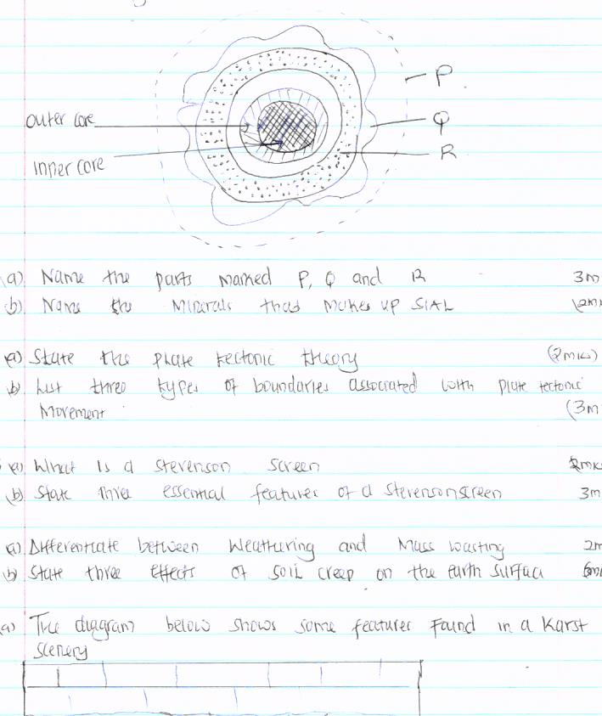

(a)Name the parts marked P, Q and R. (3mks)
(b) Name the minerals that make up SIAL (2mks)
2. (a) State the plate tectonic theory (2mks)
(b)List THREE types of boundaries associated with plate tectonic movement. (3mks)
3(a) what is a Stevenson screen (2mks)
(b)State THREE essential features of a Stevenson screen (3mks)
4(a) Differentiate between weathering and mass wasting (2mks)
(b)State THREE effects of soil creep on the earth surface (3mks)
5(a) The diagram below shows some features found in Karst Scenery.
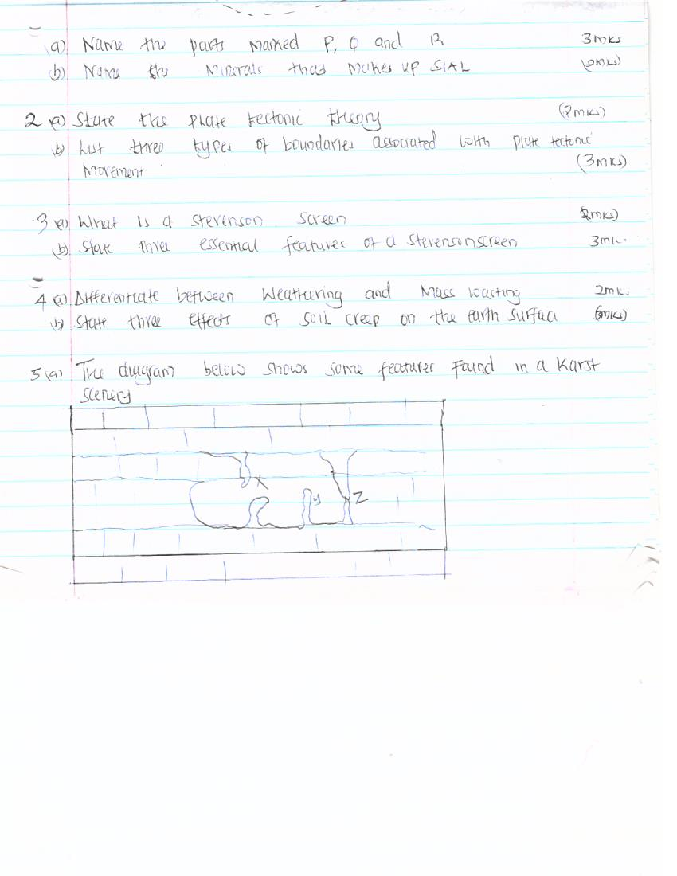

(a)Name the features marked X, Y and Z (3mks)

(b) State TWO ways in which lakes influence the natural environment (2mks)

SECTION B
ANSWER QUESTION 6 AND ANY OTHER TWO QUESTIONS FROM THIS SECTION
6. Study the map of MIGWANI (1:50,000) sheet 151/1 provided and answer the following questions
(a (i)Give the latitudinal extent of the area covered by the map (2mks)
(ii)What is the magnetic variation of the map (1mk?)
(iii)Convert the ratio scale of the map into statements scale (2mks)
(b)Citing evidence from the map give THREE economic activities carried out in the area covered by the map. (6mks)
(c) Explain how relief has influenced the distribution of settlement in the area covered by the map (4mks)
(d) (I)Using a vertical scale of 1cm to represent 100metres, draw a cross-section along the line marked J-K (4mks)
(iii)On it mark and label the following
-Footpath (1mk)
-Road (1mk)
- Water pipeline (1mk)
-steep slope (1mk)
(Iv)Calculate the vertical exaggeration of the cross-section (2mks)
7(a) (i) what is a river divide (1mk)
(ii)Describe THREE ways by which a river transport its load (6mks)
(b)Describe the characteristics of a river on its old stage (7mks)
(c) Describe each of the following drainage system and patterns
(i) Superimposed drainage system (3mks)
(ii)Centripetal drainage pattern (2mks)
(d)You have planned to carry out a field study of a river in its youthful stage.
(i)State TWO ways in which you would prepare for the study (2mks)
(ii)Name TWO features you are likely to study (2mks)
(iii)List TWO problems you are likely to experience during the study (2mks)
8(a) List FOUR processes through which coasts are eroded (4mks)
(b)Using well-labeled diagram, explain how each of the following features is formed
(i)A spit (4mks)
(Ii)A blow hole (2mks)
(iii)A toll (5mks)
(c) Some students carried out a field study on the coastal features found along the coast.
(i)List THREE features formed as a result of coastal emergence that they are likely to have studied (3mks)
(ii)State THREE methods that student may have used to record their data (3mks)
(iii)Describe TWO ways in which features resulting from coastal emergence are of significance to Kenya (2mks)
9(a) (i)Distinguish between Orogenic And Epeirogenic earth movement(2mks)
(ii)Describe how convectional currents cause earth movements (5mks)
(b)Explain THREE factors that determine the type of features resulting from earth movements (6mks)
(c) Describe the types of boundaries created as a result of earth movement (6mks)
(d)A form two class conducted a field study in an area that had undergone earth movement
(i)Give TWO examples of transform faults they would have observed (2mks)
(Ii)Name TWO oceanic plate they would have observed (2mks)
(Iii)Give the main reason why the interview method was not the appropriate method collecting the data (2mks)
10 (a)(i)Apart from fold mountains name THREE other features resulting from folding (3mks)
(ii)Identify FOUR examples of Fold Mountains outside Africa (4mks)
(b)Explain TWO major factors that influence folding (4mks)
(c) Describe the formation of Fold Mountains using the contraction theory (6mks)
(d)Explain the effects of folding on the following Agriculture(2mks) tourism (2mks) mining (2mks Transport (2mks)

