GEOGRAPHY
TIME: 2 HOURS

INSTRUCTIONS TO CANDIDATES
- This paper consist of Sections A and B
- Answer ALL questions in both section A

1. Define geography (2mks)

2. Define the term environment. (2mks)

3. Name two branches of geography. (2mks)

4. A part from planets name two other heavenly bodies. (2mks)

5. What is longitude. (2mks)

6. The diagram below shows the structure of the earth. Use it to answer questions a and b.
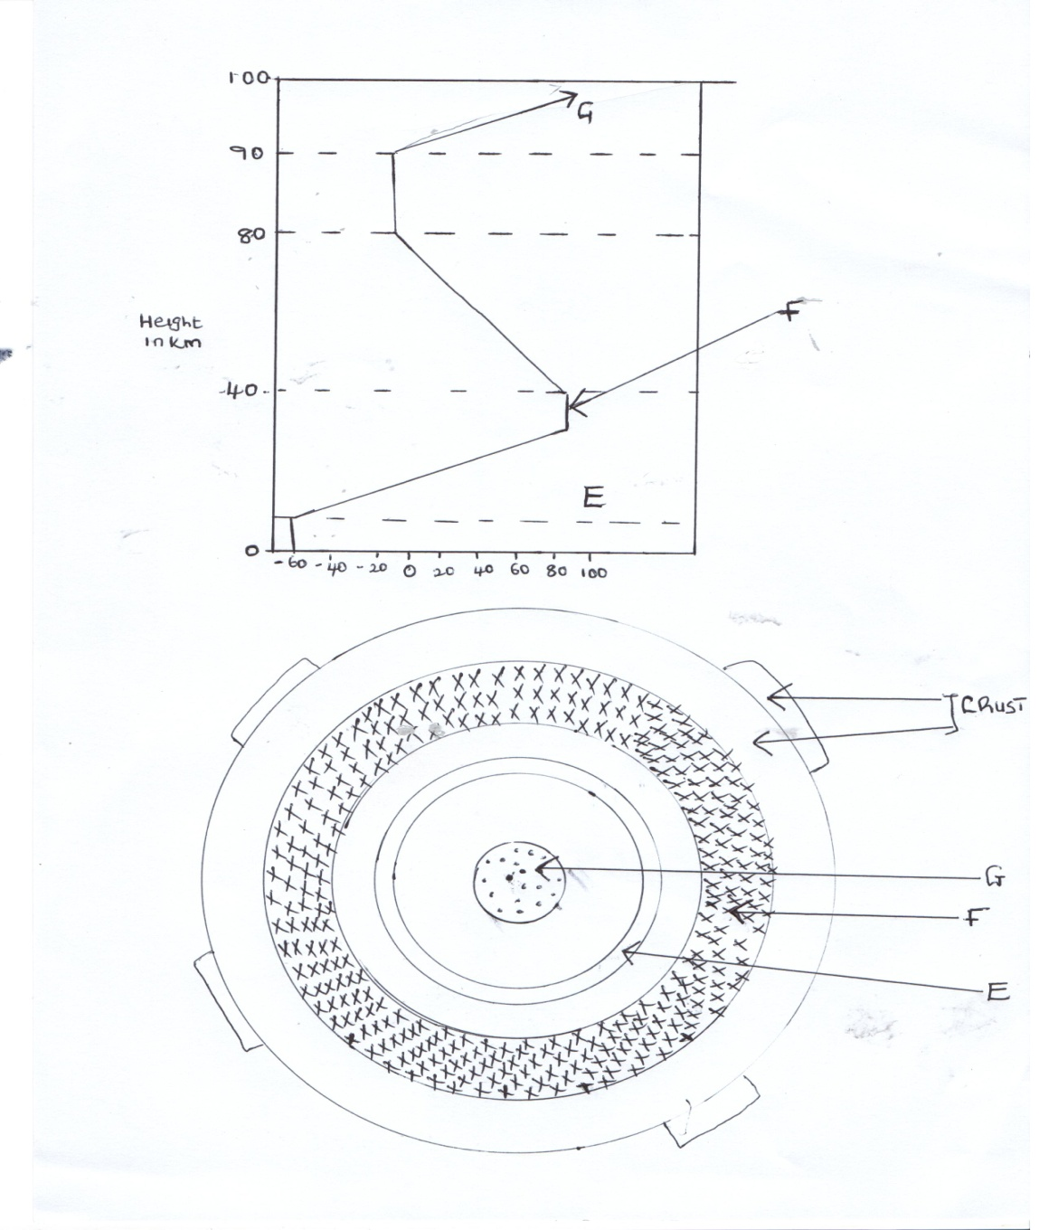

a) Name parts marked E, F and G. (3mks)
E
F
G

a) Name the minerals that make the crust. (2mks)

7. Give two dates in a year when the number of hours of daylight and darkness are equal . (2mks)

8. State two theories that have been put forward to explain the origin of the earth. (2mks)

9. The diagram below shows a set up of two thermometers use it to answer question (i) and (ii) .
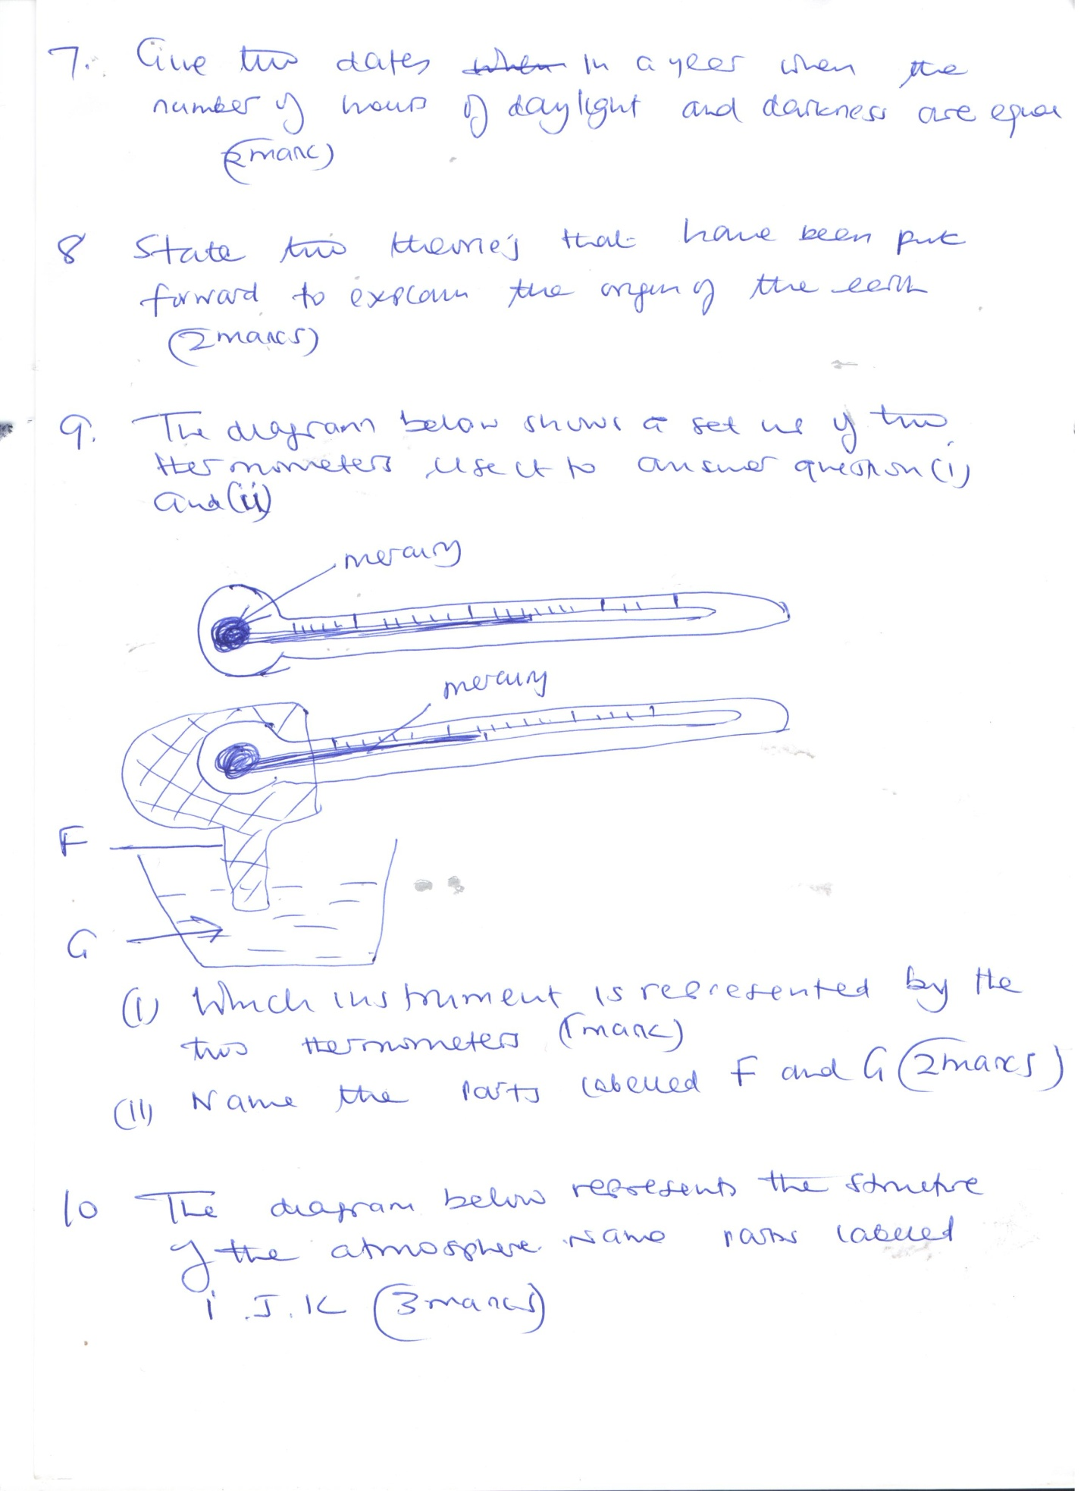
i) Which instrument is represented by the two thermometers. (1mk)

ii) Name the parts labeled F and G (2mks)

10. The diagram below represents the structure of the atmosphere name parts labelled(3mks)
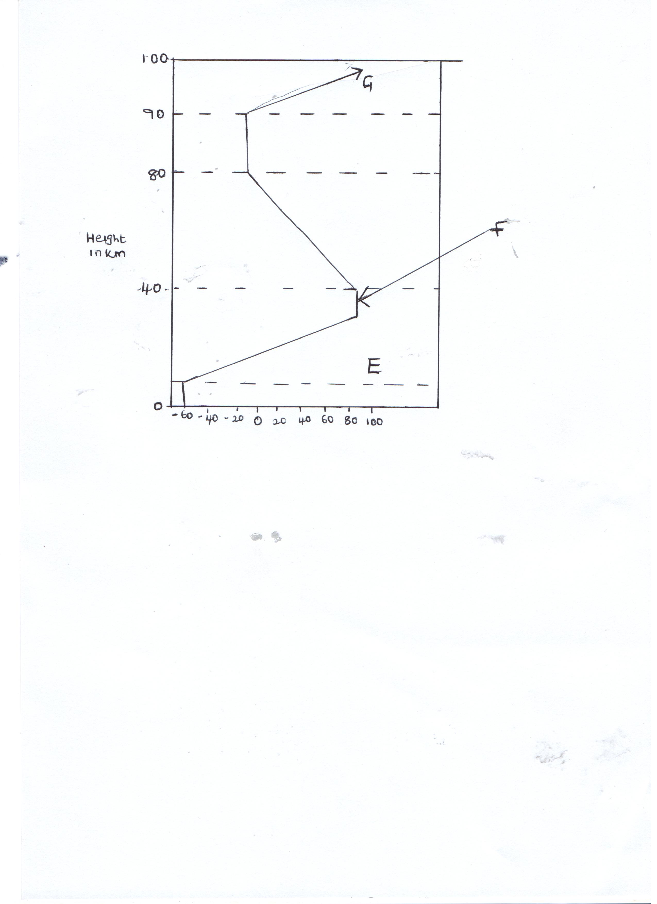
I
J
K
SECTION B 75 MARKS
Answer all questions in the spaces provided.
11A) Identify three areas studied in human geography. (3mks)

b) Explain four reasons why geography is studied in Kenyan schools. (8mks)

c) Name four subjects that relate with geography. (4mks)

12a) State three effects of earths rotation on its own axis. (3mks)

b) Use a well labeled diagram to show how a lunar eclipse occurs. (6mks)

c) Explain three proofs that earth is spherical. (6mks)

13a) Define weather . (2mks)

b) Name five elements of weather. (5mks)

c) State three factors to consider when citing a weather station . (3mks)

d) Name three gases that make the earths atmosphere. (3mks)

e) State two reasons why weather forecasting is important. (2mks)

14a) Draw a map of Kenya on the map label the following
i) River Tana and Athi. (2mks)
ii) Mt Kenya (1mk)
iii) The equator (1mk)

c) Draw a diagram of the globe and label three important line of latitude. (3mks)

d) Draw a well labeled diagram of relief rainfall. (6mks)

15a) State three factors that affect amount of insolation reaching the earths surface.
(3mks)

b) Name three types of clouds’. (3mks)
c) Name three instruments that are kept in the stevensons screen. (3mks)

d) The data below shows temperature of Thika town recorded on 24/1/2014
Maximum Temperature 20⁰c
Minimum Temperature 15⁰
Calculate diurnal range of temperature for Thika town . (2mks)

ii) Calculate the mean daily temperature for Thika town . (2mks)

e) Name the elements of weather measured by the following instruments
i) Anemometer (1mk)

ii) Barometer (1mk)

