GEOGRAPHY FORM 1 MARKING SCHEME

- What is Geography? (2mks)
- It is the scientific study of the earth as the home of mankind

- State four reasons why it is important to study Geography (1x4=4mks)
- It provides knowledge on the environment/it makes us understand the earth we live in
- It creates awareness on social values which create National Unity in our country
- It helps students to manage time properly
- It promotes international awareness which promote International understanding/Cooperation
- It promotes awareness on proper use of resources/environment
- It prepares one for career opportunities
- It promotes development of practical skills and critical thinking/developmental skills
- It provides knowledge on formation and evolution of land forms
- a) Name two branches studied in Geography (1x2=2mks)
- Physical Geography
- Human Geography

b) Name three areas studied in practical Geography (1x3=3mks)
  - Statistical methods
  - Maps and map work
  - Field work
  - Photographic interpretation

c) State the relationship between Geography and Mathematics (2x1=2mks)
  - Mathematical formulae and principles are used in Geography to calculate area, distance, mean, bearing, percentage and density
  - Geographical concepts are used in calculating direction/bearing in mathematics
  - Geographical information is analysed and presented using mathematical methods like graphs, tables

- a) What is the solar system? (2x1=2mks)
- The sun, the planets and other celestrial bodies orbiting around it/held together by the force of gravity

b) Name four components of the solar system (1x4=4mks)

- The sun
- The planets
- Natural satellites/moons
- Asteroids
- Meteors/meteorites
- Comets

c) State three characteristics of the earth (1x3=3mks)
  - Is the 3rd planet from the sun
  - Rotates on its axis 24hrs
  - Has a thin layer of air around it/atmosphere
  - Supports plant and animal life
  - 149 million kms from the sun
  - Revolves around the sun for 365¹/₄ or 366 days in a leap year on an elliptical orbit
  - Have one satellite/moon which revolves round the earth

- a) Name two theories that try to explain the origin of the earth and the solar system (1x2=2mks)
- Nebula cloud theory
- Passing star theory

b) Give three weaknesses of the passing star theory (1x3=3mks)
- Chances of another star passing near the sun are rare/Nil
- Origin of the star and sun are not explained
- The hot gas materials should have dispersed rather than condense
- Materials should have followed the star as it had greater gravitational pull
- The effect of the star setting planets on their orbits would have reduced as the star was moving away.

- a) Describe the shape of the earth (2x1=2mks)
- Earth is oblate spheroid spherical but not a perfect sphere
- Is flattened at the poles and bulges at the equatorial area

b) Name the forces that resulted to the spherical shape of the earth (1x3=3mks)
  - Centrifugal force
  - Centripetal force
  - Gravitational force

c) State four proofs that explain the spherical shape of the earth (1x4=4mks)
  - Circumnavigation
  - Satellite photographs show spherical shape of the earth
  - Gradual appearance of a ship approaching a port
  - Eclipse of the moon – Earths shadow casted on the moon appear circular or spherical
  - All planets appear spherical so the Earth must be spherical
  - Sun rises on the East and sets on the West
  - Earth’s horizon appear curved observed from a high point

d) Use a well labeled diagram to describe the lunar eclipse (7mks)
  - The earth, the moon and the sun are in a straight line
  - The earth is between the sun and the moon
  - The earth blocks sun’s light from reaching the moon’s surface. This casts a shadow on the moon’s surface which is called lunar/moon’s eclipse
  - This happens at night and during full moon
  - It lasts for about two hours as the earth is larger than the moon.
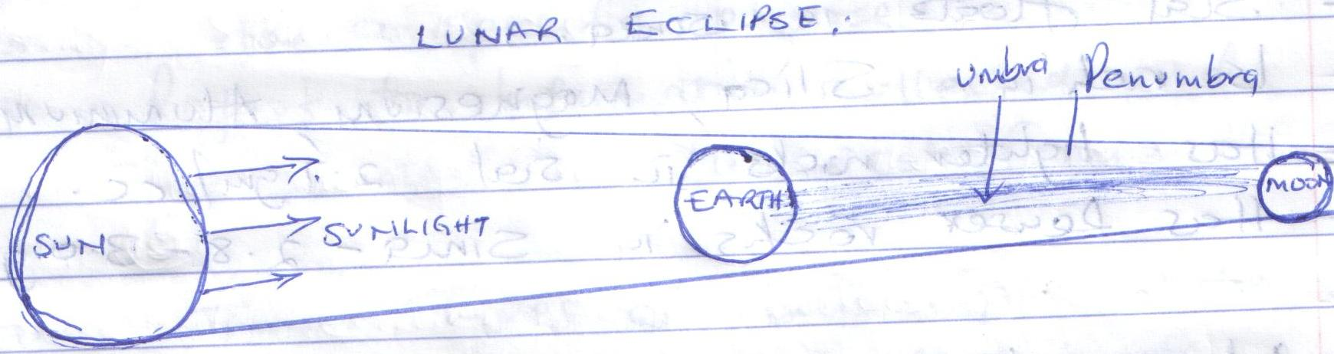
Diagram = 3mks
Text = 4mks
- a) Name two movements of the earth (1x2=2mks)
- Rotation
- Revolution

b) State four effects of earth’s rotation (1x4=4mks)
  - It causes day and night
  - It causes deflection of winds and ocean currents
  - It causes falling and rising of ocean tides
  - It causes a difference in time at different longitudes
  - It causes changes in atmospheric pressure over the earth’s surface

c) Differentiate summer solstice and winter solstice (2x2=4mks)
  - Summer solstice is a time of the year when the path of the sun is overhead the Tropical of Capricorn or Cancer and the regions have summer seasons
  - Winter solstice is a time of the year when the overhead sun is far away from either the Northern or Southern hemisphere and the regions have winter seasons

d) What is Equinox? (2x1=mks)
- It is the time of the year when the path of the sun is high and overhead the Equator on 21st March and 23rd September.

- a) State three characteristics of the crust (1x3=3mks)
- Is made of solid or brittle rocks
- Is divided into Sial and Sima
- Sial floats in Sima
- Is rich in Silica, Magnesium, Aluminium and Iron
- Has lighter rocks in Sial 2.7gm/cc
- Has denser rocks in Sima 2.8-3.0gm/cc

b) Name three components of the atmosphere (1x3=3mks)
  - Gases/Air
  - Water vapour/moisture
  - Hygroscopic particles/smoke/dust/salt/pollen grains

c) Name three layers of the atmosphere (1x3=3mks)

  - Troposphere
  - Stratosphere
  - Mesosphere
  - Thermosphere/Ionosphere

d) State three characteristics of the Troposphere (1x3=3mks)
  - Is the lowest layer 0-16km upwards
  - Contains 75% of the total gases in the atmosphere
  - Is the life supporting layer
  - Has water vapour/cloud cover
  - Temperature decreases with increase of Altitude
  - Pressure decreases upwards
  - Wind speed increases with increase of height
  - Separated from stratosphere by tropopause

e) Differentiate positive lapse rate and negative lapse rate (2x2=4mks)
  - Positive lapse rate – Is a decrease in temperature with an increase in height
  - Negative Lapse rate – Is an increase in temperature with an increase in height

- a) Define these terms (4mks)
- Statistics(2x1=2mks)
- Refers to numerical facts and figures collected and arranged in a systematic order for a specific purpose

- Data (2x1=2mks)
- Refers to information collected and presented in Numerical form

b) Name two types of statistical data (2x1=2mks)

- Discrete data
- Continuous data
- Individual data
- Grouped data

c) State three sources of primary data (1x3=3mks)

  - Interview to resource person
  - Questionnaires
  - Observation in the field
  - Experiments
  - Measurements
  - Counting
  - Collecting samples
  - photographing

d) State three sources of secondary data (1x3=3mks)

  - Text books
  - Magazines
  - Journals
  - Maps/Atlas
  - Census reports
  - Geological maps
  - Newspapers
  - Periodicals
  - Statistical Abstracts
  - Video tapes
  - Photographs
  - Audio tapes

e) State three advantages of using observation as a method of data collection (1x3=3mks)
  - Provides first hand information
  - Helps to collect reliable data
  - Saves on time
  - Helps to collect relevant and accurate data
  - Easy to remember/improves visual memory
  - Helps to collect data not found in text books

- a) Differentiate between weather and climate (4mks)
- Weather: Is the state of the atmosphere of a given place over a short period of time (2x1=2mks)
- Climate: Is the average weather conditions of a place recorded over a long period of time (10-30years) (2x1=2mks)

b) State three characteristics of a Stevenson’s screen (1x3=3mks)
  - It has lovoured sides
  - It is painted white
  - It has double roofing
  - It is placed 121cm above the ground level

c) State three reasons why data can be inaccurate (1x3=3mks)
  - Use of defective instruments
  - Human error
  - Interference with the instruments by people
  - Poor citing of a weather station
  - Extreme/Harsh weather conditions
  - Natural calamities may damage instruments

d) Explain briefly how you can measure rainfall using a rain gauge (4mks)
  - Remove the water collecting jar from the metal holder/container
  - Pour the water into a measuring cylinder
  - Take readings from the measuring cylinder
  - Record the readings on a table/chart
  - Interpret the readings and then reset the rain gauge

