GEOGRAPHY FORM 2 END OF TERM 1
MARKING SCHEME
SECTION A
- a) Define the term solar system (1mk)
sun and the nine planets orbiting around it
b) List down two theories that explain the origin of the solar system (2mks)
- passing star theory
- Nebula cloud theory
- a) Give a brief explanation about the origin of the earth (4mks)
- 3rd planet on the solar system
- formed about 4600 million years ago
- a hot mass of gas was thrown off the sun
- these gases cool to form liquid
- Heavier material collected at the centre to form the core
- Less heavier formed mantle and crust
- As cooling continued the outer part of the earth hardened faster to form crust.
b) Fill in the blank spaces on the dimension of the earth (4mks)
Equatorial diameter 12762 km
polar diameter 12722km
equatorial circumference 40085 km
polar circumference 39955 km
c) List down four proofs that the earth is spherical (4mks)
- circumnavigation
- Approaching ship
- earth rotates from west to East
- Eclipse of the moon
- Earth curved horizon
- All other planets are round
- Aerial photographs
- a) List down four effects of rotation of the Earth (4mks)
- Day and night
- Drifference of 1 hour between meridians 15° apart.
- Deflection of winds and ocean currents
- variation in speed of air masses
- rising and falling of ocean tides
b)with the aid of a well labelled diagram, explain how solar eclipse occurs (4mks)

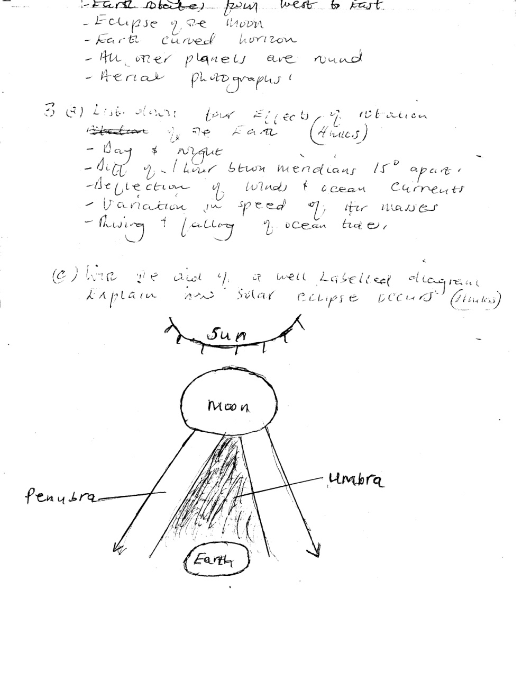

- a) Define the term weather (1mk)
condition of the atmosphere of a given place at a specific time over a short period of time e.g a day, month or a year.
b) List down four factors that determine the amount of solar radiation which reaches the earth surface. (4mks)
- intensity of suns radiation in space
- Transparency of the atmosphere i.e transmission absorption, scattering and reflection
- Position of the earth on its orbit
- The angle of inclination or surface on which the sun’s rays fall
- Area and nature of the surface on which rays fall
- a) Explain the term humidity (1mk)
Condition of the atmosphere with reference to its water vapour content
b)Differentiate between absolute humidity and relative humidity (2mks)
Absolute – amount of water vapour in a given volume of air at a particular temperature expressed in gm/m³
Relative – Ratio between absolute humidity of a given mass of air and the maximum amount of H₂O vapour that it can hold at the same temperature.
- a) What is the meaning of the term winds? (1mks)
Moving air over the earth’s surface
b) With Aid of well labelled diagrams explain how land and sea breezes occur (6mks)

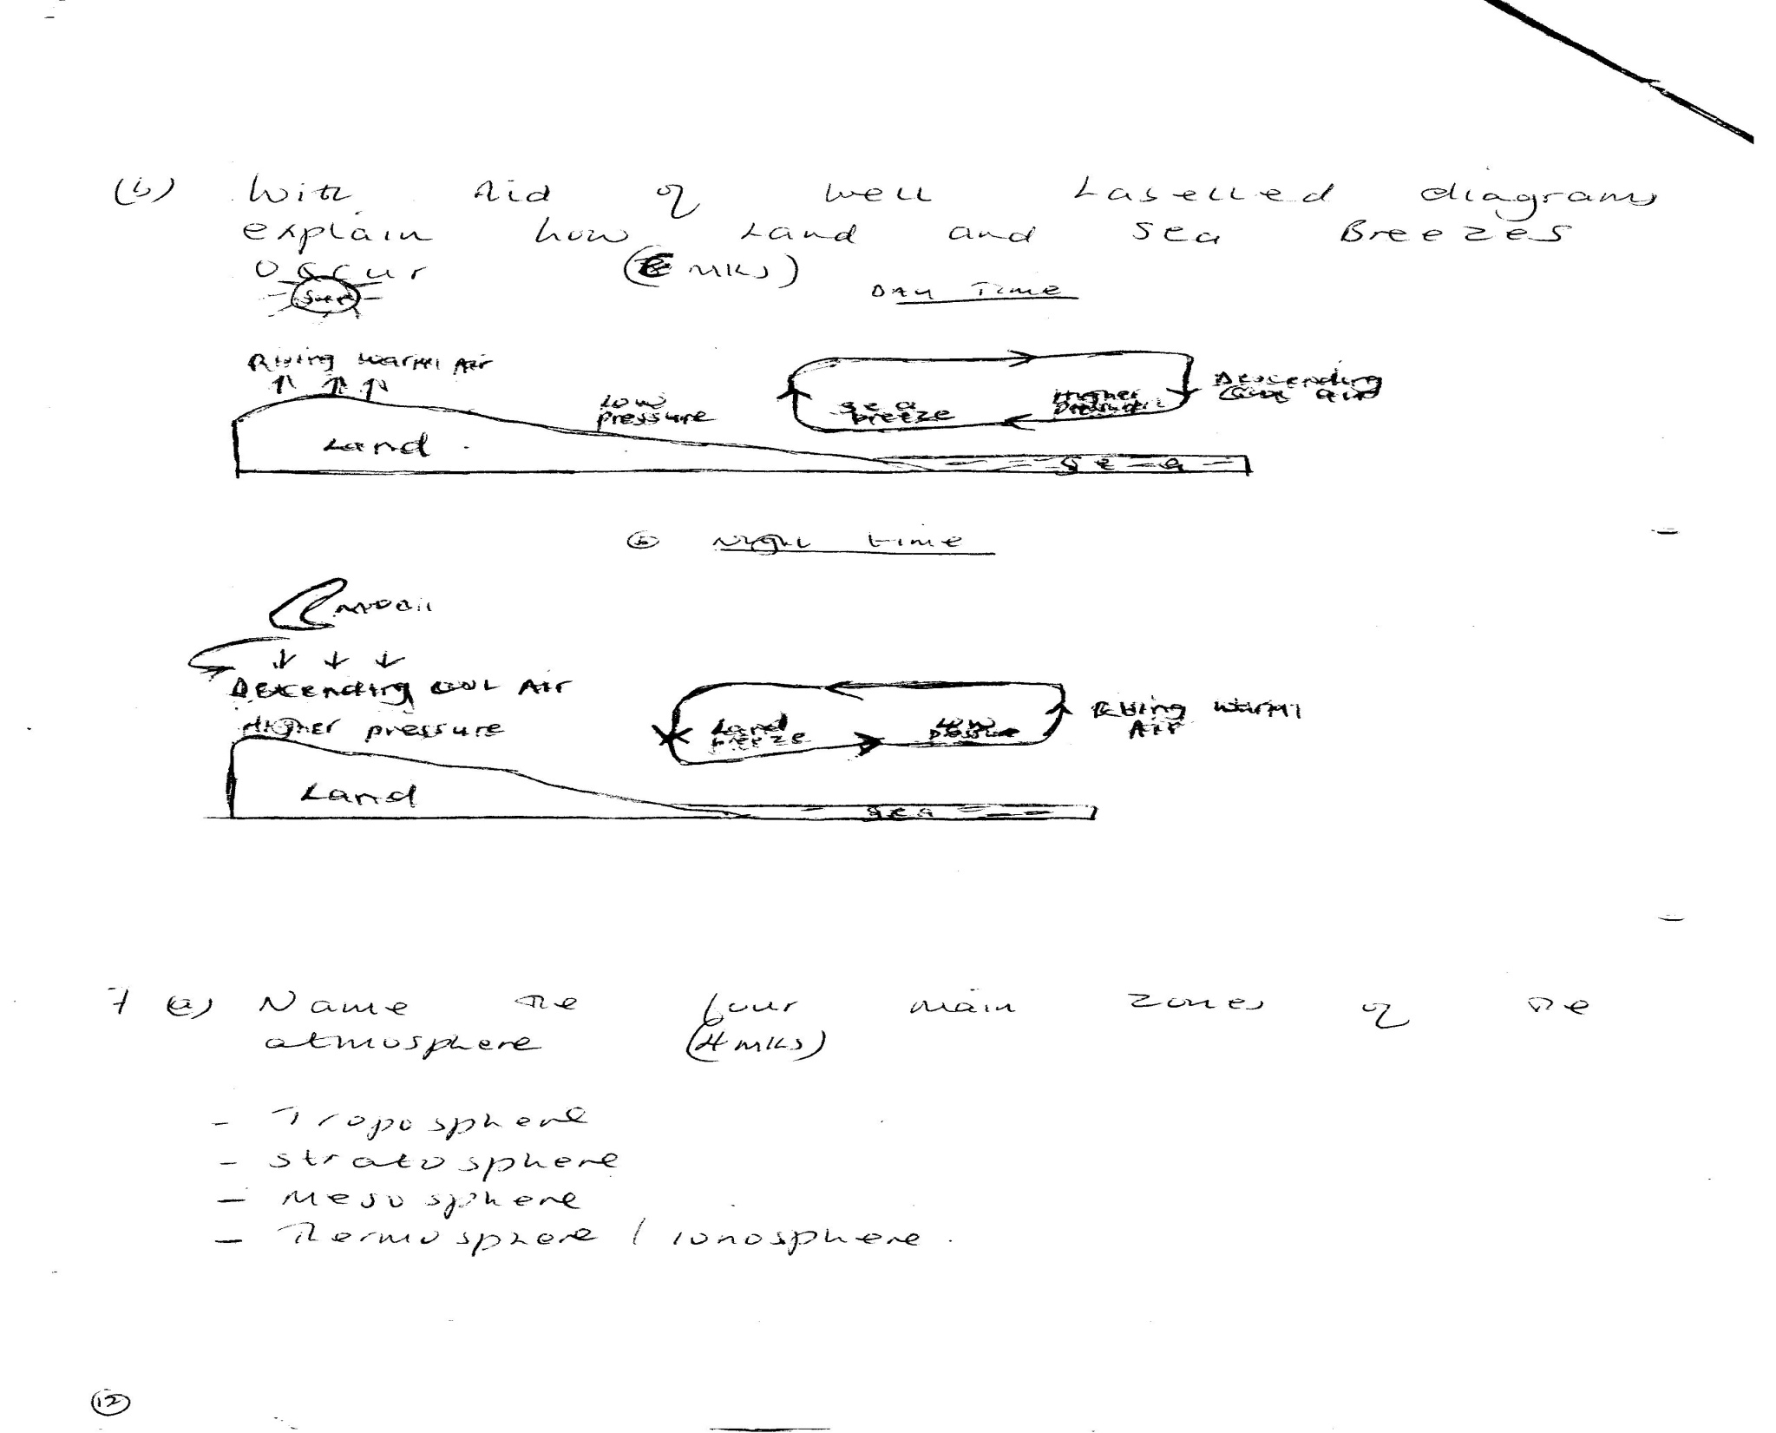
- a) Name the four main zones of the atmosphere (4mks)
- Troposphere
- Stratosphere
- Mesosphere
- Thermosphere/ionosphere
b) Differentiate between negative, positive and zero lapse rate. (3mks)
Negative – Temp increase with increase in altitude
Zero- no charge in temp with increase in altitude
Normal lapse rate – decrease in temperature with increase in height
c) What is the ozone layer? (2mks)
Layer that absorbs ultra- violet rays from the sun/protective layer
d) What is its importance to man? (2mks)
- Protective layer, shields man from ultra-violet rays which may cause skin cancer and other forms of ailments.
- The table below shows rain fall and temperature in town x use it to answer the questions that follow
Months | j | F | M | A | M | J | J | A | S | O | N | D
Temp °C | 23 | 24 | 26 | 28 | 29 | 28 | 26 | 26 | 26 | 30 | 28 | 25
Rainfall mm | 3 | 0 | 3 | 1 | 18 | 500 | 720 | 408 | 300 | 70 | 15 | 0

- Calculate
- The total annual rainfall (2mks)
2038
- The mean monthly rainfall (2mks)
169.83
- The annual range of temperature (2mks)
drifference between highest and lowest mean niontaly temperature in year 30-23 = 7°C
- The mean annual temperature (2mks)
Mean annual temp = sum mean monthly temperature 319
12 12
26.58°C
- Using the table indicate the following
- The wettest month (1mks)
July
- The hottest month (1mk)
October
- The coolest month (1mk)
January
SECTION B
- a) Define the term Earth movements (1mk)
Movement of crustal rocks by forces originating and operating in the interior of the earth known as tectonic forces
b) Formation of internal or External land formas by tectonic forces is determined by the following (3mks)
- Nature and age of the earth’s materials e.g degree of elasticity
- Type of movement involved
- Intensity and scale of the forces involved.
c) List down two types of eath movements (2mks)
- Horizontal/orogenic/lateral
- vertical /Epeirogenic
- a) Give two causes of earth movements (2mks)
- Magma movement
- Gravitational force
- convectional currents
- isostatic adjustment
b) List down thre evidences supporting continental drift theory (3mks)
- Climatolog
- sea floor spreading
- jig saw fit of continental margin
- geological structure
- paleomagnetic studies
- ancient glacial deposits
- mid-Atlantic ridge
c) List down three types of boundaries associated with plate tectonic movements 93mks)
- Extension/constructive margins
- Compressional /destructive margin
- transform faults /conservative margins
- a) Define the term folding (1mk)
bending/ crumbling of rocks on the earth’s crust.
b) Briefly explain the process of folding (3mks)
- compression of rocks – anticlines and synclines formed
- geosynclines filled with rediments –pressure created due to additional weight
- Compression in the earth’s crust- sediments wrinkle forming foreland and back land
c) List down three different types of folds 93msk)
- simple symmetrical
- asymmetrical
- over fold
- isoclinals fold
- recumbent fold
- napple/over thrust
- Aticlinorium synclinorium complex
d) List down three features resulting from folding (3mks)
- fold mountains
- Escarpments
- synclinal valley
- depressions
c) Fill in the gaps below (5mks)

Fold mountain where found
- Atlas N.W Africa
- Alps Europe
- Himalagas Asia
- Andes S. America
- Rockies North America
f) Give three significances of folding to human activities (3mks)
- a) Define the term faulting (1mks)
Its cracking or fracturing of rocks of the earth’s crust

b) List down three types of faults (3mks)
- Normal fault
- Reversed fault
- tear, shear slip fault
- Thrust fault
- An anti-clinal fault
c) i)What is a rift valley? (1mk)
Long narrow trough between two or more parallel faults with steep faults scarps on either side.
ii) Mention three ways in which the rift valley may have been formed (3mks)
- Tension
- compression
- Anticlinal arching
- a) Explain the meaning of the following terms;
- A picture (1mk)
An image of an actual object represented either as drawing, painting or photograph
- A map (1mk)
Representation of part or whole earth on a flat surface e.g. sheet of paper and drawn to scale
- A plan (1mk)
map of a place or a picture drawn to scale for a specific use.

- Give three uses of maps (3mks)
- giving direction and location of place
- showing human and economic activities
- indicate physical features
- showing weather trends
- showing political and administrative boundaries
- for military strategy

